Supplementary Figure 1. Schematic overview for the intervention period and outcomes in this sub-study.

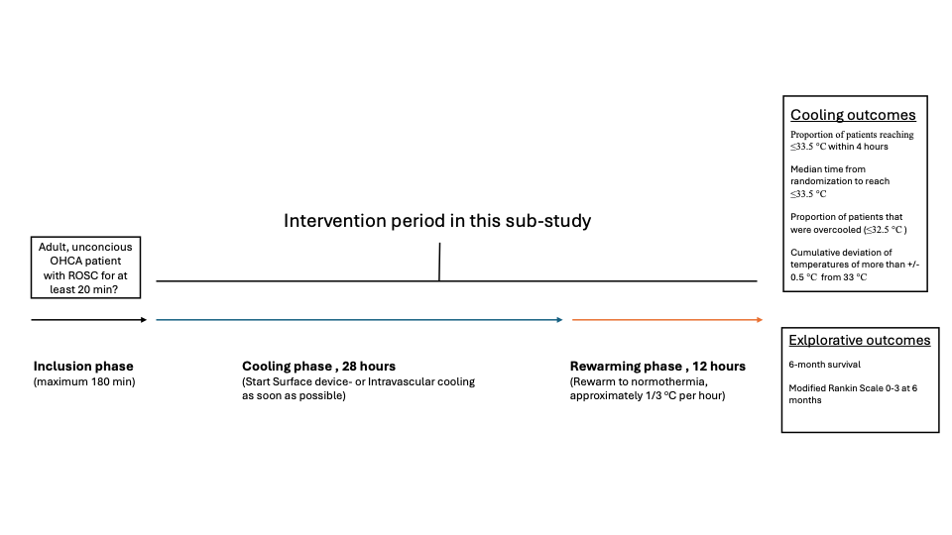

Supplementary Figure 2. Explorative outcomes using Frequentist and Bayesian analyses comparing intravascular device (IC) vs surface device (SFC)

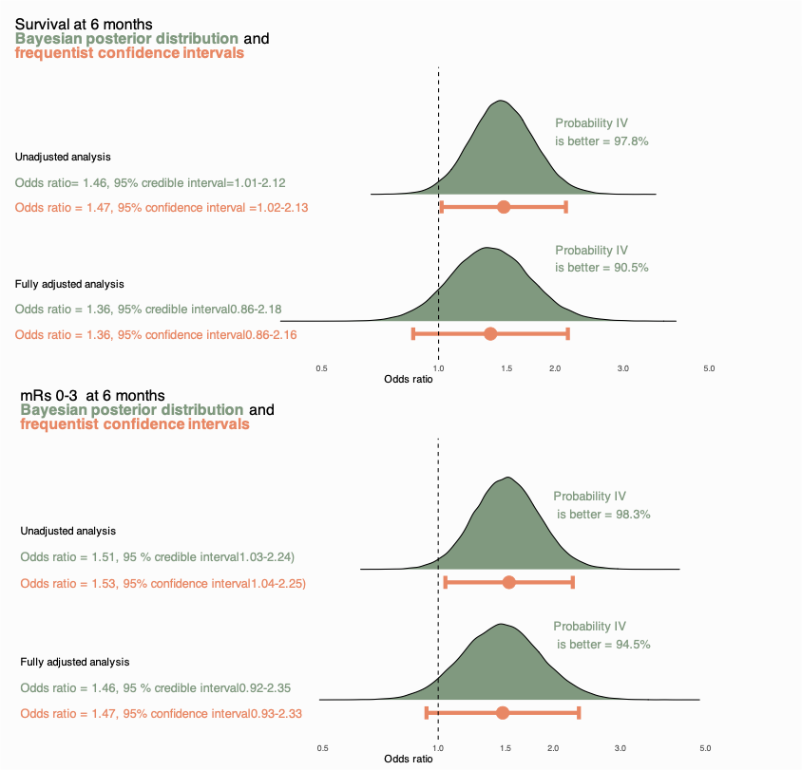

The adjusted model is adjusted for age, sex, initial rhythm, frailty score, time to ROSC, witnessed status, bystander CPR, location (i.e., at home or outside home), coronary angiography within 2 hours, Charlson comorbidity index and study site (as random effect). For the Bayesian analyses a neutral distribution N (0,1) was used as prior distribution (log-odds). The large green shaded area to the right of the line represents values above 1 (i.e., a beneficial effect of IC) and the small green shaded area to the left of line represents values below 1 (i.e., harmful effect of IC). CrI indicates credible interval.

Supplementary Figure 3. Probability of survival up to 180 days after randomization

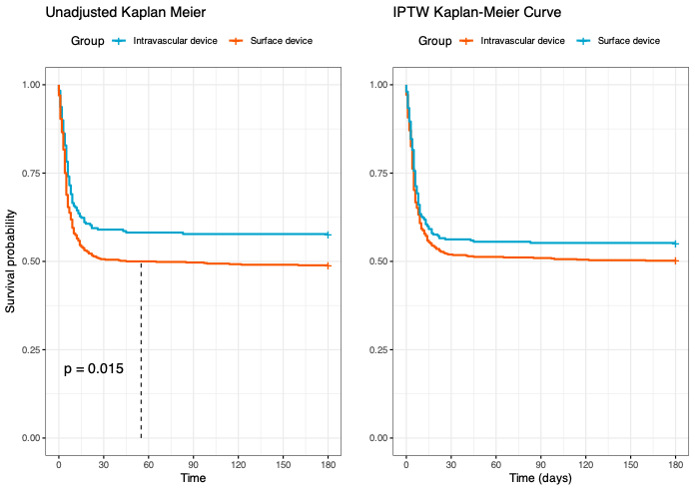

Supplementary Figure 4. Crude distribution of modified Rankin Scale (mRS) scores at 6 months

mRS Score | Intravascular device – no (%) | Surface device – no (%)
0 | 46 (20) | 91 (15)
1 | 25 (11) | 59 (9.8)
2 | 39 (17) | 90 (15)
3 | 12 (5.3) | 22 (3.7)
4 | 3 (1.3) | 12 (2.0)
5 | 2 (0.9) | 5 (0.8)
6 | 101 (44) | 323 (54)
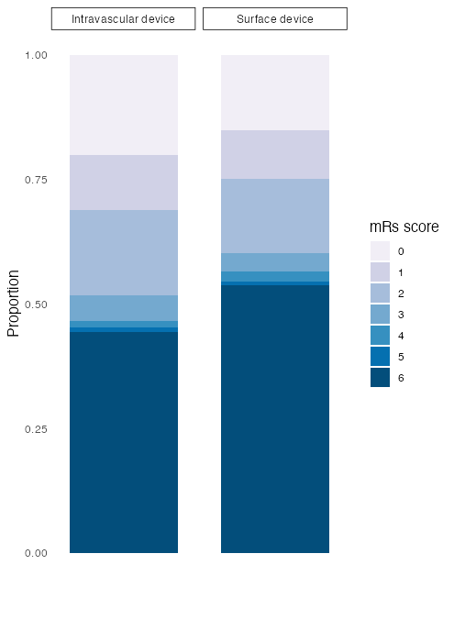

Supplementary Table 1. Among patients randomized to hypothermia, number of patients treated with Intravascular cooling (IC) or Surface cooling (SFC) device at each hospital
 | Intravascular device | Surface device
Örebro University Hospital | 0 | 3
Aarhus Hospital | 31 | 7
Akademiska University Hospital, Uppsala | 0 | 5
Austin Hospital, VIC | 0 | 7
Bern University Hospital | 32 | 2
Birmingham University Hospital | 3 | 0
Bournemouth | 10 | 0
Bristol Royal Infirmary | 0 | 68
Cantonal Hospital St. Gallen | 20 | 8
Capio-St.Göran Hospital | 0 | 3
Centralsjukhuset Karlstad | 0 | 12
Charité | 0 | 23
Christchurch Hospital | 0 | 13
Cochin University Hospital, Paris | 0 | 27
Concord Repatriation General Hospital | 0 | 1
Erasme Hospital, Brussles | 0 | 11
Hallands Sjukhus, Halmstad | 0 | 16
Haukeland, Bergen | 6 | 0
Helsingborg Hospital | 2 | 15
Hradec Kralove | 0 | 23
Innsbruck | 2 | 0
John Hunter Hospital, NSW | 0 | 1
Lariboisiere, Paris | 2 | 11
Lausanne University Hospital | 2 | 18
Liberec Hospital | 3 | 2
Limoges Hospital | 0 | 14
Linköping University Hospital | 0 | 8
Liverpool Hospital | 0 | 8
Lugano Cardiocentro | 14 | 0
Manchester Royal Infirmary | 0 | 12
Mayo Clinic | 0 | 1
Modena NOCSAE Hospital | 2 | 4
Trollhättan Hospital | 0 | 12
Nantes | 0 | 11
Nepean Hospital, NSW | 0 | 6
Northern Hospital, VIC | 0 | 6
Oslo University Hospital | 0 | 28
Pittsburgh | 0 | 2
Prague General University Hospital | 11 | 24
Princess Alexandra Hospital, QLD | 0 | 8
Queen Alexandra - Portsmouth | 12 | 0
Royal Berkshire Hospital | 0 | 5
Royal North Shore Hospital, NSW | 0 | 9
Royal Victoria Hospital, Belfast | 0 | 14
Södersjukhuset, Stockholm | 0 | 15
Sahlgrenska Universitetssjukhuset | 0 | 38
San Martino, Genova University Hospital | 0 | 15
Skåne University Hospital Lund | 8 | 14
Skåne University Hospital Malmö | 3 | 28
Skaraborgs sjukhus Skövde | 0 | 8
Sorlandet Hospital Arendal | 0 | 11
St Vincent's Hospital Sydney, NSW | 0 | 2
St. Olav's University Hospital | 10 | 1
The Alfred, VIC | 0 | 5
The Essex Cardiac Centre | 31 | 3
Trieste University Hospital | 4 | 0
University Hospital of Wales, Cardiff | 0 | 25
Versailles | 1 | 8
Wellington Regional Hospital | 0 | 16
Ziekenhuis Oost, Limburg | 0 | 1
Zurich University Hospital | 30 | 0

Supplementary Table 2. Adverse events and shivering

 | Intravascular cooling | Surface cooling | p value | Missing (%)
Bleeding - no (%) | 15 (6.3) | 25 (3.9) | 0.14 | 0.2
Sepsis - no (%) | 20 (8.4) | 78 (12) | 0.11 | 0.3
Pneumonia - no (%) | 83 (35) | 240 (38) | 0.4 | 0.2
Arrhythmias - no (%) | 50 (21) | 160 (25) | 0.2 | 0.2
Skin complication - no (%) | 1 (0.4) | 9 (1.4) | 0.3 | 0.2
Any shivering* day 1 - no (%) | 69 (30) | 139 (23) | 0.02 | 3.9
Any shivering day 2 – no (%) | 67 (30) | 161 (27) | 0.5 | 6.3
Any shivering day 3 – no (%) | 58 (26) | 128 (23) | 0.3 | 11.4
Severe shivering** day 1 - no (%) | 16 (7) | 24 (3.9) | 0.06 | 3.9
Severe shivering day 2 – no (%) | 10 (4.4) | 23 (3.9) | 0.7 | 6.3
Severe shivering day 3 – no (%) | 16 (7.3) | 20 (3.6) | 0.03 | 11.4

*Grade 0-3 on The Bedside Shivering Assessment Scale (BSAS)
** Grade 3 on The Bedside Shivering Assessment Scale (BSAS)

Supplementary Table 3. Outcomes for intravascular cooling (IC) and surface cooling (SFC) treated patients in the hypothermia group compared to IPTW matched normothermia patients at the same hospital

6-month survival
IC hypothermia | Normothermia | p-value
57.4% | 55.2% | 0.6
SFC hypothermia | Normothermia
49.1% | 51.0% | 0.5
Modified Rankin Scale (mRS) 0-3 at 6-months
IC hypothermia | Normothermia | p-value
53.2% | 47.1% | 0.2
SFC hypothermia | Normothermia
43.8% | 44.4% | 0.8

#The Invserse Probability Treatment Weighting (IPTW) matching included age, sex, initial rhythm, frailty score, time to ROSC, witnessed status, bystander CPR, location, Charlson comorbidity score, coronary angiography within 2 hours, study site

Supplementary Table 4. Outcomes for intravascular versus surface devices using IPTW*analysis also including the variable Bilateral pupillary reflexes
 | Intravascular cooling  (n=212) | Surface device cooling  (n=506) | OR (95% CI)
Survival at 180 days after IPTW matching# | 54.4% | 50.5% | 1.17 (0.84-1.63)
Survival with mRS^ 0-3 at 180 days after IPTW matching# | 50.6% | 45.2% | 1.24 (0.88-1.74)

^Modified Rankin Scale 0–3
#The Invserse Probability Treatment Weighting (IPTW) matching included age, sex, initial rhythm, frailty score, time to ROSC, witnessed status, bystander CPR, location, Charlson comorbidity score, coronary angiography within 2 hours, Bilateral pupillary reflexes. Only complete cases were included

