Intensive Care Medicine
Electronic Supplementary Material 1

Trial Protocol

Efficacy of targeting high mean arterial pressure for older patients with septic shock (OPTPRESS): a multicentre, pragmatic, single-blind, randomised controlled trial

Authors:
Akira Endo, MD ^{1, 2}, Kazuma Yamakawa, MD³, Takashi Tagami, MD⁴, Yutaka Umemura, MD⁵, Takeshi Wada, MD⁶, Ryo Yamamoto, MD⁷, Hiroki Nagasawa, MD⁸, Wataru Takayama, MD², Masayuki Yagi, MD⁹, Kyosuke Takahashi, MD¹⁰, Mitsuaki Kojima, MD^{2,11}, Chihiro Narita, MD¹², Satoshi Kazuma, MD¹³, Jiro Takahashi, MD¹⁴, Atsushi Shiraishi, MD¹⁵, Masaki Todani, MD¹⁶, Masaki Nakane, MD¹⁷, Toshihiko Nagata, MD¹⁸, Shohei Tanaka, MD¹⁹, Yuta Yokokawa, MD²⁰, Kunihiko Takahashi, PhD²¹, Haruka Ishikita, MD^{1, 2}, Ryo Hisamune, MD³, Junichi Sasaki, MD⁷, Ken-ichi Muramatsu, MD⁸, Hiroyuki Sonobe, MD⁹, Kazunobu Minami, MD²², Hiromasa Hoshi, MD^{1, 2}, Yasuhiro Otomo, MD^{2, 23}, on behalf of the OPTPRESS trial investigators

Affiliations:
¹Department of Acute Critical Care Medicine, Tsuchiura Kyodo General Hospital, 4-1-1 Otsuno, Tsuchiura, Ibaraki, Japan
²Trauma and Acute Critical Care Center, Tokyo Medical and Dental University Hospital, 1-5-45 Yushima, Bunkyo, Tokyo, Japan
³Department of Emergency and Critical Care Medicine, Osaka Medical and Pharmaceutical University, 2-7 Daigakumachi, Takatsuki, Osaka, Japan
⁴Department of Emergency and Critical Care Medicine, Nippon Medical School Musashikosugi Hospital, 1-396 Kosugimachi, Nakahara-ku, Kawasaki, Kanagawa, Japan
⁵Division of Trauma and Surgical Critical Care, Osaka General Medical Center, 3-1-56 Bandai-Higashi, Sumiyoshi, Osaka, Japan
⁶Division of Acute and Critical Care Medicine, Department of Anesthesiology and Critical Care Medicine, Faculty of Medicine, Hokkaido University, N15, W7, Kita-ku, Sapporo Japan.
⁷Department of Emergency and Critical Care Medicine, Keio University School of Medicine, 35 Shinanomachi, Shinjuku, Tokyo, Japan.
⁸Department of Acute Critical Care Medicine, Shizuoka Hospital, Juntendo University, 1129 Nagaoka, Izunokuni City, Shizuoka, Japan
⁹Emergency Medicine and Acute Care Surgery, Matsudo City General Hospital, 993-1 Sendabori, Matsudo-shi, Chiba, Japan
¹⁰Emergency and Critical Care Center, Hyogo Prefectural Nishinomiya Hospital, 13-9, Rokutanjicho, Nishinomiya City, Hyogo, Japan
¹¹Emergency and Critical Care Medicine, Tokyo Women’s Medical University Adachi Medical Center, 4-33-1 Kohoku, Adachi-ku, Tokyo, Japan
¹²Department of Emergency Medicine, Shizuoka General Hospital, 4-27-1 Kitaando, Aoiku, Shizuoka, Japan
¹³Department of Intensive Care Medicine, Sapporo Medical University School of Medicine, S1, W16, Chuo-ku, Sapporo, Hokkaido, Japan
¹⁴Department of Acute Medicine, Kawasaki Medical School, 577 Matsushima, Kurashiki, Okayama, Japan.
¹⁵Emergency and Trauma Center, Kameda Medical Center, 929 Higashicho, Kamogawa, Chiba, Japan
¹⁶Emergency and Critical Care Medicine, Yamaguchi University, 1-1-1 Minami-Kogushi, Ube, Yamaguchi, Japan
¹⁷Department of Emergency and Critical Care Medicine, Yamagata University Hospital, 2-2-2 Iida-nishi, Yamagata, Japan
¹⁸Department of Emergency and Critical Care Medicine, Yodogawa Christian Hospital, 1-7-50, Kunijima, Higashi-Yodogawa, Osaka, Japan
¹⁹Department of Emergency Medicine, Sunagawa City Medical Center, 3-1-1 Nishi 4-jo Kita, Sunagawa, Hokkaido, Japan.
²⁰Division of Emergency and Critical Care Medicine, Tohoku University Graduate School of Medicine, 1-1 Seiryocho, Aoba-ku, Sendai, Miyagi, Japan
²¹Department of Biostatistics, M&D Data Science Center, Tokyo Medical and Dental University, 1-5-45 Yushima, Bunkyo, Tokyo, Japan
²²Department of Intensive Care Medicine, Kameda Medical Center, 929 Higashicho, Kamogawa, Chiba, Japan
²³Department of Trauma and Critical Care Medicine, National Hospital Organization Disaster Medical Center, 3256, Midori-cho, Tachikawa, Tokyo, Japan

Correspondence to:
Akira Endo, MD, PhD
Department of Acute Critical Care Medicine, Tsuchiura Kyodo General Hospital, 4-1-1 Otsuno, Tsuchiura, Ibaraki, Japan
Department of Acute Critical Care and Disaster Medicine, Tokyo Medical and Dental University Graduate School of Medicine and Dental Sciences, 1-5-45 Yushima, Bunkyo, Tokyo, Japan
Tel: +81-3-3813-6111
E-mail: akira.endo.0112@gmail.com

Introduction
Sepsis is a leading cause of death worldwide. The mortality rate of septic shock diagnosed using the Sepsis-3 criteria is approximately 52∙1% [1]. Initial resuscitation targeting haemodynamic stabilisation to optimise regional tissue perfusion of vital organs and maintain oxygen metabolism is a core component of treatment for patients with septic shock. The 2021 Surviving Sepsis Campaign (SSC) guidelines recommend an initial target mean arterial pressure (MAP) of 65 mmHg for adults with septic shock on vasopressors [2]. However, this target MAP has not been supported by sufficient evidence, and its optimal target blood pressure remains controversial [3–6].
Previous randomised controlled trials did not show any survival benefits for target MAPs >65–70 mmHg and reported a reduced frequency of renal replacement therapy among patients with known hypertension [7, 8]. These results suggest that uniform adoption of a higher target MAP for all adult patients with septic shock, including young individuals with no comorbidities, may not be beneficial. Catecholamine-related adverse effects might affect the outcomes and outweigh the therapeutic effects of maintaining a higher blood pressure [9, 10]. The effectiveness of the high-MAP target strategy should be assessed using early administration of vasopressin, which has been proposed as a novel approach in recent years [11–13].
A higher target MAP may be beneficial in older patients, particularly those with arteriosclerosis [3, 4]. Individualised management of intraoperative blood pressure for high-risk patients significantly reduces postoperative organ dysfunction compared with standard management [14]. Moreover, the optimal target blood pressure for patients requiring intensive respiratory and circulatory management may differ based on their background [15].
Considering these findings, the effectiveness of higher blood pressure management in patients with septic shock and chronic hypertension using strategies that minimise catecholamine dose requires further investigation. Therefore, this randomised controlled trial was conducted based on the hypothesis that older patients with septic shock, who generally have high blood pressure under normal conditions, would benefit from management using a higher blood pressure target.

Methods and Analysis
Trial design
The ‘optimal target blood pressure in older adults with septic shock (OPTPRESS)’ trial is a multicentre, pragmatic single-blind randomised controlled trial enrolling patients with septic shock aged ≥65 years. Twenty-eight hospitals in Japan participated in the OPTPRESS trial, including universities, nonuniversities, and urban, rural, public, and private hospitals (Table 1). Although it is ideal to include only patients with chronic hypertension, in actual clinical settings, information on normal blood pressure is unavailable for many patients brought to the emergency room with potentially fatal conditions. Therefore, to make the trial design more practical in the real world, patients with chronic hypertension were included based on their age. The cut-off value of age was determined based on surveys from Japan and other countries [16, 17], showing a normal MAP of individuals aged >65 years of approximately 90 mmHg.
The participants will be randomly assigned in a 1:1 ratio to one of the following two groups according to the target MAP: (i) 80–85 mmHg (high-target group) or (ii) 65–70 mmHg (control group). Stratified block randomisation will be performed based on the presence or absence of a history of hypertension and age (<80 or ≥80 years) using a clinical trial data management system (HOPE eACReSS, https://acress-host2.tmd.ac.jp/gcp/index_top.htm). The block size will not be disclosed to all study members to reduce the predictability of random sequences, except for the programmer who generates the random allocation. Owing to the nature of the trial, the physician in charge cannot be blinded to the patient's assigned group. However, statisticians will be blinded to the group allocation. The trial was registered in the UMIN Clinical Trials Registry (UMIN000041775).

List of participating hospitals
Principal institution
Trauma and Acute Critical Care Center, Tokyo Medical and Dental University Hospital
Other participating institutions
Department of Emergency Medicine, Osaka Medical and Pharmaceutical University
Department of Emergency and Critical Care Medicine, Nippon Medical School Musashikosugi Hospital
Division of Trauma and Surgical Critical Care, Osaka General Medical Center
Emergency and Critical Care Center, Hyogo Prefectural Nishinomiya Hospital
Department of Acute Critical Care Medicine, Shizuoka Hospital, Juntendo University
Department of Acute Critical Care Medicine, Tsuchiura Kyodo General Hospital
Emergency and Critical Care Medicine, Tokyo Women’s Medical University Adachi Medical Center
Critical Care Medical Center, Hiroshima Prefectural Hospital
Emergency Medicine and Acute Care Surgery, Matsudo City General Hospital
Department of Emergency and Critical Care Medicine, Keio University School of Medicine
Department of Acute Medicine, Kawasaki Medical School
Department of Emergency and Critical Care Medicine, Yamagata University Hospital
Department of Anesthesia, Kyoto University Hospital
Department of Emergency Medicine, Shizuoka General Hospital
Department of Intensive Care Medicine, Sapporo Medical University School of Medicine
Department of Emergency and Critical Care Medicine, Faculty of Medicine
Emergency and Critical Care Medical Center, Teine Keijinkai Hospital
Division of Acute and Critical Care Medicine, Department of Anesthesiology and Critical Care Medicine
Department of Emergency Medicine, Sunagawa City Medical Center,
Department of Emergency and Critical Care Medicine, Faculty of Medicine, Saga University
Advanced Medical Emergency and Critical Care Center, Yamaguchi University Hospital
Emergency and Trauma Center, Kameda Medical Center
Department of Emergency and Critical Care Medicine, Tokyo Medical University
Division of Emergency and Critical Care Medicine, Tohoku University Graduate School of Medicine
Department of Emergency Medicine, Ibaraki Seinan Medical Center Hospital
Department of Emergency Medicine, Sapporo City General Hospital
Department of Emergency Fukuoka City Hospital

Patients
A flowchart of the patient enrolment process is presented in the figure below. Individuals who meet all of the following criteria will be included:
(i) Patients who are aged ≥65 years
(ii) Patients who are diagnosed with septic shock clinically
(iii) Patients admitted to an intensive care unit.
The location of septic shock onset (i.e., inside or outside the hospital) will not be considered. Sepsis and septic shock are defined according to the Sepsis-3 standard [18] as persistent hypotension requiring vasopressors to maintain a MAP of ≥65 mmHg and a serum lactate level of >2 mmol/L despite adequate fluid resuscitation. According to the guidelines, adequate initial fluid replacement is defined as the ’administration of at least 30 mL/kg of a crystalloid solution within 3 hours of sepsis diagnosis;’ however, owing to recent findings suggesting harmful effects from excessive fluid replacement [19, 20], the determination of ’adequate‘ is left to the treating clinician.
Patients who meet either of the following criteria will be excluded:
(i) Patients who are highly likely to be transferred to another hospital within 72 hours of randomisation
(ii) Patients who have been on vasopressors for ≥3 hours
(iii) Patients experiencing cardiac arrest before randomisation
(iv) Patients who are diagnosed with coronavirus disease 2019 requiring treatment intervention
(v) Patients who have advanced directives restricting the implementation of standard critical care (e.g., catecholamine use, mechanical ventilation, and renal replacement therapy)
(vi) Patients with other diseases requiring stricter blood pressure control than for maintaining haemodynamic in septic shock (uncontrollable active bleeding, aneurysms, arterial dissection, among others)
(vii) Patients participating in other clinical trials involving interventions
(viii) Patients requiring arrest, detainment, or placed into custody by law enforcement or legal agencies
(ix) Patients who refuse to participate in the trial
(x) Patients deemed ineligible to participate by a clinical physician.
Any patient unable to provide consent, either by themselves or through a legally authorised representative, will also be excluded from the analysis. The present trial is designed to randomise patients within 3 hours of norepinephrine administration, as a previous meta-analysis suggested the potential risk of targeting higher MAP >6 hours after norepinephrine administration [21]. The principal investigator will contact the person responsible at the participating hospital, as appropriate, to monitor certainties and problems in patient enrolment.

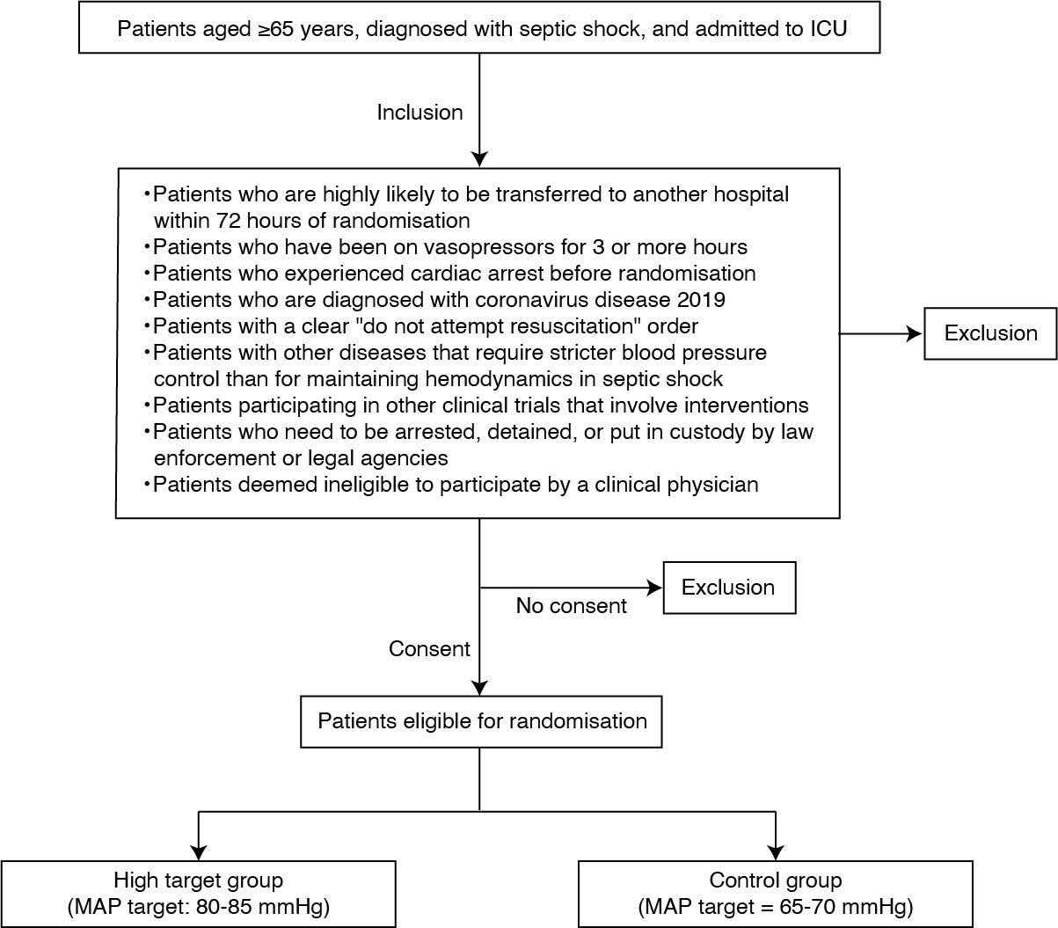
Abbreviations: ICU, intensive care unit; MAP, mean arterial pressure

Interventions
The subjects will be assigned in a 1:1 ratio to the (i) high-target group (target MAP=80–85 mmHg) or (ii) control group following the 2021 SSC guidelines (target MAP=65–70 mmHg) [2]. The target MAP in the present trial will be maintained for 72 hours after randomisation or until vasopressors are no longer needed, owing to improvement in the patient's condition. The target MAP after 72 hours will be at the discretion of the physician in charge. If surgery is performed, the aim is to maintain the assigned MAP target. The assigned group will not be changed for patients in whom the target MAP cannot be achieved, even after increasing the vasopressor dose or providing fluid replacement. In principle, blood pressure will be measured noninvasively on either the left or the right upper arm. If noninvasive blood monitoring is not possible, blood pressure will be evaluated by direct measurement of arterial pressure (priority: radial artery > femoral artery > brachial artery > others). In the high-target group, if an adverse event potentially related to the administration of vasopressors (bleeding requiring transfusion, myocardial infarction, arrhythmia [ventricular tachycardia, supraventricular arrhythmia that affects haemodynamics], intestinal ischaemia, or peripheral limb ischaemia) occurs, the target MAP will be reduced to 65 mmHg.
The amount and speed of fluid administration will be determined at the discretion of the physician-in-charge. Norepinephrine will be the first-line vasopressor; however, to minimise the adverse effects related to catecholamines, if a norepinephrine dose of ≥0∙1 µg/kg/min is needed to maintain the target MAP, vasopressin will be initiated and increased to 0∙04 U/min. This haemodynamic management protocol is designed based on the finding that the early use of vasopressin along with catecholamines leads to a requirement for lower catecholamine doses and less renal replacement therapy [11, 12]. If the target MAP cannot be maintained despite these measures, the physician in charge can add another vasopressor, increase the norepinephrine dose, or add dobutamine or hydrocortisone. In principle, physicians are required to follow the latest SSC or Japanese clinical practice guidelines for sepsis management [22] and attempt to meet the target MAP as much as possible. The decision to reduce or discontinue vasopressors will be determined by the physician in charge.
The initial choice of empirical antibacterial agent, including multidrug therapy and subsequent de-escalation, will be appropriately determined by the physician in charge. The introduction of mechanical ventilation and renal replacement therapy, as well as the use of thrombomodulin, antithrombin, immunoglobulin formulations, and other medications, will also be determined by the physician in charge. Although the type and dose of analgesics, sedatives, and muscle relaxants will also be determined by the physician in charge, in principle, the treatment should aim to obtain a score of -3 to 0 on the Richmond Agitation-Sedation Scale, with assessments performed at least once daily [23].

Assessments and follow-up
Assessment data will be recorded using an electronic trial data-capture system (HOPE eACReSS; https://acress-host2.tmd.ac.jp/gcp/index_top.htm). Patients will be followed up for 90 days after randomisation. If a patient is discharged from the hospital within 90 days, the investigators will contact the patient by telephone to obtain information regarding their status.
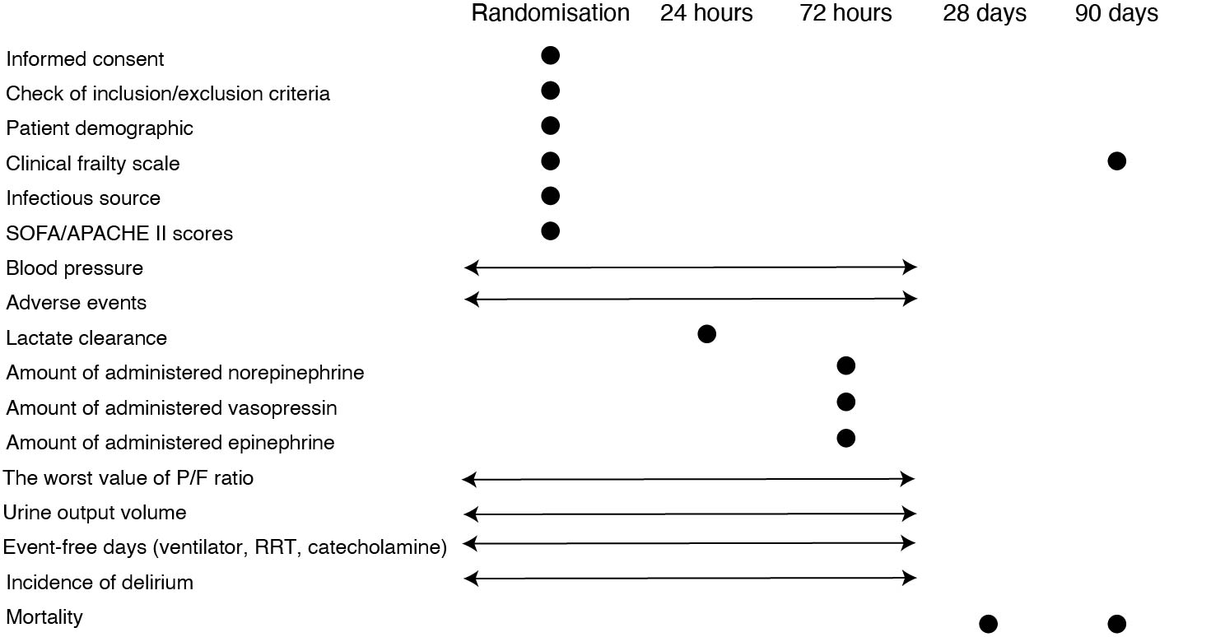

Safety monitoring
Three safety monitoring experts, independent of the conduct of the trial, will monitor to ensure the reliability of the trial regarding the protection of human rights, safety, and welfare of the subjects. If the principal investigator is notified of a severe adverse event (SAE) related to the trial intervention, a report will be presented promptly to the Safety Monitoring and Ethics Review Boards of the principal institution. Additionally, the principal investigator will take appropriate action and promptly share information on adverse events with other investigators involved in the trial. The Safety Monitoring and Ethics Review Boards of the principal institution will review and examine the report and provide written recommendations in response to the principal investigator. In addition, other trial monitoring experts, independent of the conduct of the trial, will monitor whether the trial is being conducted in accordance with the protocol and whether the data reported by the investigators are being collected accurately.

Primary endpoint
All-cause mortality at 90 days after randomisation

Secondary endpoints
- Lactate clearance at 24 h
- Incidence of arrhythmia (ventricular tachycardia or supraventricular arrhythmia affecting haemodynamics) within 72 h
- Incidence of thromboembolism (myocardial infarction, cerebral infarction, intestinal necrosis, or irreversible ischaemia of the peripheral limbs) within 72 h
- Incidence of haemorrhagic events within 72 h
- All-cause mortality at 28 days
- Mortality from sepsis at 28 days
- Ventilator-free days at 28 days
- Renal replacement therapy-free days at 28 days
- Catecholamine-free days at 28 days
- Mortality from sepsis at 90 days
The 90-day outcomes were confirmed by the treating physician after 90 days of randomisation using one of the following methods, as appropriate: medical records, telephone to the patient or their relatives, or telephone to the facility to which the patient was transferred. Adverse events, such as arrhythmia or thromboembolism, will be clinically judged by the physician in charge based on laboratory data, images, and other findings. Ventilator, renal replacement therapy, and catecholamine-free days were defined as the number of days from day 1 to day 28 after randomisation when the patient was alive and free from support for at least 24 consecutive hours. Patients who die within 28 days or still require support after 28 days will be assigned a score of zero.

Sample size estimation
We hypothesised a 45% incidence of the primary endpoint in the control group and an absolute difference from the intervention of 10% based on previously reported mortality in patients with sepsis diagnosed using the Sepsis-3 criteria [1], age of the included patients and improvements in sepsis treatment [24]. With a two-sided alpha level of 0∙05, a significance level, and a power of 0∙80, each group requires 376 cases, for a total of 752 cases. Assuming that approximately 10% of patients will drop out because of patient withdrawal or other reasons, approximately 836 cases will be needed.

Statistical plan
The final analysis will be performed after obtaining the 90-day outcomes of the participants. In the main analysis, the intention-to-treat population will be examined by comparing the differences in 90-day mortality between the groups using the Fisher exact test. The secondary analysis will include logistic regression using factors stratified at allocation as adjustment factors and survival time analysis using the time from allocation to death as the endpoint by estimating Kaplan–Meier curves, log-rank test, adjustment analysis, and other methods. The per-protocol population will be analysed in the same manner as in the primary analysis. If many missing values cannot be ignored, a sensitivity analysis will be performed using multiple imputations of the missing values. The tests will be two-tailed, and a significance level of 5% and 95% confidence coefficient will be considered.
For the secondary endpoints of mortality and the incidence of adverse events, the analysis of the intention-to-treat population will be the same as that of the primary endpoint. For the secondary endpoints of lactate clearance and each organ support-free day, summary statistics will be calculated for each group in the intention-to-treat population and compared using Student's t-test and other methods, as appropriate.
An interim analysis will be conducted after the registration of 300 cases, and their survival/death will be confirmed 90 days later. Subject registration will continue during interim analysis. In the statistical analysis, Bayesian predictive power will be calculated when the planned number of cases is registered based on the current data. If this declines markedly (to approximately 5% or less), trial discontinuation will be considered. Because no decision regarding trial suspension due to efficacy is made, the significance level will not be adjusted in the final analysis.

Patient and public involvement
Patients and the public were not involved in the conduct of the present trial. However, the trial protocol was strictly reviewed by the institutional review board of the principal institute, in which public panellists were included as the reviewers.

Ethics and Dissemination
The clinical trial will be conducted according to the principles of the Declaration of Helsinki (revised in October 2013) and Ethical Guidelines for Medical and Health Research Involving Human Subjects published by the Ministry of Health, Labour, and Welfare of Japan and the Japanese Ministry of Education, Culture, Sports, Science, and Technology. The study protocol was approved by the Ethics Committee of the principal hospital (approval number: R2020-015) and participating hospitals. If any modification in the trial protocol is made, the principal investigator will immediately contact the responsible person at the participating hospital, the Ethics Committee of the principal hospital, the Safety Monitoring Committee, and the Data Monitoring Committee.
To obtain voluntary written consent, the investigators will explain the study orally and in writing and provide the consent form approved by the Institutional Review Board to the participants or their legally authorised representatives. If written consent cannot be obtained immediately from a legally authorised representative, explanations and consent can be provided over the phone, and written consent can be obtained later. In case of an inability to obtain consent when providing emergency resuscitation, an explanation must be provided, and informed consent should be obtained from the patient or their legally authorised representative at a later date. The findings of this trial will be presented at relevant scientific congresses and disseminated through publication in peer-reviewed journals.

References
1 Vincent JL, Jones G, David S, Olariu E, Cadwell KK (2019) Frequency and mortality of septic shock in Europe and North America: A systematic review and meta-analysis. Crit Care 23:196. https://doi.org/10.1186/s13054-019-2478-6
2 Evans L, Rhodes A, Alhazzani W et al (2021) Surviving sepsis campaign: International guidelines for management of sepsis and septic shock 2021. Intensive Care Med 47:1181–1247. https://doi.org/10.1007/s00134-021-06506-y
3 Russell JA (2020) Personalized blood pressure targets in shock: What if your normal blood pressure is ‘Low’? Am J Respir Crit Care Med 202:10–12. https://doi.org/10.1164/rccm.202004-1124ED
4 Leone M, Asfar P, Radermacher P, Vincent JL, Martin C (2015) Optimizing mean arterial pressure in septic shock: A critical reappraisal of the literature. Crit Care 19:101. https://doi.org/10.1186/s13054-015-0794-z
5 Corrêa TD, Jakob SM, Takala J (2015) Arterial blood pressure targets in septic shock: Is it time to move to an individualized approach? Crit Care 19:264. https://doi.org/10.1186/s13054-015-0958-x
6 Fiorese Coimbra KT, De Freitas FGR, Bafi AT et al (2019) Effect of increasing blood pressure with noradrenaline on the microcirculation of patients with septic shock and previous arterial hypertension. Crit Care Med 47:1033–1040. https://doi.org/10.1097/CCM.0000000000003795
7 Asfar P, Meziani F, Hamel JF et al (2014) High versus Low Blood-Pressure Target in Patients with Septic Shock. N Engl J Med 370:1583–1593. https://doi.org/10.1056/NEJMoa1312173
8 Lamontagne F, Meade MO, Hébert PC et al (2016) Higher versus lower blood pressure targets for vasopressor therapy in shock: A multicentre pilot randomized controlled trial. Intensive Care Med 42:542–550. https://doi.org/10.1007/s00134-016-4237-3
9 Andreis DT, Singer M (2016) Catecholamines for inflammatory shock: A Jekyll-and-Hyde conundrum. Intensive Care Med 42:1387–1397. https://doi.org/10.1007/s00134-016-4249-z
10 Stolk RF, van der Pasch E, Naumann F et al (2020) Norepinephrine dysregulates the immune response and compromises Host Defense during Sepsis. Am J Respir Crit Care Med 202:830–842. https://doi.org/10.1164/rccm.202002-0339OC
11 Russell JA, Walley KR, Singer J et al (2008) Vasopressin versus norepinephrine infusion in patients with septic shock. N Engl J Med 358:877–887. https://doi.org/10.1056/NEJMoa067373
12 Gordon AC, Mason AJ, Thirunavukkarasu N et al (2016) Effect of early vasopressin vs norepinephrine on kidney failure in patients with septic shock: The VANISH randomized clinical trial. JAMA 316:509–518. https://doi.org/10.1001/jama.2016.10485
13 Sacha GL, Bauer SR (2023) Optimizing vasopressin use and initiation timing in septic shock: A narrative review. Chest 164:1216–1227. https://doi.org/10.1016/j.chest.2023.07.009
14 Futier E, Lefrant JY, Guinot PG et al (2017) Effect of individualized vs standard blood pressure management strategies on postoperative organ dysfunction among high-risk patients undergoing major surgery: A randomized clinical trial. JAMA 318:1346–1357. https://doi.org/10.1001/jama.2017.14172
15 Vincent JL, Singer M, Einav S et al. (2021) Equilibrating SSC guidelines with individualized care. Crit Care 25:397. https://doi.org/10.1186/s13054-021-03813-0
16 Japanese Ministry of Health, Labour and Welfare Portal site of official statistics of Japan: Result of National health and nutrition examination survey. https://www.e-stat.go.jp/stat-search/files?page=1&toukei=00450171&tstat=000001041744
17 Beaney T, Schutte AE, Tomaszewski M et al. (2018) May Measurement Month 2017: An analysis of blood pressure screening results worldwide. Lancet Glob Health 6:e736–e743. https://doi.org/10.1016/S2214-109X(18)30259-6
18 Singer M, Deutschman CS, Seymour CW et al (2016) The third international consensus definitions for sepsis and septic shock (Sepsis-3). JAMA 315:801–810. https://doi.org/10.1001/jama.2016.0287
19 Hjortrup PB, Haase N, Bundgaard H et al (2016) Restricting volumes of resuscitation fluid in adults with septic shock after initial management: The Classic randomised, parallel-group, multicentre feasibility trial. Intensive Care Med 42:1695–1705. https://doi.org/10.1007/s00134-016-4500-7
20 Sakr Y, Rubatto Birri PN, Kotfis K et al (2017) Higher fluid balance increases the risk of death from sepsis: Results from a large international audit. Crit Care Med 45:386–394. https://doi.org/10.1097/CCM.0000000000002189
21 Lamontagne F, Day AG, Meade MO et al (2018) Pooled analysis of higher versus lower blood pressure targets for vasopressor therapy septic and vasodilatory shock. Intensive Care Med 44:12–21. https://doi.org/10.1007/s00134-017-5016-5
22 Egi M, Ogura H, Yatabe T et al (2021) The Japanese clinical practice guidelines for management of sepsis and septic shock 2020 (J-SSCG 2020). J Intensive Care 9:53. https://doi.org/10.1186/s40560-021-00555-7
23 Sessler CN, Grap MJ, Brophy GM (2001) Multidisciplinary management of sedation and analgesia in critical care. Semin Respir Crit Care Med 22:211–226. https://doi.org/10.1055/s-2001-13834
24 Bauer M, Gerlach H, Vogelmann T, Preissing F, Stiefel J, Adam D (2020) Mortality in sepsis and septic shock in Europe, North America and Australia between 2009 and 2019—Results from a systematic review and meta-analysis. Crit Care 24:239. https://doi.org/10.1186/s13054-020-02950-2

