Health-Related Quality of Life after intensive care for sepsis,
a national cohort study.

Electronic online supplements
Peter Halvorsen¹, Michael Marks-Hultström^{1,2}, Ewa Wallin1, Björn Ahlström^{1,3}, Miklós Lipcsey^{1,4}
1. Anesthesiology and Intensive Care Medicine, Department of Surgical Sciences, Uppsala University, Uppsala, Sweden.
2. Integrative Physiology, Department of Medical Cell Biology, Uppsala University, Uppsala, Sweden.
3. Center for Clinical Research Dalarna, Uppsala University, Sweden
4. Hedenstierna Laboratory, Department of Surgical Sciences, Uppsala University, Uppsala, Sweden.

Corresponding author:
Peter Halvorsen
peter.halvorsen@uu.se
Department of Anesthesia and Intensive Care
Akademiska sjukhuset, Ing 70
Uppsala University
Uppsala, S-751 85
Sweden
ORCID iD: 0009-0004-9727-8144

Order of content:
The selection process of cases and controls
The RAND-36 instrument
The collection of RAND-36 data for the Swedish intensive care registry
Imputation process
Statistical programs and packages
Supplemental Figure 1. Patient selection flowchart.
Supplemental figure 2. A histogram of RAND-36 follow-up and division into groups.
Supplemental figure 3. The main analysis of RAND-36 data with confidence intervals.
Supplemental figure 4. A forest plot panel of the mixed effects model stratified in time as the main analysis.
Supplemental figure 5. A forest plot of the mixed effects model of our imputed dataset.
Supplemental figure 6. A forest plot of the mixed effects model of our imputed data set, with the lowest 5% of each RAND-36 dimension censored.
Supplemental Figure 7. A graph showing the mean and confidence interval of the sick-leave in subgroup 25-60 years old.
Supplemental figure 8. A forest plot of the mixed effects model of the subgroup with age 25-60 with RAND-36 data, where we added sick-leave to the analysis.
Supplemental figure 9. A forest plot of the linear model between sick-leave and HRQoL.
Supplemental table 1. A table over the diagnoses and corresponding ICD-10 codes.
Supplemental Table 2. A table showing the coding of the education.
References

The selection process of cases and controls
The original cohort from SIR had 42,151 intensive care unit (ICU) patients with sepsis, 73 were excluded due to absence in the SCB registers, and one was excluded due to faulty registration of Swedish identity number, amounting to 42,077 sepsis cases with data (Supplement figure 1, patient selection flowchart). Among the sepsis cases, we received RAND-36 data on 14,041 individuals. Since there was a considerable spread in time of the RAND-36 observations, we chose to group the observations in three strata according to Supplement Figure 2 and discard observations outside the range of day 10 - 450 after ICU discharge, leaving us with 14,006 individuals and 28,396 questionnaires. The strata were used to analyze each RAND-36 dimension over time, corresponding to 3-, 6-, and 12-month follow-up, each containing between 7,873 – 10,835 observations. Statistics Sweden provided four matched controls for each case, amounting to 168,308 controls. Individuals were only eligible to be controls once; however, 817 controls later became cases.
The 11,813 cases in the subgroup of working-age sepsis patients were compared with four matched controls each (47,252). Of these, 2,256 (19%) patients had died at 24 months, of whom 814 (7%) died in the first month, whereas in the control group, 181 (.3%) individuals died within 24 months and 3 (.06‰) in the first month.

The RAND-36 instrument
The RAND-36 was developed to reflect the part of the World Health Organization’s definition of health that pertains to self-reports of physical, mental and social well-being and functional ability[1, 2] and it has been translated and validated for the Swedish language[3]. The instrument is standardized and validated to assess physical, mental and social aspects of health and contains 36 items divided into eight subscales or dimensions to measure health status. These dimensions are physical function, physical role function, bodily pain, general health, vitality, social function, emotional role function and mental health. The first four dimensions measure physical health and the last four mental and social health. All sub-scales are transformed to a scale from 0 (the worst score) to 100 (the best score).

Our scoring of RAND-36
From the scoring manual from RAND: “Items that are left blank (missing data) are not taken into account when calculating the scale scores. Hence, scale scores represent the average for all items in the scale that the respondent answered.”[4] However, when less than half of the items were answered, we judged that the data was unreliable and censored that dimension, hence the 50% rule.

The collection of RAND-36 data for the Swedish intensive care registry
The data is collected as part of standard care and sent to the Swedish Intensive Care Registry. Patients received the RAND-36 form prior to their follow-up visit to the “Post ICU clinic”, prompted to fill it out and then hand it in to the out-patient clinic nurse. The only criterion for inclusion is ability to fill in the form and hand it in, patients not able or willing are excluded/missing. The follow-up is done at the discretion of the treating intensive care units, but the recommendation from the registry at the time was to offer follow-up for patients with a length of stay (LoS) exceeding 72-96 hours, although, in some units, patients with shorter LoS were offered a follow-up, especially if requested by themself. The intention of the registry at the time was to follow-up patients at 3, 6 and 12 months after ICU discharge.

Imputation process
For sensitivity analysis, we imputed non-dependent missing values using Multivariate Imputation by Chained Equations. We imputed education level and Simplified Acute Physiology Score (SAPS) 3 without points for age with predictive mean matching, invasive ventilation and continuous renal replacement therapy (CRRT) was imputed with logistic regression, making it possible to include an additional 4,700 RAND-36 observations in each dimension, which were excluded in the original multi-variable mixed effects model. We made 15 imputed datasets with 100 iterations and pooled the analysis of those.

Statistical programs and packages
We used R version 4.2.2 2 (The R Foundation for Statistical Computing, Vienna, Austria; https://www.r-project.org) with packages ggplot2 version 3.4.4, lme4 version 1.1-35.1, mice version 3.16.0, sjPlot version 2.8.16, ggpubr version 0.6.0, table1 version 1.4.3 for data management, statistical analysis, graphs and tables.

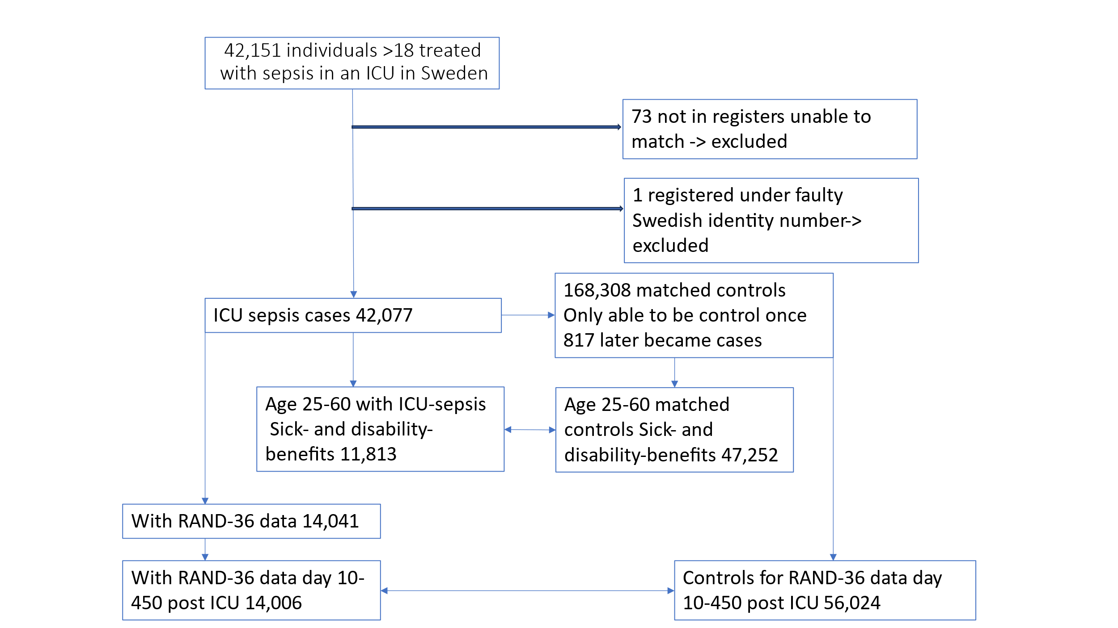

Supplemental Figure 1. Showing the selection of cases and controls in the study. ICU (intensive care unit). Double arrows show comparisons.
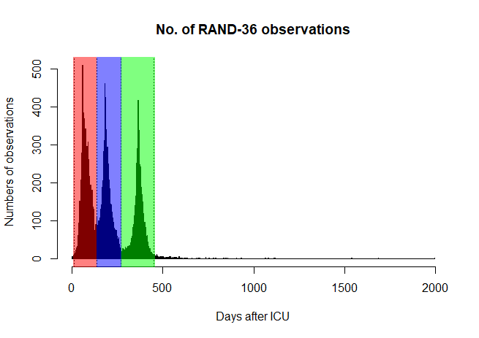
Supplemental Figure 2. Health-Related Quality of Life measured using RAND-36 observations over time after ICU discharge in 14,006 sepsis patients. Each color represents the period grouping by which the RAND-36 was analyzed; red 10-134 days, blue 135-269 days, and green 270-450 days after ICU discharge. Values outside the limits were omitted. The colored areas correspond with the colors in Figure 1 and Supplemental Figure 3.

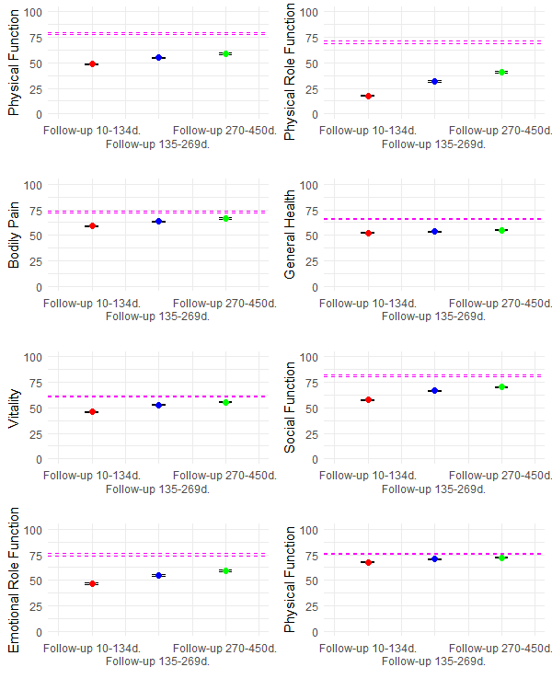Supplemental Figure 3.
Recovery of Health-Related Quality of Life measured using RAND-36 in 14006 patients after intensive care unit (ICU) care for sepsis in Sweden between 2008 and 2020. Each panel shows a dimension of RAND-36 showing means and 95% confidence intervals of the mean at 3 months, 6 months and 1 year after ICU. The dotted line indicates the mean of a Swedish population reference [5].

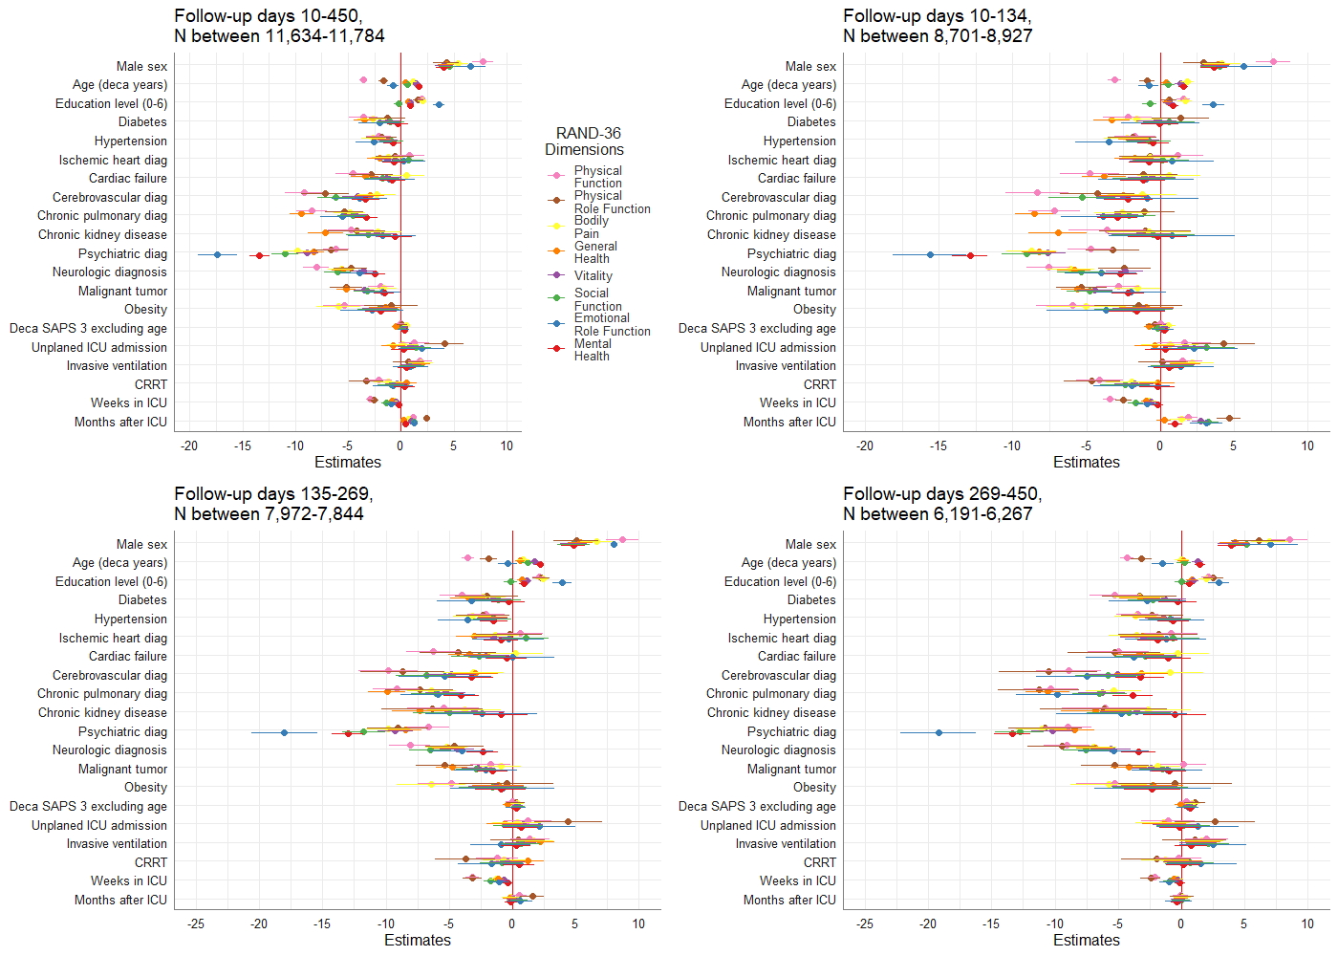 Supplemental Figure 4. Risk factors for low score in RAND-36 dimensions in the first 15 months after intensive care for sepsis using a multi-variable mixed effects analysis. First, for the whole period, as in Figure 3 in the main manuscript, and then disaggregated into the three time period groups shown in Supplemental figure 1. Comorbidity diagnosis groups are shown in Supplemental table 1, and education level score in Supplemental Table 2.

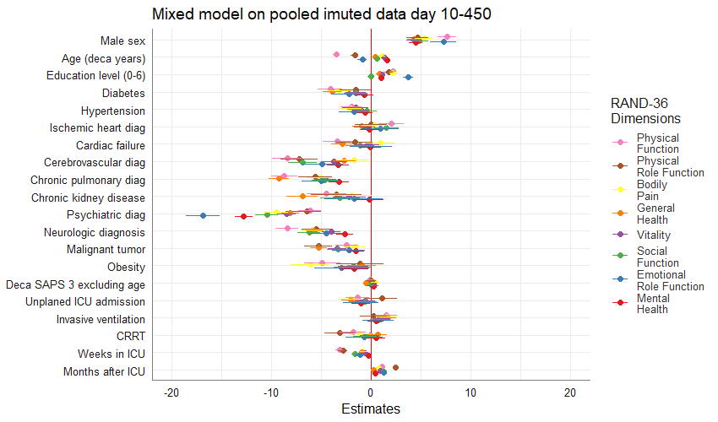Supplemental Figure 5. Sensitivity analysis of risk factors affecting the different RAND-36 dimensions in the first 15 months after intensive care for sepsis using a multi-variable mixed effects analysis with imputed SAPS3 score without age, CRRT, invasive ventilation and education level.

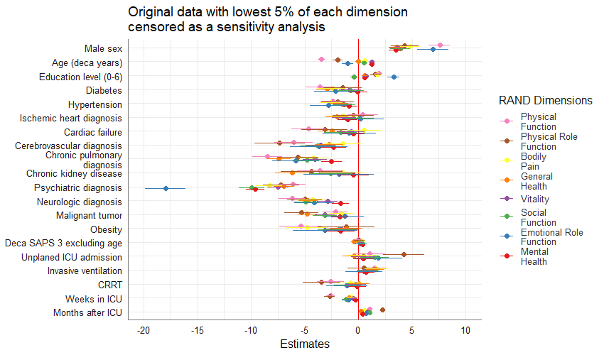
Supplemental Figure 6.
Sensitivity analysis of the effect of outliers on risk factors affecting the different RAND-36 dimensions in the first 15 months after intensive care for sepsis in the multi-variable mixed effects model, where the 5% with the lowest RAND-36 scores were removed. The results are similar to the main analysis, indicating that outlier-effects do not significantly alter the results.

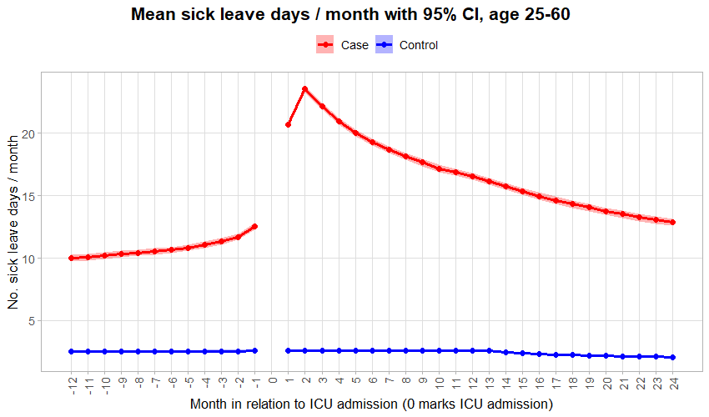
Supplemental Figure 7. Average days per month of sick-leave in the subgroup 25-60 years old patients treated for sepsis that also reported RAND-36. The shaded area indicates 95% confidence intervals. Patients who died were censored from that month forward. The average shows that patients who developed sepsis had a markedly higher burden of work incapacity already a year before being admitted to the ICU, indicating a greater vulnerability. At 24 months, they still had a higher number of sick-leave days per month than at baseline. The increase in sick-leave time between months 1 and 2 after ICU can be explained by the first two weeks of any period of sick-leave in Sweden being paid by the employer, and thus not being registered as sick-leave.

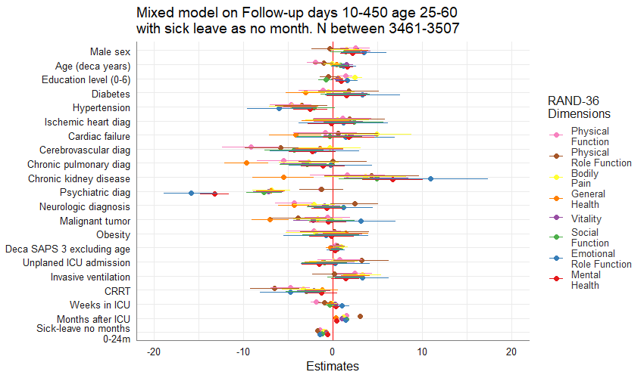

Supplemental Figure 8. A forest plot over the factors affecting the different RAND-36 dimensions in the first 15 months after intensive care for sepsis in the multi-variable mixed effects model on the subgroup aged 25-60, where we added sick-leave after ICU to the model.

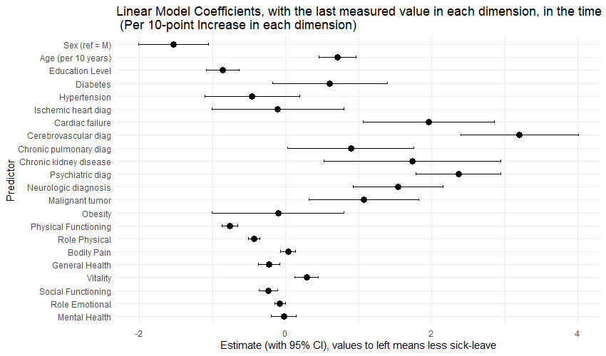
Supplemental Figure 9. Risk factors for sick-leave after intensive care for sepsis in the subgroup aged 25-60 with RAND-36 data available. The results show a lower risk of sick-leave for men and patients with higher education, whereas age and comorbidities are associated with a higher risk of sick-leave. Better Health-Related Quality of Life, represented by the RAND-36 dimension, was mostly protective.

Supplemental Table 1. Showing how we coded the diagnoses in relation to ICD-10.
Diagnose group
Diagnose group | ICD-10 code
Diabetes | E10 - E15
Hypertension | I11
Ischemic heart diag | I20 - I25
Cardiac failure | I50
Cerebrovascular diag | I6
Chronic pulmonary diag | J4
Chronic kidney diag | N18
Psychiatric diag | F
Neurologic diag | G
Malignant tumor | C00 - C99
Obesity | E66
Obesity | E66

Supplemental Table 2. Coding for the highest level of education.
Education level achieved
Education level achieved | Coded as
Pre-school | 0
Elementary school 9 years or less | 1
Elementary school 10 years or more | 2
High school | 3
Education post High school 2 years or less | 4
Education post High school more than 2 years | 5
Degree in research | 6

References
1. Hays RD, Sherbourne CD, Mazel RM (1993) The rand 36-item health survey 1.0. Health Econ 2:217–227. https://doi.org/10.1002/hec.4730020305
2. Hays RD, Morales LS (2001) The RAND-36 measure of health-related quality of life. Ann Med 33:350–357. https://doi.org/10.3109/07853890109002089
3. Orwelius L, Nilsson M, Nilsson E, et al (2018) The Swedish RAND-36 Health Survey - reliability and responsiveness assessed in patient populations using Svensson’s method for paired ordinal data. J Patient-Rep Outcomes 2:4. https://doi.org/10.1186/s41687-018-0030-0
4. 36-Item Short Form Survey (SF-36) Scoring Instructions | RAND. https://www.rand.org/health-care/surveys_tools/mos/36-item-short-form/scoring.html. Accessed 30 Apr 2025
5. Ohlsson-Nevo E, Hiyoshi A, Norén P, et al (2021) The Swedish RAND-36: psychometric characteristics and reference data from the Mid-Swed Health Survey. J Patient-Rep Outcomes 5:66. https://doi.org/10.1186/s41687-021-00331-z

