Supplemental data
Supplemental Table 1. Differences between patients with or without factual memories of the ICU
 | Factual memories  n = 356 | No factual memories  n = 70 | P-value
Delusional memories | 153 (43%) | 11 (16%) | <0.01
Female sex | 102 (29%) | 28 (40%) | 0.06
Age | 61.6 (±13.2) | 64.5 (±12.0) | 0.05
Admission type |  |  | 0.15
Acute surgery | 63 (18%) | 6 (8.6%)
Elective surgery | 175 (49%) | 40 (57%)
Medical | 118 (33%) | 24 (34%)
APACHE-IV score† | 61.2 (±21.3) | 64.7 (±24.0) | 0.35
SOFA score† | 6.2 (±3.1) | 7.3 (±3.1) | <0.01
Mechanical ventilation | 306 (86%) | 66 (94%) | 0.06
Deep sedation | 154 (43%) | 37 (53%) | 0.14
Days with deep sedation† | 1.0 [0.0-3.0] | 2.0 [1.0-5.0] | <0.01
Delirium | 86 (24%) | 24 (34%) | 0.08
Physically restrained | 70 (20%) | 20 (29%) | 0.10
ICU length of stay | 3.1 [1.5-6.3] | 2.1 [0.9-8.9] | 0.34
Hospital length of stay | 12.9 [7.1-25.1] | 8.9 [6.6-20.2] | 0.14
3-month PTSD symptoms† | 15/352 (4.3%) | 4/67 (6.0%) | 0.52
12-month PTSD symptoms^{†ꝿ} | 21/204 (10%) | 4/46 (8.7%) | 0.99
Data are presented as mean (±SD) or median [IQR], depending on distribution. Categorical variables are presented as counts (%).
† Completely missing data for 43 patients (10%, APACHE-IV score); 5 patients (1.2%, SOFA score); 2 patients (0.5%, days with deep sedation); 7 patients (1.6%, 3-month PTSD) and 176 patients (41%, 12-month PTSD), which were unimputed.
^{ꝿ} 11 (2.6%) patients had 1 missing questionnaire item at 12 months post-ICU, which was imputed with the individual’s mean score.

Supplemental Table 2. Differences between patients having delusional memories with or without factual memories
 | Delusional memories with factual memories  n = 153 | Delusional memories without factual memories  n = 11 | P-value
Female sex | 48 (31%) | 6 (55%) | 0.18
Age | 59.4 (±14.0) | 60.9 (±15.8) | 0.51
Admission type |  |  | 0.35
Acute surgery | 41 (27%) | 2 (18%)
Elective surgery | 52 (34%) | 2 (18%)
Medical | 60 (39%) | 7 (64%)
APACHE-IV score† | 65.9 (±23.7) | 87.2 (±35.3) | 0.04
SOFA score† | 6.8 (±3.2) | 9.1 (±2.4) | 0.01
Mechanical ventilation | 137 (90%) | 11 (100%) | 0.60
Deep sedation | 96 (63%) | 10 (91%) | 0.10
Days with deep sedation† | 2.0 [1.0-6.0] | 10.0 [2.0-17.0] | <0.01
Delirium | 60 (39%) | 8 (73%) | 0.05
Physically restrained | 46 (30%) | 5 (45%) | 0.32
ICU length of stay | 5.6 [3.0-10.0] | 15.3 [4.7-29.7] | 0.04
Hospital length of stay | 19.6 [12.0-32.9] | 28.8 [18.1-48.8] | 0.12
3-month PTSD symptoms† | 10/153 (6.5%) | 1/10 (10%) | 0.51
12-month PTSD symptoms^{†ꝿ} | 17/97 (18%) | 2/8 (25%) | 0.63
Data are presented as mean (±SD) or median [IQR], depending on distribution. Categorical variables are presented as counts (%).
† Completely missing data for 26 patients (16%, APACHE-IV score); 3 patients (1.8%, SOFA score); 2 patients (1.2%, days with deep sedation); 1 patient (0.6%, 3-month PTSD) and 59 patients (36%, 12-month PTSD), which were unimputed.
^{ꝿ} 5 (3.0%) patients had 1 missing questionnaire item at 12 months post-ICU, which was imputed with the individual’s mean score.

Supplemental Table 3. Differences between responders and non-responders at 12 months post-ICU
 | Non-responders  n = 176 | Responders  n = 250 | P-value
Female sex | 62 (35%) | 68 (27%) | 0.08
Age | 60.3 (±14.7) | 63.4 (±11.7) | 0.04
Admission type |  |  | 0.09
Acute surgery | 22 (13%) | 47 (19%)
Elective surgery | 99 (56%) | 116 (46%)
Medical | 55 (31%) | 87 (35%)
APACHE-IV score† | 56.7 (±21.8) | 65.6 (±21.0) | <0.01
SOFA score† | 6.1 (±3.1) | 6.6 (±3.1) | 0.10
Mechanical ventilation | 145 (82%) | 227 (91%) | 0.01
Deep sedation | 53 (30%) | 138 (55%) | <0.01
Days with deep sedation† | 1.0 [0.0-2.0] | 2.0 [1.0-4.0] | <0.01
Delirium | 35 (20%) | 75 (30%) | 0.02
Physically restrained | 25 (14%) | 65 (26%) | <0.01
ICU length of stay | 1.9 [0.9-4.2] | 3.9 [2.0-7.9] | <0.01
Hospital length of stay | 9.9 [5.9-19.0] | 14.9 [8.0-29.3] | <0.01
3-month PTSD symptoms† | 9/173 (5.2%) | 10/246 (4.1%) | 0.58
Data are presented as mean (±SD) or median [IQR], depending on distribution. Categorical variables are presented as counts (%).
† Completely missing data for 43 patients (10%, APACHE-IV score); 5 patients (1.2%, SOFA score); 2 patients (0.5%, days with deep sedation) and 7 patients (1.6%, 3-month PTSD), which were unimputed.

Supplemental Table 4. Mean IES scores and subscores at 3- and 12-months post-ICU between the memory groups
 | Overall  N = 426 | Factual memories w/o delusional memories  n = 203 | Amnesia for the ICU  n = 59 | Delusional memories  n = 164
3 months post-ICU | n = 419† | n = 199† | n = 57† | n = 163†
Mean IES-6 score | 0.33 [0.00-0.83] | 0.17 [0.00-0.50] | 0.17 [0.00-1.00] | 0.33 [0.17-0.83]^{f*}
Avoidance subscore | 0.00 [0.00-1.00] | 0.00 [0.00-1.00] | 0.00 [0.00-1.00] | 0.00 [0.00-1.00]^{f}
Hyperarousal subscore | 1.00 [0.00-2.00] | 1.00 [0.00-2.00] | 1.00 [0.00-2.00] | 1.00 [0.00-2.00]
Intrusions subscore | 0.00 [0.00-2.00] | 0.00 [0.00-1.00] | 0.00 [0.00-1.00] | 1.00 [0.00-2.00]^{f*}
12 months post-ICU^{ꝿ} | n = 250† | n = 107† | n = 38† | n = 105†
Mean IES-6 score | 0.17 [0.00-1.00] | 0.17 [0.00-0.83] | 0.00 [0.00-0.33] | 0.33 [0.00-1.33]^{f,a*}
Avoidance subscore | 0.00 [0.00-2.00] | 0.00 [0.00-1.00] | 0.00 [0.00-1.00] | 0.00 [0.00-3.00]^{f}
Hyperarousal subscore | 0.00 [0.00-2.00] | 0.00 [0.00-2.00] | 0.00 [0.00-1.00] | 1.00 [0.00-2.00]ª
Intrusions subscore | 0.00 [0.00-2.00] | 0.00 [0.00-1.00] | 0.00 [0.00-0.00] | 1.00 [0.00-3.00]^{f*,a*}
Data are presented as median [IQR].
^{F,A,D} Significantly more/higher compared to factual memories (f), amnesia (a), or delusional memories (d), with a * indicating p<0.01. All p-values were adjusted for multiple testing using the Holm method.
† Completely missing IES-6 data for 7 (1.6%) and 176 (41%) patients at 3 and 12 months post-ICU, respectively, which were unimputed.
^{ꝿ} 11 (2.6%) patients had 1 missing questionnaire item at 12 months post-ICU, which was imputed with the individual’s mean score.

Supplemental Table 5. Prevalence of PTSD symptoms in patients with or without delirium and delusional memories
 | No delirium  n = 316 | Delirium  n = 110 | P-value | Delirium without delusional memories  n = 42 | Delirium with delusional memories  n = 68 | P-value
3 months post-ICU†
Prevalence of PTSD symptoms | 15/315 (4.8%) | 4/104 (3.8%) | 0.91 | 2/37 (5.4%) | 2/67 (3.0%) | 0.62
Mean IES-6 score | 0.3 [0.0-0.7] | 0.3 [0.2-0.8] | 0.43 | 0.2 [0.0-0.7] | 0.3 [0.2-0.8] | 0.04
12 months post-ICU^{† ꝿ}
Prevalence of PTSD symptoms | 13/175 (7.4%) | 12/75 (16%) | 0.04 | 2/30 (6.7%) | 10/45 (22%) | 0.11
Mean IES-6 score | 0.2 [0.0-0.8] | 0.3 [0.0-1.3] | 0.04 | 0.3 [0.0-1.0] | 0.3 [0.2-1.7] | 0.04
Data presented as median [IQR] or counts (%).
† 3- and 12-month IES-6 data were completely missing and unimputed for 7 (1.6%) and 176 (41%) patients, respectively, in the full dataset (left table), and for 6 (5.5%) and 35 (32%) patients, respectively, in the delirium dataset (right table).
^{ꝿ} 11 (2.6%) patients had 1 missing questionnaire item at 12 months post-ICU, which was imputed with the individual’s mean score.

Supplemental Table 6. Sensitivity analysis of baseline characteristics, excluding all patients who stayed in the ICU shorter than 48 hours.
 | Overall  N = 262 | Factual memories w/o delusional memories  n = 99 | Amnesia for the ICU  n = 26 | Delusional memories  n = 137
Female sex | 88 (34%) | 30 (30%) | 10 (38%) | 48 (35%)
Age | 60.8 (±13.3) | 63.5 (±11.6)^{d} | 62.5 (±10.3) | 58.6 (±14.6)
Admission type
Acute surgery | 62 (24%) | 18 (18%) | 4 (15%) | 40 (29%)
Elective surgery | 83 (32%) | 41 (41%)^{d} | 9 (35%) | 33 (24%)
Medical | 117 (45%) | 40 (40%) | 13 (50%) | 64 (47%)
APACHE-IV score† | 67.8 (±23.9) | 65.3 (±19.5) | 64.5 (±23.3) | 70.3 (±26.8)
SOFA score† | 6.8 (±3.2) | 5.8 (±2.9) | 8.0 (±3.7)^{f*} | 7.2 (±3.3)^{f*}
Mechanical ventilation | 237 (90%) | 85 (86%) | 25 (96%) | 127 (93%)
Deep sedation | 163 (62%) | 45 (45%) | 18 (69%) | 100 (73%)^{f*}
Days with deep sedation† | 2.0 [1.0-5.0] | 1.0 [0.0-2.0] | 3.0 [1.0-9.0]^{f*} | 3.0 [1.0-7.0]^{f*}
Delirium | 100 (38%) | 21 (21%) | 14 (54%)^{f*} | 65 (47%)^{f*}
Physically restrained | 80 (31%) | 20 (20%) | 12 (46%)^{f} | 48 (35%)^{f}
ICU length of stay | 5.0 [3.2-9.3] | 3.8 [2.9-5.7] | 4.3 [2.8-13.8] | 7.2 [4.6-14.1]^{f*}
Hospital length of stay | 19.0 [10.9-31.7] | 13.6 [9.7-27.0] | 18.2 [8.9-39.0] | 23.0 [14.2-35.2]^{f*}
Data are presented as mean (±SD) or median [IQR], depending on distribution. Categorical variables are presented as counts (%).
^{F,A,D} Significantly more/higher compared to factual memories (f), amnesia (a), or delusional memories (d), with a * indicating p<0.01.
All p-values were adjusted for multiple testing using the Holm method.
† Completely missing data for 42 patients (16%, APACHE-IV score), 4 patients (1.5%, SOFA score) and 2 patients (0.8%, days with deep sedation), which were unimputed.

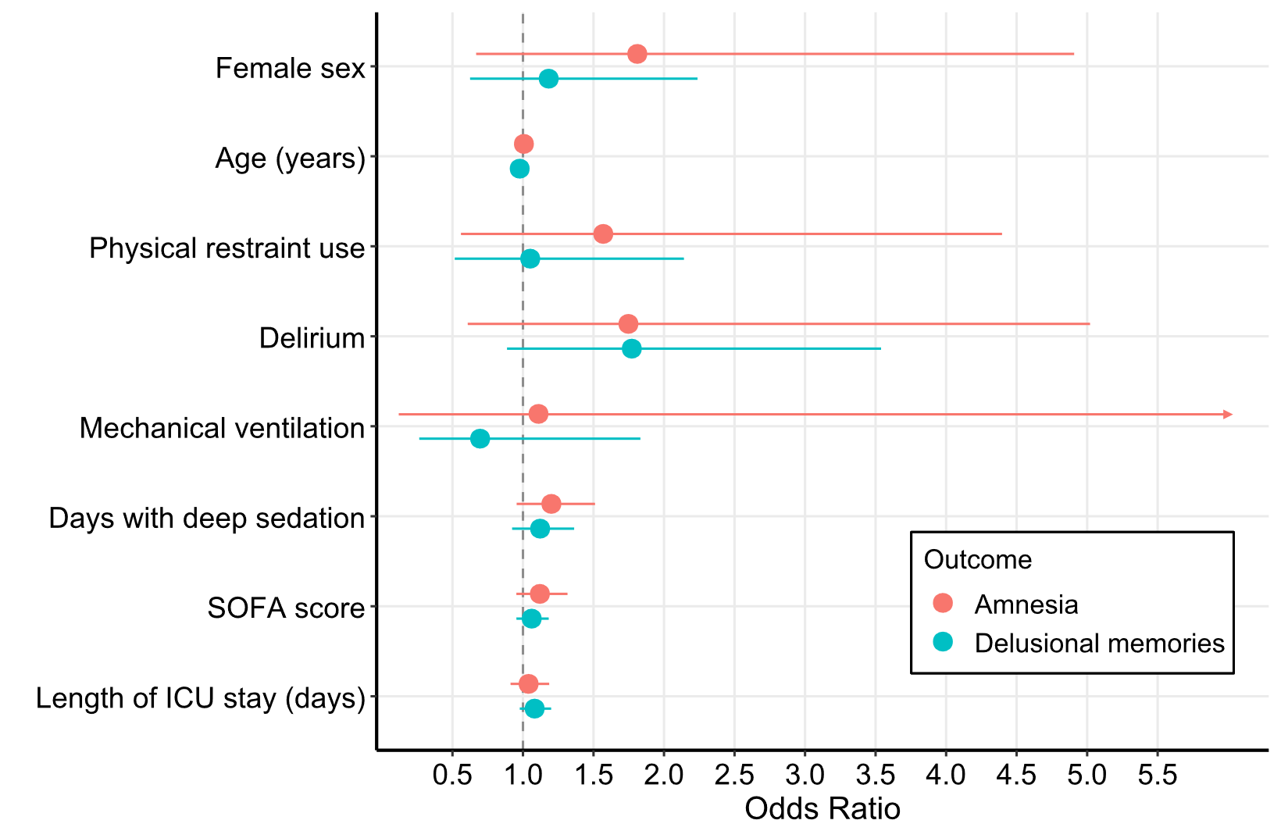
Supplemental Figure 1. Demographic and clinical determinants of different ICU memory types (sensitivity analysis after exclusion of patients with an ICU stay <48h)
Note: The reference group is factual memories without delusional memories. Coloured lines represent 95% confidence intervals.
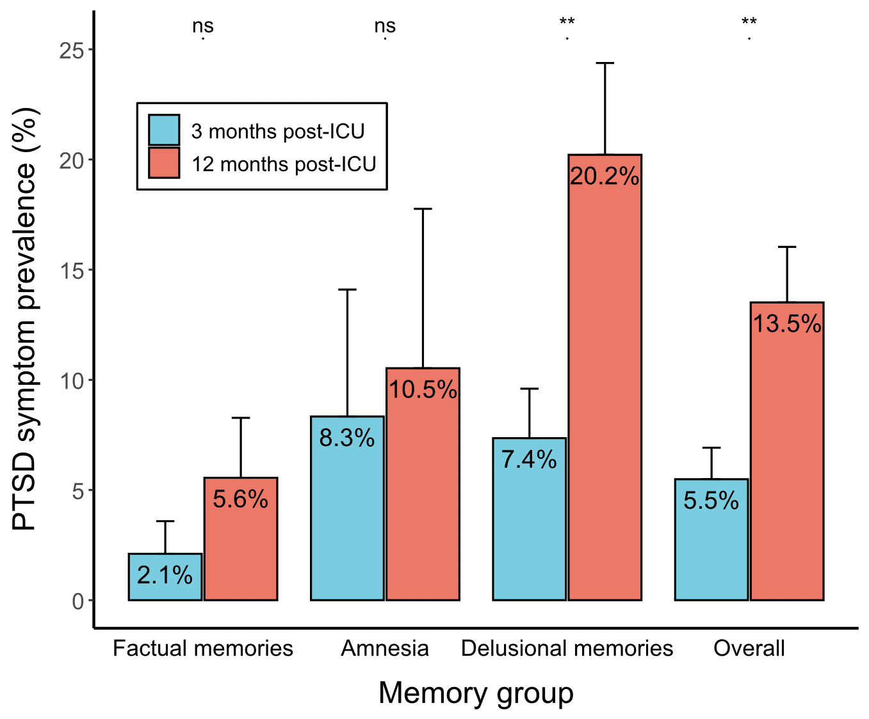
Supplemental Figure 2. Prevalence of PTSD symptoms per timepoint and memory group (sensitivity analysis after exclusion of patients with an ICU stay <48h)
Note: * p<0.05; ** p<0.01. A mean IES-6 score ≥1.75 was used as a cut-off to determine presence of PTSD symptoms.
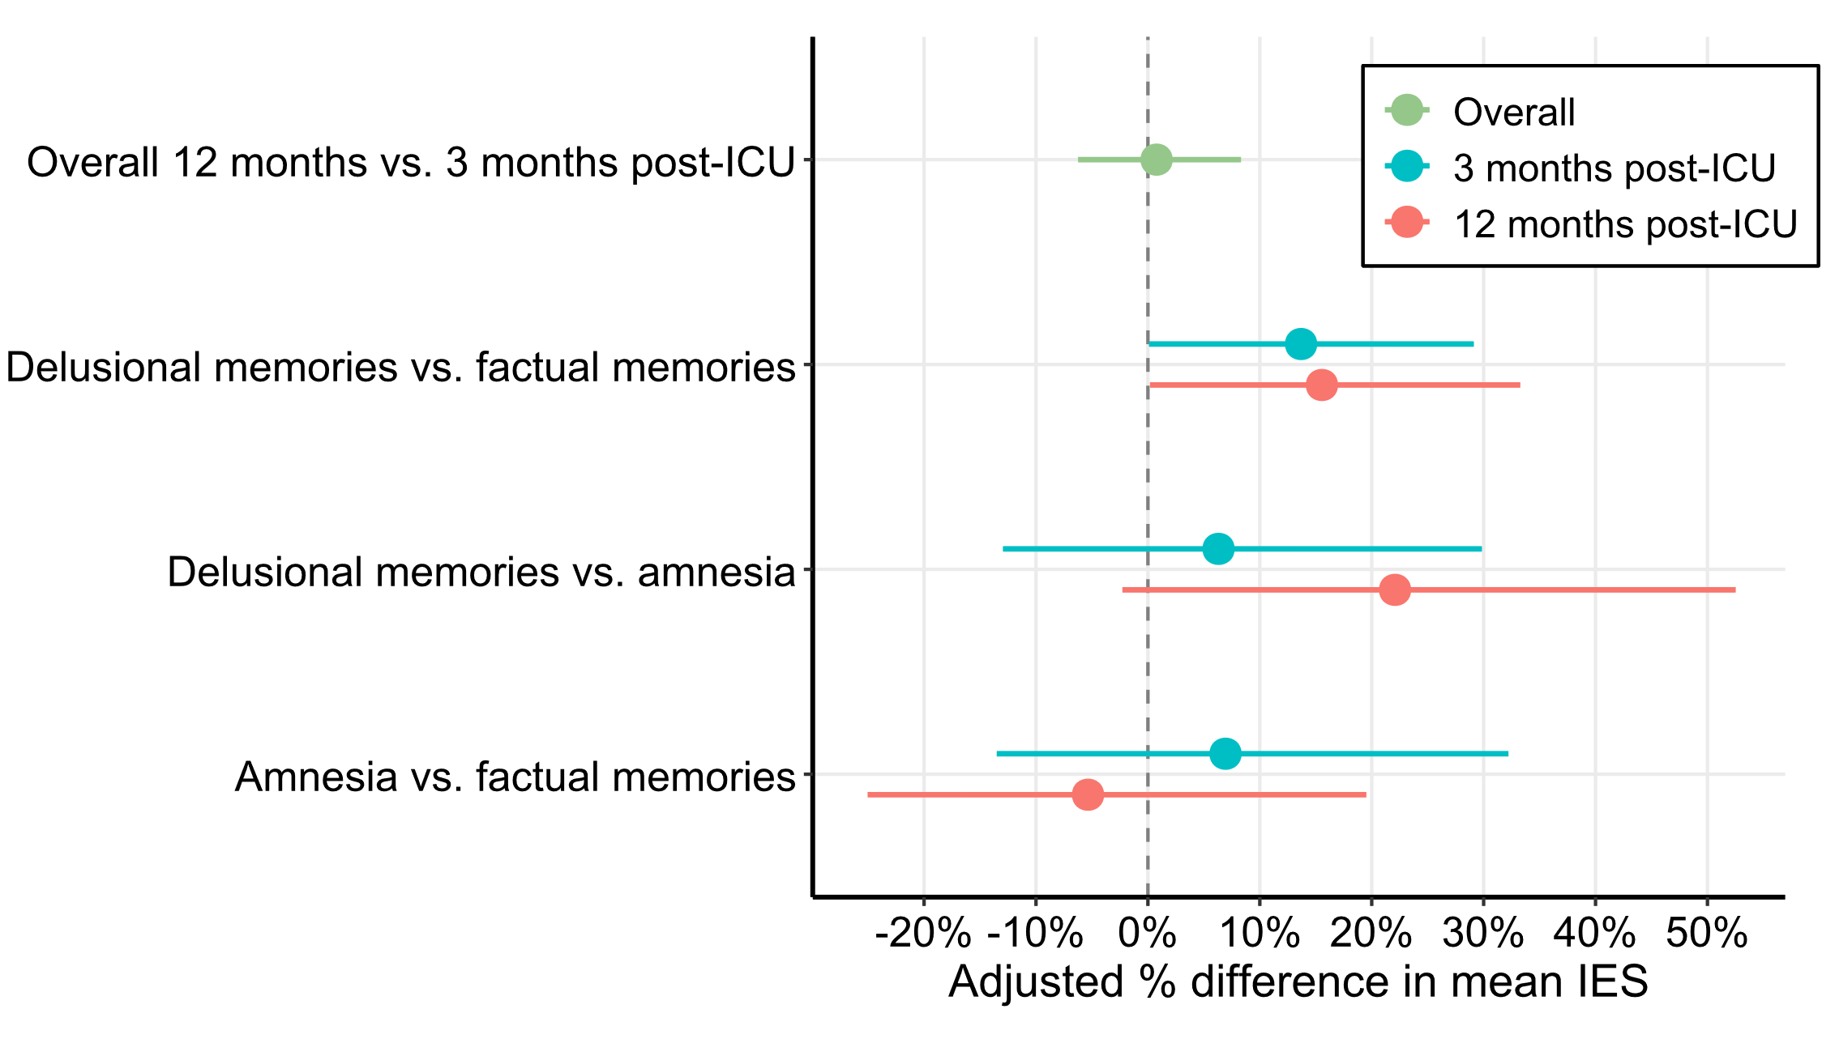
Supplemental Figure 3. The relationship between different ICU memories and the development and trajectory of PTSD symptoms (sensitivity analysis after exclusion of patients with an ICU stay <48h)
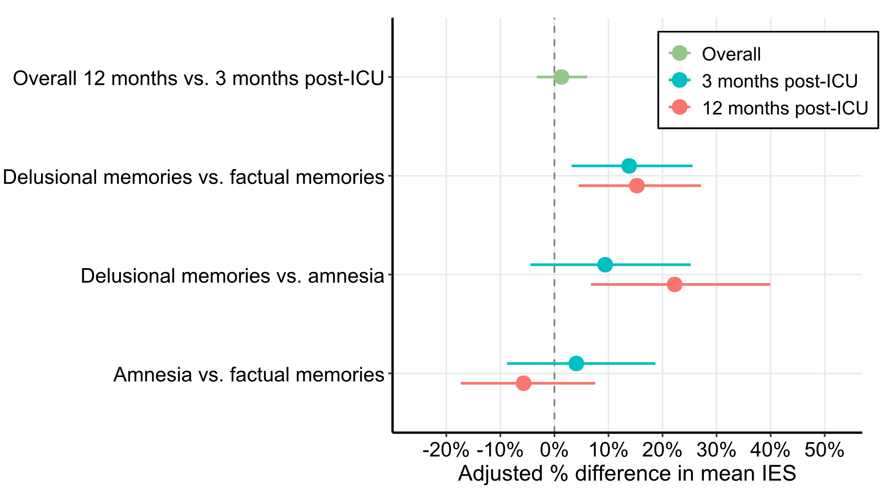 Supplemental Figure 4. The relationship between different ICU memories and the development and trajectory of PTSD symptoms (sensitivity analysis following imputation of 12-month IES-6 data)

