Supplement
Title: Individualised Early Mobilisation Treatment Effects in Mechanically Ventilated Patients: A Secondary Analysis of the TEAM Trial

Contents
Supplementary Methods 2
eTable 1. Predictor variable definitions 3
eTable 2. Summary statistics overall and by train versus test 9
eTable 3. Qini coefficient sensitivity analysis for swapping train and test datasets 11
eTable 4. Secondary length of stay outcomes 12
eTable 5. Adverse Events by individualised treatment effect on mortality tertiles in test set 13
eTable 6. Characteristics of diabetic patients predicted to benefit from EM compared to patients predicted to experience harm from EM 14
eFigure 1. Analysis pipeline 15
eFigure 2. Qini curve 16
eFigure 3. Test set model calibration 17
eFigure 5. Spaghetti plot illustration of creation of ITE predictions 19
References 20

Supplementary Methods
The X-BART ITE effect-model is a type of meta-learner. Meta-learners are modelling strategies that involve the construction of intermediate models that are then combined to form the final ITE prediction. These intermediate models can implement any algorithm one chooses. Specifically, X-BART is an X-learner with underlying models created using Bayesian additive regression trees (BART).
To build an X-learner, first divide the data into treatment and control subgroups and build a model to predict the outcome according to pre-treatment characteristics in each group. Then obtain predictions for the outcome in the unobserved state by applying each model to the opposite subgroup. Calculated the difference in probabilities between the treated and untreated state. In the treated group this will be observed outcome minus predicted outcome and in the control group this will be predicted outcome – observed outcome. Build another model in treated and control groups separately to predict this difference according to pre-treatment characteristics. Finally, for a new observation, obtain predictions from both of these models for the difference and take the mean between these to obtain the final predicted ITE.
BART algorithms consist of a collection of decision trees. Similar to a gradient boosted machine, each tree is built to improve the prediction errors from the previous tree. However, random perturbations are made to the previous tree in order to reduce over fitting.
Default hyperparameter settings from the original ‘causaltoolbox’ package implementation of X-BART were used¹.

eTable 1. Predictor variable definitions
Primary Manuscript Table | Variable Name | Type | Categories | Included in Model | Notes
Table 1
 | Age | Continuous | NA | X
 | Sex | Categorical | - Female  - Male | X
 | Body-mass index (BMI) | Continuous |  | X
 | Clinical Frailty Scale | Continuous |  | X
 | Functional Comorbidity Index | Continuous |  | X
 | WHODAS 2.0 | Continuous |  | X
 | ICU Mobility Scale score in wk before ICU admission | Continuous |  | X
 | Time from ICU admission to randomisation | Continuous |  | X
 | Time from hospital admission to randomisation | Continuous |  | X
 | ICU admission type | Categorical | - Planned ICU admission after elective surgery  - Unplanned ICU admission | X
 | RASS score | Continuous |  | X
 | PEEP | Continuous |  | X
 | P/F Ratio | Continuous |  | X
 | Receipt of vasopressors by infusion | Categorical | - Yes  - No | X
 | Receipt of renal-replacement therapy | Categorical | - Yes  - No | X
 | APACHE II score | Continuous |  | X
 | Diagnosis subgroup: Sepsis | Categorical | - Yes  - No |  | Using admission diagnosis
 | Diagnosis subgroup: Trauma | Categorical | - Yes  - No |  | Subgroup too small
 | Diagnosis subgroup: COVID-19 | Categorical | - Yes  - No |  | Subgroup too small
Table S1
 | Weight | Continuous |  |  | Redundant with BMI
 | Country of enrolment | Categorical | - Australia  - New Zealand  - Germany  - Ireland  - United Kingdom  - Brazil |  | Limits utility of study
 | Ethnicity | Categorical | - European  - Maori  - Pacific Island  - Asian  - Middle East  - Other |  | Limits utility of study
 | Married or de facto relationship | Categorical | - Yes  - No  - Unknown |  | Cross tabs showed high overlap with home living type home with partner
 | Type of home living | Categorical | - Home with partner (spouse, de-facto)  - Home alone  - Home living with other people (e.g. daughter/son, friend)  - Other | X | Combined home alone and other to get  - Home alone or other  - Home living with other people  - Home with partner
 | Current Employment status | Categorical | - Retired or full-time home duties  - Employed, full or part-time  - Unemployed (due to health reasons)  - Self-employed, full or parttime  - Unemployed (due to other reasons)  - Non-paid work (e.g. voluntary work)  - Students  - Other | X | - Retired or full-time home duties  - Unemployed or other (unemployed (due to health reasons), unemployed (due to other reasons), other)  - Employed, full or part-time (employed, full or part-time, self-employed, full or part-time, student, full or part-time, non-paid work)
Table S2
 | Clinical frailty scale (CFS) category | Categorical | - Very fit  - Well  - Managing well  - Vulnerable  - Mildly frail  - Moderately frail  - Severely frail  - Very severely frail |  | Redundant continuous version
 | Frail | Categorical | - CFS 5 and above  - Below CFS 5 |  | Redundant with continuous version
 | WHODAS 2.0 score category |  | - No disability  - Mild disability  - Moderate disability  - Severe disability  - Complete disability |  | Redundant continuous version
Table S3
 | FCI: No comorbid conditions | Categorical | - Yes  - No
 | FCI: BMI > 30 | Categorical | - Yes  - No |  | Overlap with BMI
 | FCI: Diabetes type I and/or II | Categorical | - Yes  - No | X
 | FCI: COPD, ARDS, or emphysema | Categorical | - Yes  - No |  | Redundant with non-op respiratory diag
 | FCI: Congestive heart failure (or heart disease) | Categorical | - Yes  - No | X
 | Asthma | Categorical | - Yes  - No | X
 | Depression | Categorical | - Yes  - No | X | Combined with anxiety or panic disorders
 | Upper GI disease (e.g. ulcer, hernia, reflux) | Categorical | - Yes  - No | X
 | Anxiety or panic disorders | Categorical | - Yes  - No | X | Combined with depression
 | Arthritis (rheumatoid and osteoarthritis) | Categorical | - Yes  - No |  | Subgroup too small
 | Heart attack (myocardial infarction) | Categorical | - Yes  - No |  | Subgroup too small
 | Degenerative disc disease (e.g. back disease, spinal stenosis, or severe chronic back pain) | Categorical | - Yes  - No |  | Subgroup too small
 | Stroke or transient ischemic attack (TIA) | Categorical | - Yes  - No |  | Subgroup too small
 | Osteoporosis | Categorical | - Yes  - No |  | Subgroup too small
 | Visual impairment (e.g. cataracts, glaucoma, macular degeneration) | Categorical | - Yes  - No |  | Subgroup too small
 | Peripheral vascular disease | Categorical | - Yes  - No |  | Subgroup too small
 | Angina | Categorical | - Yes  - No |  | Subgroup too small
 | Hearing impairment (i.e. very hard of hearing, even with hearing aids) | Categorical | - Yes  - No |  | Subgroup too small
 | Neurological disease (e.g. multiple sclerosis or Parkinson’s disease) | Categorical | - Yes  - No |  | Subgroup too small
Table S4
 | ICU admission source | Categorical | - ED  - Hospital ward  - Admitted from Operating Theatre following elective surgery  - Admitted from Operating Theatre following emergency surgery  - Transfer from another hospital (expect from another ICU)  - Transfer from another ICU | X | - Planned: after elective surgery  - Unplanned: from emergency surgery or from another hospital or ICU  - Unplanned: from emergency department  - Unplanned: from ward  Also in table 1
 | Operative admission diagnosis | Categorical | - Cardiovascular  - Gastrointestinal  - Respiratory  - Musculoskeletal/skin  - Trauma  - Renal  - Neurological  - Gynecological  - Metabolic | X | - Cardiovascular  - Gastrointestinal  - Other
 | Non-operative admission diagnosis | Categorical | - Respiratory  - Sepsis  - Cardiovascular  - Trauma  - Metabolic  - Renal  - Hematological  - Neurological  - Musculoskeletal/skin | X | - Respiratory  - Sepsis  - Other
Table S5
 | GCS | Continuous |  | X
 | Serum creatinine | Continuous |  | X
 | PaO2 | Continuous |  | X
 | RASS | Continuous |  | X | Also in Table 1
 | CAM-ICU | Categorical | - Positive  - Negative |  | Subgroup too small
 | Sedatives via continuous infusion | Categorical | - Yes  - No |  | Subgroup too small
 | Vasopressors via continuous infusion | Categorical | - Yes  - No | X | Also in Table 1
 | Renal replacement therapy | Categorical | - Yes  - No | X | Also in Table 1
 | Corticosteroids | Categorical | - Yes  - No | X

eTable 2. Summary statistics overall and by train versus test
 | Overall  (n = 687) | Train  (n=345) | Test  (n=342)
DEMOGRAPHICS - n (%)
Age (yrs) - mean (SD) | 60 (15) | 59 (15) | 61 (15)
Body-mass index (kg/m²) - mean (SD) | 30.3 (7.9) | 30.6 (8.4) | 29.9 (7.3)
Female sex | 258 (37.6%) | 136 (39.4%) | 122 (35.7%)
Employment status
Retired or full-time home duties | 293 (42.6%) | 136 (39.4%) | 157 (45.9%)
Unemployed or other¹ | 142 (20.7%) | 89 (25.8%) | 53 (15.5%)
Employed, full or part-time² | 252 (36.7%) | 120 (34.8%) | 132 (38.6%)
Type of home living
Home alone or other | 150 (21.8%) | 75 (21.7%) | 75 (21,9%)
Home living with other people | 134 (19.5%) | 77 (22.3%) | 57 (16.7%)
Home with partner | 403 (58.7%) | 193 (55.9%) | 210 (61.4%)
FRAILTY & FUNCTION - median [IQR]
Clinical frailty scale | 3 [2, 4] | 3 [2, 4] | 3 [2, 4]
Functional comorbidity index | 2 [1, 3] | 2 [1, 3] | 1 [1, 3]
Highest score on ICU mobility scale in week before ICU admission | 10 [10, 10] | 10 [10, 10] | 10 [10, 10]
WHODAS 2.0 | 9.1 [2.1, 24.0] | 10.4 [2.1, 22.9] | 8.3 [2.1, 25.0]
FUNCTIONAL COMORBIDITY INDEX CONDITIONS - n (%)
Anxiety, panic disorders, or depression | 128 (18.6%) | 81 (23.5%) | 47 (13.7%)
Asthma | 92 (13.4%) | 50 (14.5%) | 42 (12.3%)
Congestive heart failure or heart disease | 110 (16.0%) | 44 (12.8%) | 66 (19.3%)
Diabetes types I and/or type II | 152 (22.1%) | 75 (21.7%) | 77 (22.5%)
Upper gastrointestinal disease | 89 (13.0%) | 51 (14.8%) | 38 (11.1%)
ICU ADMISSION -n (%)
Hours from ICU admission to randomisation - median [IQR] | 57.2  [32.7, 91.0] | 54.7  [31.2, 87.4] | 59.0  [36.5, 94.6]
Hours from hospital admission to randomisation - median [IQR] | 81.5  [48.3, 137.9] | 73.5  [43.8, 124.4] | 91.1  [50.6, 151.9]
Diagnosis
Non-operative
Respiratory | 211 (30.7%) | 136 (39.4%) | 75 (21.9%)
Sepsis | 117 (17.0%) | 73 (21.2%) | 44 (12.9%)
Other | 123 (17.9%) | 62 (18.0%) | 61 (17.8%)
Operative
Cardiovascular | 104 (15.1%) | 15 (4.3%) | 89 (26.0%)
Gastrointestinal | 67 (9.8%) | 41 (11.9%) | 26 (7.6%)
Other | 65 (9.5%) | 18 (5.2%) | 47 (13.7%)
Source
Planned
After elective surgery | 120 (17.5%) | 22 (6.4%) | 98 (28.7%)
Unplanned
From emergency surgery or from another hospital or ICU | 221 (32.2%) | 112 (32.5%) | 109 (31.9%)
From emergency department | 210 (30.6%) | 124 (35.9%) | 86 (25.1%)
From ward | 136 (19.8%) | 87 (25.2%) | 49 (14.3%)
PRE-RANDOMISATION TREATMENT - n (%)
Corticosteroids | 317 (46.1%) | 162 (47.0%) | 155 (45.3%)
Renal replacement therapy | 146 (21.3%) | 66 (19.1%) | 80 (23.4%)
Vasopressor infusion | 433 (63.0%) | 201 (58.3%) | 232 (67.8%)
VITALS & LABS - median [IQR]
APACHE II | 18 [14, 22] | 18 [14, 23] | 17 [13, 21]
Creatinine | 102 [70, 165] | 95 [67, 181] | 106 [74, 157]
GCS | 15 [14, 15] | 15 [14, 15] | 15 [15, 15]
PEEP - mean (SD) | 8.9 (3.0) | 9.2 (3.1) | 8.7 (2.9)
PF ratio - mean (SD) | 228.6 (82.0) | 215.5 (75.8) | 241.7 (86.0)
PaO2 - mean (SD) | 84.7 (28.3) | 80.7 (22.0) | 88.7 (33.0)
RASS | -3 [-4, -2] | -3 [-4, -2] | -3 [-4, -2]
TREATMENT - n (%)
Early mobilisation | 346 (50.4%) | 175 (50.7%) | 171 (50.0%)
OUTCOME - n (%)
Death at day 180
Total | 141 (20.5%) | 64 (18.6%) | 77 (22.5%)
Early mobilisation | 75 (21.7%) | 35 (20.0%) | 40 (23.4%)
Usual care | 67 (19.6%) | 29 (17.1%) | 38 (22.2%)
AVERAGE TREATMENT EFFECT (ATE) - % (95% CI) | 2.03% (–4.02,8.08) | 2.94% (–5.24,11.13) | 1.17% (–7.72,10.06)
¹ Unemployed or other = unemployed (due to health reasons), unemployed (due to other reasons), other
²Employed, full or part-time = employed, full or part-time, self-employed, full or part-time, student, full or part-time, non-paid work
SD = standard deviation, IQR = interquartile range, ICU = intensive care unit, WHODAS = World Health Organisation Disability Assessment Schedule, APACHE = acute physiology and chronic health evaluation, GCS = Glasgow Coma Scale, PEEP = positive end-expiratory pressure, PF = PaO2/FiO2, RASS = Richmond Agitation-Sedation Scale

eTable 3. Qini coefficient sensitivity analysis for swapping train and test datasets
 | Original analysis | Sensitivity analysis
Cross Validation in train | 2.80 | 2.94
Test | 2.50 | 2.14
Legend: To evaluate the robustness of the results we performed a sensitivity analysis in which we switched the train and test datasets and compare the resulting qini coefficients. This table shows similar performance both for the cross validation (median qini coefficient shown) within the training and for the held-out test data results.

eTable 4. Secondary length of stay outcomes
 | Lower Third | Middle Third | Upper Third | P-value
Days from randomization to ICU discharge, median [IQR]
Patients who survived to day 180 | 7.1 [3.4, 14.0] | 10.0 [5.1, 18.1] | 8.1 [5.0,14.0] | 0.04
Patients with 180-day mortality | 10.1 [4.3, 15.5] | 9.2 [6.2, 16.3] | 9.4 [5.4, 19.7] | 0.77
Days from randomization to hospital discharge, median [IQR]
Patients who survived to day 180 | 11.9 [5.7, 21.0] | 13.1 [9.1, 25.7] | 17.4 [6.1,26.1] | 0.69
Patients with 180-day mortality | 17.1 [9.2, 28.1] | 20.8 [11.5, 34.6] | 17.9 [11.1, 31.0] | 0.40
Legend: Secondary outcomes of days from randomization to ICU discharge and days from randomization to hospital discharge are summarized for patients with 180-day mortality and those without across the individualised treatment effect tertiles in test set. P-values were calculated using the Kruskal-Wallis test to determine statistical significance across medians.

eTable 5. Adverse Events by individualised treatment effect on mortality tertiles in test set
 | Lower third  (predicted benefit from  enhanced EM)  N = 114 | Middle third  (predicted similar  outcome w/ & w/o  enhanced EM)  N=114 | Upper third  (predicted harm  from enhanced EM)  N=114
Patients with ≥1 adverse event potentially due to  Mobilization – n (%) | 9 (7.9) | 7 (6.1) | 14 (12.3)

Legend: Secondary outcome of adverse event rates by tertile.

eTable 6. Characteristics of diabetic patients predicted to benefit from EM compared to patients predicted to experience harm from EM

 | Diabetic Patients in Lower Third  (predicted benefit from  enhanced EM)  N = 6 | Diabetic Patients in Upper Third  (predicted harm  from enhanced EM)  N= 45
Vasopressor infusion – n (%) | 1 (16.7) | 41 (91.1)
RASS – median [IQR] | –1.5 [–2.0, –0.3] | –3.0 [–4.0, –2.0]
Source: unplanned from ward – n (%) | 1 (16.7) | 7 (15.6)
Anxiety or depression – n (%) | 0 (0.0) | 8 (17.8)
Source: unplanned from emergency  surgery or from another hospital or ICU – n (%) | 0 (0.0) | 17 (37.8)
Diagnosis non-operative: other – n (%) | 0 (0.0) | 9 (20.0)
WHODAS 2.0 – median [IQR] | 0.0 [0.0, 30.2] | 8.3 [2.1, 23.9]
Functional comorbidity index – median [IQR] | 3 [2,3] | 3 [2,4]
Diagnosis: non-operative sepsis – n (%) | 0 (0.0) | 11 (24.4%)

Legend: Descriptive summary statistics comparing the top 10 most important variables (excluding diabetes) across patients in the benefit and harm thirds with diabetes.
Abbreviations: EM = early mobilisation, RASS = Richmond Agitation-Sedation Scale, ICU = intensive care unit, WHODAS = World Health Organisation Disability Assessment Schedule

eFigure 1. Analysis pipeline
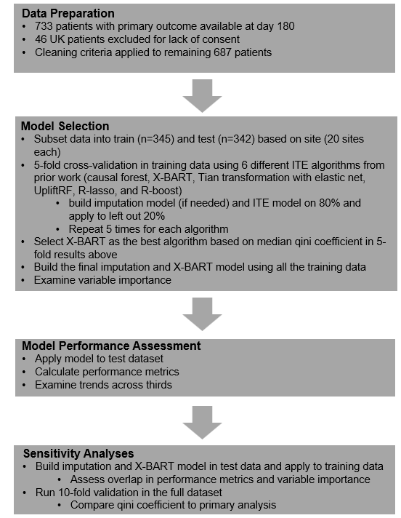

eFigure 2. Qini curve

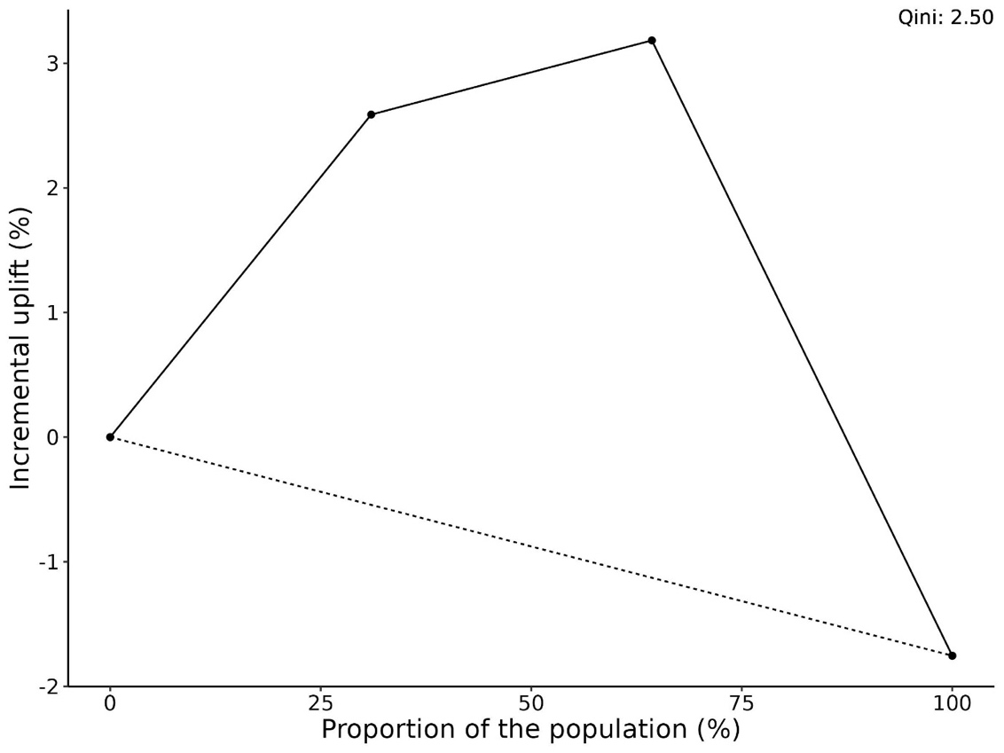
Legend: The x-axis shows the proportion of the test population being treated. The y-axis shows the incremental uplift. The solid line represents allocating treatment according to which patients were predicted to benefit most from early mobilisation. The dashed line represents random allocation. The Qini coefficient is calculated as the value under this curve with higher values representing a combination of treatment effect heterogeneity and model discrimination.

eFigure 3. Test set model calibration
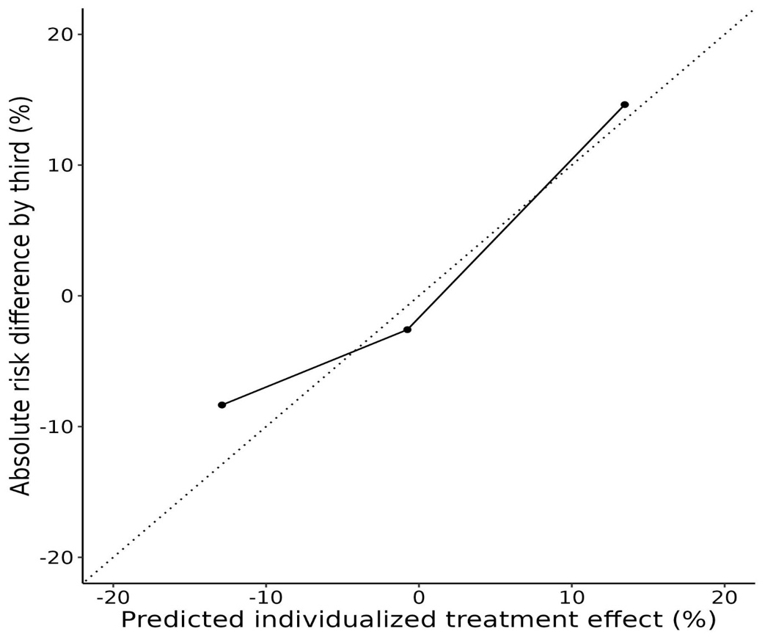
Legend: The x-axis shows the mean predicted individualised treatment effect in each third while the y-axis shows the absolute risk difference observed in each third. The dashed line indicates perfect calibration. The solid line shows the models calibration.

eFigure 4: Treatment intensity 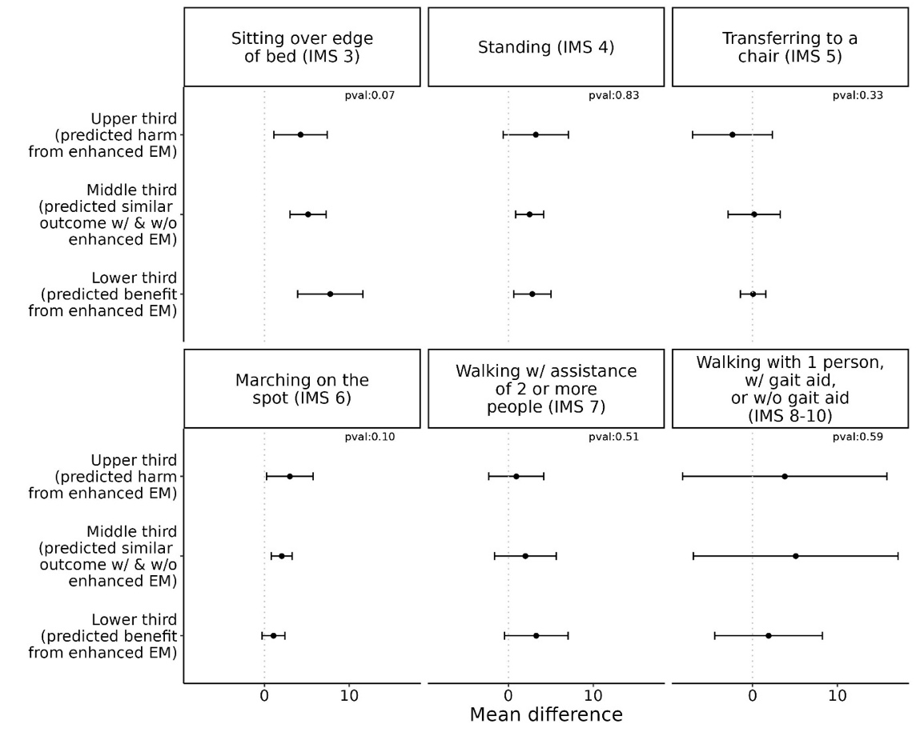
Legend: The x-axis shows the mean difference in minutes spent per day between patients who received enhanced versus usual care early mobilisation and the y-axis is the corresponding recommendation third. Each panel is for a different level of the ICU mobility scale. The lines around each point represent 95% confidence intervals for the mean differences. The p-value is from a likelihood ratio test comparing a model with each IMS as the dependent variable with treatment and ITE prediction as the independent variables with and without an interaction term between them. A lack of difference across thirds indicates the treatment effect heterogeneity is not a result of treatment intensity level.
Abbreviations: IMS = ICU mobility scale

eFigure 5. Spaghetti plot illustration of creation of ITE predictions
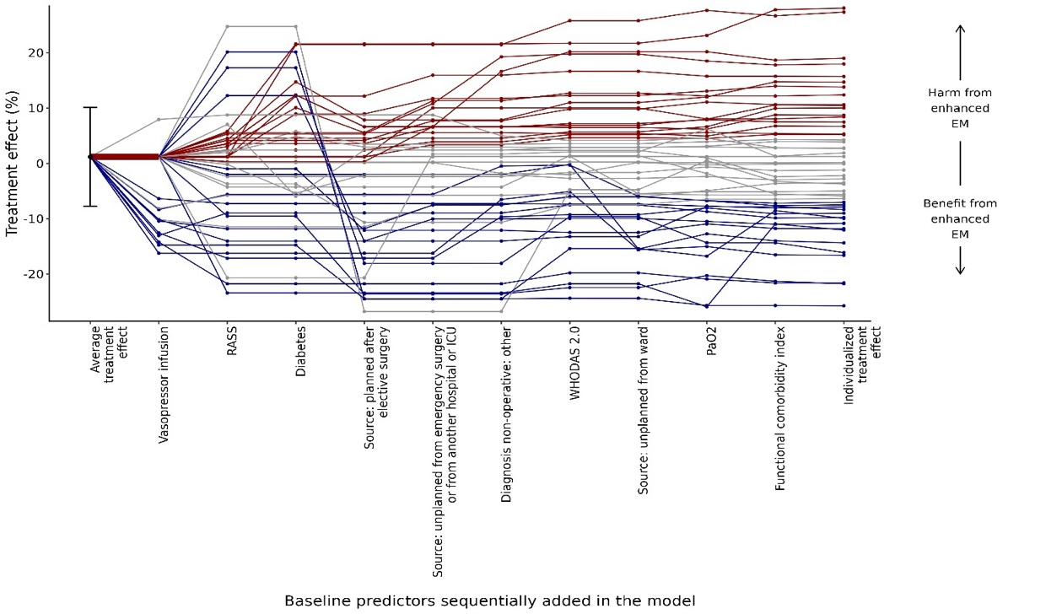
Legend: The x-axis shows progression from the average treatment effect in the test set to individualised treatment effect with the sequential addition of each of the top 10 most important variables for 50 patients from the test set. The y-axis shows the treatment effect. Each line represents a patient and is coloured according to their corresponding recommendation third
Abbreviations: EM = early mobilisation, RASS = Richmond Agitation-Sedation Scale

References
1. Kunzel SR, Sekhon JS, Bickel PJ, Yu B. Metalearners for estimating heterogeneous treatment effects using machine learning. Proc Natl Acad Sci U S A. 2019;116:4156-65.

