Supplemental Tables and Figures

eTable 1: Biomarkers

Abbreviation | Biomarker
Resistance
IL-6 | Interleukin-6
IL-8 | Interleukin-8
E-selectin | Endothelial Leukocyte Adhesion Molecule-1
ICAM-1 | Intercellular Adhesion Molecule-1
Tolerance
IL-10 | Interleukin-10
HO-1 | Heme Oxygenase-1
Ang-1 | Angiopoietin-1
[TIMP-2]·[IGFBP7] | Tissue inhibitor of metalloproteinase-2 and insulin-like growth factor binding protein-7
ATIII | Antithrombin III
Damage
Ang-2 | Angiopoietin-2
Syn-1 | Syndecan-1
HMGB1 | High-Mobility Group Box 1
PAI-1 | Plasminogen Activator Inhibitor-1
Uric Acid | Uric Acid
Lactate | Lactate
Bicarbonate | Bicarbonate

This table shows the classification of 16 measured biomarkers into the mechanistic concepts of host resistance, disease tolerance, and damage based on expert consensus scoring. Biomarkers were assigned to one of the three mechanistic categories for principal component analysis.

eFigure 1. Patient accrual

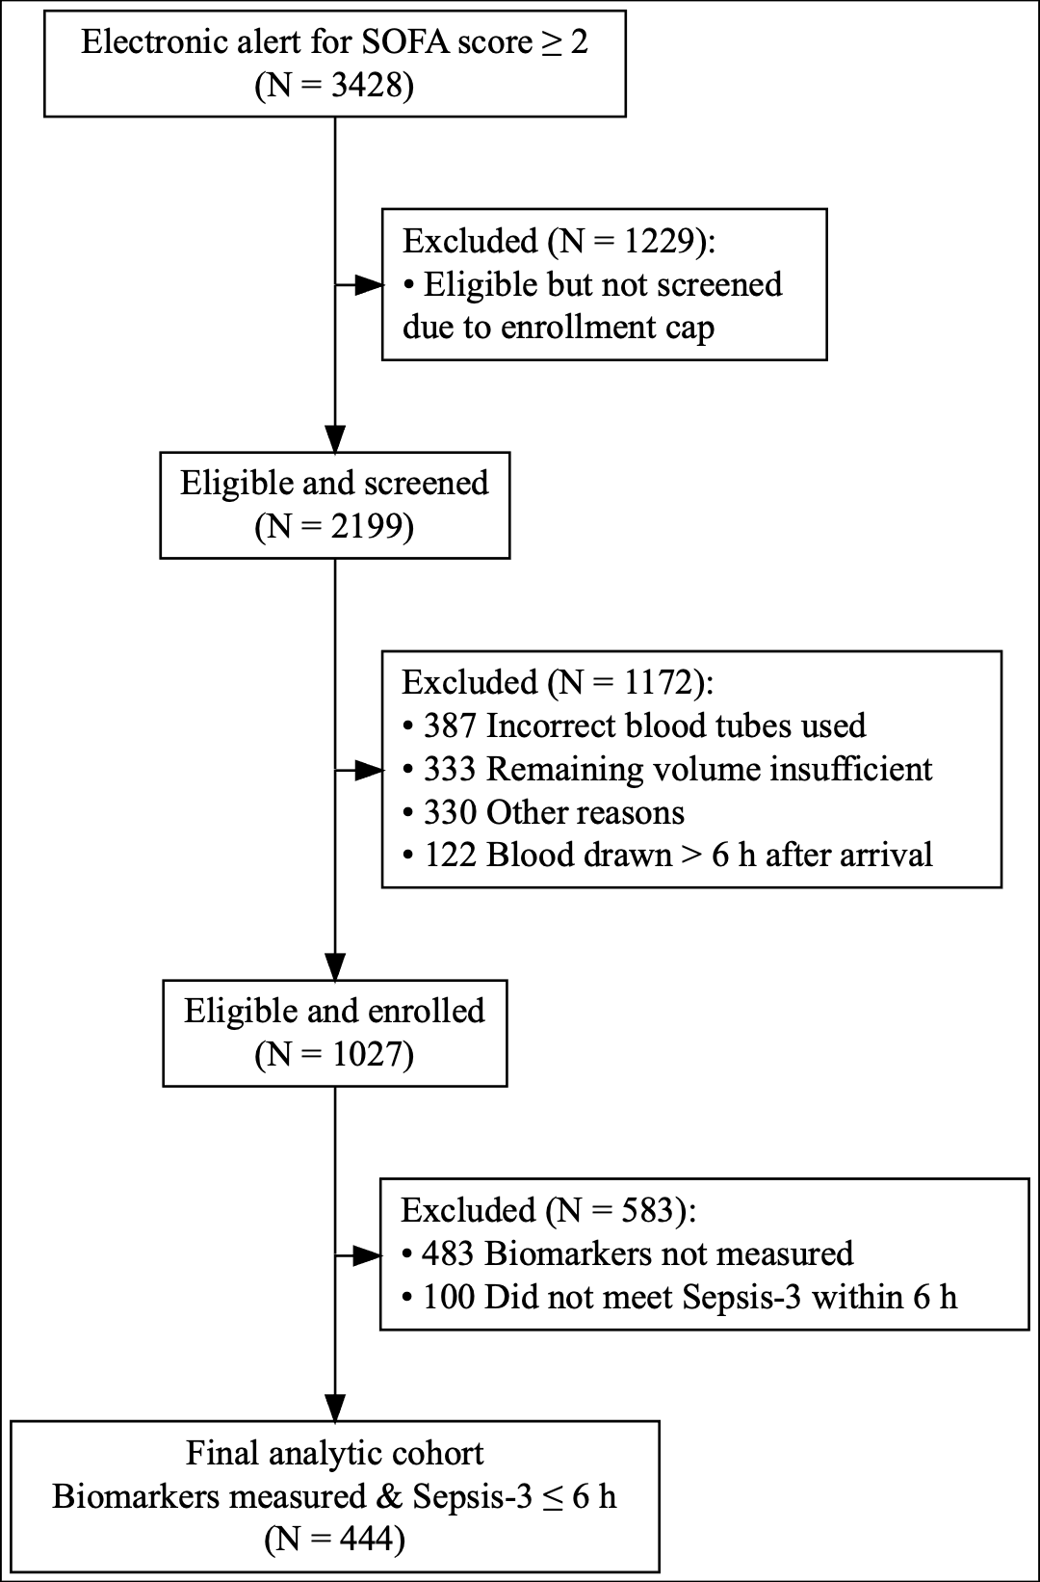

Patient flow diagram for enrollment and inclusion in the study cohort. Outlines inclusion and exclusion of screened patients with community-onset sepsis from 2017–2019.

eTable 2. Baseline Patient Characteristics by Sepsis Subtypes.

Patient Characteristics by Sepsis Subtypesª
 |  | Alpha (N=135) | Beta (N=152) | Gamma (N=94) | Delta (N=63) | Overall (N=444)
Age, mean (SD), years |  | 54 (17) | 63 (15) | 63 (17) | 60 (14) | 60 (16)
Sex, No. (%)
 | Male | 75 (56%) | 96 (63%) | 43 (46%) | 38 (60%) | 252 (57%)
 | Female | 60 (44%) | 56 (37%) | 51 (54%) | 25 (40%) | 192 (43%)
Race, No.^{b} (%)
 | White | 111 (82%) | 127 (84%) | 81 (86%) | 56 (89%) | 375 (85%)
 | Non-white | 24 (18%) | 25 (16%) | 13 (14%) | 7 (11%) | 69 (15%)
ICU admission during encounter, No (%) |  | 40 (30%) | 62 (41%) | 61 (65%) | 50 (79%) | 213 (48%)
Mechanical ventilation during encounter, No^{c} (%) |  | 19 (14%) | 31 (20%) | 26 (28%) | 34 (54%) | 110 (25%)
Vasopressor use during encounter, No^{d} (%) |  | 9 (7%) | 28 (18%) | 23 (25%) | 23 (37%) | 83 (19%)
SOFA score, mean (SD) |  | 3.3 (1.5) | 4.6 (2.0) | 3.7 (1.9) | 6.5 (3.3) | 4.3 (2.3)
Elixhauser, mean (SD) |  | 2.9 (1.8) | 5.1 (2.3) | 3.5 (2.1) | 4.5 (2.3) | 4.0 (2.3)
In-hospital mortality, No (%) |  | 5 (4%) | 11 (7%) | 11 (12%) | 13 (21%) | 40 (9%)
90-Day mortality, No (%) |  | 11 (8%) | 26 (17%) | 17 (18%) | 21 (33%) | 75 (17%)
Abbreviations: SOFA, Sequential Organ Failure Assessment.
ª All variables reflect data from the first 6 hours of presentation unless otherwise specified.
^{b} Race was derived from structured electronic health record documentation.
^{c} Mechanical ventilation refers to invasive positive-pressure ventilation.
^{d} Vasopressor use includes norepinephrine, epinephrine, vasopressin, or equivalent agents.

eFigure 2.
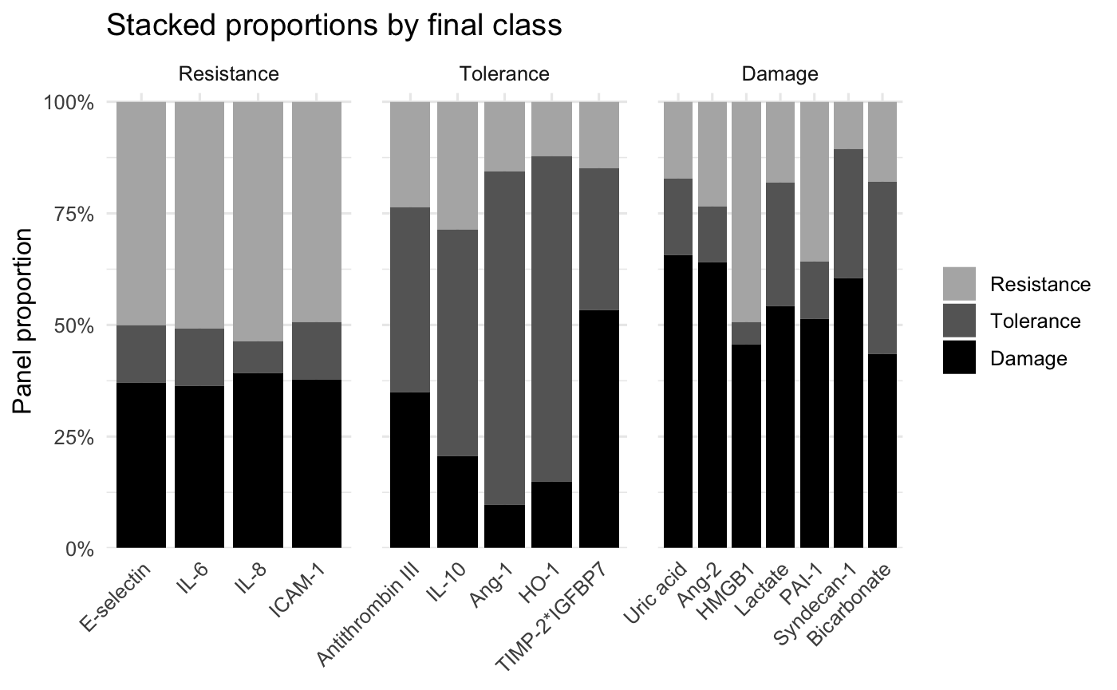

Expert consensus mapping of biomarkers to mechanistic concepts. Stacked bars show the mean expert percentage attribution of each biomarker to host resistance, disease tolerance, and damage. Biomarkers are displayed within facets according to the primary domain assignment used for primary analyses after review by a consensus committee. Note: HMGB1 and [TIMP-2]·[IGFBP7] were reassigned during committee review despite having higher mean attribution to a different concept (HMGB1: higher mean attribution to host resistance; [TIMP-2]·[IGFBP7]: higher mean attribution to damage).
eFigure 3.

A  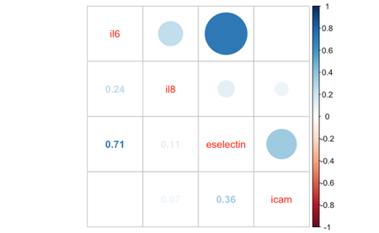 | 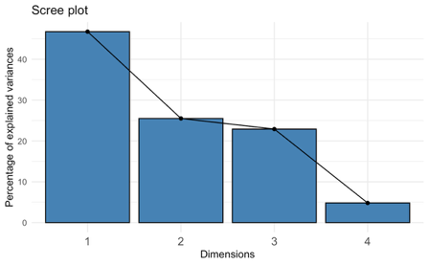 | 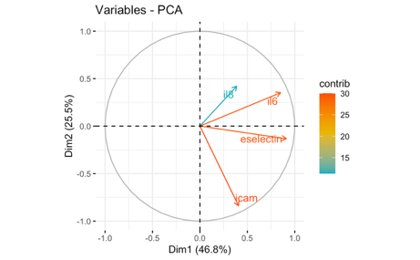
B  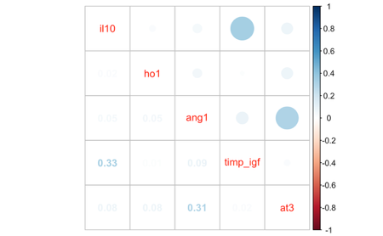 | 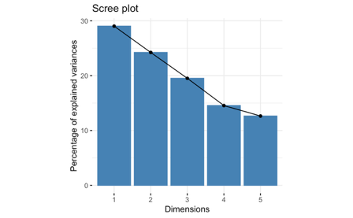 | 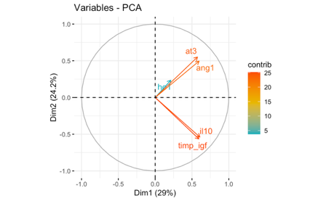
C  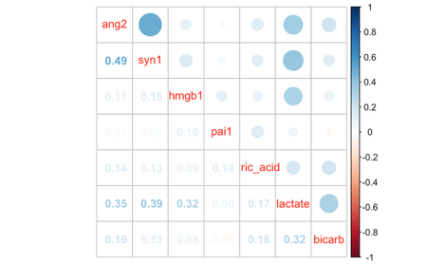 | 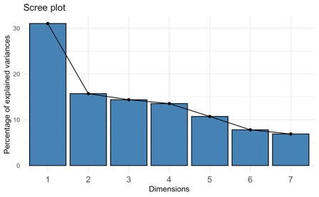 | 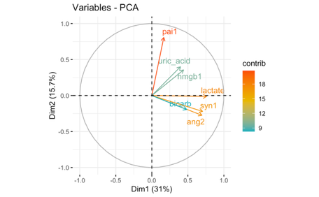

Pairwise correlation plots (left panel), scree plots of variance explained (middle panel) and PCA variable correlation plot (right panel) for each mechanistic concept: host resistance (A), disease tolerance (B), and damage (C).

eTable 3. Baseline Characteristics of the Study Cohort According to Host Resistance Level (Below vs Above Median)

Resistanceª
 |  | Low (N=222) |  | High (N=222) |  | Overall (N=444)
Age, mean (SD), years |  | 62 (17) |  | 58 (16) |  | 60 (16)
Sex, No. (%)
 | Male | 123 (55%) |  | 129 (58%) |  | 252 (57%)
 | Female | 99 (45%) |  | 93 (42%) |  | 192 (43%)
Race, No.^{b} (%)
 | White | 184 (83%) |  | 191 (86%) |  | 375 (85%)
 | Non-white | 38 (17%) |  | 31 (14%) |  | 69 (15%)
ICU admission during encounter, No (%) |  | 101 (46%) |  | 112 (51%) |  | 213 (48%)
Mechanical ventilation during encounter^{c}, No^{c} (%) |  | 50 (23%) |  | 60 (27%) |  | 110 (25%)
Vasopressor use during encounter, No^{d} (%) |  | 29 (13%) |  | 54 (24%) |  | 83 (19%)
SOFA score, mean (SD) |  | 4.2 (2.3) |  | 4.4 (2.5) |  | 4.3 (2.3)
Elixhauser, mean (SD) |  | 4.1 (2.4) |  | 3.9 (2.1) |  | 4.0 (2.3)
In-hospital mortality, No (%) |  | 20 (9%) |  | 20 (9%) |  | 40 (9%)
90-Day mortality, No (%) |  | 45 (20%) |  | 30 (14%) |  | 75 (17%)
Abbreviations: SOFA, Sequential Organ Failure Assessment.
ª All variables reflect data from the first 6 hours of presentation unless otherwise specified.
^{b} Race was derived from structured electronic health record documentation.
^{c} Mechanical ventilation refers to invasive positive-pressure ventilation.
^{d} Vasopressor use includes norepinephrine, epinephrine, vasopressin, or equivalent agents.

eTable 4. Baseline Characteristics of the Study Cohort According to Disease Tolerance Level (Below vs Above Median)

Toleranceª
 |  | Low (N=222) | High (N=222) |  |  | Overall (N=444)
Age, mean (SD), years |  | 61 (16) | 59 (17) |  |  | 60 (16)
Sex, No. (%)
 | Male | 124 (56%) | 128 (58%) |  |  | 252 (57%)
 | Female | 98 (44%) | 94 (42%) |  |  | 192 (43%)
Race, No.^{b} (%)
 | White | 191 (86%) | 184 (83%) |  |  | 375 (85%)
 | Non-white | 31 (14%) | 38 (17%) |  |  | 69 (15%)
ICU admission during encounter, No (%) |  | 114 (51%) | 99 (45%) |  |  | 213 (48%)
Mechanical ventilation during encounter, No^{c} (%) |  | 55 (25%) | 55 (25%) |  |  | 110 (25%)
Vasopressor use during encounter, No^{d} (%) |  | 49 (22%) | 34 (15%) |  |  | 83 (19%)
SOFA score, mean (SD) |  | 4.9 (2.6) | 3.7 (1.9) |  |  | 4.3 (2.3)
Elixhauser, mean (SD) |  | 4.5 (2.3) | 3.6 (2.2) |  |  | 4.0 (2.3)
In-hospital mortality, No (%) |  | 26 (12%) | 14 (6%) |  |  | 40 (9%)
90-Day mortality, No (%) |  | 45 (20%) | 30 (14%) |  |  | 75 (17%)
Abbreviations: SOFA, Sequential Organ Failure Assessment.
ª All variables reflect data from the first 6 hours of presentation unless otherwise specified.
^{b} Race was derived from structured electronic health record documentation.
^{c} Mechanical ventilation refers to invasive positive-pressure ventilation.
^{d} Vasopressor use includes norepinephrine, epinephrine, vasopressin, or equivalent agents.

eTable 5. Baseline Characteristics of the Study Cohort According to Damage Level (Below vs Above Median)

Damageª
 |  | Low (N=222) |  | High (N=222) |  | Overall (N=444)
Age, mean (SD), years |  | 60 (18) |  | 60 (16) |  | 60 (16)
Sex, No. (%)
 | Male | 123 (55%) |  | 129 (58%) |  | 252 (57%)
 | Female | 99 (45%) |  | 93 (42%) |  | 192 (43%)
Race, No.^{b} (%)
 | White | 179 (81%) |  | 196 (88%) |  | 375 (85%)
 | Non-white | 43 (19%) |  | 26 (12%) |  | 69 (15%)
ICU admission during encounter, No (%) |  | 88 (40%) |  | 125 (56%) |  | 213 (48%)
Mechanical ventilation during encounter^{c}, No (%) |  | 43 (19%) |  | 67 (30%) |  | 110 (25%)
Vasopressor use during encounter, No^{d} (%) |  | 24 (11%) |  | 59 (27%) |  | 83 (19%)
SOFA score, mean (SD) |  | 3.9 (1.9) |  | 4.65 (2.6) |  | 4.3 (2.3)
Elixhauser, mean (SD) |  | 3.9 (2.3) |  | 4.2 (2.3) |  | 4.0 (2.3)
In-hospital mortality, No (%) |  | 8 (4%) |  | 32 (14%) |  | 40 (9%)
90-Day mortality, No (%) |  | 23 (10%) |  | 52 (23%) |  | 75 (17%)
Abbreviations: SOFA, Sequential Organ Failure Assessment.
ª All variables reflect data from the first 6 hours of presentation unless otherwise specified.
^{b} Race was derived from structured electronic health record documentation.
^{c} Mechanical ventilation refers to invasive positive-pressure ventilation.
^{d} Vasopressor use includes norepinephrine, epinephrine, vasopressin, or equivalent agents.

eTable 6. Primary Model Adjusted for Sepsis Subtype Membership
A: Host Resistance
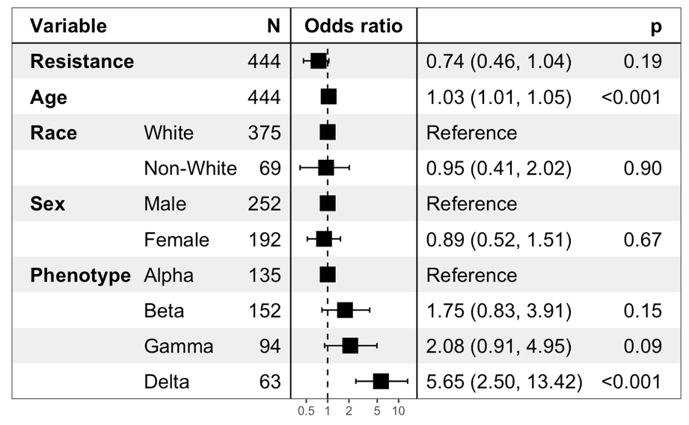
B: Disease Tolerance
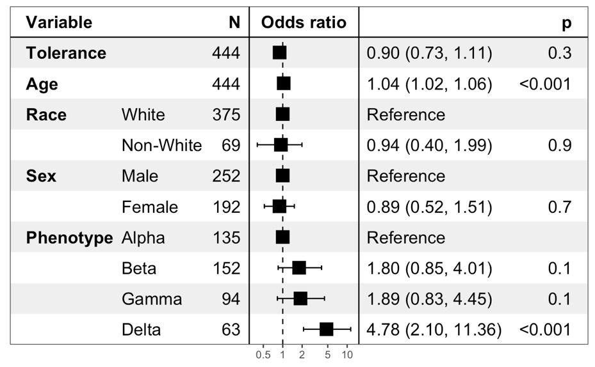
C: Damage
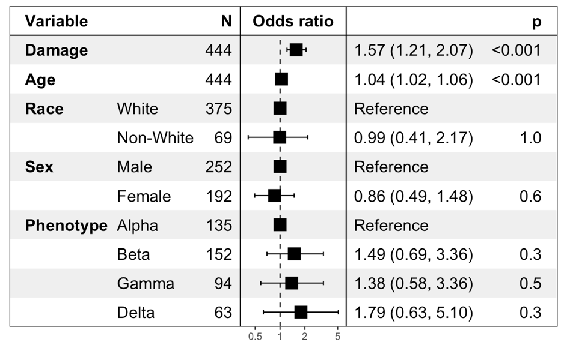
Multivariable logistic regression assessing the association between A) host resistance, B) disease tolerance and C) damage with 90-day mortality, adjusted for patient sepsis subtype membership.

eTable 7. Sensitivity Analysis – Excluding Biomarkers with High Missingness.
A: Host Resistance
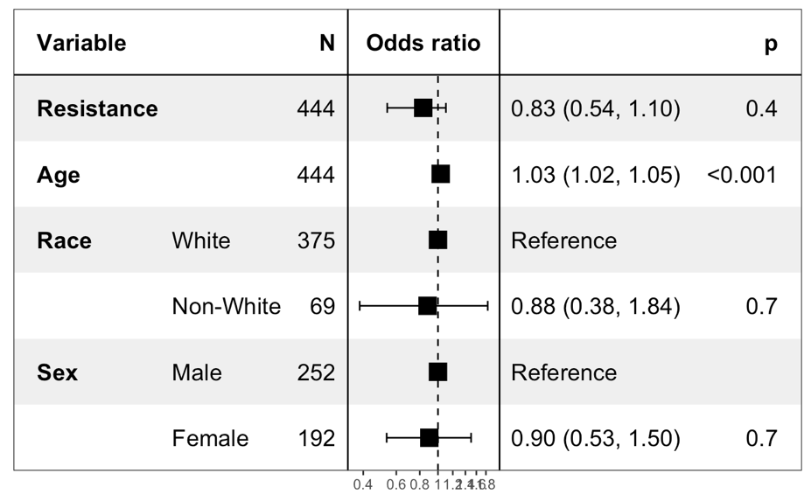
B: Disease Tolerance
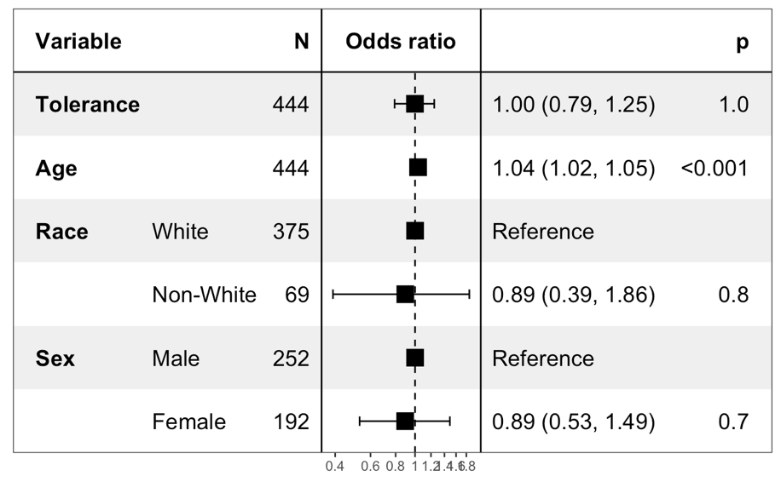
C: Damage
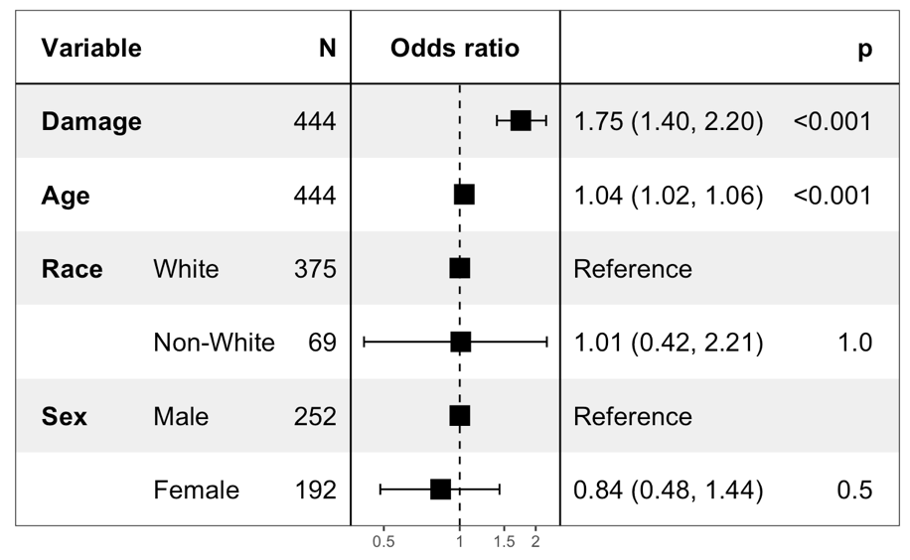
Risk-adjusted associations between A) host resistance, B) disease tolerance and C) damage and 90-day mortality after excluding biomarkers with greater than 20% missing data.
eTable 8. Sensitivity Analysis Using 2D PCA for Mechanistic Concepts.
A: Host Resistance
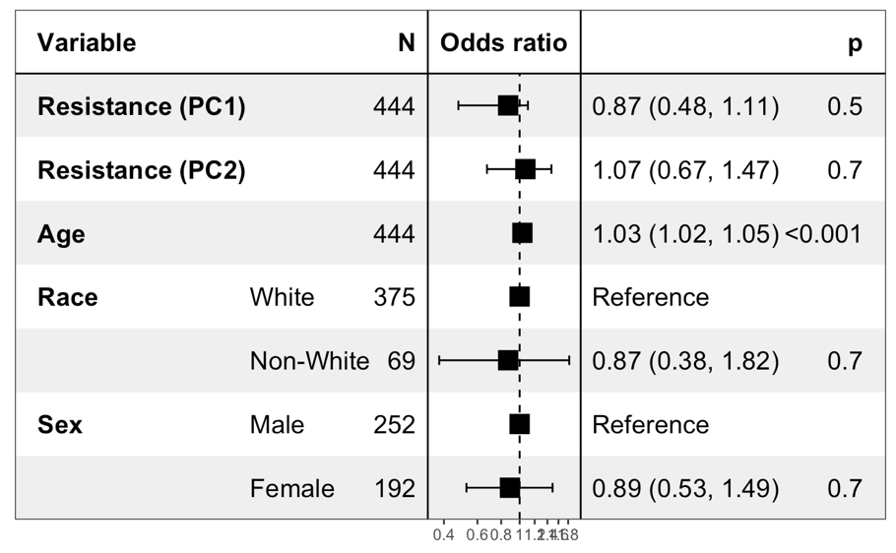
B: Disease Tolerance
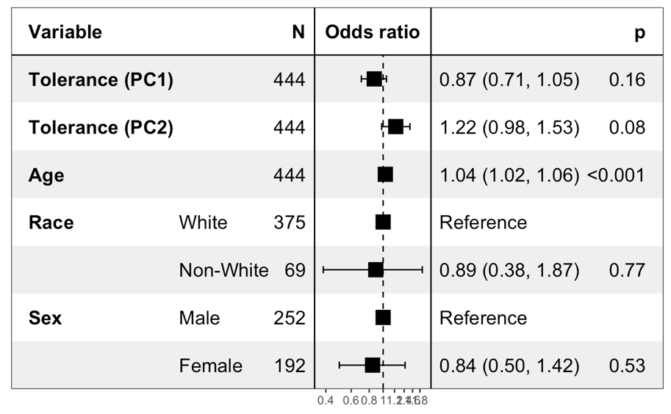
C: Damage
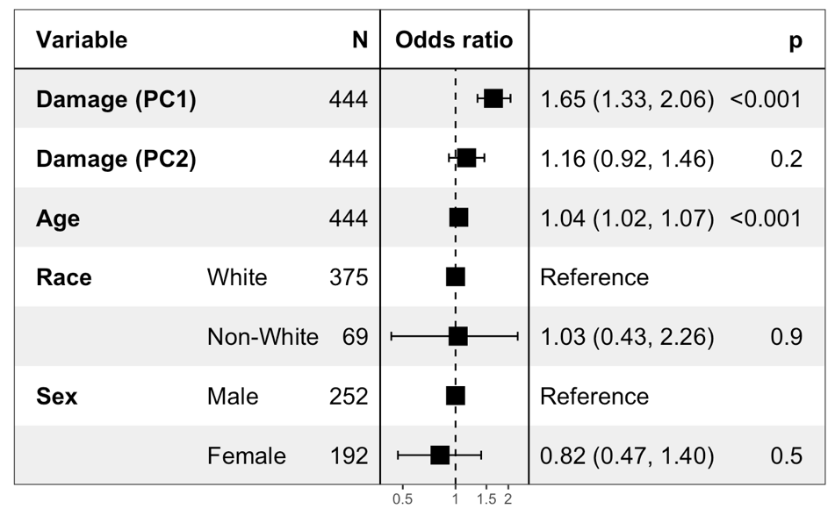
Risk-adjusted associations between A) host resistance, B) disease tolerance and C) damage and 90-day mortality using two-dimensional principal component analysis (PCA) to define mechanistic concepts.

eTable 9. Sensitivity Analysis Using Proportional Expert Agreement for Concept Mapping.
A: Host Resistance
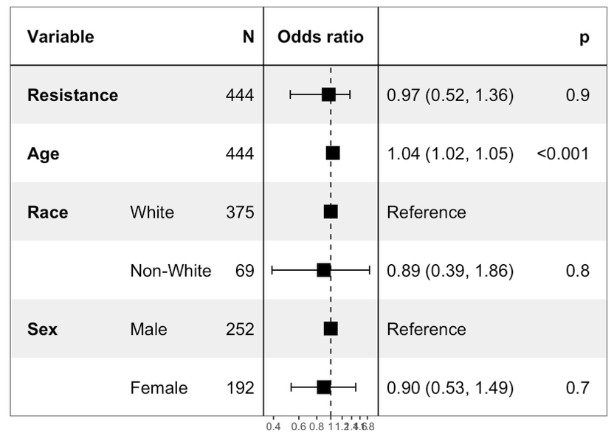
B: Disease Tolerance
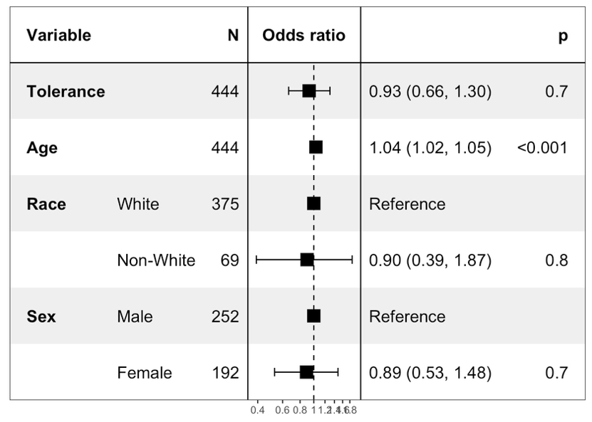
C: Damage
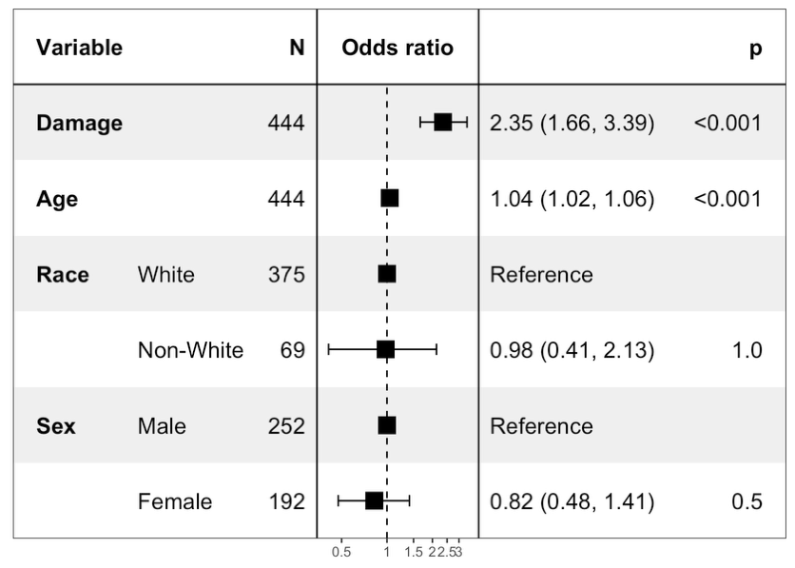

Risk-adjusted associations between A) host resistance, B) disease tolerance and C) damage and 90-day mortality using weighted concept assignments based on proportional expert agreement for biomarker classification.
eTable 10. Baseline patient characteristics by cross-classification of host resistance and disease tolerance (Low/Low, High/Low, Low/High, High/High).

 |  | Low R/ Low T  (N=109) | High R/ Low T  (N=113) | Low R/ High T  (N=113) | High R/ High T  (N=109) | Overall (N=444)
Age, mean (SD), years |  | 62 (17) | 59 (15) | 61 (17) | 57 (17) | 60 (16)
Sex, No. (%)
 | Male | 64 (59%) | 60 (53%) | 59 (52%) | 69 (63%) | 252 (57%)
 | Female | 45 (41%) | 53 (47%) | 54 (48%) | 40 (37%) | 192 (43%)
Race, No.^{b} (%)
 | White | 92 (84%) | 99 (88%) | 92 (81%) | 92 (84%) | 375 (85%)
 | Non-white | 17 (16%) | 14 (12%) | 21 (19%) | 17 (16%) | 69 (15%)
ICU admission during encounter, No (%) |  | 54 (50%) | 60 (53%) | 47 (42%) | 52 (48%) | 213 (48%)
Mechanical ventilation during encounter, No^{c} (%) |  | 22 (20%) | 33 (29%) | 28 (25%) | 27 (25%) | 110 (25%)
Vasopressor use during encounter, No^{d} (%) |  | 17 (16%) | 32 (28%) | 12 (11%) | 22 (20%) | 83 (19%)
SOFA score, mean (SD) |  | 4.7 (2.5) | 4.96 (2.6) | 3.7 (1.9) | 3.7 (1.9) | 4.3 (2.3)
Elixhauser, mean (SD) |  | 4.6 (2.2) | 4.4 (2.4) | 3.7 (2.5) | 3.5 (2.0) | 4.0 (2.3)
In-hospital mortality, No (%) |  | 12 (11%) | 14 (12%) | 8 (7%) | 6 (6%) | 40 (9%)
90-Day mortality, No (%) |  | 27 (25%) | 18 (16%) | 18 (16%) | 12 (11%) | 75 (17%)
Abbreviations: R, Host Resistance; T, Disease Tolerance, SOFA, Sequential Organ Failure Assessment.
ª All variables reflect data from the first 6 hours of presentation unless otherwise specified.
^{b} Race was derived from structured electronic health record documentation.
^{c} Mechanical ventilation refers to invasive positive-pressure ventilation.
^{d} Vasopressor use includes norepinephrine, epinephrine, vasopressin, or equivalent agents.

eTable 11. Risk-adjusted 90-day mortality by combined host resistance/disease tolerance group.
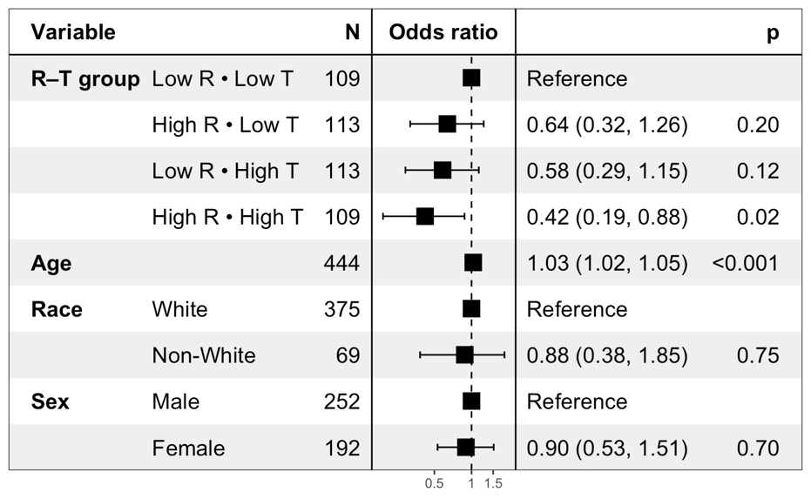
Multivariable logistic regression results for 90-day mortality with the four-group combination as the independent variable, adjusted for age, sex, and race. Reference category: Low R + Low T. Abbreviations: R: Host resistance, T: Disease tolerance.

eFigure 4.
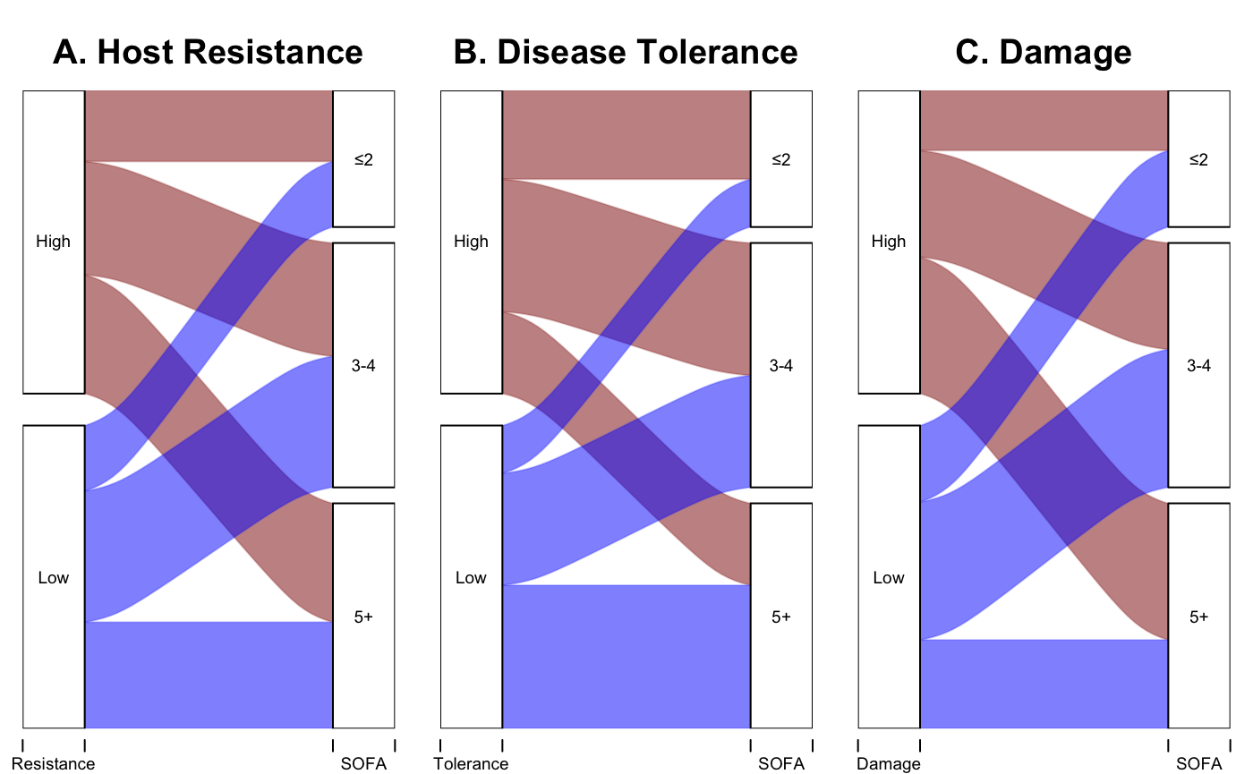

We compared median-split host resistance, disease tolerance, and damage scores with admission SOFA categories (≤2, 3–4, ≥5) and visualized overlap using alluvial plots. High and low strata of host resistance, disease tolerance, and damage were represented across all SOFA categories, suggesting these mechanistic signatures were not simply proxies for illness severity.

eFigure 5.

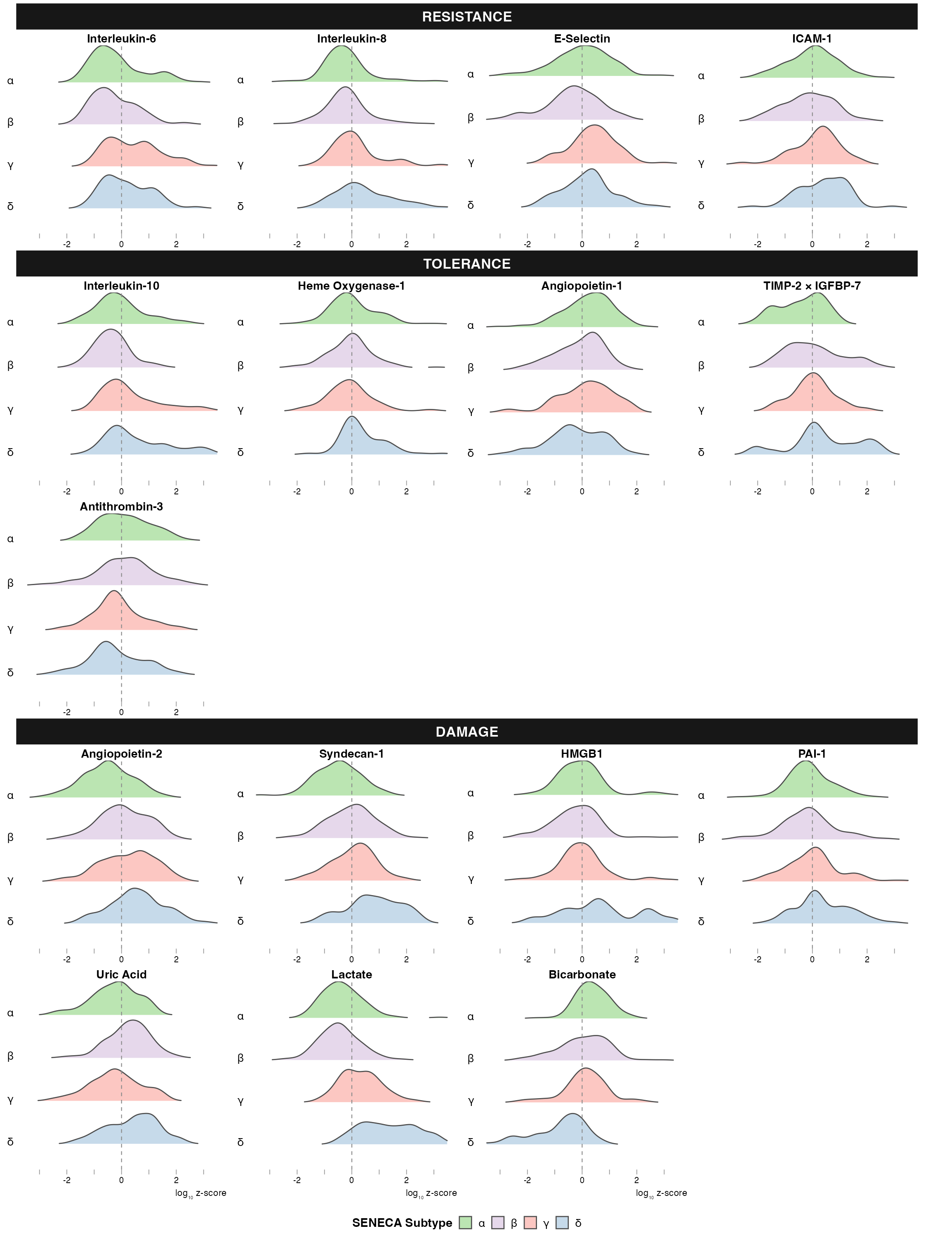

Ridge plots show log-transformed, z-scored levels of 16 biomarkers in sepsis patients (N = 444), grouped by SENECA subtype (α, β, γ, δ). Biomarkers are organized into: Resistance (IL-6, IL-8, E-selectin, ICAM-1), Tolerance (IL-10, HO-1, Ang-1, [TIMP-2]·[IGFBP7], antithrombin-3), and Damage (Ang-2, syndecan-1, HMGB1, PAI-1, uric acid, lactate, bicarbonate). The dashed line marks the cohort mean (z = 0). [TIMP-2]·[IGFBP7] reflects the AKI risk index (÷1000); lactate is the 6-hour maximum and bicarbonate the 6-hour minimum.

