Electronic Supplementary Material

Title: Standard of Care for Rehabilitation in Critical Illness

Authors: Carol Hodgson^{1,2,3,4} (0000-0002-0114-276X), Elizabeth Ayre¹ (0000-0002-0682-1569), Tessa Broadley¹ (0000-0002-5555-0777), Lisa Burry^{5,6,7,8} (0000-0002-6545-3890), Kelly Casey⁹, Craig Dale^{10,11} (0000-0002-5042-0332), Sabrina Eggmann^{1,12,13} (0000-0002-7379-7343), Amy Freeman-Sanderson^{1,14,15,16} (0000-0003-2161-6421), Michelle E Kho^{17,18.19} (0000-0003-3170-031X), Michelle Paton^{1,20} (0000-0001-6126-4753), Emma J Ridley^{1,21}, Louise Rose²² (0000-0003-1700-3972), Stefan J Schaller^{23.24} (0000-0002-6683-9584), , Margaret S. Herridge^{8,25,26} (0000-0002-2903-1631)

Table of Contents
eTable 1: Tests of Strength and Physical Function in the ICU 2
eTable 2. Strategies for Pressure Relief 3
Figure 3. Medication optimisation processes 4

eTable 1: Tests of Strength and Physical Function in the ICU
Domain | Test / Measure | What It Assesses | Requirements | Strengths | Limitations
Volitional Strength | MRC Sum Score [1] | Global limb strength | Awake, able to follow commands | Defines ICU-AW (<48/60); easy to administer | Ceiling effects; not usable when sedated/delirious
 | Handgrip Dynamometry [2] | Isometric grip strength | Ability to hold device and follow instructions | Quick, reliable, predictive of outcomes | Affected by limb injury/oedema
 | Handheld Myometry [3] | Quantified isometric force of individual muscles | Cooperative patient; trained assessor | More sensitive than MRC grades 4–5 | Requires equipment; more time-consuming
Functional Strength | 5x Sit-to-Stand (5xSTS) [4] | Lower limb strength & endurance | Able to stand with/without aid | Real-world relevance; highly responsive | Not usable in non-ambulatory patients
 | PFIT-s (Physical Function in ICU Test–scored) [5] | Strength, endurance, marching | Partial participation possible | ICU-validated; responsive early | Some components not feasible in unstable patients
 | CPAx (Chelsea Critical Care Physical Assessment Tool) [6] | Strength, respiratory function, mobility | Ability to participate; broad assessment | Covers ICU→ward transitions; holistic | Requires training
Mobility & Physical Function Scores | ICU Mobility Scale (IMS) [7] | Highest level of mobility on a 0–10 scale | Patient assessment via observation | Very quick; widely used; valid and reliable | Measures mobility level, not strength
 | FSS-ICU (Functional Status Score for the ICU) [8] | 5 mobility tasks scored 0–7 each | Requires patient participation | Valid and reliable | More time-consuming than IMS
 | AM-PAC "6-Clicks" (Basic Mobility) [9] | Tasks such as bed mobility, transfers, walking | Short questionnaire for clinicians | Predicts discharge needs; rapid | Not ICU-specific, relies on clinician judgment
 | Perme ICU Mobility Score [10] | Mobility milestones | Patient participation + medical record review | Captures both mobility and ICU-specific barriers | Slightly longer; requires training
Non-Volitional Strength | Peripheral Nerve Twitch Force | Evoked muscle contraction | Nerve stimulator; monitoring | Objective, usable even when sedated | Mostly research-based
 | Muscle Ultrasound | Muscle mass, architecture, wasting | Ultrasound machine; trained operator | Sensitive to early muscle loss; | Does not measure strength directly
 | Electrical Impedance Myography | Muscle quality & atrophy risk | Minimal patient engagement | Quick, non-invasive | Limited normative ICU data

eTable 2. Strategies for Pressure Relief
Strategy | Indication | Intervention | Considerations
General principles | Prevention | See specific strategies below | Check skin at least daily, consider wrinkles and sheer of linens, identify hot spots (pain, redness, bruising, oedema, mottled or boggy skin)
Prophylaxis | Prevention | Sacral and heel dressings, consistent skin checks, repositioning | Check skin at least daily, check for wrinkles in the dressing, skin tears
Head Positioning | Attention to back of head and face, neck tightness | Rolled sheets, towels, fluidized positioners | Maintain head at midline to engage with environment
Trunk Positioning in bed | Attention to sacrum, back | Bolster, wedge, recline, tilt | Consider anti-slip material to prevent from sliding down in bed
Prone Positioning | Attention to vulnerable areas including anterior surface area including face, nipples, dorsum hands and feet | Support under anterior ankles, off-load breasts, foam positioners at chest | Care with repositioning, avoid shoulder subluxation when rolling or overextension (for example, in swimmers’ position)
Trunk Positioning in chair | Prevention or off-loading sacral wound | Recline, tilt, custom cut or waffle cushion | Consider gel, foam cushions, crosshatch cutting for pressure relief, wound cut outs
Limb Positioning | Attention to external rotation of hips, extension of elbows and fingers | Elevation, range of motion, lateral knee/hip rolled sheet | Full support under proximal limb to ensure heels are completely contact free from bed. Add pillow/wedge at foot of bed against plantar surface of foot to prevent plantar flexion contracture.
Functional mobility | Positional changes | Rolling, long-sitting in bed, sitting at the edge of the bed, transferring out of bed to a chair or wheelchair or multifunctional positioning aid. | Consider safe patient handling and positioning equipment such as a tilt bed/chair.
Prefabricated Splinting | Risk of contracture, skin breakdown, need for protection for wound/bony prominences | Palm protector, resting hand, multipodus boot, soft off-loading boot | Schedule time in and out of splints, alternate 1 boot between right and left foot
Custom Splinting | Risk of contracture, skin breakdown, need for protection for wound/bony prominences, wound vac, flap, partial amputation, contracture | Cut out, blow out, accommodating | Measure and stage wound, avoid splint or strapping across wound, pad, blow out for bony prominences. Ambulation with wound/amputation may need custom AFO and walking shoe.
Communication | Nursing, care team, caregivers | Position and splinting schedule changes, timing, duration, and frequency | Simplicity with scheduling, consider with nursing cares

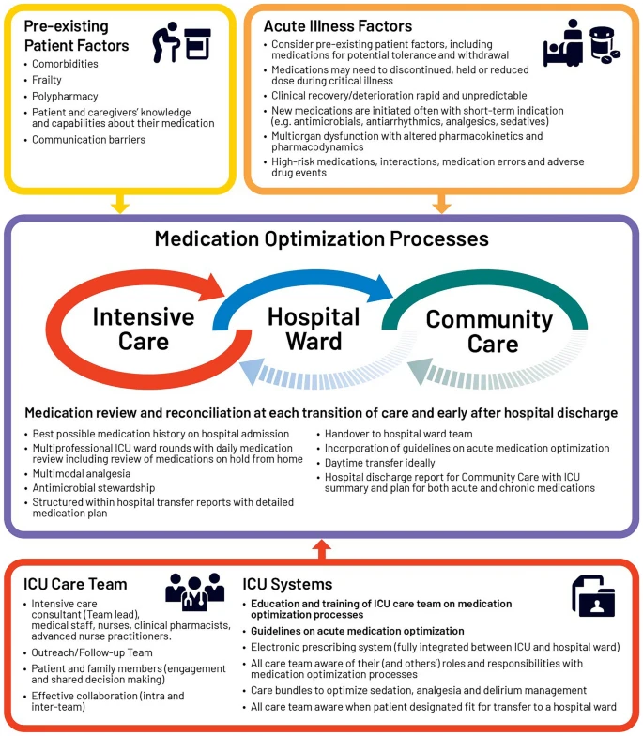

eFigure 1. Medication optimisation processes

References

1. Hermans, G., Clerckx, B., Vanhullebusch, T., Segers, J., Vanpee, G., Robbeets, C., . . . Van Den Berghe, G. 2012 Interobserver agreement of medical research council sum-score and handgrip strength in the intensive care unit. Muscle & Nerve.45 1:18-25. https://doi.org/10.1002/mus.22219
2. Luna-Heredia, E., Martín-Peña, G., and Ruiz-Galiana, J. 2005 Handgrip dynamometry in healthy adults. Clinical Nutrition.24 2:250-258.
3. Van der Ploeg, R., Fidler, V., and Oosterhuis, H. 1991 Hand-held myometry: reference values. Journal of Neurology, Neurosurgery & Psychiatry.54 3:244-247.
4. Csuka, M. and McCarty, D.J. 1985 Simple method for measurement of lower extremity muscle strength. The American journal of medicine.78 1:77-81.
5. Denehy, L., de Morton, N.A., Skinner, E.H., Edbrooke, L., Haines, K., Warrillow, S., and Berney, S. 2013 A physical function test for use in the intensive care unit: validity, responsiveness, and predictive utility of the physical function ICU test (scored). Physical therapy.93 12:1636-1645.
6. Corner, E., Wood, H., Englebretsen, C., Thomas, A., Grant, R., Nikoletou, D., and Soni, N. 2013 The Chelsea critical care physical assessment tool (CPAx): validation of an innovative new tool to measure physical morbidity in the general adult critical care population; an observational proof-of-concept pilot study. Physiotherapy.99 1:33-41.
7. Hodgson, C., Needham, D., Haines, K., Bailey, M., Ward, A., Harrold, M., . . . Higgins, A. 2014 Feasibility and inter-rater reliability of the ICU Mobility Scale. Heart & Lung.43 1:19-24.
8. Thrush, A., Rozek, M., and Dekerlegand, J.L. 2012 The Clinical Utility of the Functional Status Score for the Intensive Care Unit (FSS-ICU) at a Long-Term Acute Care Hospital: A Prospective Cohort Study. Physical Therapy.92 12:1536-1545. 10.2522/ptj.20110412
9. Jette, D.U., Stilphen, M., Ranganathan, V.K., Passek, S.D., Frost, F.S., and Jette, A.M. 2014 Validity of the AM-PAC “6-Clicks” inpatient daily activity and basic mobility short forms. Physical therapy.94 3:379-391.
10. Perme, C., Nawa, R.K., Winkelman, C., and Masud, F. 2014 A tool to assess mobility status in critically ill patients: the Perme Intensive Care Unit Mobility Score. Methodist DeBakey cardiovascular journal.10 1:41.

