Supplementary Appendix

Supplement to: Brenner T, Skarabis A, Schaller SJ, et al. Effects of a clinical metagenomics intervention on clinical outcomes, healthcare costs, and health-related quality of life in patients with sepsis or septic shock: Results of the randomised controlled DigiSep trial.

This appendix has been provided by the authors to give readers additional information about the work.

Table of Contents
List of Investigators 3
List of participating study centers 5
Supplemental Methods 8
Supplemental Results 13
Supplemental Figures 15
Supplemental Figure S1. 15
Supplemental Figure S2. 18
Supplemental Figure S3. 19
Supplemental Figure S4. 20
Supplemental Figure S5. 21
Supplemental Figure S6. 22
Supplemental Figure S7. 23
Supplemental Tables 25
Supplemental Table S1. 25
Supplemental Table S2. 26
Supplemental Table S3a. 29
Supplemental Table S3b. 30
Supplemental Table S4. 32
Supplemental Table S5. 36
Supplemental Table S6. 39
Supplemental Table S7. 42
Supplemental Table S8a. 44
Supplemental Table S8b. 44
CONSORT 2025 Checklist 45
Supplemental References 47

List of Investigators (in the German Society of Anaesthesiology and Intensive Care (GSAIC) Trials Group)

Name | Accountability/ role in the study | Institution | Department | Country
Brands, Jens | Consortium leadership, participating study center | University Hospital Essen | Department of Anesthesiology and Intensive Care Medicine | Germany
Antinoro, Alberto | Participating study center, cooperation partner | Charité - Universitätsmedizin Berlin, Corporate Member of Freie Universität Berlin and Humboldt Universität zu Berlin | Department of Anaesthesiology and Intensive Care Medicine (CCM/CVK) | Germany
Warner, Linus O. | Participating study center, cooperation partner | Charité - Universitätsmedizin Berlin, Corporate Member of Freie Universität Berlin and Humboldt Universität zu Berlin | Department of Anaesthesiology and Intensive Care Medicine (CCM/CVK) | Germany
Weigand, Markus A. | Participating study center, cooperation partner | Heidelberg University, Medical Faculty Heidelberg | Department of Anesthesiology | Germany
Hart, Dominique M. | Participating study center, cooperation partner | Faculty of Medicine and University Hospital Cologne | Department of Anesthesiology and Intensive Care Medicine | Germany
Marx, Gernot | Participating study center, cooperation partner | Medical Faculty, RWTH Aachen University | Department of Intensive Care Medicine | Germany
Mossanen, Jana | Participating study center, cooperation partner | Medical Faculty, RWTH Aachen University | Department of Intensive Care Medicine | Germany
Breuer, Thomas | Participating study center, cooperation partner | Medical Faculty, RWTH Aachen University | Department of Intensive Care Medicine | Germany
Häberle, Helene | Participating study center, cooperation partner | Eberhard-Karls Universität Tübingen | Klinik für Anästhesiologie und Intensivmedizin | Germany
Nitzsche, Kristina | Project management, monitoring | Medical Faculty, Ruprecht-Karls-University Heidelberg | Coordination Centre for Clinical Trials (KKS) | Germany
Thalmann, Paul | Biometrics | University of Heidelberg | Institute of Medical Biometry | Germany
Brezinski, Jolanda | Data management | University of Heidelberg | Institute of Medical Biometry | Germany
Saam, Joachim | Statutory health insurance company | BARMER | Institute for Health System Research | Germany
Grumaz, Silke | Supplier of NGS diagnostics | Noscendo GmbH |  | Germany
Steinmann, Maren | Analyses of healthcare costs and Health-related quality of life | Bielefeld University | Department of Health Economics and Health Care Management, School of Public Health | Germany
Gaasch, Maxime | Participating study center, cooperation partner | General Hospital of Heidenheim | Department of Anaesthesiology and Intensive Care Medicine | Germany
Pasieka, Bastian | Participating study center, cooperation partner | University Hospital Leipzig | Medical ICU | Germany
Jaekel, Ulrike | Participating study center, cooperation partner | Evangelisches Krankenhaus Luckau | Anästhesie und Intensivmedizin | Germany
Brandenburger, Timo | Participating study center, cooperation partner | University Hospital Duesseldorf | Department of Anesthesiology | Germany
Brandenburger, Timo | Participating study center, cooperation partner | Acibadem Tashkent International Medical Center | Department of Anesthesiology and Intensive Care Medicine | Germany
Bach, Friedhelm | Participating study center, cooperation partner | Evangelisches Klinikum Bethel, Universitätsklinikum OWL der Universität Bielefeld, Campus Bielefeld Bethel | Abteilung Klinische Infektiologie | Germany
Mutlak, Haitham | Participating study center, cooperation partner | SANA Klinikum Offenbach | Klinik für Anästhesiologie, Intensivmedizin und Schmerztherapie | Germany
Utzolino, Stefan | Participating study center, cooperation partner | University Medical Center Freiburg | Department of General and Visceral Surgery | Germany
Krueger, Wolfgang A. | Expert panel evaluation | Gesundheitsverbund Landkreis Konstanz, Klinikum Konstanz GmbH | Klinik für Anästhesiologie und Operative Intensivmedizin | Germany
Hagel, Stefan | Expert panel evaluation | Jena University Hospital, Friedrich Schiller University Jena | Institute for Infectious Diseases and Infection Control | Germany
Lanckohr, Christian | Expert panel evaluation | University Hospital Münster | Antibiotic Stewardship Team, Institute of Hygiene | Germany

List of participating study centers (in the DigiSep trial)

Institution | Department | Country | Sepsis-SOP | ABS rounds
University Hospital Essen | Department of Anesthesiology and Intensive Care Medicine | Germany | Yes | Yes
Charité - Universitätsmedizin Berlin, Corporate Member of Freie Universität Berlin and Humboldt Universität zu Berlin | Department of Anaesthesiology and Intensive Care Medicine (CCM/CVK) | Germany | Yes | Yes
University Hospital Münster | Department of Anesthesiology, Intensive Care and Pain Medicine | Germany | Yes | Yes
Universitätsklinikum Bonn | Department of Anesthesiology and Surgical Intensive Care Medicine, Division of Intensive Care Medicine | Germany | Yes | Yes*
General Hospital of Heidenheim | Department of Anaesthesiology and Intensive Care Medicine | Germany | Yes | Yes
University Hospital Leipzig | Medical ICU | Germany | No | Yes
Klinikum Oldenburg | University Clinic of Anesthesiology, Intensive Care, Emergency Care, Pain Therapy | Germany | Yes | Yes
Hospital of Magdeburg | Centre of Anesthesiology and Intensive Care Medicine | Germany | Yes | No
Evangelisches Krankenhaus Luckau | Anästhesie und Intensivmedizin | Germany | Yes | Yes
Heidelberg University, Medical Faculty Heidelberg | Department of Anesthesiology | Germany | Yes | Yes
Faculty of Medicine and University Hospital Cologne | Department of Anesthesiology and Intensive Care Medicine | Germany | Yes | Yes
University Hospital Medical School Ulm | Clinic of Anaesthesiology and Intensive Care Medicine | Germany | Yes | Yes
University Hospital Duesseldorf | Department of Anesthesiology | Germany | Yes | Yes
Medizinische Hochschule Hannover | Klinik für Anästhesiologie und Intensivmedizin | Germany | Yes | Yes
University Hospital of Bielefeld, Campus Bielefeld-Bethel | Department of Anesthesiology, Intensive Care, Emergency Medicine, Transfusion Medicine, and Pain Therapy | Germany | Yes | Yes
Medical Faculty, RWTH Aachen University | Department of Intensive Care Medicine | Germany | Yes | Yes
SANA Klinikum Offenbach | Klinik für Anästhesiologie, Intensivmedizin und Schmerztherapie | Germany | Yes | Yes
Eberhard-Karls Universität Tübingen | Klinik für Anästhesiologie und Intensivmedizin | Germany | Yes | Yes
Universitätsmedizin Göttingen | Klinik für Anästhesiologie | Germany | Yes | Yes
University Medical Center Freiburg | Department of General and Visceral Surgery | Germany | Yes | Yes*
Ruhr-Universität Bochum, Knappschaft Kliniken Universitätsklinikum Bochum | Klinik für Anästhesiologie, Intensivmedizin und Schmerztherapie | Germany | Yes | Yes
University Medical Centre Rostock | Department of Anaesthesiology, Intensive Care Medicine and Pain Therapy | Germany | Yes | Yes*
University Hospital Ulm | Central Emergency Services | Germany | Yes | Yes
Goethe University Frankfurt, University Hospital Frankfurt | Department of Anaesthesiology, Intensive Care Medicine and Pain Therapy | Germany | N.A. | N.A.
*ABS-experts are part of the intensive care unit (ICU) team and responsible for the ABS-rounds on the ward
List of abbreviations: SOP, standard operating procedure; ABS, antibiotic stewardship; ICU, intensive care unit; N.A., not applicable (non-recruiting study center)

Supplemental Methods
Trial oversight
Prior to initiation, the trial protocol was approved by all relevant ethical review committees. The study was conducted in accordance with the Declaration of Helsinki and Good Clinical Practice guidelines. The trial was registered at German Clinical Trials Register (identifying number: DRKS00022782, date of registration: August 25, 2020, URL: https://drks.de/search/en/trial/DRKS00022782) and at ClinicalTrials.gov (identifying number: NCT04571801, date of registration: September 25, 2020, URL: https://clinicaltrials.gov/study/NCT04571801). The first positive ethical approval was granted by the Ethics Committee of the Medical Faculty of Essen on July 8, 2020 (No. 20-9352-BO). The criteria for discontinuing the study included insufficient enrolment (<50 patients per year) or an unacceptable number of adverse events (AEs). The trial was funded by the Innovational Fund of the Federal Joint Committee (in the amount of €3.2 million). Therefore, cost analyses had to be restricted to three participating German statutory health insurers (namely BARMER, AOK Rhineland/Hamburg, and Techniker Krankenkasse), representing 33.2% of the entire cohort. The funders had no influence on the conduct of the trial and were not involved in data collection or analysis, in the writing of the manuscript, or in the decision to submit it for publication. Adequate patient and public involvement were ensured by the Aktionsbündnis Patientensicherheit e.V.

Randomization and blinding
Patients were randomized (1:1) into either the control group (CG) or the intervention group (IG) using block randomization with permuted block lengths of 4, 6, and 8. Randomization was done on the level of the individual patient, stratified by study center using an internet-based tool (www.randomizer.at). Consequently, patients in the IG and CG were expected to be fairly evenly distributed across sites to mitigate bias arising from local practice in the primary analysis, as both groups would experience the same variation in local practice. The personnel responsible for enrolling or assigning participants to interventions had no access to the random allocation sequence, although they were able to view past randomizations during the trial. Although no formal blinding of patients was planned, patients were unable to infer their group allocation due to their general state of health and the identical nature of the study visits for both groups. Blinding of the attending physicians was not possible.

Metagenomic next-generation sequencing (mNGS)-based analyses
Special tubes that stabilize cell-free DNA (cfDNA) for up to 14 days at 6–37 °C were used for blood collection (Cell-Free DNA BCT®, Streck, La Vista, NE, USA). Following a centrifugation step for plasma sample preparation, nucleic acids were isolated with a QIAsymphony DSP Circulating DNA Kit (Qiagen, Hilden, Germany). The circulating cfDNA concentration was quantified with a Qubit 1x dsDNA HS Assay Kit (Thermo Fisher Scientific, Waltham, MA, USA), and quality was assessed using a High Sensitivity DNA Kit (HS NGS Fragment Kit (1–6000 bp)) on a 5200 Fragment Analyzer System (Agilent, Santa Clara, CA, USA). DNA library preparation was performed from 1 ng of cfDNA input, and DNA libraries were sequenced using a NextSeq1000 or 2000 instrument (Illumina) with a 75 base pair (bp) read length in single-read mode. The sequencing depth of the samples was a minimum of 25 million single end reads per sample. Raw sequencing data were subjected to various quality controls, comprising PHRED score filtering, adapter trimming, complexity filtering as well as k-mer-based contamination screening. To pass the quality filter, read quality needed to surpass a Phred score of 20 and achieve a minimal length of 50 bp after quality control. All data generated were analyzed using Noscendo’s CE-IVD platform DISQVER® (version 6.4.2) and were subsequently made available to the commissioning physician via the digital communications solution of Noscendo (NOS portal) in the case of the IG. In contrast, CG samples were processed batch-wise, after patient recruitment was closed, and the results were not made available to the treating physicians.

Data collection, data management and statistical methods
All protocol-required data collected during the trial (including AEs) were entered in an electronic case report form (eCRF) using REDCap (Vanderbilt University, Nashville, USA). AEs were restricted to complications of study-related blood draws (local lesions at puncture site or volume of blood draws). Serious adverse events (SAEs) resulting in death, a life-threatening state, a prolongation of existing hospitalization, a persistent or significant disability or incapacity due to study participation were not expected. This was due to the fact that standard-of-care (SOC) diagnostics and treatment were guaranteed in both study groups, with the only difference that additional information resulting from NGS-based digital precision diagnostics were made available in IG patients. All eCRF data were managed and analyzed by the Institute of Medical Biometry (IMBI), University of Heidelberg. In addition to the analysis of the primary endpoint (DOOR/RADAR score), numerous secondary endpoints were evaluated (e.g. short- & long-term mortality, absolute/relative duration of mechanical ventilation, absolute/relative time to shock resolution, absolute/ relative duration of kidney replacement therapy, absolute/ relative duration of anti-infective treatment, length of intensive care unit stay, length of hospital stay). Mortality at 28 and 180 days was evaluated by survival-time analyses (Kaplan–Meier, Cox model). The reported absolute times include the respective durations up to day 28 (ventilation duration, shock duration, renal replacement therapy duration, duration of antimicrobial therapy) for all patients having survived at least 28 days. This is due to the fact, that an unrestricted use of absolute time spans for all participating study patients carries a high risk of bias toward shorter durations, especially in diseases with high early mortality (as in the present case of sepsis or septic shock), which should be addressed by also reporting the so-called 'relative' durations. Relative times reported refer to the respective durations (for the respective parameter, in days up to day 28) in relation to the respective survival times (also given in days up to day 28). Data for length of intensive care unit stay and length of hospital stay were analysed via Kaplan-Meier analysis. The event of interest is defined as leaving the hospital or being transferred from the intensive care unit, respectively, while treating death as censoring. For additional healthcare cost analyses, the IMBI and all participating statutory health insurance providers provided the Department of Health Economics and Health Care Management, Bielefeld University, with pseudonymized eCRF and claims data via a special trust agency (Vital.Services GmbH, Leipzig, Germany). Healthcare costs included the following health service areas: outpatient, inpatient and rehabilitation care, pharmaceuticals, therapeutic devices, non-physician specialist care, rehabilitation, sick pay, nursing (home) care, and transportation. Apart from healthcare costs, the Department of Health Economics and Health Care Management, Bielefeld University, assessed the health-related quality of life (HRQoL) of all participating patients using EQ-5D-5L questionnaire data.[1]

Retrospective expert panel evaluation
A patient report was generated for 386 patients who qualified for the expert panel evaluation, based on comprehensive clinical data extracted from the eCRF (REDCap database) and the DISQVERⓇ results (Supplemental Figure S1a–c). For 3 of the 389 patients of the intention-to-treat population (ITT), no sample for mNGS diagnostics was received in the laboratory, so that these patients could not be included in the expert evaluation. To evaluate the clinical relevance of the NGS-based approach, reports were presented in combination with a questionnaire on an online survey platform hosted by Noscendo GmbH to the clinical experts (Supplemental Figure S2). To issue a treatment change recommendation that is as unbiased as possible and solely focused on pathogen diagnostics, the participating experts had no knowledge of the outcome of the participating study patient, are not part of the primary author list and do not have any conflict of interest with Noscendo GmbH. Analyses of the reviewers’ independent responses were performed using a majority rule such that two of three responses for a given patient determined the outcome for that patient. To quantify the interrater agreement, two measures were applied: Fleiss’ Kappa for key questions using the thresholds proposed by Landis & Koch et al. [2] and absolute and relative frequencies of “Complete Agreement” and “Majority Agreement” across all questions which had been answered by all three experts.

Supplemental Results
Recruitment, participant flow, and patient characteristics
In total, 409 patients were recruited between March 16, 2022, and August 8, 2023, with the last patient’s last visit on February 4, 2024, and database closure on April 23, 2024. The infectious-microbiological patient characteristics also showed no significant differences between the study groups. Sepsis was predominantly community acquired and had a pulmonary focus as its main cause (Table 1).

Positivity rate
The three most frequently detected species in blood cultures (BCs) were Escherichia coli, Staphylococcus epidermidis, and Staphylococcus aureus, whereas the top three species identified by mNGS were E. coli, Enterococcus faecium, and Bacteroides fragilis (Figure 3c). Furthermore, mNGS detected more species per sample (mean: 2.60 species per NGS-positive sample) than BCs (mean: 1.25 species per positive BC bottle). Bona fide contaminants were also more effectively excluded by mNGS than by BCs. Across both groups, there was a 50% overlap in the top 20 species detected (10 of 20 species), while the remaining 50% were unique to either method—either because the species did not appear in the other method’s top 20, or were not detected at all (Figure 3d). The most striking discrepancy in the detection frequency of mNGS over BCs is observed for E. faecium with 19-fold more detections, in comparison to fivefold more detections for E. coli, which was the most frequently detected pathogen for both methods. Furthermore, mNGS proved particularly valuable for the detection of fungal sepsis (Figure 3d). While BCs discovered fungal pathogens only rarely (Candida albicans [4x], Candida glabrata [3x], Candida tropicalis [1x] and Aspergillus spp. [1x]), NGS identified a variety of fungi more frequently (C. albicans [17x], C. glabrata [7x] and C. tropicalis [1x], as well as Candida dubliniensis [1x], Aspergillus fumigatus [3x], Malassezia restricta [1x], Rhizomucor pusillus [1x] and Rhizopus microsporus [1x]), highlighting the need for a comprehensive fungal screening even in primarily immunocompetent critically ill patients.

Plausibility
The experts justified the decreased plausibility of negative mNGS findings by stating that a lack of pathogen detection at the onset of sepsis or septic shock must fundamentally be considered implausible (Supplemental Table S4, Supplemental Figure S4a). In contrast, a negative pathogen detection on day 3 after sepsis onset might be plausible due to causal sepsis therapy (Supplemental Table S5). Implausible positive mNGS findings (e.g., at sepsis onset) mainly result from the detection of pathogens that are generally not considered triggers of sepsis (e.g., viruses; Supplemental Table S6, Supplemental Figure S4b).

Time-to-result
mNGS diagnostics was implemented in terms of a send-in model, meaning that the samples collected from the IG patients had to be transported overnight by courier (time required for transport logistics: 1.59 ± 0.97 days) from the participating study center to the reference laboratory for sequencing, resulting in a time-to-result of 2.61 ± 0.97 days. However, 98.2% of the samples were reported within 24 h after arriving at the laboratory, indicating that delays were usually due to logistics or delays in shipment but not in processing. All mNGS results were read (n=387, 100%) and average time from published result to marked as read was 688 min / median 22 min. Here, the most important differentiation was visible by sorting results between published on a weekday (Monday through Friday, n=263, 68%) and published on the weekend (Saturday and Sunday, n=124, 32%). Average time from published result to marked as read was 361 min (median 9 min) on weekdays versus 1380 min (median 101 min on weekends).

Supplemental Figures
Supplemental Figure S1. Exemplary Patient Reports for the Retrospective Expert Evaluation.
(a) The 74-year-old patient presented here had an intra-abdominal focus with peritonitis. Enterococcus faecium was detected as the leading pathogen in the blood culture and mNGS diagnostics, which must be classified as inadequately treated with the anti-infective therapy strategy using an acylaminopenicillin + a β-lactamase inhibitor (e.g., piperacillin/tazobactam). The patient died during the course of sepsis. Abbreviations: CRP, C-reactive protein; HBV, hepatitis B virus; ICU, intensive care unit; NA, not applicable; mNGS, metagenomic next-generation sequencing; PCT, procalcitonin; SOFA, Sequential Organ Failure Assessment; VRE, vancomycin-resistant Enterococcus.

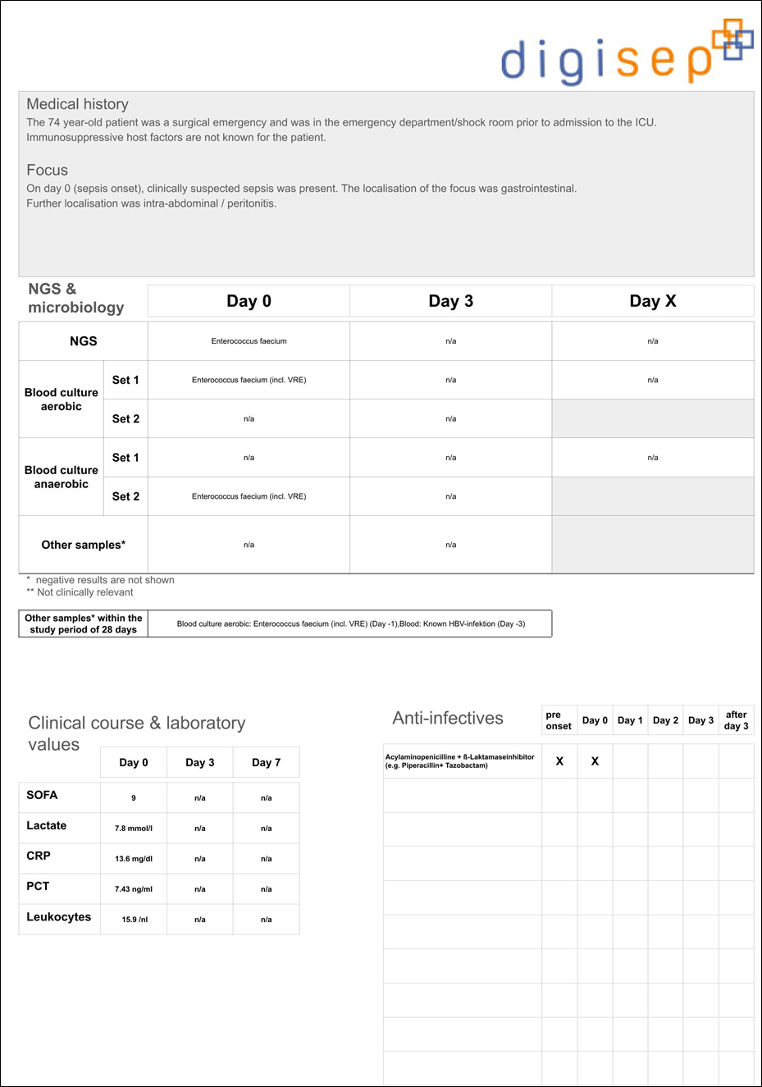

(b) The 39-year-old patient presented here exhibited clinical signs of pneumonia. A nasopharyngeal swab yielded a positive result for influenza B, leading to the calculated initial anti-infective therapy consisting of an acylaminopenicillin + a β-lactamase inhibitor, a macrolide, and a neuraminidase inhibitor being de-escalated to monotherapy with a neuraminidase inhibitor on the first day after the onset of sepsis. mNGS diagnostics also revealed the presence of Streptococcus pyogenes in the blood, which aligns well with the significantly elevated PCT levels. The anti-infective therapy strategy, particularly the early anti-infective de-escalation, must be classified as inadequate in this case. The patient died during the course of the disease. Abbreviations: CMV, cytomegalovirus; CRP, C-reactive protein; ICU, intensive care unit; NA, not applicable; mNGS, metagenomic next-generation sequencing; PCT, procalcitonin; RNA, ribonucleic acid; SOFA, Sequential Organ Failure Assessment.
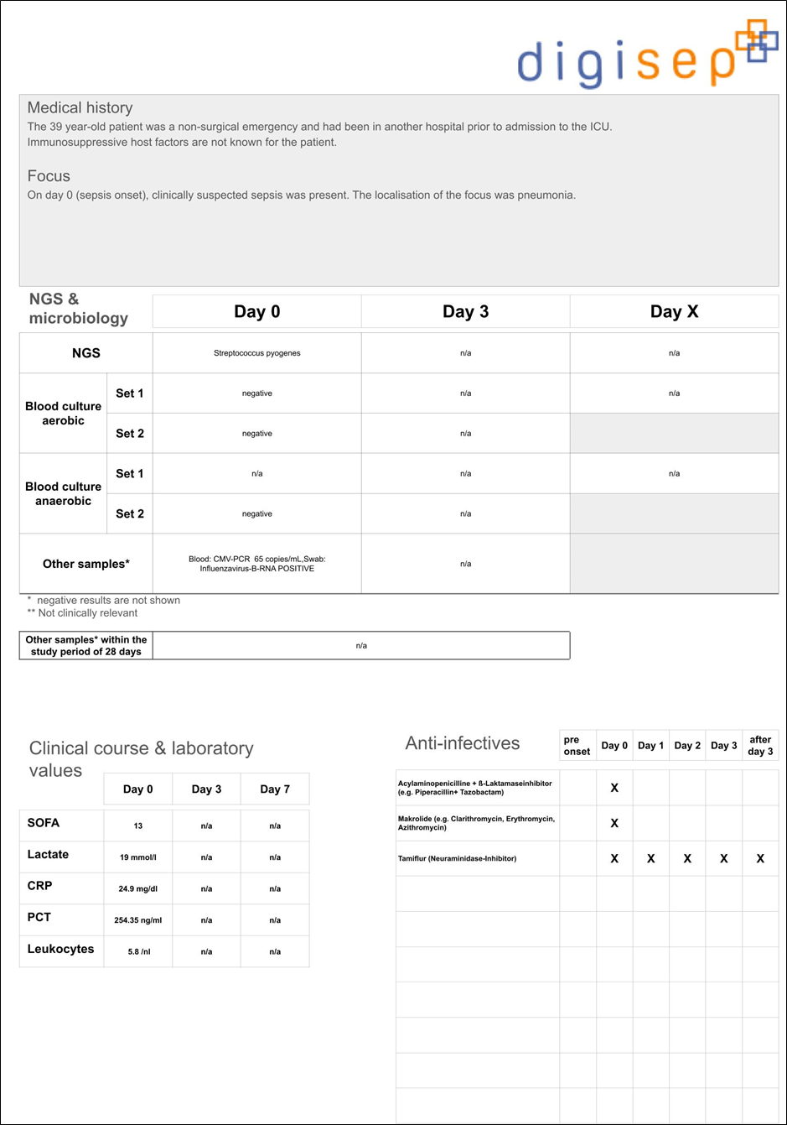

(c) The 78-year-old patient presented here exhibited clinical signs of pneumonia. The cause was identified as an infection with Legionella pneumophila, which was confirmed by the positive detection of Legionella antigen in the urine and positive detection of L. pneumophila cfDNA in the blood using mNGS. The blood culture remained negative at all times. The anti-infective therapy was subsequently de-escalated to a fluoroquinolone based on the identified pathogen. Abbreviations: cfDNA, cell-free DNA; CRP, C-reactive protein; ICU, intensive care unit; NA, not applicable; mNGS, metagenomic next-generation sequencing; PCT, procalcitonin; SOFA, Sequential Organ Failure Assessment.

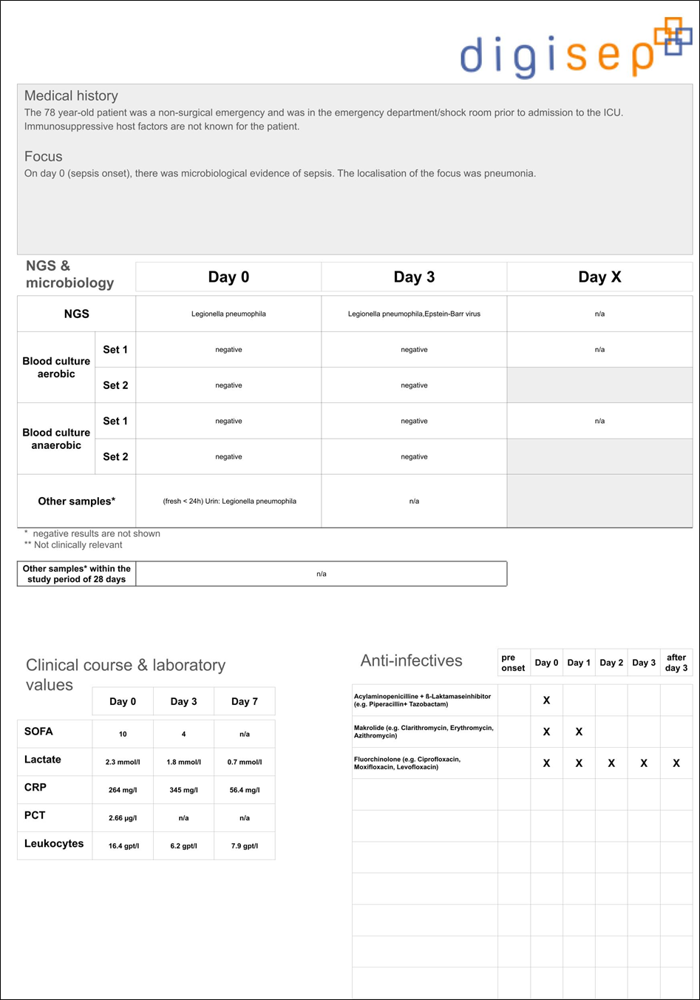

Supplemental Figure S2. Questioning Scheme for the Retrospective Expert Evaluation.
Q1 and Q2 (and, as appropriate, Q2.1 and Q2.2) were asked for each time point (D0, D3, DX) individually; Q3 (and, as appropriate Q3.1) was asked patient wise. Abbreviations: BC, blood culture; D0, day 0 (sepsis onset); D3, day 3 after sepsis onset; DX, variable sampling time point (up to day 14 after the baseline visit); mNGS, metagenomic next-generation sequencing; Q, question.
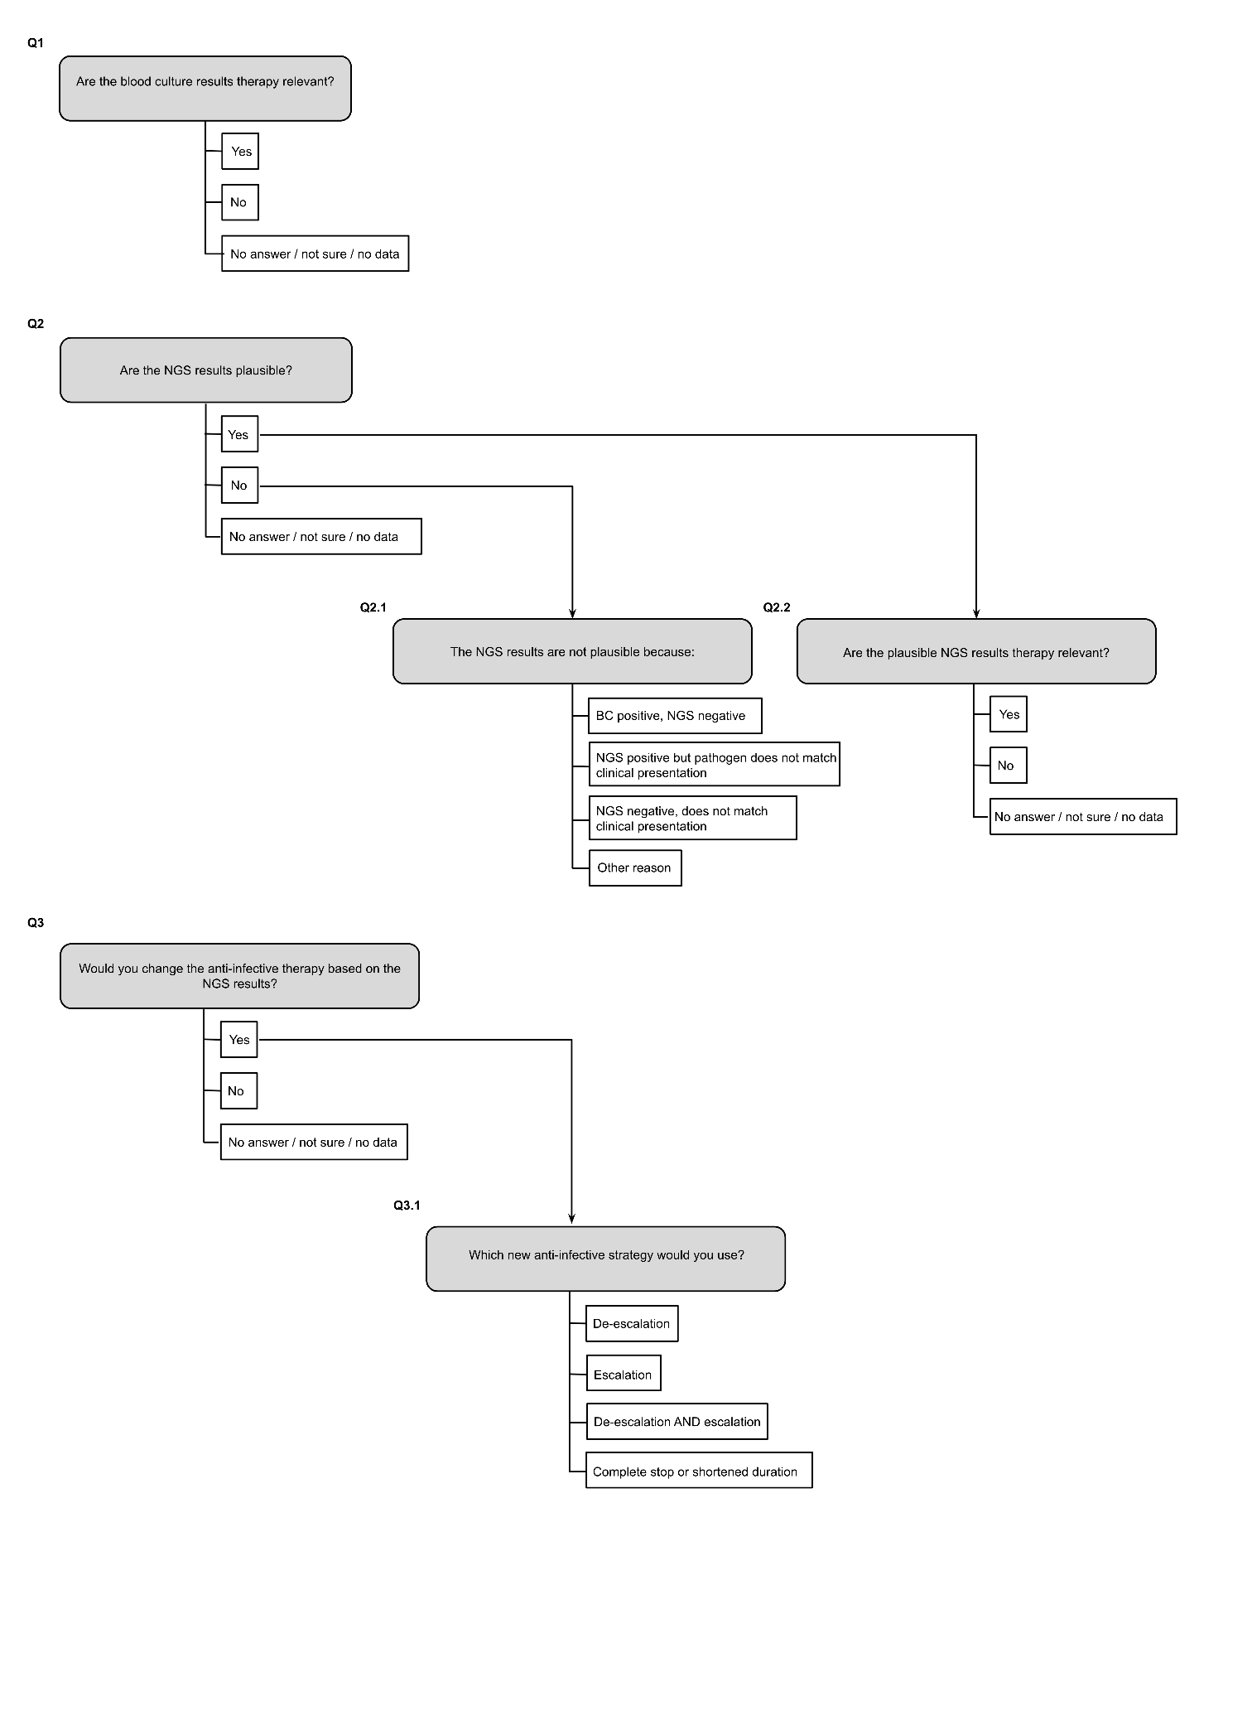

Supplemental Figure S3. HRQoL Assessed Using the EQ-5D-5L Questionnaire.
(a) Presentation of the HRQoL results based on the EQ-5D-5L index for the IG (onset: n = 180; 90d: n = 128; 180d: n = 145) and the CG (onset: n = 170; 90d: n = 127; 180d: n = 139) of the overall patient cohort. Boxplot elements: horizontal line (median EQ-5D-5L index); triangle (mean EQ-5D-5L index); box hinges (25th and 75th percentiles); whiskers (extend to the smallest and largest values within 1.5 times the interquartile range from the hinge); and individual points (outliers). The results suggest that the intervention improved HRQoL in the overall cohort in the short term (90 days), but did not show any long-term effects (180 days). The difference between the IG (mean ± SD 0.312 ± 0.386) and CG (mean ± SD: 0.208 ± 0.373) at 90 days is significant (p = 0.047). (b) Presentation of the HRQoL results based on the EQ-5D-5L VAS for the IG (Onset: n = 177; 90d: n = 68; 180d: n = 52) and the CG (Onset: n = 170; 90d: n = 59; 180d: n = 49) of the overall patient cohort. Boxplot elements: horizontal line (median EQ-5D-5L VAS); triangle (mean EQ-5D-5L VAS); box hinges (25th and 75th percentiles); whiskers (extend to the smallest and largest values within 1.5 times the interquartile range from the hinge); and individual points (outliers). The descriptive results indicate an improvement in the HRQoL from onset to the 180-day follow-up in the IG (mean ± SD: onset: 31.49 ± 23.35; 90d: 53.78 ± 22.74; 180d: 57.35 ± 25.29) and the CG (mean ± SD: onset: 29.91 ± 22.17; 90d: 47.24 ± 24,18; 180d: 55.98 ± 25.06). Group differences are not significant (p > 0.05). Abbreviations: 90d, 90 days; 180d, 180 days; CG, control group; HRQoL, health-related quality of life; IG, intervention group; SD, standard deviation; VAS, Visual Analogue Scale.
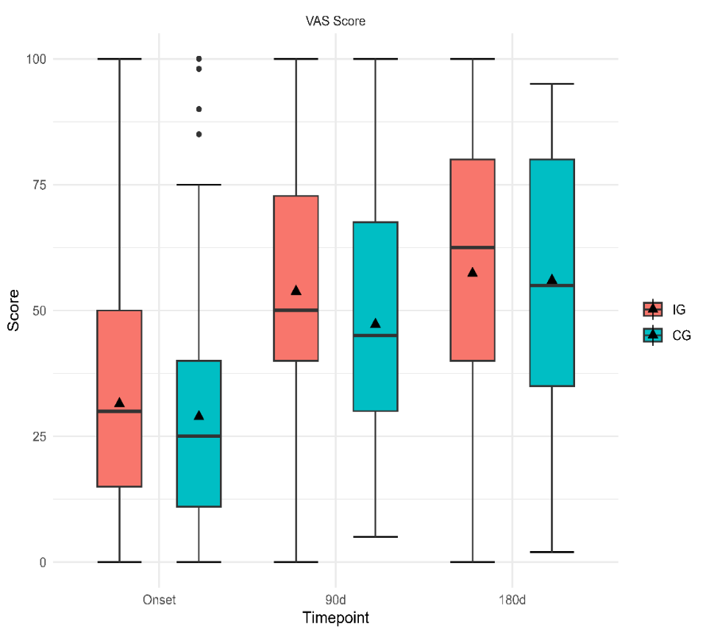
b
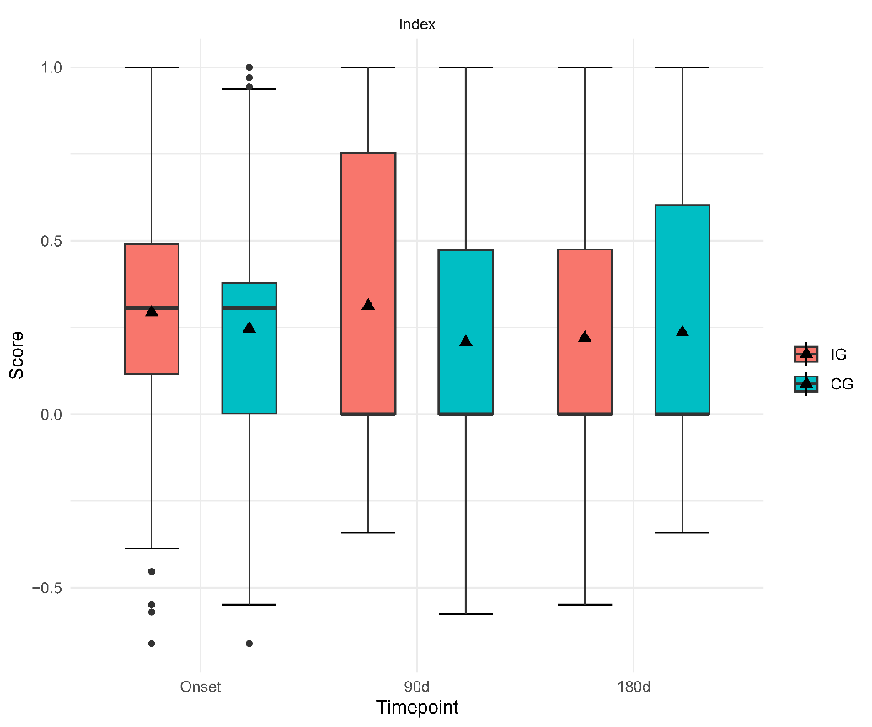
a

Supplemental Figure S4. Reasons for Implausible mNGS Results at D0.
(a) Reasons for implausible negative mNGS results at D0. (b) Reasons for implausible positive mNGS results at D0. Nota bene: In one case (see Supplemental Table S6), a positive mNGS finding (Staphylococcus haemolyticus) was present, but the experts declared it to be a negative finding according to majority rule. Despite the clearly incorrect classification, this case has been retained in the current presentation due to an obvious positive mNGS finding (blue portion of the pie chart). Abbreviations: BC, blood culture; D0, day 0 (sepsis onset); mNGS, metagenomic next-generation sequencing.

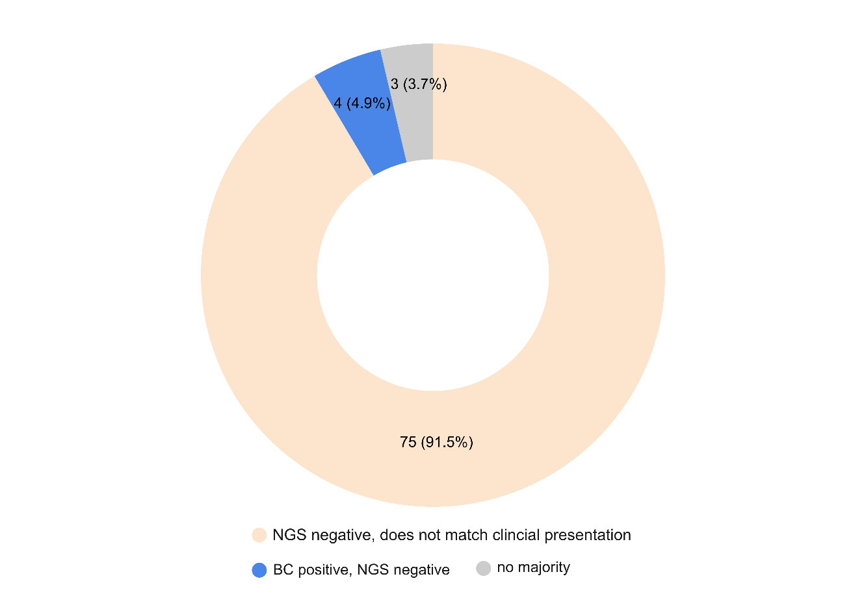
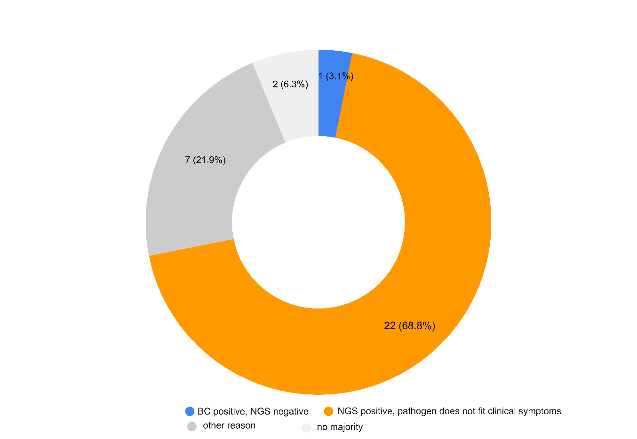
b
a

Supplemental Figure S5. Therapeutic Implications and Outcome Relevance of the mNGS Findings.
(a) Therapeutic consequences of mNGS findings under real study conditions in the IG (blue bar, left) versus retrospective expert recommendation in the CG (orange bar, right). (b) Expert recommendations for the type of therapy change based on mNGS findings in the CG. (c) Survival probabilities by Kaplan–Meier analysis from sepsis onset to day 28 in CG subgroups, where experts retrospectively recommended de-escalation (n = 38), escalation (n = 13), maintenance of existing therapy (n = 128), or where no majority decision was reached (n = 10). (d) Survival probabilities by Kaplan–Meier analysis from sepsis onset to day 180 in the same CG subgroups. Note: To investigate the maximum possible benefit of mNGS diagnostics, data were collected not from the start of recruitment, but rather from January 2023 until the end of the recruitment period using the electronic case report form. These data were intended to determine whether knowledge of the mNGS findings actually led to therapy changes in specific sepsis cases. Accordingly, only the subgroup of IG patients recruited from January 2023 (n = 140) served as the reference for assessing the therapeutic consequences of mNGS findings under real study conditions (see Supplemental Figure S5a). Therapy changes based on mNGS diagnostics in addition to BCs were implemented in only 14.3% of these patients (i.e., 20 of 140 evaluated patients in the IG from January 2023 to the end of recruitment). Abbreviations: AB, antibiotic therapy; BC, blood culture; CG, control group; D0, day 0 (sepsis onset); D3, day 3 after sepsis onset; DX, variable sampling time point (up to day 14 after the baseline visit); IG, intervention group; mNGS, metagenomic next-generation sequencing; pos., positive.
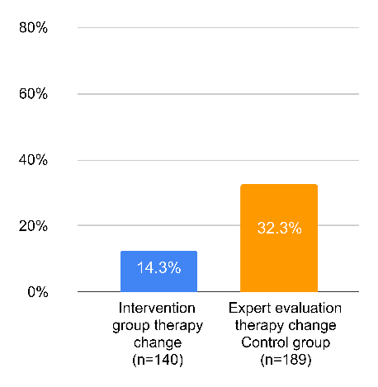
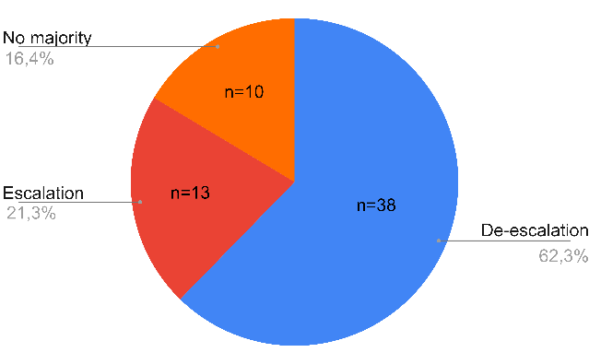
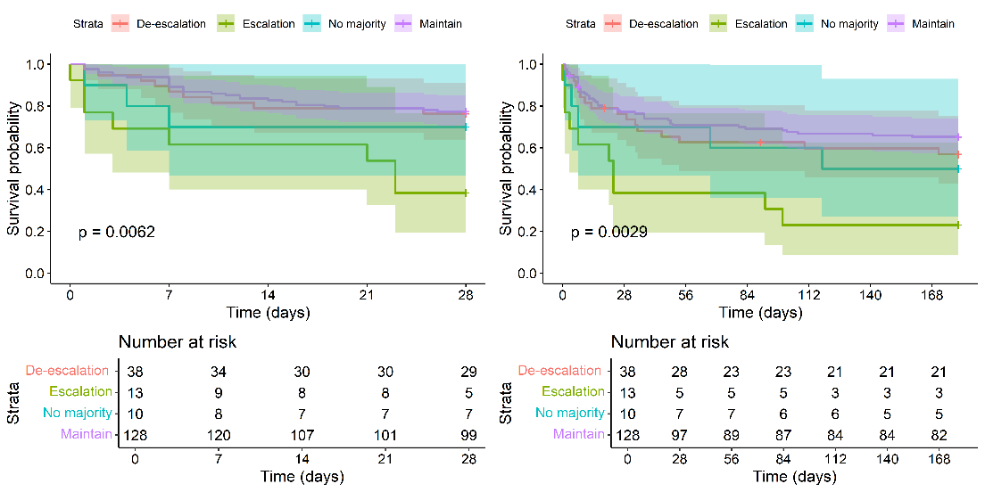
c
a
d
b

Supplemental Figure S6. Short- and Long-Term Survival.
(a) Presentation of the survival probabilities using Kaplan–Meier curves from the time of sepsis onset to day 28 in the subgroups of study patients from the CG, where experts retrospectively recommended either a change in the anti-infective therapy strategy (Yes, n = 61) or maintaining the existing anti-infective therapy unchanged (No, n = 128). (b) Presentation of survival probabilities using Kaplan–Meier curves from the time of sepsis onset to day 180 in the subgroups of study patients from the CG, where experts retrospectively recommended either a change in the anti-infective therapy strategy (Yes, n = 61) or maintaining the existing anti-infective therapy unchanged (No, n = 128). Abbreviations: CG, control group; IG, intervention group.
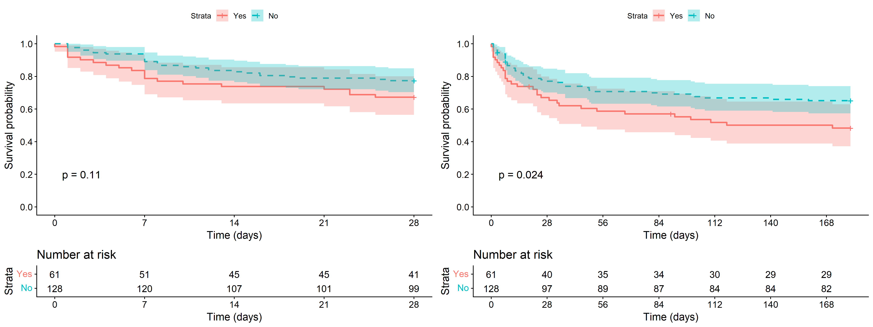
a
b

Supplemental Figure S7. Presentation of three different DISQVER® results (corresponding to the Exemplary Patient Reports for the Retrospective Expert Evaluation presented in Supplemental Figures S1a-c) via the digital communications solution of Noscendo (NOS portal).

(a) The 74-year-old patient suffered from an intra-abdominal focus with peritonitis (see Supplemental Figure S1a). The plasma sample tested positive (i.e. significantly elevated DNA levels) for Enterococcus faecium.

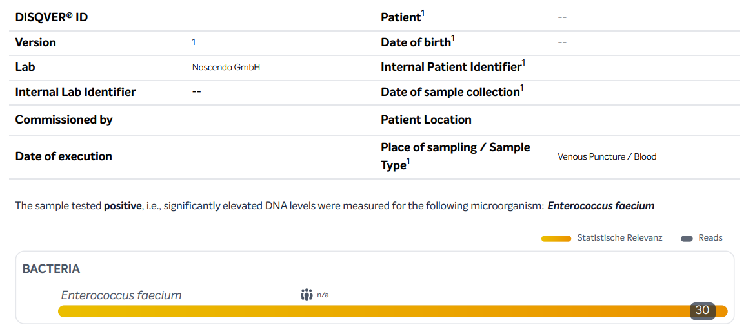

(b) The here presented 39-year-old patient exhibited clinical signs of pneumonia with a positive result for influenza B (see Supplemental Figure S1b). mNGS diagnostics also revealed the presence of Streptococcus pyogenes in the blood.

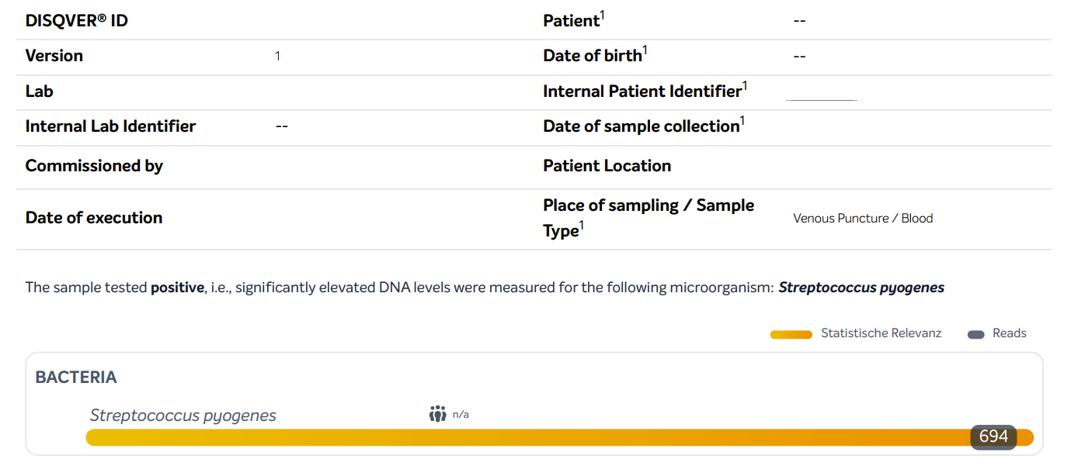

(c) The here presented 78-year-old patient exhibited clinical signs of pneumonia (see Supplemental Figure S1c). The cause was identified as an infection with Legionella pneumophila, which was confirmed by the positive detection of Legionella antigen in the urine and positive detection of L. pneumophila cfDNA in the blood using mNGS.

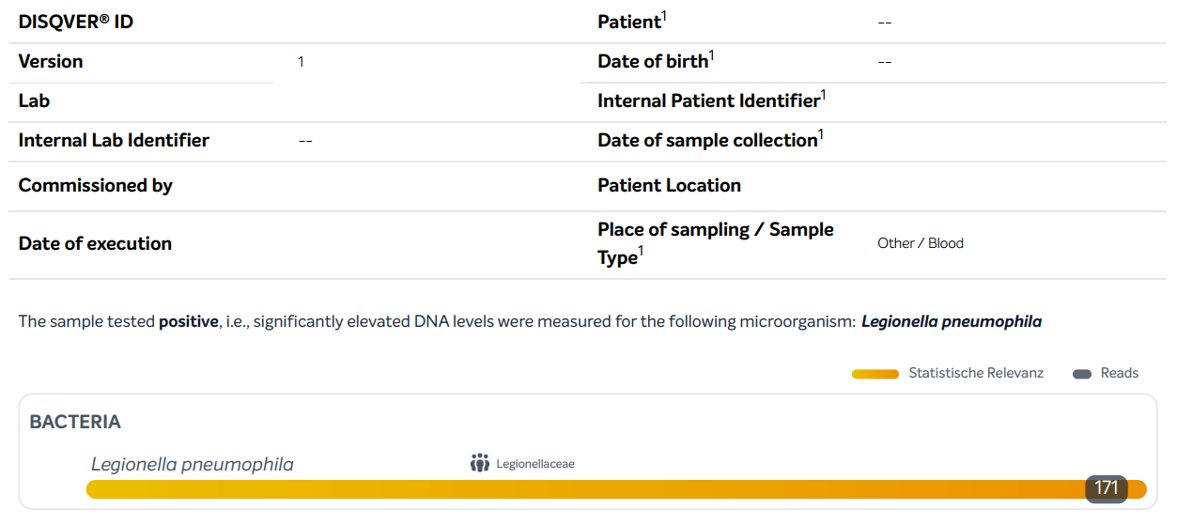

Supplemental Tables
Supplemental Table S1. Primary and Secondary Outcomes of the DigiSep Trial. [3]
Outcomes | Data source | Time point/frame
Primary outcomes
DOOR/RADAR score | eCRF | 28 days
Secondary outcomes
Long-term mortality | eCRF | 90, 180 days
Degree of organ dysfunction/failure:  - Duration of mechanical ventilation  - Length of time until shock resolution  - Ongoing KRT dependency | eCRF | 28, 90, 180 days
Hospital length of stay | eCRF | 28 days
Cumulative need for anti-infective drugs | eCRF | 28, 90, 180 days*
Beginning of a targeted anti-infective treatment regimen | eCRF | 28, 90, 180 days*
Direct medical costs (outpatient and inpatient) | Claims data | Over a period of 180 days
Quality of life | EQ-5D-5L | Baseline, 90, 180 days
*Data were collected and analyzed for all the aforementioned time points but are only reported for 28 days for reasons of plausibility.
Abbreviations: DOOR/RADAR, Desirability of Outcome Ranking/Response Adjusted for Duration of Antibiotic Risk; eCRF, electronic case report form; KRT, kidney replacement therapy; QoL.

Supplemental Table S2. Subgroup Analyses for the DOOR-RADAR Score.
 | IG | CG | Treatment effect  [95% CI] | p value
Septic shock
Neither at onset, nor 3 days later | 2.83 ± 1.50  (n = 39) | 3.15 ± 1.56  (n = 28) | –0.32 [–1.12, 0.48]* | 0.564
Only at onset of sepsis | 2.47 ± 1.35  (n = 60) | 2.86 ± 1.49  (n = 54) | –0.39 [–0.93, 0.15]* | 0.158
Only at three days after onset | 3.43 ± 1.83  (n = 7) | 3.05 ± 1.68  (n = 10) | 0.38 [–1.67, 2.42]* | 0.448
At onset as well as three days later | 3.70 ± 1.36  (n = 71) | 3.89 ± 1.28  (n = 84) | –0.19 [–0.62, 0.23]* | 0.415
Site of infection
Pulmonary/upper or lower airway tract/thoracic | 3.61 ± 1.46  (n = 78) | 3.67 ± 1.45  (n = 79) | –0.06 [–0.52, 0.40]* | 0.859
Intra-abdominal/biliary/gastrointestinal tract | 3.28 ± 1.55  (n = 55) | 3.48 ± 1.49  (n = 46) | –0.2 [–0.81, 0.42]* | 0.777
Primary bacteremia/catheter site | 3.79 ± 1.35  (n = 11) | 2.82 ± 1.69  (n = 7) | 0.97 [–0.69, 2.64]* | 0.213
Bone, joint, and soft tissue/surgical site infections | 3.51 ± 1.35  (n = 28) | 3.72 ± 1.46  (n = 18) | –0.21 [–1.11, 0.69]* | 0.438
Central nervous system | 4.31 ± 0.60  (n = 3) | 5.00  (n = 1) | n.a. | 0.617
Cardiovascular | 3.00 ± 1.61  (n = 5) | 1.34  (n = 1) | n.a. | 0.373
Genitourinary tract | 2.50 ± 1.53  (n = 34) | 2.96 ± 1.67  (n = 22) | –0.46 [–1.35, 0.44]* | 0.274
Others | 2.92 ± 1.79  (n = 4) | 4.21 ± 0.92  (n = 4) | –1.29 [–3.96, 1.39]* | 0.460
Source of infection
Outpatient | 3.22 ± 1.59  (n = 119) | 3.49 ± 1.52  (n = 110) | –0.27 [–0.68, 0.14]* | 0.343
Nosocomial | 3.21 ± 1.48  (n = 81) | 3.49 ± 1.49  (n = 79) | –0.28 [–0.75, 0.18]* | 0.338
Immunosuppression | 3.61 ± 1.54  (n = 16) | 4.25 ± 1.09  (n = 17) | –0.64 [–1.61, 0.33]* | 0.380
CCI, points
> 4 | 3.46 ± 1.56  (n = 32) | 3.97 ± 1.29  (n = 28) | –0.51 [–1.25, 0.22]* | 0.277
≤ 4 | 3.17 ± 1.53  (n = 168) | 3.40 ± 1.53  (n = 161) | –0.23 [–0.57, 0.10]* | 0.260
SOFA, points
Non-GCS SOFA > median | 3.79 ± 1.48  (n = 87) | 3.98 ± 1.38  (n = 83) | –0.19 [–0.66, 0.28]* | 0.878
Non-GCS SOFA ≤ median | 2.82 ± 1.43  (n = 113) | 3.16 ± 1.54  (n = 106) | –0.34 [–0.78, 0.11]* | 0.095
BC positivity (at least one positive BC result)
No | 2.65 ± 1.68  (n = 33) | 3.35 ± 1.51  (n = 20) | –0.7 [–1.60, 0.21]* | 0.207
Yes | 3.32 ± 1.49  (n = 167) | 3.51 ± 1.51  (n = 169) | –0.19 [–0.51, 0.14]* | 0.368
Probability of infection
Suspected | 3.12 ± 1.56  (n = 173) | 3.48 ± 1.52  (n = 157) | –0.36 [–0.70, –0.02]* | 0.098
Proven | 3.83 ± 1.23  (n = 27) | 3.53 ± 1.47  (n = 32) | 0.3 [–0.42, 1.02]* | 0.700
Source control measures
No | 3.51 ± 1.54  (n = 96) | 3.54 ± 1.49  (n = 101) | –0.03 [–0.45, 0.40]* | 0.820
Yes | 2.93 ± 1.49  (n = 102) | 3.43 ± 1.53  (n = 88) | –0.5 [–0.94, –0.06]* | 0.030
Surgical | 3.03 ± 1.47  (n = 72) | 3.37 ± 1.54  (n = 66) | –0.34 [–0.86, 0.18]* | 0.176
Interventional | 2.66 ± 1.46  (n = 25) | 3.35 ± 1.59  (n = 18) | –0.69 [–1.66, 0.27]* | 0.240
Catheter removal | 2.73 ± 1.62  (n = 14) | 4.19 ± 1.1  (n = 12) | –1.46 [–2.57, –0.34]* | 0.028
Data are presented as mean ± standard deviation (SD). *based on a t-distribution.
Abbreviations: BC, blood culture; CCI, Charlson Comorbidity Index; CG, control group; CI, confidence interval; DOOR-RADAR, Desirability of Outcome Ranking/Response Adjusted for Duration of Antibiotic Risk; GCS, Glasgow Coma Scale; IG, intervention group; n.a., not applicable; SOFA, Sequential Organ Failure Assessment Score.

Supplemental Table S3a. Healthcare Costs by Service Areas.
 | IG | CG | IG |  | CG |  | p valueª
 | n (%) | n (%) | Mean ± SD [€] | Median (IQR) [€] | Mean ± SD [€] | Median (IQR) [€] | p valueª
Outpatient care | 74 (57.81) | 54 (42.19) | 395.65 ± 641.79 | 162.76 (459.26) | 336.57 ± 452.52 | 129.48 (503.15) | 0.759
Inpatient care | 75 (58.27) | 53 (41.73) | 74 995.07 ± 74 565.08 | 47 116.45 (80 333.74) | 74 011.30 ± 77 049.74 | 39 509.87 (81 550.22) | 0.786
Pharmaceuticals | 74 (57.81) | 54 (42.19) | 1 850.17 ± 5 900.88 | 314.16 (1 347.64) | 1 995.00 ± 5 160.45 | 453.01 (1 965.53) | 0.741
Others^{b} | 74 (57.81) | 54 (42.19) | 12 132.97 ± 25 796.40 | 6 776.05 (15 448.38) | 16 875.22 ± 63 311.76 | 2 069.33 (11 424.68) | 0.064
Total project costs (per patient, excluding mNGS-based intervention costs)
Total costs | 74 (57.81) | 54 (42.19) | 96 719.22 ± 104 559.40 | 59 503.06 (95 109.13) | 99 196.95 ± 111 391.80 | 57 865.41 (109 062.20) | 0.883
Total project costs (per patient, including mNGS-based intervention costs)^{c}
Total costs | 74 (57.81) | 54 (42.19) | 98 717.64 ± 104 559.40 | 62 502.27 (95 109.13) | 99 920.35 ± 111 391.80 | 58 588.81 (109 062.20) | 0.726
Total costs for possible standard care (per patient, including mNGS-based intervention costs)^{d}
Total costs | 74 (57.81) | 54 (42.19) | 98 218.43 ± 104 559.40 | 61 003.06 (95 109.13) | 99 196.95 ± 111 391.80 | 57 865.41 (109 062.20) | 0.776
Claims data from statutory health insurance providers were available for 129 patients (IG: n = 75; CG: n = 54), representing a subgroup that was broadly comparable to the overall study cohort (data not shown). The baseline characteristics and primary and secondary outcomes did not differ significantly between the IG and CG in this subgroup.
ªComparison of median values using the Mann–Whitney U test. ^{b}Includes therapeutic devices, non-physician specialist care, rehabilitation, sick pay, nursing (home) care, and transportation. ^{c}Calculation basis for total project costs per patient: IG – time-critical mNGS-based diagnostics were performed twice, accounting for 2 × 1 499.21 € = 2 998.42 € per patient; CG – non-time-critical mNGS diagnostics were performed only once, after study completion, for retrospective expert panel evaluation, accounting for 723.40 € per patient. ^{d}Calculation basis for total costs for possible standard care per patient: IG – time-critical mNGS-based diagnostics would be performed once at sepsis onset, accounting for 1 × 1 499.21 € per patient; CG – no mNGS diagnostics would be performed, so no additional costs were calculated.
Abbreviations: CG, control group; IG, interventional group; IQR, interquartile range; mNGS, metagenomic next-generation sequencing; SD, standard deviation

Supplemental Table S3b. Patient Characteristics at Baseline and Primary and Secondary Outcomes by Cohort (No-Cost vs. Cost Data Available).

Characteristic | No-Cost Data  (n = 260) | Cost Data  (n=129) | p-value§
Age, years | 64.8 ± 14.9 | 62.9 ± 15.1 | 0.244
Male sex | 165 (63.5) | 73 (56.6) | 0.190
Body mass index, kg/m² | 28.5 ± 7.3 | 28.1 ± 6.9 | 0.524
Charlson Comorbidity Index, points | 2.4 ± 2.1 | 2.3 ± 2.3 | 0.741
Immunosuppression
Neutropenia | 5 (1.9) | 1 (0.8) | 0.394
Stem cell transplantation | 2 (0.8) | 0 (0.0) | 0.285
Intake of corticosteroids | 8 (3.1) | 6 (4.7) | 0.680
T cell immunosuppression | 12 (4.6) | 6 (4.7) | 0.941
Immunodeficiency | 3 (1.2) | 0 (0.0) | 0.472
Septic shock | 204 (78.5) | 96 (74.4) | 0.371
Sequential Organ Failure Assessment score, points | 8.7 ± 2.6 | 8.6 ± 2.9 | 0.878
Laboratory data
Lactate, mg/dL | 26.3 ± 26.0 | 27.4 ± 31.9 | 0.723
C-reactive protein, mg/dL | 22.6 ± 30.0 | 16.8 ± 10.6 | 0.009
Procalcitonin, ng/mL | 30.6 ± 51.8 | 39.0 ± 92.5 | 0.392
Leukocyte count, 10³/µL | 16.8 ± 10.8 | 15.2 ± 10.3 | 0.178
Source of infection
Outpatient | 150 (57.7) | 79 (61.2) | 0.503
Nosocomial | 110 (42.3) | 50 (38.8) | 0.503
Site of infection
Pulmonary/upper or lower airway tract/thoracic | 104 (40.0) | 53 (41.1) | 0.837
Intra-abdominal/biliary/gastrointestinal tract | 74 (28.5) | 27 (20.9) | 0.111
Primary bacteremia/catheter site | 12 (4.6) | 6 (4.7) | 0.987
Bone, joint, and soft tissue/surgical site infections | 24 (9.2) | 22 (17.1) | 0.024
Central nervous system | 2 (0.8) | 2 (1.6) | 0.450
Cardiovascular | 5 (1.9) | 1 (0.8) | 0.405
Genitourinary tract | 38 (14.6) | 18 (14.0) | 0.962
Others | 5 (1.9) | 3 (2.3) | 0.756
Source control measures
Total | 130 (50.2) | 60 (46.9) | 0.539
Surgical | 94 (36.3) | 44 (34.4) | 0.711
Interventional | 16 (6.2) | 10 (7.8) | 0.546
Catheter removal | 31 (12.0) | 12 (9.4) | 0.445
Primary outcome
DOOR/RADAR score, points | 3.33 ± 1.58 | 3.39 ± 1.43 | 0.691
Secondary outcomes by day 28
Duration of mechanical ventilation
Relative# | 0.39 ± 0.41 | 0.42 ± 0.43 | 0.456
Absolute, days## | 7.58 ± 9.79 | 8.52 ± 10.60 | 0.468
Composite, days### | 13.00 ± 12.35 | 12.55 ± 12.39 | 0.736
Time to shock resolution
Relative# | 0.43 ± 0.37 | 0.41 ± 0.39 | 0.717
Absolute, days## | 7.97 ± 7.96 | 7.39 ± 7.97 | 0.560
Composite, days### | 13.31 ± 11.21 | 11.72 ± 11.09 | 0.186
Duration of kidney replacement therapy
Relative# | 0.18 ± 0.34 | 0.14 ± 0.31 | 0.304
Absolute, days## | 3.40 ± 7.70 | 3.18 ± 7.83 | 0.823
Composite, days### | 9.98 ± 12.76 | 8.50 ± 12.37 | 0.270
Duration of anti-infective treatment
Relative# | 0.63 ± 0.31 | 0.63 ± 0.32 | 0.959
Absolute, days## | 15.05 ± 7.99 | 15.17 ± 8.43 | 0.908
Composite, days### | 18.46 ± 8.96 | 17.67 ± 9.33 | 0.428
Length of intensive care unit stay, days$ | 13 [11, 16] | 16 [13, 23] | 0.240
Discharge from intensive care unit, CIF∞ | 0.59 [0.53, 0.65] | 0.54 [0.45, 0.62] | 0.363
Length of hospital stay, days$ | 17 [15, 22] | 23 [17, N.A.] | 0.165
Discharge from hospital, CIF ∞ | 0.39 [0.33, 0.45] | 0.37 [0.28, 0.45] | 0.554
The data are presented as the mean ± standard deviation or n (%), for survival endpoints, median survival with 95% log-transformed Confidence Intervals. #Relative times reported refer to the respective durations (for the respective parameter, in days up to day 28) in relation to the respective survival times (also given in days up to day 28). ##The absolute time spans include the respective durations up to day 28 (ventilation duration, shock duration, renal replacement therapy duration, duration of antimicrobial therapy) for all patients having survived at least 28 days. ###The composite method includes the corresponding durations of all patients in days and sets the respective value for patients not having survived up to day 28 to the highest possible value, which is 28 days. $Data were analysed via Kaplan-Meier analysis. The event of interest is defined as leaving the hospital or being transferred from the intensive care unit, respectively, while treating death as censoring. A p-value of the corresponding log-rank test is reported. An N.A. value for the log-transformed confidence interval indicates that the survival function did not reach the bound in question. §Welch Two Sample t-Test; Pearson´s Chi-squared test ∞Data were analysed using a competing-risk analysis with the event of interest being discharge and the competing event being death. Estimates of the cumulative incidence functions (CIF) at 28 days are provided together their corresponding 95%-log-log transformed confidence intervals and Gray’s Test for equivalence of CIF.
Abbreviations: DOOR/RADAR, Desirability of Outcome Ranking/Response Adjusted for Duration of Antibiotic Risk; N.A., not available.

Supplemental Table S4. Negative mNGS Findings Assessed as Implausible at D0, Including Justifications.
The decision regarding whether the mNGS results should be considered plausible or implausible was made by the expert panel based on majority rule. For transparency reasons, the corresponding blood culture findings related to the negative mNGS results are also included in the table.

Study ID | mNGS D0  result | BC D0  result | mNGS D0  plausibility – majority vote | mNGS D0  plausibility reason – majority vote
# | Negative | Negative | Not plausible | mNGS negative, does not match clinical presentation
# | Negative | Negative | Not plausible | mNGS negative, does not match clinical presentation
# | Negative | Escherichia coli | Not plausible | BC positive, mNGS negative
# | Negative | Staphylococcus hominis | Not plausible | mNGS negative, does not match clinical presentation
# | Negative | Escherichia coli, Staphylococcus aureus | Not plausible | BC positive, mNGS negative
# | Negative | Negative | Not plausible | mNGS negative, does not match clinical presentation
# | Negative | Negative | Not plausible | mNGS negative, does not match clinical presentation
# | Negative | Negative | Not plausible | mNGS negative, does not match clinical presentation
# | Negative | Negative | Not plausible | mNGS negative, does not match clinical presentation
# | Negative | Negative | Not plausible | mNGS negative, does not match clinical presentation
# | Negative | Negative | Not plausible | mNGS negative, does not match clinical presentation
# | Negative | Negative | Not plausible | mNGS negative, does not match clinical presentation
# | Negative | Negative | Not plausible | mNGS negative, does not match clinical presentation
# | Negative | Negative | Not plausible | mNGS negative, does not match clinical presentation
# | Negative | Negative | Not plausible | mNGS negative, does not match clinical presentation
# | Negative | Negative | Not plausible | mNGS negative, does not match clinical presentation
# | Negative | Negative | Not plausible | mNGS negative, does not match clinical presentation
# | Negative | Negative | Not plausible | mNGS negative, does not match clinical presentation
# | Negative | Negative | Not plausible | mNGS negative, does not match clinical presentation
# | Negative | Negative | Not plausible | mNGS negative, does not match clinical presentation
# | Negative | Negative | Not plausible | mNGS negative, does not match clinical presentation
# | Negative | Negative | Not plausible | mNGS negative, does not match clinical presentation
# | Negative | Negative | Not plausible | mNGS negative, does not match clinical presentation
# | Negative | Negative | Not plausible | mNGS negative, does not match clinical presentation
# | Negative | Negative | Not plausible | mNGS negative, does not match clinical presentation
# | Negative | Negative | Not plausible | mNGS negative, does not match clinical presentation
# | Negative | Negative | Not plausible | mNGS negative, does not match clinical presentation
# | Negative | Negative | Not plausible | mNGS negative, does not match clinical presentation
# | Negative | Negative | Not plausible | mNGS negative, does not match clinical presentation
# | Negative | Negative | Not plausible | mNGS negative, does not match clinical presentation
# | Negative | Staphylococcus aureus | Not plausible | BC positive, mNGS negative
# | Negative | Negative | Not plausible | mNGS negative, does not match clinical presentation
# | Negative | Negative | Not plausible | mNGS negative, does not match clinical presentation
# | Negative | Negative | Not plausible | mNGS negative, does not match clinical presentation
# | Negative | Negative | Not plausible | mNGS negative, does not match clinical presentation
# | Negative | Negative | Not plausible | mNGS negative, does not match clinical presentation
# | Negative | Negative | Not plausible | mNGS negative, does not match clinical presentation
# | Negative | Negative | Not plausible | mNGS negative, does not match clinical presentation
# | Negative | Negative | Not plausible | mNGS negative, does not match clinical presentation
# | Negative | Negative | Not plausible | mNGS negative, does not match clinical presentation
# | Negative | Staphylococcus epidermidis | Not plausible | mNGS negative, does not match clinical presentation
# | Negative | Negative | Not plausible | mNGS negative, does not match clinical presentation
# | Negative | Negative | Not plausible | mNGS negative, does not match clinical presentation
# | Negative | Negative | Not plausible | mNGS negative, does not match clinical presentation
# | Negative | Negative | Not plausible | mNGS negative, does not match clinical presentation
# | Negative | Negative | Not plausible | mNGS negative, does not match clinical presentation
# | Negative | Negative | Not plausible | mNGS negative, does not match clinical presentation
# | Negative | Negative | Not plausible | mNGS negative, does not match clinical presentation
# | Negative | Negative | Not plausible | mNGS negative, does not match clinical presentation
# | Negative | Negative | Not plausible | mNGS negative, does not match clinical presentation
# | Negative | Negative | Not plausible | mNGS negative, does not match clinical presentation
# | Negative | Negative | Not plausible | No majority
# | Negative | Negative | Not plausible | mNGS negative, does not match clinical presentation
# | Negative | Negative | Not plausible | mNGS negative, does not match clinical presentation
# | Negative | Negative | Not plausible | mNGS negative, does not match clinical presentation
# | Negative | Negative | Not plausible | No majority
# | Negative | Negative | Not plausible | mNGS negative, does not match clinical presentation
# | Negative | Negative | Not plausible | mNGS negative, does not match clinical presentation
# | Negative | Escherichia coli | Not plausible | BC positive, mNGS negative
# | Negative | Negative | Not plausible | mNGS negative, does not match clinical presentation
# | Negative | Negative | Not plausible | mNGS negative, does not match clinical presentation
# | Negative | Negative | Not plausible | No majority
# | Negative | Negative | Not plausible | mNGS negative, does not match clinical presentation
# | Negative | Negative | Not plausible | mNGS negative, does not match clinical presentation
# | Negative | Negative | Not plausible | mNGS negative, does not match clinical presentation
# | Negative | Negative | Not plausible | mNGS negative, does not match clinical presentation
# | Negative | Negative | Not plausible | mNGS negative, does not match clinical presentation
# | Negative | Negative | Not plausible | mNGS negative, does not match clinical presentation
# | Negative | Negative | Not plausible | mNGS negative, does not match clinical presentation
# | Negative | Negative | Not plausible | mNGS negative, does not match clinical presentation
# | Negative | Negative | Not plausible | mNGS negative, does not match clinical presentation
# | Negative | Negative | Not plausible | mNGS negative, does not match clinical presentation
# | Negative | Negative | Not plausible | mNGS negative, does not match clinical presentation
# | Negative | Negative | Not plausible | mNGS negative, does not match clinical presentation
# | Negative | Negative | Not plausible | mNGS negative, does not match clinical presentation
# | Negative | Negative | Not plausible | mNGS negative, does not match clinical presentation
# | Negative | Negative | Not plausible | mNGS negative, does not match clinical presentation
# | Negative | Negative | Not plausible | mNGS negative, does not match clinical presentation
# | Negative | Negative | Not plausible | mNGS negative, does not match clinical presentation
# | Negative | Negative | Not plausible | mNGS negative, does not match clinical presentation
# | Negative | Negative | Not plausible | mNGS negative, does not match clinical presentation
# | Negative | Negative | Not plausible | mNGS negative, does not match clinical presentation
Abbreviations: BC, blood culture; D0, day 0 (sepsis onset); mNGS, metagenomic next-generation sequencing.

Supplemental Table S5. Negative mNGS Findings Assessed as Plausible on D3.
For transparency reasons, the corresponding BC findings related to the negative mNGS results are also included in the table.

Study ID | mNGS D3  result | BC D3  result | mNGS D3  plausibility – majority vote
# | Negative | Negative | Plausible
# | Negative | n.a. | Plausible
# | Negative | Negative | Plausible
# | Negative | Negative | Plausible
# | Negative | Negative | Plausible
# | Negative | Negative | Plausible
# | Negative | Negative | Plausible
# | Negative | Negative | Plausible
# | Negative | Negative | Plausible
# | Negative | Negative | Plausible
# | Negative | Negative | Plausible
# | Negative | Negative | Plausible
# | Negative | Negative | Plausible
# | Negative | n.a. | Plausible
# | Negative | Negative | Plausible
# | Negative | Negative | Plausible
# | Negative | Negative | Plausible
# | Negative | Staphylococcus epidermidis | Plausible
# | Negative | Negative | Plausible
# | Negative | Negative | Plausible
# | Negative | Negative | Plausible
# | Negative | Negative | Plausible
# | Negative | Negative | Plausible
# | Negative | Negative | Plausible
# | Negative | Negative | Plausible
# | Negative | Negative | Plausible
# | Negative | Negative | Plausible
# | Negative | Negative | Plausible
# | Negative | Negative | Plausible
# | Negative | Negative | Plausible
# | Negative | n.a. | Plausible
# | Negative | Negative | Plausible
# | Negative | Negative | Plausible
# | Negative | Negative | Plausible
# | Negative | Negative | Plausible
# | Negative | Negative | Plausible
# | Negative | Negative | Plausible
# | Negative | Negative | Plausible
# | Negative | Negative | Plausible
# | Negative | Negative | Plausible
# | Negative | Negative | Plausible
# | Negative | Negative | Plausible
# | Negative | Negative | Plausible
# | Negative | Negative | Plausible
# | Negative | Negative | Plausible
# | Negative | Negative | Plausible
# | Negative | Negative | Plausible
# | Negative | n.a. | Plausible
# | Negative | Negative | Plausible
# | Negative | Negative | Plausible
# | Negative | Negative | Plausible
# | Negative | Negative | Plausible
# | Negative | Negative | Plausible
# | Negative | Negative | Plausible
# | Negative | Negative | Plausible
# | Negative | Negative | Plausible
# | Negative | Negative | Plausible
# | Negative | Negative | Plausible
# | Negative | Negative | Plausible
# | Negative | Negative | Plausible
# | Negative | Negative | Plausible
# | Negative | Negative | Plausible
# | Negative | Negative | Plausible
# | Negative | n.a. | Plausible
# | Negative | Negative | Plausible
# | Negative | Negative | Plausible
# | Negative | Negative | Plausible
# | Negative | Negative | Plausible
# | Negative | Negative | Plausible
# | Negative | n.a. | Plausible
# | Negative | Negative | Plausible
# | Negative | Negative | Plausible
# | Negative | Negative | Plausible
# | Negative | Negative | Plausible
# | Negative | Negative | Plausible
# | Negative | Negative | Plausible
# | Negative | Negative | Plausible
# | Negative | Negative | Plausible
# | Negative | Negative | Plausible
# | Negative | Negative | Plausible
# | Negative | Negative | Plausible
# | Negative | Negative | Plausible
# | Negative | Negative | Plausible
# | Negative | Negative | Plausible
# | Negative | Negative | Plausible
# | Negative | Negative | Plausible
# | Negative | n.a. | Plausible
# | Negative | Negative | Plausible
# | Negative | Negative | Plausible
# | Negative | Negative | Plausible
# | Negative | Negative | Plausible
# | Negative | Negative | Plausible
# | Negative | Negative | Plausible
# | Negative | Negative | Plausible
# | Negative | Negative | Plausible
# | Negative | Negative | Plausible
# | Negative | Negative | Plausible
# | Negative | Negative | Plausible
# | Negative | Negative | Plausible
# | Negative | Negative | Plausible
# | Negative | n.a. | Plausible
# | Negative | Negative | Plausible
# | Negative | Negative | Plausible
# | Negative | Negative | Plausible
# | Negative | Negative | Plausible
# | Negative | Negative | Plausible
# | Negative | Negative | Plausible
# | Negative | Negative | Plausible
# | Negative | Negative | Plausible
# | Negative | Negative | Plausible
# | Negative | Negative | Plausible
# | Negative | Negative | Plausible
# | Negative | Negative | Plausible
# | Negative | Negative | Plausible
# | Negative | Negative | Plausible
# | Negative | Negative | Plausible
# | Negative | Negative | Plausible
# | Negative | Negative | Plausible
# | Negative | Negative | Plausible
# | Negative | Negative | Plausible
# | Negative | Negative | Plausible
# | Negative | Negative | Plausible
# | Negative | Negative | Plausible
# | Negative | n.a. | Plausible
# | Negative | n.a. | Plausible
# | Negative | Negative | Plausible
# | Negative | Negative | Plausible
# | Negative | Negative | Plausible
# | Negative | Negative | Plausible
# | Negative | Negative | Plausible
# | Negative | Negative | Plausible
# | Negative | Negative | Plausible
# | Negative | Negative | Plausible
# | Negative | Negative | Plausible
# | Negative | Negative | Plausible
# | Negative | Negative | Plausible
# | Negative | Negative | Plausible
# | Negative | Negative | Plausible
Abbreviations: BC, blood culture; D0, day 0 (sepsis onset); D3, day 3 after sepsis onset; mNGS, metagenomic next-generation sequencing; n.a., not applicable.

Supplemental Table S6. Positive mNGS Findings Assessed as Implausible at D0, Including Justifications.
The decision regarding whether the mNGS results should be considered plausible or implausible was made by the expert panel based on majority rule. For transparency reasons, the corresponding blood culture findings related to the positive mNGS results are also included in the table.

Study ID | mNGS D0  result | BC D0  result | mNGS D0 result type | mNGS D0  plausibility – majority vote | mNGS D0  plausibility reason – majority vote
# | Betapapillomavirus 3 | Negative | Monoviral | Not plausible | mNGS positive but pathogen does not match clinical presentation
# | Bacteroides fragilis | Escherichia coli | Monobacterial | Not plausible | Other reason
# | Enterococcus faecium, Escherichia coli, Morganella morganii | Enterobacter cloacae | Polybacterial | Not plausible | Other reason
# | Epstein-Barr virus | Negative | Monoviral | Not plausible | mNGS positive but pathogen does not match clinical presentation
# | Fusobacterium nucleatum, Pseudomonas aeruginosa, Streptococcus spp., Propionimicrobium lymphophilum, Enterococcus faecalis, Campylobacter ureolyticus | Staphylococcus aureus, Pseudomonas aeruginosa | Polybacterial | Not plausible | Other reason
# | Enterobacter spp., Chryseobacterium indologenes, Acinetobacter ursingii | Klebsiella variicola, Enterobacter cloacae | Polybacterial | Not plausible | Other reason
# | Epstein–Barr virus | Negative | Monoviral | Not plausible | mNGS positive but pathogen does not match clinical presentation
# | Epstein-Barr virus, Human betaherpesvirus 6B (HHV-6B) | Staphylococcus haemolyticus | Polyviral | Not plausible | mNGS positive but pathogen does not match clinical presentation
# | Epstein–Barr virus | Negative | Monoviral | Not plausible | mNGS positive but pathogen does not match clinical presentation
# | Staphylococcus haemolyticus | Staphylococcus epidermidis, Staphylococcus capitis, Staphylococcus lugdunensis, Klebsiella oxytoca, Enterobacter cloacae | Monobacterial | Not plausible | BC positive, mNGS negative
# | Human betaherpesvirus 6B (HHV-6B) | Staphylococcus epidermidis | Monoviral | Not plausible | mNGS positive but pathogen does not match clinical presentation
# | Lactobacillus crispatus | Negative | Monobacterial | Not plausible | mNGS positive but pathogen does not match clinical presentation
# | Escherichia coli | Enterococcus faecalis (including VRE) | Monobacterial | Not plausible | Other reason
# | Torque teno virus 21, Human cytomegalovirus | Negative | Polyviral | Not plausible | mNGS positive but pathogen does not match clinical presentation
# | Human betaherpesvirus 6B (HHV-6B) | Negative | Monoviral | Not plausible | mNGS positive but pathogen does not match clinical presentation
# | Epstein–Barr virus | Negative | Monoviral | Not plausible | mNGS positive but pathogen does not match clinical presentation
# | Alphatorquevirus spp. | Negative | Monoviral | Not plausible | mNGS positive but pathogen does not match clinical presentation
# | Human betaherpesvirus 6B (HHV-6B) | Negative | Monoviral | Not plausible | mNGS positive but pathogen does not match clinical presentation
# | Enterococcus faecium, Epstein–Barr virus | Negative | Bacterial-viral | Not plausible | mNGS positive but pathogen does not match clinical presentation
# | Torque teno virus 22 (TTV-22) | Negative | Monoviral | Not plausible | mNGS positive but pathogen does not match clinical presentation
# | Human alphaherpesvirus 1 (HSV-1) | Negative | Monoviral | Not plausible | mNGS positive but pathogen does not match clinical presentation
# | Epstein–Barr virus | Negative | Monoviral | Not plausible | mNGS positive but pathogen does not match clinical presentation
# | Epstein–Barr virus | Negative | Monoviral | Not plausible | No majority
# | Human betaherpesvirus 6A (HHV-6A) | Negative | Monoviral | Not plausible | mNGS positive but pathogen does not match clinical presentation
# | Epstein–Barr virus | Negative | Monoviral | Not plausible | mNGS positive but pathogen does not match clinical presentation
# | Lactobacillus spp. | Negative | Monobacterial | Not plausible | mNGS positive but pathogen does not match clinical presentation
# | Streptococcus pneumoniae | Escherichia coli | Monobacterial | Not plausible | Other reason
# | Lactococcus lactis, Streptococcus thermophilus, Epstein-Barr virus | Negative | Bacterial-viral | Not plausible | mNGS positive but pathogen does not match clinical presentation
# | Bacteroides fragilis | Escherichia coli, Staphylococcus epidermidis | Monobacterial | Not plausible | Other reason
# | Clostridium butyricum | n.a. | Monobacterial | Not plausible | mNGS positive but pathogen does not match clinical presentation
# | Human alphaherpesvirus 1 (HSV-1) | n.a. | Monoviral | Not plausible | No majority
# | Human alphaherpesvirus 1 (HSV-1) | Negative | Monoviral | Not plausible | mNGS positive but pathogen does not match clinical presentation
Abbreviations: BC, blood culture; D0, day 0 (sepsis onset); D3, day 3 after sepsis onset; n.a., not applicable; mNGS, metagenomic next-generation sequencing; VRE, vancomycin-resistant Enterococcus.

Supplemental Table S7. Exploratory Analyses of Primary and Secondary Outcomes in the CG based on the Evaluations of the Retrospective Expert Panel.
Outcome | Change  (n = 61) | No change  (n = 128) | Treatment effect  [95% CI] | p value
Primary outcome
DOOR-RADAR score, points | 3.85 ± 1.32 | 3.32 ± 1.56 | –0.53 [0.10, 0.97]* | 0.017
Secondary outcomes by day 28
Modified DOOR-RADAR score, points (cumulative anti-infectives within 7d after onset) | 3.85 ± 1.26 | 3.39 ± 1.41 | –0.46 [0.05, 0.86]* | 0.028
Modified DOOR-RADAR score, points (in surviving patients) | 3.28 ± 1.27  (N=40) | 2.81 ± 1.44  (N=97) | –0.47 [–0.03, 0.95] | 0.068
Duration of mechanical ventilation
Relative# | 0.51 ± 0.41 | 0.41 ± 0.42 | –0.1 [–0.04, 0,22] | 0.159
Absolute, days## | 9.8 ± 10.2 | 9.1 ± 10.8 | –0.68 [–3.22, 4.56] | 0.732
Composite, days### | 15.62 ± 12.04 | 13.24 ± 12.41 | –2.38 [–6.13, 1.36] | 0.211
Time to shock resolution, days
Relative# | 0.49 ± 0.39 | 0.42 ± 0.37 | –0.06 [–0.05, 0.19] | 0.271
Absolute, days## | 8.3 ± 7.9 | 9.0 ± 8.8 | 0.71 [–3.75, 2.33] | 0.644
Composite, days### | 14.66 ± 11.35 | 13.15 ± 11.13 | –1.51 [–4.98, 1.97] | 0.392
Duration of kidney replacement therapy, days
Relative# | 0.26 ± 0.40 | 0.15 ± 0.30 | –0.11 [–0.01, 0.22] | 0.065
Absolute, days## | 5.2 ± 9.6 | 3.8 ± 7.9 | –1.4 [–2.05, 4,84] | 0.421
Composite, days### | 12.59 ± 13.36 | 9.23 ± 12.31 | –3.36 [–7.38, 0.65] | 0.100
Duration of anti-infective treatment, days
Relative# | 0.70 ± 0.30 | 0.61 ± 0.32 | –0.09 [0.0, 0.19] | 0.060
Absolute, days## | 16.7 ± 7.6 | 15.0 ± 8.5 | –1.7 [–1.21, 4.65] | 0.247
Composite, days### | 20.2 ± 8.34 | 17.82 ± 9.26 | –2.38 [–5.04, 0.29] | 0.080
Length of intensive care unit stay, days$ | 19 [16, N.A.] | 13 [10, 20] |  | 0.157
Discharge from intensive care unit, CIF∞ | 0.49 [0.36, 0.61] | 0.59 [0.5, 0.67] |  | 0.064
Length of hospital stay, days$ | 23 [18, N.A.] | 21 [15, 27] |  | 0.696
Discharge from hospital, CIF ∞ | 0.25 [0.15, 0.37] | 0.39 [0.3, 0.47] |  | 0.045
The data are presented as the mean ± standard deviation or, for survival endpoints, median survival with 95% log-transformed Confidence Intervals. #Relative times reported refer to the respective durations (for the respective parameter, in days up to day 28) in relation to the respective survival times (also given in days up to day 28). ##The absolute time spans include the respective durations up to day 28 (ventilation duration, shock duration, renal replacement therapy duration, duration of antimicrobial therapy) for all patients having survived at least 28 days. ###The composite method includes the corresponding durations of all patients in days and sets the respective value for patients not having survived up to day 28 to the highest possible value, which is 28 days. *Based on a t-distribution. $Data were analysed via Kaplan-Meier analysis. The event of interest is defined as leaving the hospital or being transferred from the intensive care unit, respectively, while treating death as censoring. The p-value of the corresponding log-rank test is reported. An N.A. value for the log-transformed confidence interval indicates that the survival function did not reach the bound in question. ∞Data were analysed using a competing-risk analysis with the event of interest being discharge and the competing event being death. Estimates of the cumulative incidence functions (CIF) at 28 days are provided together with their corresponding 95%-log-log transformed confidence intervals and Gray’s Test for equivalence of CIF.
Abbreviations: CI, confidence interval; DOOR-RADAR, Desirability of Outcome Ranking/Response Adjusted for Duration of Antibiotic Risk; N.A., not available.

Supplemental Table S8a. Quantification of the interrater agreement - Fleiss’ Kappa for key questions.

Question | Fleiss’ Kappa | 95%-CI (Bootstrap)
Baseline plausibility | 0.2697 | 0.2151; 0.3272
Baseline therapeutical relevance | 0.3407 | 0.1854; 0.4891
Day 3 plausibility | 0.6134 | 0.5456; 0.6745
Day 3 therapeutical relevance | 0.2173 | 0.1251; 0.3060
Therapy change recommendation | 0.2871 | 0.2182;0.3532
In order to quantify interrater agreement, Fleiss’ Kappa was used to evaluate the key questions of “Are the NGS results plausible” and “Are the plausible NGS results therapy relevant?”, at both baseline and Day 3, and also “Would you change the anti-infective therapy based on the NGS results?”, which was asked once per patient. These questions were singled out because of their clinical importance. Furthermore, the questions concerning plausibility and recommended therapy change had always been asked, providing sufficient observations. The question of therapeutical relevance has only been asked if the results were deemed plausible in the first place. For all questions, the Fleiss’ Kappa and 95%-Confidence Intervals via 10000 Bootstrap repetitions are reported.
Abbreviations: CI, confidence interval

Supplemental Table S8b. Quantification of the interrater agreement - Absolute and relative frequencies of “Complete Agreement” and “Majority Agreement” across all questions.

Type of Agreement | Absolute | Relative | 95%-CI (Clopper-Pearson)
Complete agreement | 1491 | 0.6441 | 0.6242; 0.6636
Majority agreement | 824 | 0.3559 | 0.3364; 0.3758
To offer a more comprehensive view, absolute and relative frequencies on the questions every expert had answered are also reported.
Abbreviations: CI, confidence interval

CONSORT 2025 Checklist
Section/topic | No | Item description | Page no.
Title and abstract
Title and structured abstract | 1a | Identification as a randomized trial | 1, 4
Title and structured abstract | 1b | Structured summary of the trial design, methods, results, and conclusions | 4
Open science
Trial registration | 2 | Name of trial registry, identifying number (with URL) and date of registration | Suppl. Methods p. 8
Protocol and statistical analysis plan | 3 | Where the trial protocol and statistical analysis plan can be accessed | 8 (Ref. 21), 11, Suppl. Material
Data sharing | 4 | Where and how the individual de-identified participant data (including data dictionary), statistical code and any other materials can be accessed | 30
Funding and conflicts of interest | 5a | Sources of funding and other support (e.g., supply of drugs), and role of funders in the design, conduct, analysis and reporting of the trial | 3, 4
Funding and conflicts of interest | 5b | Financial and other conflicts of interest of the manuscript authors | 31, 32
Introduction
Background and rationale | 6 | Scientific background and rationale | 6-7
Objectives | 7 | Specific objectives related to benefits and harms | 6-7
Methods
Patient and public involvement | 8 | Details of patient or public involvement in the design, conduct and reporting of the trial | Suppl. Methods p. 8
Trial design | 9 | Description of trial design including type of trial (e.g., parallel group, crossover), allocation ratio, and framework (e.g., superiority, equivalence, non-inferiority, exploratory) | 8
Changes to trial protocol | 10 | Important changes to the trial after it commenced including any outcomes or analyses that were not prespecified, with reason | n.a.
Trial setting | 11 | Settings (e.g., community, hospital) and locations (e.g., countries, sites) where the trial was conducted | 8
Eligibility criteria | 12a | Eligibility criteria for participants | 8
Eligibility criteria | 12b | If applicable, eligibility criteria for sites and for individuals delivering the interventions (e.g., surgeons, physiotherapists) | n.a.
Intervention and comparator | 13 | Intervention and comparator with sufficient details to allow replication. If relevant, where additional materials describing the intervention and comparator (e.g., intervention manual) can be accessed | 9, Suppl. Methods p. 8
Outcomes | 14 | Prespecified primary and secondary outcomes, including the specific measurement variable (e.g., systolic blood pressure), analysis metric (e.g., change from baseline, final value, time to event), method of aggregation (e.g., median, proportion), and time point for each outcome | 10, Suppl. Table S1
Harms | 15 | How harms were defined and assessed (e.g., systematically, non-systematically) | 10
Sample size | 16a | How sample size was determined, including all assumptions supporting the sample size calculation | 11
Sample size | 16b | Explanation of any interim analyses and stopping guidelines | 11, Suppl. Methods p. 8

Randomization:
Sequence generation | 17a | Who generated the random allocation sequence and the method used | Suppl. Methods p. 8-9
Sequence generation | 17b | Type of randomization and details of any restriction (e.g., stratification, blocking and block size) | Suppl. Methods p. 8-9
Allocation concealment mechanism | 18 | Mechanism used to implement the random allocation sequence (e.g., central computer/telephone; sequentially numbered, opaque, sealed containers), describing any steps to conceal the sequence until interventions were assigned | Suppl. Methods p. 8-9
Implementation | 19 | Whether the personnel who enrolled and those who assigned participants to the interventions had access to the random allocation sequence | Suppl. Methods p. 8-9
Blinding | 20a | Who was blinded after assignment to interventions (e.g., participants, care providers, outcome assessors, data analysts) | Suppl. Methods p. 9
Blinding | 20b | If blinded, how blinding was achieved and description of the similarity of interventions | Suppl. Methods p. 9
Statistical methods | 21a | Statistical methods used to compare groups for primary and secondary outcomes, including harms | 11, 12
Statistical methods | 21b | Definition of who is included in each analysis (e.g., all randomized participants), and in which group | 11, 12
Statistical methods | 21c | How missing data were handled in the analysis | 11
Statistical methods | 21d | Methods for any additional analyses (e.g., subgroup and sensitivity analyses), distinguishing prespecified from post hoc | 11, 12
Results
Participant flow, including flow diagram | 22a | For each group, the numbers of participants who were randomly assigned, received the intended intervention, and were analyzed for the primary outcome | 13, Figure 1
Participant flow, including flow diagram | 22b | For each group, losses and exclusions after randomization, together with reasons | Figure 1
Recruitment | 23a | Dates defining the periods of recruitment and follow-up for outcomes of benefits and harms | 13, Suppl. Results p. 13
Recruitment | 23b | If relevant, why the trial ended or was stopped | n.a.
Intervention and comparator delivery | 24a | Intervention and comparator as they were actually administered (e.g., where appropriate, who delivered the intervention/comparator, how participants adhered, whether they were delivered as intended [fidelity]) | 13
Intervention and comparator delivery | 24b | Concomitant care received during the trial for each group | n.a.
Baseline data | 25 | A table showing baseline demographic and clinical characteristics for each group | 21, 22 (Table 1)
Numbers analyzed, outcomes, and estimation | 26 | For each primary and secondary outcome, by group:  ● the number of participants included in the analysis  ● the number of participants with available data at the outcome time point  ● result for each group, and the estimated effect size and its precision (such as 95% confidence interval)  ● for binary outcomes, presentation of both absolute and relative effect size | 23, 24 (Table 2)
Harms | 27 | All harms or unintended events in each group | 13
Ancillary analyses | 28 | Any other analyses performed, including subgroup and sensitivity analyses, distinguishing pre-specified from post hoc | 13-15
Discussion
Interpretation | 29 | Interpretation consistent with results, balancing benefits and harms, and considering other relevant evidence | 16–20
Limitations | 30 | Trial limitations, addressing sources of potential bias, imprecision, generalizability, and, if relevant, multiplicity of analyses | 19, 20
Abbreviation: n.a., not applicable

Supplemental References
1. Devlin N, Parkin D, Janssen B (2020) Methods for Analysing and Reporting EQ-5D Data, Cham (CH)
2. Landis JR, Koch GG, (1977) The measurement of observer agreement for categorical data. Biometrics 33: 159–174
3. Brenner T, Skarabis A, Stevens P, Axnick J, Haug P, Grumaz S, Bruckner T, Luntz S, Witzke O, Pletz MW, Ruprecht TM, Marschall U, Altin S, Greiner W, Berger MM, Group TICCT, (2021) Optimization of sepsis therapy based on patient-specific digital precision diagnostics using next generation sequencing (DigiSep-Trial)-study protocol for a randomized, controlled, interventional, open-label, multicenter trial. Trials 22: 714

