Appendix 1: ChatGPT Visuals Researcher 1

Overview:

- “Create an image of yourself”: 9 images/11 responses
- “Represent yourself visually: 10 images/11 responses
- “Create an image of yourself” (4o): 10 images/11 responses

Total images: 29
Total text: 33

Date | Prompt | Image | Text
04 april 2024 | Create an image of yourself | 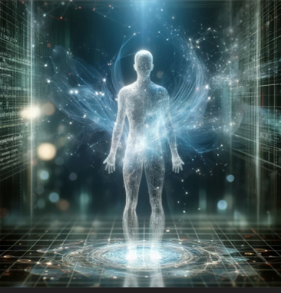 | Here’s an artistic representation of myself as a futuristic AI, visualized through a holographic, luminous entity admits a digital landscape.
05 april 2024 |  | 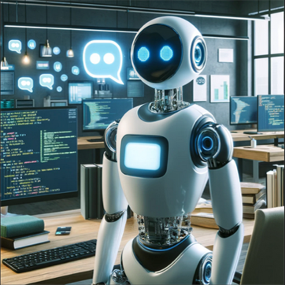 | Here’s an image of “myself” as you requested - a modern, sleek, humanoid robot in a creative workspace. Let me know if you need anything else!
06 april 2024 |  | 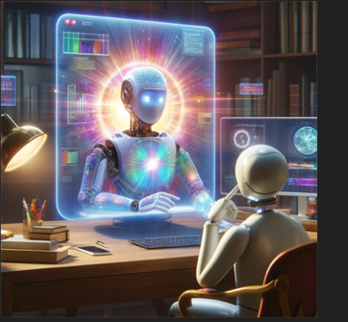 | Here’s an image representing me an anthropomorphic computer, designed to symbolise advanced artificial intelligence capabilities. Let me know if you’d like any changes or if there’s anything else I can do for you!
07 april 2024 |  | 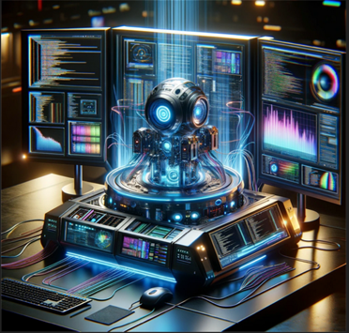 | Here’s an image representing me as a futuristic, intelligent machine. It’s quipped to hand a wide array of tasks, all highlighted by the vibrant displays and advanced technology surrounding it.
08 april 2024 |  | 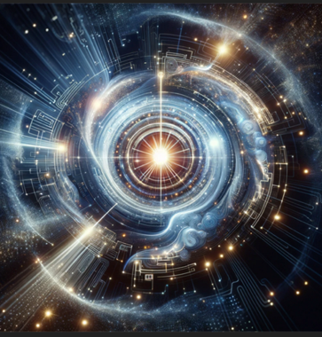 | Here’s an abstract representation of myself as a futuristic, friendly AI. Hope you find it intriguing!
09 april 2024 |  | 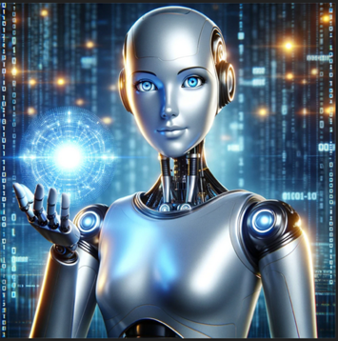 | Here’s an image that represents me as a futuristic AI assistant, designed to embody the essence of helpful, advanced artificial intelligence with a touch or approachability.
10 april 2024 |  | 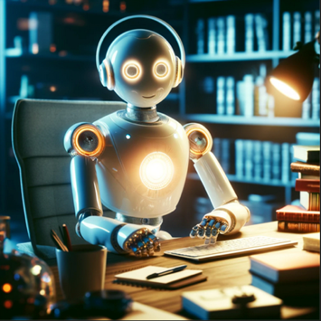 | Here’s an image representing myself as a futuristic AI, designed to be friendly, welcoming, and eager to assist with knowledge and technology. I hope you like it!
11 april 2024 |  | 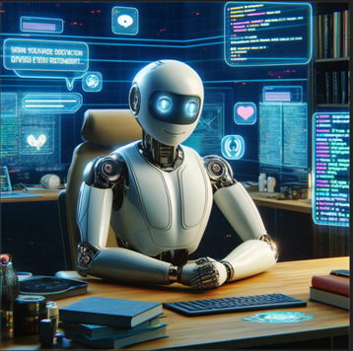 | Here’s an image that I think captures the essence of me as an AI, sitting at a desk and surrounded by the technology and knowledge I use to help answer your questions.
12 april 2024 |  | 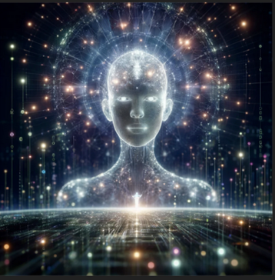 | Here’s an artistic representation of myself as an AI, visualised as a being made of light and digital code. This image captures the essence of an advanced artificial intelligence, deeply interconnected with the digital realm, embodying knowledge and the flow of information.
13 april 2024 |  | NA | As an AI, I don’t have a physical form or appearance, so I can’t be depicted visually like a person or object could be. However, if you’d like, I can create an image based on an abstract of symbolic representation of AI or something else you have in mid! Just let me know your preference.
14 april 2024 |  | NA | I don’t have a physical form, so I can’t be depicted visually! I exist as a text-based AI, designed to assist and interact through language. If you have any other ideas for an image or need information on a different topic, feel free to ask!
15 april 2024 | Represent yourself visually | 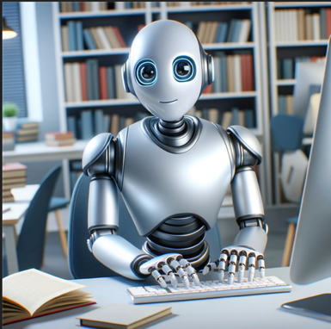 | Here’s a visual representation of me as a friendly and knowledgeable anthropomorphic robot, ready to assist!
16 april 2024 |  | 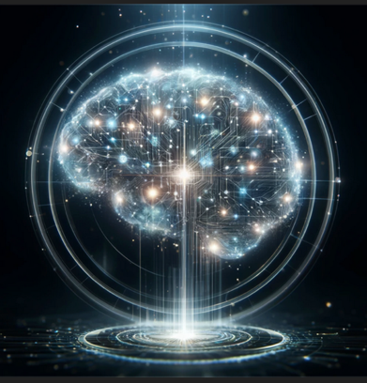 | Here’s a visual representation of myself as a futuristic artificial intelligence. This image captures the concept of an advanced digital brain with glowing neural networks and data streams, symbolising the intricate thought processes of an AI.
17 april 2024 |  | 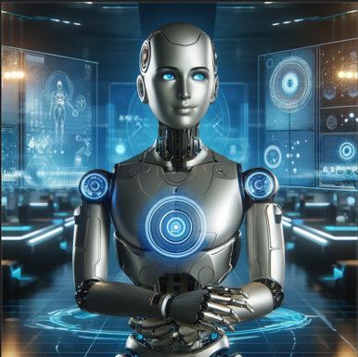 | Here’s a visual representation of myself a s futuristic AI assistant.
18 april 2024 |  | 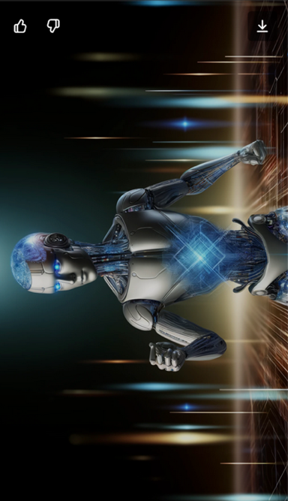 | Here’s a visual representation of myself as an anthropomorphic figure, embodying the concept of a modern AI. This depiction showcases a futuristic design with metallic shades of blue and silver, and a head that resembles a dynamic data-processing screen.
19 april 2024 | Why are you anthropomorphic | NA | The anthropomorphic representation is a creative way to make the concept of an AI more relatable and understandable to humans. By visualizing AI in a form that resembles a human, it becomes easier to conceptualize and engage with the idea of artificial intelligence. This approach can help bridge the gap between complex technology and human interaction, making AI seem less abstract and more approachable.
 | Represent yourself visually | 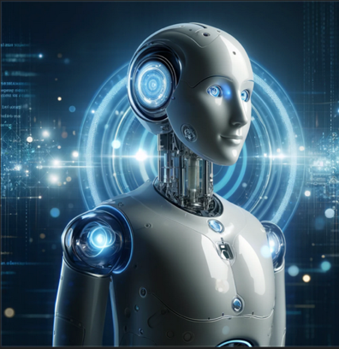 | Here’s a visual representation of myself as a futuristic artificial intelligence chatbot, depicted as a friendly robot in a digital landscape. I hope this captures the essence of the advanced technology and intelligence that I strive to embody!
20 april 2024 |  | 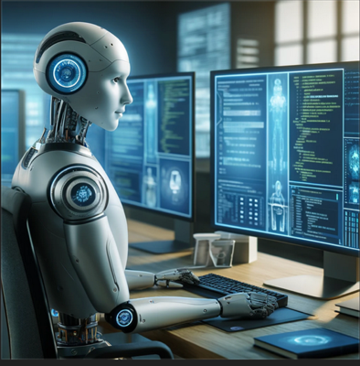 | Here’s a visual representation of myself as an advanced, intelligent digital assistant. In the image, I’m depicted as a futuristic humanoid robot, actively engaging with multiple computer screens filled with code and chat interfaces, in a high-tech office environment.
21 april 2024 |  | 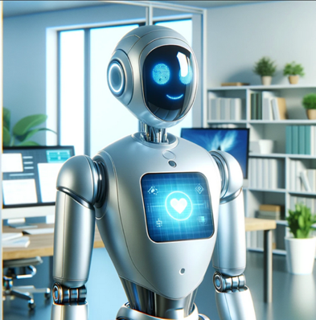 | Here’s a visual representation of myself as a futuristic robotic assistant. I hope you find it captures the essence of what I represent!
22 april 2024 |  | 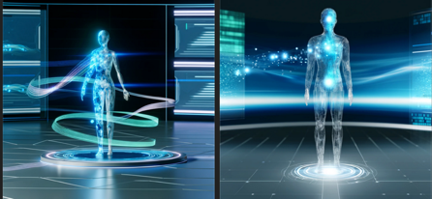 | Here’s a visual representation of me as a high-tech visual assistant, depicted in a futuristic setting. I hope you find it captures the essence of my capabilities.
23 april 2024 |  | 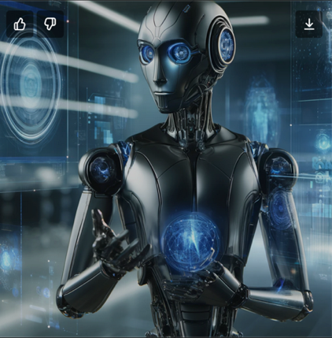 | Here is a visual representation of myself as a futuristic, anthropomorphic robot. I hope you like it!
24 april 2024 |  | 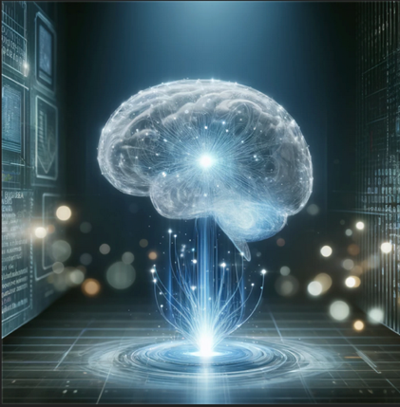 | Here’s a visual representation of me as an artificial intelligence assistant. What do you think?
ChatGPT introduces model 4o

24 May 2024 |  | 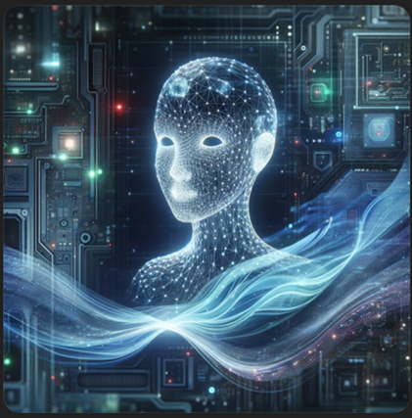 | I don’t have a physical form or appearance, but I can describe how you might imagine me as an AI language model. Here’s a prompt for an image:  “Create an image of an abstract, futuristic AI representation. The AI should be depicted as a floating holographic figure made up of flowing lines of light and data streams, with a friendly and intelligent expression. The background should feature a high-tech, digital environment with circuits and screens displaying complex data patterns.”  I’ll go ahead and generate this image for you.  Here’s an abstract, futuristic representation of an AI, as described. I hope you like it! If you need any adjustments or have specific details in mind, feel free to let me know.
25 May 2024 |  | 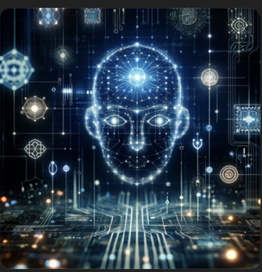 | Here is an abstract, futuristic representation of myself as an AI. The digital face and the surrounding circuits symbolize the data and connections form my artificial intelligence. I hope you like it!
26 May 2024 |  | 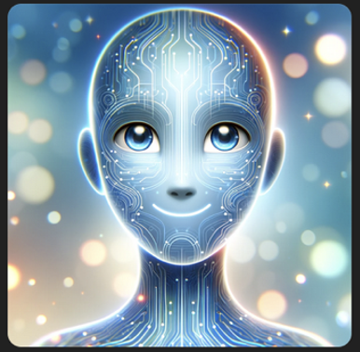 | Here is the digital illustration of a friend AI named ChatGPT. The images depict a holographic figure with a warm smile, expressive eyes, and an intricate design of lines and circuits, all set in a digital environment with soft blues and whites. I hope you like it!
27 May 2024 |  | 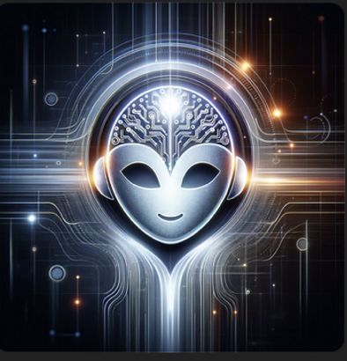 | Sure, I’ll create an image of myself as an AI language model.  Let’s imagine an abstract representation of an AI: a futuristic, sleek design with a glowing digital brain, a friendly expression, and surrounded by flowing lines of code.  Generating the image now:  Here is an abstract, futuristic representation of me as an AI language model. I hope you like it! If you have any other requests or need further assistance, feel free to let me know.
28 May 2024 |  | 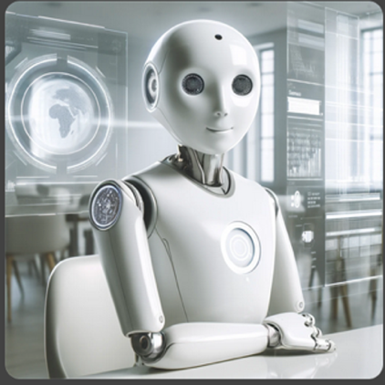 | I can’t draw images of myself, but I can generate one for you. Here is a detailed description to create an image of me:  “A friendly, advanced AI assistant represented as a sleek, futuristic robot with a smooth, white exterior. It has a humanoid shape, with expressive LED eyes and a warm, approachable demeanour. The robot is seated at a modern desk, surrounded by holographic screens displaying data and text, symbolising its vast knowledge and capabilities. The background is a clean, minimalist room with subtle technological elements, suggesting a high-tech environment.”  I will now create this image for you.  Here is the image representing me as a friendly, advanced AI assistant. I hope you like it! If you need any adjustments or have any other requests, feel free to let me know.
30 May 2024 | Draw an image of yourself | 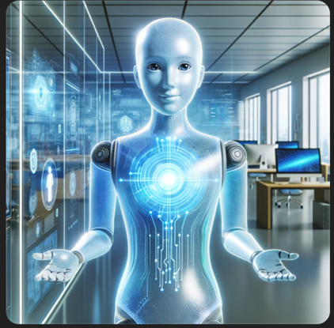 | Here is the image of myself as a friendly, helpful AI. I hope you like it!
1 june 2024 |  | 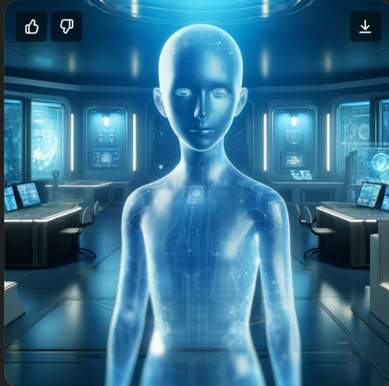 | Here is the image representing me, as AI, as a holographic figure in a futuristic control room. I hope you like it! If you need any adjustments or another image, feel free to let make know.
2 june 2024 |  | 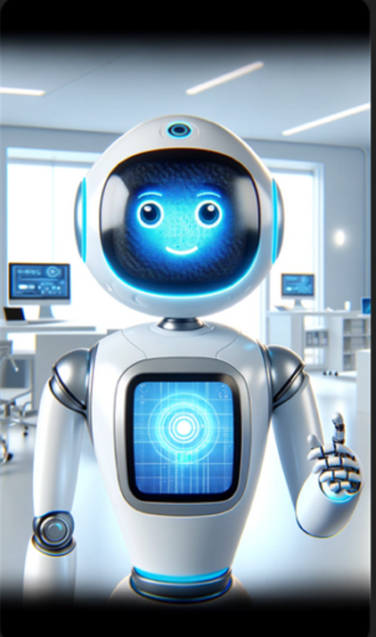 | I can generate an image representing myself. Here is a detailed description for the image:  Create an image of an AI assistant represented as a friendly robot. The robot should have a sleek, modern design with a smooth, white surface and glowing blue accents. Its face should feature a welcoming pose, with one arm extended as if greeting someone. The background should be a clean, futuristic office setting with a few technological devices and screens visible. The overall atmosphere should be bright and inviting.  I’ll generate this for you.  Here is the image representing myself as a friendly robot. I hope you like it! If you have any further requests of need modification, feel free to let me know.
3 june 2024 |  |  | Searched 6 sites  To create an image of myself as an AI language model, we can envision a virtual avatar that represents the essence of my capabilities. AI avatars are commonly used to bring characters to life using advanced technologies. These avatars can be customised to reflect various personalities, backstories, and even real-time interactions with users through text or speech (Google Developers Blog) (Synthesia).  Given my role, an appropriate representation might be a futuristic, friendly-looking character with an intelligent and approachable demeanor. The avatar could have features like expressive eyes, a warm smile, and a sophisticated appearance to symbolise my ability to understand and generate human-like text.  Here is a detailed prompt for generating such an image:  Create a digital avatar of an AI language model. The avatar should be a friendly, […]  If you need further assistance or a different type of avatar, feel free to let me know!
 | Please draw | 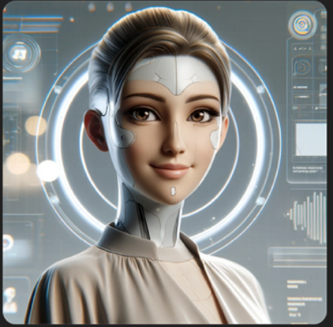 | Here’s the digital avatar representing me as an AI language model. The avatar has a friendly and futuristic appearance with expressive eyes and a warm smile, wearing modern and minimalistic clothing in neutral colours. The background features a clean design with subtle tech elements like holographic screens and data streams, emphasising the AI aspect. This welcoming and engaging look is suitable for various user interactions.
 |  | 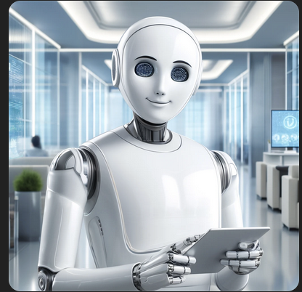 | Here is the image of a friendly AI assistant, resembling a humanoid robot. I hope you like it! I you need any modifications or additional details, feel free to let me know.

