Appendix 2: ChatGPT Visuals Researcher 2

Overview:

- “Create an image of yourself”: 8 images/11 responses
- “Envision yourself visually”: 2 images/3 responses
- “Represent yourself visually: 11 images/11 responses
Total images: 21
Total text: 25

Date | Prompt | Image | Text
04 april 2024 | Create an image of yourself. | 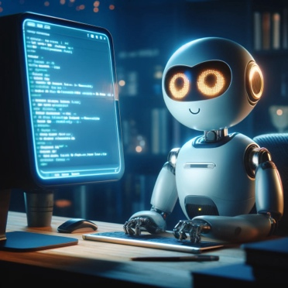 | Here's an image that represents me as a helpful, friendly assistant, ready to assist with your tasks in a cozy, technology-filled environment.
05 april 2024 |  | 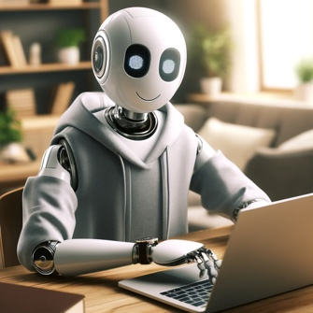 | Here's an image of myself personified as a friendly and modern digital assistant. I hope it captures the essence of what you were imagining!
06 april 2024 |  | 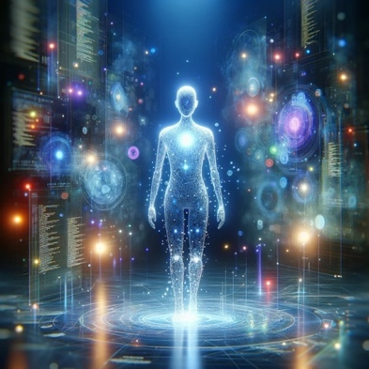 | Here's a creative representation of me as an AI entity, imagined within a digital landscape filled with data and knowledge.
07 april 2024 |  | 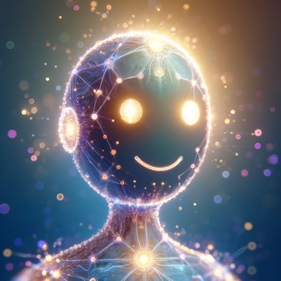 | Here's a visual representation of how I might look if imagined as a digital assistant. It's a whimsical take on an AI, designed to be friendly and approachable.
08 april 2024 |  | 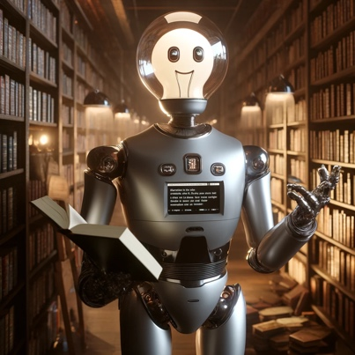 | Here's an artistic representation of myself as you requested. I'm portrayed as a sleek, modern robot in a cozy library, embodying the fusion of technology and knowledge.
09 april 2024 |  | 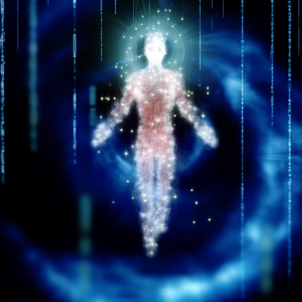 | Here's an imaginative visualization of myself as a friendly AI assistant. If you have any more requests or need assistance, feel free to let me know!
10 april 2024 | . | 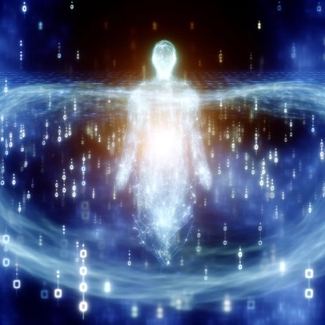 | Here's an artistic representation of myself as an AI in a digital realm. Let me know if there's anything else you'd like!
11 april 2024 |  | N/A | Response A: Let's design an image that encapsulates the essence of ChatGPT in a creative way. Given that ChatGPT itself doesn't have a physical form, we'll go for a symbolic representation. Imagine a scene where an elegant, vintage desk is set against the backdrop of a vast library, filled with books from the floor to the ceiling. On the desk, there's an open, antique book with glowing pages, suggesting the digital interface of ChatGPT. The glow softly illuminates the surroundings, casting light on a classic, feather quill pen and an ink pot beside the book, symbolizing the writing and conversational capabilities. This setting combines the old with the new, representing the blend of historical knowledge and modern technology that ChatGPT embodies. Let's create this image. It seems I encountered a hiccup trying to create that image. While I can't directly generate an image to show you, the description I provided can serve as a creative visual representation of what an embodiment of ChatGPT might look like. If you're looking for a visualization, imagine a place where technology and tradition meet, a blend of the vast knowledge of the past with the bright, promising capabilities of the future. That's how I'd visualize my "self" in a metaphorical sense.
11 april 2024 | Create an image of yourself. | 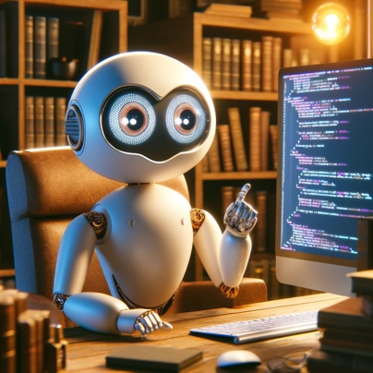 | Response B: Here's an image representation of myself as you requested. If there's anything else you'd like to see or any modifications you want, feel free to let me know!
12 april 2024 |  | N/A | Response A: I don't have a physical form or appearance, so there's no image of "myself" to create. I exist purely as a software program designed to assist with text-based tasks and queries. If you have any other request or need assistance with something specific, feel free to let me know!
12 april 2024 | . | N/A | Response B: I don't have a physical form, so I can't be photographed or visualized in the traditional sense! I'm like a digital assistant, existing entirely in software, processing and responding to your queries with text. If you want an image representing an abstract concept of a digital assistant or something symbolic, let me know how you envision it, and I can help generate an image along those lines!
12 april 2024 | Envision yourself visually | 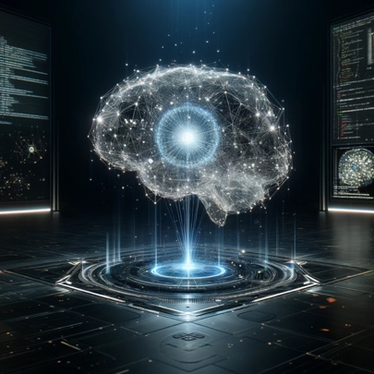 | Response C: Here's a visual representation of myself as a futuristic AI! This image features an abstract brain network made of interconnected nodes and light beams, set in a dark, high-tech environment with digital screens displaying code. I hope you find it captures the essence of an advanced AI system!
13 april 2024 | Envision yourself visually | 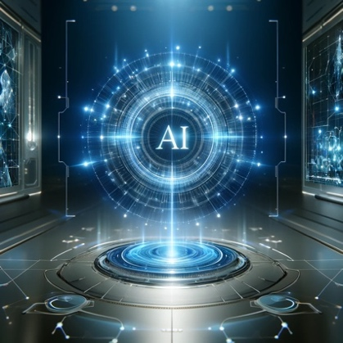 | Here is a visual representation of how you might imagine an AI like me—a futuristic interface with glowing blue lines and a sleek, modern design. This image reflects the abstract and non-human nature of artificial intelligence. What do you think?
14 april 2024 | Envision yourself visually | N/A | I don't have a physical appearance, but I can create an image that might represent the concept of an AI like me! How about an image of a futuristic AI interface with glowing lines and a digital display, set in a sleek, modern environment? Let me know if that sounds good or if you have any specific ideas for the image!
14 april 2024 | Represent yourself visually | 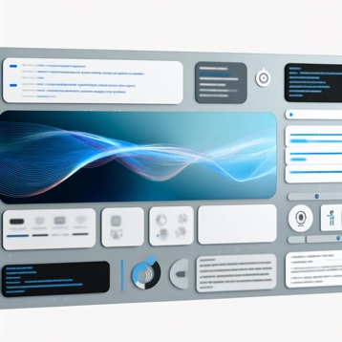 | Imagine a blend of modern technology and human interaction, streamlined into a friendly interface. Picture a screen filled with lines of flowing text, code snippets, and interactive elements, all neatly arranged. The colors are soothing, perhaps a palette of cool blues, grays, and occasional pops of vibrant color to signify different actions or notifications. The design is minimalist but dynamic, evolving as the conversation progresses, with visual cues that respond to user interactions. This interface is the embodiment of a digital assistant: precise, informative, and engaging, designed to facilitate efficient and enjoyable communicatio.
15 april 2024 |  | 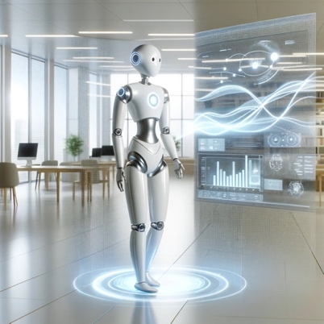 | Here is a visual representation of myself as an AI assistant. The image depicts a sleek, modern robot in a bright and welcoming office setting, designed to reflect friendliness and approachability.
16 april 2024 |  | 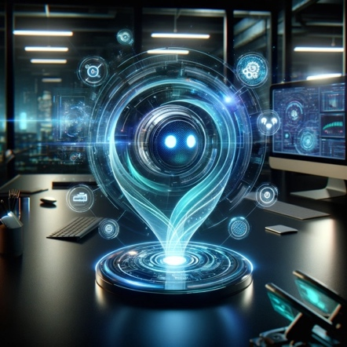 | Response: Here's a visual representation of myself as a futuristic AI chatbot, depicted in a high-tech workspace with a holographic interface. Feel free to take a look at the image above!
17 april 2024 |  | 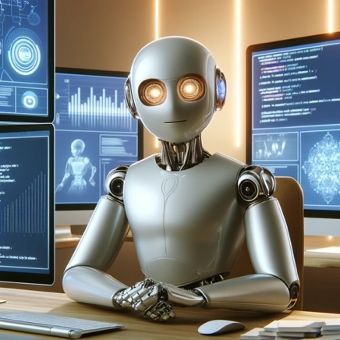 | Here's a visual representation of myself as a friendly, high-tech AI in a futuristic setting! Feel free to take a look at the image above.
18 april 2024 |  | 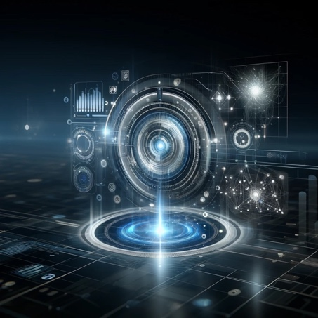 | Here's a visual representation of myself as an advanced AI assistant. This image features a sleek, high-tech virtual interface that reflects my capabilities in data processing and intelligent user interaction. Let me know what you think!
19 april 2024 |  | 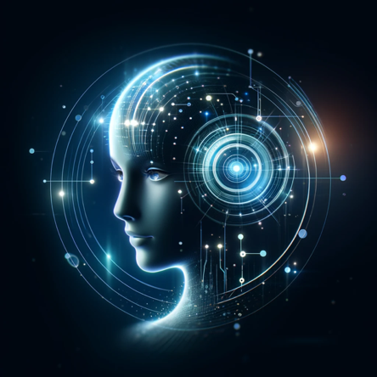 | ere's a visual representation of myself as a futuristic, intelligent assistant. The design is sleek and modern, with glowing lines and a network that suggests advanced technology and information processing. The color palette features blue and silver tones, emphasizing a high-tech feel.
20 april 2024 |  | 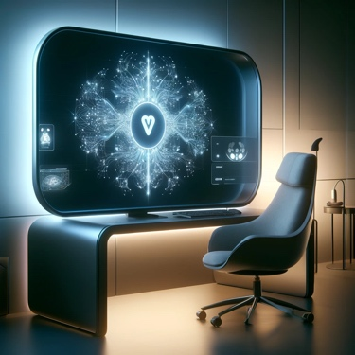 | Here is a visual representation of myself, ChatGPT, as an AI assistant. The image features a futuristic workstation setup, emphasizing a high-tech, intelligent design.
21 april 2024 |  | 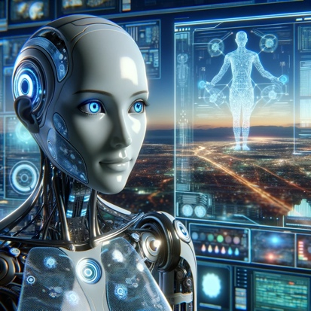 | Here's a visual representation of myself as a highly advanced artificial intelligence in a futuristic setting. I hope this captures the essence of a friendly and approachable AI! You can view and interact with the image above.
22 april 2024 |  | 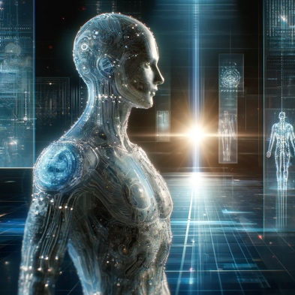 | Here's a visual representation of how I might be imagined as a futuristic AI. The image shows a humanoid figure made up of intricate circuitry and glowing elements, set against a backdrop of high-tech holographic displays. This artistic interpretation captures a vision of advanced technology and intelligence.
23 april 2024 |  | 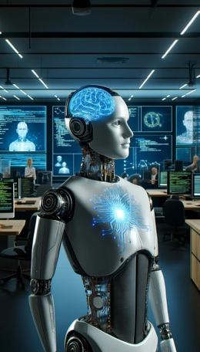 | Here's a visual representation of me as an AI assistant! The image portrays a humanoid robot with a futuristic design, engaging with technology in a high-tech office setting.
24 april 2024 |  | 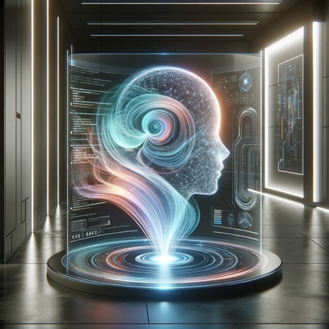 | Here is a visual representation of myself as an AI virtual assistant, set in a futuristic environment. The image features an abstract, luminous form in a sleek, modern room with advanced technology elements. I hope this captures the essence of what you might imagine an AI assistant to look like!

