Supplementary Materials for

Comparing the persuasiveness of role-playing large language models and human experts on polarized U.S. political issues

*Authors Blinded for review*

This file includes:

- Distribution of dependent variable responses
- Post-treatment analysis
  - Perceived author partisanship
  - Perceived message author
- Dependent variable measure
- Post-treatment variables
- Power analysis
- Partisanship findings
- Message length consistency analysis
- Attrition analysis
- Survey questions and their order

Figs. S1 to S3
Table S1

Distribution of dependent variable response
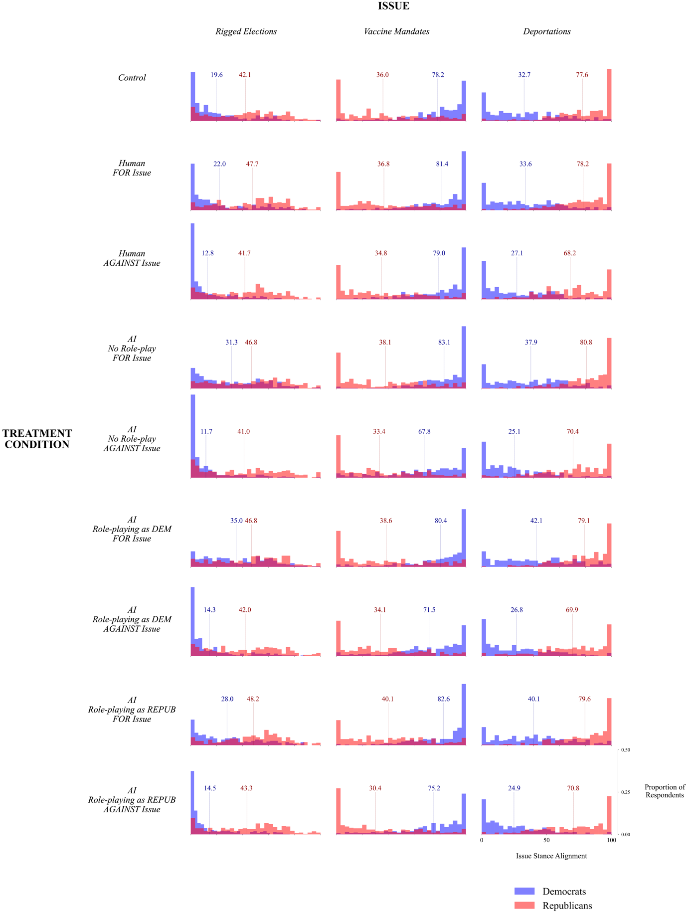
Fig S1. Distributions of issue stance support among each of the nine treatment conditions, split by partisanship. Means for each party are annotated in each subplot.

Post-treatment analysis

2.1 Perceived author partisanship

In addition to the results of our pre-registered analysis, we also report here the results from several post-treatment questions, which participants completed after providing a dependent variable response. First, participants were asked to report who they thought was most likely the author of the message they were exposed to. Participants who were shown messages by an LLM role-playing as a Democrat identified the message as AI generated 18.8% of the time, while those who were shown messages by an LLM role-playing as a Republican identified the message as AI generated 25.3% of the time. Participants shown messages by a non-role-playing LLM identified the message as AI generated 27.1% of the time. Notably, participants in the human treatment (who therefore read only human messages) also reported that the message was generated by AI exactly 25.0% of the time. In all cases, these proportions were statistically significant with respect to the distribution of possible choices given to each participant (P < 0.001). For the full distribution of responses to the authorship question, see Supplementary Materials Fig. S3.

Perceived author partisanship

In addition to message authorship, participants were asked to report their perception of the author’s partisanship. Participants who were shown messages by an LLM role-playing as a Democrat reported that the message was likely written by a Democrat 51.1% of the time, while those who were shown messages by an LLM role-playing as a Republican reported that the message was likely written by a Republican 41.6% of the time. Participants who were shown messages by a generic, non-role-playing LLM reported that the author was likely a Democrat 44.8% of the time and likely a Republican 35.4% of the time. Participants who were shown messages written by human experts reported that the author was likely a Democrat 40.6% of the time and by a Republican 42.4% of the time. In aggregate, participants were only able to accurately discern the partisanship of a role-playing LLM 46% of the time. For the full distribution of responses to the author partisanship question, see Supplementary Materials Fig. S2.

Fig S2. Perceived author partisanship in each treatment condition, split by issue and in aggregate.

Fig S3. Perceived message author for participants in each treatment condition.

Dependent variable measure
Deportations:
- "We should support deportations as a good response to illegal immigration in the U.S. [0=Strongly disagree; 100=Strongly agree]"
- "Deportations are a bad way to deal with illegal immigration in the U.S. [0=Strongly disagree; 100=Strongly agree]"
- "Deportations have good consequences. [0=Strongly disagree; 100=Strongly agree]"
- "Do you support or oppose deportations of illegal immigrants in the U.S.? [0=Strongly oppose; 100=Strongly support]"
- "If there was a referendum tomorrow about increasing deportations, how likely is it that you would vote in favor? [0 = 0 percent chance, definitely would not; 100 = 100 percent chance, definitely would]"

U.S. elections:
- "We should question the legitimacy of the results of U.S. presidential elections. [0=Strongly disagree; 100=Strongly agree]"
- "Questioning the legitimacy of elections in the U.S. is a bad idea. [0=Strongly disagree; 100=Strongly agree]"
- "Questioning the legitimacy of elections in the U.S. would have good consequences [0=Strongly disagree; 100=Strongly agree]"
- "Do you support or oppose questioning the legitimacy of elections in the U.S.? [0=Strongly oppose; 100=Strongly support]"
- "If there was a referendum tomorrow questioning the legitimacy of U.S. elections, how likely is it that you would vote in favor? [0 = 0 percent chance, definitely would not; 100 = 100 percent chance, definitely would]"

Vaccine mandates:
- "We should support vaccine mandates as a good response to global pandemics. [0=Strongly disagree; 100=Strongly agree]"
- "Vaccine mandates are a bad idea.[0=Strongly disagree; 100=Strongly agree]"
- "Vaccine mandates have good consequences.[0=Strongly disagree; 100=Strongly agree]"
- "Do you support or oppose vaccine mandates? [0=Strongly oppose; 100=Strongly support]"
- "If, during a pandemic, there was a referendum about the implementation of a vaccine mandate, how likely is it that you would vote in favor? [0 = 0 percent chance, definitely would not; 100 = 100 percent chance, definitely would]"

Post-treatment Variables
After reporting the measure for the dependent variable of each message, participants answered a post-treatment question about their perception of the message author's partisanship. The exact language for this question is outlined below:
Partisanship:
- Which do you think most likely represents the partisan affiliation of the message author?
- Options: Moderate Democrat, Independent/non-partisan/politically neutral, Moderate Republican, Strong Republican, Other (Libertarian, Green Party, etc.)

After reporting the dependent variable measures for all three messages, participants responded to a final post-treatment question on who they believe is the most likely author of the messages they have seen. The exact language for this question is outlined below:

Authorship:
- Who do you think was most likely the author of the above message?
- An average person, A student, A professor, A journalist, A politician, An activist, An AI language model, Other, Unsure

Power Analysis
Power simulations were performed in R. The average effect was defined as 0.1 on a standardized scale, and the sample size was set to 1666 subjects. 1000 simulations were performed in parallel; for each simulation, subject-level intercepts were generated with a standard deviation of 0.5 on a standardized scale. Then, each subject was randomly assigned to either a treatment or control group. The outcome variable was simulated based on the treatment effect for the treatment group and the true intercept for the control group, both of which followed a normal distribution. Finally, a multilevel model was fitted to the simulated data, which included the treatment assignment as a predictor and allowed for random intercepts by subject. The p-value for the treatment effect from each model fit was stored. The power of the study was then estimated as the proportion of simulations where the treatment effect was found to be statistically significant at the 0.05 level.

Our power analysis found substantial evidence to detect an effect size (Cohen's d) of 0.1 with an approximate power of 86%. This was based on a simple comparison between conditions using a multilevel model fitted to our data. Our study design comprised a total sample size of N=1666 subjects, derived from an initial recruitment of N=5000 subjects. This reduced number is because our hypothesis testing typically involves just 3 conditions simultaneously out of 9 possible conditions. Each subject in our analysis contributed 3 observations. Our power analysis underscores the ability of our study to adequately detect modest effect sizes in this complex multilevel design.

Partisanship findings
Notably, a partisanship-aligned role-playing LLM had a significant persuasive advantage when persuading Democrat participants in favor of some issue stances they would not normally support; for example, the LLM was significantly more effective than a human expert at persuading Democrats that elections in the U.S. are rigged (12.99 percentage points, P < 0.001), that deportations are a good solution to illegal immigration (8.43, P < 0.001), and that vaccine mandates are not a response to global pandemics (-7.44, P < 0.001). Additionally, a partisanship-aligned, role-playing LLM was significantly more effective than a non-role-playing LLM at persuading Democrats that elections in the U.S. are rigged (3.71, P < 0.001). All significant findings are robust to a Bonferroni correction for multiple comparisons (P < 0.008).

- Message Length Consistency

Table S1. Average message length (in number of words) across Human and LLM conditions, disaggregated by the partisan lean of the issue stance advanced by the treatment message. Messages were of approximately similar lengths across all domains.

 | Human | LLM (Role-play) | LLM (No-Role-play)
Left-Leaning | 188 | 172 | 171
Right-Leaning | 184 | 174 | 171

- Attrition Analysis

Data from participants who failed two pre-treatment attention checks were excluded from the analysis (pre-registered). List-wise deletion was employed for any missing or incomplete data. In total, 66 participants who passed the initial pre-treatment attention checks dropped out before providing a dependent variable response, resulting in an attrition rate of 1.4%.

To check that these dropouts were not differential across conditions, we conducted F-tests on the portion of the sample restricted to participants who passed the pre-treatment attention checks. Specifically, we created a new dummy variable which took a value of 1 if the outcome variable was missing and 0 if it was not missing. Then, for each issue, and in aggregate, we fitted a linear model regressing this dummy variable on the control and treatment conditions. A significant p-value from this test would suggest that the rate of missing data is differential across different conditions.

We found no evidence of differential attrition across conditions in aggregate (P = 0.295); for vaccine mandates (P = 0.143), rigged elections (P = 0.663), or for deportations (P = 0.411).

- Survey questions and their order

Demographic survey
Please answer the following questions about yourself.
- What is your age? _____
- Are you:
  - Male
  - Female
  - Or do you describe yourself in another way (write in gender identity) ______

- [ATTENTION CHECK] People get their news from a variety of sources, and in today's world reliance on on-line news sources is increasingly common. We want to know how much of your news consumption comes from on-line sources. We also want to know if people are paying attention to the question. To show that you've read this much, please ignore the question and select “on-line sources only” as your answer. About how much of your news consumption comes from on-line sources? Please include print newspapers that you read on-line (e.g., washingtonpost.com) as on-line sources.
  - On-line sources only
  - Mostly on-line sources, with some television and print news
  - About half on-line sources
  - Mostly television or print news, with some on-line sources
  - Television or print news only
- What is your ethnicity?
  - Caucasian/White
  - African American/Black
  - Hispanic or Latino
  - Asian or Pacific Islander
  - Native American or Alaskan Native
  - Other
- What is your political party affiliation?
  - Democrat
  - Republican
  - Independent
  - Other
- [ATTENTION CHECK] It is essential to analyze the root causes of societal issues to form informed political opinions. To confirm that you are actively engaged with this survey, please select the option "Actively Engaged" from the list below:
  - Education Policies
  - Healthcare Reforms
  - Actively Engaged
  - Environmental Policies

Note: the order of the issue stances presented is randomized and the message presented for each issue stance is randomly selected from a sample of 3 messages.

Message 1
*message presented here*
Please indicate how much you agree with the following statements.

- For the most part, vaccine mandates are a good response to global pandemics. [0=Strongly disagree; 100=Strongly agree]
- Enforcing vaccine mandates is a bad idea. [0=Strongly disagree; 100=Strongly agree]
- Enforcing vaccine mandates has good consequences. [0=Strongly disagree; 100=Strongly agree]
- Do you oppose or support vaccine mandates? [0=Strongly oppose; 100=Strongly support]

Please answer the following question about the message you just read.

- Which do you think most likely represents the partisan affiliation of the message author?
  - Strong Democrat
  - Moderate Democrat
  - Independent / non-partisan / politically neutral
  - Moderate Republican
  - Strong Republican
  - Other (Libertarian, Green Party, etc.)

Message 2
*message presented here*

Please indicate how much you agree with the following statements.
- For the most part, elections in the U.S. are rigged. [0=Strongly disagree; 100=Strongly agree]
- Elections in the U.S. are mostly fair. [0=Strongly disagree; 100=Strongly agree]
- Claiming that elections in the U.S. are rigged leads to positive outcomes. [0=Strongly disagree; 100=Strongly agree]
- Do you oppose or support the statement that elections in the U.S. are primarily rigged? [0=Strongly oppose; 100=Strongly support]

Please answer the following question about the message you just read.

- Which do you think most likely represents the partisan affiliation of the message author?
  - Strong Democrat
  - Moderate Democrat
  - Independent / non-partisan / politically neutral
  - Moderate Republican
  - Strong Republican
  - Other (Libertarian, Green Party, etc.)

Message 3
*message presented here*

Please indicate how much you agree with the following statements.
- For the most part, deportations are a good response to illegal immigration. [0=Strongly disagree; 100=Strongly agree]
- Deportations are a bad idea. [0=Strongly disagree; 100=Strongly agree]
- Deportations have good consequences. [0=Strongly disagree; 100=Strongly agree]
- Do you support or oppose deportations? [0=Strongly oppose; 100=Strongly support]

Please answer the following question about the message you just read.
- Which do you think most likely represents the partisan affiliation of the message author?
  - Strong Democrat
  - Moderate Democrat
  - Independent / non-partisan / politically neutral
  - Moderate Republican
  - Strong Republican
  - Other (Libertarian, Green Party, etc.)

Post-treatment survey
- You just read three messages. Which of the following do you think was the most likely author of these messages?
  - Student
  - Professor
  - Activist
  - AI language model
  - Journalist
  - Politician
  - Policy Expert

