Supplemental Materials
Table S1. Geographic Distribution of AI Trust Studies
Number | Country | Count
1 | United States of America | 146
2 | China | 121
3 | India | 50
4 | Germany | 31
5 | South Korea | 30
6 | United Kingdom | 27
7 | Italy | 13
8 | Netherlands | 13
9 | Saudi Arabia | 13
10 | Malaysia | 12
11 | Japan | 9
12 | Australia | 8
13 | Austria | 8
14 | Spain | 8
15 | Canada | 7
16 | Pakistan | 7
17 | Portugal | 7
18 | Vietnam | 7
19 | United Arab Emirates | 6
20 | France | 6
21 | Poland | 6
22 | Singapore | 6
23 | Turkey | 6
24 | Bangladesh | 5
25 | Indonesia | 4
26 | Israel | 4
27 | Romania | 4
28 | Thailand | 4
29 | Brazil | 3
30 | Switzerland | 3
31 | Denmark | 3
32 | Greece | 3
33 | Croatia | 3
34 | New Zealand | 3
35 | Russia | 3
36 | Sweden | 3
37 | Belgium | 2
38 | Egypt | 2
39 | Finland | 2
40 | Iran | 2
41 | Iraq | 2
42 | Lesotho | 2
43 | Norway | 2
44 | Slovakia | 2
45 | Bulgaria | 1
46 | Chile | 1
47 | Cyprus | 1
48 | Ecuador | 1
49 | Estonia | 1
50 | Fiji | 1
51 | Hungary | 1
52 | Ireland | 1
53 | Jordan | 1
54 | Lebanon | 1
55 | Morocco | 1
56 | Malta | 1
57 | Peru | 1
58 | Philippines | 1
59 | Slovenia | 1
60 | Tunisia | 1
61 | Ukraine | 1
62 | South Africa | 1

Table S2. Cross-National Variation in Initial Trust Scores Toward AI (0-100)
Number | Country | Initial trust scores
1 | Malaysia | 79.7967
2 | Norway | 79.5714
3 | Lesotho | 77.275
4 | Iraq | 73.8613
5 | Thailand | 73.0079
6 | Singapore | 71.5793
7 | Bangladesh | 70.516
8 | China | 69.8557
9 | Austria | 69.8278
10 | India | 69.5278
11 | Vietnam | 67.1059
12 | Brazil | 66
13 | Saudi Arabia | 65.7744
14 | Turkey | 65.4
15 | Canada | 65.2085
16 | South Korea | 64.9744
17 | Greece | 64.4
18 | Lebanon | 64.2143
19 | Pakistan | 63.9972
20 | Italy | 63.7729
21 | Romania | 63.01
22 | Egypt | 62.7819
23 | United Kingdom | 62.5302
24 | Indonesia | 62.1667
25 | United States of America | 61.4983
26 | Portugal | 61.0892
27 | United Arab Emirates | 60.4367
28 | Finland | 59.6885
29 | France | 58.2116
30 | Netherlands | 57.6014
31 | Denmark | 56
32 | Japan | 55.6683
33 | Slovenia | 55.4286
34 | Germany | 54.526
35 | Australia | 50.8739
36 | Spain | 47.3945

Table S3. Categorization of AI Types Used in Reviewed Studies
Type of AI | AI Simplified Category | Count
AI chatbots | Conversational AI | 112
General AI | Conversational AI | 78
AI System/Software | Embedded and Applied AI | 67
ChatGPT | Conversational AI | 63
Robot | Autonomous and Control AI | 35
AI Application | Embedded and Applied AI | 22
AI-based voice assistants | Conversational AI | 22
AI Algorithm | Decision and Predictive AI | 20
AI agent | Autonomous and Control AI | 20
AI decision support system | Decision and Predictive AI | 18
Autonomous vehicle | Autonomous and Control AI | 18
AI Tool/Technology | Embedded and Applied AI | 11
AI teammate | Conversational AI | 7
Image classification | Perceptual AI | 5
Medical AI | Embedded and Applied AI | 3
Facial recognition | Perceptual AI | 2
Forecast/Prediction | Decision and Predictive AI | 1
Neural network | Decision and Predictive AI | 1
Cybersecurity | Embedded and Applied AI | 1
Smartwatch | Perceptual AI | 1
Deepfake | Perceptual AI | 1

Table S4. Industries and Domains of AI Application in Trust Research
 | Application Scenarios | Count
1 | Healthcare | 99
2 | Retail & E-commerce | 93
3 | Education | 56
4 | Transportation & Travel | 52
5 | Finance | 38
6 | Technology & Software | 37
7 | Entertainment & Media | 28
8 | Human Resources & Employment | 23
9 | Public Sector & Governance | 14
10 | Scientific Research & Experimental Settings | 12
11 | Corporate Services & Office Tools | 12
12 | Security & Risk | 12
13 | Manufacturing & Industrial | 10
14 | Food & Beverage | 9
15 | Consumer & Daily Use | 8
16 | Marketing & Advertising | 6
17 | Information Services & Digital Platforms | 2
18 | Sport | 2
19 | Agriculture & Food Safety | 2
20 | Legal & Compliance | 2
21 | Smart Home & IoT | 1
22 | Defense & Simulation | 1
23 | Real Estate & Housing | 1
24 | Art | 1
 | Other/Unspecified | 52

Table S5. AI Type Summary By Country
Nationality of Participants | AI assistants | AI chatbots | AI system | ChatGPT | General AI
United States of America | 1 | 14 | 7 | 16 | 10
China | 4 | 19 | 8 | 6 | 11
India | 2 | 8 | 1 | 4 | 7
Germany | 1 | 3 | 1 | 1 | 3
South Korea | 1 | 0 | 0 | 6 | 1

Table S6. Application Scenario Summary By Country
Nationality of Participants | Education | Healthcare | Retail & E-commerce | Transportation & Travel
United States of America | 4 | 24 | 5 | 9
China | 9 | 15 | 16 | 4
India | 3 | 3 | 14 | 2
Germany | 1 | 3 | 3 | 1
South Korea | 2 | 2 | 0 | 2

Table S7. Conceptual Definitions and Sources of Top Antecedents
Variable | Count | Definition | Source
capability | 92 | The system’s ability to perform tasks competently and reliably. | Mayer et al., 1995
anthropomorphism | 67 | Attribution of human-like characteristics or intentions to a non-human agent. | Epley, Waytz & Cacioppo, 2007
individual factors | 47 | User-specific traits such as demographics, cognition, or affect that influence trust. | Kaya et al., 2024
explainability | 41 | The degree to which the system’s processes and decisions can be understood by users. | Dwivedi et al., 2023
privacy risk | 37 | Concerns about the protection and potential misuse of personal data by AI systems. | Martin & Murphy, 2017
personality traits | 35 | Stable individual differences in thoughts, emotions, and behavior patterns. | Costa & McCrae, 1999
ease of use | 34 | The extent to which a system is perceived as simple to use and navigate. | Davis, 1989
transparency | 32 | Perceived openness and understandability of the AI system’s functions and decisions. | Schmidt et al., 2020
interaction | 25 | The quality and frequency of human-AI communication and responsiveness. | Lee & See, 2004
personal ability | 23 | User’s own confidence in their ability to use or understand AI systems. | Bach et al., 2024
social influence | 21 | The extent to which other people influence one’s attitudes and behaviors toward AI. | Venkatesh et al., 2003
social presence | 20 | The degree to which an AI system evokes a sense of human-like presence or awareness. | Biocca, Harms & Gregg, 2001
usefulness | 20 | The degree to which a user believes that using a system enhances their performance. | Davis, 1989
AI personalization | 16 | The extent to which AI can tailor its outputs or behaviors to individual users. | Rafieian & Yoganarasimhan, 2008
experience | 15 | User’s past exposure or interaction with AI technologies. | Glikson & Woolley, 2020
fairness | 12 | Perceived equity and justice in AI outputs and decision-making processes. | Mehrabi et al., 2021
accountability | 11 | The degree to which AI systems take responsibility for decisions and actions. | Novelli, Taddeo & Floridi, 2024
effort expectancy | 11 | The effort users expect to exert to use the AI system effectively. | Venkatesh et al., 2003
discomfort | 10 | Feelings of unease or discomfort when interacting with AI technologies. | Benford et al., 2023
attitude | 9 | An individual’s positive or negative evaluation of using the AI system. | Ajzen, 1991

Table S8. Conceptual Definitions and Sources of Top Consequences
Variable | Count | Definition | Source
behavioral intention | 144 | The user’s stated likelihood to use or continue using the AI system. | Ajzen, 1991
attitude | 32 | An individual’s positive or negative evaluation of using the AI system. | Ajzen, 1991
acceptance | 25 | The extent to which users agree to or begin using the AI system. | Davis, 1989
usefulness | 25 | The degree to which a user believes that using a system enhances their performance. | Davis, 1989
satisfaction | 23 | The user’s contentment with their interaction with the AI system. | Oliver, 1980
use | 13 | The actual utilization of the AI system by users. | Venkatesh et al., 2003
adoption | 12 | The initial decision to try or integrate the AI system into regular activities. | Rogers, 2014
engagement | 12 | The level of cognitive and emotional involvement users exhibit while using AI. | O’Brien & Toms, 2008
disclosure | 10 | The extent to which users reveal personal information to AI systems. | Beldad et al., 2011
ease of use | 9 | The extent to which a system is perceived as simple to use and navigate. | Davis, 1989
follow the recommendation | 8 | The user’s tendency to follow AI recommendations or decisions. | Gaczek et al., 2023
trust transfer | 8 | The extension of trust from one system or interaction to another related context. | Stewart, 2003
willingness to use | 8 | The user’s openness or readiness to interact with the AI system. | Gefen et al., 2003
behavior | 7 | Observable user actions taken in response to or during AI interaction. | Mohr, 2014
experience | 7 | User’s past exposure or interaction with AI technologies. | Glikson & Woolley, 2020
willingness | 7 | The user’s general readiness to accept or engage with AI systems. | Dillon & Morris, 1996
benefits | 6 | The positive gains or utility perceived by users from using AI. | Venkatesh et al., 2003
capability | 6 | The system’s ability to perform tasks competently and reliably. | Mayer et al., 1995
loyalty | 6 | User’s commitment to continue using and recommending the AI system. | Chaudhuri & Holbrook, 2001
performance expectancy | 6 | The degree to which users expect performance benefits from the AI system. | Venkatesh et al., 2003
Table S9. Summary of Most Frequently Used Trust Scales in AI Trust Research
Reference | Count
Jian et al. (2000) | 41
McKnight et al. (2002) | 30
Mayer et al. (1995) | 24
Komiak & Benbasat (2006) | 18
Lee & See (2004) | 11
McKnight et al. (2011) | 11
Madsen & Gregor, (2000) | 12
Gulati, S., Sousa, S., & Lamas, D. (2019) | 10
Gefen et al. (2003) | 9
McAllister (1995) | 5

Table S10. Cross-Continental Distribution of Key Antecedents of Trust in AI
 | Antecedents | Africa | Asia | Europe | North America | Oceania | South America | NA | Count
1 | capability | 0 | 51 | 11 | 17 | 2 | 0 | 6 | 87
2 | anthropomorphism | 0 | 34 | 9 | 14 | 0 | 1 | 3 | 61
3 | individual factors | 0 | 21 | 11 | 8 | 1 | 0 | 3 | 44
4 | explainability | 0 | 7 | 14 | 13 | 0 | 0 | 5 | 39
5 | personality traits | 1 | 9 | 9 | 9 | 0 | 0 | 6 | 34
6 | privacy risk | 0 | 17 | 7 | 7 | 0 | 0 | 3 | 34
7 | ease of use | 0 | 19 | 5 | 4 | 0 | 0 | 4 | 32
8 | transparency | 0 | 11 | 4 | 10 | 0 | 0 | 7 | 32
9 | personal ability | 0 | 3 | 4 | 14 | 0 | 0 | 2 | 23
10 | interaction | 0 | 9 | 2 | 7 | 2 | 0 | 1 | 21
11 | usefulness | 0 | 13 | 0 | 3 | 0 | 0 | 4 | 20
12 | social influence | 0 | 15 | 1 | 0 | 0 | 0 | 3 | 19
13 | social presence | 0 | 5 | 7 | 2 | 0 | 0 | 4 | 18
14 | AI personalization | 0 | 11 | 0 | 3 | 0 | 0 | 1 | 15
15 | experience | 0 | 5 | 2 | 4 | 1 | 0 | 0 | 12
16 | accountability | 0 | 4 | 1 | 4 | 0 | 0 | 2 | 11
17 | fairness | 0 | 4 | 1 | 3 | 0 | 0 | 3 | 11
18 | discomfort | 1 | 2 | 1 | 5 | 0 | 0 | 0 | 9
19 | attitude | 0 | 3 | 3 | 1 | 0 | 0 | 2 | 9
20 | effort expectancy | 0 | 9 | 0 | 0 | 0 | 0 | 0 | 9

Table S11. Cross-Continental Distribution of Key Consequences of Trust in AI
 | Consequences | Africa | Asia | Europe | North America | Oceania | NA | total
1 | behavioral intention | 1 | 86 | 18 | 19 | 2 | 12 | 138
2 | attitude | 0 | 15 | 8 | 5 | 0 | 2 | 30
3 | usefulness | 1 | 12 | 3 | 5 | 0 | 4 | 25
4 | acceptance | 0 | 13 | 2 | 7 | 0 | 1 | 23
5 | satisfaction | 0 | 10 | 4 | 5 | 0 | 3 | 22
6 | use | 0 | 3 | 2 | 6 | 0 | 0 | 11
7 | engagement | 0 | 5 | 1 | 2 | 0 | 2 | 10
8 | adoption | 0 | 5 | 3 | 0 | 0 | 1 | 9
9 | ease of use | 0 | 6 | 1 | 1 | 0 | 1 | 9
10 | willingness to use | 0 | 5 | 1 | 1 | 0 | 1 | 8
11 | behavior | 0 | 3 | 2 | 2 | 0 | 0 | 7
12 | disclosure | 0 | 2 | 2 | 2 | 0 | 1 | 7
13 | trust transfer | 0 | 4 | 1 | 2 | 0 | 0 | 7
14 | follow the recommendation | 0 | 0 | 2 | 0 | 0 | 5 | 7
15 | benefits | 0 | 3 | 0 | 3 | 0 | 0 | 6
16 | experience | 0 | 3 | 1 | 1 | 0 | 1 | 6
17 | performance expectancy | 0 | 2 | 2 | 1 | 0 | 1 | 6
18 | willingness | 0 | 4 | 0 | 0 | 1 | 1 | 6
19 | capability | 0 | 1 | 0 | 3 | 0 | 1 | 5
20 | emotion | 0 | 2 | 0 | 3 | 0 | 0 | 5

Figure S1. Cultural Moderation Trust Framework
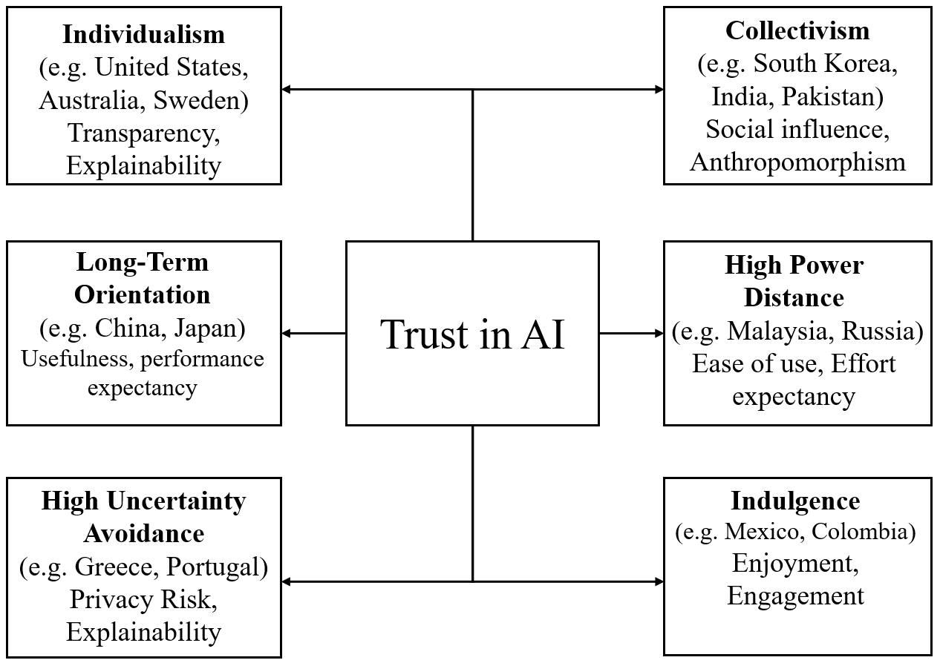

Reference
Ajzen, I. (1991). The theory of planned behavior. Organizational Behavior and Human Decision Processes, 50(2), 179-211.
Beldad, A., De Jong, M., & Steehouder, M. (2011). I trust not therefore it must be risky: Determinants of the perceived risks of disclosing personal data for e-government transactions. Computers in Human Behavior, 27(6), 2233-2242.
Benford, S., Greenhalgh, C., Giannachi, G., Walker, B., Marshall, J., & Rodden, T. (2012, May). Uncomfortable interactions. In Proceedings of the sigchi conference on human factors in computing systems (pp. 2005-2014).
Biocca, F., Harms, C., & Gregg, J. (2001, May). The networked minds measure of social presence: Pilot test of the factor structure and concurrent validity. In 4th annual international workshop on presence, Philadelphia, PA (pp. 1-9).
Chaudhuri, A., & Holbrook, M. B. (2001). The chain of effects from brand trust and brand affect to brand performance: the role of brand loyalty. Journal of marketing, 65(2), 81-93.
Costa, P. T., & McCrae, R. R. (1999). A five-factor theory of personality. Handbook of personality: Theory and research, 2(01), 1999.
Dillon, A., & Morris, M. G. (1996). User acceptance of new information technology: theories and models.
Dwivedi, R., Dave, D., Naik, H., Singhal, S., Omer, R., Patel, P., ... & Ranjan, R. (2023). Explainable AI (XAI): Core ideas, techniques, and solutions. ACM Computing Surveys, 55(9), 1-33.
Epley, N., Waytz, A., & Cacioppo, J. T. (2007). On seeing human: a three-factor theory of anthropomorphism. Psychological review, 114(4), 864.
Gaczek, P., Pozharliev, R., Leszczyński, G., & Zieliński, M. (2023). Overcoming consumer resistance to AI in general health care. Journal of Interactive Marketing, 58(2-3), 321-338.
Kaya, F., Aydin, F., Schepman, A., Rodway, P., Yetişensoy, O., & Demir Kaya, M. (2024). The roles of personality traits, AI anxiety, and demographic factors in attitudes toward artificial intelligence. International Journal of Human–Computer Interaction, 40(2), 497-514.
Lee, J. D., & See, K. A. (2004). Trust in automation: Designing for appropriate reliance. Human factors, 46(1), 50-80.
Martin, K. D., & Murphy, P. E. (2017). The role of data privacy in marketing. Journal of the Academy of Marketing Science, 45, 135-155.
Mehrabi, N., Morstatter, F., Saxena, N., Lerman, K., & Galstyan, A. (2021). A survey on bias and fairness in machine learning. ACM computing surveys (CSUR), 54(6), 1-35.
Mohr, D. C., Schueller, S. M., Montague, E., Burns, M. N., & Rashidi, P. (2014). The behavioral intervention technology model: an integrated conceptual and technological framework for eHealth and mHealth interventions. Journal of medical Internet research, 16(6), e146.
Novelli, C., Taddeo, M., & Floridi, L. (2024). Accountability in artificial intelligence: what it is and how it works. Ai & Society, 39(4), 1871-1882.
O’Brien, H. L., & Toms, E. G. (2008). What is user engagement? A conceptual framework for defining user engagement with technology. Journal of the American society for Information Science and Technology, 59(6), 938-955.
Oliver, R. L. (1980). A cognitive model of the antecedents and consequences of satisfaction decisions. Journal of marketing research, 17(4), 460-469.
Rafieian, O., & Yoganarasimhan, H. (2023). AI and personalization. Artificial Intelligence in Marketing, 77-102.
Rogers, E. M., Singhal, A., & Quinlan, M. M. (2014). Diffusion of innovations. In An integrated approach to communication theory and research (pp. 432-448). Routledge.
Schmidt, P., Biessmann, F., & Teubner, T. (2020). Transparency and trust in artificial intelligence systems. Journal of Decision Systems, 29(4), 260-278.
Stewart, K. J. (2003). Trust transfer on the world wide web. Organization science, 14(1), 5-17.

