Supplementary Material 1
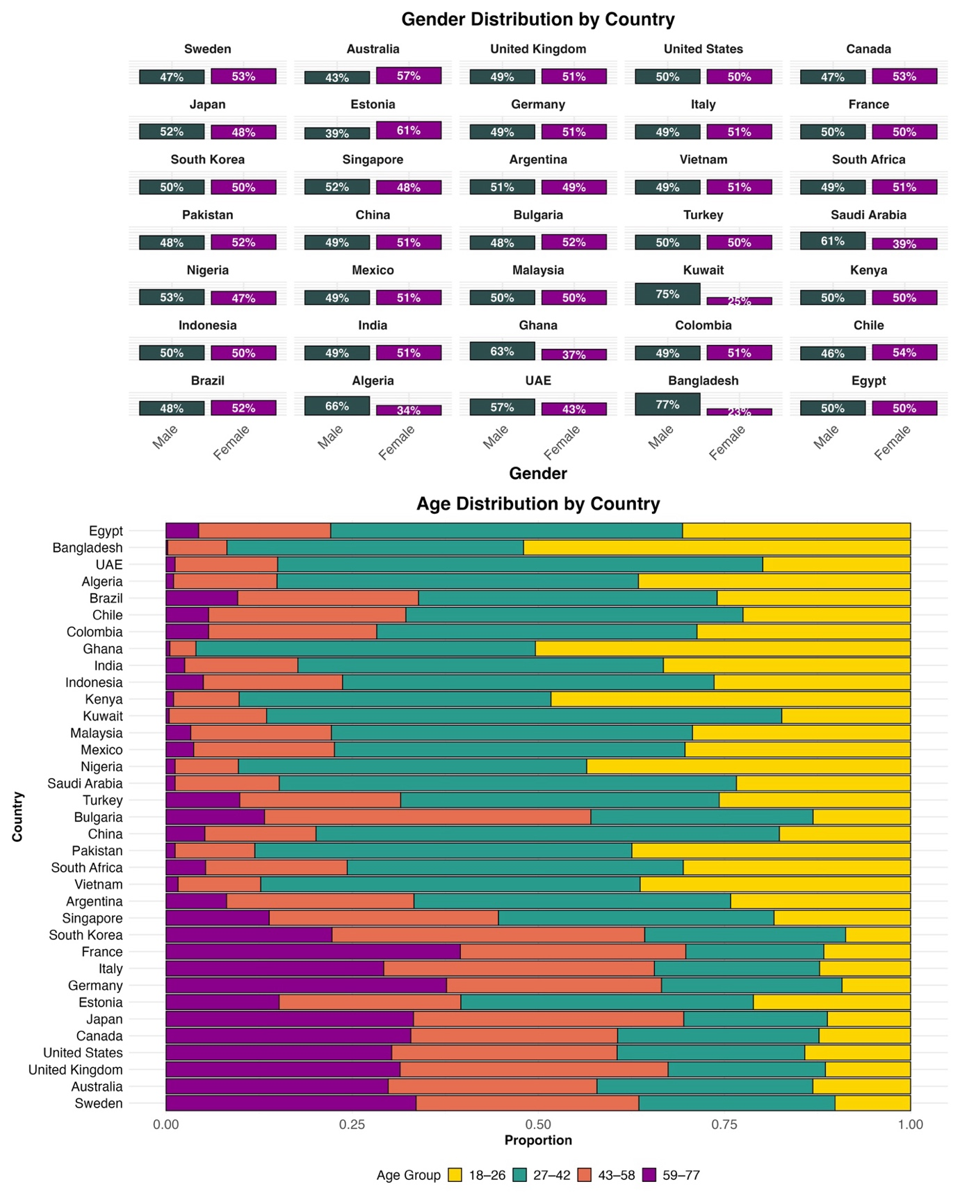

Supplementary Material 2
Reliability of DAS-7 (Depression, Anxiety, Stress)
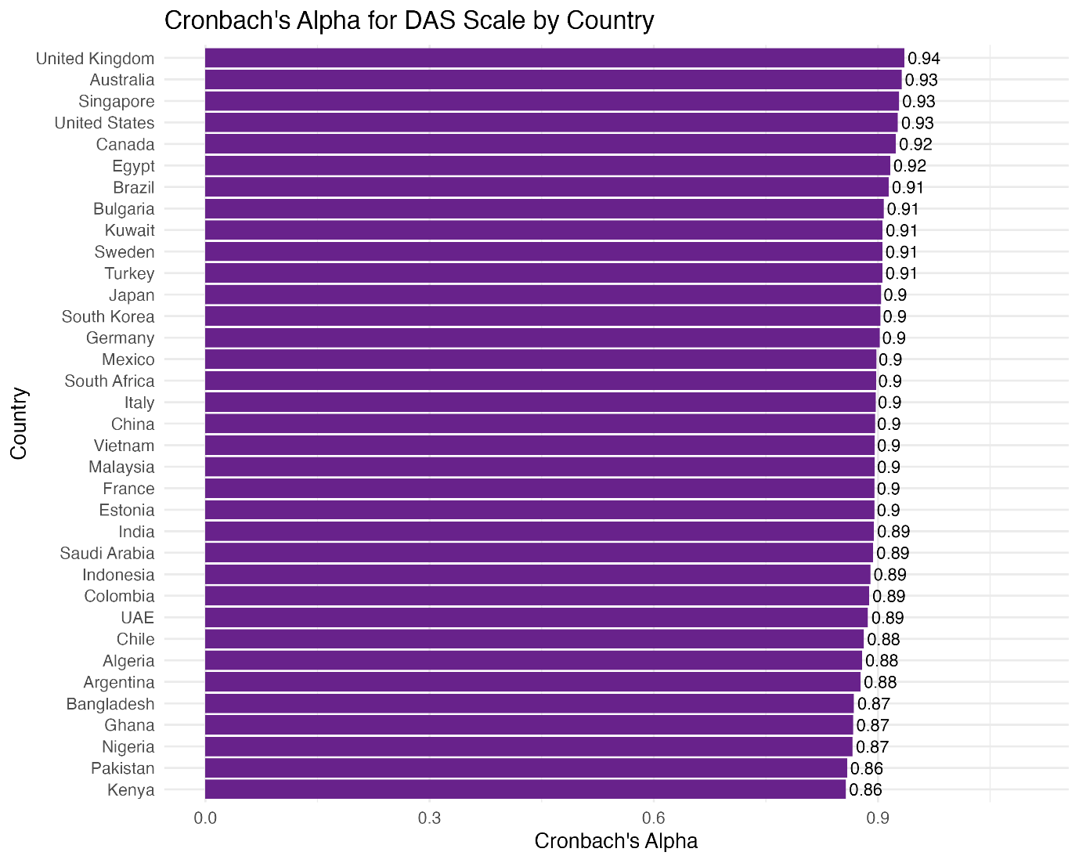

Supplementary Material 3
Reliability of Loneliness questionnaire
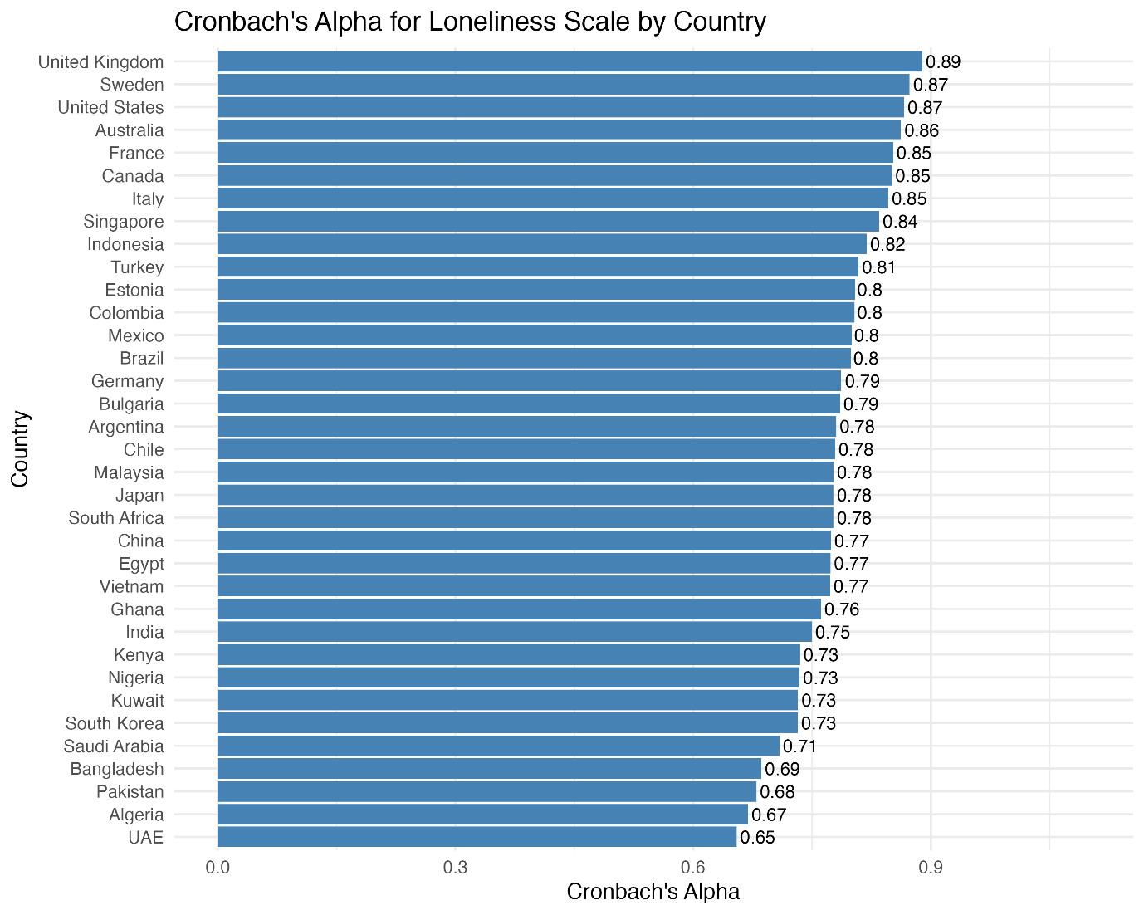

Supplementary Material 4
Weighted Mean and 95% CI for Life Satisfaction across countries
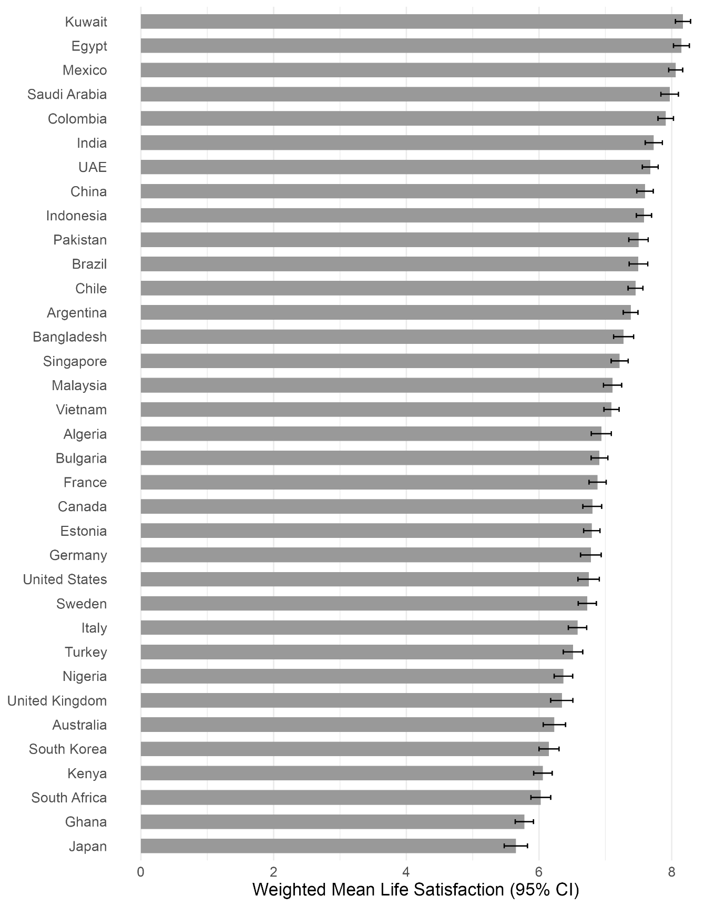

Supplementary Material 5
Weighted Mean and 95% CI for Life Optimism across countries
Note: Life optimism was measured on a scale 0-10.
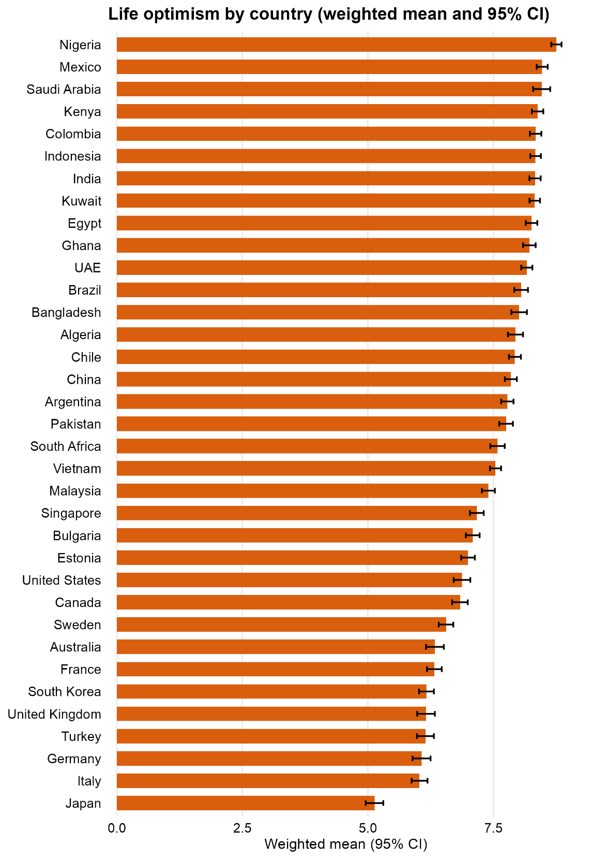

Supplementary Material 6
Weighted Mean and 95% CI for Trust in online information across countries
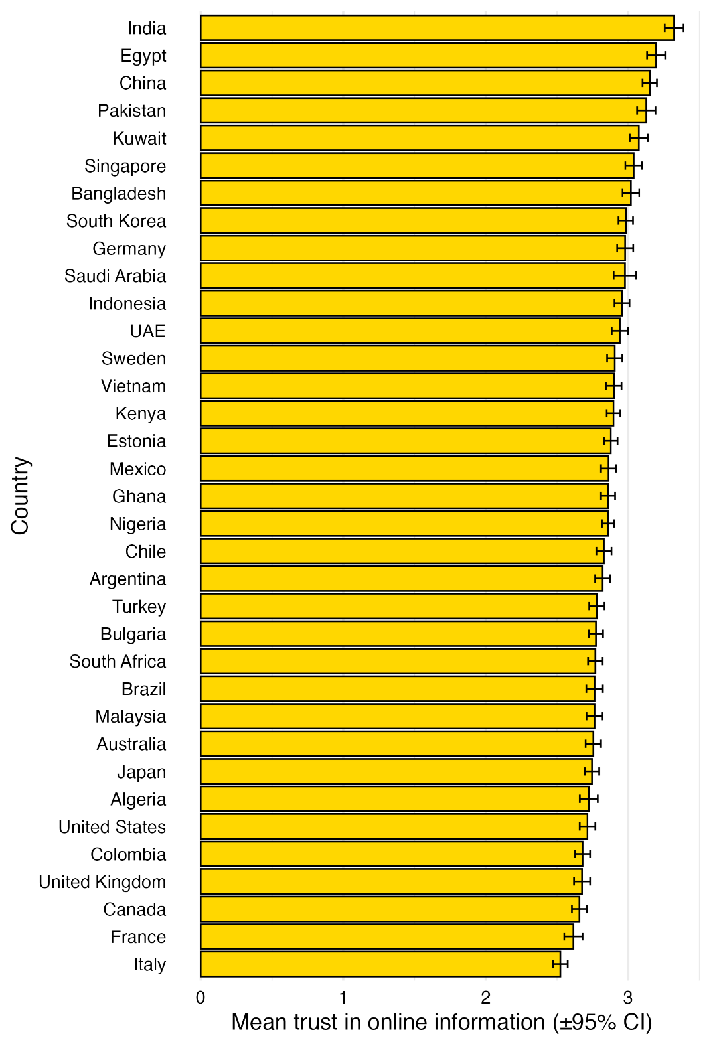

Supplementary Material 7
Summary of imputed variables
Variable | Imputed_Values | Total_Rows | Proportion_Imputed
ai_health_issue | 1551 | 30994 | 0.05
ai_teacher | 1630 | 30994 | 0.0526
ai_doctor | 1433 | 30994 | 0.0462
ai_companion | 1213 | 30994 | 0.0391
trust_info_online | 476 | 30994 | 0.0154

Visual inspection of imputation procedure
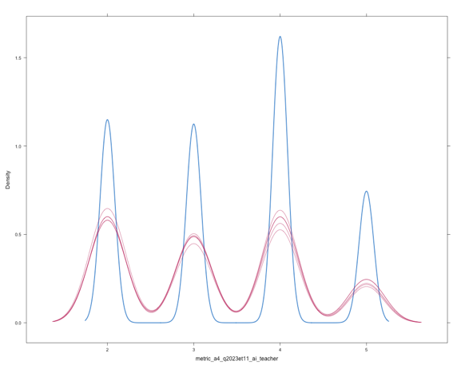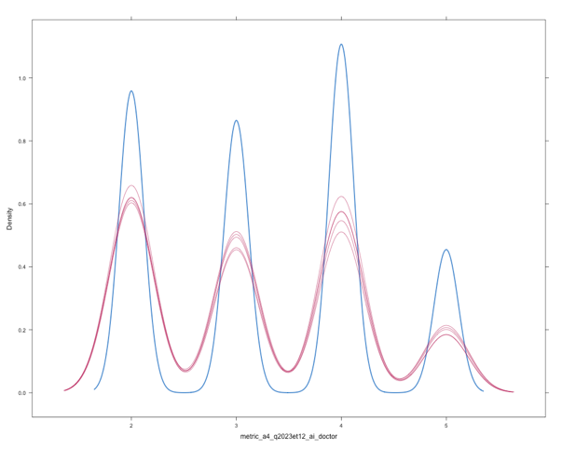
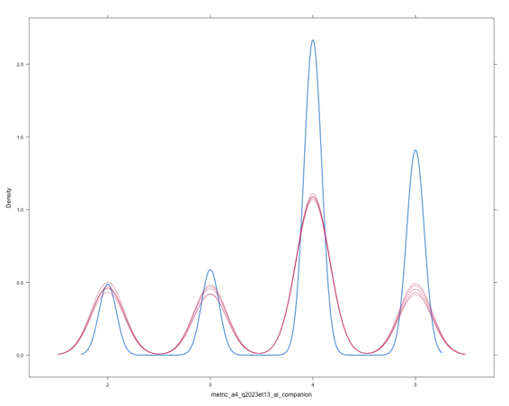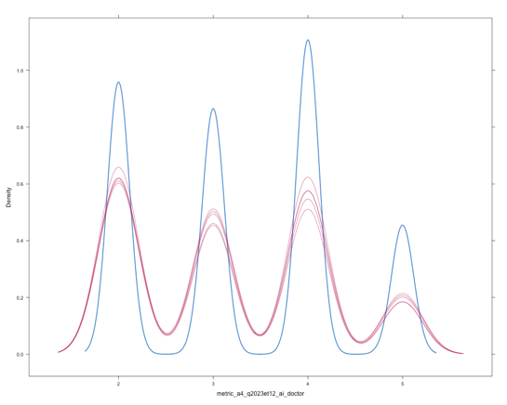

Supplementary Material 8

