Supplementary Material A: Scatterplots and Monotonicity Assessment

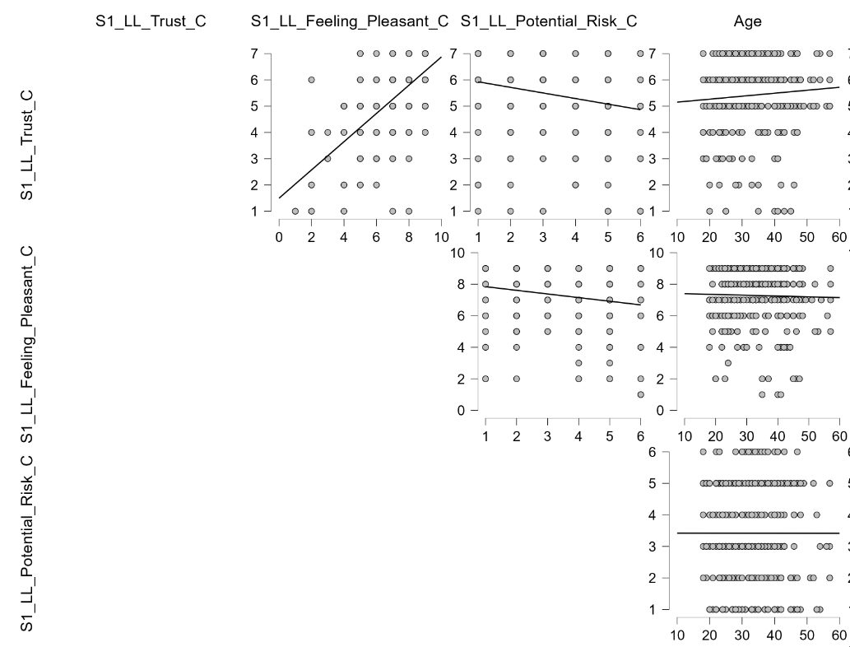
Figure 1. Scatterplots and Monotonicity Assessment for Arab Sample — First Scenario: Low Automation, Low Criticality.

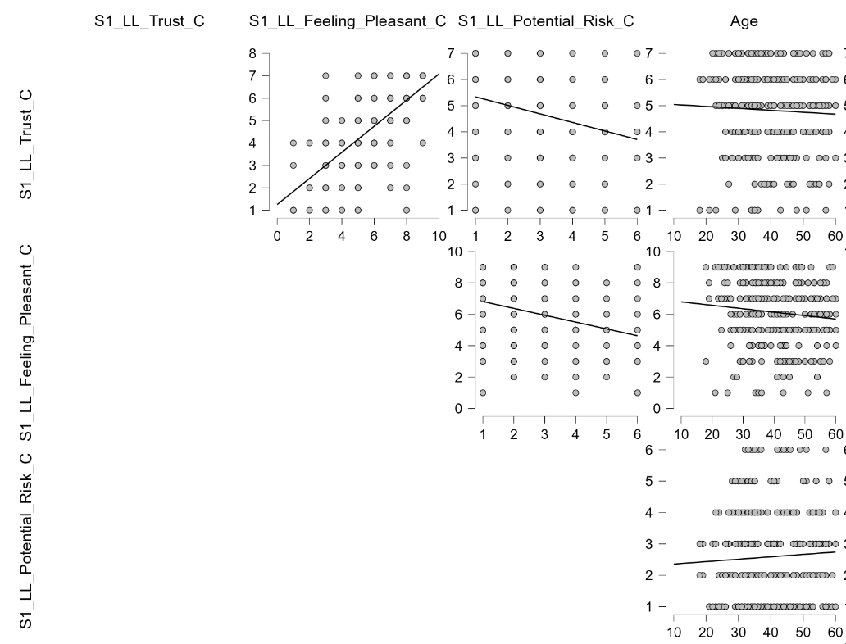
Figure 2. Scatterplots and Monotonicity Assessment for UK Sample — First Scenario: Low Automation, Low Criticality.

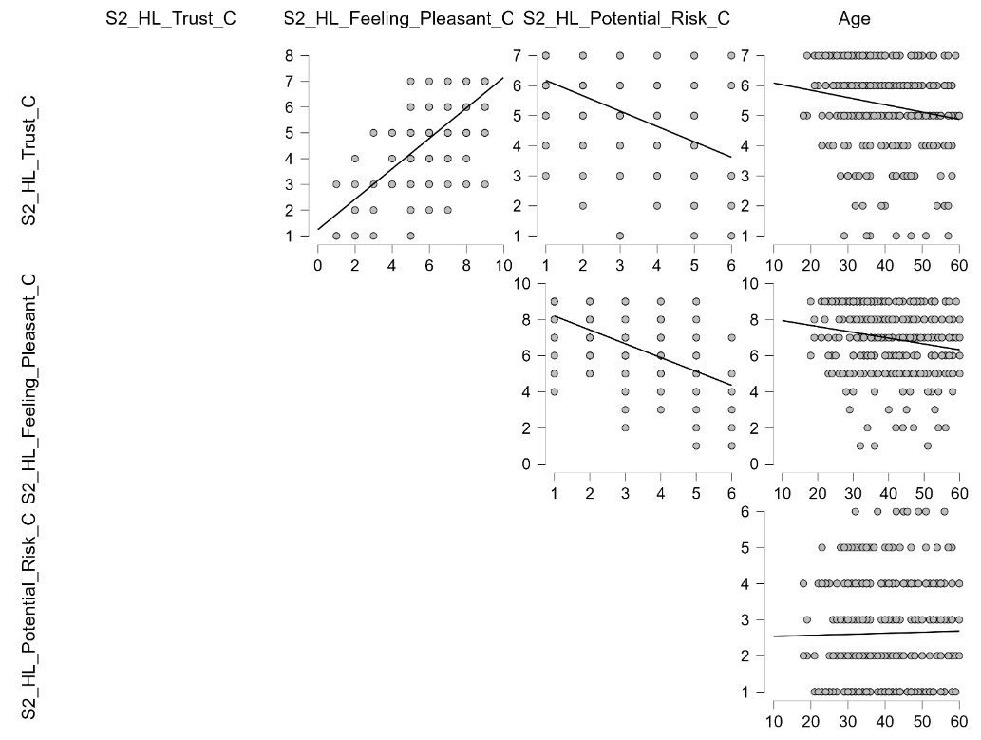

Figure 3. Scatterplots and Monotonicity Assessment for UK Sample — Second Scenario: High Automation, Low Criticality.

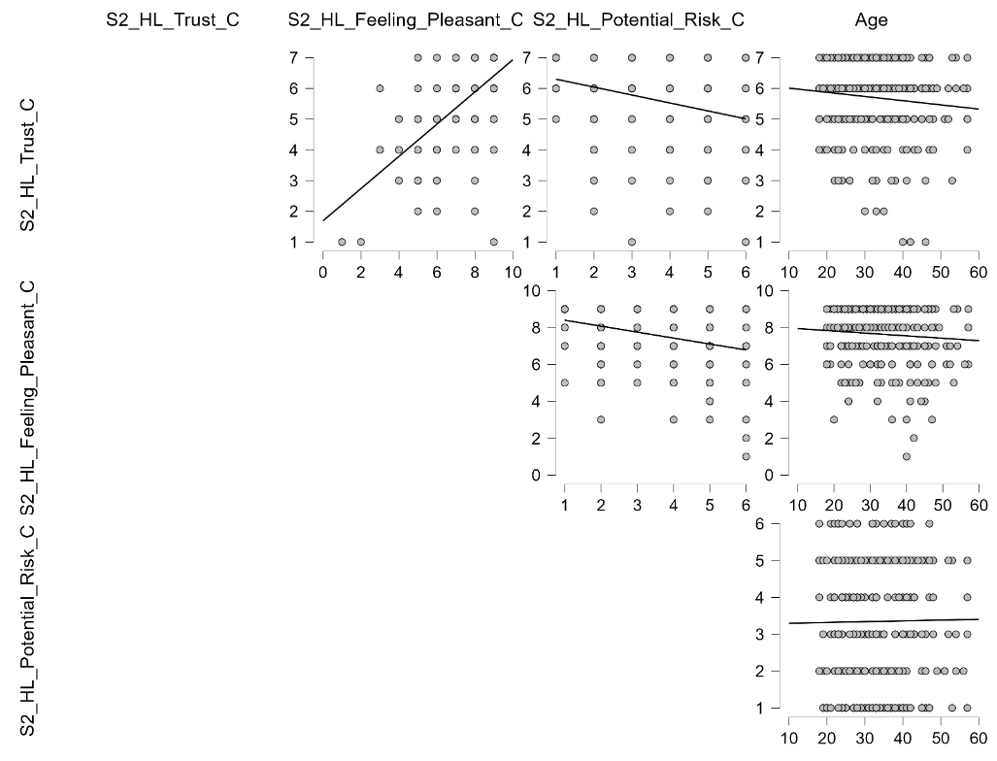
Figure 4. Scatterplots and Monotonicity Assessment for Arab Sample — Second Scenario: High Automation, Low Criticality.

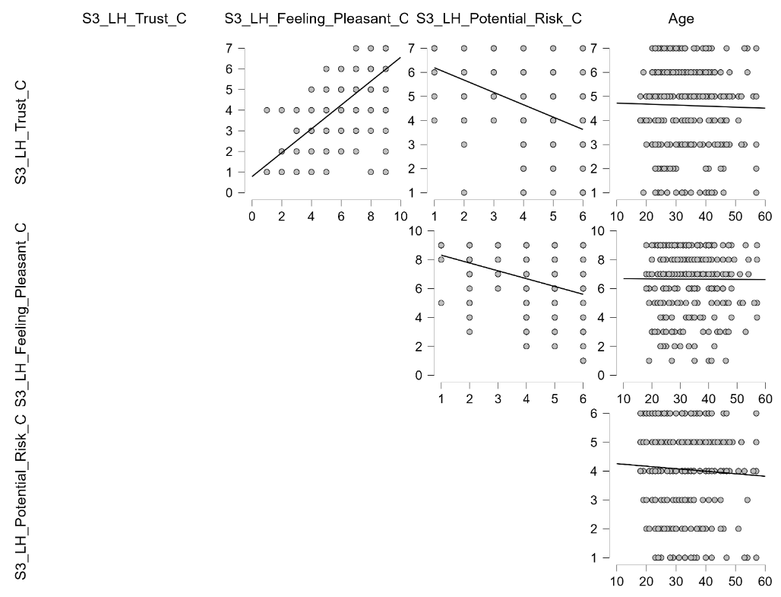
Figure 5. Scatterplots and Monotonicity Assessment for Arab Sample — Third Scenario: Low Automation, High Criticality.

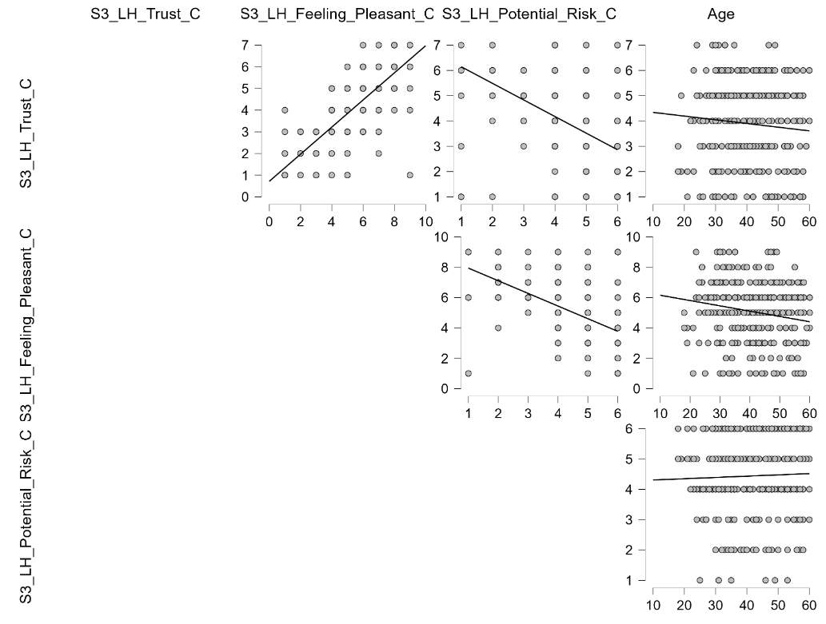
Figure 6. Scatterplots and Monotonicity Assessment for UK Sample — Third Scenario: Low Automation, High Criticality.

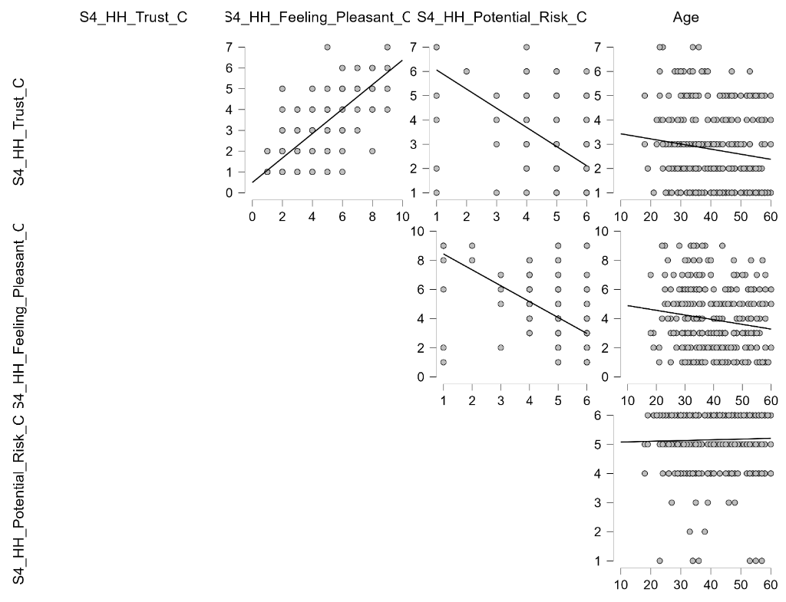
Figure 7. Scatterplots and Monotonicity Assessment for UK Sample — Fourth Scenario: High Automation, High Criticality.

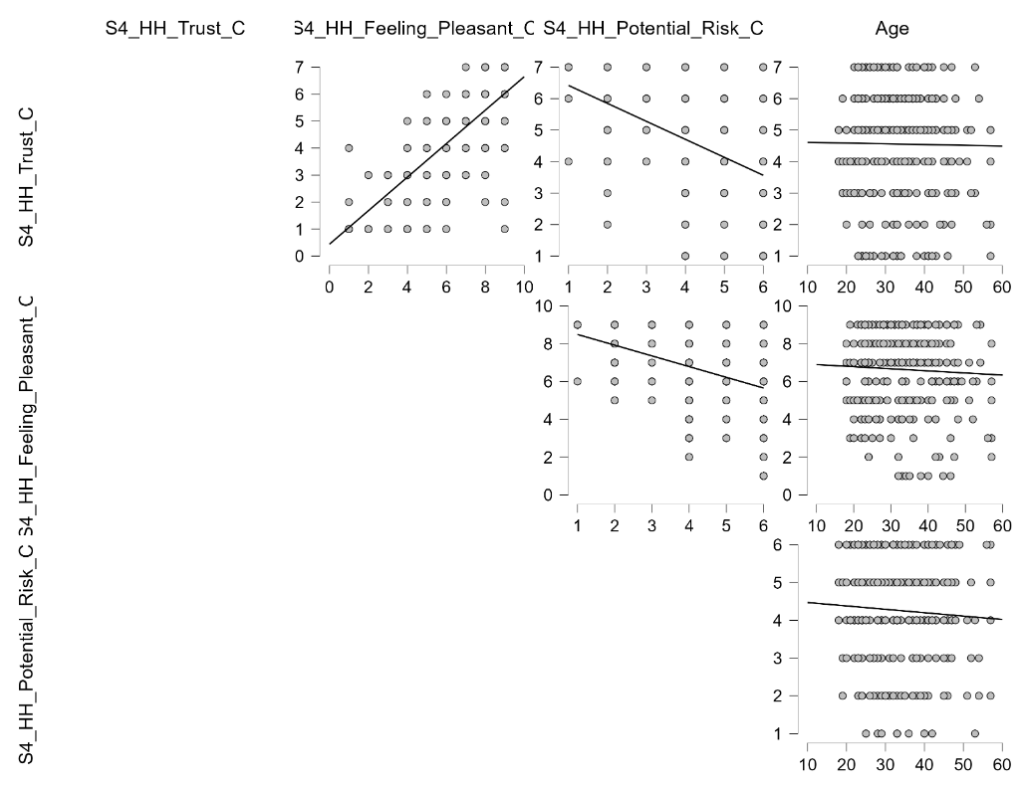
Figure 8. Scatterplots and Monotonicity Assessment for Arab Sample — Fourth Scenario: High Automation, High Criticality.

Pearson's r heatmap – UK sample
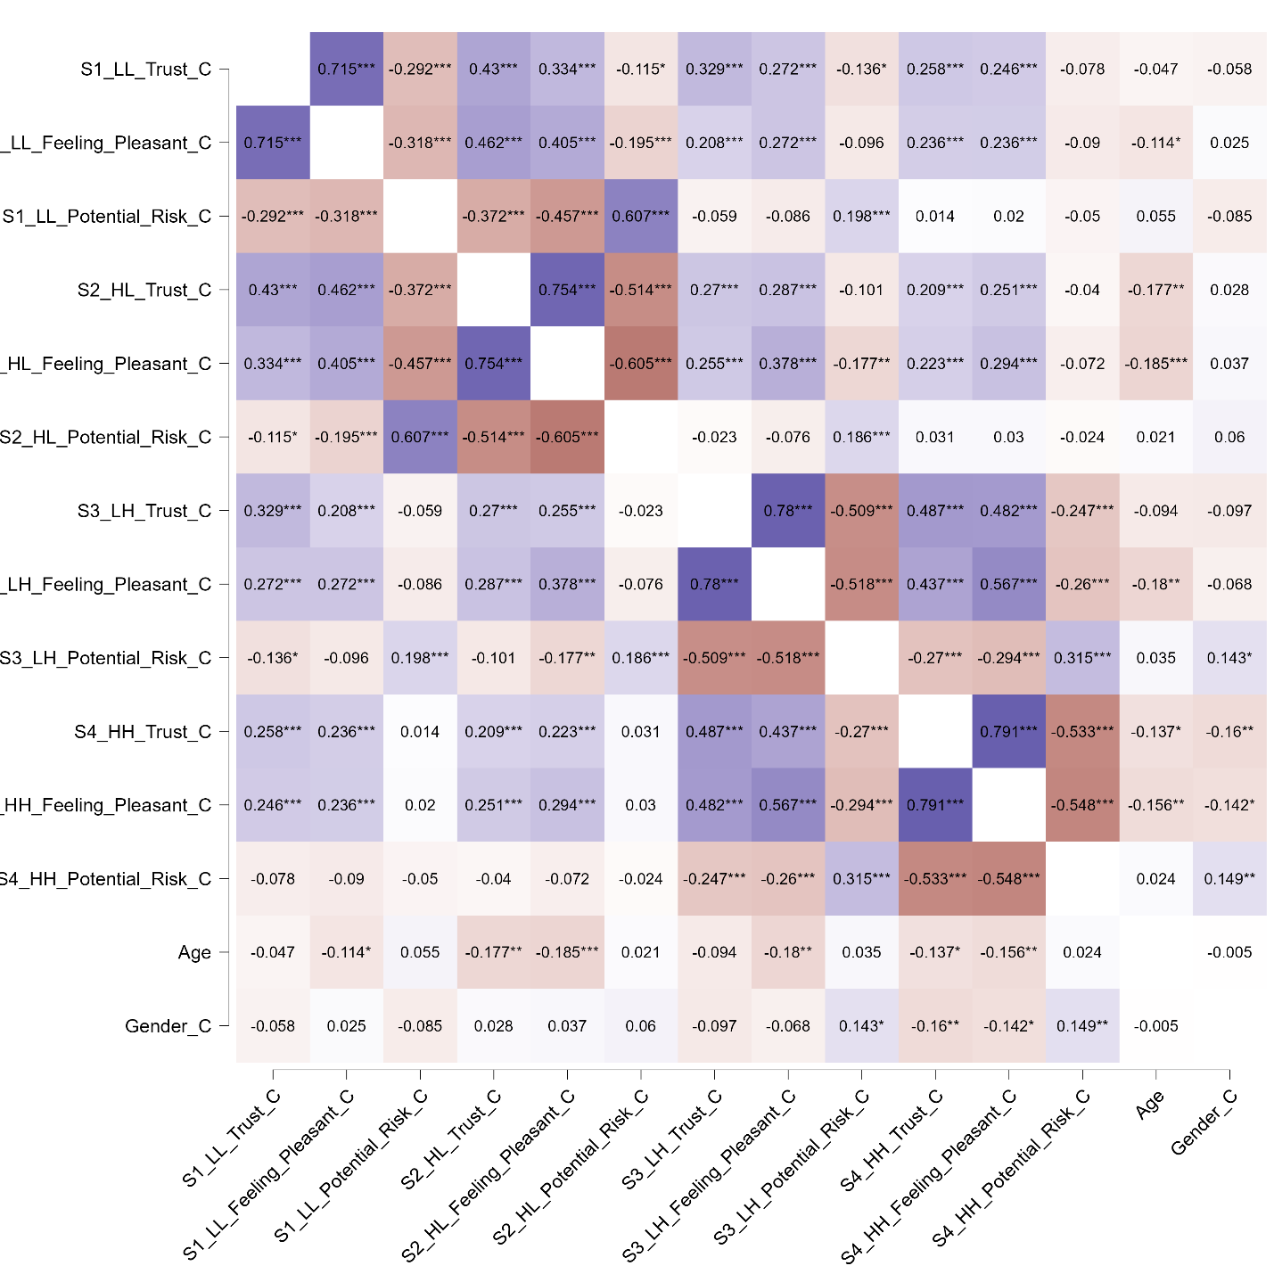

Figure 9. Pearson’s correlations for the variable of interest in the UK sample

Pearson's r heatmap – Arab sample
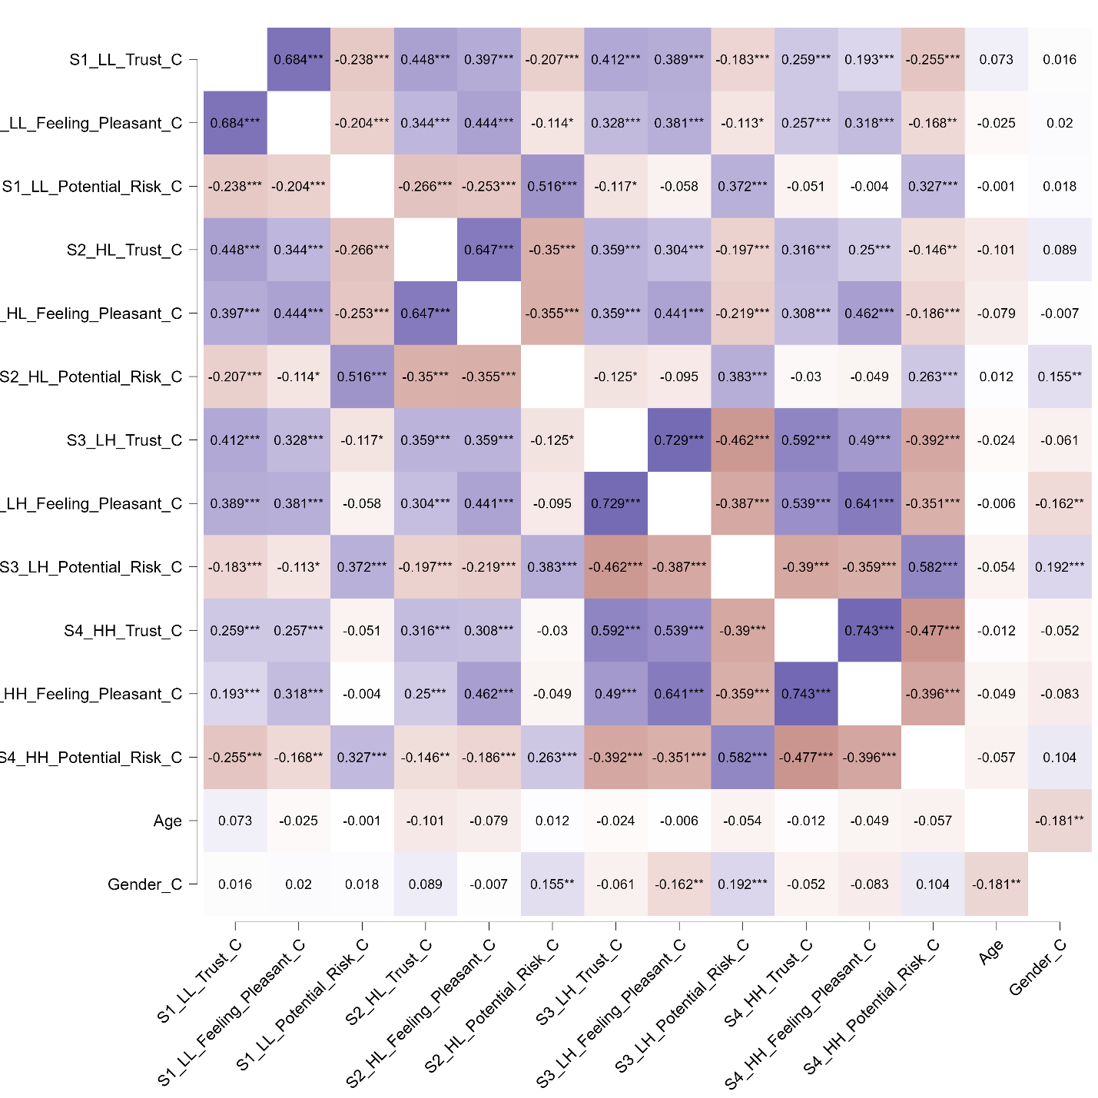

Figure 10. Pearson’s correlations for the variable of interest in the Arab sample

Supplementary Material B: Detailed VIF tables for the four scenarios in UK and Arab samples
 |  |  | UK |  |  |  | Arab GCC
 |  | Model | Emotional response | Potential risk | Age | Gender | Emotional response | Potential risk | Age | Gender
Scenario | LL | Mediator | - | 1.01 | 1.00 | 1.01 | - | 1.00 | 1.03 | 1.03
Scenario | LL | Outcome | 1.12 | 1.12 | 1.01 | 1.01 | 1.04 | 1.04 | 1.03 | 1.04
Scenario | HL | Mediator | - | 1.00 | 1.00 | 1.00 | - | 1.03 | 1.04 | 1.06
Scenario | HL | Outcome | 1.67 | 1.62 | 1.05 | 1.01 | 1.15 | 1.18 | 1.04 | 1.06
Scenario | LH | Mediator | - | 1.02 | 1.00 | 1.02 | - | 1.04 | 1.03 | 1.07
Scenario | LH | Outcome | 1.42 | 1.39 | 1.04 | 1.02 | 1.19 | 1.20 | 1.04 | 1.08
Scenario | HH | Mediator | - | 1.02 | 1.00 | 1.02 | - | 1.01 | 1.04 | 1.04
Scenario | HH | Outcome | 1.48 | 1.45 | 1.03 | 1.03 | 1.20 | 1.20 | 1.04 | 1.05

Table 1. Variance Inflation Factors (VIF) for Mediator and Outcome Models Across the Four Scenarios in UK and Arab Samples.

