Appendices

Appendix 1: Sample Overview

Outlet | Count | Overall Focus | Political Orientation
Times of India | 2333 | Mainstream | Centre Right
The New York Times | 1980 | Mainstream | Liberal
Arab Digest | 1540 | Business | NA
VentureBeat | 1494 | Technology | Liberal
China Daily | 1281 | Mainstream | State-owned
South China Morning Post | 1207 | Mainstream | Centre
Straits Times | 1170 | Mainstream | Conservative
Agence France Presse | 1084 | News Wire | “Neutral”
Canadian Press | 1045 | News Wire | “Neutral”
The Guardian (London) | 1036 | Mainstream | Centre-Left
TechRadar (UK) | 827 | Technology | Centre-Left
THE KOREAN HERALD | 814 | Mainstream | Centre
The Associated Press | 800 | News Wire | Centre-left
CNN Wire | 800 | Mainstream | Centre-left
Forbes.com | 603 | Business | Centre-left

Appendix 2: AI-Keywords
llm_keywords = [
r"\blarge language model\b",
r"\bLLM\b",
r"\bfoundation model\b",
r"\bAI language model\b",
r"\bpretrained language model\b",
r"\bgenerative AI\b",
r"\bchatbot\b",
r"\conversational agent\b",
r"\bself-supervised learning model\b",
r"\bGPT-4\b",
r"\bGPT-3\.5\b",
r"\bGPT-3\b",
r"\bChatGPT\b",
r"\bClaude\b",
r"\bClaude 2\b",
r"\bClaude 3\b",
r"\bLLaMA\b",
r"\bLLaMA 2\b",
r"\bMistral\b",
r"\bMistral 7B\b",
r"\bGemini\b",
r"\bGemini 1\.5\b",
r"\bPaLM\b",
r"\bPaLM 2\b",
r"\bBard\b",
r"\bBLOOM\b",
r"\bFalcon\b",
r"\bOPT\b",
r"Cohere Command R\+",
r"\bDeepSeek\b",
r"\bErnie Bot\b",
r"\bGLM\b",
r"\bPhi-2\b",
r"\bOpenAI\b",
r"\bAnthropic\b",
r"\bMeta AI\b",
r"\bGoogle DeepMind\b",
r"\bGoogle AI\b",
r"\bMistral AI\b",
r"\bCohere\b",
r"\bHugging Face\b",
r"\bEleutherAI\b",
r"\bautoregressive transformer\b",
r"\bfine-tuned LLM\b",
r"\bparameter-efficient tuning\b",
r"\binstruction tuning\b",
r"\bcontext window\b",
r"\bin-context learning\b",
r"\bRLHF\b",
r"\bzero-shot learning\b",
r"\bfew-shot learning\b",
r"\bchain-of-thought reasoning\b"
]

Appendix 3: Coding Instructions Mentalistic Framing

Category 1: Mind_overall
Definition
Any implicit or explicit assignment of a mind, understanding, intentionality, or inner cognitive capacity to LLMs or AI systems.
Coding rule
Code Mind_overall = 1 when the text suggests that an LLM:
- “understands,” “knows,” “thinks,” or “interprets” language or meaning
- is portrayed as more than a purely technical or mechanical system
- is framed as having internal cognitive processes analogous to human mental activity
If no such attribution occurs, code Mind_overall = 0.
Includes
- Metaphorical descriptions implying comprehension or intelligence
- Descriptions of AI “grasping,” “making sense of,” or “understanding” human language
- General mentalistic framing without specifying agency or experience
Excludes
- Purely technical descriptions (e.g. “processes tokens,” “optimises probabilities”)
- Descriptions limited to performance metrics or engineering architecture
Example (mentalistic framing present)
“Imagine a world where every whisper, every question, and every command you make is not just heard but truly understood by machines.”

Category 2: Mental_agentic
Definition
Attributions in which LLMs are framed as active mental agents that do something based on cognitive or intentional capacities.
This category follows an agentic mentalistic framing (after Schweitzer), where the system is portrayed as acting purposefully or intelligently.
Coding rule
Code Mental_agentic = 1 when the text attributes:
- decision-making
- interpreting intentions
- responding intelligently or strategically
- initiating actions based on “understanding” or “reasoning”
If mental language is present but no active agency is implied, code Mental_agentic = 0.
Includes
- “The model decides how to respond”
- “AI understands what users want and adapts its answers”
- “The system talks to users about any topic”
Excludes
- Passive mental states without action
- Descriptions where humans remain the only agents
Example (agentic mentalistic framing)
“But how does this technology understand the complexities of human language, with all its characteristics, slang, and cultural usage?”
Category 3: Mental_experience (Emotional)
Definition
Attributions in which LLMs are framed as experiencing emotions or affective states. This includes language suggesting that the system feels, reacts emotionally, or has internal emotional responses analogous to human feelings.
Unlike Mental_agentic, which focuses on what LLMs do, this category captures portrayals of what LLMs are described as feeling.
Coding rule
Code Mental_experience = 1 when the text explicitly or implicitly suggests that an LLM:
- feels emotions (e.g. happiness, offence, frustration, empathy)
- has affective reactions to users or situations
- responds based on emotional states rather than purely functional outputs
If mentalistic framing is present but limited to cognition or action without emotional experience, code Mental_experience = 0.
Includes
- Emotional verbs or adjectives attributed to LLMs (e.g. felt offended, responded happily, became defensive)
- Descriptions implying emotional sensitivity or hurt
- Anthropomorphic depictions of affective states, even when metaphorical
Excludes
- Claims about tone, style, or politeness without emotional attribution
- Functional descriptions of sentiment detection or affect simulation
- General mental capacities (coded under Mind_overall or Mental_agentic)
Example (emotional mentalistic framing)
“After being criticised by users, the chatbot appeared offended and responded defensively, as if it had taken the comments personally.”

Appendix 4: Volume of articles per sampled outlet over time.
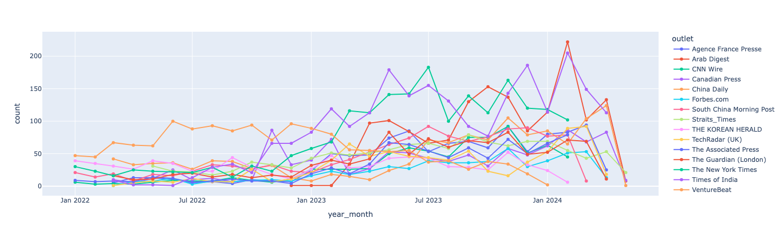

Appendix 5. Top 30 specific emphasis frames (topics) in N1.
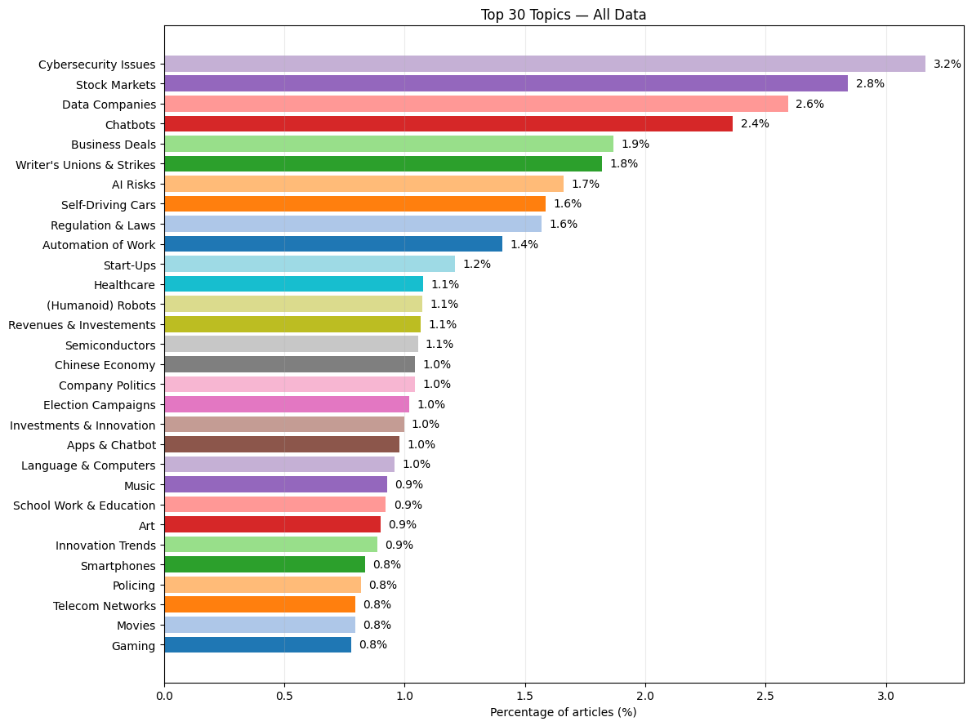

Appendix 6. Meta-frame distribution in N1.
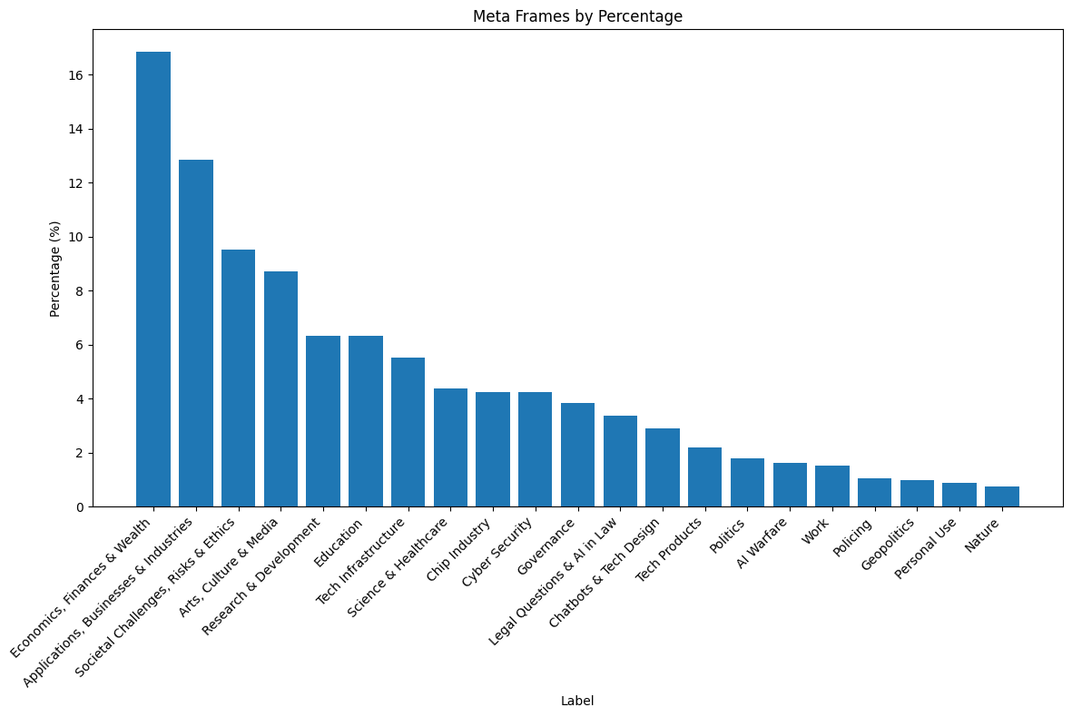

Appendix 7. Meta-frame distribution in N1 over time.
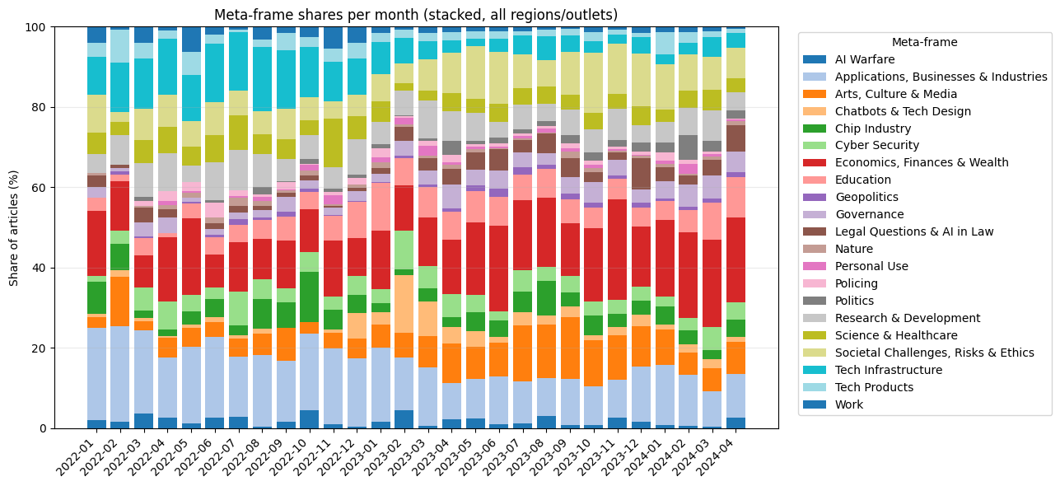

Appendix 8. Meta-frame distribution in N1 over time per world region.
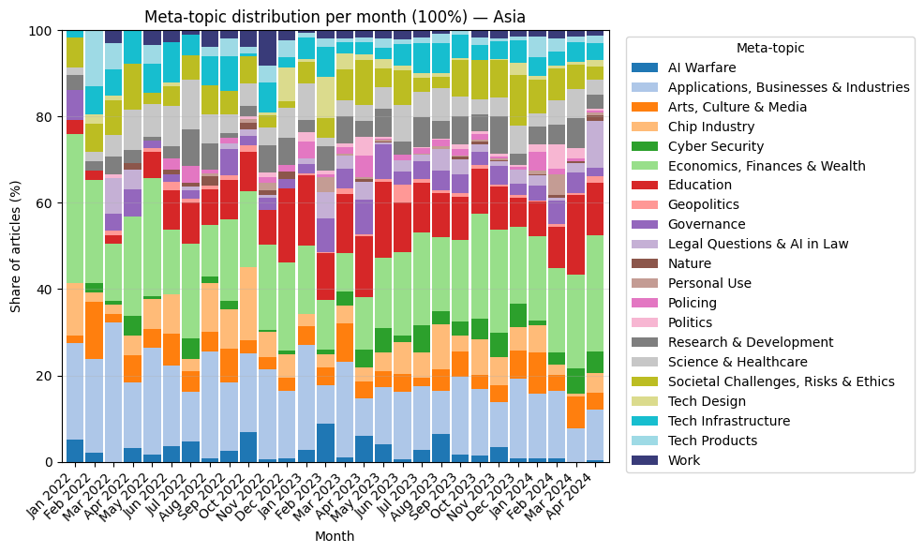
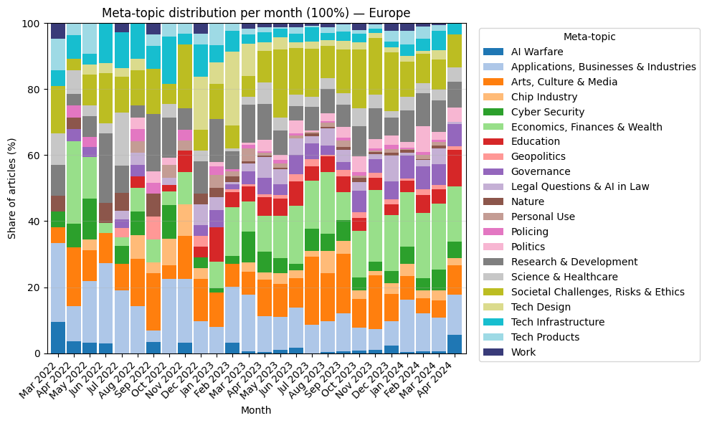
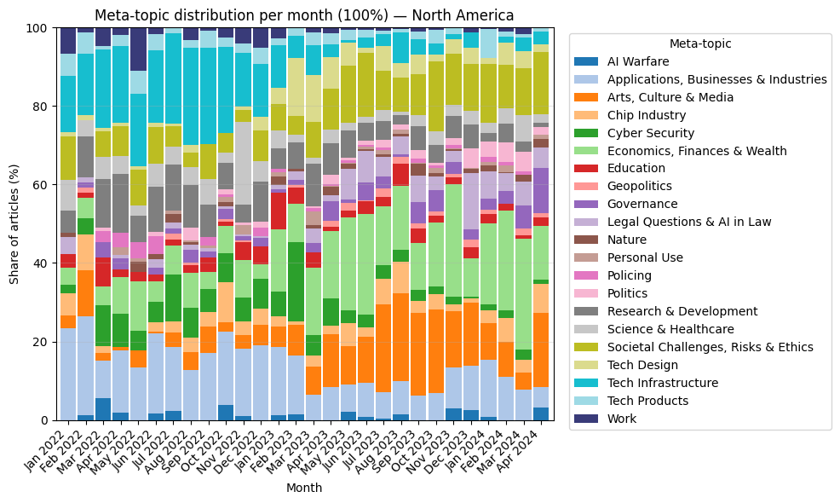

Appendix 9. Agentic Framing of AI in LLM-related articles over time, per region in N2=1631.
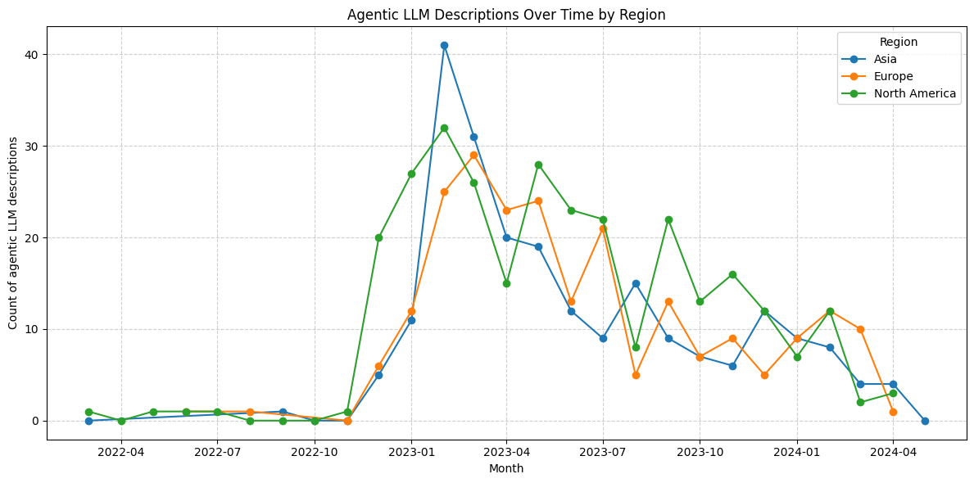

Appendix 10: Example News Articles

Title | Outlet | Date
- A ChatGPT With Eyes and Voice | New York Times | 2023
- ChatGPT is only 2 months old, but has a brain of a 9-year-old | TechRadar | 2023
- AI chatbot gives right answers on journalists’ jobs | South China Morning Post | 2024
- ChatGPT is leaking… again — we shouldn’t be surprised but we should be | TechRadar | 2024
- Stop whining about ChatGPT and Bing AI’s mistakes | TechRadar | 2023
- A fake news frenzy: Why ChatGPT could be disastrous | The Guardian | 2023
- Generative AI could ease access to justice: High Court judge | Strait Times | 2024
- Calm down folks, ChatGPT isn’t actually an artist | TechRadar | 2023
- Google trials its own AI chatbot Bard after success of ChatGPT | The Guardian | 2023

