Framing Artificial Intelligence: Risk and Benefit Narratives in a Preregistered Experiment in Denmark

SUPPLEMENTARY MATERIALS

Table S1. Descriptive statistics of the data used in the study
 | Control group | Treatment group 1 | Treatment group 2 | Total
N | 465 (33.3%) | 464 (33.3%) | 466 (33.4%) | 1,395 100.0%)
Gender
Men | 238 (51.2%) | 240 (51.7%) | 224 (48.1%) | 702 (50.3%)
Women | 227 (48.8%) | 224 (48.3%) | 242 (51.9%) | 693 (49.7%)
Region
Hovedstaden | 129 (27.7%) | 159 (34.3%) | 160 (34.3%) | 448 (32.1%)
Sjælland | 64 (13.8%) | 64 (13.8%) | 69 (14.8%) | 197 (14.1%)
Syddanmark | 96 (20.6%) | 104 (22.4%) | 98 (21.0%) | 298 (21.4%)
Midtjylland | 125 (26.9%) | 97 (20.9%) | 99 (21.2%) | 321 (23.0%)
Nordjylland | 51 (11.0%) | 40 (8.6%) | 40 (8.6%) | 131 (9.4%)
Age group
25-34 | 112 (24.1%) | 114 (24.6%) | 107 (23.0%) | 333 (23.9%)
35-44 | 97 (20.9%) | 114 (24.6%) | 116 (24.9%) | 327 (23.4%)
45-54 | 127 (27.3%) | 128 (27.6%) | 125 (26.8%) | 380 (27.2%)
55-64 | 129 (27.7%) | 108 (23.3%) | 118 (25.3%) | 355 (25.4%)

Table S2. Codes per Question
Question | Primary Codes | Secondary Codes
Q1 | P = Positive (AI creates opportunities, improves work, makes jobs easier)  N = Negative (AI eliminates jobs, reduces opportunities, causes unemployment)  NI = Neutral/No Impact (no significant change expected)  M = Mixed (both positive and negative impacts mentioned)  U = Uncertain/Unclear (unsure about impact or response unclear, e.g., “I am a pensioner”) | JR = Job Replacement (AI will take over entire jobs)  JA = Job Assistance (AI will help/augment human work, specific tasks can be automated)  JC = Job Creation (new types of jobs will emerge)  NC = No Change expected (summary for all responses that are not referring to JA, JC, JR)
Q2 | D = Dependent (“Yes, current generation is too dependent on AI”)  ND = Not Dependent (“No, not too dependent”)  M = Mixed/Uncertain (“both dependency and benefits”, “unsure”; “too early to tell”; “can't compare”; response does not give an explicit answer, might only give an example) | CT = Critical Thinking Loss (lack of independent thought, uncritical acceptance, does not think for self)  SK = Skills Erosion (loss of abilities: writing, math, problem-solving, cognitive abilities, “we are getting dumber”, “will be a lack of knowledge”, “cannot manage without it”)  LZ = Laziness/Passivity (taking easy route, “why spend time on things”, “becoming dull and complacent”)  MI = Misinformation Risk (vulnerable to false information, lack of source criticism)  CR = Creativity Loss (reduced creativity, innovation)  NA = not applicable - everything else that does not fit in any of the above-mentioned categories

Automated Coding of Open-Ended Survey Responses Using LLM
Danish survey respondents (n = 1400) answered the following two open-ended questions:
- Q1. “How do you think AI advancements will impact job opportunities in your field over the next decade?” (n of valid responses: 683)
- Q2. “Do you feel that the current generation has become too dependent on artificial intelligence compared to your parents' generation's self-reliance?” (n of valid responses: 675)
We inductively created coding schemes for both questions. We distinguish between primary codes (the high-level response to the question) and secondary codes (more detailed responses, focusing on the reasoning behind the initial response).
The annotation task in itself is not trivial given the shortness of responses. Using a generative model allowed to provide more context and some examples (“few shot”), leading to reliable classification. Initial attempts using an encoder LLM (i.e., a RoBERTA classifier using a base model for Danish, fine-tuned for the annotation task) yielded highly unsatisfactory results (macro F1 < 0.6). Thus, we used a local generative LLM (Qwen 2.5 with 7 billion parameters) which we accessed via the Ollama framework and the ellmer package (Wickham et al. 2024) in R. The analyses were conducted on a 2021 MacBook Pro with an M1Pro chip, processing times were approximately 3 hours (~10s per response). We set a seed (42) and the temperature parameter to 0.1 (to ensure reproducibility). While temperature=0.1 does not guarantee perfect reproducibility, we found it to perform slightly better than temperature=0 (see Figure S2) in the case of Q1 (Primary), a question where both models showed lowest accuracy overall. We weighed this higher than Q2 (secondary), where temperature=0 performed better. However, it is worth noting that the models’ performances in terms of accuracy lie well within the 95% confidence intervals and their alignment is almost perfect (Krippendorff’s Alpha=[0.91–1]).

Prompting strategy
The model receives instructions via prompting, which allowed us to include further context (such as the survey question and examples – “few shot”). The prompt was formatted in Markdown format since this has been shown to be well “understood” by such models. During prompt development, the LLM-provided reasoning was qualitatively reviewed for a sub-sample to identify systematic biases or misinterpretations of the coding scheme and the prompt was refined subsequently. During classification, the model was reinitialized each round to mitigate misclassifications due to memory effects. The prompt structure looked as follows (including examples for Q1, primary code):

(1) Its role:
“You are a Danish research assistant tasked with coding open-ended survey responses. “
(2) the survey question context:
“The survey question was: 'How do you think AI advancements will impact job opportunities in your field over the next decade? (please write at least three words)'”
(3) coding category definitions with brief descriptions (see Table S4):
“CODING INSTRUCTIONS:
PRIMARY IMPACT DIRECTION (choose ONE):
P = Positive (AI creates opportunities, improves work, makes jobs easier)
N = Negative (AI eliminates jobs, reduces opportunities, causes unemployment)
NI = Neutral/No Impact (no significant change expected)
M = Mixed (both positive and negative impacts mentioned)
U = Uncertain/Unclear (unsure about impact or response unclear, e.g., 'I am a pensioner')”
(4) specific rules – here, we provided some examples that the model seemed to commonly misclassify:
“SPECIAL INSTRUCTIONS:
- For very short responses, use your best judgment, code as U when in doubt
- If multiple contradictory views are expressed in one response, code as M (Mixed)
- Always provide a verbatim English translation
- 'På ingen måde' and 'Overhovedet ikke' (not at all) refers to NI”
(5) required output structure. The prompt submitted via “ellmer” (Wickham et al. 2024) further instructed the model to provide three fields for each response: code (constrained to the respective coding options), reasoning (brief justification), and translation (verbatim English translation of the response).

Table S3. Classification performance metrics
Classification Task | Accuracy | Krippendorff’s Alpha | F1 | Support
Q26 (primary) | 0.95 | 0.93 | Class:P = 0.97  Class:NI = 0.96  Class:N = 0.96  Class:U = 0.86 | Class:P = 19  Class:NI = 34  Class:N = 37  Class:U = 10
Q26 (secondary) | 0.9 | 0.84 | Class:JA = 0.97  Class:JC = 0.57  Class:JR = 0.84  Class:NC = 0.92 | Class:JA = 20  Class:JC = 3  Class:JR = 19  Class:NC = 58
Q27 (primary) | 0.89 | 0.83 | Class:D = 0.94  Class:ND = 0.89  Class:M = 0.82 | Class:D = 43  Class:ND = 28  Class:M = 29
Q27 (secondary) | 0.90 | 0.88 | Class:CR = 1.00  Class:CT = 0.91  Class:LZ = 1.00  Class:MI = 1.00  Class:SK = 0.78  Class:NA = 0.97 | Class:CR = 1  Class:CT = 10  Class:LZ = 2  Class:MI = 1  Class:SK = 9  Class:NA = 77

Classification performance
Comparing them against a manually annotated test set of 100 manually annotated examples (1 sample per primary/secondary code respectively, 4 samples total) yielded the results shown in Table S3. These results are highly robust. Especially given the fact that some classes are highly underrepresented (e.g., MI and LZ), which traditional supervised classification approaches tend to struggle with. The complete system prompts, R code, and validation dataset are available at OSF https://osf.io/dt3c9/overview?view_only=80a8a3fc03b242588f9fb8ce1cb44cec.
Some limitations prevail: First, our results might be model-specific and thus not generalize to other LLMs without recalibration. Second, our small validation sample (n=100) provides initial reliability estimates but may not capture all edge cases. Third, we found coding performance to depend strongly on the quality of the system prompt. Finally, our catch-all categories might conflate multiple distinct reasons for non-classification, which reduces their interpretability.

Table S4. Pairwise comparisons of treatment and control groups with the outcome measure of the impact of AI on society
 | Contrast | SE | P>|t| | 95%CI low | 95%CI high
Impact of AI on society (strongly positive=1, strongly negative=5)
Treatment group 1 vs Control group | 0.12 | 0.08 | 0.106 | -0.03 | 0.27
Treatment group 2 vs Control group | -0.17 | 0.08 | 0.030 | -0.33 | -0.02
Treatment group 2 vs Treatment group 1 | -0.29 | 0.08 | 0.001 | -0.46 | -0.13
(Strongly) Positive impact of AI on society
Treatment group 1 vs Control group | -0.04 | 0.03 | 0.222 | -0.10 | 0.02
Treatment group 2 vs Control group | 0.06 | 0.03 | 0.049 | 0.00 | 0.13
Treatment group 2 vs Treatment group 1 | 0.10 | 0.03 | 0.004 | 0.03 | 0.17
(Strongly) Negative impact of AI on society
Treatment group 1 vs Control group | 0.05 | 0.03 | 0.103 | -0.01 | 0.12
Treatment group 2 vs Control group | -0.09 | 0.03 | 0.005 | -0.16 | -0.03
Treatment group 2 vs Treatment group 1 | -0.15 | 0.04 | 0.000 | -0.22 | -0.07

Table S5. Results for survey experiments with the outcome measure of the AI might cause the current generation to lose important skills
 | Contrast | SE | P>|t| | 95%CI low | 95%CI high
AI might cause the current generation to lose important skills (strongly agree=1, strongly disagree=5)
Treatment group 1 vs Control group | -.04 | .07 | 0.539 | -.17 | .09
Treatment group 2 vs Control group | -.08 | .06 | 0.186 | -.21 | .04
Treatment group 2 vs Treatment group 1 | -.04 | .06 | 0.498 | -.17 | .08
(Strongly) agree that AI might cause the current generation to lose important skills
Treatment group 1 vs Control group | -.00 | .03 | 0.980 | -.06 | .06
Treatment group 2 vs Control group | .02 | .03 | 0.460 | -.04 | .08
Treatment group 2 vs Treatment group 1 | .02 | .03 | 0.467 | -.04 | .09
(Strongly) disagree that AI might cause the current generation to lose important skills
Treatment group 1 vs Control group | -.00 | .02 | 0.924 | -.04 | .04
Treatment group 2 vs Control group | -.02 | .02 | 0.318 | -.06 | .02
Treatment group 2 vs Treatment group 1 | -.02 | .02 | 0.366 | -.06 | .02

A. Visual seen as part of treatment by Group 1 | B. Visual seen as part of treatment by Group 2
 | 
Figure S1. Visuals seen by treatment group participants, along with the text described in the study

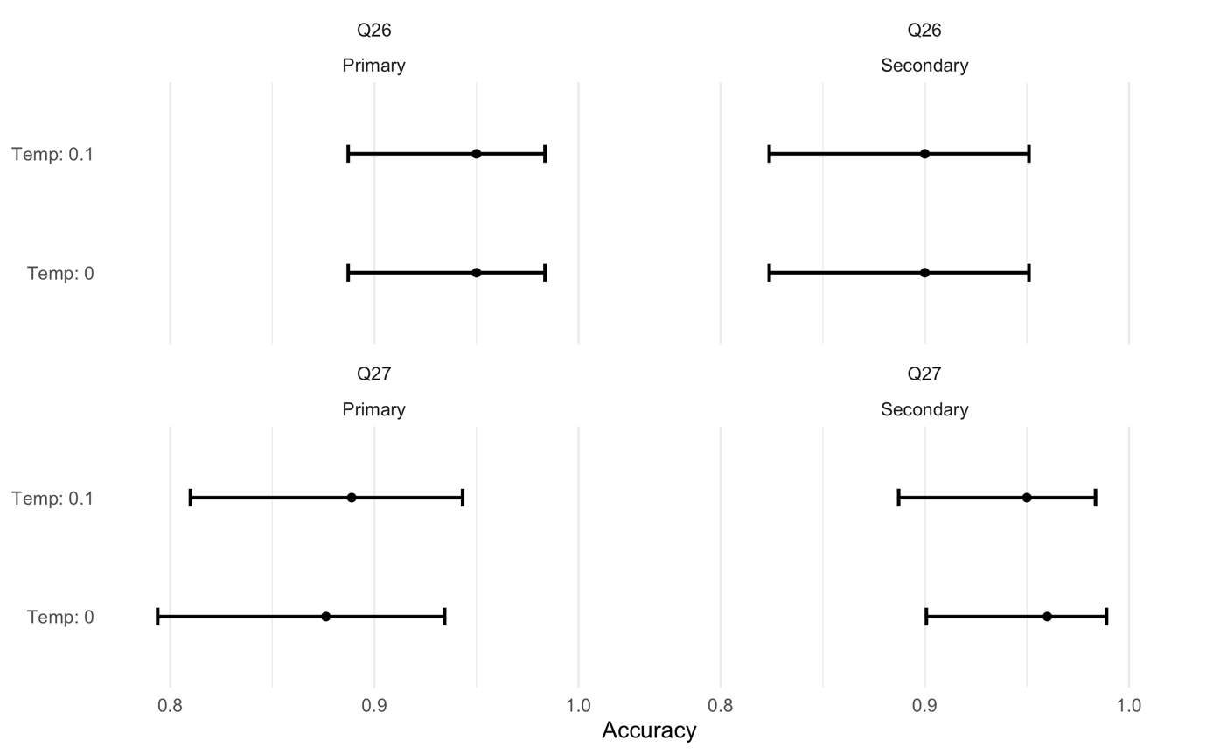
Figure S2. Comparing temperatures 0 and 0.1, bars show 95% confidence intervals.

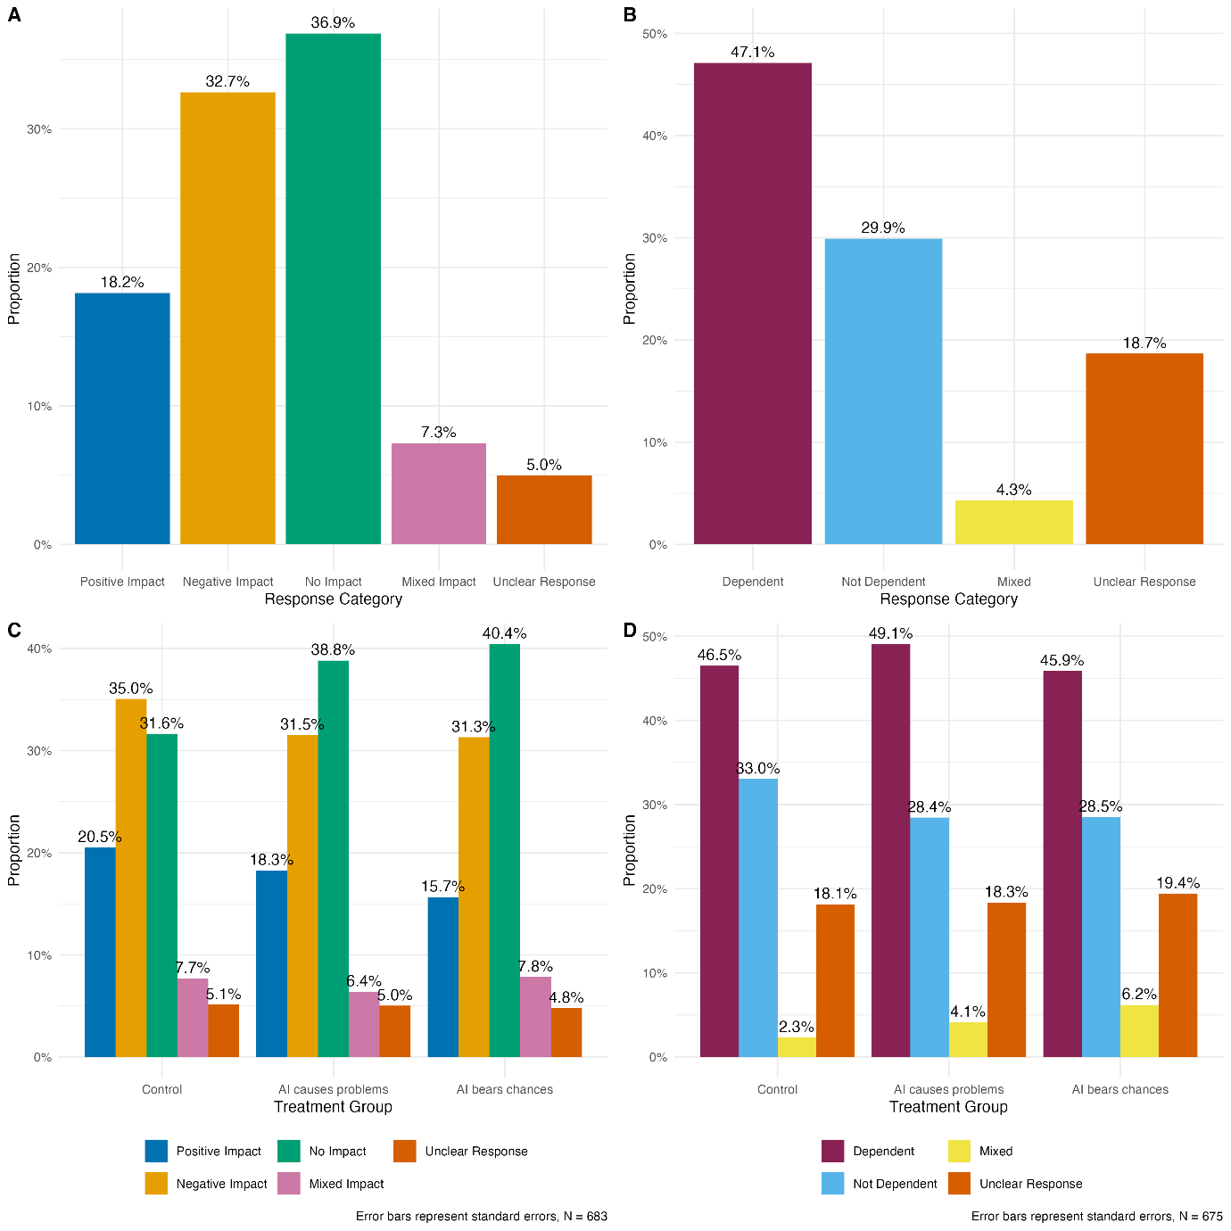
Figure S3. Distribution of open-ended responses on the effect of AI on jobs and dependency,
and by a randomized survey experiment, bars show 95% confidence intervals.

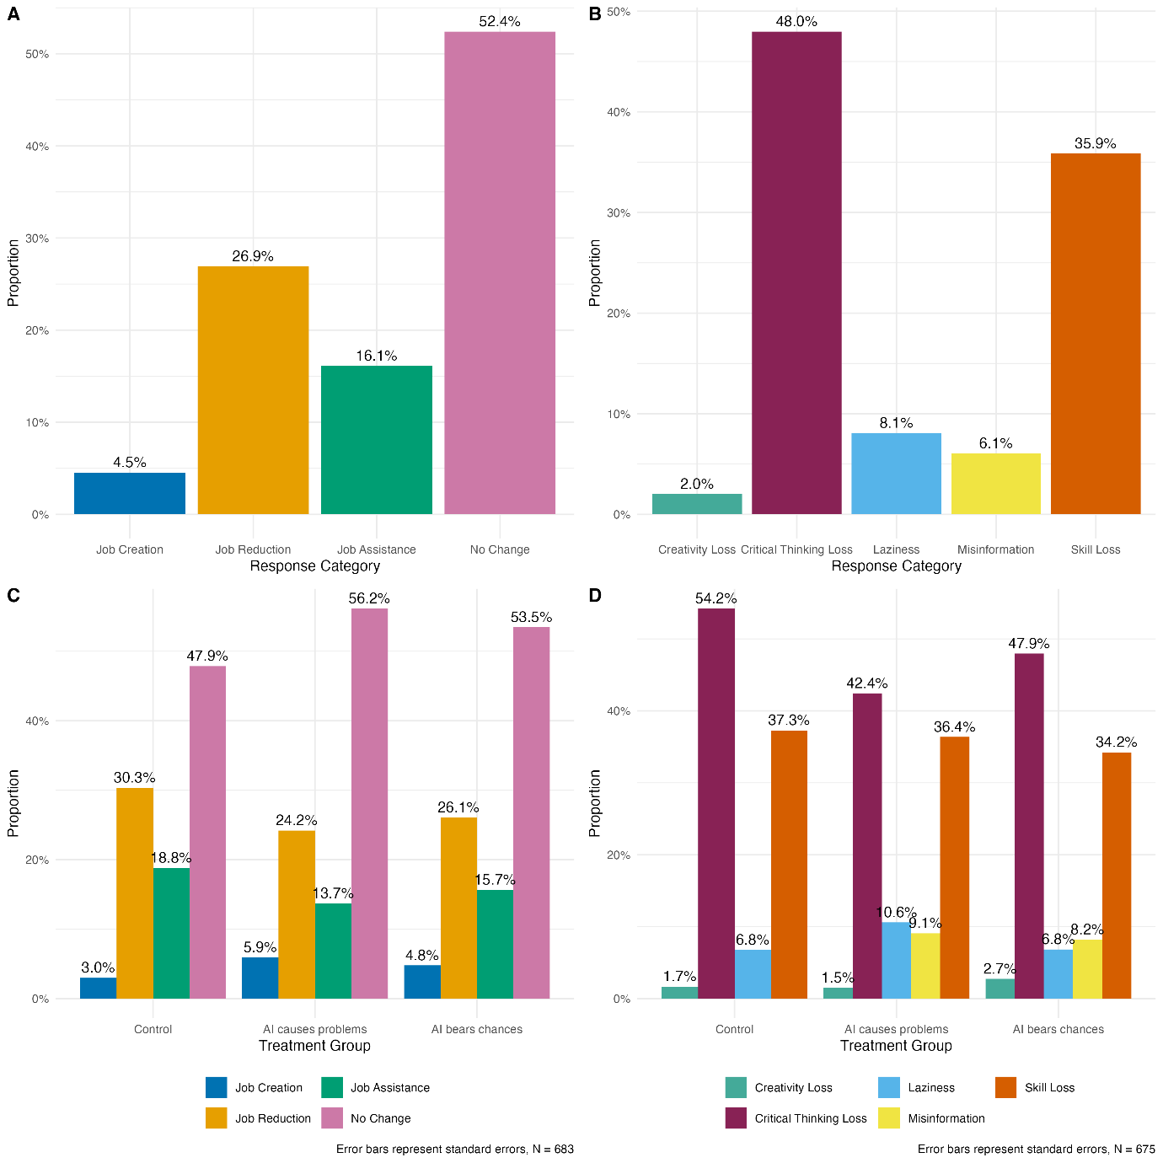

Figure S4. Distribution of open-ended responses on the effect of AI on jobs and dependency by mechanisms, and by the randomized survey experiment, bars show 95% confidence intervals.

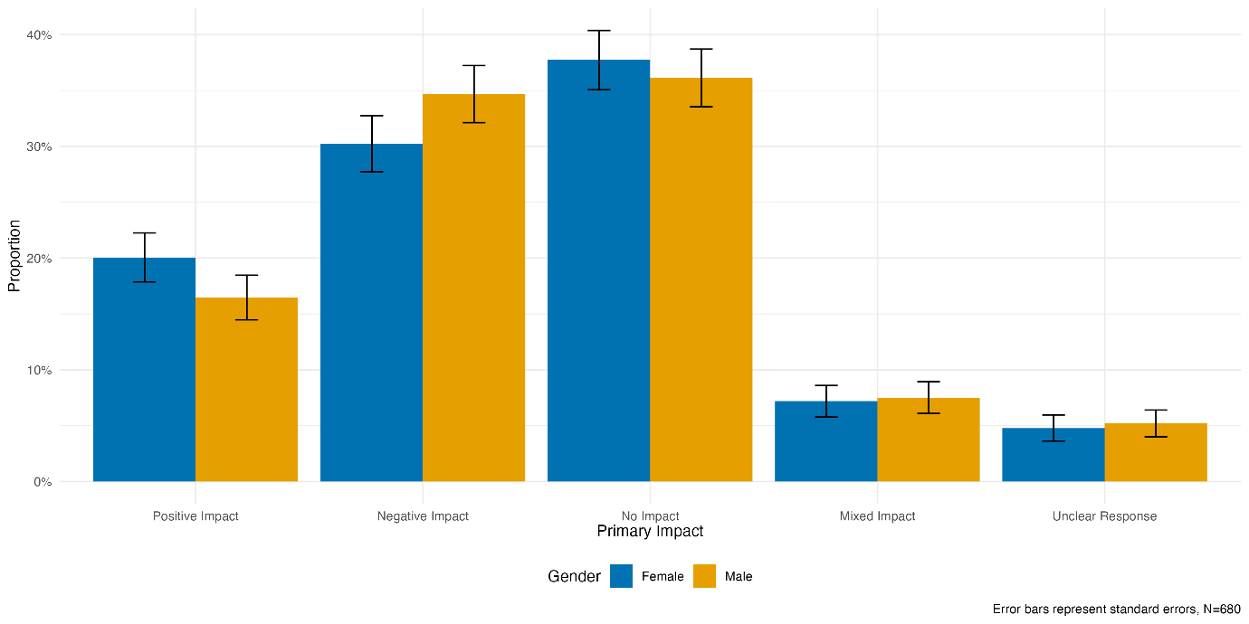
Figure S5. Distribution of open-ended responses on the primary impact of AI on jobs by gender.

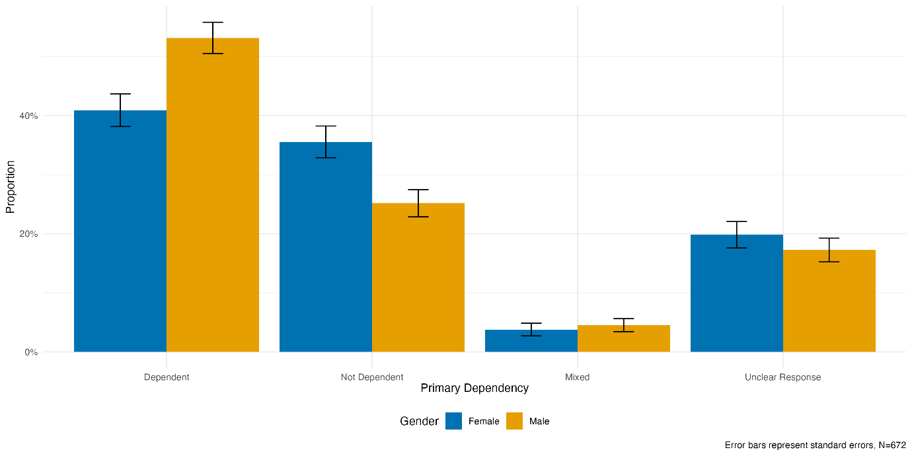
Figure S6. Distribution of open-ended responses on the primary dependency on AI by gender.

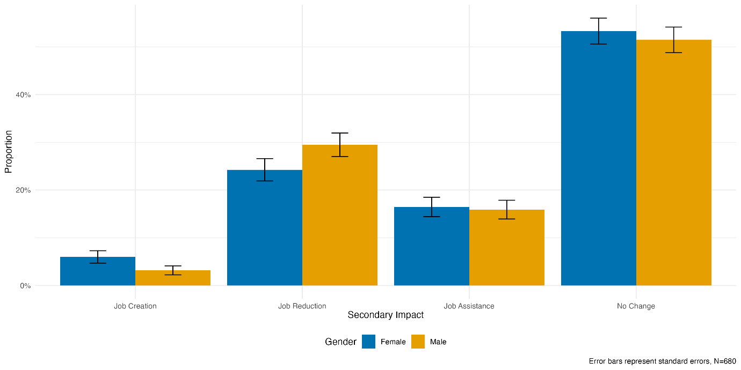
Figure S7. Distribution of open-ended responses on the secondary impact of AI on jobs by gender.

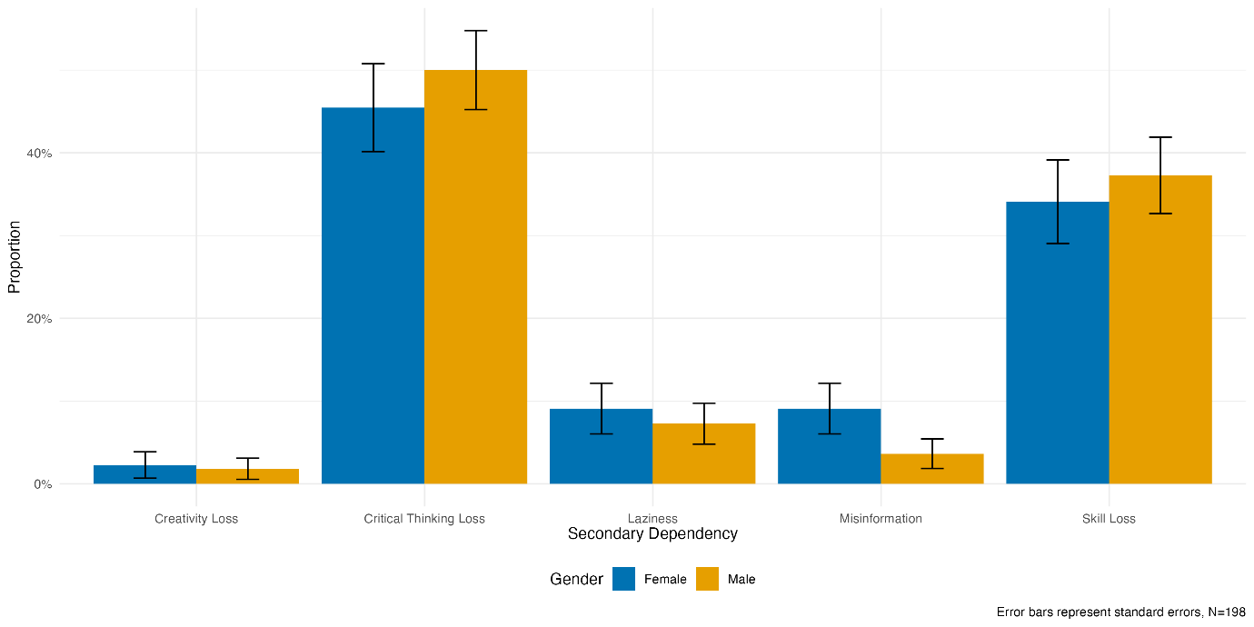
Figure 8. Distribution of open-ended responses on the secondary dependency on AI by gender.

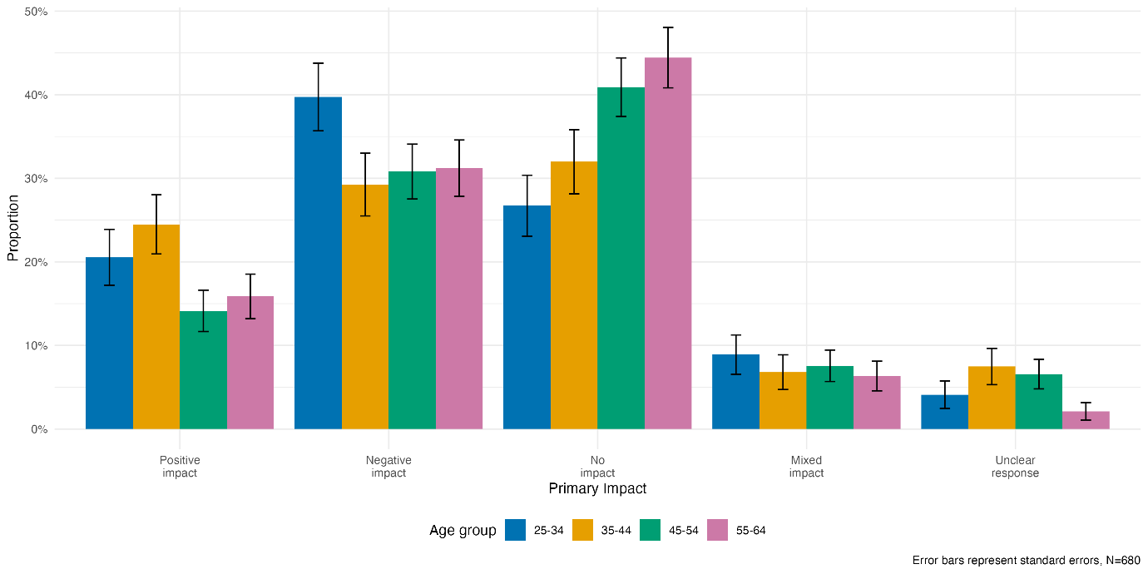
Figure S9. Distribution of open-ended responses on the primary impact of AI on jobs by age groups.

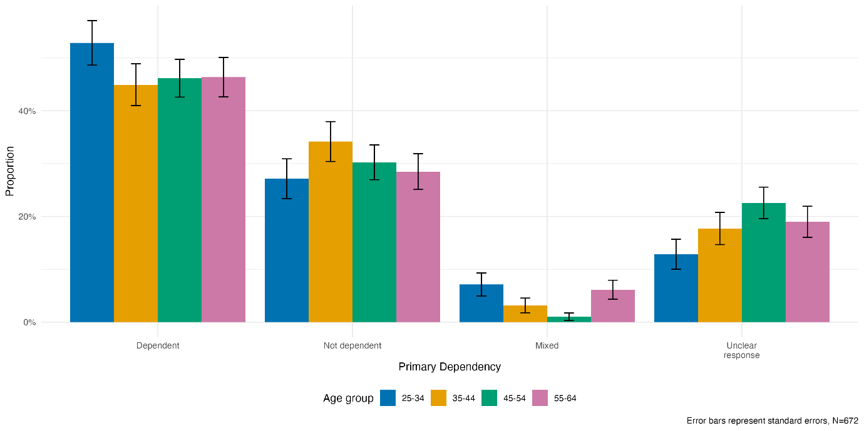
Figure S10. Distribution of open-ended responses on the primary dependency on AI by age groups.

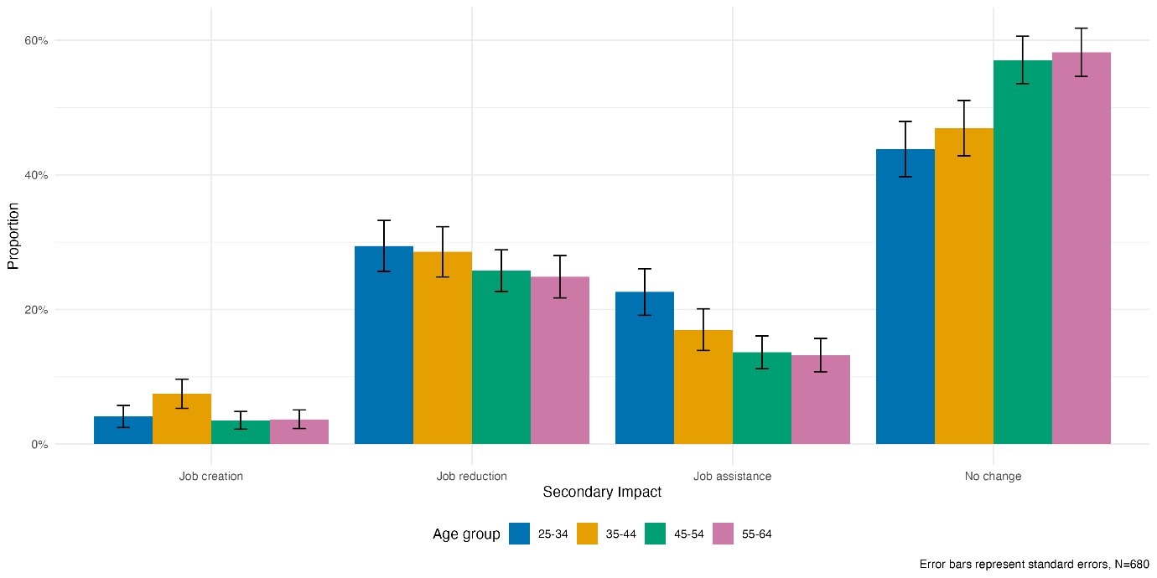
Figure S11. Distribution of open-ended responses on the secondary impact of AI on jobs by age groups.

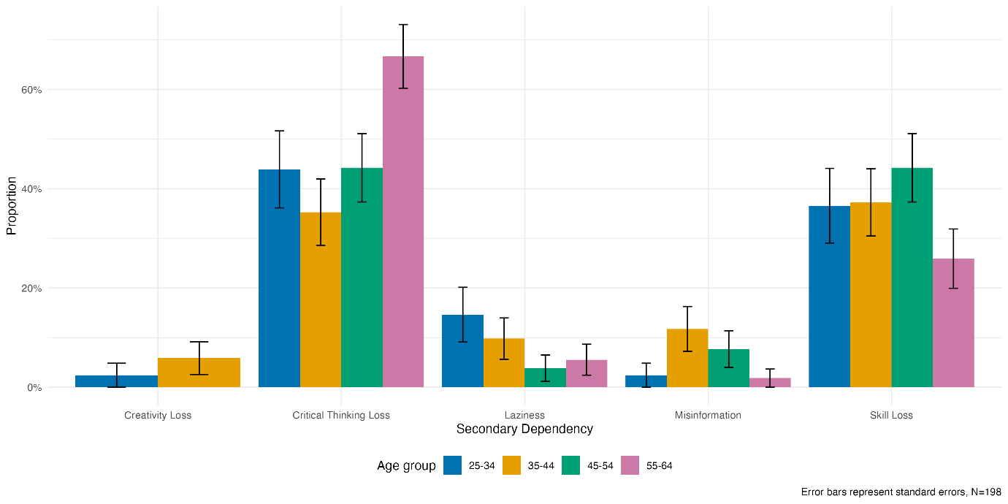
Figure S12. Distribution of open-ended responses on the secondary dependency on AI by age groups.

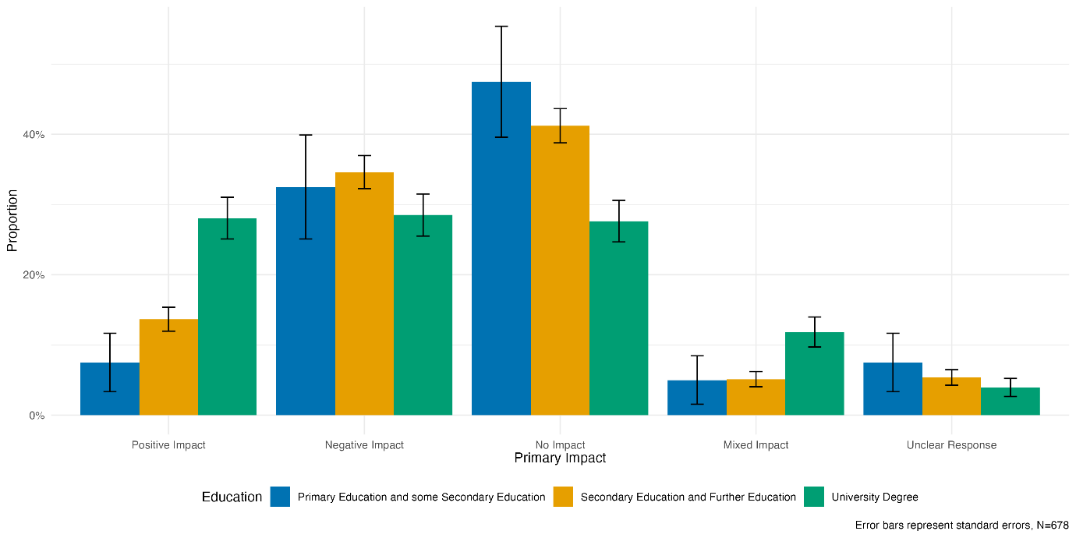
Figure S13. Distribution of open-ended responses on the primary impact of AI on jobs by education.

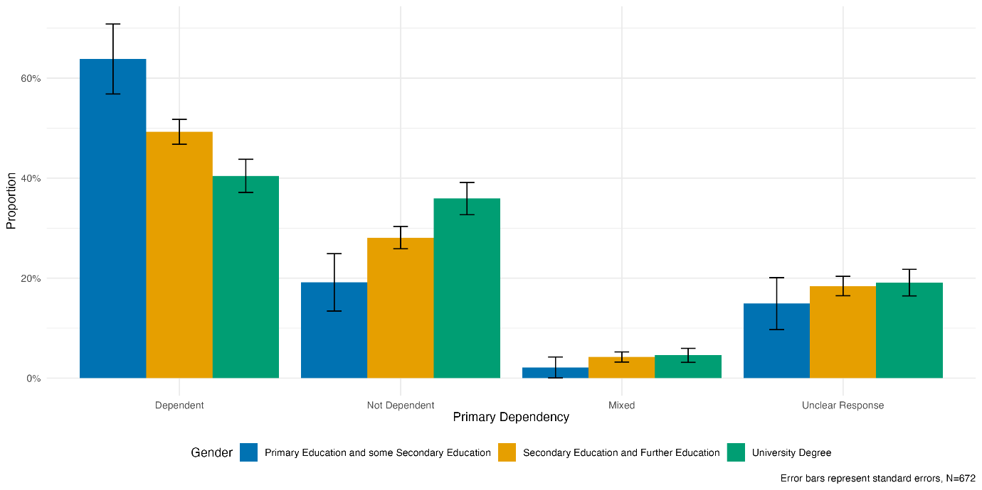
Figure S14. Distribution of open-ended responses on the primary dependency on AI by education.

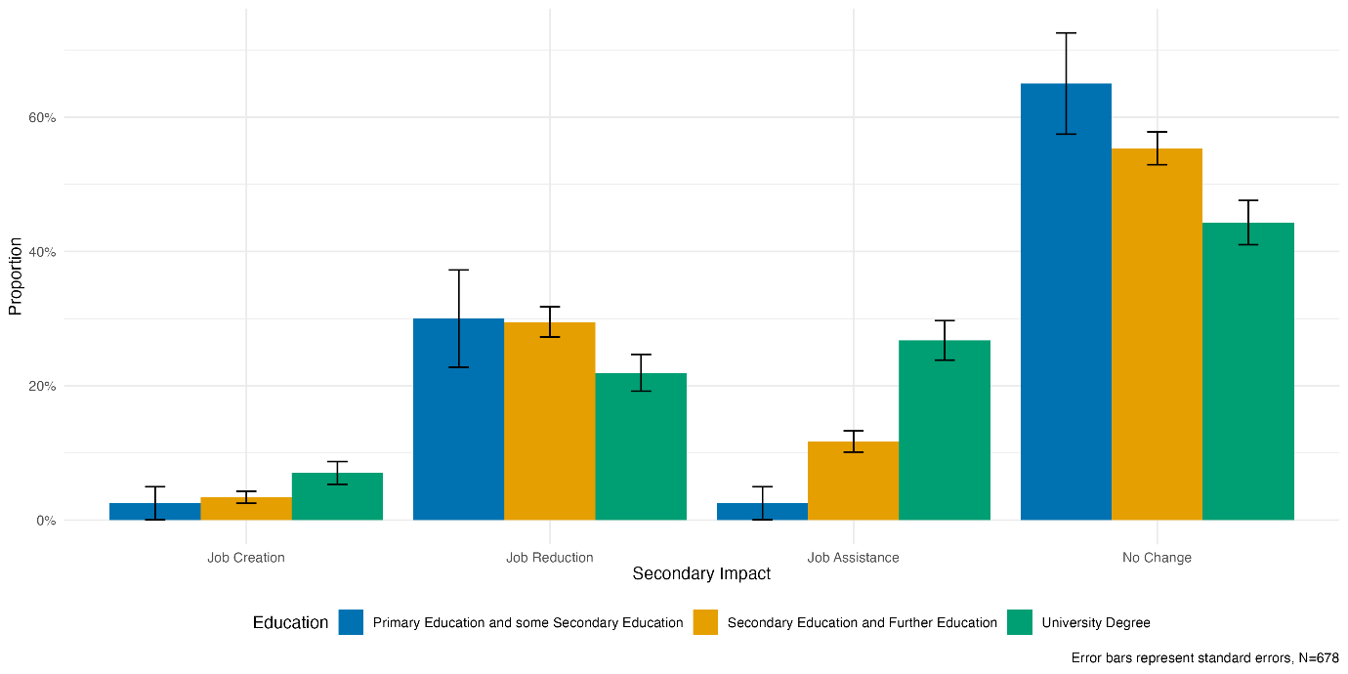
Figure S15. Distribution of open-ended responses on the secondary impact of AI on jobs by education.

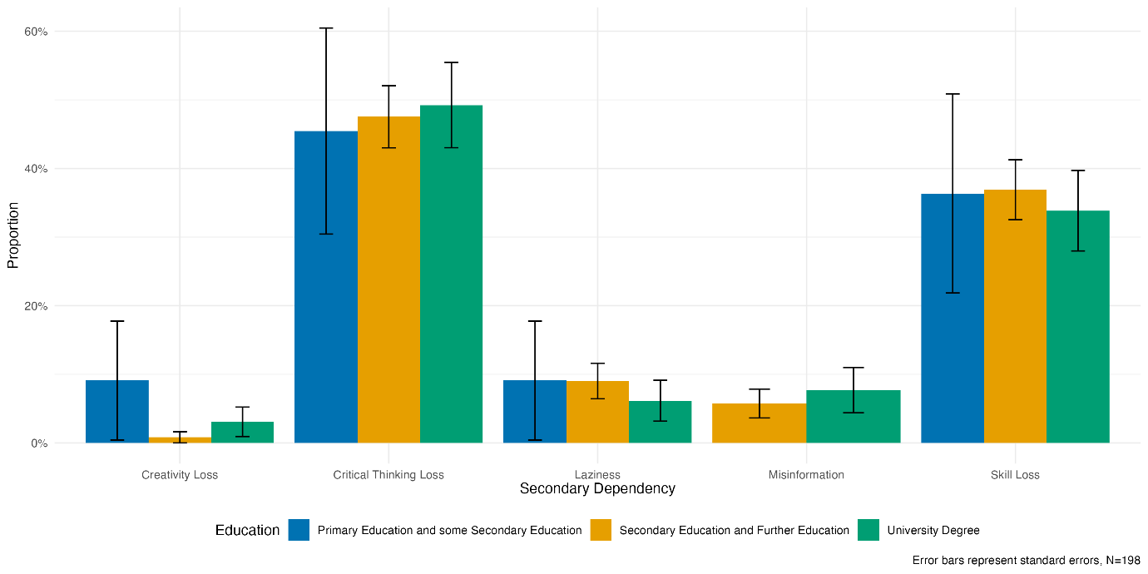
Figure S16. Distribution of open-ended responses on the secondary dependency on AI by education.

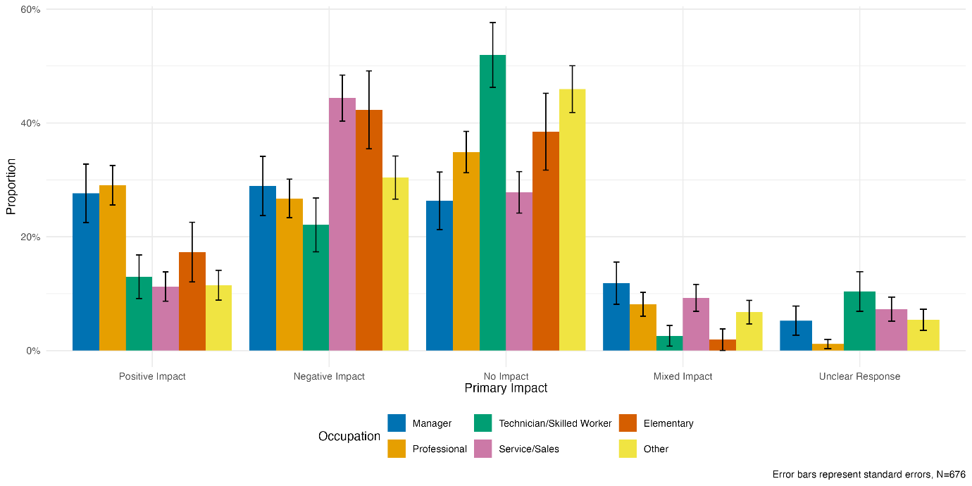
Figure S17. Distribution of open-ended responses on the primary impact of AI on jobs by occupation.

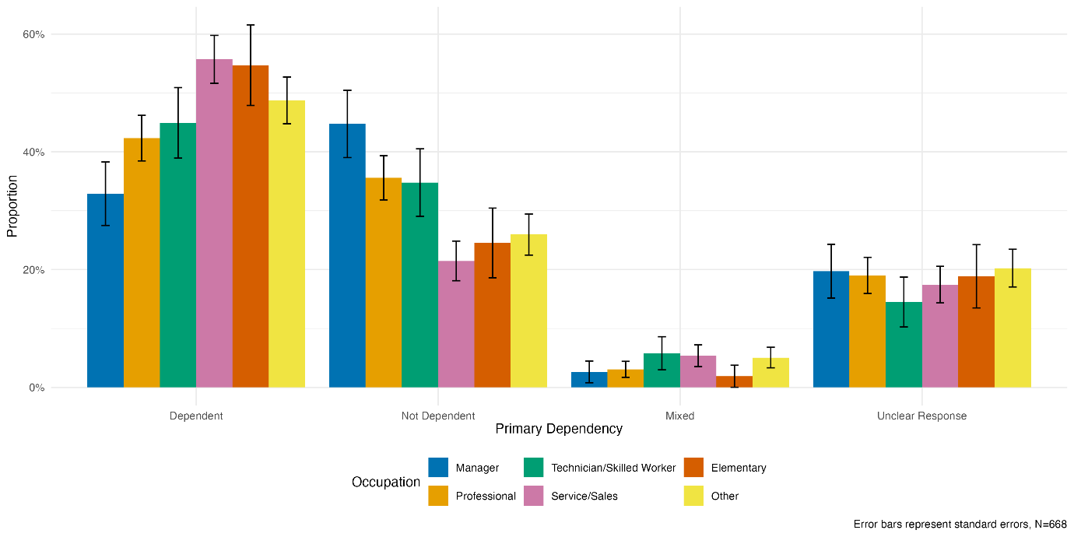
Figure S18. Distribution of open-ended responses on the primary dependency on AI by occupation.

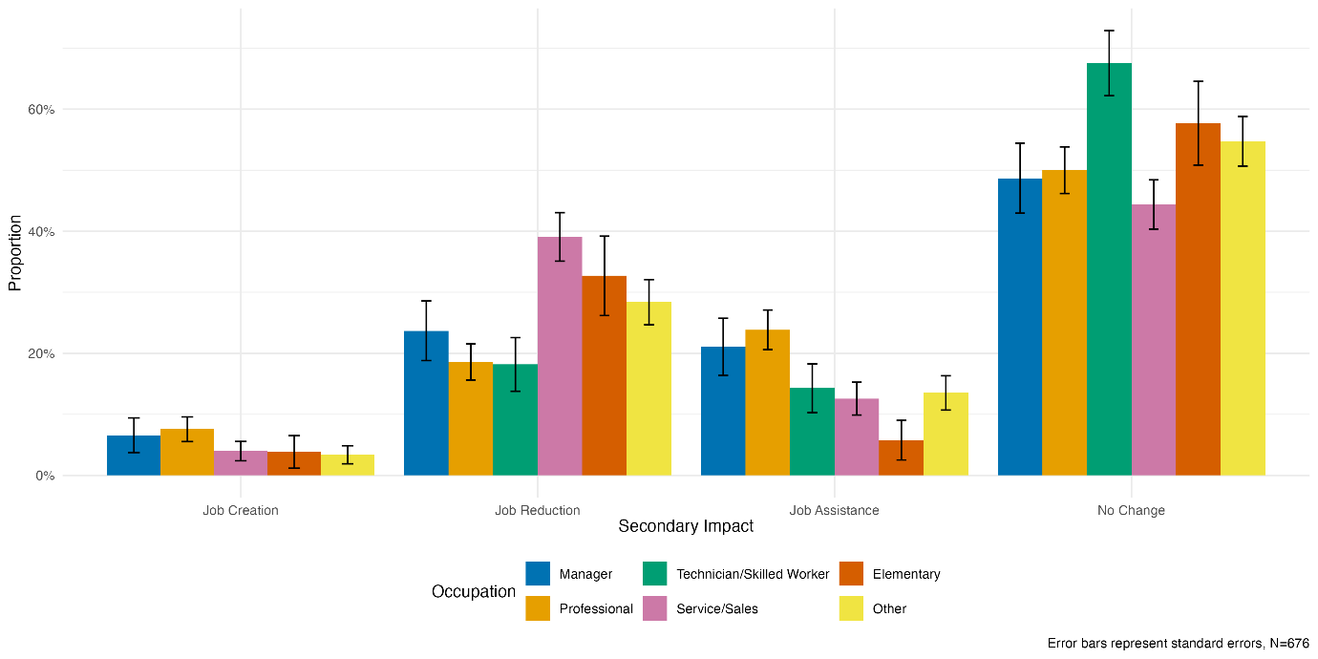
Figure S19. Distribution of open-ended responses on the secondary impact of AI on jobs by occupation.

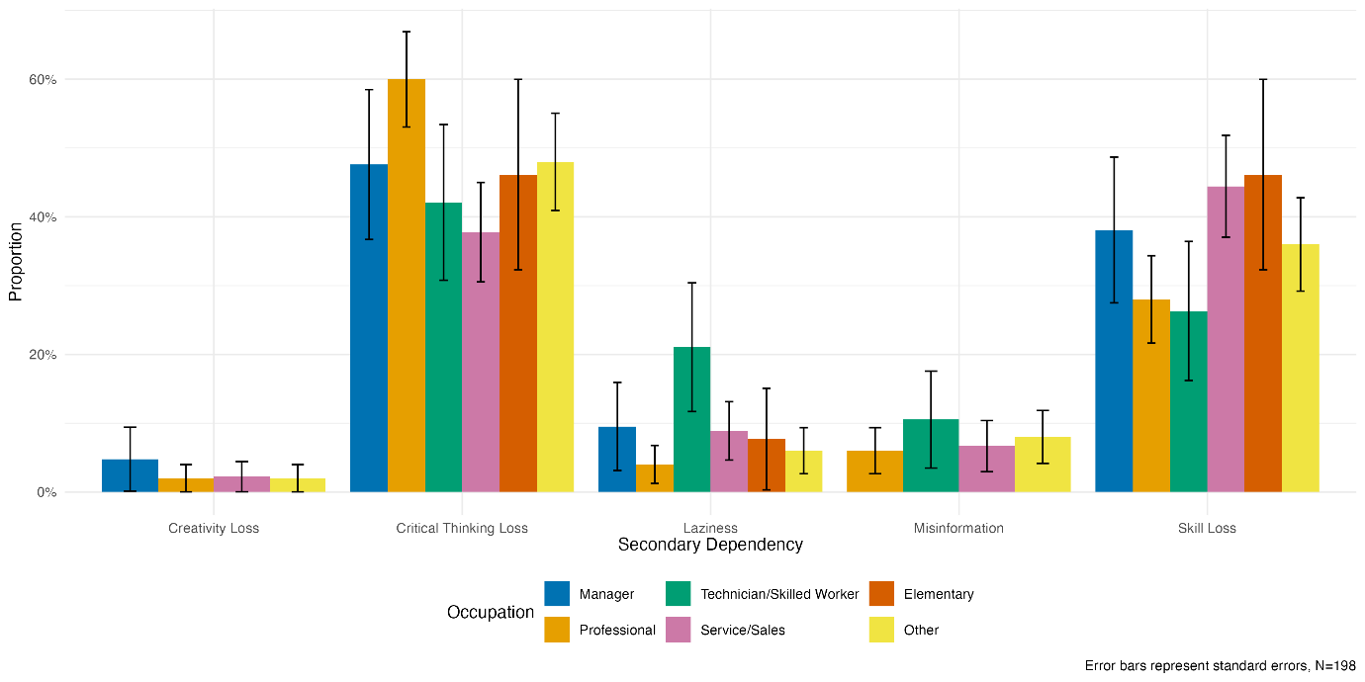
Figure S20. Distribution of open-ended responses on the secondary dependency on AI by occupation.

