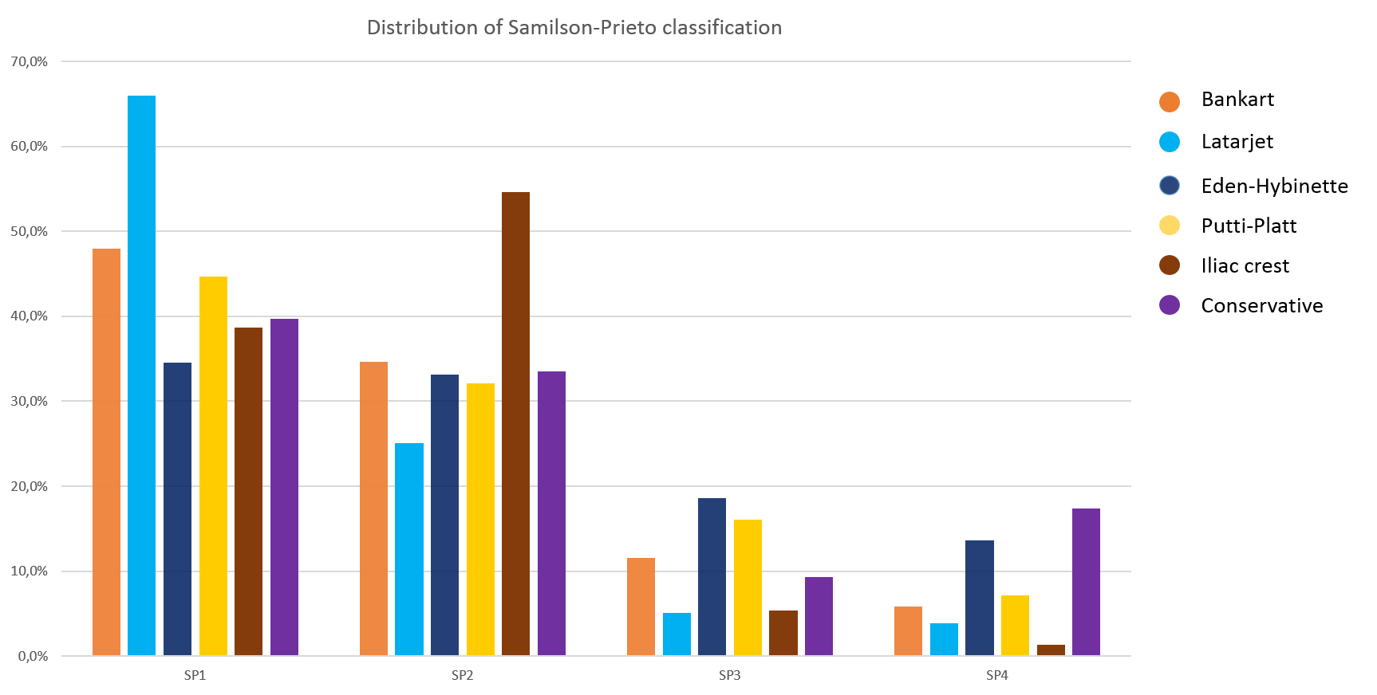
Appendix 1 Distribution of Samilson-Prieto classification. This figure shows the distribution of the Samilson-Prieto classifications for treatment options with a pooled sample size of more than 50. SP = Samilson-Prieto
Appendix 2 Search terms Pubmed/Medline.
(((((((("Shoulder Dislocation"[Mesh] OR "Bankart Lesions"[Mesh])) OR (("Shoulder"[Mesh] OR "Shoulder Joint"[Mesh]) AND "Joint Instability"[Mesh])) OR ((shoulder*[tiab] OR glenohumeral[tiab]) AND (instab*[tiab] OR dislocat*[tiab] OR luxat*[tiab])))) AND (("Orthopedic Procedures"[Mesh] OR "surgery" [Subheading] OR surg*[tiab] OR repair*[tiab]))) AND ((("Arthritis"[Mesh] OR osteoarthr*[tiab] OR arthrosis[tiab] OR arthritis[tiab] OR long term[tiab] OR follow up[tiab])) OR ((osteo*[tiab] AND arthr*[tiab]) OR arthropath*[tiab])))) AND (english[Language] OR dutch[Language] OR german[Language]) NOT
("Editorial" [Publication Type] OR "Comment" [Publication Type] OR editorial[ti] OR comment[ti])
NOT ("Animals"[Mesh] NOT "Humans"[Mesh])

Appendix 3 Search terms EMBASE.
# | Searches | Results
1 | shoulder dislocation/ or Bankart lesion/ | 6492
2 | ((shoulder* or glenohumeral) and (instab* or dislocat* or luxat*)).ti,ab,kw. | 11764
3 | 1 or 2 | 13860
4 | exp orthopedic surgery/ or surgery.fs. or (surg* or repair*).ti,ab,kw. | 4177706
5 | exp arthritis/ or arthropathy/ | 508788
6 | (osteoarthr* or arthrosis or arthritis or arthropath* or long term or follow up).ti,ab,kw. | 2536715
7 | (osteo* and arthr*).ti,ab,kw. | 71534
8 | 5 or 6 or 7 | 2727100
9 | 3 and 4 and 8 | 3673
10 | limit 9 to conference abstract status | 332
11 | 9 not 10 | 3341
12 | limit 11 to (dutch or english or german) | 3026
13 | editorial/ or erratum/ or letter/ or exp conference paper/ or (editorial or letter).ti. | 2696934
14 | 12 not 13 | 2938
15 | animal/ not human/ | 1454804
16 | 14 not 15 | 2927

Appendix 4 Search terms Cochrane.
#1 (shoulder dislocation OR bankart lesion*):ti,ab,kw 491
#2 ((shoulder* OR glenohumeral) AND (instab* OR dislocat* OR luxat*)):ti,ab,kw 688
#3 #1 or #2 694
#4 (orthopedic procedure* OR surg* OR repair*):ti,ab,kw 229379
#5 ((osteo* AND arthr*)):ti,ab,kw 8609
#6 (osteoarthr* OR arthrosis OR arthritis or arthropath* or long term or follow up):ti,ab,kw 299376
#7 #5 or #6 299831
#8 #3 and #4 and #7 in Cochrane Reviews, Trials 185

