Appendix I.

Case 1
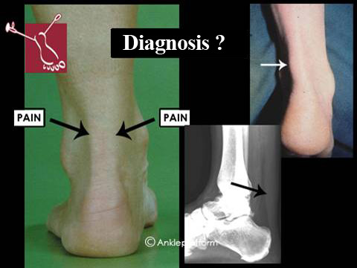
The photo on the left shows the location of the pain in a normal ankle. The photos on the right show the pathology.

- 40-year-old male.
- Pain over his right Achilles tendon, which impairs his activity.
- Painful localized fusiform swelling of the Achilles tendon located 6 cm proximal to the insertion onto the calcaneus.
- X-ray shows deviation of soft tissue contours.
- Ultrasound showed a larger tendon than normal (in cross-sectional area and antero-posterior diameter). There were hypoechoic areas within the Achilles tendon and increased tendon vascularity (mainly in the ventral peritendinous area).
What is your diagnosis? Mid-portion Achilles tendinopathy

Case 2
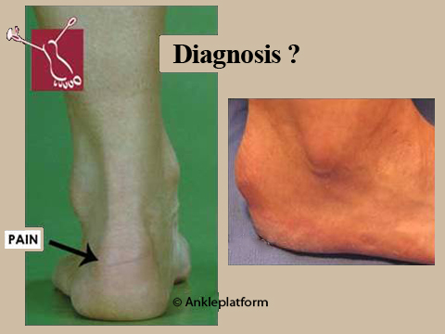
The photo on the left shows the location of the pain in a normal ankle. The photos on the right show the pathology.

- 30-year-old female.
- Posterolateral heel pain on the right side (worsens with shoes with rigid posterior portion).
- Visible, painful and solid swelling with discoloration of the skin located at the posterolateral calcaneus.
- X-ray shows no abnormality.
- Ultrasound showed fluid between the skin and the Achilles tendon.
What is your diagnosis? Superficial calcaneal bursitis

Case 3
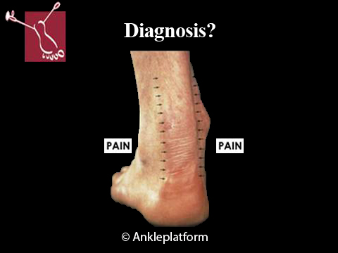

- 32-year-old male.
- Since 4 days edema and hyperemia around the midportion Achilles tendon on the left side.
- Redness and swelling of the skin over the full length of the Achilles tendon. .
- On palpation there are crepitations.
- X-ray shows no abnormalities.
- Ultrasound showed a normal Achilles tendon with a circumferential hypoechogenic halo.
What is your diagnosis? Acute Achilles paratendinopathy

Case 4
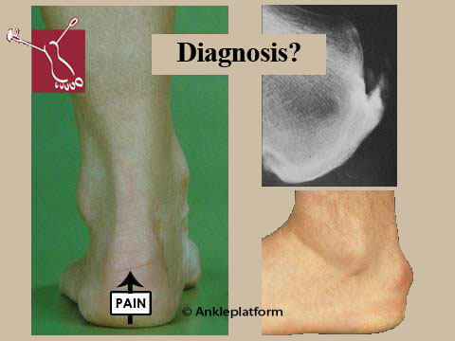
The photo on the left shows the location of the pain in a normal ankle. The photos on the right show the pathology.

- 60-year-old male.
- Stiffness and pain on the posterior aspect of the calcaneus on the left foot.
- Painful Achilles tendon insertion at the mid-portion of the posterior aspect of the calcaneus with visible swelling
- X-ray shows calcaneal bone spur at the insertion of the Achilles tendon.
What is your diagnosis? Insertional Achilles tendinopathy

Case 5
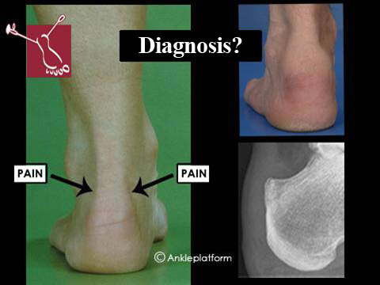
The photo on the left shows the location of the pain in a normal ankle. The photos on the right show the pathology.

- 35-year-old female patient.
- Painful swelling superior to the calcaneus of the left foot.
- Painful soft tissue swelling, medial and lateral to the Achilles tendon at the level of the posterosuperior calcaneus.
- X-ray shows bony prominence of the posterosuperior calcaneus.
- Ultrasound showed fluid in the retrocalcaneal area (hyperechoic).
What is your diagnosis? Retrocalcaneal bursitis

Case 6
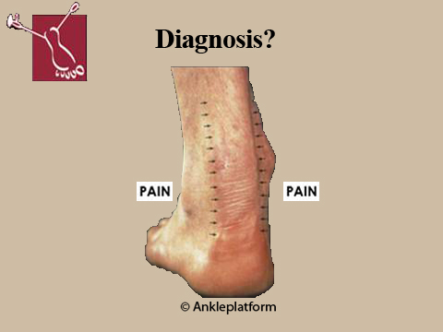

- 39-year-old male.
- Since one year exercise-induced pain around the midportion Achilles tendon of the left foot.
- Minimal swelling and some crepitations around the midportion Achilles tendon.
- X-ray shows no abnormalities.
- Ultrasound shows thickened hypoechoic paratenon and the echo-Doppler shows increased tendon vascularity (mainly in ventral peritendinous area).
What is your diagnosis? Chronic Achilles paratendinopathy

