Appendix Table 1: Variables and Data

No. | Variable | Description | Level | Sign | Mean value |  | CV
 |  |  |  |  | EU15 | CEECs | EU15 | CEECs
1 | Market size | GDP at constant prices, chain-linked volumes, in billions of Euros. ‡ | R | + | 48.30 | 11.26 | 1.10 | 0.33
2 | EU market potential | Gravity-weighted sum of GDP for EU25. GDP as in Market size. | C | + | 38.39 | 36.12 | 0.39 | 2.08
3 | Population density | Millions of people per km² of land area. | R | + / - | 0.351 | 0.016 | 2.07 | 2.01
4 | GDP growth rate | Growth rate of real GDP (Euro), expressed as a fraction. | R | + | 0.018 | 0.032 | 1.81 | 1.53
5 | Secondary education rate | Highest attainment of 25-64 years-old at ISCED levels 3-4, fraction. | R / C | + | 0.428 | 0.648 | 0.31 | 0.13
6 | Tertiary education rate | Highest attainment of 25-64 years-old at ISCED levels 5-6, fraction. | R / C | + | 0.231 | 0.155 | 0.32 | 0.43
7 | Labour market rigidity | Unemployed labour force aged 15+ and seeking employment, fraction. | R / C | - | 0.080 | 0.097 | 0.53 | 0.50
π8 | Physical infrastructure | Motorway network density, km of motorways per 10 km². | R | + | 0.324 | 0.063 | 0.98 | 1.63
9 | Wage rate† | Hourly compensation cost in manufacturing at constant Euro prices.‡ | C | - | 24.06 | 3.19 | 0.25 | 0.73
10 | Competitiveness | Real Effective Exchange Rate (REER) for 36 countries. | C | - | 0.991 | 0.952 | 0.05 | 0.14
11 | Market volatility | Absolute change in REER in previous year. | C | - | 0.024 | 0.046 | 1.13 | 0.78
12 | Single currency | Dummy variable = 1 if Euro is country’s national currency. | C | + / - | 0.689 | 0.023 | 0.67 | 6.55
13 | Political risk | Political risk rating index of country, 0 to 1, where 0 = no risk. | C | + / - | 83.77 | 76.50 | 0.06 | 0.06
14 | Corporate tax rate | Adjusted top statutory rate of corporate tax, fraction. | C | - | 0.344 | 0.246 | 0.20 | 0.31
15 | EU Structural funds | EU Structural Fund payments, expressed Euros (hundreds of millions).‡ | R | + | 0.800 | 0.417 | 2.08 | 1.88
16 | Industrial diversity | Inverse sum of absolute difference in country and EU25 industry shares. | C | - | 4.818 | 2.392 | 0.32 | 0.65
17 | EU membership (EU) | Dummy variable = 1 if CEEC is an EU Member State; otherwise = 0. | R | + | 0.50 | 0.478 | 1.00 | 1.05
18 | EU commitment to enlarge | Dummy variable = 1 for Council of Ministers commitment; otherwise = 0. | R | + | 0 | 0.672 | - | 0.70
19 | 1-year post-EU membership | Dummy variable = 1 one or more years after membership for CEECs. | R | - | 0 | 0.401 | - | 1.22
20 | 2-year post-EU membership | Dummy variable = 1 two or more years after membership for CEECs. | R | - | 0 | 0.325 | - | 1.44
21 | 3-year post-EU membership | Dummy variable = 1 three or more years after membership for CEECs. | R | - | 0 | 0.248 | - | 1.74
Notes: Variables measured annually over 1997-2010, or from 1995 if lagged, and by region (R) or country (C) (R / C = regional level from 1999 only). CV = coefficient of variation. † Missing cases dummied out but not reported. ‡ Deflator = price index, 2005 = 100, based on 2005 exchange rates. Sources: Eurostat (Nos. 1, 3, 4, 7, 8, 10 and 11); World Bank (5 and 6); U.S. Bureau of Labor Statistics (9); International Country Risk Guide, Political Risk Services Group (13); Directorate General for Taxation, European Commission (14); Directorate General for Regional Policy, European Commission (15); KLEMS employment data (16). Authors’ calculations (remainder).

Appendix Table 2: Baseline Results and Alternative Estimators

 | SAR |  | SAR – EU25 shares |  | System-GMM |  | LSDV
ln (FDI)_{r(t -1)} | 0.776*** |  | 0.786*** |  | 0.629*** |  | 0.109***
W ln (FDI)_{rt} | 0.116*** |  | 0.036 |  | 0.186*** |  | 0.252***
EU enlargement | 0.297*** |  | 0.510** |  | 0.354*** |  | 0.161
EU commitment to enlarge | 0.053 |  | 0.074 |  | 0.035 |  | 0.069
1-year post-EU membership | -0.330*** |  | -0.334*** |  | -0.322** |  | -0.168***
2-year post-EU membership | -0.337*** |  | -0.366*** |  | -0.283** |  | -0.289***
3-year post-EU membership | 0.185** |  | 0.202** |  | 0.056 |  | 0.084
Regional controls: | EU15 | CEECs | EU15 | CEECs | EU15 | CEECs | EU15 | CEECs
Market size | 0.003*** | 0.011*** | 0.002*** | 0.010*** | 0.004*** | 0.018*** | 0.010*** | 0.012
EU market potential | 0.002 | 0.005 | 0.003 | 0.003 | 0.004 | 0.010* | 0.004 | 0.102***
Population density | 0.010 | 0.001 | 0.001 | 0.004 | 0.017 | 0.005 | -0.453* | 1.520
GDP growth rate | -1.153*** | -0.132 | -0.984** | -0.058 | -0.726 | 0.047 | -0.737* | 1.009**
Secondary education rate | 0.411** | 0.443 | 0.361** | 0.493 | 0.409 | 0.105 | 0.208 | -0.637
Tertiary education rate | 0.685*** | 1.026* | 0.785*** | 0.975* | 0.893*** | 1.084 | -0.109 | 0.481
Labour market rigidity | -0.259 | -0.498 | 0.020 | -0.468 | -0.651 | -0.099 | -0.161 | -0.558
Physical infrastructure | 0.125** | 0.099 | 0.110** | -0.116 | 0.139** | -0.198 | -0.363 | -0.081
Wage rate | -0.001 | 0.078* | -0.003 | 0.066 | -0.003 | 0.085 | -0.027** | -0.390***
Competitiveness | -0.185 | -0.731*** | -0.207 | -0.767*** | -0.179 | -0.735** | -0.498** | -0.587**
Market volatility | -0.925* | -0.200 | -0.765 | -0.189 | -0.031 | -0.478 | -0.431 | -0.186
Single currency | -0.017 | 0.303*** | -0.024 | 0.277*** | -0.019 | 0.392** | 0.011 | 0.498***
Political risk | -0.252 | -0.512 | -0.382 | -0.439 | 0.158 | -0.274 | -0.772* | -0.924
Corporate tax rate | -0.329 | -0.879** | -0.488* | -1.118*** | -0.717* | -0.752 | -0.652* | -1.437**
EU Structural Funds | 0.211** | 0.795 | 0.191** | 0.817 | 0.200* | 1.160** | -0.104 | 0.463
Industrial diversity | -0.037** | 0.004 | -0.031** | 0.020 | -0.040* | -0.017 | -0.093*** | 0.004
Log-pseudolikelihood | -2,757.2 |  | -2,799.5 |  | - |  | -
AR(1), (2), (3) test (z-statistic) | - |  | - |  | -9.91***, 4.86***, -1.71 |  | -
Hansen J test / diff test (p-value) | - |  | - |  | 0.12 / 0.08 |  | -
R² | - |  | - |  | - |  | 0.85
Number of observations / groups | 3,380 / 260 |  | 3,380 / 260 |  | 3,380 / 260 |  | 3,380 / 260
Notes: Estimation of Equation (1) excluding border terms, but with other Z controls and time fixed effects. Second column expresses FDI in term of EU25 total projects in each year, but third and fourth columns as first column. LSDV standard errors clustered at country level. ***, ** and * = 1%, 5% and 10% significance level.

Appendix Table 3: The West-East Border Effect: EU Origin Only

Column | Distance |  |  | Contiguity
 | All FDI | Manuf.  FDI | Greenfield FDI | All FDI | Manuf.  FDI | Greenfield FDI
All: | -0.093*** | -0.087*** | -0.082** | 0.347*** | 0.340*** | 0.255**
Short-run:
Direct | -0.005 | -0.089** | -0.083** | 0.350*** | 0.402*** | 0.260**
Indirect | -0.014** | -0.016** | -0.011** | 0.050*** | 0.070*** | 0.036**
Total | -0.006 | -0.104** | -0.095** | 0.400*** | 0.472*** | 0.296**
Long-run:
Direct | -0.322*** | -0.243** | -0.206** | 1.157*** | 1.060*** | 0.631**
Indirect | -0.210** | -0.152** | -0.084** | 0.720*** | 0.612** | 0.250**
Total | -0.533*** | -0.396** | -0.291** | 1.877*** | 1.672*** | 0.881**
Notes: See note to Table 6. ***, ** and * = 1%, 5% and 10% significance level.

Appendix Figure 1(a): Contiguity with the West-East Border: CEEC Regions

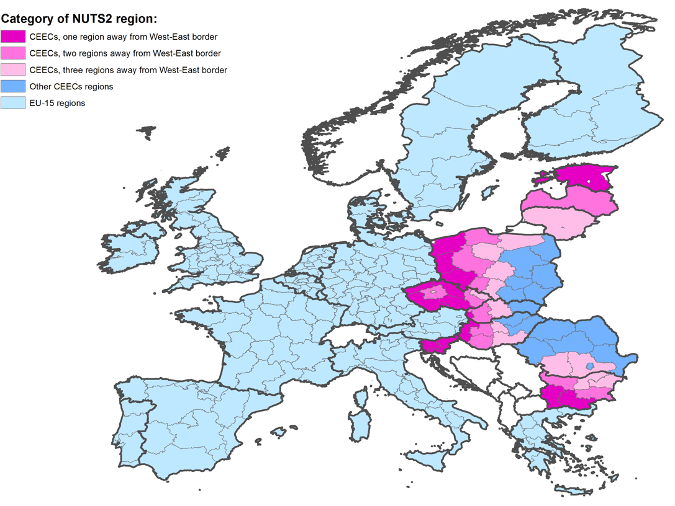

Appendix Figure 1(b): Contiguity with the West-East Border: EU15 Regions

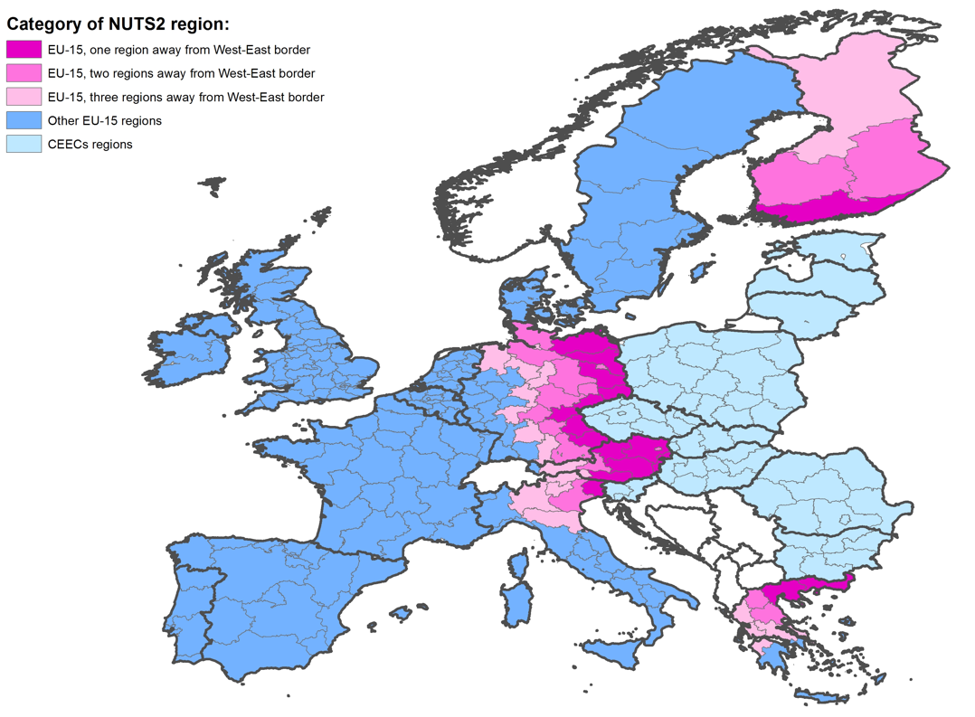

Appendix Figure 2(a): National Border Regions Internal to EU25

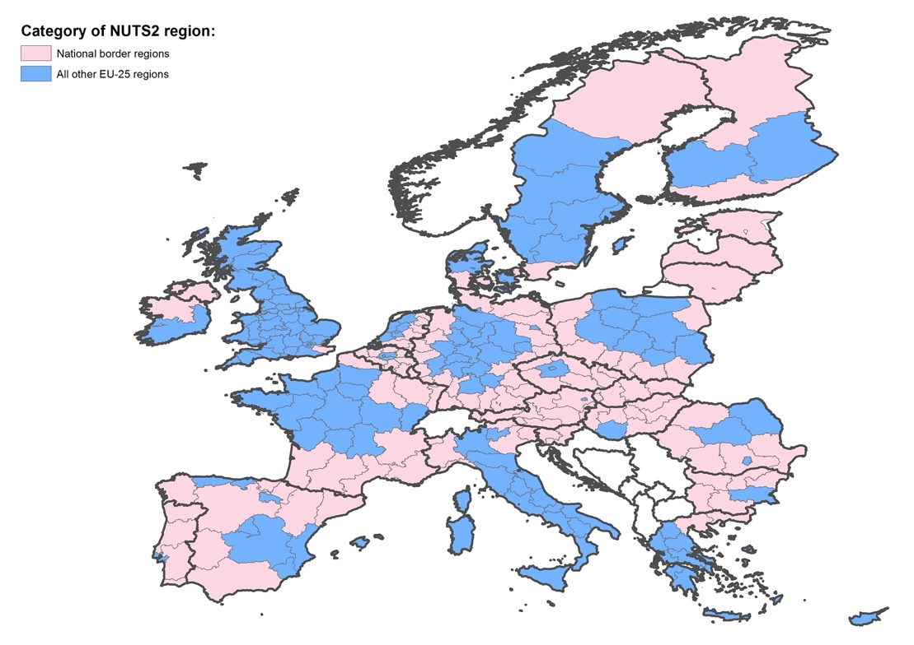

Appendix Figure 2(b): National Border Regions Internal to Schengen Area

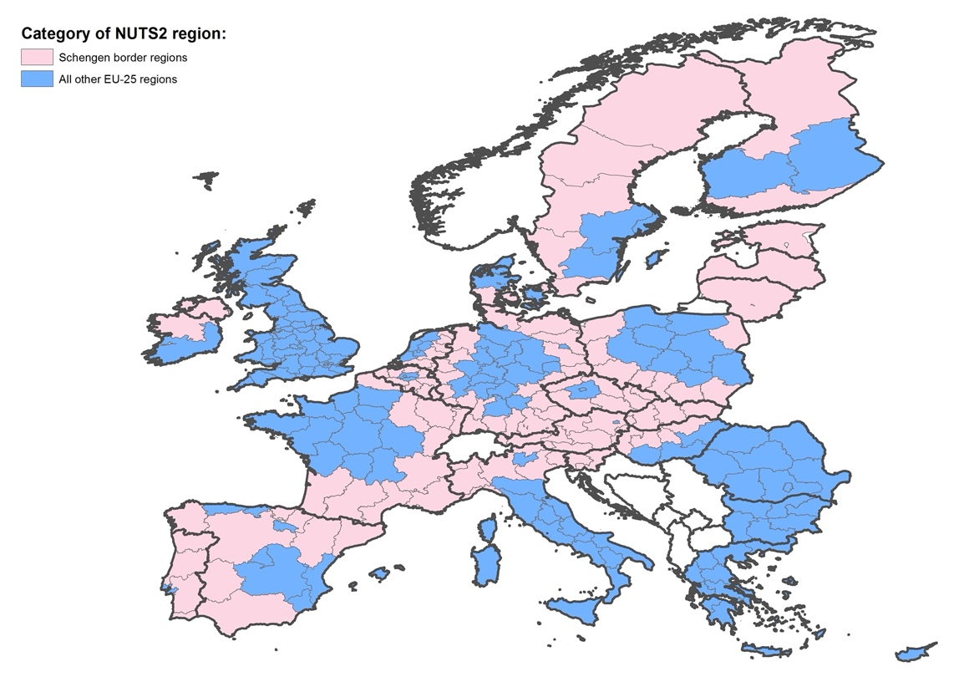

Note: Northern Ireland-Eire border included even though not formal part of Schengen Agreement.

