Appendix A: Additional table
Table A.I List of Italian regions in the dataset and associated macro-area
NUTS-2 regions | NUTS-1 macro-area | Centre-North vs. South classification
Emilia-Romagna | North-East | Centre-North
Friuli-Venezia Giulia | North-East | Centre-North
Lazio | Centre | Centre-North
Liguria | North-West | Centre-North
Lombardia | North-West | Centre-North
Marche | Centre | Centre-North
Piemonte | North-West | Centre-North
Provincia Autonoma Bolzano | North-East | Centre-North
Provincia Autonoma Trento | North-East | Centre-North
Toscana | Centre | Centre-North
Umbria | Centre | Centre-North
Valle d'Aosta | North-West | Centre-North
Veneto | North-East | Centre-North
Abruzzo | South | South
Basilicata | South | South
Calabria | South | South
Campania | South | South
Molise | South | South
Puglia | South | South
Sardegna | Islands | South
Sicilia | Islands | South
Note: The first column corresponds to the NUTS-2 classification, the second column shows the NUTS-1 macro-area to which each NUTS-2 region belongs, while the third column indicates the classification used in Section 3 to estimate the effects in the Centre-North and South, shown in Figure 2.

Appendix B: Robustness checks
Panel A: EAFRD
Panel B: ERDF
Fig. A1 Different lag
Note: The chart shows the impulse response functions and the associated 90 (68) percent confidence bands. Estimates based on the equation $y_{i,t+k}=α_{i}^{k}+θ_{t}^{k}+β_{1}^{k}{SF}_{i,t}+β_{2}^{k}X_{i,t}+\left(δ_{i}^{k}+μ_{t}^{k}+γ_{1}^{k}{SF}_{i,t}+γ_{2}^{k}X_{i,t}\right)ε_{i,t+k}$, using a sample of 21 regions over the period 1995-2022 where ${SF}_{i,t}$ is the log expenditure per capita, instrumented with the shock constructed in section 3, $y_{i,t}$is the regional GDP per capita, $X_{i,t}$is a vector of control variables (see section 3 for more details). The left charts indicate the location effect, based on the first part of the equation, and the right charts, scale effects (second part of the equation). This robustness check is based on changing the number of lags of $y_{i,t}$ and ${SF}_{i,t}$ in the set of control variables. In the legend, within parentheses, the first number is the number of lags for the dependent variable and the second is for the main explanatory variable.
Source: Authors’ own elaboration based on ISTAT Regional Accounts data and European Commission Historic EU Payments by NUTS-2 Regions Database. Figures produced using Stata 18/MP4.

Panel A: EAFRD
Panel B: ERDF
Fig. A2 Dropping the outliers
Note: The chart shows the impulse response functions and the associated 90 (68) percent confidence bands. Estimates based on the equation $y_{i,t+k}=α_{i}^{k}+θ_{t}^{k}+β_{1}^{k}{SF}_{i,t}+β_{2}^{k}X_{i,t}+\left(δ_{i}^{k}+μ_{t}^{k}+γ_{1}^{k}{SF}_{i,t}+γ_{2}^{k}X_{i,t}\right)ε_{i,t+k}$, using a sample of 21 regions over the period 1995-2022, where ${SF}_{i,t}$ is the log expenditure per capita, instrumented with the shock constructed in section 3, $y_{i,t}$is the regional GDP per capita, $X_{i,t}$is a vector of control variables (see section 3 for more details). The left charts indicate the location effect, based on the first part of the equation, and the right charts, scale effects (second part of the equation). The estimation is based on dropping outliers from the dependent variable at the top and bottom 1% percentiles of the distribution in each time horizon.
Source: Authors’ own elaboration based on ISTAT Regional Accounts data and European Commission Historic EU Payments by NUTS-2 Regions Database. Figures produced using Stata 18/MP4.

Panel A: EAFRD
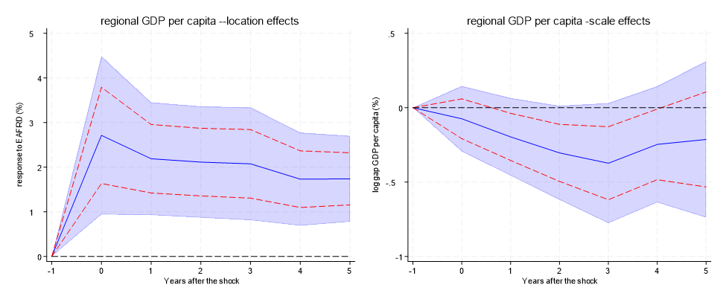
Panel B: ERDF
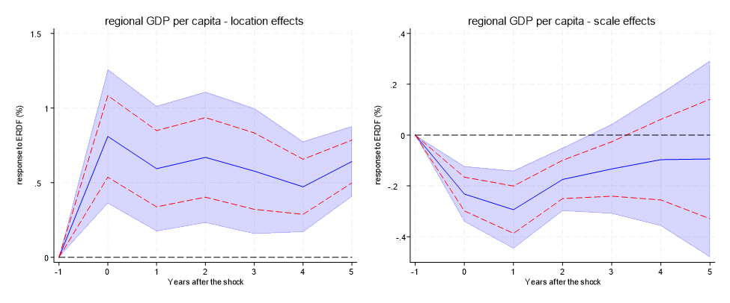
Fig. A3 Additional control (GFCF)
Note: The chart shows the impulse response functions and the associated 90 (68) percent confidence bands. bands. Estimates based on the equation $y_{i,t+k}=α_{i}^{k}+θ_{t}^{k}+β_{1}^{k}{SF}_{i,t}+β_{2}^{k}X_{i,t}+\left(δ_{i}^{k}+μ_{t}^{k}+γ_{1}^{k}{SF}_{i,t}+γ_{2}^{k}X_{i,t}\right)ε_{i,t+k}$, using a sample of 21 regions over the period 1995-2022, where ${SF}_{i,t}$ is the log expenditure per capita, instrumented with the shock constructed in section 3, $y_{i,t}$is the regional GDP per capita, $X_{i,t}$is a vector of control variables (see section 3 for more details). The left charts indicate the location effect, based on the first part of the equation, and the right charts, scale effects (second part of the equation). The estimation is based on adding one lag of the GFCF as additional control variable.
Source: Authors’ own elaboration based on ISTAT Regional Accounts data and European Commission Historic EU Payments by NUTS-2 Regions Database. Figures produced using Stata 18/MP4.

Panel A: EAFRD
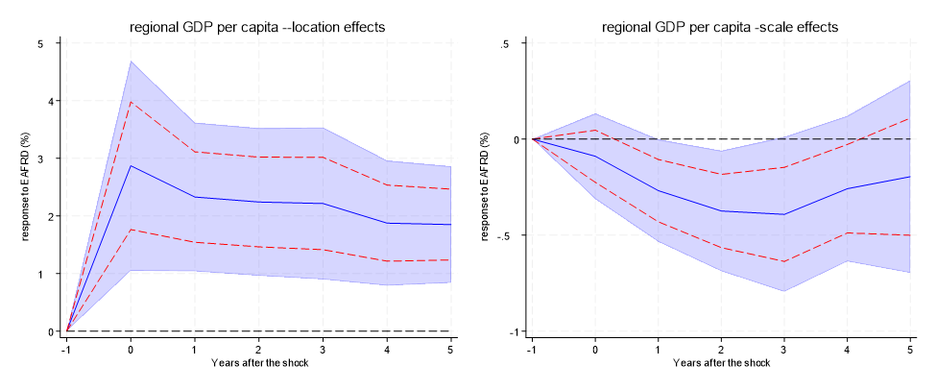
Panel B: ERDF
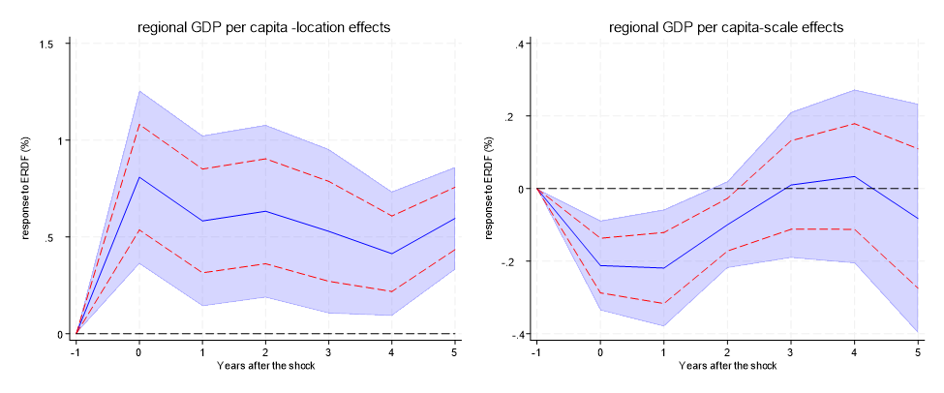
Fig. A4 Additional control (log of population)
Note: The chart shows the impulse response functions and the associated 90 (68) percent confidence bands. Estimates based on the equation $y_{i,t+k}=α_{i}^{k}+θ_{t}^{k}+β_{1}^{k}{SF}_{i,t}+β_{2}^{k}X_{i,t}+\left(δ_{i}^{k}+μ_{t}^{k}+γ_{1}^{k}{SF}_{i,t}+γ_{2}^{k}X_{i,t}\right)ε_{i,t+k}$, using a sample of 21 regions over the period 1995-2022, where ${SF}_{i,t}$ is the log expenditure per capita, instrumented with the shock constructed in section 3, $y_{i,t}$is the regional GDP per capita, $X_{i,t}$is a vector of control variables (see section 3 for more details). The left charts indicate the location effect, based on the first part of the equation, and the right charts, scale effects (second part of the equation). The estimation is based on adding one lag of regional population as additional control variable.
Source: Authors’ own elaboration based on ISTAT Regional Accounts data and European Commission Historic EU Payments by NUTS-2 Regions Database. Figures produced using Stata 18/MP4.

Panel A: EAFRD

Panel B: ERDF

Fig. A5 Response of the regional GDP per capita to the SF fund (considering a 3-year average share of manufacturing value added)
Note: The chart shows the impulse response functions and the associated 90 (68) percent confidence bands. Estimates based on the equation $y_{i,t+k}=α_{i}^{k}+γ_{t}^{k}+south×\left[ β^{k,south}{SF}_{i,t}+θ^{k,south}X_{i,t}\right]+\left(1-south\right)×\left[ β^{k,nsouth}{SF}_{i,t}+θ^{k,nsouth}X_{i,t}\right]+ϵ_{i,t+k}^{k}$ using a sample of 21 regions over the period 1995-2022, where ${SF}_{i,t}$ is the log expenditure per capita, $y_{i,t}$is the regional GDP per capita, $X_{i,t}$is a vector of control variables, $south$ is a geographical dummy equal to 1 for Southern regions. The interaction between the geographical dummies and ${SF}_{i,t}$ are instrumented with the interaction between the geographical dummies and the shock (see section 3 for more details). This robustness check is based on considering a 3-year average (1995-1997) share of manufacturing value added to alternatively construct the instrument for the GDP per capita used to estimate equation (2) to extract the shock (see section 3 for more details).
Source: Authors’ own elaboration based on ISTAT Regional Accounts data and European Commission Historic EU Payments by NUTS-2 Regions Database. Figures produced using Stata 18/MP4.

Panel A: EAFRD
Panel B: ERDF
Fig. A6 Distributional effects of the regional GDP per capita expenditure (considering a 3-year average share of manufacturing value added)
Note: The chart shows the impulse response functions and the associated 90 (68) percent confidence bands. Estimates based on the equation $y_{i,t+k}=α_{i}^{k}+θ_{t}^{k}+β_{1}^{k}{SF}_{i,t}+β_{2}^{k}X_{i,t}+\left(δ_{i}^{k}+μ_{t}^{k}+γ_{1}^{k}{SF}_{i,t}+γ_{2}^{k}X_{i,t}\right)ε_{i,t+k}$, using a sample of 21 regions over the period 1995-2022 where ${SF}_{i,t}$ is the log expenditure per capita, instrumented with the shock constructed in section 3, $y_{i,t}$is the regional GDP per capita, $X_{i,t}$is a vector of control variables (see section 3 for more details). The left charts indicate the location effect, based on the first part of the equation, and the right charts show the scale effects (second part of the equation). This robustness check is based on considering a 3-year average (1995-1997) share of manufacturing value added to alternatively construct the instrument for the GDP per capita used to estimate equation (2) to extract the shock (see section 3 for more details).
Source: Authors’ own elaboration based on ISTAT Regional Accounts data and European Commission Historic EU Payments by NUTS-2 Regions Database. Figures produced using Stata 18/MP4.

