Functional specialization and upgrading along global value chains in European regions:
new insights from FDI data

Tables and Figures in the Online Supplementary Material

Appendix A. Descriptive statistics on fDi Markets
This appendix provides additional descriptive evidence on the structure and distribution of the greenfield FDI dataset used in the analysis.

Table A.1. Number of greenfield FDI projects by year (2003–2018) and period
Year | Number of FDI | Share (%)
2003 | 1,903 | 3.37
2004 | 2,412 | 4.28
2005 | 2,934 | 5.2
2006 | 3,450 | 6.12
2007 | 3,644 | 6.46
2008 | 4,039 | 7.16
2009 | 2,989 | 5.3
2010 | 3,057 | 5.42
2011 | 3,277 | 5.81
2012 | 3,249 | 5.76
2013 | 3,375 | 5.98
2014 | 3,511 | 6.22
2015 | 4,049 | 7.18
2016 | 4,193 | 7.43
2017 | 5,079 | 9
2018 | 5,248 | 9.3
2003-2008 (pre-crisis) | 18,382 | 32.59
2009-2012 (crisis) | 12,572 | 22.29
2013-2018 (post-crisis) | 25,455 | 45.13
Total | 56,409 | 100
Source: authors’ elaboration based on fDi Markets data.
Table A.1 reports the number of greenfield FDI projects by year and by macro-period. The final dataset includes 56,409 projects over 2003–2018. With respect to the Global Financial Crisis (GFC), FDI activity increased steadily during the pre-crisis years, rising from 1,903 projects in 2003 to 4,039 in 2008. A marked contraction is observed after the global financial crisis, with projects falling to 2,989 in 2009. Flows progressively recovered during the post-crisis period, reaching more than 5,000 projects annually by 2017–2018. Overall, 32.6% of projects belong to the pre-crisis period (2003–2008), 22.3% to the crisis period (2009–2012), and 45.1% to the post-crisis period (2013–2018). The pre/post-crisis discontinuity is therefore clearly visible in the data, with the volume of FDI flows contracting sharply after 2008 before recovering progressively and exceeding pre-crisis levels from 2015 onwards. This temporal pattern motivates our choice of period boundaries and supports treating the 2009–2012 interval as a distinct transition phase rather than assigning it to either the pre- or post-crisis period.

Figure A.1. Number of greenfield FDI projects by year (2003–2018)
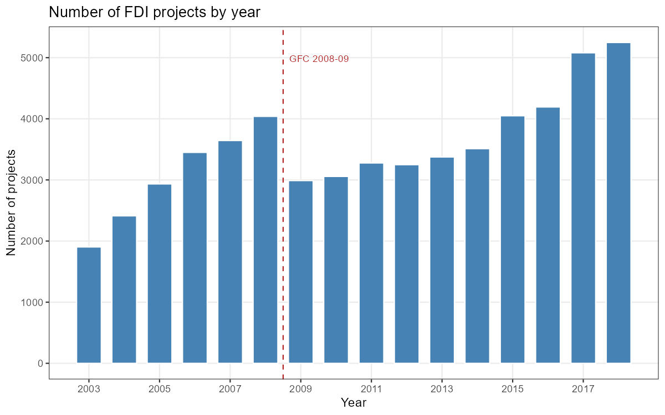
Source: authors’ elaboration based on fDi Markets data.

Figure A.1 displays the annual number of greenfield FDI projects over the full sample period. The figure confirms a clear pre/post-crisis discontinuity in the volume of FDI flows. Project counts increased steadily during the pre-crisis years, from 1,903 in 2003 to a peak of 4,039 in 2008. The onset of the Global Financial Crisis (GFC) in 2008–2009 is associated with a sharp contraction, with the number of projects falling to 2,989 in 2009 — a decline of approximately 26% relative to the previous year. During the transition period (2009–2012), FDI activity remained subdued and broadly flat. A sustained recovery is visible from 2013 onwards, with annual project counts rising progressively and exceeding 5,000 by 2017–2018. The dashed vertical line marks the GFC 2008–09 break.

Figure A.2. FDI by GVC function: total distribution and by period
Panel (a)
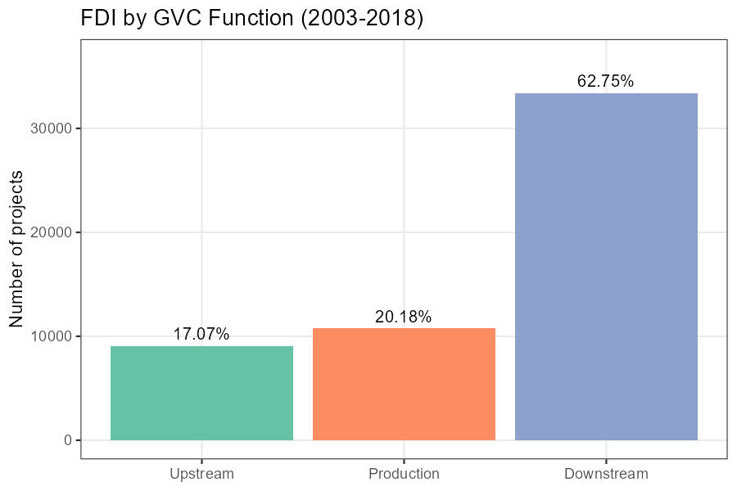
Panel (b)
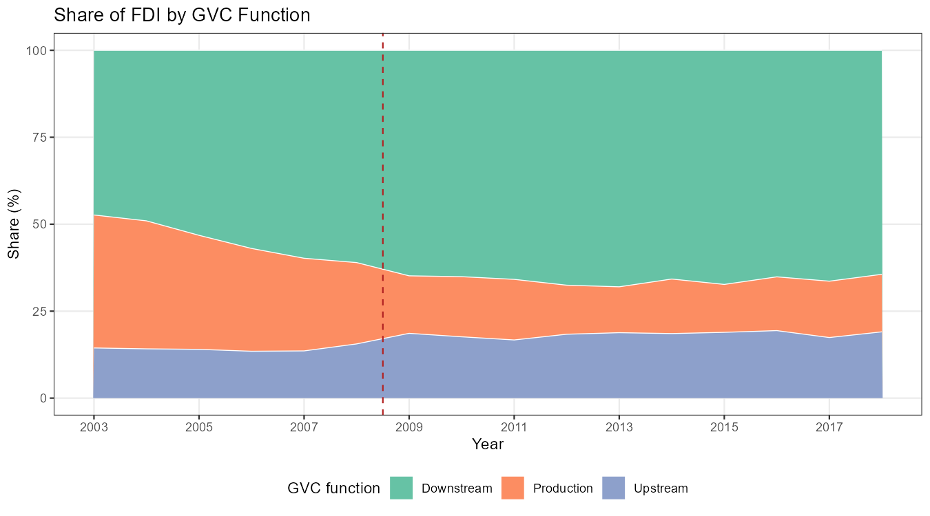
Source: authors’ elaboration based on fDi Markets data.

The upper panel (a) of Figure A.2 reports the total number of greenfield FDI projects by GVC function over 2003–2018. Downstream activities account for the dominant share (62.75%), followed by production (20.18%) and upstream activities (17.07%). The lower panel (b) displays the annual share of greenfield FDI projects by GVC function over 2003–2018. Downstream activities consistently account for the dominant share throughout the entire period, representing around 50% in the early 2000s and rising up to the global financial crisis (indicated by the dashed vertical line) and stabilising at approximately 65% from 2010 onwards. The production share, by contrast, declines considerably after 2008, falling from around 35% in the pre-crisis years to approximately 15–20% in the post-crisis period. The upstream share remains the smallest of the three functional categories throughout, fluctuating between roughly 10% and 20% with a modest upward trend in the final years of the sample. These compositional shifts are consistent with a structural reorientation of European FDI towards downstream, market-oriented activities following the global financial crisis, at the expense of production-stage investments. Importantly, the transition appears to be largely discontinuous — concentrated around the 2008–2009 break — rather than a gradual long-run trend, which supports the periodization adopted in the main analysis and the treatment of 2009 as a meaningful structural break in the functional composition of FDI flows.

Figure A.3. Functional specialization (FS) in FDI across GVC stages
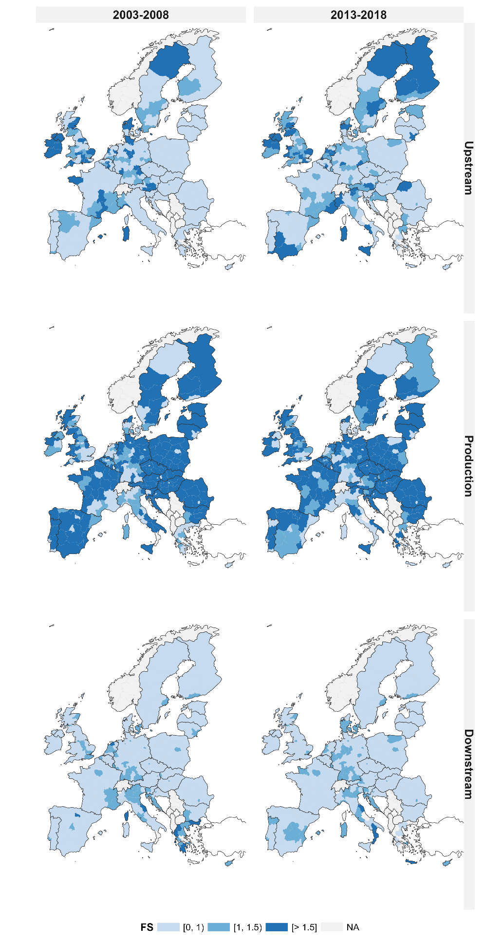
Note: NA stands for ‘not available’ and includes regions which did not receive FDIs over the periods (e.g., a few Italian and Greek regions) as well as non-EU27 countries (i.e., Albania, Bosnia and Herzegovina, Kosovo, Montenegro, North Macedonia, Norway, Serbia and Switzerland). Source: authors’ elaboration based on fDi Markets data.

Table A.2. The Revised Pavitt Taxonomy
RPC | Description | Industry examples (NACE Rev. 2 code)
Science-Based industries (SB) | Sectors where innovation is based on advances in science and R&D (such as the pharmaceuticals, electronics, computer services) where research laboratories are important, leading to intense product innovation and a high propensity to patent. | Chemical (C20); pharmaceutial (C21); electronics (C26); computer programming (J62-J63)
Specialised Supplier industries (SS) | Sectors producing machinery and equipment; their products are new processes for other industries. R&D is present but an important innovative input comes from tacit knowledge and design skills embodied in the labour force. Average firm size is small and innovation is carried out in close relation with customers. | Electrical equipment (C27); machinery and equipment (C28); legal and accounting activities (M69-M70); architectural and engineering activities (M71)
Scale and Information Intensive industries (SI) | Sectors (such as the automotive sector and financial services) characterized by large economies of scale and oligopolistic markets where technological change is usually incremental. New processes (often related to information technology) shape the organisation of production and coexist with new product development. | Basic metals (C24); Motor vehicles (C29); publishing activities (J58); Financial services (K64)
Supplier Dominated industries (SD) | Sectors (such as food, textile, retail services) where internal innovative activities are less relevant, small firms are prevalent and technological change is mainly introduced through the inputs and machinery provided by suppliers from other industries. Firms in this group do not carry out much R&D or other innovative activities. | Food (C10-C12); textile (C13-C15); wholesale trade (G46); accomodation (I)
Note: RPC stands for Revised Pavitt Paxonomy.
Source: authors’ elaboration based on Bogliacino and Pianta (2010, pp. 801, 807).

Figure A.4. FDI by Pavitt class: total distribution and by period
Panel (a)
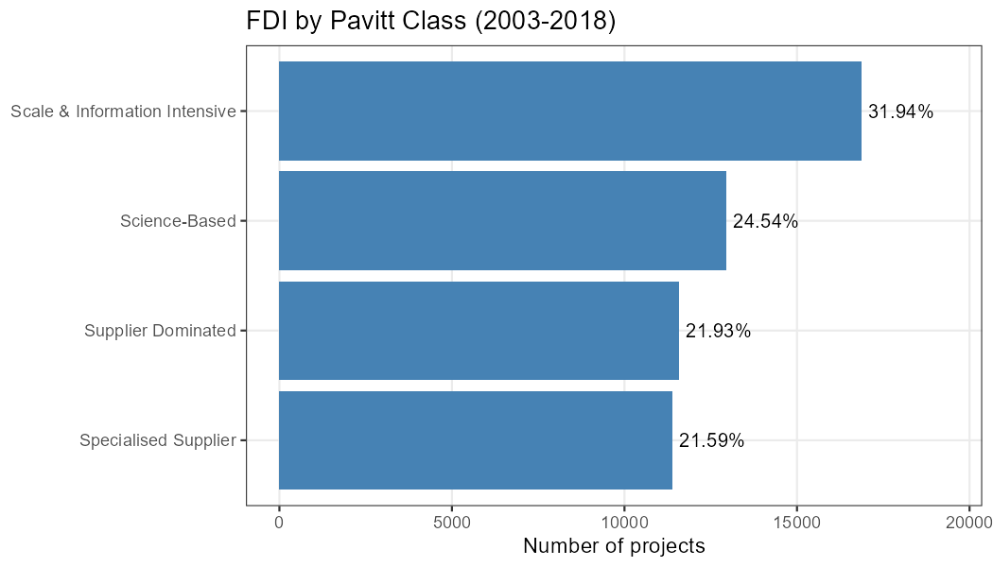
Panel (b)
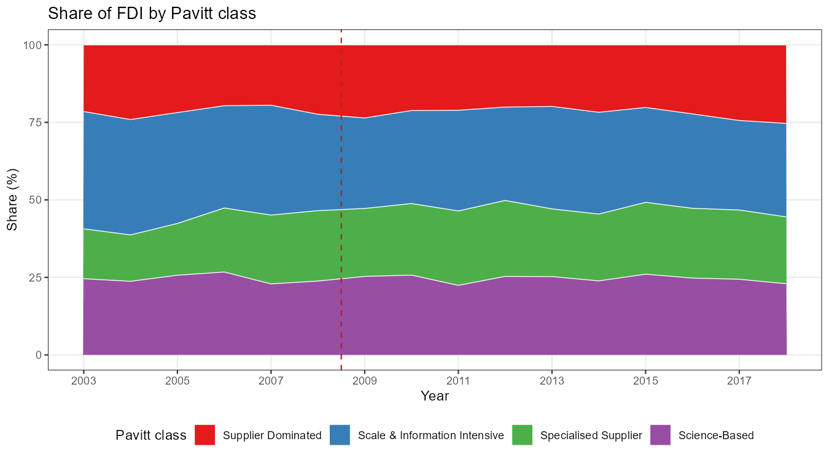
Source: authors’ elaboration based on fDi Markets data.
Figure A.4 reports the sectoral composition of greenfield FDI projects across Pavitt technological classes. The bar chart in panel (a) shows the total distribution over 2003–2018: Scale & Information Intensive industries (SII) account for the largest share (31.94%), followed by Science-Based (SB) (24.54%), Supplier Dominated (SD) (21.93%), and Specialised Supplier (SS) sectors (21.59%). The distribution is relatively balanced across technological classes, with no single category accounting for more than a third of total projects, which reflects the broad sectoral coverage of the greenfield FDI dataset. The figure in in panel (b) reveals that this sectoral composition is remarkably stable over time. The shares of all four Pavitt classes fluctuate only modestly around their long-run averages throughout the 2003–2018 period, with no discernible structural break around the global financial crisis (indicated by the dashed vertical line). SB industries maintain a broadly constant share of approximately 20–25%, while SII industries consistently account for the largest portion, oscillating between roughly 35% and 45%. SS and SD sectors each contribute approximately 20–25% throughout.

Table A.3. Spatial distribution of greenfield FDI projects across Europe
 | Num.  regions | % of total  projects  per region | Mean num.  of projects  per region | Median num.  of projects  per region | Num. of  sparse  regions  (<5 FDI) | % of sparse  regions  (<5 FDI) | Num.  of sparse  regions  (Q1) | % of sparse  regions  (Q1)
East | 51 | 18.2% | 181.9 | 133 | 0 | 0 | 14 | 27.5
North | 59 | 29.9% | 258.1 | 115 | 1 | 3.4 | 15 | 25.4
South | 62 | 12.6% | 103.3 | 31.5 | 9 | 14.5 | 17 | 27.4
West | 94 | 39.3% | 213 | 92.5 | 2 | 2.1 | 24 | 25.5
Source: authors’ elaboration based on fDi Markets data.
Table A.3 reports the spatial distribution of greenfield FDI projects across four European macro-regions, defined as follows: Northern Europe includes Denmark, Estonia, Finland, Ireland, Lithuania, Latvia, Sweden, and the United Kingdom; Western Europe includes Austria, Belgium, Germany, France, Luxembourg, and the Netherlands; Southern Europe includes Cyprus, Greece, Spain, Croatia, Italy, Malta, Portugal, and Slovenia; Eastern Europe includes Bulgaria, Czech Republic, Hungary, Poland, Romania, and Slovakia.
Western Europe hosts the largest number of NUTS-2 regions in the dataset (94) and accounts for the largest share of total projects (39.3%), followed by Northern Europe (29.9%), Eastern Europe (18.2%), and Southern Europe (12.6%). Mean project counts per region are highest in Northern Europe (258.1) and Western Europe (213.0), while Southern Europe records the lowest mean (103.3) and by far the lowest median (31.5 projects per region), indicating a skewed within-group distribution with many regions attracting very limited FDI activity.
Two complementary measures of sparsity are reported. The first identifies regions that recorded fewer than five FDI projects over the 2003–2018 period, thereby providing a direct indicator of areas with very limited FDI activity (absolute-threshold measure). The second is a relative measure based on the bottom quartile of the within-group distribution of NUTS-2 project counts, capturing concentration patterns within each macro-region independently of overall project volumes. The degree of absolute sparsity is markedly higher in Southern Europe, where 9 out of 62 regions (14.5%) record fewer than five projects over the full sample period — compared to just 1 region in Northern Europe (3.4%), 2 in Western Europe (2.1%), and none in Eastern Europe. The relative bottom-quartile measure reveals a more uniform pattern across macro-regions, with approximately 25–28% of regions in each group falling in the bottom quartile of their within-group distribution, suggesting that within-region concentration is a pervasive structural feature of FDI geography rather than a problem confined to specific macro-areas.
Taken together, this descriptive evidence highlights the uneven spatial distribution of FDI activity across European regions and provides useful context for interpreting the FS and RFS indicators presented in the main analysis. In particular, the presence of regions characterised by very limited FDI activity, and the heterogeneity in project counts across European regions suggest that specialisation measures are likely to be more informative when based on sufficiently large pools of observations, allowing them to reflect persistent structural characteristics rather than short-term fluctuations.

Appendix B. Specialization by Pavitt macro-sectors: comparing FDI-based with employment-based indices
As a robustness test, we compared our FDI-based specialisation indices by Pavitt macro-sectors with the same indices computed using Eurostat employment data. As already mentioned, this validation exercise allows to measure the extent to which our indicator accurately proxies the specialization of the regions’ domestic economic activity.
In developing this analysis, we measure the domestic economic activity in each region by relying on employment data (retrieved from the Eurostat’s regional Structural Business Statistics) and compute a specialization index of (domestic) regional economies following the same approach as in Eq. 3 (i.e., Balassa’s index by Pavitt macro-sectors). Although employment data cannot be used to directly compute an alternative measure of functional specialization, they can be used to measure the sectoral specialization of the domestic (regional) economy. Hence, we use regional employment data to measure the sectoral specialization of regions’ domestic economy and compare it to our FDI-based indicators of sectoral specialization. This validation exercise allows us to assess to which extent the specialization patterns computed by relying on FDI data are a good proxy for the specialization patterns of the domestic economic activity of regions. In analytical terms, we focus on the Pavitt macro-sectors and, for each region i and each sector s, we compute the Balassa index based on domestic employment data (i.e., ${RCA}_{Empl(i,s)}$); then, we compare it to the FDI-based index of sectoral specialization (i.e., ${RCA}_{FDI(i,s)}$). This allows us to assess to which extent, given the employment-based specialisation of each region in a given macro-sector (i.e., if ${RCA}_{Empl(i,s)}≥1$), we observe that the same region is specialised in that given macro-sector also according to FDI data (${RCA}_{FDI(i,s)}≥1$).
Results reported by Table B.1 suggest that, on average, in 60% of the cases the FDI-based specialisation index predicts the same outcome as the employment-based specialization index over the period 2003-2007. Interestingly, the share increases to 68% in the years 2013-2018, signalling an even higher correspondence in the more recent time period.
Finally, since employment data are classified according to NACE Rev. 1.1 until 2007 and according to NACE Rev. 2 from 2008 onwards, we conducted the same analysis including data for 2008 in the first time period as an additional robustness test. In both cases, results remain qualitatively unchanged and are available upon request.

Table B.1. Comparison between (domestic) employment-based and FDI-based sectoral specialization of regions
 | 2003-2007 | 2013-2018
Science-Based sectors | 63% | 73%
Specialized Supplier sectors | 61% | 69%
Scale and Information Intensive sectors | 65% | 70%
Supplier Dominated sectors | 48% | 61%
Avg. | 60% | 68%
Note: Percentages represent the share of region-sector cases in which the FDI-based specialisation index predicts the same outcome as the employment-based index. Source: authors’ elaboration on Eurostat’s regional Structural Business Statistics.

Appendix C. Robustness on time periods
We assess the sensitivity of our results to the definition of period boundaries and to the use of pooled discrete periods rather than annual or rolling-window measures of functional specialization.

Table C.1. Robustness of transition patterns to alternative period splits
 | Baseline | A | B | C | Avg.  A-B-C
Persistent
Persistently upstream | 73% | 70% | 66% | 84% | 73%
Persistently production | 88% | 90% | 85% | 87% | 87%
Persistently downstream | 70% | 77% | 68% | 73% | 73%
Upgrading
Upgrading to upstream | 7% | 6% | 10% | 8% | 8%
Upgrading to downstream | 5% | 4% | 5% | 5% | 5%
Downgrading
Downgrading from upstream | 13% | 16% | 20% | 8% | 15%
Downgrading from downstream | 14% | 11% | 14% | 12% | 12%
From/to upstream-downstream
From upstream to downstream | 14% | 14% | 14% | 8% | 12%
From downstream to upstream | 16% | 13% | 18% | 15% | 15%
Notes: The table reports the share of NUTS-2 regions in each functional trajectory group under the Baseline periodization (2003–2008 / 2009–2012 / 2013–2018) and three alternative temporal splits: (A) earlier crisis start (2003–2007 / 2008–2012 / 2013–2018), (B) later crisis start (2003–2009 / 2010–2012 / 2013–2018), and (C) longer post-crisis window (2003–2008 / 2009–2014 / 2015–2018). The last column reports the unweighted average across alternatives A–C. Trajectory groups are defined as in Table 4. Source: authors’ elaboration based on fDi Markets data.

Table C.1 replicates the transition matrix (Table 4) under the baseline and three alternative temporal splits:
- Baseline (2003–2008 / 2009–2012 / 2013–2018)
- (A) an earlier crisis start (2003–2007 / 2008–2012 / 2013–2018)
- (B) a later crisis start (2003–2009 / 2010–2012 / 2013–2018)
- (C) a longer post-crisis window (2003–2008 / 2009–2014 / 2015–2018)

The alternative periodisations yield highly consistent results. Persistence rates remain largely unchanged relative to the baseline specification: on average across alternatives A–C, 73% of upstream-specialized regions remain upstream (baseline 73%), 87% of production-specialized regions remain in production (baseline 88%), and 73% of downstream-specialized regions remain downstream (baseline 70%). Similarly, the shares of regions experiencing upgrading or downgrading display only minor variation across specifications. Overall, the evidence indicates that the observed transition patterns are highly robust and not sensitive to the specific choice of period boundaries.

Figure C.1. Annual RFS trends and moving averages
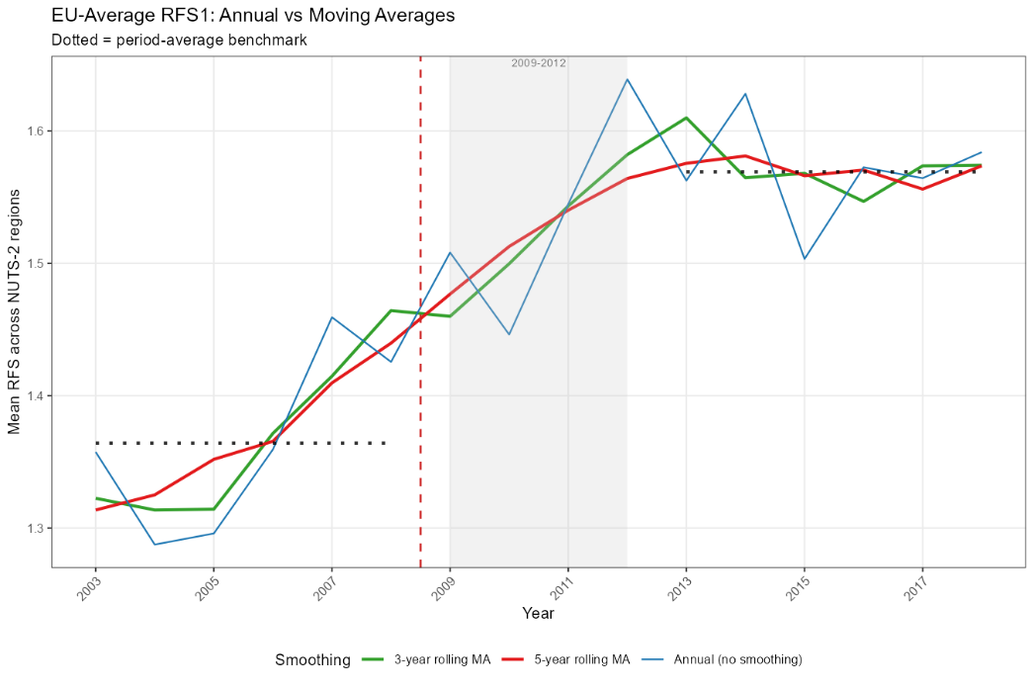
Source: authors’ elaboration based on fDi Markets data.
Figure C.1 plots the EU-average RFS index over 2003–2018 under three smoothing variants: annual values (blue line), 3-year rolling moving average (green line), and 5-year rolling moving average (red line). The dotted horizontal lines indicate the period-average benchmark for the pre-crisis (2003–2008) and post-crisis (2013–2018) periods. The results show that the EU-average RFS increased from the pre-crisis to the post-crisis period, rising from approximately 1.33–1.36 to approximately 1.55–1.58, indicating a shift towards relatively more production-oriented functional specialization across European regions. The evidence highlights the difference between annual and smoothed measures of functional specialization. While annual values exhibit higher short-run volatility, the 3-year and 5-year moving averages reveal a much more stable medium-term pattern and closely track the period-based indicators used in the paper. These results suggest that multi-year aggregation is better suited to capturing persistent specialization patterns than measures based on annual FDI flows alone.

Appendix D. Spatial robustness checks
To assess the sensitivity of our results to spatial dependence, we re-estimate all specifications in Table 3 using Conley (1999) spatial HAC standard errors under two alternative distance cut-offs: 1,500 km, approximating the maximum nearest-neighbour distance, and 2,000 km, approximating the average inter-regional distance.
The Conley correction allows for spatial correlation in the error structure within geographically bounded clusters of neighbouring regions, without imposing a fully specified structural model of spatial interaction. This approach is robust to arbitrary patterns of spatial correlation and heteroskedasticity within the specified bandwidth, without requiring a fully specified structural model of spatial interaction. Indeed, regional functional specialization patterns may be systematically affected by geographically correlated shocks (such as macro-regional demand fluctuations, sector-specific investment cycles, or EU cohesion policy interventions) as well as by cross-regional FDI spillovers and agglomeration externalities that could induce spatial correlation in the regression disturbances. Under such conditions, conventional standard errors, even when clustered at the NUTS-2 level, may be inconsistent if the scope of spatial correlation extends beyond individual regions and is not adequately captured by the clustering structure.
The results, reported in Table D.1, confirm the sign, magnitude, and statistical significance of all coefficients across specifications and distance cut-offs. The Conley-corrected standard errors are in most cases smaller than the NUTS-2 clustered baseline estimates, indicating that spatial correlation in the error structure does not materially inflate inference under either bandwidth assumption — if anything, the baseline clustered standard errors are conservative relative to the spatially HAC-corrected counterparts. The point estimates are numerically identical to the baseline by construction, as the Conley correction affects only the variance-covariance matrix and leaves the coefficient vector unchanged. Taken together, these results provide strong reassurance that the main findings of the paper are robust to alternative treatments of spatial dependence in the disturbance process, and that the estimated associations between regional structural characteristics and functional specialization are not an artifact of spatially correlated measurement error or omitted spatial confounders.

Table D.1. Robustness to spatial dependence: Conley spatial HAC standard errors
 | Upstream FS | Production FS | Downstream FS | RFS index
GVA p.c. (log) | 0.2045 | -1.6215 | 0.5348 | -1.1338
 | (0.0036)*** | (0.0077)*** | (0.0030)*** | (0.0077)***
 | [0.0031]*** | [0.0067]*** | [0.0026]*** | [0.0067]***
Patents (log) | 1.2311 | -1.6207 | 0.7072 | -1.4917
 | (0.0162)*** | (0.0181)*** | (0.0055)*** | (0.0166)***
 | [0.0140]*** | [0.0157]*** | [0.0047]*** | [0.0144]***
Urban areas | 0.1627 | -0.3252 | 0.1250 | -0.4358
 | (0.0023)*** | (0.0036)*** | (0.0014)*** | (0.0024)***
 | [0.0020]*** | [0.0031]*** | [0.0012]*** | [0.0021]***
N. obs. | 4256 | 4256 | 4256 | 4256
Year FE | Yes | Yes | Yes | Yes
Country FE | Yes | Yes | Yes | Yes
Std. errors | Conley | Conley | Conley | Conley
Note. Conley standard errors are reported in parentheses below each coefficient: standard errors in () use a 1,500 km cut-off; standard errors in [] use a 2,000 km cut-off. The 1,500 km threshold approximates the maximum nearest-neighbour distance, while 2,000 km approximates the average inter-regional distance. All specifications include year and country fixed effects. *** p<0.01, ** p<0.05, * p<0.1. The variable ‘Urban areas’ is computed as a dummy variable equal to 1 if the region is predominantly urban and is characterized by the presence of at least one Metropolitan area (i.e., agglomerations of at least 250 000 inhabitants). Source: authors’ elaboration based on fDi Markets, OECD and Eurostat data.

Appendix E. Functional trajectory and inter-sectoral upgrading
To complement the descriptive evidence reported in Table 5, we conduct three additional exercises examining the relationship between functional trajectories and sectoral upgrading patterns.
First, we perform chi-squared tests of independence between functional trajectory groups and the dominant Pavitt specialization class of each region. The dominant Pavitt class is defined as the sectoral category with the highest specialization index (and PS > 1) within a given period. We construct contingency tables relating functional trajectories to: (i) the sectoral Pavitt-based Specialization (PS) in the dominant Pavitt class in the pre-crisis period (2003–2008); (ii) the PS in the dominant Pavitt class in the post-crisis period (2013–2018); and (iii) changes in dominant Pavitt specialization between the two periods. Table E.1 reports the results. The null hypothesis of independence is rejected in all cases, indicating a systematic association between functional trajectories and sectoral specialization patterns.
Second, we examine whether regions experiencing functional upgrading also display stronger inter-sectoral upgrading. For each region, we compute the change in specialization in Science-Based industries (ΔPS_SB) between the first and third periods and compare upgrading regions with the other trajectory groups using Welch t-tests. As reported in Table E.2, regions undergoing functional upgrading record significantly larger increases in Science-Based specialization than most other groups, particularly relative to persistently production-specialized and downgrading regions. Conversely, regions experiencing functional downgrading, and to a lesser extent those persistently specialized in production functions, tend to exhibit weaker changes in Science-Based specialization. Overall, the results point to systematic differences in sectoral upgrading across functional trajectories.
Third, we estimate OLS regressions where the dependent variable is the change in regional specialization in Science-Based industries (ΔPS_SB) between the two periods. Functional trajectory groups are included as explanatory variables, with persistently production-specialised regions serving as the reference category. Table E.3 reports the results. Column (1) includes only trajectory-group indicators; Column (2) additionally controls for the initial level of Science-Based specialisation; and Column (3) further controls for the initial level of relative functional specialisation (RFS). Across all specifications, the coefficient associated with functional upgrading remains positive and statistically significant.
Taken together, these results indicate that regions experiencing functional upgrading are also more likely to increase their specialization in Science-Based industries. While the period-based structure of the analysis does not allow the temporal ordering of functional and sectoral change to be identified, the evidence is consistent with the view that the two processes tend to co-evolve over time.

Table E.1. Chi-squared test: functional trajectory group and dominant Pavitt class
Test | χ² | p-value
Functional Trajectory x Dominant Pavitt class (period 1) | 77.65 | 0.0001
Functional Trajectory x Dominant Pavitt class (period 3) | 40.23 | 0.0004
Trajectory x Pavitt change (p1 p3) | 125.97 | 0.0013
Source: authors’ elaboration based on fDi Markets data.

Table E.2. T-test: change in Science-Based PS by functional trajectory
(A) Regions experiencing functional upgrading
 | Mean ΔPS_SB  (Upgrading) |  | Mean ΔPS_SB  (Other) |  | Difference |  | p-value
Upgrading vs Persistently production | 0.4837 |  | -0.0364 |  | 0.5201* |  | 0.0608
Upgrading vs Persistently upstream | 0.4837 |  | 0.0268 |  | 0.4569* |  | 0.0986
Upgrading vs Persistently downstream | 0.4837 |  | -0.0076 |  | 0.4914* |  | 0.0752
Upgrading vs Downgrading | 0.4837 |  | -0.1175 |  | 0.6012** |  | 0.0349
Upgrading vs Up-Down switch | 0.4837 |  | 0.0342 |  | 0.4495 |  | 0.1044
Upgrading vs All others | 0.4837 |  | -0.0214 |  | 0.5051* |  | 0.0667
(B) Regions persistently specialized in production functions
 |  | Mean ΔPS_SB  (Persistently production) |  | Mean ΔPS_SB  (Other) |  | Difference |  | p-value
Persistently production vs Persistently upstream |  | -0.0364 |  | 0.0268 |  | -0.0632 |  | 0.3389
Persistently production vs Persistently downstream |  | -0.0364 |  | -0.0076 |  | -0.0287 |  | 0.5991
Persistently production vs Upgrading |  | -0.0364 |  | 0.4837 |  | -0.5201* |  | 0.0608
Persistently production vs Downgrading |  | -0.0364 |  | -0.1175 |  | 0.0811 |  | 0.2889
Persistently production vs Up-Down switch |  | -0.0364 |  | 0.0342 |  | -0.0706 |  | 0.3073
Persistently production vs All others |  | -0.0364 |  | 0.0673 |  | -0.1036* |  | 0.0827
(C) Regions experiencing functional downgrading
 | Mean ΔPS_SB  (Downgrading) |  | Mean ΔPS_SB  (Other) |  | Difference |  | p-value
Downgrading vs Upgrading | -0.1175 |  | 0.4837 |  | -0.6012** |  | 0.0349
Downgrading vs Persistently production | -0.1175 |  | -0.0364 |  | -0.0811 |  | 0.2889
Downgrading vs Persistently upstream | -0.1175 |  | 0.0268 |  | -0.1443* |  | 0.0940
Downgrading vs Persistently downstream | -0.1175 |  | -0.0076 |  | -0.1099 |  | 0.1572
Downgrading vs Up-Down switch | -0.1175 |  | 0.0342 |  | -0.1518* |  | 0.0871
Downgrading vs All others | -0.1175 |  | 0.0226 |  | -0.1401* |  | 0.0639
Note: ΔPS_SB denotes the change in regional specialization in Science-Based industries between the first and the third periods. Source: authors’ elaboration based on fDi Markets data.

Table E.3. Change in Science-Based PS on functional trajectory group
 | (1) | (2) | (3)
Upgrading | 0.5201*** | 0.5329*** | 0.5621***
 | (0.1154) | (0.1092) | (0.1103)
Persistently upstream | 0.0632 | 0.1423* | 0.2243**
 | (0.0840) | (0.0807) | (0.0947)
Persistently downstream | 0.0287 | 0.0168 | 0.1045
 | (0.0856) | (0.0810) | (0.0969)
Downgrading | -0.0811 | -0.0910 | -0.0124
 | (0.1282) | (0.1213) | (0.1301)
Up-Down switch | 0.0706 | 0.0758 | 0.1635
 | (0.1212) | (0.1147) | (0.1262)
PS in SB (2003-2008) |  | -0.3240*** | -0.3080***
 |  | (0.0575) | (0.0582)
RFS (2003-2008) |  |  | 0.0580
 |  |  | (0.0354)
N | 266 | 266 | 266
R² | 0.1965 | 0.2521 | 0.2608
Adj. R² | 0.1785 | 0.2326 | 0.2387
Notes: OLS regression. Dependent variable: change in region-level Pavitt Specialization (PS) in Science-Based (SB) industries. Reference category: Persistently production. Column (2) controls for baseline level of PS in SB at period 1. Column (3) additionally controls for baseline level of RFS at period 1. *, **, *** significant at 10%, 5%, 1%.
Source: authors’ elaboration based on fDi Markets data.

The functional trajectories are: Persistently upstream, Persistently production, Persistently downstream, Upgrading, Downgrading, and Up-Down switch. The dominant Pavitt class are: Science-Based, Supplier Dominated, Scale Intensive, and Specialised Supplier industries.

