Supplementary material
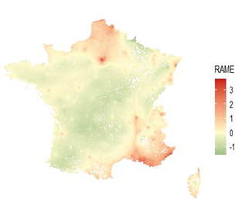
Figure S1. MAP showing RAME index levels

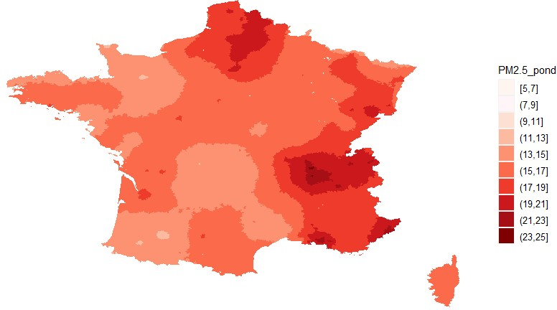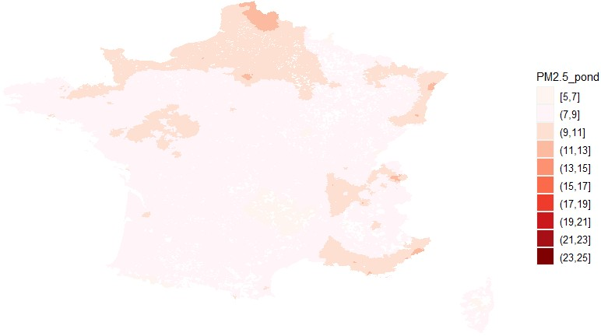
Figure S2. Map showing pollution levels of PM2.5 in 2009 (left) and in 2019 (right)

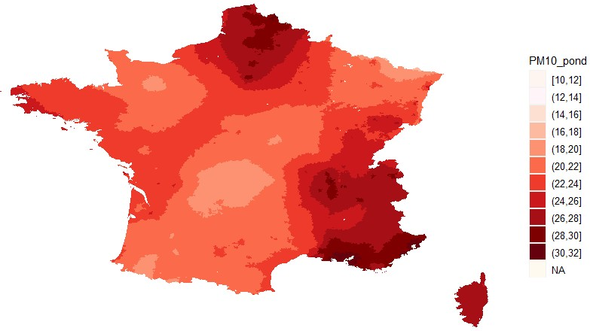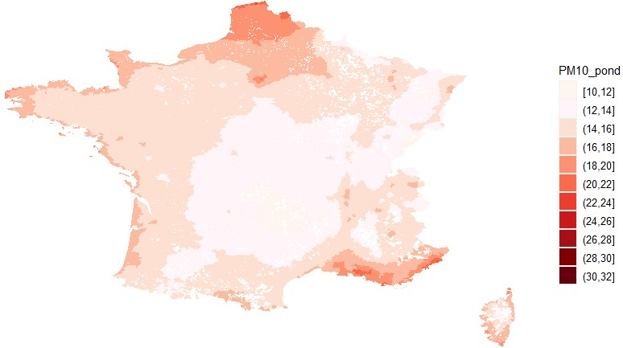
Figure S3. Map showing pollution levels of PM10 in 2009 (left) and in 2019 (right)

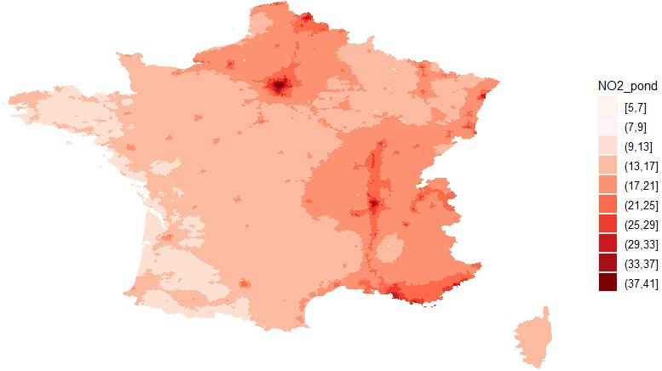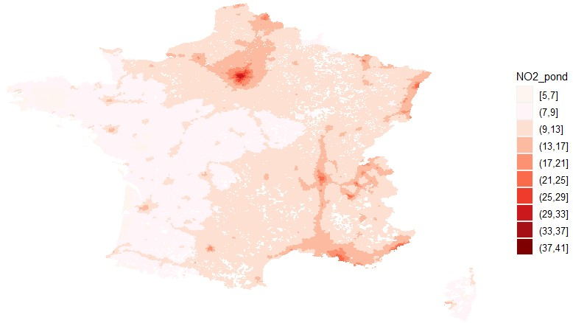
Figure S4. Map showing pollution levels of NO2 in 2009 (left) and in 2019 (right)
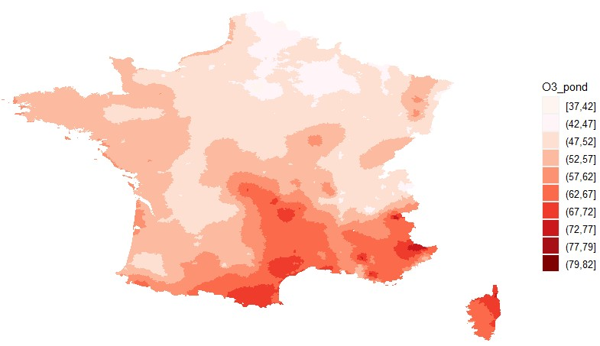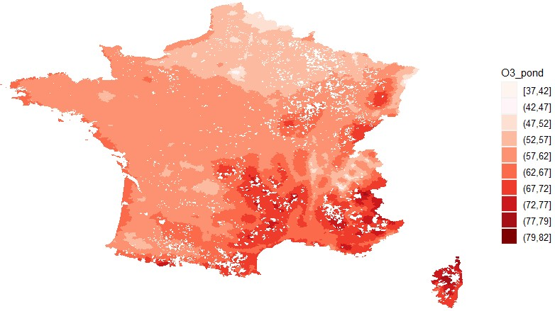
Figure S5. Map showing pollution levels of O3 in 2009 (left) and in 2019 (right)

Figure S6. Air pollution exposure by income per consumption unit percentile, full sample (all municipalities)
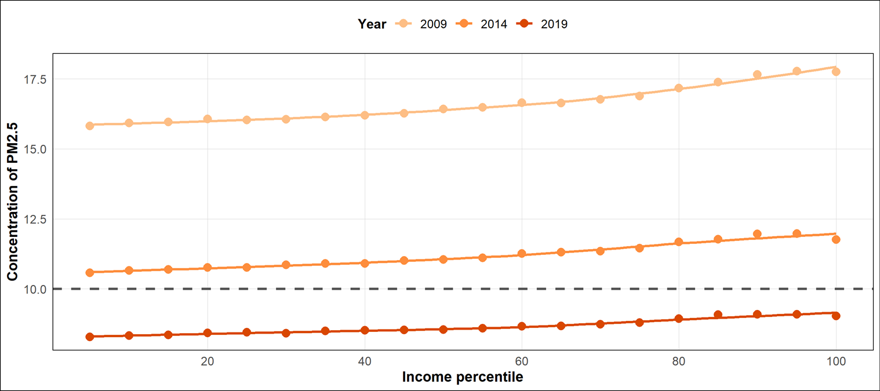  All years:  ↗ | 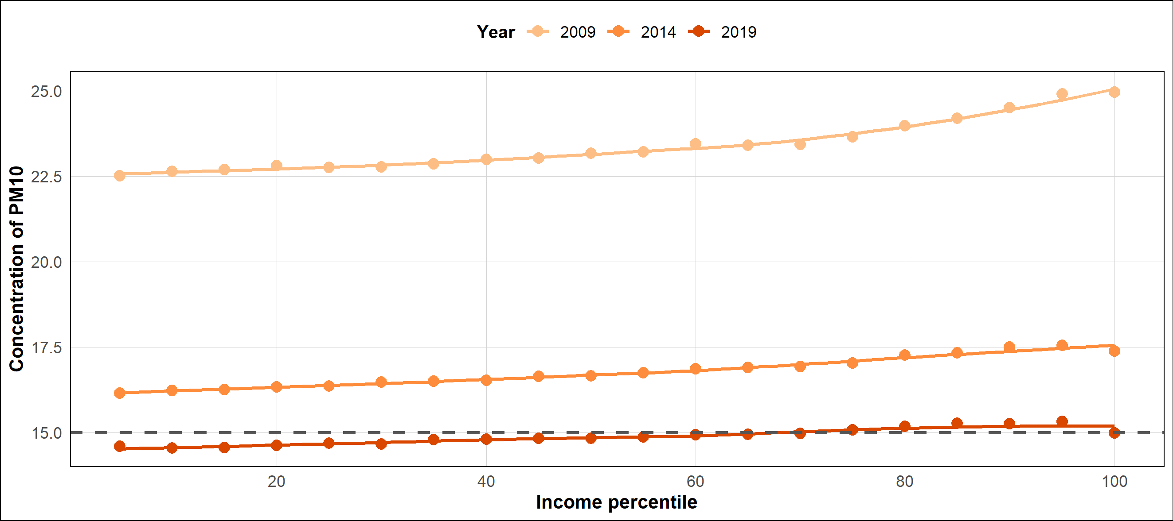  All years:  ↗
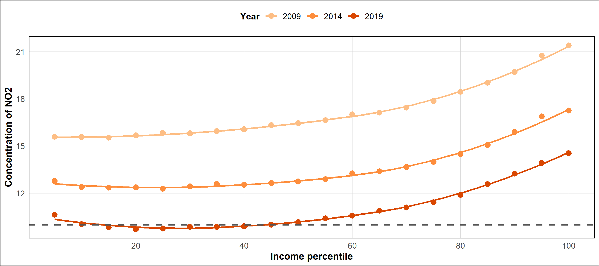  All years: ∪ | 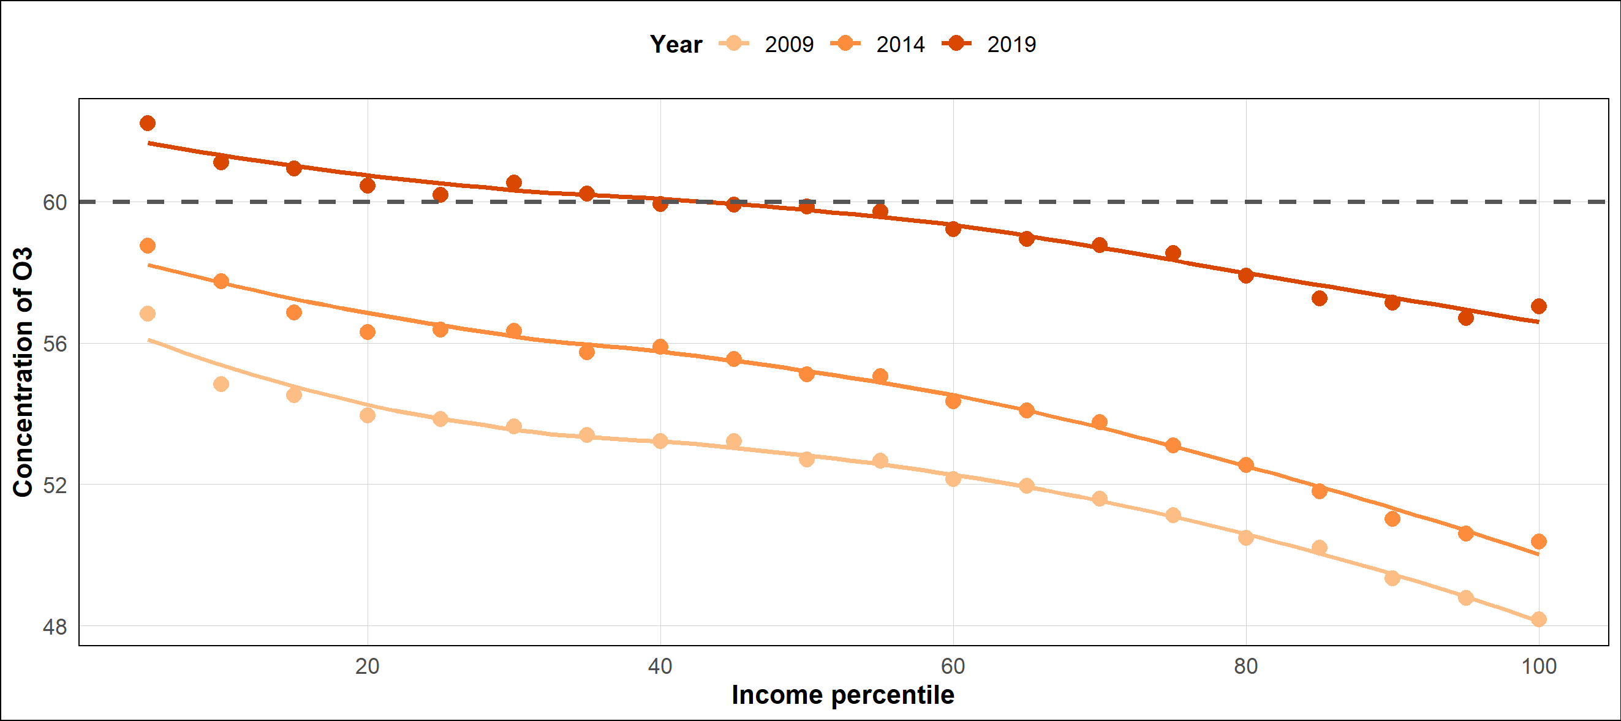  All years: ↘
Reading key: The horizontal axis represents the income percentile, so 20 represents 20% of our sample. The vertical axis represents the level of concentration for each pollutant. The gray dotted line represents the WHO threshold. Each point is the mean value for the income-group corresponding. The line is the LOESS fitting.
The symbols refer to the results of regressions testing the shape of the relationship (see Tables S1-S4 below): a reported symbol indicates that the corresponding shape is statistically significant; NS indicates that no significant relationship has been found.
Figure S7. Percentage of municipalities that exceed the WHO’s threshold by income per consumption unit percentile and urbanization degree
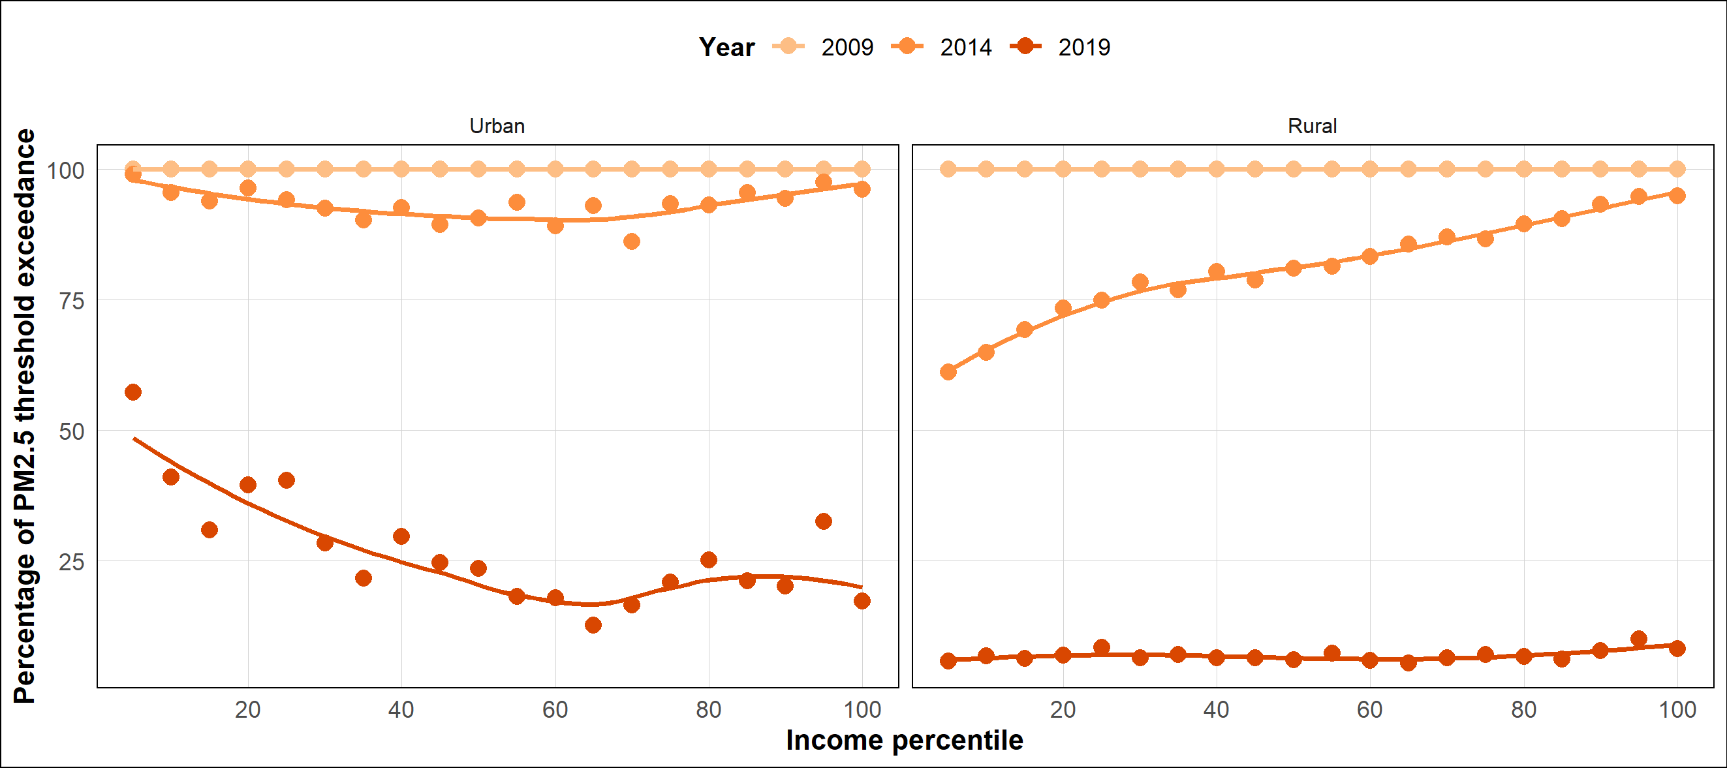  2009: NS  2014 : ↗  2019 : ∪  2009 : NS  2014 : ↗  2019 : ∪ | 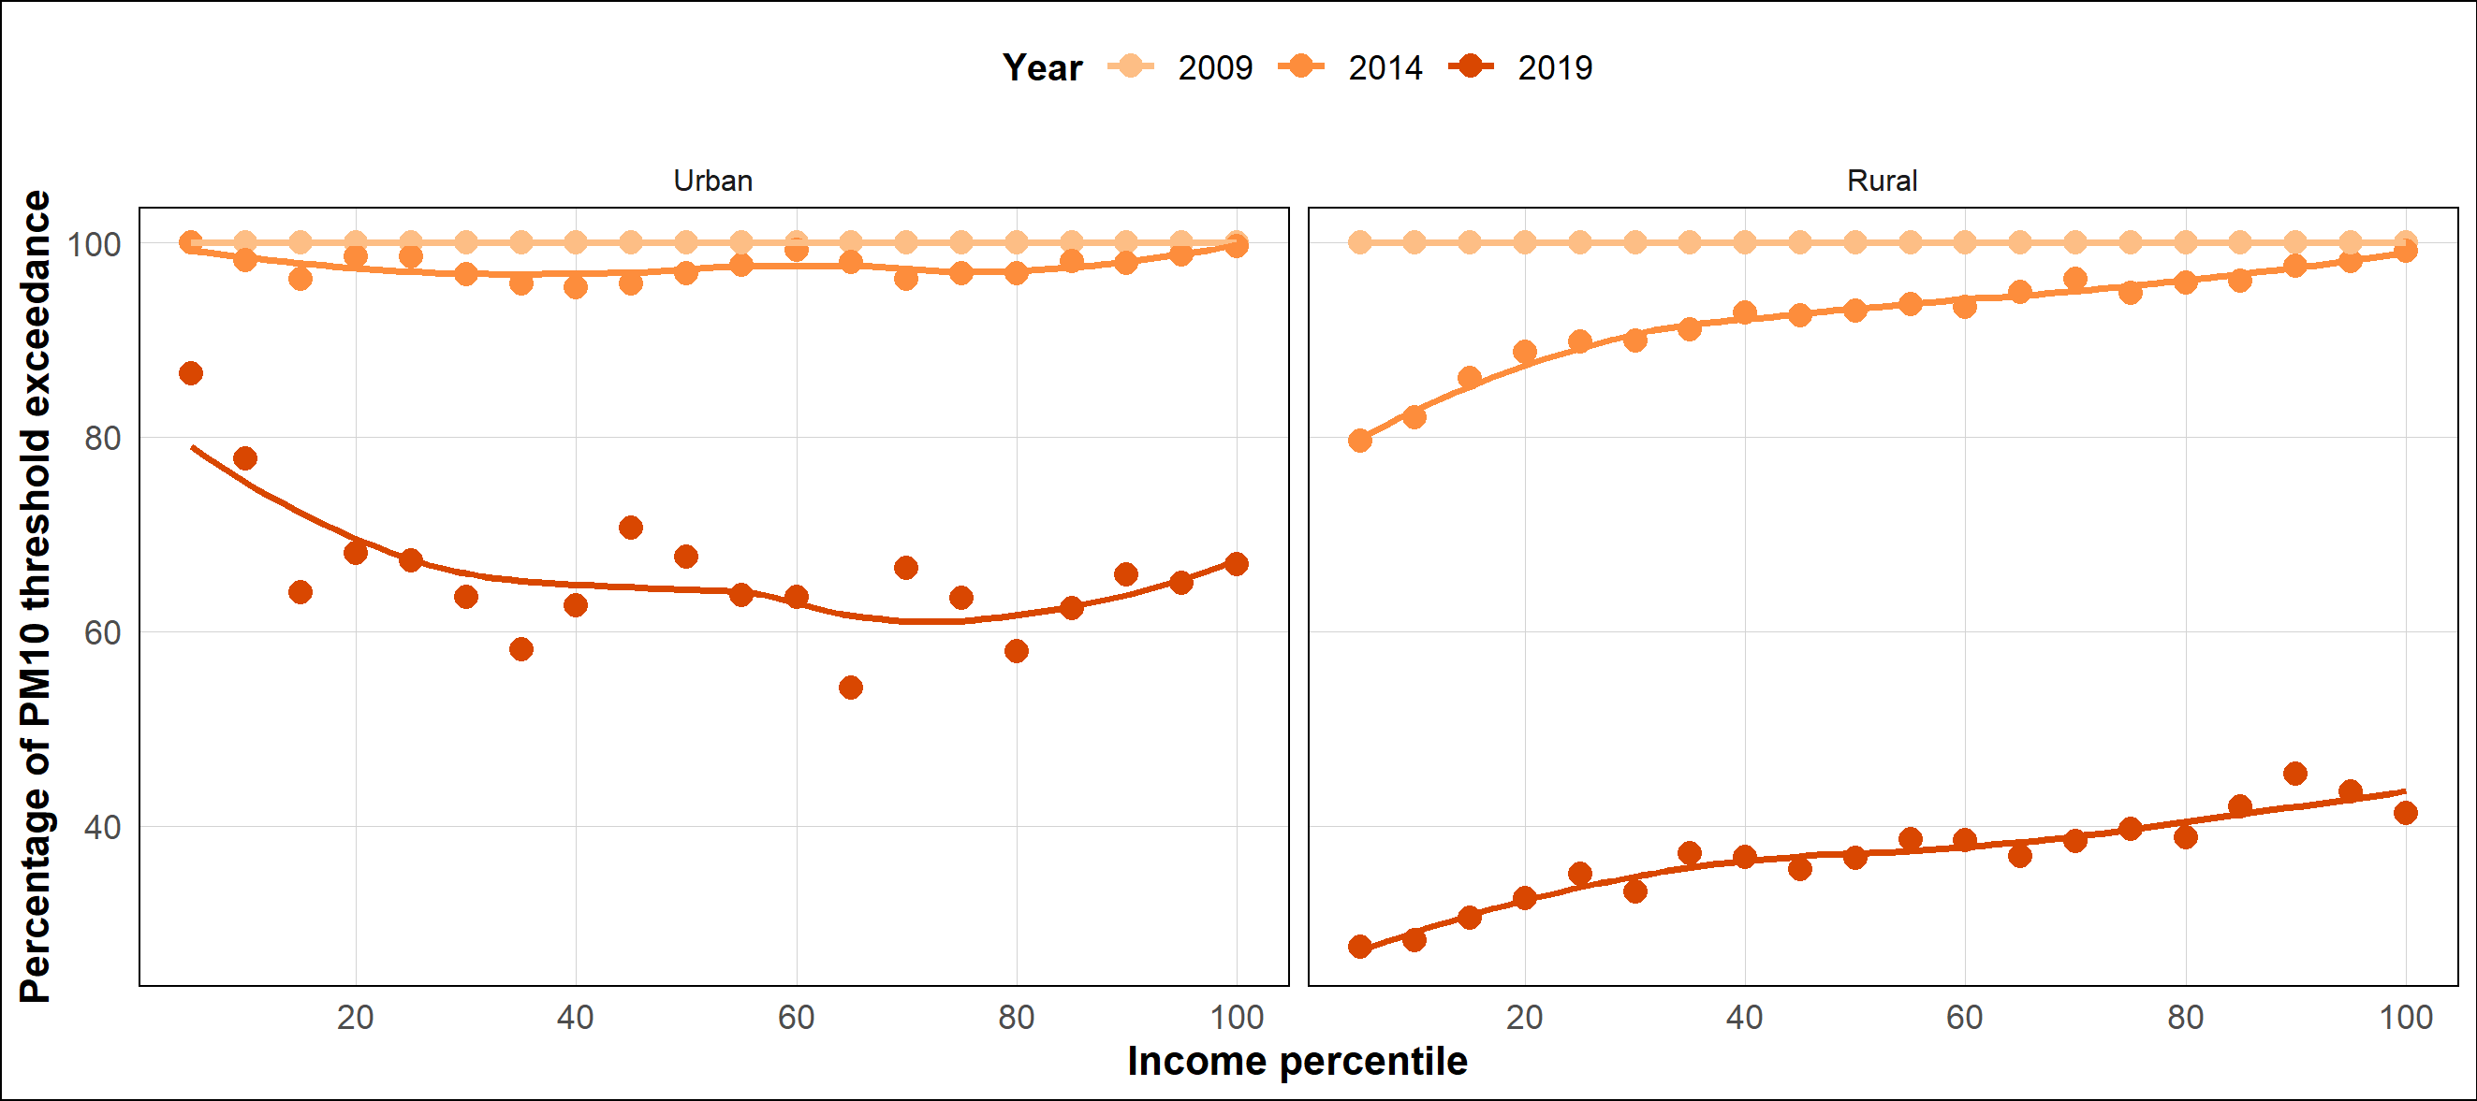  2009 : NS  2014 :2019 : ↗  2009 : NS  2014/2019 : ↗
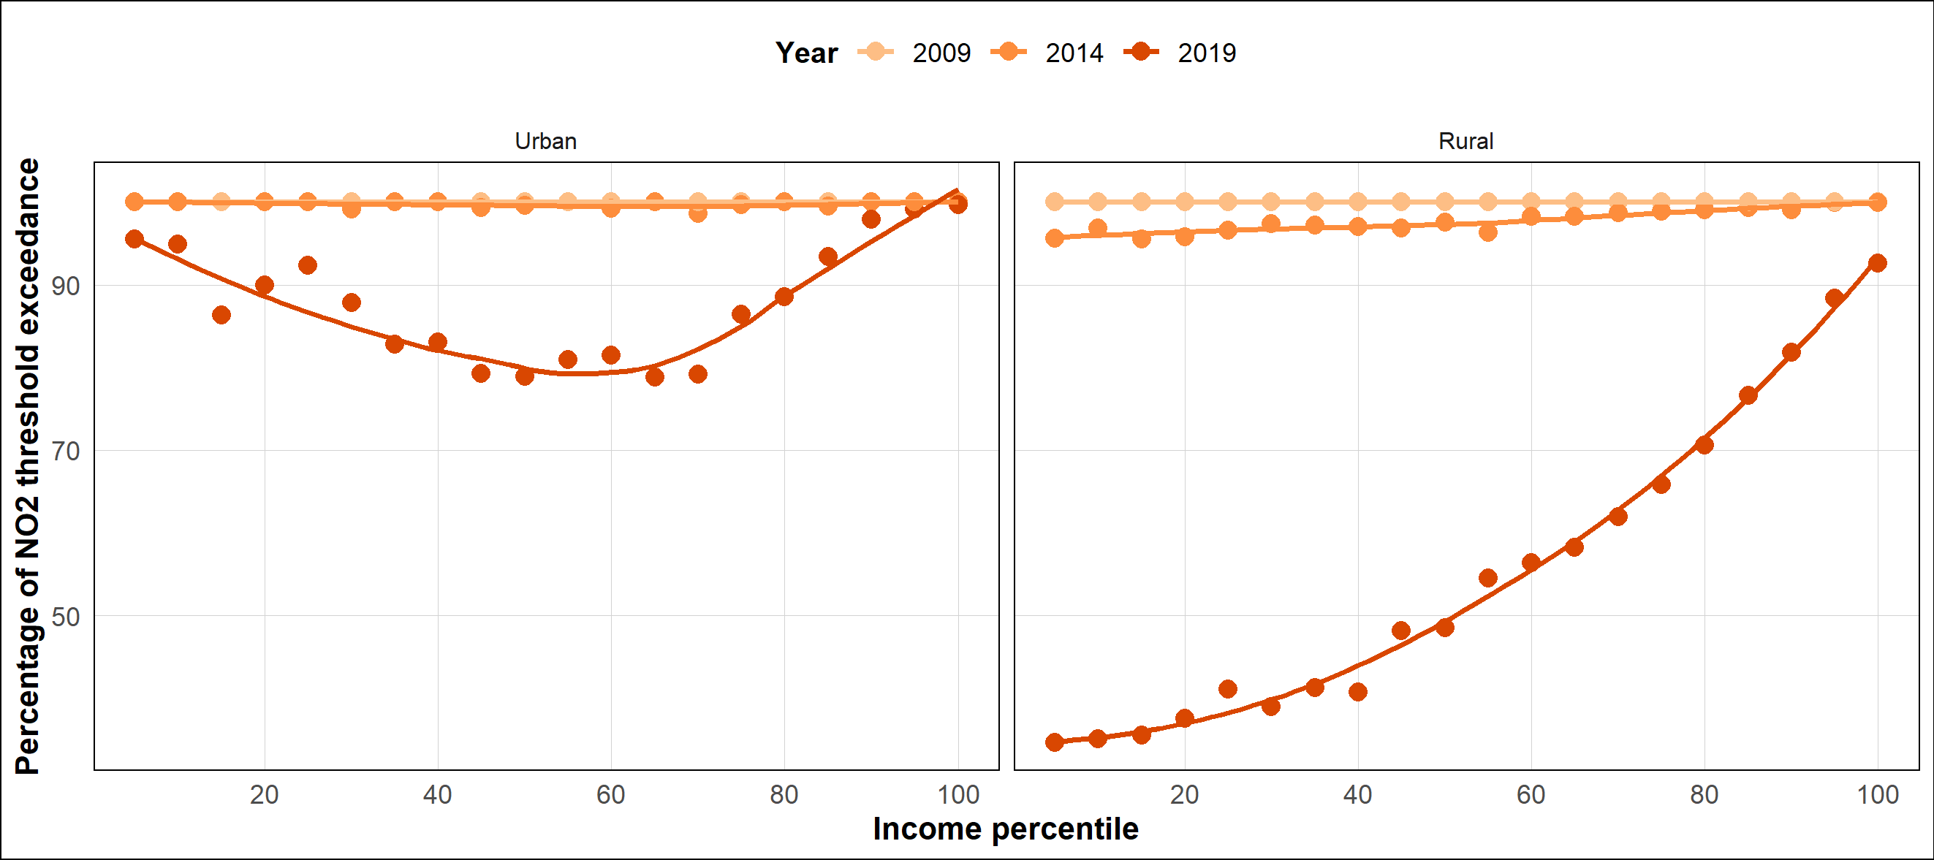  2009 : NS  2014/2019 : ↗  2009 : NS  2014/2019 : ↗ | 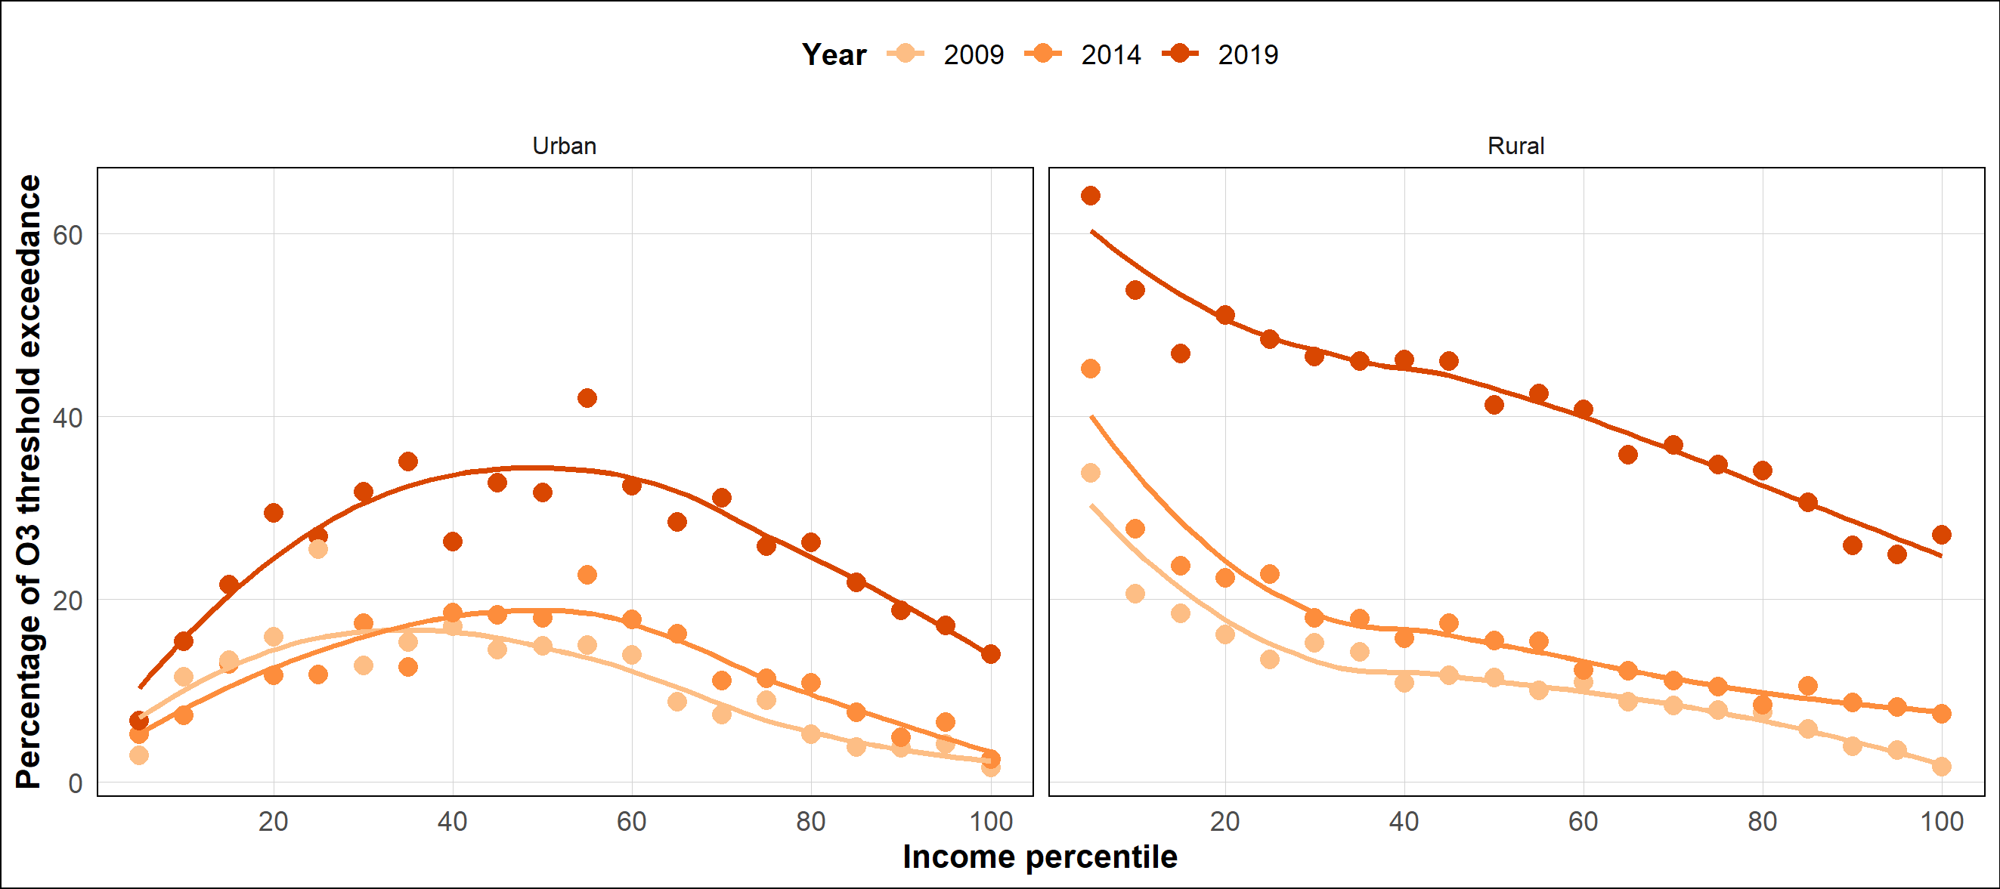  All years : ↘  All years : ↘
Reading key: The horizontal axis represents the income percentile, so 20 represents 20% of our sample. The vertical axis represents the percentage of municipalities within an income group that exceed the WHO threshold. Each point is the percentage for the income-group corresponding. The line is the LOESS fitting.
The symbols refer to the results of regressions testing the shape of the relationship (see Tables S13-S20 below): a reported symbol indicates that the corresponding shape is statistically significant; NS indicates that no significant relationship has been found.

Figure S8. SOMO35 by income per consumption unit percentile and urbanization degree
All years: ∩
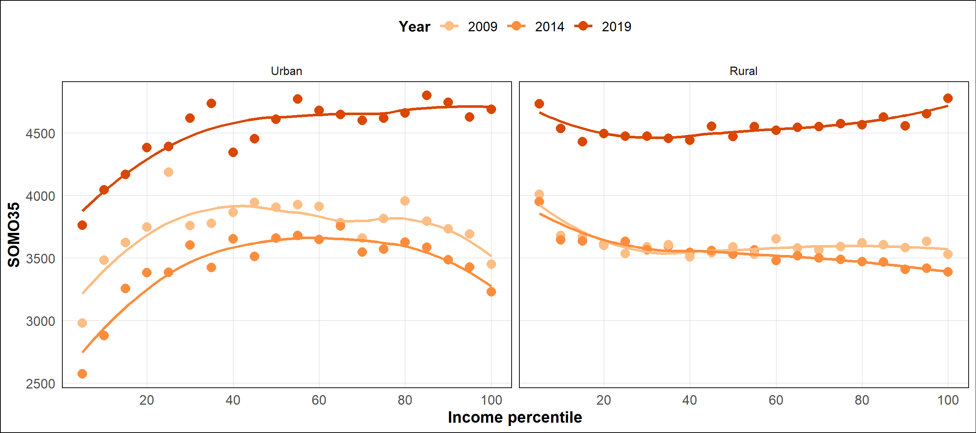
2009: NS
2014: ↘
2019: ∪
201

Reading key: The horizontal axis represents the income percentile, so 20 represents 20% of our sample. The vertical axis represents the level of both indicators. Each point is the mean value for the income-group corresponding. The line is the LOESS fitting. The symbols refer to the results of regressions testing the shape of the relationship (see Tables S25-S26 below): a reported symbol indicates that the corresponding shape is statistically significant; NS indicates that no significant relationship has been found.

The tables below report regression results supporting the analyses presented in the main text. For each pollutant and, where relevant, each subsample (urban/rural) or outcome (mean level, threshold exceedance, RAME/RTME, SOMO35), columns (1), (3), and (5) report the linear relationship between the pollutant outcome and the income group rank for 2009, 2014, and 2019 respectively, with robust standard errors. Columns (2), (4), and (6) add a squared income group rank term to test for a non-linear relationship in each of these years, respectively. Columns (7) and (8) pool all years and regress the pollutant outcome on continuous municipality-level income, without and with a squared income term respectively, including year fixed effects (with 2009 as the reference year) and standard errors clustered at the department level.

Table S1. Regression results for PM2.5 level
 | (1) | (2) | (3) | (4) | (5) | (6) | (7) | (8)
VARIABLES | 2009 | 2009 | 2014 | 2014 | 2019 | 2019 | Full sample | Full sample
Income/Income group | 0.104*** | -0.004 | 0.074*** | 0.034** | 0.044*** | 0.015* | 0.137*** | 0.334***
 | (0.008) | (0.014) | (0.005) | (0.015) | (0.003) | (0.008) | (0.018) | (0.067)
Income/Income group squared |  | 0.005*** |  | 0.002*** |  | 0.001*** |  | -0.004***
 |  | (0.001) |  | (0.001) |  | (0.0005) |  | (0.001)
2010 |  |  |  |  |  |  | -0.070  (0.095) | -0.086  (0.097)
2011 |  |  |  |  |  |  | -1.011***  (0.132) | -1.042***  (0.136)
2012 |  |  |  |  |  |  | -2.637***  (0.127) | -2.702***  (0.135)
2013 |  |  |  |  |  |  | -3.220***  (0.150) | -3.295***  (0.159)
2014 |  |  |  |  |  |  | -5.646***  (0.174) | -5.724***  (0.185)
2015 |  |  |  |  |  |  | -5.226***  (0.143) | -5.306***  (0.150)
2016 |  |  |  |  |  |  | -6.448***  (0.129) | -6.531***  (0.140)
2017 |  |  |  |  |  |  | -6.949***  (0.135) | -7.035***  (0.148)
2018 |  |  |  |  |  |  | -7.507***  (0.171) | -7.597***  (0.186)
2019 |  |  |  |  |  |  | -8.394***  (0.170) | -8.484***  (0.186)
Constant | 15.508*** | 15.905*** | 10.417*** | 10.564*** | 8.196*** | 8.303*** | 14.015*** | 11.936***
 | (0.082) | (0.059) | (0.041) | (0.045) | (0.025) | (0.028) | (0.398) | (0.792)
Extreme point |  | 0.405 |  | -8.785 |  | -5.324 |  | 37.904
Lind/Mehlum test (p-value) |  | NR |  | NR |  | NR |  | 0.044
Significant shape | ↗ |  | ↗ |  | ↗ |  | ↗ | ∩
Observations | 20 | 20 | 20 | 20 | 20 | 20 | 341,113 | 341,113
R-squared | 0.926 | 0.986 | 0.951 | 0.968 | 0.936 | 0.961 | 0.808 | 0.809
Standard errors in parentheses. *** p<0.01, ** p<0.05, * p<0.1. NR: Not relevant (implausible value of the extremum).
In columns (1) to (6), the average level of pollutant in each municipality group is regressed on the income group rank with robust SE.
In columns (7) and (8), the level of pollutant is regressed on the level of income of each municipality with clustered SE at the department level (see introductory note for more information about the construction of this table).

Table S2. Regression results for PM10 level
 | (1) | (2) | (3) | (4) | (5) | (6) | (7) | (8)
VARIABLES | 2009 | 2009 | 2014 | 2014 | 2019 | 2019 | Full sample | Full sample
Income/Income group | 0.119*** | -0.034 | 0.074*** | 0.042*** | 0.039*** | 0.040** | 0.150*** | 0.373***
 | (0.012) | (0.021) | (0.004) | (0.012) | (0.005) | (0.018) | (0.026) | (0.096)
Income/Income group squared |  | 0.007*** |  | 0.002** |  | -0.0001 |  | -0.005***
 |  | (0.001) |  | (0.001) |  | (0.001) |  | (0.002)
2010 |  |  |  |  |  |  | -1.149***  (0.134) | -1.167***  (0.135)
2011 |  |  |  |  |  |  | -1.307***  (0.159) | -1.342***  (0.162)
2012 |  |  |  |  |  |  | -3.493***  (0.156) | -3.566***  (0.165)
2013 |  |  |  |  |  |  | -4.261***  (0.182) | -4.346***  (0.198)
2014 |  |  |  |  |  |  | -6.851***  (0.229) | -6.939***  (0.244)
2015 |  |  |  |  |  |  | -6.145***  (0.236) | -6.235***  (0.249)
2016 |  |  |  |  |  |  | -7.875***  (0.195) | -7.968***  (0.211)
2017 |  |  |  |  |  |  | -7.858***  (0.202) | -7.956***  (0.221)
2018 |  |  |  |  |  |  | -8.340***  (0.245) | -8.442***  (0.267)
2019 |  |  |  |  |  |  | -8.966***  (0.233) | -9.069***  (0.255)
Constant | 22.138*** | 22.702*** | 16.003*** | 16.119*** | 14.480*** | 14.474*** | 20.550*** | 18.196***
 | (0.112) | (0.097) | (0.032) | (0.035) | (0.036) | (0.059) | (0.606) | (1.180)
Extreme point |  | 2.338 |  | -13.994 |  | 264.438 |  | 37.356
Lind/Mehlum test (p-value) |  | 0.159 |  | NR |  | NR |  | 0.064
Significant shape | ↗ |  | ↗ |  | ↗ |  | ↗
Observations | 20 | 20 | 20 | 20 | 20 | 20 | 341,113 | 341,113
R-squared | 0.891 | 0.979 | 0.967 | 0.978 | 0.883 | 0.883 | 0.712 | 0.713
Standard errors in parentheses. *** p<0.01, ** p<0.05, * p<0.1. NR: Not relevant (implausible value of the extremum).
In columns (1) to (6), the average level of pollutant in each municipality group is regressed on the income group rank with robust SE.
In columns (7) and (8), the level of pollutant is regressed on the level of income of each municipality with clustered SE at the department level (see introductory note for more information about the construction of this table).

Table S3. Regression results for NO2 level
 | (1) | (2) | (3) | (4) | (5) | (6) | (7) | (8)
VARIABLES | 2009 | 2009 | 2014 | 2014 | 2019 | 2019 | Full sample | Full sample
Income/Income group | 0.278*** | -0.182*** | 0.227*** | -0.283*** | 0.212*** | -0.317*** | 0.400*** | 0.339*
 | (0.035) | (0.035) | (0.039) | (0.028) | (0.040) | (0.026) | (0.034) | (0.174)
Income/Income group squared |  | 0.022*** |  | 0.024*** |  | 0.025*** |  | 0.001
 |  | (0.002) |  | (0.001) |  | (0.001) |  | (0.004)
2010 |  |  |  |  |  |  | 0.477***  (0.067) | 0.482***  (0.072)
2011 |  |  |  |  |  |  | -1.666***  (0.112) | -1.656***  (0.123)
2012 |  |  |  |  |  |  | -3.103***  (0.129) | -3.083***  (0.155)
2013 |  |  |  |  |  |  | -3.383***  (0.130) | -3.360***  (0.159)
2014 |  |  |  |  |  |  | -4.436***  (0.120) | -4.412***  (0.143)
2015 |  |  |  |  |  |  | -4.966***  (0.129) | -4.942***  (0.152)
2016 |  |  |  |  |  |  | -4.724***  (0.149) | -4.699***  (0.170)
2017 |  |  |  |  |  |  | -5.405***  (0.162) | -5.378***  (0.182)
2018 |  |  |  |  |  |  | -6.914***  (0.176) | -6.886***  (0.203)
2019 |  |  |  |  |  |  | -7.655***  (0.164) | -7.627***  (0.186)
Constant | 14.284*** | 15.973*** | 11.212*** | 13.080*** | 8.786*** | 10.721*** | 9.643*** | 10.280***
 | (0.347) | (0.149) | (0.398) | (0.111) | (0.370) | (0.135) | (0.715) | (1.883)
Extreme point |  | 4.159 |  | 5.825 |  | 6.29 |  | -125.65
Lind/Mehlum test (p-value) |  | 0.000 |  | 0.000 |  | 0.000 |  | NR
Significant shape | ↗ | ∪ | ↗ | ∪ | ↗ | ∪ | ↗
Observations | 20 | 20 | 20 | 20 | 20 | 20 | 341,113 | 341,113
R-squared | 0.848 | 0.988 | 0.756 | 0.985 | 0.723 | 0.992 | 0.441 | 0.441
Standard errors in parentheses. *** p<0.01, ** p<0.05, * p<0.1. NR: Not relevant (implausible value of the extremum).
In columns (1) to (6), the average level of pollutant in each municipality group is regressed on the income group rank with robust SE.
In columns (7) and (8), the level of pollutant is regressed on the level of income of each municipality with clustered SE at the department level (see introductory note for more information about the construction of this table).

Table S4. Regression results for O3 level
 | (1) | (2) | (3) | (4) | (5) | (6) | (7) | (8)
VARIABLES | 2009 | 2009 | 2014 | 2014 | 2019 | 2019 | Full sample | Full sample
Income/Income group | -0.358*** | -0.225 | -0.394*** | -0.202** | -0.250*** | -0.151** | -0.532*** | -1.681***
 | (0.026) | (0.139) | (0.020) | (0.094) | (0.015) | (0.079) | (0.089) | (0.327)
Income/Income group squared |  | -0.006 |  | -0.009** |  | -0.005 |  | 0.026***
 |  | (0.006) |  | (0.004) |  | (0.003) |  | (0.006)
2010 |  |  |  |  |  |  | 0.979***  (0.145) | 1.069***  (0.153)
2011 |  |  |  |  |  |  | 2.138***  (0.190) | 2.318***  (0.207)
2012 |  |  |  |  |  |  | 2.300***  (0.211) | 2.677***  (0.266)
2013 |  |  |  |  |  |  | 3.013***  (0.242) | 3.448***  (0.292)
2014 |  |  |  |  |  |  | 3.274***  (0.261) | 3.727***  (0.296)
2015 |  |  |  |  |  |  | 4.698***  (0.240) | 5.165***  (0.312)
2016 |  |  |  |  |  |  | 0.814***  (0.263) | 1.294***  (0.339)
2017 |  |  |  |  |  |  | 3.811***  (0.286) | 4.314***  (0.362)
2018 |  |  |  |  |  |  | 8.367***  (0.354) | 8.890***  (0.421)
2019 |  |  |  |  |  |  | 8.813***  (0.335) | 9.339***  (0.405)
Constant | 56.086*** | 55.600*** | 58.708*** | 58.003*** | 61.952*** | 61.591*** | 62.296*** | 74.397***
 | (0.319) | (0.750) | (0.234) | (0.522) | (0.189) | (0.419) | (1.891) | (4.195)
Extreme point |  | -17.829 |  | -11.035 |  | -16.174 |  | 32.741
Lind/Mehlum test (p-value) |  | NR |  | NR |  | NR |  | 0.001
Significant shape | ↘ |  | ↘ |  | ↘ |  | ↘ | ∪
Observations | 20 | 20 | 20 | 20 | 20 | 20 | 341,113 | 341,113
R-squared | 0.946 | 0.954 | 0.961 | 0.975 | 0.946 | 0.955 | 0.212 | 0.221
Standard errors in parentheses. *** p<0.01, ** p<0.05, * p<0.1. NR: Not relevant (implausible value of the extremum).
In columns (1) to (6), the average level of pollutant in each municipality group is regressed on the income group rank with robust SE.
In columns (7) and (8), the level of pollutant is regressed on the level of income of each municipality with clustered SE at the department level (see introductory note for more information about the construction of this table).

Table S5. Regression results for PM2.5 level - urban municipalities
 | (1) | (2) | (3) | (4) | (5) | (6) | (7) | (8)
VARIABLES | 2009 | 2009 | 2014 | 2014 | 2019 | 2019 | Full sample | Full sample
Income/Income group | 0.012 | -0.281*** | -0.017 | -0.167*** | -0.018 | -0.162*** | 0.024 | -0.095
 | (0.024) | (0.047) | (0.014) | (0.035) | (0.012) | (0.027) | (0.024) | (0.116)
Income/Income group squared |  | 0.014*** |  | 0.007*** |  | 0.007*** |  | 0.002
 |  | (0.002) |  | (0.001) |  | (0.001) |  | (0.002)
2010 |  |  |  |  |  |  | -0.256**  (0.117) | -0.250**  (0.119)
2011 |  |  |  |  |  |  | -0.839***  (0.198) | -0.829***  (0.204)
2012 |  |  |  |  |  |  | -2.569***  (0.154) | -2.544***  (0.164)
2013 |  |  |  |  |  |  | -2.975***  (0.191) | -2.944***  (0.203)
2014 |  |  |  |  |  |  | -5.618***  (0.265) | -5.585***  (0.277)
2015 |  |  |  |  |  |  | -5.204***  (0.178) | -5.170***  (0.181)
2016 |  |  |  |  |  |  | -6.158***  (0.178) | -6.123***  (0.194)
2017 |  |  |  |  |  |  | -6.733***  (0.196) | -6.695***  (0.213)
2018 |  |  |  |  |  |  | -7.261***  (0.276) | -7.222***  (0.297)
2019 |  |  |  |  |  |  | -8.314***  (0.240) | -8.275***  (0.262)
Constant | 17.435*** | 18.511*** | 12.197*** | 12.749*** | 9.564*** | 10.088*** | 17.075*** | 18.435***
 | (0.300) | (0.225) | (0.184) | (0.195) | (0.154) | (0.134) | (0.602) | (1.492)
Extreme point |  | 10.055 |  | 11.672 |  | 11.833 |  | 19.417
Lind/Mehlum test (p-value) |  | 0.000 |  | 0.000 |  | 0.000 |  | 0.242
Significant shape |  | ∪ |  | ∪ |  | ∪
Observations | 20 | 20 | 20 | 20 | 20 | 20 | 45,309 | 45,309
R-squared | 0.023 | 0.776 | 0.117 | 0.680 | 0.163 | 0.770 | 0.756 | 0.756
Standard errors in parentheses. *** p<0.01, ** p<0.05, * p<0.1.
In columns (1) to (6), the average level of pollutant in each municipality group is regressed on the income group rank with robust SE.
In columns (7) and (8), the level of pollutant is regressed on the level of income of each municipality with clustered SE at the department level (see introductory note for more information about the construction of this table).

Table S6. Regression results for PM2.5 level - rural municipalities
 | (1) | (2) | (3) | (4) | (5) | (6) | (7) | (8)
VARIABLES | 2009 | 2009 | 2014 | 2014 | 2019 | 2019 | Full sample | Full sample
Income/Income group | 0.081*** | 0.010 | 0.065*** | 0.045*** | 0.036*** | 0.031** | 0.147*** | 0.395***
 | (0.006) | (0.014) | (0.003) | (0.014) | (0.003) | (0.014) | (0.016) | (0.061)
Income/Income group squared |  | 0.003*** |  | 0.001 |  | 0.0002 |  | -0.006***
 |  | (0.001) |  | (0.001) |  | (0.001) |  | (0.001)
2010 |  |  |  |  |  |  | -0.038  (0.097) | -0.057  (0.099)
2011 |  |  |  |  |  |  | -1.029***  (0.131) | -1.068***  (0.134)
2012 |  |  |  |  |  |  | -2.639***  (0.126) | -2.716***  (0.133)
2013 |  |  |  |  |  |  | -3.247***  (0.149) | -3.335***  (0.154)
2014 |  |  |  |  |  |  | -5.638***  (0.165) | -5.730***  (0.174)
2015 |  |  |  |  |  |  | -5.217***  (0.145) | -5.310***  (0.153)
2016 |  |  |  |  |  |  | -6.478***  (0.127) | -6.573***  (0.135)
2017 |  |  |  |  |  |  | -6.965***  (0.133) | -7.064***  (0.144)
2018 |  |  |  |  |  |  | -7.526***  (0.162) | -7.626***  (0.171)
2019 |  |  |  |  |  |  | -8.385***  (0.165) | -8.485***  (0.177)
Constant | 15.513*** | 15.772*** | 10.405*** | 10.478*** | 8.189*** | 8.206*** | 13.710*** | 11.164***
 | (0.058) | (0.050) | (0.032) | (0.071) | (0.037) | (0.076) | (0.363) | (0.657)
Extreme point |  | -1.536 |  | -23.653 |  | -70.545 |  | 34.652
Lind/Mehlum test (p-value) |  | NR |  | NR |  | NR |  | 0.006
Significant shape | ↗ |  | ↗ |  | ↗ |  | ↗ | ∩
Observations | 20 | 20 | 20 | 20 | 20 | 20 | 295,804 | 295,804
R-squared | 0.941 | 0.984 | 0.967 | 0.973 | 0.930 | 0.931 | 0.827 | 0.828
Standard errors in parentheses. *** p<0.01, ** p<0.05, * p<0.1. NR: Not relevant (implausible value of the extremum).
In columns (1) to (6), the average level of pollutant in each municipality group is regressed on the income group rank with robust SE.
In columns (7) and (8), the level of pollutant is regressed on the level of income of each municipality with clustered SE at the department level (see introductory note for more information about the construction of this table).

Table S7. Regression results for PM10 level - urban municipalities
 | (1) | (2) | (3) | (4) | (5) | (6) | (7) | (8)
VARIABLES | 2009 | 2009 | 2014 | 2014 | 2019 | 2019 | Full sample | Full sample
Income/Income group | -0.020 | -0.464*** | -0.019 | -0.141*** | -0.047*** | -0.195*** | 0.010 | -0.173
 | (0.037) | (0.070) | (0.014) | (0.044) | (0.015) | (0.040) | (0.031) | (0.158)
Income/Income group squared |  | 0.021*** |  | 0.006*** |  | 0.007*** |  | 0.004
 |  | (0.003) |  | (0.002) |  | (0.002) |  | (0.003)
2010 |  |  |  |  |  |  | -1.425***  (0.183) | -1.416***  (0.183)
2011 |  |  |  |  |  |  | -1.118***  (0.142) | -1.103***  (0.144)
2012 |  |  |  |  |  |  | -3.323***  (0.178) | -3.285***  (0.181)
2013 |  |  |  |  |  |  | -3.898***  (0.216) | -3.850***  (0.232)
2014 |  |  |  |  |  |  | -7.029***  (0.324) | -6.978***  (0.333)
2015 |  |  |  |  |  |  | -6.120***  (0.312) | -6.068***  (0.313)
2016 |  |  |  |  |  |  | -7.568***  (0.224) | -7.514***  (0.236)
2017 |  |  |  |  |  |  | -7.602***  (0.222) | -7.544***  (0.237)
2018 |  |  |  |  |  |  | -8.145***  (0.335) | -8.085***  (0.363)
2019 |  |  |  |  |  |  | -8.969***  (0.292) | -8.908***  (0.318)
Constant | 25.103*** | 26.731*** | 18.040*** | 18.490*** | 16.490*** | 17.028*** | 24.606*** | 26.699***
 | (0.465) | (0.356) | (0.193) | (0.246) | (0.203) | (0.181) | (0.921) | (2.115)
Extreme point |  | 10.972 |  | 12.083 |  | 13.855 |  | 22.879
Lind/Mehlum test (p-value) |  | 0.000 |  | 0.004 |  | 0.022 |  | 0.156
Significant shape |  | ∪ |  | ∪ | ↘ | ∪
Observations | 20 | 20 | 20 | 20 | 20 | 20 | 45,309 | 45,309
R-squared | 0.027 | 0.831 | 0.145 | 0.526 | 0.443 | 0.703 | 0.664 | 0.665
Standard errors in parentheses. *** p<0.01, ** p<0.05, * p<0.1.
In columns (1) to (6), the average level of pollutant in each municipality group is regressed on the income group rank with robust SE.
In columns (7) and (8), the level of pollutant is regressed on the level of income of each municipality with clustered SE at the department level (see introductory note for more information about the construction of this table).

Table S8. Regression results for PM10 level - rural municipalities
 | (1) | (2) | (3) | (4) | (5) | (6) | (7) | (8)
VARIABLES | 2009 | 2009 | 2014 | 2014 | 2019 | 2019 | Full sample | Full sample
Income/Income group | 0.085*** | 0.018 | 0.061*** | 0.063*** | 0.031*** | 0.070*** | 0.152*** | 0.465***
 | (0.007) | (0.023) | (0.003) | (0.014) | (0.006) | (0.016) | (0.027) | (0.090)
Income/Income group squared |  | 0.003*** |  | -0.0001 |  | -0.002*** |  | -0.007***
 |  | (0.001) |  | (0.001) |  | (0.001) |  | (0.002)
2010 |  |  |  |  |  |  | -1.097***  (0.131) | -1.121***  (0.133)
2011 |  |  |  |  |  |  | -1.314***  (0.166) | -1.363***  (0.169)
2012 |  |  |  |  |  |  | -3.485***  (0.160) | -3.583***  (0.170)
2013 |  |  |  |  |  |  | -4.275***  (0.182) | -4.386***  (0.195)
2014 |  |  |  |  |  |  | -6.780***  (0.224) | -6.895***  (0.240)
2015 |  |  |  |  |  |  | -6.101***  (0.237) | -6.219***  (0.252)
2016 |  |  |  |  |  |  | -7.869***  (0.237) | -7.990***  (0.213)
2017 |  |  |  |  |  |  | -7.840***  (0.208) | -7.965***  (0.225)
2018 |  |  |  |  |  |  | -8.301***  (0.239) | -8.428***  (0.254)
2019 |  |  |  |  |  |  | -8.893***  (0.233) | -9.020***  (0.250)
Constant | 22.162*** | 22.407*** | 16.003*** | 15.996*** | 14.437*** | 14.291*** | 20.317*** | 17.097***
 | (0.066) | (0.113) | (0.037) | (0.071) | (0.065) | (0.078) | (0.575) | (1.017)
Extreme point |  | -2.812 |  | 343.958 |  | 18.6 |  | 32.242
Lind/Mehlum test (p-value) |  | NR |  | NR |  | 0.375 |  | 0.004
Significant shape | ↗ |  | ↗ |  | ↗ |  | ↗ | ∩
Observations | 20 | 20 | 20 | 20 | 20 | 20 | 295,804 | 295,804
R-squared | 0.926 | 0.961 | 0.966 | 0.966 | 0.779 | 0.858 | 0.736 | 0.738
Standard errors in parentheses. *** p<0.01, ** p<0.05, * p<0.1. NR: Not relevant (implausible value of the extremum).
In columns (1) to (6), the average level of pollutant in each municipality group is regressed on the income group rank with robust SE.
In columns (7) and (8), the level of pollutant is regressed on the level of income of each municipality with clustered SE at the department level (see introductory note for more information about the construction of this table).

Table S9. Regression results for NO2 level - urban municipalities
 | (1) | (2) | (3) | (4) | (5) | (6) | (7) | (8)
VARIABLES | 2009 | 2009 | 2014 | 2014 | 2019 | 2019 | Full sample | Full sample
Income/Income group | 0.079 | -0.862*** | 0.069 | -0.787*** | 0.083 | -0.711*** | 0.209*** | -0.429
 | (0.079) | (0.136) | (0.073) | (0.124) | (0.064) | (0.088) | (0.062) | (0.367)
Income/Income group squared |  | 0.045*** |  | 0.041*** |  | 0.038*** |  | 0.013*
 |  | (0.005) |  | (0.005) |  | (0.004) |  | (0.007)
2010 |  |  |  |  |  |  | 0.281***  (0.096) | 0.311***  (0.100)
2011 |  |  |  |  |  |  | -1.327***  (0.123) | -1.274***  (0.134)
2012 |  |  |  |  |  |  | -2.497***  (0.140) | -2.363***  (0.184)
2013 |  |  |  |  |  |  | -2.776***  (0.135) | -2.608***  (0.188)
2014 |  |  |  |  |  |  | -3.900***  (0.192) | -3.722***  (0.227)
2015 |  |  |  |  |  |  | -4.310***  (0.217) | -4.128***  (0.245)
2016 |  |  |  |  |  |  | -4.217***  (0.190) | -4.030***  (0.225)
2017 |  |  |  |  |  |  | -4.819***  (0.194) | -4.617***  (0.231)
2018 |  |  |  |  |  |  | -6.063***  (0.231) | -5.855***  (0.282)
2019 |  |  |  |  |  |  | -7.069***  (0.247) | -6.858***  (0.285)
Constant | 19.441*** | 22.891*** | 16.084*** | 19.221*** | 13.083*** | 15.993*** | 16.095*** | 23.389***
 | (0.947) | (0.748) | (0.863) | (0.674) | (0.730) | (0.474) | (1.391) | (4.419)
Extreme point |  | 9.623 |  | 9.654 |  | 9.408 |  | 16.274
Lind/Mehlum test (p-value) |  | 0.000 |  | 0.000 |  | 0.000 |  | 0.179
Significant shape |  | ∪ |  | ∪ |  | ∪ | ↗
Observations | 20 | 20 | 20 | 20 | 20 | 20 | 45,309 | 45,309
R-squared | 0.092 | 0.886 | 0.084 | 0.855 | 0.141 | 0.921 | 0.214 | 0.223
Standard errors in parentheses. *** p<0.01, ** p<0.05, * p<0.1.
In columns (1) to (6), the average level of pollutant in each municipality group is regressed on the income group rank with robust SE.
In columns (7) and (8), the level of pollutant is regressed on the level of income of each municipality with clustered SE at the department level (see introductory note for more information about the construction of this table).

Table S10. Regression results for NO2 level - rural municipalities
 | (1) | (2) | (3) | (4) | (5) | (6) | (7) | (8)
VARIABLES | 2009 | 2009 | 2014 | 2014 | 2019 | 2019 | Full sample | Full sample
Income/Income group | 0.180*** | -0.031 | 0.154*** | -0.070** | 0.156*** | -0.090*** | 0.352*** | 0.512***
 | (0.017) | (0.030) | (0.018) | (0.031) | (0.020) | (0.024) | (0.028) | (0.117)
Income/Income group squared |  | 0.010*** |  | 0.011*** |  | 0.012*** |  | -0.004
 |  | (0.001) |  | (0.002) |  | (0.001) |  | (0.003)
2010 |  |  |  |  |  |  | 0.544*** | 0.532***
 |  |  |  |  |  |  | (0.063) | (0.066)
2011 |  |  |  |  |  |  | -1.633*** | -1.658***
 |  |  |  |  |  |  | (0.116) | (0.124)
2012 |  |  |  |  |  |  | -3.043*** | -3.093***
 |  |  |  |  |  |  | (0.131) | (0.149)
2013 |  |  |  |  |  |  | -3.290*** | -3.347***
 |  |  |  |  |  |  | (0.131) | (0.149)
2014 |  |  |  |  |  |  | -4.319*** | -4.378***
 |  |  |  |  |  |  | (0.121) | (0.139)
2015 |  |  |  |  |  |  | -4.854*** | -4.915***
 |  |  |  |  |  |  | (0.133) | (0.153)
2016 |  |  |  |  |  |  | -4.571*** | -4.632***
 |  |  |  |  |  |  | (0.150) | (0.165)
2017 |  |  |  |  |  |  | -5.240*** | -5.304***
 |  |  |  |  |  |  | (0.163) | (0.178)
2018 |  |  |  |  |  |  | -6.739*** | -6.804***
 |  |  |  |  |  |  | (0.165) | (0.182)
2019 |  |  |  |  |  |  | -7.426*** | -7.491***
 |  |  |  |  |  |  | (0.157) | (0.173)
Constant | 14.504*** | 15.280*** | 11.324*** | 12.143*** | 8.771*** | 9.670*** | 10.076*** | 8.434***
 | (0.159) | (0.132) | (0.167) | (0.131) | (0.193) | (0.092) | (0.584) | (1.211)
Extreme point |  | 1.543 |  | 3.27 |  | 3.839 |  | 69.615
Lind/Mehlum test (p-value) |  | 0.344 |  | 0.051 |  | 0.003 |  | NR
Significant shape | ↗ |  | ↗ |  | ↗ | ∪ | ↗
Observations | 20 | 20 | 20 | 20 | 20 | 20 | 295,804 | 295,804
R-squared | 0.911 | 0.986 | 0.868 | 0.977 | 0.856 | 0.984 | 0.561 | 0.561
Standard errors in parentheses. *** p<0.01, ** p<0.05, * p<0.1. NR: Not relevant (implausible value of the extremum).
In columns (1) to (6), the average level of pollutant in each municipality group is regressed on the income group rank with robust SE.
In columns (7) and (8), the level of pollutant is regressed on the level of income of each municipality with clustered SE at the department level (see introductory note for more information about the construction of this table).

Table S11. Regression results for O3 level - urban municipalities
 | (1) | (2) | (3) | (4) | (5) | (6) | (7) | (8)
VARIABLES | 2009 | 2009 | 2014 | 2014 | 2019 | 2019 | Full sample | Full sample
Income/Income group | -0.053 | 1.123*** | -0.014 | 1.199*** | 0.033 | 0.996*** | -0.141 | 0.639
 | (0.101) | (0.193) | (0.098) | (0.156) | (0.076) | (0.122) | (0.108) | (0.542)
Income/Income group squared |  | -0.056*** |  | -0.058*** |  | -0.046*** |  | -0.016
 |  | (0.008) |  | (0.006) |  | (0.005) |  | (0.010)
2010 |  |  |  |  |  |  | 0.436  (0.282) | 0.399  (0.294)
2011 |  |  |  |  |  |  | 0.643**  (0.304) | 0.578*  (0.314)
2012 |  |  |  |  |  |  | 0.452  (0.329) | 0.289  (0.382)
2013 |  |  |  |  |  |  | 1.354***  (0.391) | 1.148***  (0.440)
2014 |  |  |  |  |  |  | 1.422***  (0.369) | 1.204***  (0.394)
2015 |  |  |  |  |  |  | 2.973***  (0.342) | 2.751***  (0.421)
2016 |  |  |  |  |  |  | -0.852**  (0.365) | -1.080**  (0.439)
2017 |  |  |  |  |  |  | 2.335***  (0.342) | 2.089***  (0.432)
2018 |  |  |  |  |  |  | 6.727***  (0.478) | 6.474***  (0.576)
2019 |  |  |  |  |  |  | 6.858***  (0.400) | 6.600***  (0.500)
Constant | 51.086*** | 46.774*** | 51.734*** | 47.284*** | 56.336*** | 52.804*** | 53.310*** | 44.408***
 | (1.305) | (1.083) | (1.221) | (0.873) | (0.959) | (0.627) | (2.714) | (7.104)
Extreme point |  | 10.031 |  | 10.375 |  | 10.863 |  | 19.844
Lind/Mehlum test (p-value) |  | 0.000 |  | 0.000 |  | 0.000 |  | 0.154
Significant shape |  | ∩ |  | ∩ |  | ∩
Observations | 20 | 20 | 20 | 20 | 20 | 20 | 45,309 | 45,309
R-squared | 0.026 | 0.814 | 0.002 | 0.891 | 0.017 | 0.892 | 0.133 | 0.140
Standard errors in parentheses. *** p<0.01, ** p<0.05, * p<0.1.
In columns (1) to (6), the average level of pollutant in each municipality group is regressed on the income group rank with robust SE.
In columns (7) and (8), the level of pollutant is regressed on the level of income of each municipality with clustered SE at the department level (see introductory note for more information about the construction of this table).

Table S12. Regression results for O3 level - rural municipalities
 | (1) | (2) | (3) | (4) | (5) | (6) | (7) | (8)
VARIABLES | 2009 | 2009 | 2014 | 2014 | 2019 | 2019 | Full sample | Full sample
Income/Income group | -0.295*** | -0.245* | -0.325*** | -0.247* | -0.198*** | -0.187* | -0.589*** | -2.291***
 | (0.027) | (0.140) | (0.024) | (0.135) | (0.020) | (0.104) | (0.102) | (0.344)
Income/Income group squared |  | -0.002 |  | -0.004 |  | -0.001 |  | 0.039***
 |  | (0.006) |  | (0.005) |  | (0.004) |  | (0.007)
2010 |  |  |  |  |  |  | 1.064***  (0.129) | 1.195***  (0.133)
2011 |  |  |  |  |  |  | 2.371***  (0.176) | 2.632***  (0.194)
2012 |  |  |  |  |  |  | 2.604***  (0.205) | 3.136***  (0.256)
2013 |  |  |  |  |  |  | 3.291***  (0.246) | 3.896***  (0.287)
2014 |  |  |  |  |  |  | 3.581***  (0.278) | 4.208***  (0.299)
2015 |  |  |  |  |  |  | 4.988***  (0.260) | 5.631***  (0.316)
2016 |  |  |  |  |  |  | 1.095***  (0.290) | 1.751***  (0.343)
2017 |  |  |  |  |  |  | 4.063***  (0.319) | 4.743***  (0.372)
2018 |  |  |  |  |  |  | 8.651***  (0.391) | 9.339***  (0.425)
2019 |  |  |  |  |  |  | 9.140***  (0.375) | 9.830***  (0.410)
Constant | 55.907*** | 55.725*** | 58.355*** | 58.068*** | 61.700*** | 61.659*** | 63.488*** | 80.986***
 | (0.333) | (0.732) | (0.318) | (0.728) | (0.165) | (0.577) | (2.061) | (4.177)
Extreme point |  | -52.093 |  | -33.077 |  | -176.575 |  | 29.255
Lind/Mehlum test (p-value) |  | NR |  | NR |  | NR |  | 0.000
Significant shape | ↘ |  | ↘ |  | ↘ |  | ↘ | ∪
Observations | 20 | 20 | 20 | 20 | 20 | 20 | 295,804 | 295,804
R-squared | 0.929 | 0.930 | 0.949 | 0.952 | 0.918 | 0.918 | 0.226 | 0.243
Standard errors in parentheses. *** p<0.01, ** p<0.05, * p<0.1. NR: Not relevant (implausible value of the extremum).
In columns (1) to (6), the average level of pollutant in each municipality group is regressed on the income group rank with robust SE.
In columns (7) and (8), the level of pollutant is regressed on the level of income of each municipality with clustered SE at the department level (see introductory note for more information about the construction of this table).

Table S13. Regression results for PM2.5 - percent exceeding threshold - urban municipalities
 | (1) | (2) | (3) | (4) | (5) | (6) | (7) | (8)
VARIABLES | 2009 | 2009 | 2014 | 2014 | 2019 | 2019 | Full sample | Full sample
Income/Income group | 0.000 | 0.000 | 1.864*** | 2.677*** | 0.115 | -1.128*** | 0.003 | -0.015
 | (0.000) | (0.000) | (0.081) | (0.151) | (0.089) | (0.143) | (0.002) | (0.014)
Income/Income group squared |  | 0.000 |  | -0.039*** |  | 0.059*** |  | 0.000
 |  | (0.000) |  | (0.008) |  | (0.008) |  | (0.292)
2010 |  |  |  |  |  |  | -0.001  (0.001) | -0.000  (0.001)
2011 |  |  |  |  |  |  | -0.003  (0.002) | -0.001  (0.001)
2012 |  |  |  |  |  |  | -0.004  (0.003) | 0.000  (0.005)
2013 |  |  |  |  |  |  | -0.951***  (0.058) | -0.942***  (0.058)
2014 |  |  |  |  |  |  | -1.350***  (0.025) | -1.339***  (0.025)
2015 |  |  |  |  |  |  | -1.312***  (0.034) | -1.301***  (0.033)
2016 |  |  |  |  |  |  | -1.429***  (0.023) | -1.418***  (0.023)
2017 |  |  |  |  |  |  | -1.488***  (0.022) | -1.476***  (0.022)
2018 |  |  |  |  |  |  | -1.536***  (0.024) | -1.523***  (0.025)
2019 |  |  |  |  |  |  | -1.655***  (0.035) | -1.643***  (0.787)
Constant | 1.000 | 1.000 | 62.243*** | 59.261*** | 8.652*** | 13.208*** | 1.491*** | 1.691***
 | (0.000) | (0.000) | (0.786) | (0.527) | (1.032) | (0.445) | (0.045) | (1.691)
Extreme point |  | - |  | 34.573 |  | 9.532 |  | 20.392
Lind/Mehlum test (p-value) |  | - |  | NR |  | 0.000 |  | 0.174
Significant shape |  |  | ↗ |  |  | ∪
Observations | 20 | 20 | 20 | 20 | 20 | 20 | 45,309 | 45,309
R-squared |  |  | 0.982 | 0.993 | 0.099 | 0.793
Standard errors in parentheses. *** p<0.01, ** p<0.05, * p<0.1. NR: Not relevant (implausible value of the extremum).
In columns (1) to (6), the percentage of municipalities exceeding the pollution threshold in each group is regressed on the income group rank with robust SE.
In columns (7) and (8), a dummy indicating whether the municipality exceeds the pollution threshold is regressed on the level of income of each municipality with clustered SE at the department level. This model is estimated by logit and marginal effects are reported (see introductory note for more information about the construction of this table).

Table S14. Regression results for PM2.5 - percent exceeding threshold - rural municipalities
 | (1) | (2) | (3) | (4) | (5) | (6) | (7) | (8)
VARIABLES | 2009 | 2009 | 2014 | 2014 | 2019 | 2019 | Full sample | Full sample
Income/Income group | 0.000 | 0.000 | 1.419*** | 1.863*** | 0.100 | -0.949*** | 0.019*** | 0.058***
 | (0.000) | (0.000) | (0.077) | (0.305) | (0.087) | (0.106) | (0.073) | (0.010)
Income/Income group squared |  | 0.000 |  | -0.021* |  | 0.050*** |  | -0.001***
 |  | (0.000) |  | (0.013) |  | (0.005) |  | 0.000
2010 |  |  |  |  |  |  | -0.009***  (0.001) | -0.013***  (0.002)
2011 |  |  |  |  |  |  | -0.020***  (0.003) | - 0.029***  (0.004)
2012 |  |  |  |  |  |  | -0.845***  (0.087) | -0.861***  (0.085)
2013 |  |  |  |  |  |  | -1.308***  (0.049) | -1.326***  (0.050)
2014 |  |  |  |  |  |  | -1.623***  (0.023) | -1.644***  (0.026)
2015 |  |  |  |  |  |  | -1.536***  (0.029) | -1 .556***  (0.029)
2016 |  |  |  |  |  |  | -1.728***  (0.024) | -1.752***  (0.027)
2017 |  |  |  |  |  |  | -1.783***  (0.026) | -1.818***  (0.029)
2018 |  |  |  |  |  |  | -1.861***  (0.032) | -1.887***  (0.035)
2019 |  |  |  |  |  |  | -2.023***  (0.064) | - 2.044***  (0.064)
Constant | 1.000 | 1.000 | 67.336*** | 65.710 *** | 7.795*** | 11.642*** | 70.005*** | 0.963***
 | (0.000) | (0.000) | (1.124) | (1.626) | (0.843) | (0.454) | (1.165) | (0.106)
Extreme point |  | - |  | 44.112 |  | 9.496 |  | 33.647
Lind/Mehlum test (p-value) |  | - |  | NR |  | 0.000 |  | 0.002
Significant shape |  |  | ↗ |  |  | ∪ | ↗ | ∩
Observations | 20 | 20 | 20 | 20 | 20 | 20 | 295,804 | 295,804
R-squared |  |  | 0.967 | 0.972 | 0.107 | 0.806
Standard errors in parentheses. *** p<0.01, ** p<0.05, * p<0.1. NR: Not relevant (implausible value of the extremum).
In columns (1) to (6), the percentage of municipalities exceeding the pollution threshold in each group is regressed on the income group rank with robust SE.
In columns (7) and (8), a dummy indicating whether the municipality exceeds the pollution threshold is regressed on the level of income of each municipality with clustered SE at the department level. This model is estimated by logit and marginal effects are reported (see introductory note for more information about the construction of this table).

Table S15. Regression results for PM10 - percent exceeding threshold - urban municipalities
 | (1) | (2) | (3) | (4) | (4) | (6) | (7) | (8)
VARIABLES | 2009 | 2009 | 2014 | 2014 | 2019 | 2019 | Full sample | Full sample
Income/Income group | 0.000 | 0.000 | 1.017*** | 1.990*** | 1.006** | 0.267 | 0.002 | -0.003
 | (0.000) | (0.000) | (0.073) | (0.083) | (0.134) | (0.486) | (0.001) | (0.010)
Income/Income group squared |  | 0.000 |  | -0.046*** |  | 0.035 |  | 0.000
 |  | (0.000) |  | (0.004) |  | (0.024) |  | (0.000)
2010 |  |  |  |  |  |  | -0.001  (0.001) | -0.001  (0.001)
2011 |  |  |  |  |  |  | -0.002  (0.001) | -0.001  (0.002)
2012 |  |  |  |  |  |  | -0.003  (0.002) | -0.001  (0.003)
2013 |  |  |  |  |  |  | -0.692***  (0.054) | -0.690***  (0.054)
2014 |  |  |  |  |  |  | -0.901***  (0.023) | -0.899***  (0.023)
2015 |  |  |  |  |  |  | -0.804***  (0.025) | -0.802***  (0.025)
2016 |  |  |  |  |  |  | -0.987***  (0.014) | -0.985***  (0.015)
2017 |  |  |  |  |  |  | -0.975***  (0.015) | -0.972***  (0.015)
2018 |  |  |  |  |  |  | -1.025***  (0.014) | -1.022***  (0.015)
2019 |  |  |  |  |  |  | -1.071***  (0.014) | -1.068***  (0.016)
Constant | 1.000 | 1.000 | 81.412 *** | 77.846*** | 29.827*** | 32.537 *** | 1.053*** | 1.113***
 | (0.000) | (0.000) | (0.958) | (0.458) | (1.590) | (2.247) | (0.123) | (0.123)
Extreme point |  | - |  | 21.481 |  | -3.797 |  | 14.801
Lind/Mehlum test (p-value) |  | - |  | NR |  | NR |  | 0.414
Significant shape |  |  | ↗ |  | ↗
Observations | 20 | 20 | 20 | 20 | 20 | 20 | 45,309 | 45,309
R-squared |  |  | 0.939 | 0.990 | 0.847 | 0.874
Standard errors in parentheses. *** p<0.01, ** p<0.05, * p<0.1. NR: Not relevant (implausible value of the extremum).
In columns (1) to (6), the percentage of municipalities exceeding the pollution threshold in each group is regressed on the income group rank with robust SE.
In columns (7) and (8), a dummy indicating whether the municipality exceeds the pollution threshold is regressed on the level of income of each municipality with clustered SE at the department level. This model is estimated by logit and marginal effects are reported (see introductory note for more information about the construction of this table).

Table S16. Regression results for PM10 - percent exceeding threshold - rural municipalities
 | (1) | (2) | (3) | (4) | (5) | (6) | (7) | (8)
VARIABLES | 2009 | 2009 | 2014 | 2014 | 2019 | 2019 | Full sample | Full sample
Income/Income group | 0.000 | 0.000 | 0.732*** | 1.532*** | 0.840*** | 0.381* | 0.017*** | 0.059***
 | (0.000) | (0.000) | (0.082) | (0.242) | (0.063) | (0.220) | (0.003) | (0.013)
Income/Income group squared |  | 0.000 |  | -0.038*** |  | 0.022* |  | -0.001***
 |  | (0.000) |  | (0.010) |  | (0.009) |  | (0.000)
2010 |  |  |  |  |  |  | -0.008***  (0.001) | -0.013***  (0.003)
2011 |  |  |  |  |  |  | -0.018***  (0.003) | -0.028***  (0.006)
2012 |  |  |  |  |  |  | -1.205***  (0.092) | -1.221***  (0.092)
2013 |  |  |  |  |  |  | -1.449***  (0.049) | -1.467***  (0.050)
2014 |  |  |  |  |  |  | -1.633***  (0.032) | -1.653***  (0.036)
2015 |  |  |  |  |  |  | -1.564***  (0.038) | -1.584***  (0.042)
2016 |  |  |  |  |  |  | -1.811***  (0.025) | -1.835***  (0.030)
2017 |  |  |  |  |  |  | -1.793***  (0.024) | -1.818***  (0.030)
2018 |  |  |  |  |  |  | -1.875***  (0.026) | -1.901***  (0.032)
2019 |  |  |  |  |  |  | -1.943***  (0.029) | -1.969***  (0.036)
Constant | 1.000 | 1.000 | 85.014*** | 82.078*** | 31.256*** | 32.941*** | 1.515*** | 1.080***
 | (0.000) | (0.000) | (1.156) | (1.315) | (0.626) | (1.067) | (0.055) | (0.144)
Extreme point |  | - |  | 20.096 |  | -8.703 |  | 31.539
Lind/Mehlum test (p-value) |  | - |  | NR |  | NR |  | 0.004
Significant shape |  |  | ↗ |  | ↗ |  | ↗ | ∩
Observations | 20 | 20 | 20 | 20 | 20 | 20 | 295,804 | 295,804
R-squared |  |  | 0.884 | 0.947 | 0.927 | 0.944
Standard errors in parentheses. *** p<0.01, ** p<0.05, * p<0.1. NR: Not relevant (implausible value of the extremum).
In columns (1) to (6), the percentage of municipalities exceeding the pollution threshold in each group is regressed on the income group rank with robust SE.
In columns (7) and (8), a dummy indicating whether the municipality exceeds the pollution threshold is regressed on the level of income of each municipality with clustered SE at the department level. This model is estimated by logit and marginal effects are reported (see introductory note for more information about the construction of this table).

Table S17. Regression results for NO2 - percent exceeding threshold - urban municipalities
 | (1) | (2) | (3) | (4) | (5) | (6) | (7) | (8)
VARIABLES | 2009 | 2009 | 2014 | 2014 | 2019 | 2019 | Full sample | Full sample
Income/Income group | 0.000 | 0.000 | 0.244*** | 0.162*** | 3.350*** | -1.230 | 0.002*** | -0.075***
 | (0.000) | (0.000) | (0.014) | (0.061) | (0.359) | (0.885) | (0.001) | (0.011)
Income/Income group squared |  | 0.000 |  | 0.004 |  | 0.218*** |  | 0.002***
 |  | (0.000) |  | (0.003) |  | (0.046) |  | (0.000)
2010 |  |  |  |  |  |  | -0.001***  (0.000) | 0.001***  (0.000)
2011 |  |  |  |  |  |  | -0.002***  (0. 000) | 0.001***  (0. 000)
2012 |  |  |  |  |  |  | -0.003***  (0.001) | 0.004***  (0.000)
2013 |  |  |  |  |  |  | -0.004***  (0.001) | 0.005***  (0.001)
2014 |  |  |  |  |  |  | -0.360***  (0.017) | -0.340***  (0.017)
2015 |  |  |  |  |  |  | -0.385***  (0.010) | -0.364***  (0.009)
2016 |  |  |  |  |  |  | -0.389***  (0.009) | -0.368***  (0.008)
2017 |  |  |  |  |  |  | -0.420***  (0.007) | -0.398***  (0.007)
2018 |  |  |  |  |  |  | -0.444***  (0.006) | -0.421***  (0.005)
2019 |  |  |  |  |  |  | -0.452***  (0.006) | -0.428***  (0.005)
Constant | 1.000 | 1.000 | 95.356*** | 95.656*** | 25.700*** | 42.491*** | 0.443*** | 1.270***
 | (0.000) | (0.000) | (0.209) | (0.274) | (4.876) | (3.487) | (0.012) | (0.126)
Extreme point |  | - |  | -20.785 |  | 2.82 |  | 21.711
Lind/Mehlum test (p-value) |  | - |  | NR |  | 0.166 |  | 0.000
Significant shape |  |  | ↗ |  | ↗ |  | ↗ | ∪
Observations | 20 | 20 | 20 | 20 | 20 | 20 | 45,309 | 45,309
R-squared |  |  | 0.924 | 0.930 | 0.861 | 0.958
Standard errors in parentheses. *** p<0.01, ** p<0.05, * p<0.1. NR: Not relevant (implausible value of the extremum).
In columns (1) to (6), the percentage of municipalities exceeding the pollution threshold in each group is regressed on the income group rank with robust SE.
In columns (7) and (8), a dummy indicating whether the municipality exceeds the pollution threshold is regressed on the level of income of each municipality with clustered SE at the department level. This model is estimated by logit and marginal effects are reported (see introductory note for more information about the construction of this table).

Table S18. Regression results for NO2 - percent exceeding threshold - rural municipalities
 | (1) | (2) | (3) | (4) | (5) | (6) | (7) | (8)
VARIABLES | 2009 | 2009 | 2014 | 2014 | 2019 | 2019 | Full sample | Full sample
Income/Income group | 0.000 | 0.000 | 0.199*** | 0.090 | 2.824*** | -0.654*** | 0.019*** | -0.065***
 | (0.000) | (0.000) | (0.014) | (0.067) | (0.264) | (0.215) | (0.002) | (0.026)
Income/Income group squared |  | 0.000 |  | 0.005* |  | 0.166*** |  | 0.002***
 |  | (0.000) |  | (0.003) |  | (0.009) |  | (0.001)
2010 |  |  |  |  |  |  | -0.009*** (0.001) | -0.002 (0.002)
2011 |  |  |  |  |  |  | -0.689***  (0.063) | -0.671***  (0.062)
2012 |  |  |  |  |  |  | -0.831*** (0.033) | -0.795*** (0.033)
2013 |  |  |  |  |  |  | -0.903***  (0.047) | -0.862***  (0.047)
2014 |  |  |  |  |  |  | -1.043***  (0.024) | -1.000***  (0.024)
2015 |  |  |  |  |  |  | -1.100***  (0.022) | -1.053***  (0.021)
2016 |  |  |  |  |  |  | -1.074***  (0.020) | -1.027***  (0.019)
2017 |  |  |  |  |  |  | -1.199***  (0.016) | -1.147***  (0.014)
2018 |  |  |  |  |  |  | -1.288***  (0.018) | -1.235***  (0.016)
2019 |  |  |  |  |  |  | -1.309***  (0.018) | -1.255***  (0.016)
Constant | 1.000 | 1.000 | 95.787*** | 96.188*** | 28.531*** | 41.285*** | 0.901*** | 1.723***
 | (0.000) | (0.000) | (0.207) | (0.340) | (3.057) | (1.017) | (0.031) | (0.260)
Extreme point |  | - |  | -8.591 |  | 1.975 |  | 16.168
Lind/Mehlum test (p-value) |  | - |  | NR |  | 0.059 |  | 0.000
Significant shape |  |  | ↗ |  | ↗ |  | ↗ | ∪
Observations | 20 | 20 | 20 | 20 | 20 | 20 | 295,804 | 295,804
R-squared |  |  | 0.910 | 0.926 | 0.914 | 0.996
Standard errors in parentheses. *** p<0.01, ** p<0.05, * p<0.1. NR: Not relevant (implausible value of the extremum).
In columns (1) to (6), the percentage of municipalities exceeding the pollution threshold in each group is regressed on the income group rank with robust SE.
In column (7), a dummy indicating whether the municipality exceeds the pollution threshold is regressed on the level of income of each municipality with clustered SE at the department level. This model is estimated by logit and marginal effects are reported (see introductory note for more information about the construction of this table).

Table S19. Regression results for O3 - percent exceeding threshold - urban municipalities
 | (1) | (2) | (3) | (4) | (5) | (6) | (7) | (8)
VARIABLES | 2009 | 2009 | 2014 | 2014 | 2019 | 2019 | Full sample | Full sample
Income/Income group | -1.316*** | -3.006*** | -1.805*** | -4.508*** | -2.084*** | -2.234*** | -0.008** | 0.009
 | (0.217) | (0.809) | (0.261) | (0.645) | (0.103) | (0.404) | (0.004) | (0.028)
Income/Income group squared |  | 0.080** |  | 0.129*** |  | 0.007 |  | -0.000
 |  | (0.032) |  | (0.026) |  | (0.020) |  | (0.001)
2010 |  |  |  |  |  |  | 0.008**  (0.004) | 0.007*  (0.004)
2011 |  |  |  |  |  |  | 0.022  (0.019) | 0.021  (0.019)
2012 |  |  |  |  |  |  | 0.023*  (0.013) | 0.020  (0.014)
2013 |  |  |  |  |  |  | 0.032  (0.020) | 0.028  (0.020)
2014 |  |  |  |  |  |  | 0.045*  (0.25) | 0.040  (0.025)
2015 |  |  |  |  |  |  | 0.066***  (0.020) | 0.062***  (0.022)
2016 |  |  |  |  |  |  | -0.004  (0.021) | -0.009  (0.021)
2017 |  |  |  |  |  |  | 0.055***  (0.018) | 0.050**  (0.019)
2018 |  |  |  |  |  |  | 0.142***  (0.024) | 0.137***  (0.026)
2019 |  |  |  |  |  |  | 0.166***  (0.025) | 0.161***  (0.027)
Constant | 25.043*** | 31.238*** | 36.973*** | 46.881*** | 62.148*** | 0.069** | -0.083*** | -0.275***
 | (3.021) | (4.431) | (3.571) | (3.580) | (1.088) | (0.028) | (0.100) | (0.319)
Extreme point |  | 18.68 |  | 17.515 |  | 156.763 |  | 11.887
Lind/Mehlum test (p-value) |  | 0.337 |  | 0.082 |  | NR |  | 0.423
Significant shape | ↘ |  | ↘ |  | ↘ |  | ↘
Observations | 20 | 20 | 20 | 20 | 20 | 20 | 45,309 | 45,309
R-squared | 0.817 | 0.898 | 0.834 | 0.946 | 0.967 | 0.967
Standard errors in parentheses. *** p<0.01, ** p<0.05, * p<0.1. NR: Not relevant (implausible value of the extremum).
In columns (1) to (6), the percentage of municipalities exceeding the pollution threshold in each group is regressed on the income group rank with robust SE.
In columns (7) and (8), a dummy indicating whether the municipality exceeds the pollution threshold is regressed on the level of income of each municipality with clustered SE at the department level. This model is estimated by logit and marginal effects are reported (see introductory note for more information about the construction of this table).

Table S20. Regression results for O3 - percent exceeding threshold - rural municipalities
 | (1) | (2) | (3) | (4) | (5) | (6) | (7) | (8)
VARIABLES | 2009 | 2009 | 2014 | 2014 | 2019 | 2019 | Full sample | Full sample
Income/Income group | -1.009*** | -1.895 *** | -1.195*** | -2.670*** | -1.536*** | -0.813* | -0.031*** | -0.118***
 | (0.154) | (0.694) | (0.212) | (0.897) | (0.095) | (0.460) | (0.008) | (0.019)
Income/Income group squared |  | 0.042 |  | 0.070** |  | -0.034* |  | 0.002**
 |  | (0.028) |  | (0.036) |  | (0.018) |  | (0.000)
2010 |  |  |  |  |  |  | 0.025***  (0.005) | 0.033***  (0.005)
2011 |  |  |  |  |  |  | 0.086***  (0.014) | 0.103***  (0.016)
2012 |  |  |  |  |  |  | 0.112***  (0.014) | 0.145***  (0.017)
2013 |  |  |  |  |  |  | 0.118***  (0.019) | 0.154***  (0.021)
2014 |  |  |  |  |  |  | 0.138***  (0.027) | 0.176***  (0.027)
2015 |  |  |  |  |  |  | 0.187***  (0.024) | 0.225***  (0.026)
2016 |  |  |  |  |  |  | 0.068***  (0.028) | 0.107***  (0.030)
2017 |  |  |  |  |  |  | 0.140***  (0.028) | 0.180***  (0.030)
2018 |  |  |  |  |  |  | 0.309***  (0.037) | 0.346***  (0.036)
2019 |  |  |  |  |  |  | 0.375***  (0.038) | 0.410***  (0.037)
Constant | 22.539*** | 25.790*** | 28.898 *** | 34.307*** | 56.072*** | 53.420*** | 0.251*** | 1.108***
 | (2.188) | (3.754) | (2.962) | (4.931) | (1.179) | (2.541) | (0.151) | (0.251)
Extreme point |  | 22.448 |  | 19.003 |  | -11.797 |  | 28.077
Lind/Mehlum test (p-value) |  | NR |  | 0.400 |  | NR |  | 0.000
Significant shape | ↘ |  | ↘ |  | ↘ |  | ↘ | ∪
Observations | 20 | 20 | 20 | 20 | 20 | 20 | 295,804 | 295,804
R-squared | 0.835 | 0.874 | 0.801 | 0.874 | 0.951 | 0.964
Standard errors in parentheses. *** p<0.01, ** p<0.05, * p<0.1. NR: Not relevant (implausible value of the extremum).
In columns (1) to (6), the percentage of municipalities exceeding the pollution threshold in each group is regressed on the income group rank with robust SE.
In columns (7) and (8), a dummy indicating whether the municipality exceeds the pollution threshold is regressed on the level of income of each municipality with clustered SE at the department level. This model is estimated by logit and marginal effects are reported (see introductory note for more information about the construction of this table).

Table S21. Regression results for the RAME - urban municipalities
 | (1) | (2) | (3) | (4) | (5) | (6) | (7) | (8)
VARIABLES | 2009 | 2009 | 2014 | 2014 | 2019 | 2019 | Full sample | Full sample
Income/Income group | 0.004 | -0.099*** | -0.001 | -0.077*** | -0.002 | -0.087*** | 0.017** | -0.048
 | (0.008) | (0.015) | (0.007) | (0.018) | (0.007) | (0.016) | (0.008) | (0.048)
Income/Income group squared |  | 0.005*** |  | 0.004*** |  | 0.004*** |  | 0.001
 |  | (0.001) |  | (0.001) |  | (0.001) |  | (0.001)
2010 |  |  |  |  |  |  | 0.020 | 0.005
 |  |  |  |  |  |  | (0.039) | (0.030)
2011 |  |  |  |  |  |  | 0.038 | 0.026
 |  |  |  |  |  |  | (0.042) | (0.041)
2012 |  |  |  |  |  |  | 0.028 | 0.052
 |  |  |  |  |  |  | (0.055) | (0.045)
2013 |  |  |  |  |  |  | 0.030 | 0.045
 |  |  |  |  |  |  | (0.078) | (0.061)
2014 |  |  |  |  |  |  | 0.070 | 0.048
 |  |  |  |  |  |  | (0.061) | (0.083)
2015 |  |  |  |  |  |  | 0.082* | 0.089
 |  |  |  |  |  |  | (0.046) | (0.062)
2016 |  |  |  |  |  |  | 0.061 | 0.101*
 |  |  |  |  |  |  | (0.047) | (0.052)
2017 |  |  |  |  |  |  | -0.027 | 0.082
 |  |  |  |  |  |  | (0.085) | (0.053)
2018 |  |  |  |  |  |  | -0.031 | -0.006
 |  |  |  |  |  |  | (0.072) | (0.092)
2019 |  |  |  |  |  |  | 0.113 | -0.009
 |  |  |  |  |  |  | (0.203) | (0.081)
Constant | 0.437*** | 0.815*** | 0.554*** | 0.833*** | 0.542*** | 0.853*** | 0.020 | 0.859
 | (0.101) | (0.076) | (0.094) | (0.099) | (0.089) | (0.084) | (0.039) | (0.564)
Extreme point |  | 10.140 |  | 10.663 |  | 10.802 |  | 17.741
Lind/Mehlum test (p-value) |  | 0.000 |  | 0.000 |  | 0.000 |  | 0.204
Significant shape |  | U |  | U |  | U | ↗
Observations | 20 | 20 | 20 | 20 | 20 | 20 | 45,309 | 45,309
R-squared | 0.016 | 0.819 | 0.003 | 0.626 | 0.010 | 0.745 | 0.013 | 0.017
Standard errors in parentheses. *** p<0.01, ** p<0.05, * p<0.1.
In columns (1) to (6),the multi-exposure score is regressed on the income group rank with robust SE.
In columns (7) and (8), the average multi-exposure score in each municipality group is regressed on the level of income of each municipality with clustered SE at the department level (see introductory note for more information about the construction of this table).

Table S22. Regression results for RAME - rural municipalities
 | (1) | (2) | (3) | (4) | (5) | (6) | (7) | (8)
VARIABLES | 2009 | 2009 | 2014 | 2014 | 2019 | 2019 | Full sample | Full sample
Income/Income group | 0.020*** | -0.010*** | 0.024*** | 0.003 | 0.018*** | 0.001 | 0.051*** | 0.063**
 | (0.002) | (0.003) | (0.002) | (0.004) | (0.001) | (0.002) | (0.006) | (0.026)
Income/Income group squared |  | 0.001*** |  | 0.001*** |  | 0.001*** |  | -0.000
 |  | (0.0001) |  | (0.0001) |  | (0.0001) |  | (0.001)
2010 |  |  |  |  |  |  | -0.025  (0.026) | -0.026  (0.026)
2011 |  |  |  |  |  |  | -0.060  (0.039) | -0.061  (0.040)
2012 |  |  |  |  |  |  | -0.105***  (0.037) | -0.109***  (0.040)
2013 |  |  |  |  |  |  | -0.127***  (0.049) | -0.131**  (0.051)
2014 |  |  |  |  |  |  | -0.137**  (0.057) | -0.141**  (0.060)
2015 |  |  |  |  |  |  | -0.154***  (0.046) | -0.158***  (0.049)
2016 |  |  |  |  |  |  | -0.169***  (0.042) | -0.174***  (0.045)
2017 |  |  |  |  |  |  | -0.182***  (0.043) | -0.187***  (0.046)
2018 |  |  |  |  |  |  | -0.207***  (0.056) | -0.212***  (0.059)
2019 |  |  |  |  |  |  | -0.215***  (0.054) | -0.220***  (0.058)
Constant | -0.274*** | -0.163*** | -0.315*** | -0.241*** | -0.258*** | -0.193*** | -0.974*** | -1.099***
 | (0.026) | (0.011) | (0.016) | (0.012) | (0.014) | (0.012) | (0.137) | (0.292)
Extreme point |  | 3.543 |  | -1.627 |  | -0.304 |  | 112.696
Lind/Mehlum test (p-value) |  | 0.002 |  | NR |  | NR |  | NR
Significant shape | ↗ | U | ↗ |  | ↗ |  | ↗
Observations | 20 | 20 | 20 | 20 | 20 | 20 | 295,804 | 295,804
R-squared | 0.869 | 0.987 | 0.936 | 0.978 | 0.924 | 0.976 | 0.078 | 0.078
Standard errors in parentheses. *** p<0.01, ** p<0.05, * p<0.1. NR: Not relevant (implausible value of the extremum).
In columns (1) to (6), the multi-exposure score is regressed on the income group rank with robust SE.
In columns (7) and (8), the average multi-exposure score in each municipality group is regressed on the level of income of each municipality with clustered SE at the department level (see introductory note for more information about the construction of this table).

Table S23. Regression results for the RTME - urban municipalities
 | (1) | (2) | (3) | (4) | (5) | (6) | (7) | (8)
VARIABLES | 2009 | 2009 | 2014 | 2014 | 2019 | 2019 | Full sample | Full sample
Income/Income group | 0.004 | -0.099*** | -0.001 | -0.077*** | -0.002 | -0.087*** | 0.017** | -0.048
 | (0.008) | (0.015) | (0.007) | (0.015) | (0.007) | (0.016) | (0.008) | (0.048)
Income/Income group squared |  | 0.005*** |  | 0.004*** |  | 0.004*** |  | 0.001
 |  | (0.001) |  | (0.001) |  | (0.001) |  | (0.001)
2010 |  |  |  |  |  |  | 0.657*** | 0.660***
 |  |  |  |  |  |  | (0.030) | (0.030)
2011 |  |  |  |  |  |  | -0.044 | -0.038
 |  |  |  |  |  |  | (0.039) | (0.041)
2012 |  |  |  |  |  |  | -0.350*** | -0.337***
 |  |  |  |  |  |  | (0.042) | (0.045)
2013 |  |  |  |  |  |  | -0.678*** | -0.661***
 |  |  |  |  |  |  | (0.055) | (0.061)
2014 |  |  |  |  |  |  | -1.219*** | -1.200***
 |  |  |  |  |  |  | (0.078) | (0.083)
2015 |  |  |  |  |  |  | -0.933*** | -0.914***
 |  |  |  |  |  |  | (0.061) | (0.062)
2016 |  |  |  |  |  |  | -1.640*** | -1.621***
 |  |  |  |  |  |  | (0.046) | (0.052)
2017 |  |  |  |  |  |  | -1.696*** | -1.675***
 |  |  |  |  |  |  | (0.047) | (0.053)
2018 |  |  |  |  |  |  | -1.861*** | -1.839***
 |  |  |  |  |  |  | (0.085) | (0.092)
2019 |  |  |  |  |  |  | -2.237*** | -2.215***
 |  |  |  |  |  |  | (0.072) | (0.081)
Constant | 2.314*** | 2.692*** | 1.183*** | 1.462*** | 0.213*** | 0.523*** | 1.990*** | 2.736***
 | (0.101) | (0.076) | (0.094) | (0.099) | (0.089) | (0.084) | (0.203) | (0.564)
Extreme point |  | 10.140 |  | 10.663 |  | 10.802 |  | 17.741
Lind/Mehlum test (p-value) |  | 0.000 |  | 0.000 |  | 0.000 |  | 0.204
Significant shape |  | U |  | U |  | U | ↗
Observations | 20 | 20 | 20 | 20 | 20 | 20 | 45,309 | 45,309
R-squared | 0.016 | 0.819 | 0.003 | 0.626 | 0.010 | 0.745 | 0.593 | 0.595
Standard errors in parentheses. *** p<0.01, ** p<0.05, * p<0.1.
In columns (1) to (6),the multi-exposure score is regressed on the income group rank with robust SE.
In columns (7) and (8), the average multi-exposure score in each municipality group is regressed on the level of income of each municipality with clustered SE at the department level (see introductory note for more information about the construction of this table).

Table S24. Regression results for RTME - rural municipalities
 | (1) | (2) | (3) | (4) | (5) | (6) | (7) | (8)
VARIABLES | 2009 | 2009 | 2014 | 2014 | 2019 | 2019 | Full sample | Full sample
Income/Income group | 0.020*** | -0.010*** | 0.024*** | 0.003 | 0.018*** | 0.001 | 0.051*** | 0.063**
 | (0.002) | (0.003) | (0.002) | (0.004) | (0.001) | (0.002) | (0.006) | (0.026)
Income/Income group squared |  | 0.001*** |  | 0.001*** |  | 0.001*** |  | -0.000
 |  | (0.0001) |  | (0.0002) |  | (0.0001) |  | (0.001)
2010 |  |  |  |  |  |  | 0.630***  (0.026) | 0.629***  (0.026)
2011 |  |  |  |  |  |  | -0.123***  (0.039) | -0.125***  (0.040)
2012 |  |  |  |  |  |  | -0.493***  (0.037) | -0.497***  (0.040)
2013 |  |  |  |  |  |  | -0.832***  (0.049) | -0.837***  (0.051)
2014 |  |  |  |  |  |  | -1.385***  (0.057) | -1.390***  (0.060)
2015 |  |  |  |  |  |  | -1.157***  (0.046) | -1.161***  (0.049)
2016 |  |  |  |  |  |  | -1.891***  (0.042) | -1.896***  (0.045)
2017 |  |  |  |  |  |  | -1.939***  (0.043) | -1.944***  (0.046)
2018 |  |  |  |  |  |  | -2.041***  (0.056) | -2.046***  (0.059)
2019 |  |  |  |  |  |  | -2.421***  (0.056) | -2.426***  (0.058)
Constant | 1.603*** | 1.714*** | 0.313*** | 0.388*** | -0.587*** | -0.522*** | 0.903*** | 0.778***
 | (0.026) | (0.011) | (0.016) | (0.017) | (0.014) | (0.014) | (0.137) | (0.292)
Extreme point |  | 3.543 |  | -1.627 |  | -0.304 |  | 112.696
Lind/Mehlum test (p-value) |  | 0.002 |  | NR |  | NR |  | NR
Significant shape | ↗ | U | ↗ |  | ↗ |  | ↗
Observations | 20 | 20 | 20 | 20 | 20 | 20 | 295,804 | 295,804
R-squared | 0.869 | 0.987 | 0.936 | 0.978 | 0.924 | 0.976 | 0.767 | 0.767
Standard errors in parentheses. *** p<0.01, ** p<0.05, * p<0.1. NR: Not relevant (implausible value of the extremum).
In columns (1) to (6),the multi-exposure score is regressed on the income group rank with robust SE.
In columns (7) and (8), the average multi-exposure score in each municipality group is regressed on the level of income of each municipality with clustered SE at the department level (see introductory note for more information about the construction of this table).

Table S25. Regression results for SOMO35 - urban municipalities
 | (1) | (2) | (3) | (4) | (5) | (6) | (7) | (8)
VARIABLES | 2009 | 2009 | 2014 | 2014 | 2019 | 2019 | Full sample | Full sample
Income/Income group | 8.530 | 133.365*** | 24.118* | 180.143*** | 34.580*** | 120.006*** | 17.807 | 152.072
 | (13.171) | (33.784) | (13.462) | (23.304) | (8.328) | (21.971) | (24.361) | (98.223)
Income/Income group squared |  | -5.945*** |  | -7.430*** |  | -4.068*** |  | -2.772
 |  | (1.351) |  | (0.941) |  | (0.981) |  | (1.783)
2010 |  |  |  |  |  |  | 50.876 | 44.599  (71.125)
2011 |  |  |  |  |  |  | (69.171) | 294.596***  (69.953)
2012 |  |  |  |  |  |  | 305.690*** | -457.723***  (82.065)
2013 |  |  |  |  |  |  | (67.633) | -148.299  (110.221)
2014 |  |  |  |  |  |  | -429.527*** | -332.227***  (107.998)
2015 |  |  |  |  |  |  | (73.912) | 195.380  (120.315)
2016 |  |  |  |  |  |  | -112.877 | -732.008***  (105.891)
2017 |  |  |  |  |  |  | (101.917) | -308.741***  (98.066)
2018 |  |  |  |  |  |  | -294.765*** | 1,169.589***  (136.827)
2019 |  |  |  |  |  |  | (100.065) | 726.819***  (131.651)
Constant | 3,661.005*** | 3,203.275*** | 3,191.292*** | 2,619.197*** | 4,155.060*** | 3,841.831*** | 233.647** | 1,872.074
 | (173.483) | (188.557) | (168.894) | (127.531) | (114.679) | (103.815) | (105.428) | (1,311.838)
Extreme point |  | 11.217 |  | 12.123 |  | 14.750 |  | 27.428
Lind/Mehlum test (p-value) |  | 0.000 |  | 0.000 |  | 0.016 |  | 0.070
Significant shape |  | ∩ |  | ∩ | ↗ | ∩
Observations | 20 | 20 | 20 | 20 | 20 | 20 | 45,309 | 45,309
R-squared | 0.042 | 0.578 | 0.247 | 0.867 | 0.580 | 0.792 | 0.150 | 0.155
Standard errors in parentheses. *** p<0.01, ** p<0.05, * p<0.1.
In columns (1) to (6), the average level of pollutant in each municipality group is regressed on the income group rank with robust SE.
In columns (7) and (8), the level of pollutant is regressed on the level of income of each municipality with clustered SE at the department level (see introductory note for more information about the construction of this table).

Table S26. Regression results for SOMO35 - rural municipalities
 | (1) | (2) | (3) | (4) | (5) | (6) | (7) | (8)
VARIABLES | 2009 | 2009 | 2014 | 2014 | 2019 | 2019 | Full sample | Full sample
Income/Income group | -7.375 | -45.474*** | -17.427*** | -34.919* | 7.121 | -33.292** | -10.817 | -244.011***
 | (5.311) | (22.528) | (3.783) | (18.510) | (4.745) | (14.805) | (18.551) | (65.496)
Income/Income group squared |  | 1.814* |  | 0.833 |  | 1.924*** |  | 5.366***
 |  | (0.946) |  | (0.736) |  | (0.617) |  | (1.311)
2010 |  |  |  |  |  |  | 205.031*** | 222.984***
 |  |  |  |  |  |  | (40.583) | (41.148)
2011 |  |  |  |  |  |  | 470.515*** | 506.354***
 |  |  |  |  |  |  | (48.794) | (49.886)
2012 |  |  |  |  |  |  | -213.071*** | -140.176**
 |  |  |  |  |  |  | (54.098) | (59.568)
2013 |  |  |  |  |  |  | 56.493 | 139.416*
 |  |  |  |  |  |  | (69.801) | (76.036)
2014 |  |  |  |  |  |  | -37.731 | 48.183
 |  |  |  |  |  |  | (75.395) | (80.564)
2015 |  |  |  |  |  |  | 373.615*** | 461.810***
 |  |  |  |  |  |  | (58.715) | (62.679)
2016 |  |  |  |  |  |  | -553.433*** | -463.520***
 |  |  |  |  |  |  | (60.902) | (69.778)
2017 |  |  |  |  |  |  | -174.351*** | -81.072
 |  |  |  |  |  |  | (60.296) | (67.826)
2018 |  |  |  |  |  |  | 1,284.857*** | 1,379.207***
 |  |  |  |  |  |  | (79.756) | (82.246)
2019 |  |  |  |  |  |  | 966.588*** | 1,061.137***
 |  |  |  |  |  |  | (79.807) | (82.851)
Constant | 3,688.708*** | 3,828.406*** | 3,732.367*** | 3,796.503*** | 4,475.344*** | 4,623.528*** | 3,823.306*** | 6,221.765***
 | (74.095) | (117.738) | (53.247) | (101.324) | (59.719) | (78.732) | (377.938) | (787.211)
Extreme point |  | 12.532 |  | 20.961 |  | 8.65 |  | 22.735
Lind/Mehlum test (p-value) |  | 0.054 |  | NR |  | 0.022 |  | 0.000
Significant shape |  |  | ↘ |  |  | ∪ |  | ∪
Observations | 20 | 20 | 20 | 20 | 20 | 20 | 295,804 | 295,804
R-squared | 0.173 | 0.449 | 0.727 | 0.770 | 0.212 | 0.620 | 0.189 | 0.197
Standard errors in parentheses. *** p<0.01, ** p<0.05, * p<0.1. NR: Not relevant (implausible value of the extremum).
In columns (1) to (6), the average level of pollutant in each municipality group is regressed on the income group rank with robust SE.
In columns (7) and (8), the level of pollutant is regressed on the level of income of each municipality with clustered SE at the department level (see introductory note for more information about the construction of this table).

