SUPPLEMENTARY MATERIAL
Artificial Neural Networks Tools for Predicting the Functional Response of Ultrafast Laser Textured/Structured Surfaces
Luca Baronti¹, Aleksandra Michalek^{2*}, Marco Castellani², Pavel Penchev², Tian Long See³, Stefan Dimov²
¹School of Computer Science, University of Birmingham, Edgbaston, Birmingham, B15 2TT, UK
²School of Mechanical Engineering, University of Birmingham, Edgbaston, Birmingham, B15 2TT, UK
³The Manufacturing Technology Centre Ltd, Pilot Way, Ansty Park, Coventry, CV7 9JU, UK

*Corresponding author: e-mail: AMM752@bham.ac.uk.

Appendix A
A.1 Redundancy Analysis
Pearson’s coefficient was used to remove redundant (correlated) surface roughness parameters for a given Set. According to Pearson’s method, the linear correlation between two data attributes x and y is described by the correlation coefficient $ρ_{xy}∈\left[-1,1\right]$. A coefficient $ρ_{xy}=1$ indicates that two features are perfectly correlated, i.e. they are linearly related $y=mx$. A coefficient $ρ_{xy}=-1$ indicates perfect anti-correlation $y=-mx$, whilst a coefficient $ρ_{xy}=0$ indicates that the two attributes are not related. In practical cases, $ρ_{xy}$ takes intermediate values between the two extremes. Tables A.1, A.2 and A.3 provide feature redundancy results performed on Set B, for reference purposes, and for Set A and GAN.
Table A.1: Redundancy analysis on Set B. Correlated features (Pearson’s coefficient $\left\lfloor ρ\right\rfloor >0.8$) are indicated by a ‘X’.
 | Sa | Sq | Sp | Sv | Sz | S10z | Ssk | Sku | Sdq | Sdr | Sk | Spk | Svk | Smr1 | Smr2 | Vmp | Vmc | Vvc | Vvv | Sal | Str
Sa | X | X |  |  |  |  |  |  |  |  | X |  |  |  |  |  | X | X
Sq |  | X |  |  |  | X |  |  |  |  | X |  |  |  |  |  | X | X | X
Sp |  |  | X |  | X
Sv |  |  |  | X | X | X |  |  |  |  |  |  |  |  |  |  |  |  | X
Sz |  |  |  |  | X | X |  |  |  |  |  | X |  |  |  | X
S10z |  |  |  |  |  | X |  |  | X |  |  | X |  |  |  | X |  |  | X
Ssk |  |  |  |  |  |  | X
Sku |  |  |  |  |  |  |  | X
Sdq |  |  |  |  |  |  |  |  | X | X
Sdr |  |  |  |  |  |  |  |  |  | X
Sk |  |  |  |  |  |  |  |  |  |  | X |  |  |  |  |  | X | X
Spk |  |  |  |  |  |  |  |  |  |  |  | X |  |  |  | X
Svk |  |  |  |  |  |  |  |  |  |  |  |  | X |  |  |  |  |  | X
Smr1 |  |  |  |  |  |  |  |  |  |  |  |  |  | X
Smr2 |  |  |  |  |  |  |  |  |  |  |  |  |  |  | X
Vmp |  |  |  |  |  |  |  |  |  |  |  |  |  |  |  | X
Vmc |  |  |  |  |  |  |  |  |  |  |  |  |  |  |  |  | X | X
Vvc |  |  |  |  |  |  |  |  |  |  |  |  |  |  |  |  |  | X
Vvv |  |  |  |  |  |  |  |  |  |  |  |  |  |  |  |  |  |  | X
Sal |  |  |  |  |  |  |  |  |  |  |  |  |  |  |  |  |  |  |  | X
Str |  |  |  |  |  |  |  |  |  |  |  |  |  |  |  |  |  |  |  |  | X

Table A.2: Redundancy analysis on Set A. Correlated features (Pearson’s coefficient $\left\lfloor ρ\right\rfloor >0.8$) are indicated by a ‘X’.
 | Sa | Sq | Sp | Sv | Sz | S10z | Ssk | Sku | Sdq | Sdr | Sk | Spk | Svk | Smr1 | Smr2 | Vmp | Vmc | Vvc | Vvv | Sal | Str
Sa | X | X |  |  |  | X |  |  | X | X | X |  |  |  |  |  | X | X
Sq |  | X |  | X |  | X |  |  | X | X | X |  |  |  |  |  | X | X
Sp |  |  | X |  | X
Sv |  |  |  | X | X | X |  |  | X | X
Sz |  |  |  |  | X | X |  |  |  | X
S10z |  |  |  |  |  | X |  |  | X | X | X | X |  |  |  | X | X | X
Ssk |  |  |  |  |  |  | X |  |  |  |  |  |  |  | X
Sku |  |  |  |  |  |  |  | X
Sdq |  |  |  |  |  |  |  |  | X | X |  |  |  |  |  |  | X |  | X
Sdr |  |  |  |  |  |  |  |  |  | X |  |  |  |  |  |  | X |  | X
Sk |  |  |  |  |  |  |  |  |  |  | X |  |  |  |  |  | X | X
Spk |  |  |  |  |  |  |  |  |  |  |  | X |  |  |  | X
Svk |  |  |  |  |  |  |  |  |  |  |  |  | X |  |  |  |  |  | X
Smr1 |  |  |  |  |  |  |  |  |  |  |  |  |  | X
Smr2 |  |  |  |  |  |  |  |  |  |  |  |  |  |  | X
Vmp |  |  |  |  |  |  |  |  |  |  |  |  |  |  |  | X
Vmc |  |  |  |  |  |  |  |  |  |  |  |  |  |  |  |  | X | X
Vvc |  |  |  |  |  |  |  |  |  |  |  |  |  |  |  |  |  | X
Vvv |  |  |  |  |  |  |  |  |  |  |  |  |  |  |  |  |  |  | X
Sal |  |  |  |  |  |  |  |  |  |  |  |  |  |  |  |  |  |  |  | X
Str |  |  |  |  |  |  |  |  |  |  |  |  |  |  |  |  |  |  |  |  | X

Table A.3: Redundancy analysis on Set GAN. Correlated features (Pearson’s coefficient $\left\lfloor ρ\right\rfloor >0.8$) are indicated by a ‘X’.
 | Sa | Sq | Sp | Sv | Sz | S10z | Ssk | Sku | Sdq | Sdr | Sk | Spk | Svk | Smr1 | Smr2 | Vmp | Vmc | Vvc | Vvv | Sal | Str
Sa | X | X |  |  | X | X |  |  | X |  | X | X |  |  |  | X | X | X
Sq |  | X |  |  | X | X |  |  | X |  | X | X |  |  |  | X | X | X
Sp |  |  | X |  | X | X |  |  |  |  |  | X |  |  |  | X
Sv |  |  |  | X | X | X |  |  | X |  |  |  |  |  |  |  |  |  | X
Sz |  |  |  |  | X | X |  |  | X | X |  | X |  |  |  | X |  |  | X
S10z |  |  |  |  |  | X |  |  | X | X |  | X |  |  |  | X | X | X | X
Ssk |  |  |  |  |  |  | X
Sku |  |  |  |  |  |  |  | X
Sdq |  |  |  |  |  |  |  |  | X | X |  | X |  |  |  | X | X |  | X
Sdr |  |  |  |  |  |  |  |  |  | X |  | X |  |  |  | X |  |  | X
Sk |  |  |  |  |  |  |  |  |  |  | X |  |  |  |  |  | X | X
Spk |  |  |  |  |  |  |  |  |  |  |  | X |  |  |  | X | X | X
Svk |  |  |  |  |  |  |  |  |  |  |  |  | X |  |  |  |  |  | X
Smr1 |  |  |  |  |  |  |  |  |  |  |  |  |  | X
Smr2 |  |  |  |  |  |  |  |  |  |  |  |  |  |  | X
Vmp |  |  |  |  |  |  |  |  |  |  |  |  |  |  |  | X | X | X
Vmc |  |  |  |  |  |  |  |  |  |  |  |  |  |  |  |  | X | X
Vvc |  |  |  |  |  |  |  |  |  |  |  |  |  |  |  |  |  | X
Vvv |  |  |  |  |  |  |  |  |  |  |  |  |  |  |  |  |  |  | X
Sal |  |  |  |  |  |  |  |  |  |  |  |  |  |  |  |  |  |  |  | X
Str |  |  |  |  |  |  |  |  |  |  |  |  |  |  |  |  |  |  |  |  | X

A.3 Final tuning and learning curves for the tasks
Final tuning step was performed to adjust the duration (i.e. number of iterations) of the BP procedure after the feature selection analysis because of the different nature of the final validation of the ANN tools on Set B. In the feature selection stage, the aim was to provide the MLP a range of surfaces as large as possible. For this reason, the MLP training procedure used all the available surfaces, and randomly picked 20% of the samples from these surfaces for validation purposes. Thus, the learning task consisted in testing the ability of the MLP to identify defects in previously unseen samples of surface scans, having been trained using different samples of the same surfaces. In the final validation procedure, the MLP was tasked with classification and prediction samples from Set B, i.e. surfaces never seen before. This is more challenging in terms of generalisation of the learning outcomes and carries a higher risk of overfitting.
Figure A.1. and Figure A.2. shows the average learning curves of classification and regression task of 10 BP learning trials. The iterations were extended to 1000, to evaluate the correctness of the empirical 100 and 200 cycles optimal learning time set for the classification and regression task, respectively. The MLP was trained using Set A, and the test accuracy was measured on the samples of Set B. The a), b) and c) of both Figures refer to experiments carried out using the minimal group of surface parameters obtained using respectively Set A, Set GAN, and Set A+GAN. The Figure A.1 shows that, although close to its highest value after 100 iterations, the test accuracy reached its peak later. The plots also show some degree of training data overfitting. The learning curves in Figure A.2 show in all three cases noticeable overfitting of the training examples. The curves also show that the learning process is stopped slightly after overfitting has begun.

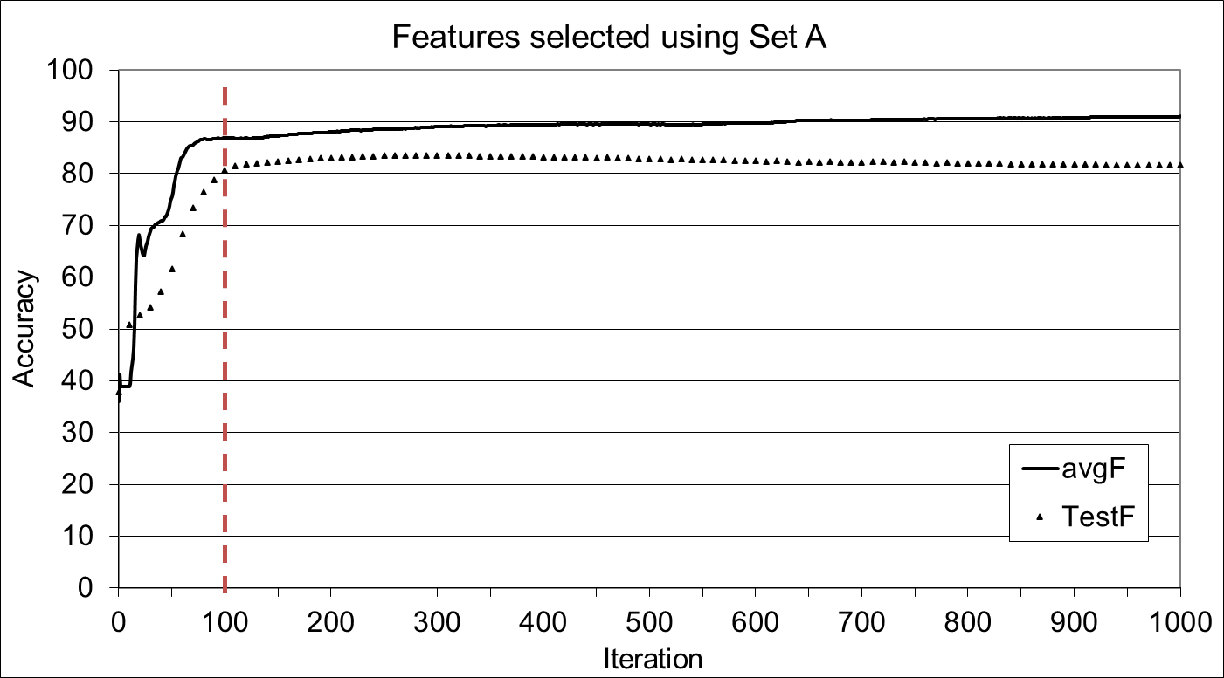
a) Feature set $F_{6}$ was used
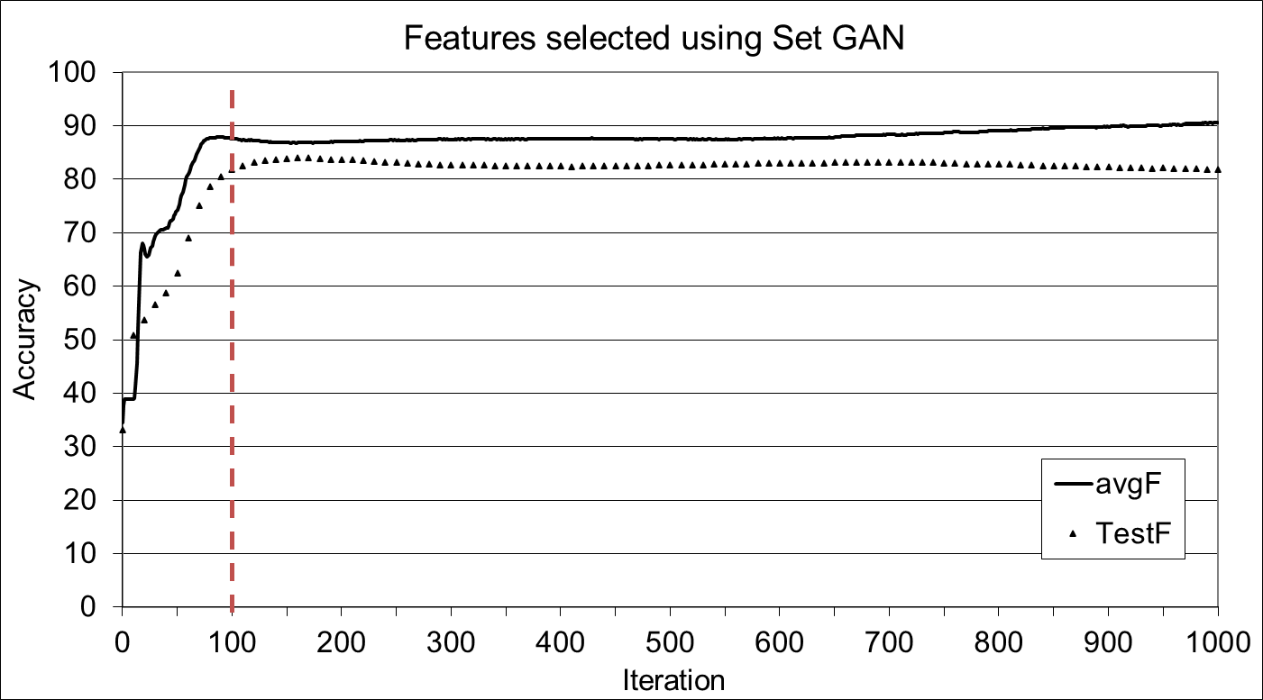
b) Feature set $F_{6}$ was used
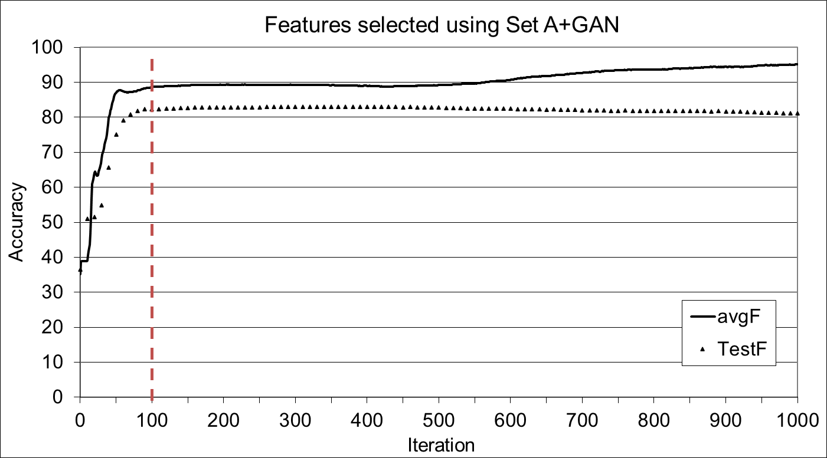
c) Feature set $F_{8}$ was used
Figure A.1. Learning curves of the BP algorithm on the accuracy of the task of processing disturbances classification. The plots average the accuracies of 10 independent learning trials. The algorithm was trained using the full data Set A and tested on data Set B. In the learning trials, the BP algorithm was stopped after 100 iterations (dashed vertical red line).
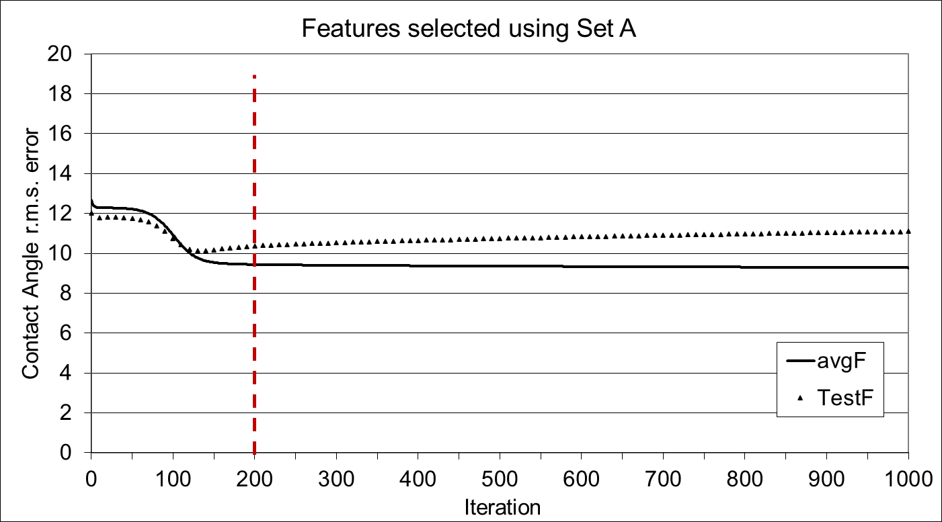
a) Feature set $F_{6}$ was used
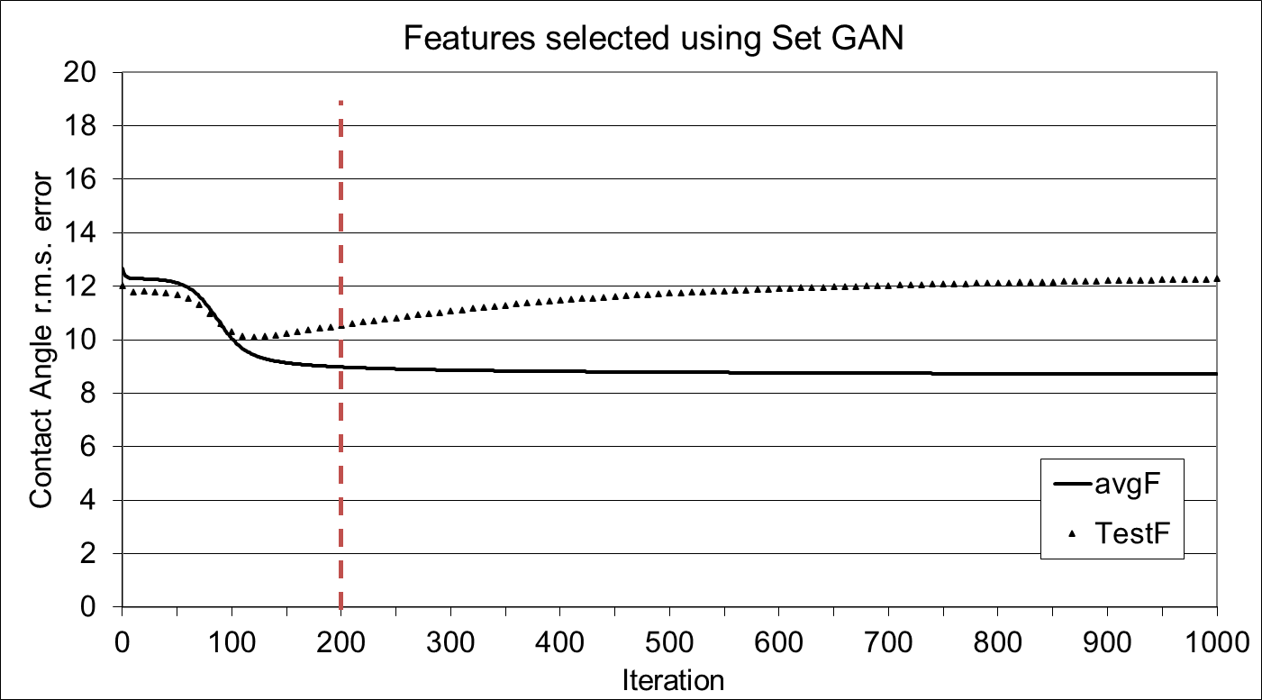
b) Feature set $F_{6}$ was used
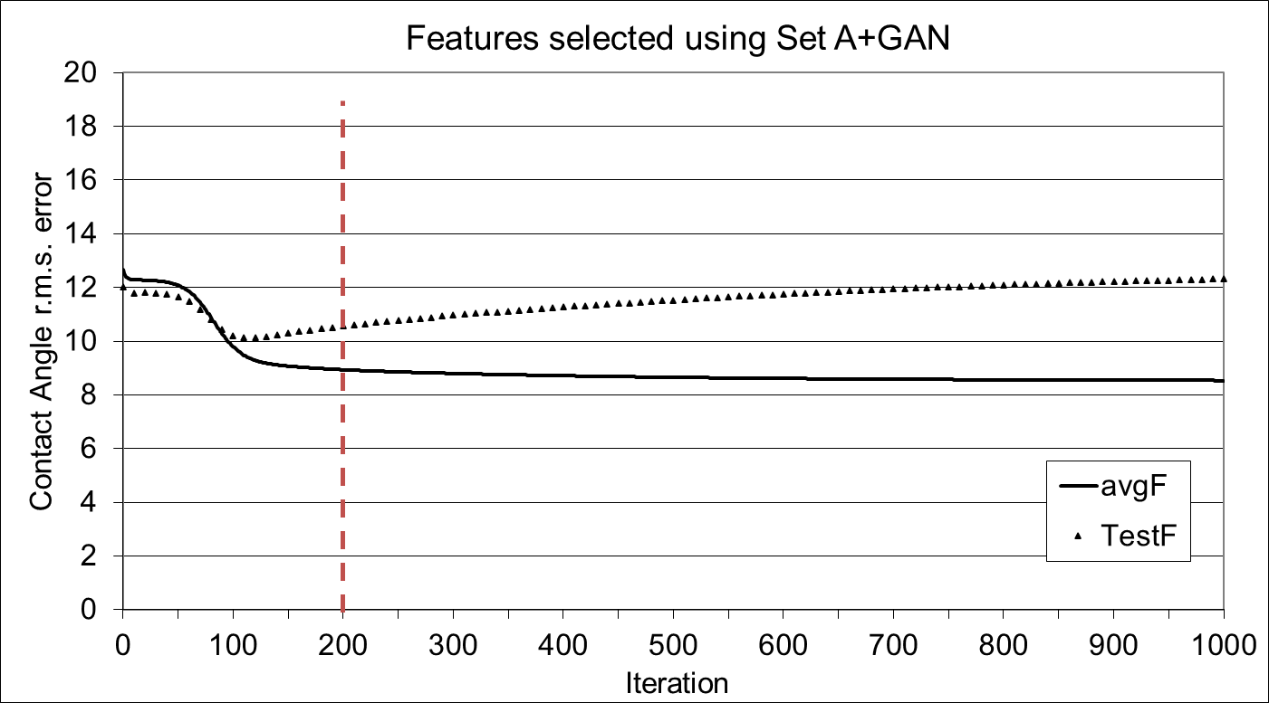
c) Feature set $F_{8}$ was used
Figure A.2. Learning curves of the BP algorithm for Contact Angle prediction task. The plots average the accuracies of 10 independent learning trials. The algorithm was trained using the full data Set A and tested on data Set B. In the learning trials, the BP algorithm was stopped after 200 iterations (dashed vertical red line).
Appendix B
B.1 Five number summary results from Task 1: Classification of laser processing disturbances
Table B.1 reports additionally the statistics of the processing disturbance classifications obtained for Set B from 100 independent runs of the BP algorithm. The table reports the learning results obtained performing feature selection and MLP training on data sets A, GAN, and A+GAN. The accuracy results are compared with those obtained using the full feature set $F_{all}$, using Mann-Whitney tests to evaluate the significance of the differences. Since the use of real LIPSS topographies achieved the best learning results, the MLP was re-trained on Set A using the feature sets selected using Set GAN and Set A+GAN and the results of this experiment are shown in Table B.2.
Table B.1. Five number summary of the classification accuracies obtained training the MLP on the full data sets A, GAN, and A+GAN, and validating the results on previously unseen Set B. Three feature sets are evaluated for each data set: the full set ($F_{All}$), the set of non-redundant features ($F_{9}$ or $F_{10}$), and the minimal set (after relevance analysis). The results obtained using reduced feature sets are compared with those obtained using the full feature set $F_{all}$, and the p-values of pairwise Mann-Whitney U-tests of significance are reported.
Trained on Set A
 | $$F_{6}$$ | $$F_{10}$$ | $$F_{All}$$
Min | 76.18 | 83.42 | 82.34
Q1 | 79.71 | 83.92 | 83.70
Median | 80.43 | 84.06 | 83.97
Q3 | 80.93 | 84.24 | 84.15
Max | 81.61 | 84.60 | 84.60
p-value | 0 | 0.0144
Trained on Set GAN
 | $$F_{6}$$ | $$F_{9}$$ | $$F_{All}$$
Min | 57.52 | 60.60 | 66.03
Q1 | 59.19 | 62.00 | 67.75
Median | 60.05 | 62.50 | 68.57
Q3 | 61.01 | 63.13 | 70.02
Max | 62.41 | 64.76 | 72.55
p-value | 0 | 0
Trained on Set A+GAN
 | $$F_{8}$$ | $$F_{10}$$ | $$F_{All}$$
Min | 74.18 | 75.54 | 79.44
Q1 | 76.09 | 76.86 | 81.16
Median | 76.54 | 77.54 | 81.61
Q3 | 76.86 | 78.08 | 81.93
Max | 77.63 | 79.26 | 82.88
p-value | 0 | 0

Table B.2. Five number summary of the classification accuracies obtained training the MLP on Set A and validating the results on previously unseen Set B. The feature sets were selected using sets GAN and A+GAN. It should be noted that redundancy elimination performed using Set A and Set A+GAN gave the same feature subset $F_{10}$. For reference, the feature selection results obtained using Set A are also reported. The results obtained using reduced feature sets are compared with those obtained using the full feature set $F_{all}$, and the p-value of pairwise Mann-Whitney U-tests of significance is reported.
 | Features selected using |  |  |  |  |  | Full Set
 | Set A |  | Set GAN |  | Set A+GAN |  | Full Set
 | $$F_{6}$$ | $$F_{10}$$ | $$F_{6}$$ | $$F_{9}$$ | $$F_{8}$$ | $$F_{10}$$ | $$F_{All}$$
Min | 76.18 | 83.42 | 79.17 | 80.62 | 81.43 | 83.33 | 82.34
Q1 | 79.71 | 83.92 | 80.80 | 82.16 | 81.97 | 83.88 | 83.70
Median | 80.43 | 84.06 | 82.07 | 82.52 | 82.25 | 84.06 | 83.97
Q3 | 80.93 | 84.24 | 82.61 | 82.70 | 82.43 | 84.24 | 84.15
Max | 81.61 | 84.60 | 83.79 | 83.51 | 83.06 | 84.51 | 84.60
p-value | 0 | 0.0144 | 0 | 0 | 0 | 0.0065 | -

The best learning results were obtained using the non-redundant features (group set $F_{10}$) selected after analysing Set A and Set A+GAN. Table B.3 reports the p-values of pairwise Mann-Whitney U-tests comparing the results from Table B.2 and obtained using the minimal parameter group set $F_{6}$ selected using Set A, and the minimal sets $F_{6}$ and $F_{8}$ obtained using respectively Set GAN and Set A+GAN. The tests indicate that the parameter group selected using Set GAN and Set A+GAN allowed the MLP statistically significantly superior learning results. The same test performed on the sets of non-redundant ISO parameter group ($F_{9}$ and $F_{10}$) revealed that $F_{10}$ (Set A and A+GAN) allowed the MLP significantly better learning results than $F_{9}$ (Set GAN).
Table B.3. Mann-Whitney pairwise U-tests of significance for accuracy results obtained utilising ISO parameters groups selected using different data sets. The results obtained using data Set GAN and A+GAN are compared with those obtained using Set A. The MLP was trained on Set A and the results validated on previously unseen Set B. It should be noted that redundancy elimination performed using Set A and Set A+GAN gave the same feature subset $F_{10}$.
Feature selection | Minimal | p-value | Non-redundant | p-value
GAN | $$F_{6}$$ | 0 | $$F_{9}$$ | 0
A+GAN | $$F_{8}$$ | 0 | $$F_{10}$$ | 0.4124
A | $$F_{6}$$ |  | $$F_{10}$$

B.2 Five number summary results from Task 2: Contact Angle Prediction
Table B.4 summarises the results of 100 independent runs of the BP algorithm and reports the statistics of the root mean square (r.m.s.) error on the prediction of the CA for Set B data samples. The table reports the learning results obtained performing feature selection and MLP training on data sets A, GAN, and A+GAN. The accuracy results are compared with those obtained using the full feature set $F_{all}$, using Mann-Whitney tests to evaluate the significance of the differences.
As for the classification task, a further experiment was run employing Set A to train the MLP, using the feature sets selected using Set GAN and Set A+GAN. The statistics of this last experiment are given in Table B.5.
Table B.4. Five number summary of the regression accuracies obtained training the MLP on the full data sets A, GAN, and A+GAN, and validating the results on previously unseen Set B. Three parameter groups are evaluated for each data set: the full set ($F_{All}$), the set of non-redundant features ($F_{9}$ or $F_{10}$), and the minimal set (after relevance analysis). The results obtained using reduced feature sets are compared with those obtained using the full feature set $F_{all}$, and the p-values of pairwise Mann-Whitney U-tests of significance are reported.
Trained on Set A
 | $$F_{6}$$ | $$F_{10}$$ | $$F_{All}$$
Min | 10.22 | 10.75 | 11.15
Q1 | 10.31 | 10.86 | 11.24
Median | 10.33 | 10.89 | 11.26
Q3 | 10.35 | 10.91 | 11.28
Max | 10.40 | 10.96 | 11.33
p-value | 0 | 0
Trained on Set GAN
 | $$F_{6}$$ | $$F_{9}$$ | $$F_{All}$$
Min | 10.26 | 10.15 | 10.21
Q1 | 10.34 | 10.18 | 10.24
Median | 10.36 | 10.20 | 10.25
Q3 | 10.38 | 10.22 | 10.26
Max | 10.43 | 10.26 | 10.34
p-value | 0 | 0
Trained on Set A+GAN
 | $$F_{8}$$ | $$F_{10}$$ | $$F_{All}$$
Min | 10.06 | 9.99 | 10.77
Q1 | 10.08 | 10.01 | 10.83
Median | 10.08 | 10.02 | 10.84
Q3 | 10.09 | 10.02 | 10.86
Max | 10.12 | 10.05 | 10.90
p-value | 0 | 0

Table B.5. Five number summary of the regression accuracies obtained training the MLP on Set A and validating the results on previously unseen Set B. The feature sets were selected using sets GAN and A+GAN. For reference, the results obtained using Set A to perform feature selection (already reported in Table 13) are also reported. The results obtained using reduced feature sets are compared with those obtained using the full feature set $F_{all}$, and the p-value of the Mann-Whitney U-tests of significance is reported.
Features selected using Set A
 | $$F_{6}$$ | $$F_{10}$$ | $$F_{All}$$
Min | 10.22 | 10.75 | 11.15
Q1 | 10.31 | 10.86 | 11.24
Median | 10.33 | 10.89 | 11.26
Q3 | 10.35 | 10.91 | 11.28
Max | 10.40 | 10.96 | 11.33
p-value | 0 | 0
Features selected using Set GAN
 | $$F_{6}$$ | $$F_{9}$$ | $$F_{All}$$
Min | 10.28 | 10.68 | 11.18
Q1 | 10.47 | 10.79 | 11.24
Median | 10.50 | 10.83 | 11.26
Q3 | 10.54 | 10.86 | 11.28
Max | 10.58 | 10.94 | 11.32
p-value | 0 | 0
Features selected using Set A+GAN
 | $$F_{8}$$ | $$F_{10}$$ | $$F_{All}$$
Min | 10.39 | 10.75 | 11.18
Q1 | 10.49 | 10.87 | 11.24
Median | 10.52 | 10.89 | 11.26
Q3 | 10.55 | 10.92 | 11.28
Max | 10.60 | 10.97 | 11.32
p-value | 0 | 0

