Supplementary material

Quantitative surface characterisation and stress concentration of additively manufactured NiTi lattice struts
M. Zheng¹, K. Ghabraie¹, Y. S. Yang ², J. Elambasseril ³, W. Xu^{1*}, Y. Wang^{1*}
¹ School of Engineering, Deakin University, Victoria 3216, Australia
² CSIRO Manufacturing, Clayton, Victoria 3169, Australia
³ Centre for Additive Manufacturing, School of Engineering, RMIT University, Melbourne, Victoria 3000, Australia
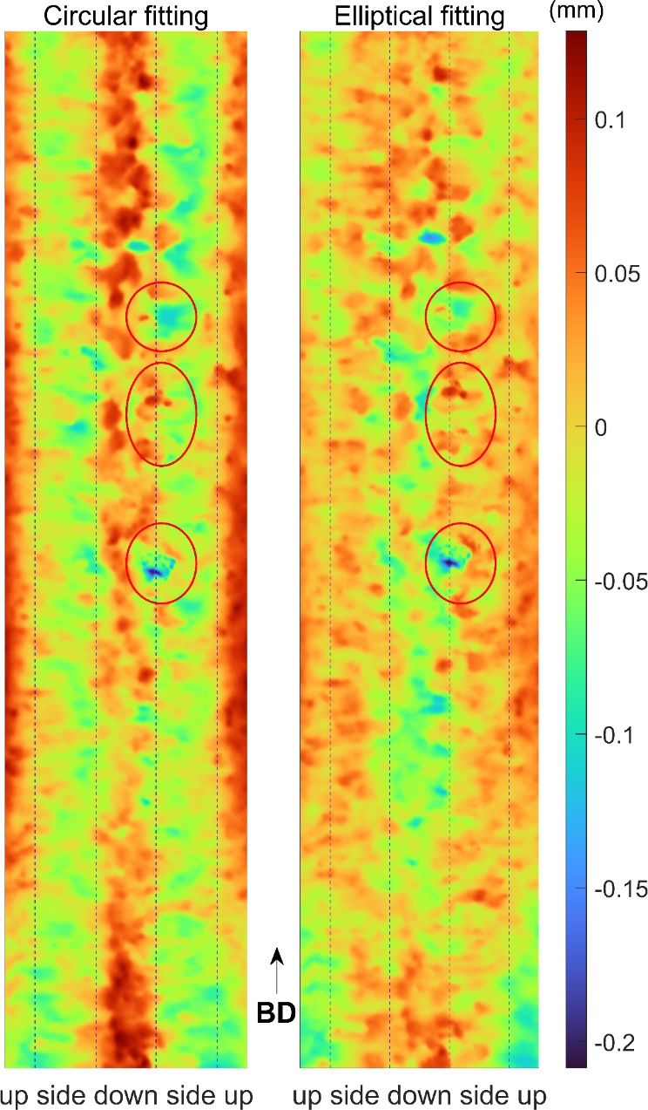
Figure S1 Subtle irregularity present in the acquired Micro-CT data after Gaussian filtration in 60 deg 0.3 mm strut. The dash lines separate the tomography mapping based on the skin areas, such as downward facing skin (down), lateral skin (side) and upward facing skin (up). The red circle marks the same irregularity regions before filter operation in Figure 9. BD at the bottom stands for build direction during the print.

