Supplementary information for
Advanced Hybrid Laminates: Elastomer Integration for Optimized Mechanical Properties

- Tensile characterization of the elastomeric material
The elastomeric film was extracted from cold storage and put in a white chamber for 3 h before cutting. Two 190 x 220 mm rectangular patches were extracted from the roll and stacked together onto an aluminum plate protected by a PTFE release film agent. The samples were cured in an autoclave at a pressure of 3 bar using the vacuum bagging technique to prevent the formation of voids and porosity in the rubber material and ensure good compaction between the two layers. The cure cycle involved a heat ramp of 2°C/min until the temperature reached 150°C, followed by a 60-minute holding period, and then cooling at a rate of 1°C/min until the temperature reached room temperature. Five rectangular samples measuring 25 x 180 mm were extracted from the produced plate and measured by a micrometer. The average thickness was 668 ± 9 μm. A fine random pattern of white water-based paint was then applied to the specimens with an AZ3 HTE2 airbrush. The tensile tests were performed at room temperature using a universal testing machine (INSTRON 5900) equipped with a 10 kN load cell at a test rate of 10 mm/min, in accordance with the ASTM D882 standard. During testing, the elongation of the samples was determined by a contactless optical measurement system (Aramis adjustable 12 M by GOM, Germany). The experimental setup is shown in Figure S 1.
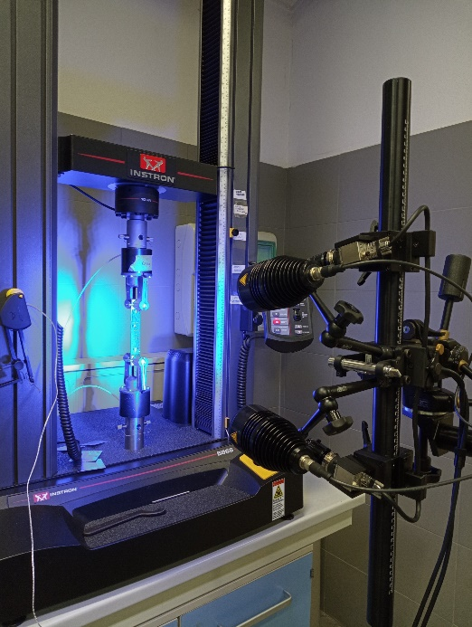
Figure S 1: Experimental setup
Good repeatability was found across all samples as demonstrated by the stress-strain curves depicted in Figure S 2a. Mean failure stress was 5.86 MPa with a CV value below 6%. Mean failure elongation was 5.86 MPa with a CV value below 6%. Results from all specimens were fitted and averaged in Matlab to provide an averaged engineering Stress-Strain curve to be fitted by the numerical model (Figure S 2b).

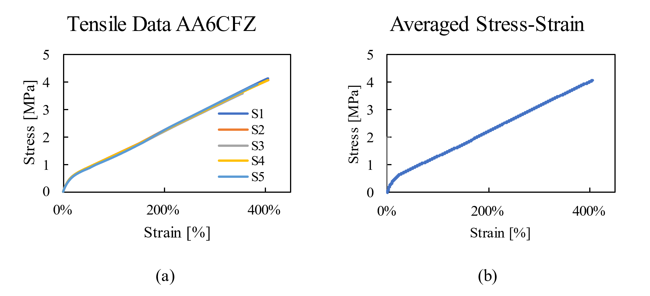
Figure S 2: Tensile test results. a) experimental curves for all tested samples (S1÷S5) b) averaged tensile curve obtained from all experimental tests.

- User Material Subroutine structure for PCM material
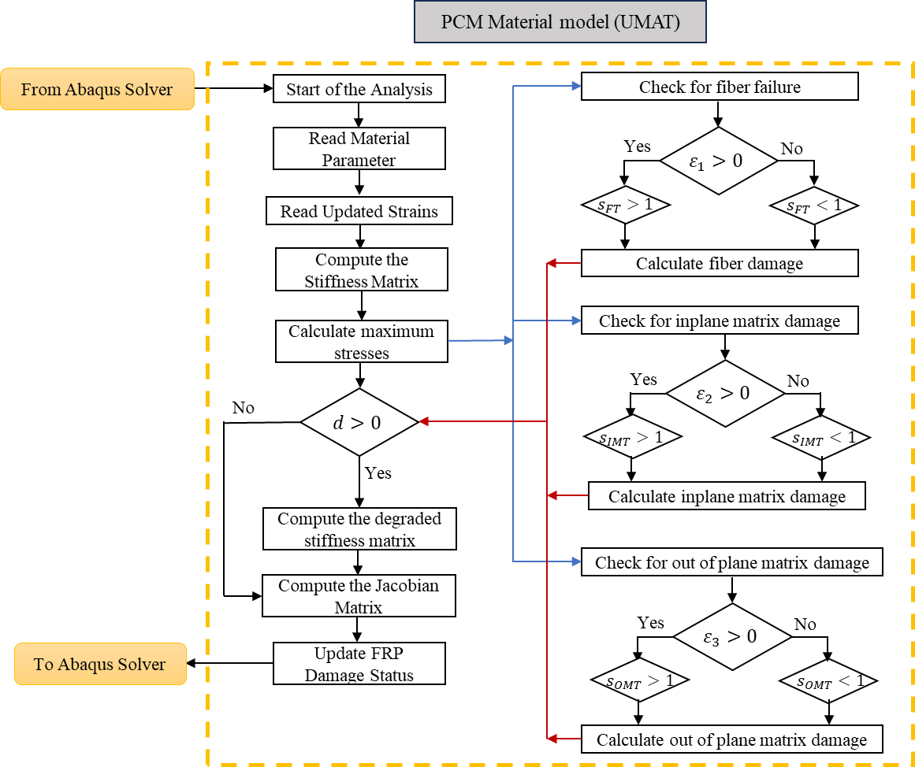
Figure S 3: Flow chart of the progressive damage simulation

