Appendix

The following section include supportive photographs with specific notes detailing identified hazards, existing safeguards, and recommended improvements. A detailed description accompanies each image to provide context and emphasize critical areas for enhancement, serving as visual evidence to support the findings and recommendations in the report. References to key standards ensure alignment with best practices: AS/NZS 4024.1-2019 outlines principles for machinery design and risk assessment; ISO 13849-1:2015 focuses on safety-related control systems and their performance levels; and ISO 12100:2010 provides guidelines for machinery design, emphasizing risk assessment and reduction. These standards collectively ensure a comprehensive approach to improving safety measures.

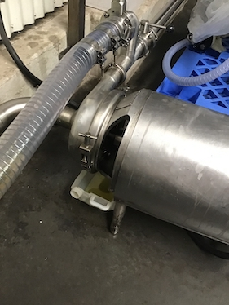 | Photograph 1  Recommend fitting guard to prevent access to entanglement by rotating shaft.
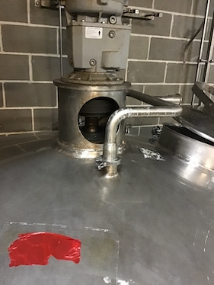 | Photograph 2  Fit a guard over opening to prevent hand reach to entanglement hazard by rotating shaft on top of tank 31 and 32.
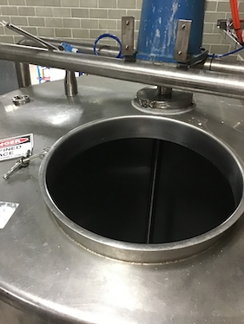 | Photograph 3  Fit cross bar guard over opening of tank 36 to prevent whole bodily access.

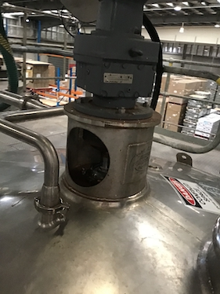 | Photograph 4  Fit a guard over opening to prevent hand reach to entanglement hazard by rotating shaft on top of tank 11, 12, 13, 21, 22, 23 and 24.
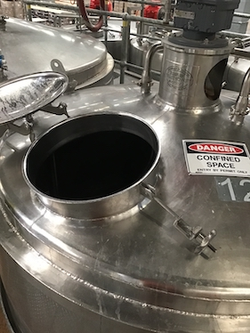 | Photograph 5  Fit cross bar guard over opening of tank 36 to prevent whole bodily access.
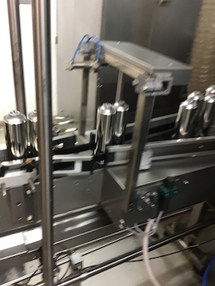 | Photograph 6  Ensure the pneumatic pressure of the out-feed guide rails actuator is reduced to eliminate potential pinch of the finger.

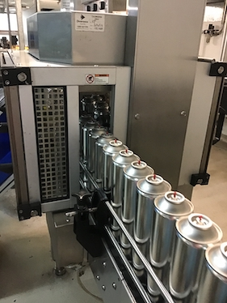 | Photograph 7  Recommend providing an in feed and out feed tunnel guard to prevent hand reach to shear hazard. The tunnel guard should provide a safety distance of 850mm.
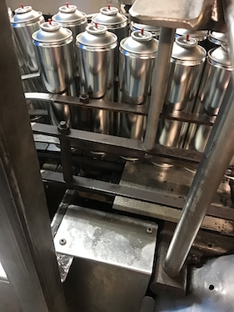 | Photograph 8  Recommend extending metal plate to prevent finger reach to in running nip hazard.
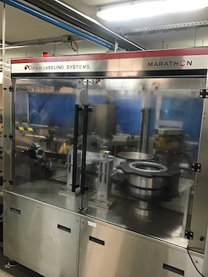 | Photograph 9  Advised slow speed hold-to-run jog control is provided through only the front interlocked guard. Ensure the safety related parts of control system is capable of meeting a Cat. 3 control system in accordance with AS 4024.1501.

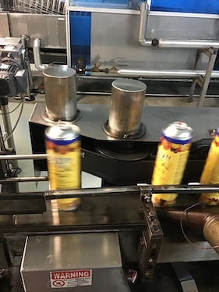 | Photograph 10  Recommend fitting a guard at the in running nip point to prevent finger reach to in running nip hazard.  This is alcohol applicable to the underside of the conveyor belt.
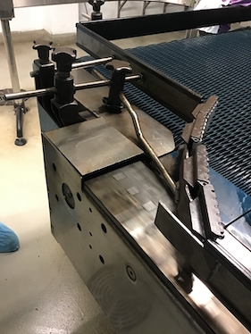 | Photograph 11  Minimise the gap between the conveyor and end plate to be no more than 5mm.
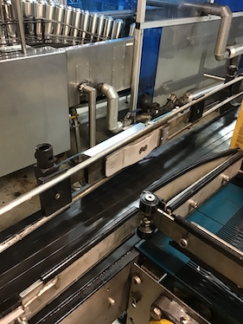 | Photograph 12  At the conveyor post heat tunnel, ensure the pneumatic slider pressure is minimised to prevent pinch of the finger.

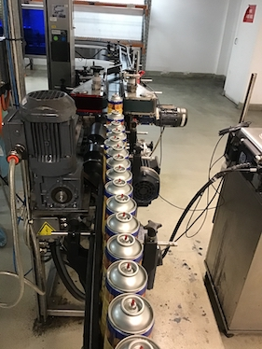 | Photograph 13  Fit external guarding to prevent finger access to nip and shear by can screw feed. This is also applicable to the green conveyor belts.
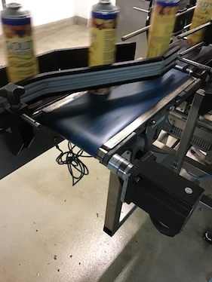 | Photograph 14  At the out feed of the coder area, fit a guard over conveyor rotating shaft.
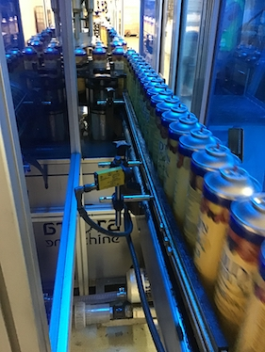 | Photograph 15  Recommend extending a return guard under the in feed and out feed tunnel guard to prevent arms reach into the safeguarded space. This is applicable to both the button placer and the lidder.

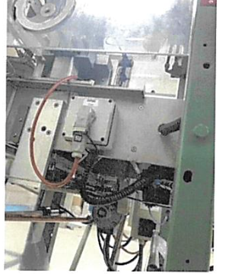 | Photograph 16  At the button Infeed guide rails, close off the existing gap in the guard above and below guide rails to prevent hand reach to various potential shear hazards.
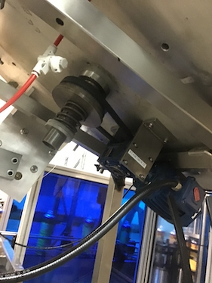 | Photograph 17  At the lid unscrambled, fit a guard to prevent finger reach to nip by drive belt.
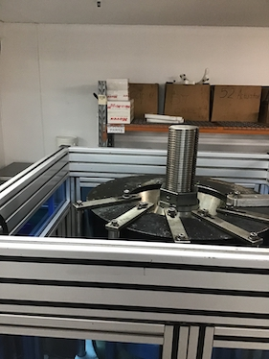 | Photograph 18  Fit a top cover over the capper to prevent hand reach to shear hazards.

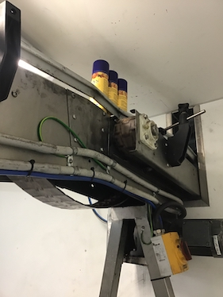 | Photograph 19  Fit guard over conveyor end shown.
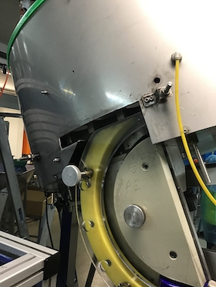 | Photograph 20  Minimise gap in the guard at the side of the lid unscrambler to prevent finger reach to various shear hazards.
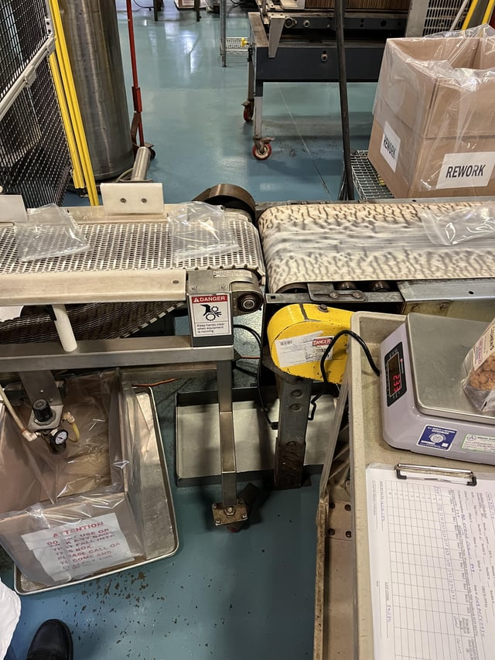 | Photograph 21  Close off the gap at the labeler to prevent hand reach to nip hazard.

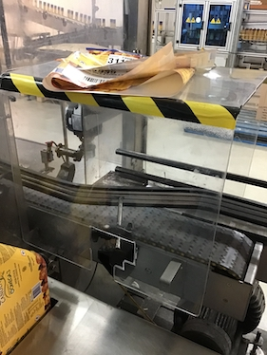 | Photograph 22  Secure the out-feed tunnel guard requiring tools to remove and extend the guard at the side of the conveyor to prevent finger access to nip hazard.
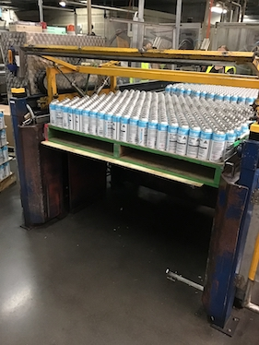 | Photograph 23  Recommend providing side fixed and/or interlocked guards and light guards at the lift table to prevent access to various potential nip, shear and crush hazards.  Ensure use of mechanical support under a raised load.
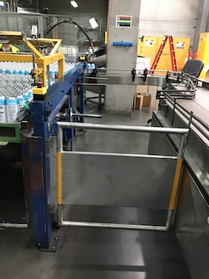 | Photograph 24  Recommend providing side fixed and/or interlocked guards and light guards at the lift table to prevent access to various potential nip, shear and crush hazards.

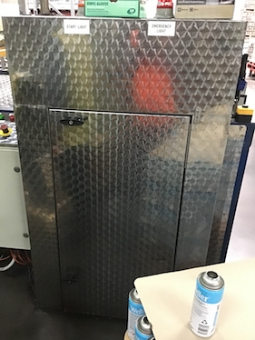 | Photograph 25  Interlock or secure side hinges guard requiring tools to remove.
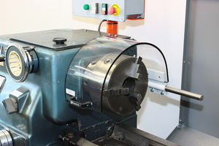 | Photograph 26  Fit a hinged interlocked guard over the opening shown.
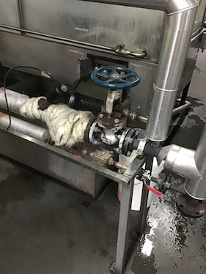 | Photograph 27  Fit lagging on hot pipe work shown.

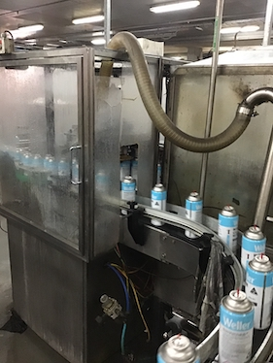 | Photograph 28  Fit a tunnel guard to the in feed and out feed to can water bath.  Also close off gap in the guard next to the out feed.
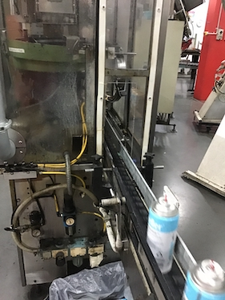 | Photograph 29  Recommend providing in feed and out feed tunnel guard.
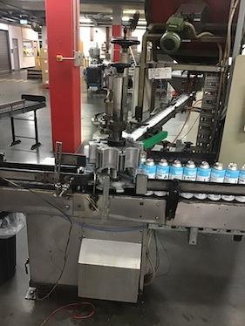 | Photograph 30  As a priority, fit external fixed and interlocked guards to prevent hand reach to shear and crush hazards.

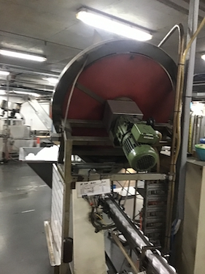 | Photograph 31  Fit additional guarding at the cap dispenser to prevent hand reach to nip and entanglement hazards.
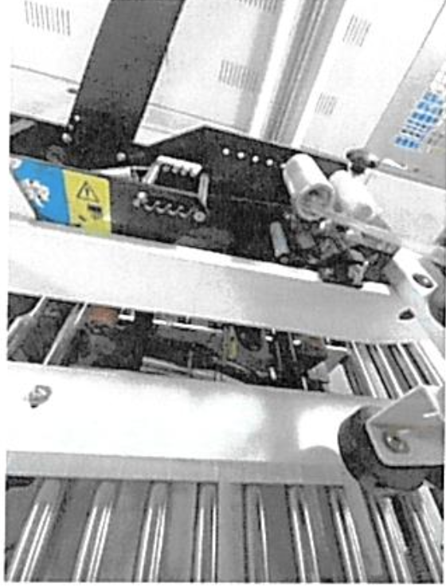 | Photograph 32  Fit guard over conveyor end drive.
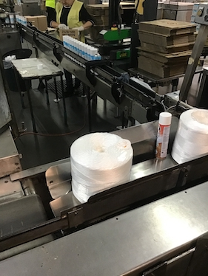 | Photograph 33  If intended to be operated, fit rear guarding to prevent arms reach to shear and crush by on arms.

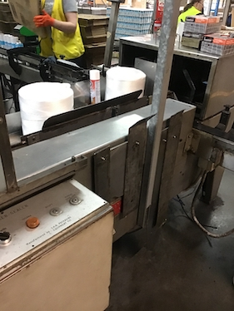 | Photograph 34  Recommend providing 2 hand, type 3 hold to run controls for the operation of the packer.
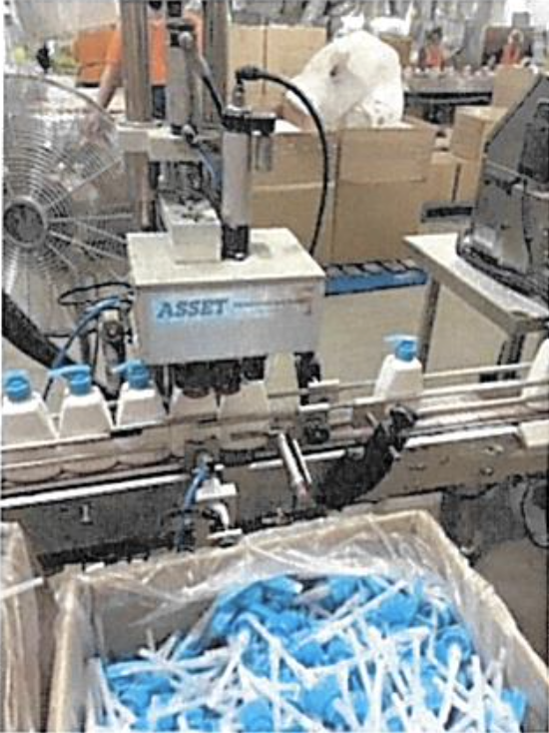 | Photograph 35  Extend the guards at the out feed to the closer.
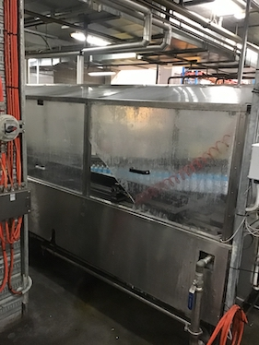 | Photograph 36  Replace damaged guard shown.

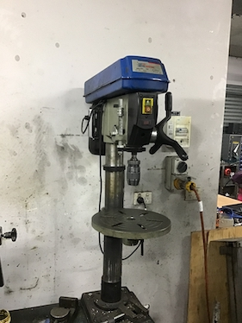 | Photograph 37  Consider interlocking the flip down chuck guard over the rotating chuck.
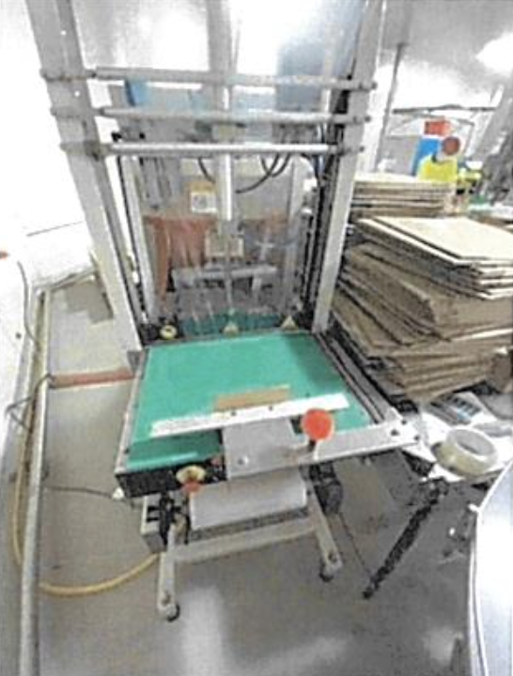 | Photograph 38  Recommend providing hinged interlocked guard over the rotating chuck.
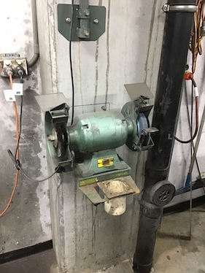 | Photograph 39  Ensure the tool rest is regularly adjusted to maintain a gap of no more than 2mm from the abrasive wheel.

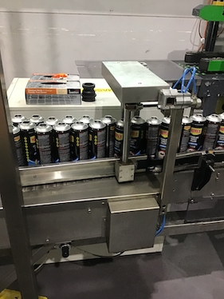 | Photograph 40  Ensure the pneumatic pressure of the out-feed guide rails actuator is reduced to eliminate potential pinch of the finger.
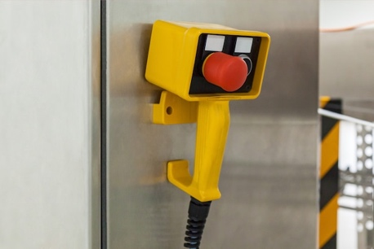 | Photograph 41  Jog control provided. Ensure the job control only temporarily suspends one interlocked door at a time, operates at reduced speed by hold-to-run control.  Ensure the safety related parts of control system is capable of meeting a Cat. 3 Control System.
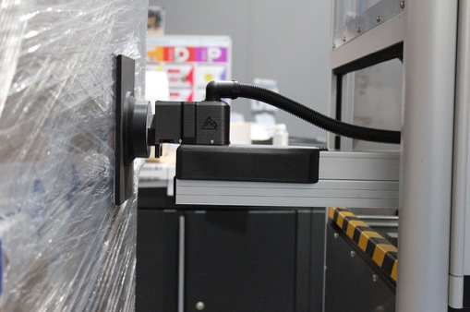 | Photograph 42  Close off the gap at the labeller to prevent hand reach to nip hazard.

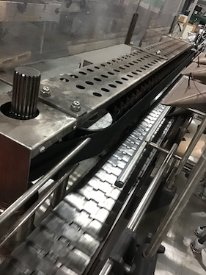 | Photograph 43  Fit an in-feed tunnel guard requiring tools to remove to prevent finger access to nip hazard.
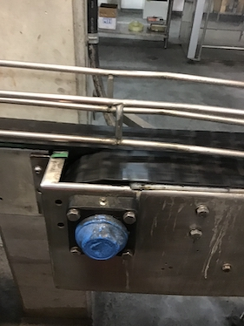 | Photograph 44  Recommend fitting a guard at the in running nip point to prevent finger reach to in running nip hazard.  This is also applicable to the underside of the conveyor belt.
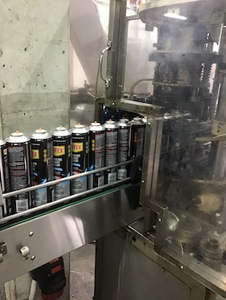 | Photograph 45  Fit guard to prevent finger access to shear between two conveyors.

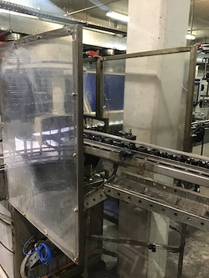 | Photograph 46  Fit in feed and out feed tunnel guards.
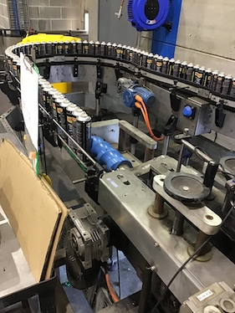 | Photograph 47  Fit external guarding to prevent finger access to nip and shear by can screw feed. This is also applicable to the green conveyor belts.
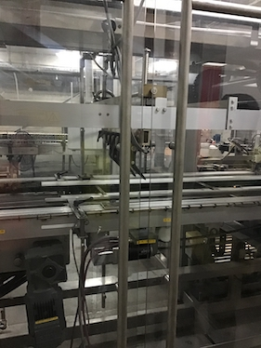 | Photograph 48  Consider reducing the slot gap between the guard to be no more than 20mm.

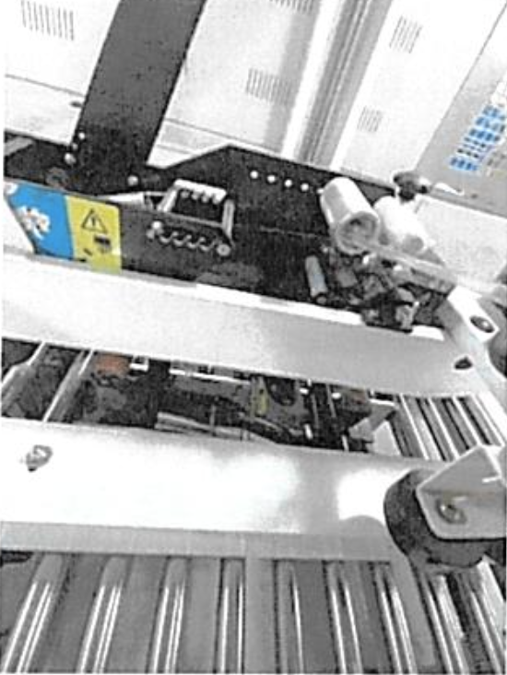 | Photograph 49  Fit an out-feed tunnel guard to prevent hand reach to shear hazard.
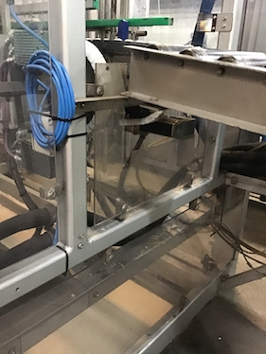 | Photograph 50  Extend the existing guard under the out feed conveyor.
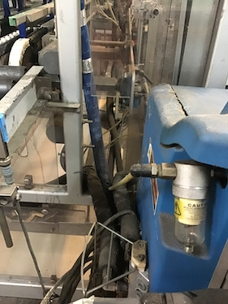 | Photograph 51  Close off the gap in the guard next to the out feed conveyor.

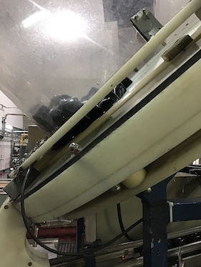 | Photograph 52  At the hopper, extend the existing side guards to prevent finger access to shear hazard.
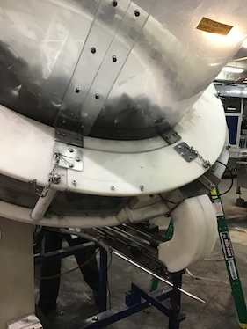 | Photograph 53  Secure the removable guard requiring tools to remove.
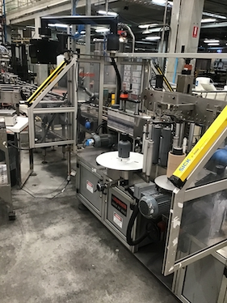 | Photograph 54  Recommend providing additional single beam light guard to prevent ease of access under existing light guard.

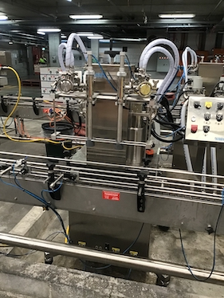 | Photograph 55  Recommend providing fixed and/or interlocked guards around each of the fillers.
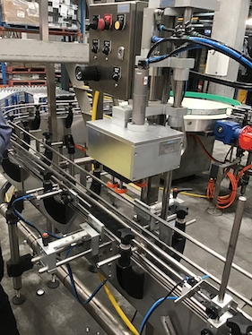 | Photograph 56  Review the pressure required to seal the lid and hold the bottles by clamp. Recommend providing fixed and/or interlocked guards around the bottle clamp and lid tightener to prevent finger reach to nip hazard.
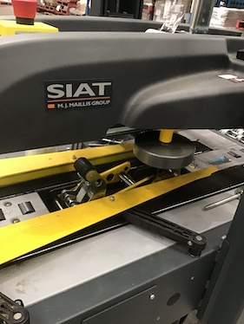 | Photograph 57  Fit spring-loaded blade cover to bottom tape cutter.

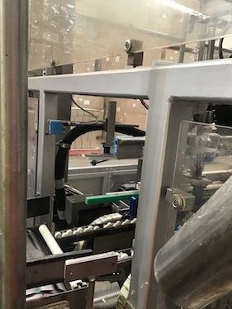 | Photograph 58  Fit an out-feed tunnel guard to prevent hand reach to shear hazard.
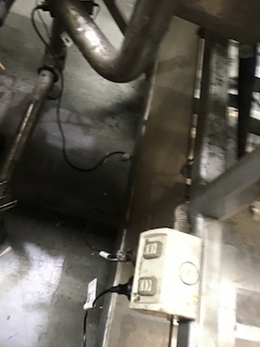 | Photograph 59  Extend existing guard under the out feed conveyor.
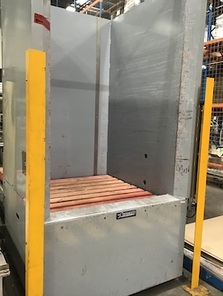 | Photograph 60  At the pallet dispenser, recommend replacing 3 beam light guard with full curtain light guard to prevent hand reach to shear between metal fixed part against lowering pallet. Provide a reset switch once light guard has been tripped.

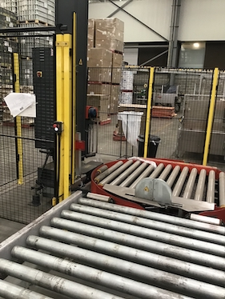 | Photograph 61  Recommend lowering the out feed light guard to minimise the gap between the conveyor and the light guard lowest beam to be no more than 50mm.
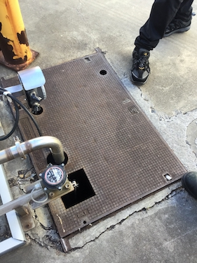 | Photograph 62  Fit confined space labelling.
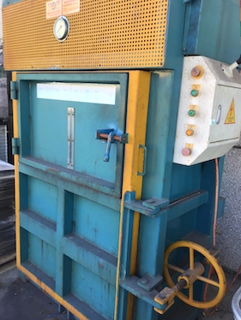 | Photograph 63  As a priority, interlock front hinged guard to stop the platen.

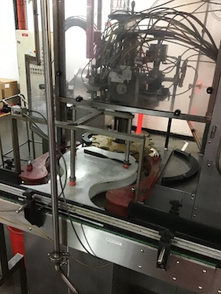 | Photograph 64  Fit a guard over the in feed, out feed opening to prevent hand reach to shear hazards.
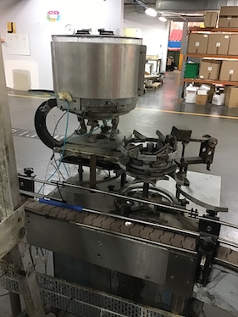 | Photograph 65  Fit external fixed and interlocked guards to prevent hand reach to nip and crush hazards by rotating parts.
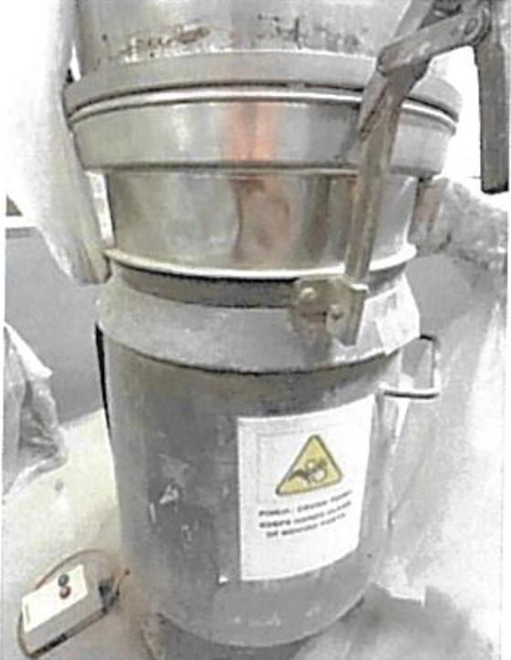 | Photograph 66  Close off gaps in the guarding shown. This image shows the modified dust collection or processing unit. To reduce the risk of operator injury during handling or cleaning, the equipment has been retrofitted with a sealing mechanism and a fixed cover to minimise direct exposure to moving or hazardous parts. We have also introduced updated labelling for visual hazard communication and mandated the use of appropriate PPE (e.g., cut-resistant gloves and respiratory protection) during routine interaction with this unit.

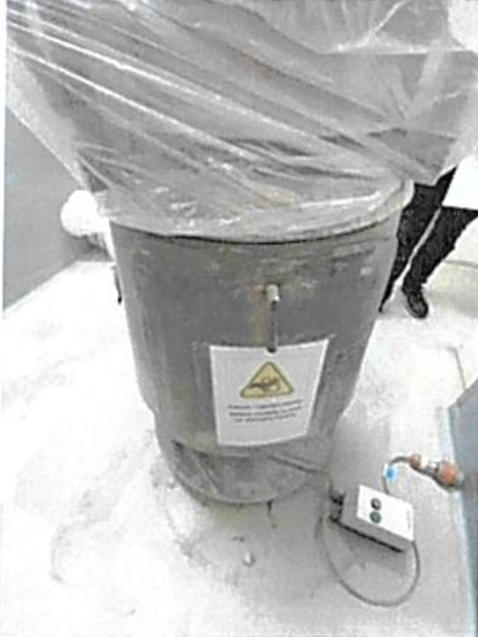 | Photograph 67  Close off gaps in the guarding shown.  This image previously displayed a gap in the guarding of the equipment. Based on your suggestion, we acknowledge that the visible gap represents a potential pinch or entrapment hazard. As a corrective measure, we have updated the photograph to reflect the recent installation of an extended fixed guard that fully encloses the previously exposed area. The updated guard ensures that there is no access to moving components while still allowing safe operation and maintenance. Additionally, we’ve incorporated a lockout-tagout (LOTO) point on the adjacent surface to enforce safe isolation practices during cleaning or servicing.

