SUPPLEMENTARY MATERIAL

The supplementary material contains three Appendices: in the first Appendix, we present a smooth model selection following Wood et al. (2016) and Wood (2020) and a preprogram test following Heckman and Hotz (1989). In the second Appendix, a comparison between the possibly misspecified parametric log-log model and the adopted semiparametric random trend model is proposed. Then, the third Appendix provides additional information of the dummy policy variable EP that was employed in the paper.

APPENDIX A: Smooth Model Selection and Preprogram Tests

A.1 Smooth model selection
Many model selection methods are defined in terms of an appropriate information criterion that aims to find the best approximating model to the unknown true DGP among the set of models under consideration. Information criteria are based on the idea of balancing fit with complexity (see Claeskens and Hjort, 2008; Konishi and Kitagawa, 2008).
When focusing on smooth model selection, one possibility is adopting an information criterion based on the conditional likelihood of the model coefficients. Within the exponential family frameworks, Hastie and Tibshirani (1990) proposed a largely used conditional AIC (Akaike Information Criterion), in which the model’s effective degrees of freedom are used rather than the number of parameters. Subsequent studies (see, e.g., Greven and Kneib, 2010) show that this approach tends to select too many complex models.
Recently, Wood et al. (2016) proposed an AIC that overcomes such a problem and, more generally, that avoids neglecting the smoothing parameter uncertainty in the conditional AIC and is easy to compute. Wood (2020) provided further details and offered useful insights to obtain a Bayesian information criterion (BIC).
While both AIC and BIC can be used to select indifferently among nested or non-nested models (Claeskens and Hjort, 2008; Konishi and Kitagawa, 2008), they have different properties. The AIC, which was derived as an asymptotic approximate estimate of the Kullback‒Leibler information discrepancy, is not strongly consistent, although it is efficient, while the opposite is true for the BIC.
Because of the property of strong consistency, we adopt the BIC (Wood et al., 2016; Wood, 2020) for model selection and specifically compare models that incorporate alternative specifications for g(.) and for the unobserved time effects. For the latter, we consider three alternative specifications: common factors with heterogeneous loadings (the CCE approach by Pesaran, 2006, as extended by Su and Jin, 2012), 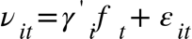the random trend model including individual time trends in linear and quadratic specifications (Wooldridge, 2005), 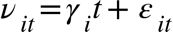_{and} 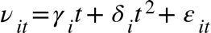, respectively, and time dummies (two-way fixed effects), 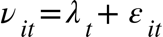. For the function g(. ), we consider both parametric linear models and semiparametric additive models that avoid the curse-of-dimensionality problem of a fully nonparametric model. Estimating the nonadditive specification (1) may be relevant but is computationally infeasible in our data setting. In total, we are considering eight alternative models.
The results in Table 1 indicate that the preferred model presents additive smooth terms for g(.) and individual time trends (random trend) to represent the latent common factors. In the following, the econometric model that we adopt can be written as follows:
(2)
Overall, the results (Table A1) provide interesting insights into model selection. It was indeed found that the random trend specification always performs better than the two-way fixed effects model and the multifactor error model (CCE). This is an extremely interesting result suggesting the use of an intermediate level of heterogeneity for the modelling of unobserved common factors; the random trend model is more efficient but less flexible than the CCE specification. It should be noted that the nuisance parameters to be estimated in the CCE are N*(K+1), with K being the number of explanatory variables, while the random trend requires the estimation of N nuisance parameters, one for each individual trend. Another relevant result is that the two-way fixed effects model is always dominated by the other two and performs the worst: imposing homogeneous effects of the time components appears to be, ex post, an excessively restrictive assumption. Finally, it should be noted that in two cases out of the three (the random trend and the two-way model), the specification with additive smooth terms outperforms the parametric linear model.
Finally, we performed diagnostic checks on the residuals, specifically focusing on the issue of cross-sectional dependence. In doing so, Pesaran’s CD test has no power when the model contains time effects or when adding cross-sectional averages in the CCE approach (Sarafidis and Wansbeek, 2012). Therefore, we tested for cross-sectional dependence using Frees’s test (1995), which does not present the weaknesses above. In principle, the residuals of all the specifications should contain only a weak cross-sectional dependence as common factors are explicitly accounted for (see, e.g., Ertur and Musolesi (2017) for a more detailed discussion). As expected, Frees's test rejected the null hypothesis in all cases. We then focused on the estimation of the exponent of cross-sectional dependence introduced in Bailey et al. (2016), which can take any value in the range [0,1]. The values of in the range [0,1/2) correspond to different degrees of weak cross-sectional dependence, whereas the values of in the range (1/2,1] relate to different degrees of strong cross-sectional dependence. As expected, the bias-corrected estimates of generally decrease by increasing the degree of flexibility and range between 0.085 for the most flexible semiparametric CCE model to approximately 0.3-0.5 for the two-way models. The threshold value 0.5 is included in the 95% confidence interval of these models, in contrast to the remaining ones. The models with individual time trends provide estimates of above the threshold, i.e., 0.725 and 0.787, for the semiparametric and parametric models, respectively.
It is interesting to note that when estimating from the continuous variables entering the econometric model, GK and its inputs, we obtain an estimated value of very close to one for all variables (detailed results are available upon request). This result indicates that all the proposed specifications that consider alternative ways of proxying time factors (two-way, random trend and CCE) and that produce residuals with a lower magnitude of cross-sectional dependence are thus able to reduce the extent of cross-sectional dependence, which is present in the data.

A.2 Placebo tests
As underlined by Heckman et al. (1999), the fact that various methods produce different inferences would suggest that selection bias is important and that some of the adopted estimators are likely to be misspecified.
To detect misspecified models, we implement `preprogram' tests along the lines depicted by Heckman and Hotz (1989) and implemented empirically in some previous papers. These tests are based on the idea that a valid estimator would correctly adjust for differences in preprogram outcomes between future participants and nonparticipants; otherwise, the estimator is rejected.
Since the Environmental Policy (EP) is not introduced in a specific year for a fixed number of countries but varies over time, a unique definition of the placebo (preprogram) test does not exist. We define a placebo sample, and a placebo treatment as follows:
- For the placebo sample, we consider the period 1982-1987, when the policy was not introduced to 18 out of 19 countries except for the United States, which was consequently excluded from the placebo sample.
- For the placebo treatment, we consider alternative policy variables, and we set three dummy variables corresponding to the policy in the years 1994, 2006 and 2012, which we label EP_{i1994}, EP_{i2006}, and EP_{i2012}, respectively.

The results are shown in Table A2. We consider both models that do not contain the continuous inputs in addition to the dummy policy variable (Column (i)) and specifications where additive smooth terms for the explanatory variables (column (ii)) are introduced.
The results are as follows. The one-way model is clearly misspecified since the effect of the policy is always significantly different from zero. Introducing time effects (two-way) leads to better results, though mostly when associated with a semiparametric specification. The interactive fixed effect models, i.e., the linear and quadratic random trend and the multifactor error model, reported insignificant estimates; hence, these specifications should not be rejected.
[Table A2 - insert here]
A.3 Summary
In the first part of this appendix, a model selection procedure based on the Bayesian information criterion proposed by Wood et al. (2016) and Wood (2020) is conducted. Among all the proposed specifications, the semiparametric random trend model performs the best according to the BIC. In the second part, a preprogram test is proposed following Heckman and Hotz (1989). The results indicate that the specifications with interactive fixed effects (linear and quadratic random trend and multifactor error model) pass the test, while the one-way and two-way models do not. In summary, given the above discussed results, our preferred model is the semiparametric random trend.

APPENDIX B: A Comparison with a Misspecified Parametric Model
It is interesting to compare the results presented in Section 4.1 with those that we would have obtained by erroneously imposing a parametric specification. This may provide relevant insights because, as Lechner (2011) stressed, for instance, the size of the bias of misspecified parametric models can be assessed only through comparison.
Specifically, when we estimate a traditional parametric random trend model, i) the policy effect decreases substantially and becomes negative with 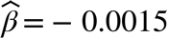and is no longer statistically significant (p value=0.97); ii) among the domestic knowledge inputs, only RD is statistically significant at the standard levels with an estimated elasticity equal to 0.47 (p value=1.62e-05), while the human capital stock has a positive effect (0.057) but is not statistically significant (p value=0.98); and iii) the estimated coefficients associated with WRD and WHK both have the wrong (negative) sign (-0.10 and -9.02, respectively), with WHK also being highly statistically significant.
Thus, the above results indicate the importance of adopting a flexible specification to highlight statistically significant policy effects. The same result is found, for instance, in Cardot and Musolesi (2020). These estimates also suggest that adopting a flexible specification permits more credible and refined results with respect to the effect of continuous knowledge inputs since nonlinearities and thresholds are important features of innovation data. Estimating a traditional parametric log-log model would have produced a substantial functional form bias.

APPENDIX C: Supplementary information on the Binary Policy Variable

The aim of this appendix is to provide some additional insights about the binary policy variable EP, which represents our measure of policy stringency in the air pollution policy domain.
Since the 1990s, there has been a global trend toward increased Environmental Policy Stringency, impacting both aggregate and individual country levels. Market-based instruments, particularly the introduction of the EU ETS in 2005, have induced significant year-to-year variations and added complexity to measuring the relationship between environmental regulations and economic outcomes. The subsequent surge in stringency, especially in the mid-2000s, highlights the dynamic nature of environmental policies, particularly those employing market-based approaches. Our EP variable encompasses a range of environmental policy instruments, extending beyond regulations to include taxes, subsidies, and tradable permits. Nevertheless, it functions as a composite measure that captures the multidimensionality of policy efforts.
This study narrows its focus to the realm of air pollution regulations, primarily due to the extended historical context of air pollution policies during the considered timeframe. The regulation of air pollution has consistently served as a foundational element in environmental policy, originating notably with the U.S. Clean Air Act in the 1970s and concurrently complementing climate policy efforts (Markandya et al., 2018).
The base indicator, determined based on each country's implementation of regulations across these six categories, assumes a specific value.
It is worth noting that taxes and fees represent the most prominent category, followed by environmentally beneficial subsidies and payments (for more details see https://oecd-main.shinyapps.io/pinedatabase/).
Specifically, it takes a value of 1 for every category in which at least one policy is introduced, with the potential for values ranging from one to six, reflecting the breadth and depth of policy engagement.
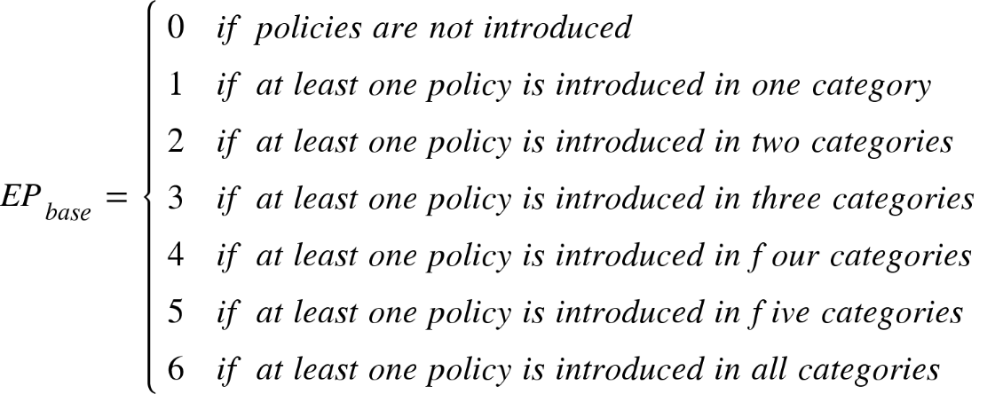
Ultimately, the base indicator culminates in a scale ranging from zero to five. Derived from this index, which serves as a comprehensive measure, the binary environmental policy variable, denoted as EP_{it}, is established. EP_{it} assumes a value of 1 if there is an introduction of one or more policies within the air pollution domain across at least two categories. Conversely, it assumes a value of 0 if such introductions are less than two. This binary variable enables a more nuanced examination of environmental policy implementation based on specific categorical thresholds.
Altogether, 45% of the observations are designated as treated units. Notably, the prevalence of treated units has undergone changes over time. Initially, very few observations were treated, with 0% in 1982 and 5% in 1983. However, this proportion experienced a substantial increase, nearly reaching 80% by 2012. According to the OECD (2016), there has been a notable escalation in the stringency of environmental policies across all OECD countries and BRIICS over the past two decades.
In the examination of cross-country variation, Nordic nations consistently emerge as proponents of the most stringent environmental policies (Botta and Kozluk, 2014). Nevertheless, heterogeneity prevails, considering divergent starting points and the observed increases from 1995 to 2014. Notably, Germany exhibits a lagged trajectory, instituting policies from the mid-2000s. Conversely, the United States, an early adopter since the early 1980s, consistently surpasses the average. Meanwhile, Italy, Korea, and Sweden demonstrate analogous behavioural patterns since the early 1990s. Moreover, Japan, is the only nation that did not introduce policies in alternative categories during the considered period, remaining the only untreated units.
By the conclusion of the designated period, Finland, Greece, Japan, and Portugal emerge as the nations exhibiting the least stringency, as they have not introduced policies in alternative categories. In contrast, the United States and Canada stand out as the most stringent countries, with 80% of treated units, indicating a notable commitment to environmental policy implementation.

References

Bailey, N., Kapetanios G. and Pesaran, M. H., (2016). Exponent of cross-sectional dependence: estimation and inference, Journal of Applied Econometrics, Vol. 31, pp. 929-960.
Cardot, H., & Musolesi, A., (2020). Modeling temporal treatment effects with zero inflated semi-parametric regression models: the case of local development policies in France, Econometric Reviews, 39(2), 135-157.
Claeskens, G., & Hjort, N. L., (2008). Model selection and model averaging, Cambridge Books.
Frees, E. W., (1995). “Assessing cross-sectional correlation in panel data”, Journal of Econometrics, Vol. 69: pp. 393-414.
Greven, S., & Kneib, T., (2010). On the behaviour of marginal and conditional AIC in linear mixed models, Biometrika, 97(4), 773-789.
Hastie T, Tibshirani R., (1990). Generalized additive models, Chapman & Hall, Boca Raton.
Heckman, J. J., Hotz, V. J., (1989). Choosing among alternative nonexperimental methods for estimating the impact of social programs: The case of manpower training, Journal of the American statistical Association, 84(408), 862-874.
Heckman, J. J., LaLonde, R. J., & Smith, J. A., (1999). The economics and econometrics of active labor market programs. In Handbook of labor economics (Vol. 3, pp. 1865-2097). Elsevier.
Konishi, S., & Kitagawa, G., (2008). Information criteria and statistical modeling. Springer Science & Business Media.
Lechner, M., (2010). The relation of different concepts of causality used in time series and microeconometrics, Econometric Reviews, 30(1), 109-127.
Pesaran, M. H., (2006). Estimation and inference in large heterogeneous panels with a multifactor error structure, Econometrica, 74(4), 967-1012.
Sarafidis, V., Wansbeek, T., (2012). Cross-sectional dependence in panel data analysis, Econometric Reviews, 31(5), 483-531.
Su, L., Jin, S., (2012). Sieve estimation of panel data models with cross section dependence, Journal of Econometrics, 169(1), 34-47.
Wood, S. N., Pya, N., & Säfken, B., (2016). Smoothing parameter and model selection for general smooth models, Journal of the American Statistical Association, 111(516), 1548-1563.
Wood, S. N., (2020). Inference and computation with generalized additive models and their extensions. TEST, 1-33.
Wooldridge, J. M., (2005). Fixed-effects and related estimators for correlated random-coefficient and treatment-effect panel data models, Review of Economics and Statistics, 87(2), 385-390.

Table A1 - Model selection and residual diagnostics for cross-sectional dependence
Specifications | BIC | Frees | Alpha
- Semiparametric additive smooth functions, individual time effects (semiparametric linear random trend) | 218.1777 | 0.497  (0.000) | 0.725  (0.666-0.784)
- Parametric, individual time effects (parametric quadratic random trend) | 225.2362 | 0.719  (0.000) | 0.787  (0.676-0.899)
- Parametric, individual time effects (parametric linear random trend) | 235.3614 | 1.149  (0.000) | 0.698  (0.652-0,744)
- Parametric, multifactor error structure (parametric CCE) | 246.0169 | 0.644  (0.000) | 0.365  (0.117-0.614)
- Semiparametric additive smooth function, multifactor error structure (semiparametric CCE) | 282.6753 | 0.343  (0.000) | 0.085  (-)
- Semiparametric additive smooth function, individual time effects (semiparametric quadratic random trend) | 289.9588 | 0.474  (0.000) | 0.761  (0.535-0.987)
- Semiparametric additive smooth function, two-way fixed effects (semiparametric two-way) | 455.1144 | 0.939  (0.000) | 0.506  (0.238-0.775)
- Parametric, two-way fixed effects (parametric two-way) | 583.9615 | 1.587  (0.000) | 0.302  (-0.08-0.685)
Legend. BIC: Bayesian Information Criterion based on Wood et al. (2016) and Wood (2020). Frees: test of cross-sectional independence by Frees (1995); p-value between brackets. Alpha: bias corrected version of the exponent of cross-sectional dependence by Bailey et al. (2016); 95% confidence interval between brackets.

Table A2 - Placebo (pre-program) tests
 | Model without additional explanatory variables  (i) |  |  | Semiparametric additive smooth functions  (ii)
 | EP_{it_94} | EP_{it_06} | EP_{it_12} | EP_{it_94} | EP_{it_06} | EP_{it_12}
One way | 3.66***  (2E-16) | 4.67***  (2E-16) | 4.63***  (2E-16) | 5.6***  (9.9E-15) | 5.6***  (9.9E-15) | 3.37***  (0.0002)
Two-way | -0.12  (0.34) | 2.10***  (2E-16) | 1.44***  (2E-16) | 2.4  (0.13) | -9.51**  (0.009) | 2.63  (0.24)
Linear random trend | -1.051E+2  (0.22) | -2.172E+1  (0.79) | -5.69  (0.5) | -1.39E+3  (0.29) | -185  (0.79) | -3267  (0.13)
Quadratic random trend | 6.264E+4  (0.56) | 2.906E+4  (0.78) | 2.906E+4  (0.78) | -1.4E+4  (0.89) | -1.6  (0.2) | -2.89  (0.107)
Multifactor error structure | 3.04  (0.5) | 3.04  (0.5) | -0.18  (0.96) | 20.5  (0.53) | 16  (0.4) | 13.5  (0.69)
Legend. Pre-program estimates of the policy effect. p-value between brackets. Significance: ‘***’0.001; ‘**’ 0.01; ‘*’ 0.05.

Figure C1 – Binary Policy Variable Frequency for Selected Countries

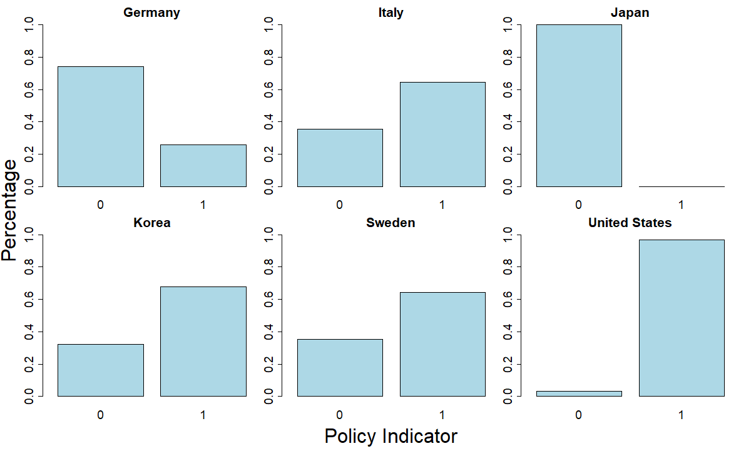

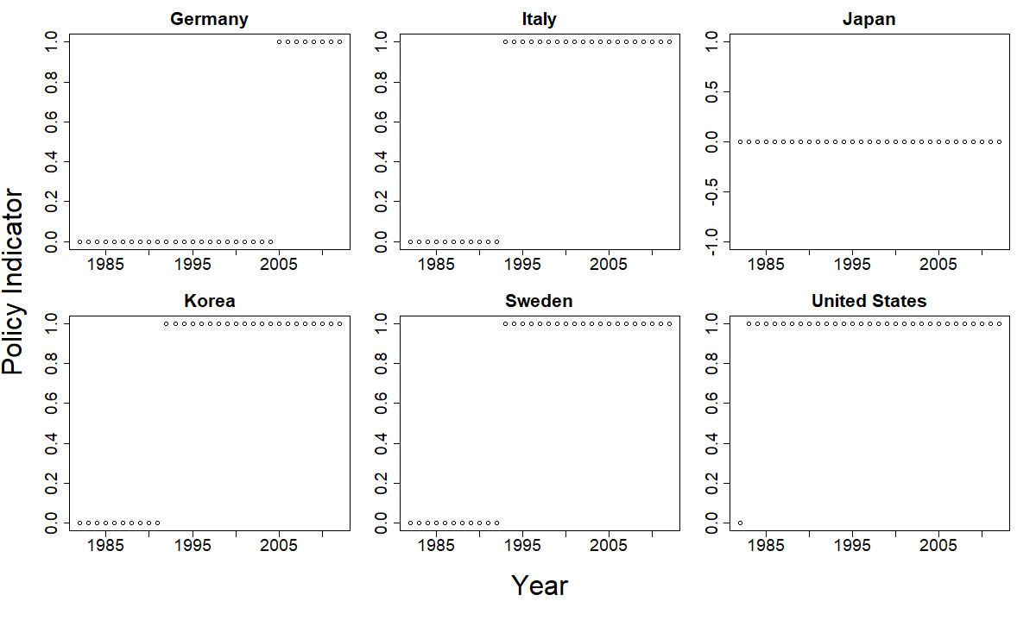

Legend. Frequency plots of EP_{it} indicating different levels of policy stringency for all the considered period (a), and over time, (b), for the selected countries.

