Online Supplementary Materials

Online Appendix A. PPP Definition in Sewerage Businesses
Although the institutions and operations of PPPs employed in each country are largely dependent on a country’s historical independence, the OECD (2011) published a general definition and categorisation of PPPs in water supply and sewerage industries. Using the OECD’s (2011) definition, we can derive four categories, which are shown on the left-hand side of Table A. In a service contract, the level of private actor involvement is the lowest among the four, since it enables a private contractor to implement only the limited tasks stipulated by a contract. Management tasks are not allowed in this contract, which means that a private contractor rarely improves the fundamental efficiency. In a management contract, a private contractor engages in not only operation but also management tasks, meaning that efficiency improvement will more likely occur through utilising the contractor’s management skills and resources. However, capital investment by a private contractor is not allowed in this contract, as it is stipulated as the public sector’s responsibility. In a lease contract, a private contractor is engaged in operation and management (O&M) with a greater degree of autonomy, and capital investment responsibility can be shared between a private contractor and the public sector. In a concession contract, financing capital investment is added to a private contractor’s responsibility. All of the four contracts described above keep asset ownership on the public sector’s side.
Since the OECD’s (2011) definition of PPPs is based on case studies of three countries (Ukraine, Armenia, and Kazakhstan), it is not necessarily applicable to other countries. In fact, in Japan’s sewerage businesses, a management contract is more particularly defined. The right-hand side of Table A shows Japan’s definition. The concept of a service contract here is the same as the OECD’s in that it allows a private contractor to be engaged in only operation.
A remarkable aspect of the Comprehensive Outsourcing Contract (COC), a type of management contract in Japan, is that it has three levels of private sector involvement. In Level 1, a private contractor is engaged in O&M. In Level 2, O&M are integrated under a single contract with utilities management, such as procurement of disposables and energies, which leads to a greater degree of cost reduction. In Level 3, maintenance and repair tasks are further integrated into a single contract, which allows efficient asset maintenance by a private actor. Since a management contract per the OECD’s definition does not include maintenance as a possible outsourcing task, COC Level 3 does not completely match the OECD’s definition of management contracts in Table A. Therefore, although the contract duration in the Japanese COC is mostly 3−5 years at all levels, which is similar to OECD’s management contract, Level 3 has some of the characteristics of a lease contract according to the OECD’s definition.

Table A. Differences in PPP Definition between OECD and Japan
Level of Private Sector Involvement | PPP Definition, OECD  (Water Supply and Sewerage) | PPP Definition, Japan  (Sewerage)
Low  High | Service Contract  For operation (technical and administrative tasks) | Service Contract  For operation
Low  High | Management Contract  For operation and management (O&M) | Comprehensive Outsourcing Contract (COC) Level 1  For O&M
Low  High | Management Contract  For operation and management (O&M) | Comprehensive Outsourcing Contract (COC) Level 2  For integration of O&M and utilities management
Low  High | Management Contract  For operation and management (O&M) | Comprehensive Outsourcing Contract (COC) Level 3  For integration of O&M, utilities management, and maintenance and repair. Capital investment is the public sector’s responsibility.
Low  High | Lease Contract  For O&M and maintenance. Capital investment is the shared responsibility between the public sector and a private contractor.
Low  High |  | Not Clearly Defined
Low  High | Concession Contract  For O&M, maintenance, capital investment, and financing | Concession Contract  For O&M, maintenance, capital investment, and financing
(Note) Created by the authors based on the OECD (2011) and Ministry of Land, Infrastructure, Transport and Tourism, Japan (2001). The OECD (2011) further defines the build-operate-transfer contract, joint venture contract, and full divestiture, which are not included in this table since they are beyond the scope of our discussion.

In Japan’s definition, a lease contract is not clearly defined for the sewerage business. This is because Japan’s definition of a lease contract assumes the temporary transition of asset ownership to a private contractor. In Japan, it is stipulated that the installation, reconstruction, repair, maintenance, and other management of public sewerage systems are implemented by local governments (the Sewerage Law Act, 3), which means that the sewerage business cannot be privatised and private asset ownership is not allowed under the current law. Concession contracts, which keep asset ownership on the public side, are more widely encouraged by the government as an important PPP/PFI practice, as is seen in the Cabinet Office (2020). However, concession contracts are not currently common in sewerage businesses; only two cities, Hamamatsu and Suzaki, employed concession contracts in 2019.

Online Appendix B. Overview of COCs in Japan’s Sewerage Business
The Japanese government has published guidelines to introduce COCs for municipalities (Ministry of Land, Infrastructure, Transport and Tourism 2001, 2023). A municipality decides whether to introduce a COC while referring to these guidelines, and the concrete design of the COC, such as contract duration and combination of outsourced tasks, can be determined under a municipality’s discretion. Whether a council resolution is necessary for introducing the COC depends on each municipality’s regulations; yet, the guidelines recommend that various prior examinations and analyses by sewerage departments be carried out prior to decision making, and that municipal leaders take the initiative for the introduction and make efforts to gain council support.
In Japan, wastewater treatment and sludge treatment have been the most popular functions of COCs. Although the service contract was the most common type of outsourcing contract in 2019, COCs have gained popularity in recent years. As shown in Fig. B, the rate of COCs, compared to the total number of each type of treatment plant in Japan, has increased in the last 13 years. The rate has risen from 10% to 28% for wastewater treatment plants and from 9% to 17% for sludge treatment plants. The increase occurred because the government developed guidelines for COC introduction (Ministry of Land, Infrastructure, Transport and Tourism 2001), and has promoted COCs by positioning them as one of the core policies for fiscal reform (Cabinet Office 2015). The increasing trend of COC introduction suggests that the number of COCs is expected to continue to grow in the future.
It is worth noting that the rates of COC Level 2 and Level 3 are growing faster than those of Level 1, which implies that private sector involvement in COCs is growing. While COC Level 2 has been most widely employed in this period in the two facilities, the rate of COC Level 3 has increased in the last five years. Level 3 is expected to grow, as the trend in Fig. B suggests.

Panel A: Wastewater Treatment Plant

Panel B: Sludge Treatment Plant

Fig. B Trend of Comprehensive Outsourcing Contracts in Japan’s Sewerage Business
Bars expressing the rates of COC adoption are shown in three colours by COC Level. The adoption of COC has gradually increased since 2007 in wastewater treatment and sludge treatment plants.

Online Appendix C. Additional Analysis for Propensity Score Matching
To accurately estimate the effects of treatment (i.e. introducing the COC in our analysis) using propensity score matching, it is crucial to hold the assumptions of common support and parallel trends.
Fig. C.1 shows the distribution of the estimated propensity scores for the whole sample in the first stage of the analysis. The propensity score distribution is highly skewed due to the limited number of treated observations present in the sample. Given this skewed distribution, we used the log of the odds of the propensity score rather than the score itself in the matching procedure. Fig. C.2 shows the distribution of log odds for both the treatment and control groups. They have almost the same distribution and common support.

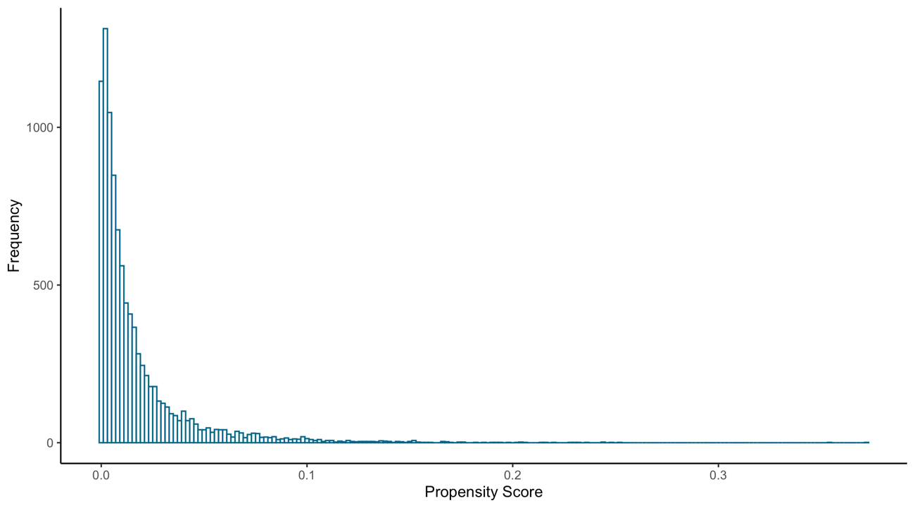
Fig. C.1 Distribution of the Propensity Scores
Bars expressing distribution of the propensity scores show that the scores are highly skewed.

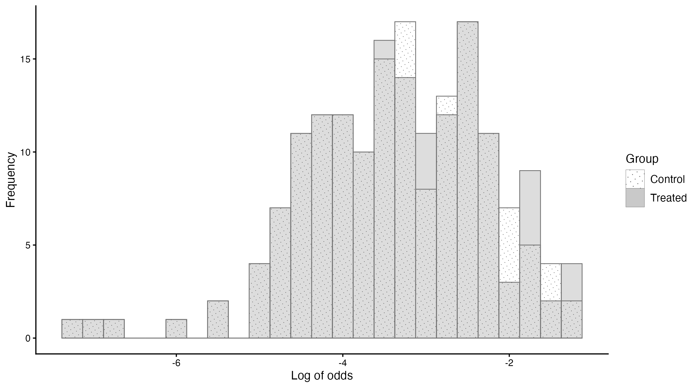
(Note) Nearest neighbour propensity score matching is used, with the caliper set at the standard deviation of the log odds of the entire sample multiplied by 0.2.
Fig. C.2 Distribution of the Log Odds for the Treatment and Control Groups
Bars expressing distributions of the log odds are shown for the treatment and control groups. The bars are mostly overlapped.

To check the parallel trend assumption, we calculated the average annual unit cost of the treatment and control groups for the period before and after the treatment year, and determined the trend. Fig. C.3 shows the results, indicating that the average unit cost has the same trend for both groups.

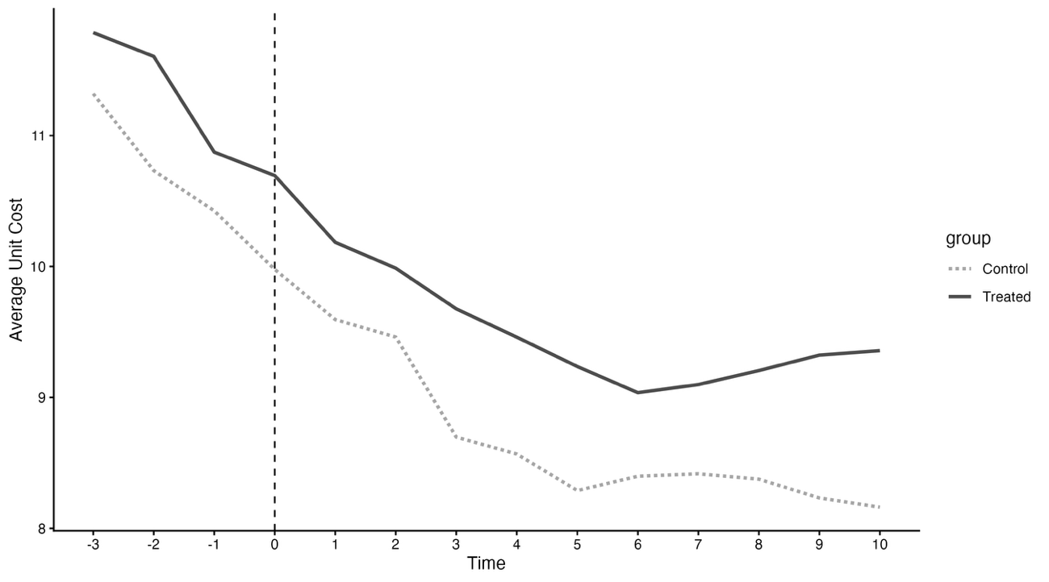
(Note) The contract year is shown as zero. Unit cost is calculated as total maintenance cost divided by the population installing flush toilets. Nearest neighbour propensity score matching is used, with the caliper set at the standard deviation of the log odds of the entire sample multiplied by 0.2.
Fig. C.3 Unit Cost Trends for the Treatment and Control Groups
Two lines are shown as the trends in unit costs for the treatment and control groups. Both lines show an initial decreasing trend after the contract, but the rate of decrease levels off around five or six years after the contract.

Online Appendix D. Full Second-Stage Estimation Results
The full results, including those for estimated equations (2)–(5), are reported in Table D. The results are stable across specifications, as the signs and magnitudes of the significant coefficients do not differ substantially among the models.

Table D. Full Second-Stage Estimation Results
 | Base Model 1 |  |  | Base Model 1 with Lock-in |  |  | Base Model 2 |  |  | Base Model 2 with Lock-in |  |  | COC Model 1 |  |  | COC Model 1 with Lock-in |  |  | COC Model 2 |  |  | COC Model 2 with Lock-in
Variable | Coef. |  | (Std. Err.) | Coef. |  | (Std. Err.) | Coef. |  | (Std. Err.) | Coef. |  | (Std. Err.) | Coef. |  | (Std. Err.) | Coef. |  | (Std. Err.) | Coef. |  | (Std. Err.) | Coef. |  | (Std. Err.)
Panel A: UC1 (N=4887) |  |  |  |  |  |  |  |  |  |  |  |  | COC=COC_{SLD} |  |  |  |  |  | COC=COC_{L3}
ln(DE_{POP}) | -0.531 | *** | (0.040) | -0.533 | *** | (0.040) | -0.530 | *** | (0.040) | -0.531 | *** | (0.040) | -0.529 | *** | (0.040) | -0.529 | *** | (0.040) | -0.530 | *** | (0.040) | -0.533 | *** | (0.040)
DE_{DENS} | 0.002 |  | (0.002) | 0.002 |  | (0.002) | 0.002 |  | (0.002) | 0.003 |  | (0.002) | 0.002 |  | (0.002) | 0.002 |  | (0.002) | 0.002 |  | (0.002) | 0.002 |  | (0.002)
ln(TE_{AGE}) | 0.030 |  | (0.036) | 0.030 |  | (0.036) | 0.029 |  | (0.036) | 0.028 |  | (0.036) | 0.026 |  | (0.036) | 0.024 |  | (0.036) | 0.029 |  | (0.036) | 0.028 |  | (0.036)
TE_{SLUDGE} | -0.027 |  | (0.029) | -0.023 |  | (0.029) | -0.027 |  | (0.029) | -0.023 |  | (0.029) | -0.025 |  | (0.029) | -0.024 |  | (0.029) | -0.027 |  | (0.029) | -0.020 |  | (0.029)
TE_{RAIN} | 0.420 | *** | (0.081) | 0.414 | *** | (0.079) | 0.433 | *** | (0.080) | 0.426 | *** | (0.077) | 0.425 | *** | (0.081) | 0.431 | *** | (0.078) | 0.433 | *** | (0.080) | 0.426 | *** | (0.078)
OS_{PRD} |  |  |  |  |  |  | 0.012 | ** | (0.005) | 0.014 | ** | (0.005) | 0.011 | ** | (0.005) | 0.013 | ** | (0.006) | 0.012 | ** | (0.005) | 0.012 | ** | (0.005)
$$\hat{d}$$ | -0.030 | *** | (0.009) | -0.036 | *** | (0.011) | -0.060 | *** | (0.015) | -0.067 | *** | (0.015) | -0.038 | * | (0.020) | -0.054 | *** | (0.020) | -0.060 | *** | (0.015) | -0.070 | *** | (0.016)
$\hat{d}∙$ T₁ |  |  |  | 0.013 |  | (0.015) |  |  |  | 0.009 |  | (0.015) |  |  |  | -0.005 |  | (0.017) |  |  |  | 0.016 |  | (0.019)
$\hat{d}∙$T₂ |  |  |  | 0.014 |  | (0.019) |  |  |  | 0.007 |  | (0.020) |  |  |  | -0.005 |  | (0.028) |  |  |  | 0.012 |  | (0.024)
$\hat{d}∙$T₃ |  |  |  | 0.080 | *** | (0.028) |  |  |  | 0.076 | *** | (0.029) |  |  |  | 0.096 | ** | (0.046) |  |  |  | 0.082 | ** | (0.034)
$\hat{d}∙$T₄ |  |  |  | 0.162 | ** | (0.077) |  |  |  | 0.162 | ** | (0.077) |  |  |  | 0.231 | * | (0.134) |  |  |  | 0.226 | *** | (0.085)
$\hat{d}∙$COC |  |  |  |  |  |  |  |  |  |  |  |  | -0.029 | * | (0.017) | -0.014 |  | (0.019) | 0.001 |  | (0.018) | 0.024 |  | (0.020)
$\hat{d}∙$T₁$∙$COC |  |  |  |  |  |  |  |  |  |  |  |  |  |  |  | 0.019 |  | (0.027) |  |  |  | -0.025 |  | (0.025)
$\hat{d}∙$T₂$∙$COC |  |  |  |  |  |  |  |  |  |  |  |  |  |  |  | 0.016 |  | (0.031) |  |  |  | -0.019 |  | (0.029)
$\hat{d}∙$T₃ $∙$COC |  |  |  |  |  |  |  |  |  |  |  |  |  |  |  | -0.057 |  | (0.051) |  |  |  | -0.022 |  | (0.047)
$\hat{d}∙$T₄ $∙$COC |  |  |  |  |  |  |  |  |  |  |  |  |  |  |  | -0.171 |  | (0.137) |  |  |  | -0.326 | * | (0.175)
Constant | 8.991 | *** | (0.524) | 8.982 | *** | (0.525) | 8.941 | *** | (0.521) | 8.932 | *** | (0.523) | 8.940 | *** | (0.522) | 8.925 | *** | (0.525) | 8.939 | *** | (0.523) | 8.975 | *** | (0.525)
R2 | 0.926 |  |  | 0.926 |  |  | 0.926 |  |  | 0.926 |  |  | 0.926 |  |  | 0.926 |  |  | 0.926 |  |  | 0.927
Panel B: UC2 (N=4777) |  |  |  |  |  |  |  |  |  |  |  |  | COC=COC_{SLD} |  |  |  |  |  | COC=COC_{L3}
ln(DE_{POP}) | -0.508 | *** | (0.039) | -0.509 | *** | (0.039) | -0.508 | *** | (0.039) | -0.509 | *** | (0.039) | -0.506 | *** | (0.039) | -0.506 | *** | (0.039) | -0.506 | *** | (0.039) | -0.510 | *** | (0.039)
DE_{DENS} | 0.000 |  | (0.002) | 0.001 |  | (0.002) | 0.000 |  | (0.002) | 0.001 |  | (0.002) | 0.000 |  | (0.002) | 0.001 |  | (0.002) | 0.000 |  | (0.002) | 0.001 |  | (0.002)
ln(TE_{AGE}) | -0.072 | ** | (0.032) | -0.073 | ** | (0.032) | -0.073 | ** | (0.033) | -0.074 | ** | (0.033) | -0.077 | ** | (0.032) | -0.079 | ** | (0.032) | -0.073 | ** | (0.033) | -0.073 | ** | (0.033)
TE_{SLUDGE} | -0.083 | *** | (0.030) | -0.077 | *** | (0.030) | -0.083 | *** | (0.030) | -0.077 | *** | (0.030) | -0.082 | *** | (0.030) | -0.080 | *** | (0.030) | -0.084 | *** | (0.030) | -0.076 | ** | (0.030)
TE_{RAIN} | 0.494 | *** | (0.075) | 0.488 | *** | (0.073) | 0.500 | *** | (0.075) | 0.493 | *** | (0.073) | 0.488 | *** | (0.076) | 0.501 | *** | (0.074) | 0.499 | *** | (0.075) | 0.490 | *** | (0.072)
OS_{PRD} |  |  |  |  |  |  | 0.005 |  | (0.005) | 0.006 |  | (0.005) | 0.004 |  | (0.005) | 0.006 |  | (0.005) | 0.005 |  | (0.005) | 0.005 |  | (0.005)
$$\hat{d}$$ | -0.024 | *** | (0.009) | -0.032 | *** | (0.011) | -0.036 | ** | (0.014) | -0.045 | *** | (0.015) | -0.005 |  | (0.020) | -0.015 |  | (0.021) | -0.038 | ** | (0.015) | -0.047 | *** | (0.016)
$\hat{d}∙$ T₁ |  |  |  | 0.016 |  | (0.015) |  |  |  | 0.014 |  | (0.015) |  |  |  | -0.015 |  | (0.019) |  |  |  | 0.019 |  | (0.019)
$\hat{d}∙$T₂ |  |  |  | 0.026 |  | (0.019) |  |  |  | 0.023 |  | (0.020) |  |  |  | -0.010 |  | (0.030) |  |  |  | 0.022 |  | (0.024)
$\hat{d}∙$T₃ |  |  |  | 0.095 | *** | (0.028) |  |  |  | 0.094 | *** | (0.029) |  |  |  | 0.105 | ** | (0.046) |  |  |  | 0.099 | *** | (0.034)
$\hat{d}∙$T₄ |  |  |  | 0.192 | ** | (0.077) |  |  |  | 0.193 | ** | (0.077) |  |  |  | 0.256 | * | (0.134) |  |  |  | 0.249 | *** | (0.086)
$\hat{d}∙$COC |  |  |  |  |  |  |  |  |  |  |  |  | -0.043 | ** | (0.017) | -0.037 | * | (0.021) | 0.007 |  | (0.018) | 0.022 |  | (0.020)
$\hat{d}∙$T₁$∙$COC |  |  |  |  |  |  |  |  |  |  |  |  |  |  |  | 0.037 |  | (0.029) |  |  |  | -0.018 |  | (0.026)
$\hat{d}∙$T₂$∙$COC |  |  |  |  |  |  |  |  |  |  |  |  |  |  |  | 0.046 |  | (0.032) |  |  |  | 0.011 |  | (0.029)
$\hat{d}∙$T₃ $∙$COC |  |  |  |  |  |  |  |  |  |  |  |  |  |  |  | -0.056 |  | (0.051) |  |  |  | -0.017 |  | (0.046)
$\hat{d}∙$T₄ $∙$COC |  |  |  |  |  |  |  |  |  |  |  |  |  |  |  | -0.177 |  | (0.137) |  |  |  | -0.287 |  | (0.175)
Constant | 4.354 | *** | (0.504) | 4.351 | *** | (0.505) | 4.341 | *** | (0.503) | 4.337 | *** | (0.505) | 4.340 | *** | (0.505) | 4.315 | *** | (0.510) | 4.328 | *** | (0.504) | 4.360 | *** | (0.506)
R2 | 0.927 |  |  | 0.928 |  |  | 0.927 |  |  | 0.928 |  |  | 0.927 |  |  | 0.928 |  |  | 0.927 |  |  | 0.928
(Note) Heteroskedasticity-robust standard errors are reported in parentheses. Superscripts ***, **, and * correspond to statistical significance at the 1%, 5%, and 10% levels, respectively. All specifications include year fixed effects and municipality fixed effects.

Online Appendix E. Discussion on Results of Technology Variables
In the first-stage estimation, only ${TE}_{CMS}$ has a statistically significant coefficient among technology variables. The positive sign for ${TE}_{CMS}$ suggests that the use of sewage pipes with interceptors leads to COC introduction. However, apart from this variable, the technology variables have minor effects on COC introduction. This suggests that technological differences do not matter greatly for a municipality’s decision making. This is consistent with the survey results of Urakami et al. (2020), indicating that the effect of COCs on technology transfer is limited. As reported by the Otsu City Public Enterprise Bureau (2015), many municipalities in Japan face the issue of technology succession or transfer to the private sector due to the aging of municipalities’ staff engaged in technological tasks. While PPP has been considered an option for technology transfer to the private sector, our result shows that, at least for municipalities, the technological issue is not one of the critical drivers for the employment of COCs. In summary, the introduction of COCs largely depends on factors such as the demand environment and a municipality’s cost structure rather than transaction or technological factors.
In the second-stage estimation, the coefficient of ${TE}_{AGE}$ has different signs between Panel A and Panel B. In Panel A, it shows a positive sign but this is not significant. By contrast, the coefficient is significantly negative in Panel B, which indicates that older plants lead to lower costs. Based on these results, we conclude that the effect of plant age could be different depending on the aspect of the production cost we focus on. The coefficient of ${TE}_{SLUDGE}$ can be interpreted in a similar way, since it is not significant in Panel A but significant with a negative sign in Panel B. The positive coefficient of ${TE}_{RAIN}$ shows that the rainwater treatment increases the unit cost in both Panels, which is reasonable in that the treatment cost of wastewater rises when the rainwater is mixed in the same plant.

References
Cabinet Office (2015) Basic Policy on Economic and Fiscal Management and Reform 2015. https://www5.cao.go.jp/keizai-shimon/kaigi/cabinet/honebuto/2015/2015_basicpolicies_en.pdf. Accessed 31 December 2024
Cabinet Office (2020) PPP/PFI Promotion Action Plan (PPP/PFI Suishin Action Plan) (in Japanese). https://www8.cao.go.jp/pfi/actionplan/pdf/actionplan2.pdf. Accessed 10 March 2023
Cabinet Office (2023) PPP/PFI Promotion Action Plan 2023 Revised Version (PPP/PFI Suishin Action Plan Reiwa 5 Nen Kaiteiban) (in Japanese). https://www8.cao.go.jp/pfi/actionplan/action_index_r5.html. Accessed 17 August 2023
Ministry of Land, Infrastructure, Transport and Tourism (2001) Guidelines for performance-based private outsourcing (Seinou Hacchu no Kangaekata ni Motodzuku Minkan Itaku no Tameno Guideline) (in Japanese). https://www.mlit.go.jp/crd/city/sewerage/info/tosikeikaku/guidelines.pdf. Accessed 10 March 2023
Ministry of Land, Infrastructure, Transport and Tourism (2023) Guidelines for introducing comprehensive outsourcing contracts in infrastructure maintenance (Infura Mentenance ni okeru Houkatsuteki Minkan Itaku Dounyuu no Tebiki) (in Japanese). https://www.mlit.go.jp/sogoseisaku/maintenance/_pdf/houkatsu_tebiki_kaisetsu.pdf. Accessed 8 November 2024
OECD (2011) Guidelines for performance-based contracts between water utilities and municipalities: lessons learnt from Eastern Europe, Caucasus and Central Asia. OECD Publishing, Paris
Otsu City Public Enterprise Bureau (2015) Study on the effectiveness of public-private partnership projects including concessions in sewerage and water supply projects (in Japanese). https://www.mlit.go.jp/common/001265581.pdf. Accessed 10 March 2023
Urakami T, Tanaka T, Nakaoka T, Kitamura T (2020) Gesuido academic incubation to advanced project 2019: an empirical study about the measurement of productivity and efficiency concerning wide-area consolidation and public-private partnership of the Japanese sewerage utilities. Questionnaire survey primary result. Kindai University Faculty of Business Administration Working Paper, No. 2020-01 (in Japanese). Kindai University, Higashiosaka

In Japan, a service contract means a specification order, where input factors, technology, and processes are specified by the municipality. Under the specification order, service provision tends to be inefficient because technology and process improvement by private businesses cannot occur. By contrast, management contracts in Japan, particularly COCs, employ performance orders to allow private actors’ managerial discretion. Municipalities specify only the output level when delegating tasks to private businesses, meaning that technology and process improvements by private actors are allowed. This makes a COC more efficient than a service contract.
In June 2023, the Japanese government added a new level, Level 3.5, to COCs, in which the contract period is longer than that of Level 3 (at least 10 years) and with a profit-sharing arrangement between municipalities and private operators, in a section entitled “Water PPP” (Cabinet Office 2023). However, since Level 3.5 is a newly defined type of COC and no observations employing this type are currently available, we have focussed on COCs from Level 1 to Level 3.
In “Water PPP”, a concession contract is defined as Level 4 (Cabinet Office 2023).

