Auxiliary Material: Quantifying Deformation in North Borneo with GPS
Mohamad Asrul Mustafar ⋅ Wim J.F. Simons ⋅ Felix Tongkul
Chalermchon Satirapod ⋅ Kamaludin Mohd Omar ⋅ Pieter Visser

There are 20 CORS stations located in North Borneo. Table A shows the availability of GPS data in North Borneo from 2009 to 2011. Two types of antennas and receivers were used as configuration for these CORS stations in North Borneo.

Table A Number of daily available GPS data for the North Borneo CORS stations in the selected 2009-2011 time period.
 |  | Year |  |  | Station Information
Station | 2009 | 2010 | 2011 | Antenna |  | Receiver
BEAU | 297 | 322 | 292 | TRM55971.00 |  | TRIMBLE NETR5
BELA | 314 | 235 | 136 | TRM55971.00 |  | TRIMBLE NETR5
BELU | 253 | 268 | 292 | TRM55971.00 |  | TRIMBLE NETR5
BIN1 | 317 | 321 | 292 | TRM55971.00 |  | TRIMBLE NETR5
DATU | 292 | 349 | 284 | TRM55971.00 |  | TRIMBLE NETR5
KENI | 266 | 348 | 268 | TRM55971.00 |  | TRIMBLE NETR5
KUDA | 288 | 349 | 288 | TRM55971.00 |  | TRIMBLE NETR5
LAB1 | 318 | 333 | 292 | TRM55971.00 |  | TRIMBLE NETR5
LAWS | 318 | 340 | 290 | TRM55971.00 |  | TRIMBLE NETR5
MIRI | 305 | 348 | 289 | TRM55971.00 |  | TRIMBLE NETR5
MRDI | 308 | 327 | 282 | TRM55971.00 |  | TRIMBLE NETR5
MRDU | 275 | 330 | 283 | TRM55971.00 |  | TRIMBLE 5700
NIAH | 278 | 323 | 285 | TRM41249.00 |  | TRIMBLE 5700
RANA | 269 | 335 | 289 | TRM55971.00 |  | TRIMBLE NETR5
SAND | 316 | 342 | 283 | TRM55971.00 |  | TRIMBLE NETR5
SEMP | 292 | 336 | 285 | TRM55971.00 |  | TRIMBLE NETR5
TAWX | 267 | 335 | 287 | TRM55971.00 |  | TRIMBLE NETR5
TENM | 310 | 345 | 286 | TRM55971.00 |  | TRIMBLE NETR5
TMBN | 315 | 356 | 295 | TRM55971.00 |  | TRIMBLE 5700
UMSS | 316 | 346 | 270 | TRM41249.00 |  | TRIMBLE 5700

Table B: GPS velocities (mm/yr) from the 1999-2004 solution. V_lon, V_lat and V_up are the velocity components in respectively the longitude, latitude and vertical direction. S_lon, S_lat and S_up represent the velocity errors in each direction at 99% confidence level. Listed IGS stations were used in mapping into IGS08 frame. The Sol column denotes the number of weekly-averaged solution within the solution period and the Corr column gives the correlation coefficient between the latitude and longitudinal component. An asterisk (*) behind the station name indicate position jumps(s) were estimated.
Site | Lon | Lat | Height | V_lon | V_lat | V_up | S_lon | S_lat | S_up | Corr | #sol | span
#Malaysia
ARAU | 100.280 | 6.450 | 18.047 | 32.95 | -2.98 | 0.01 | 0.33 | 0.27 | 1.22 | 0.058 | 292 | 99-04
BEHR | 101.517 | 3.765 | 68.692 | 31.21 | -3.30 | 0.33 | 0.61 | 0.48 | 2.38 | -0.008 | 106 | 02-04
BINT | 113.067 | 3.262 | 48.756 | 27.37 | -11.04 | 0.67 | 0.44 | 0.33 | 1.07 | -0.010 | 239 | 99-04
GETI | 102.105 | 6.226 | -0.505 | 32.16 | -4.21 | 1.48 | 0.32 | 0.24 | 1.06 | 0.003 | 256 | 99-04
IPOH | 101.126 | 4.588 | 41.821 | 31.47 | -2.74 | -0.57 | 0.33 | 0.25 | 1.01 | -0.148 | 203 | 99-04
KINA* | 116.039 | 5.905 | 51.732 | 25.80 | -8.99 | -0.66 | 0.26 | 0.20 | 0.99 | 0.046 | 282 | 99-04
KTPK | 101.718 | 3.171 | 99.754 | 31.39 | -3.22 | 2.11 | 0.34 | 0.26 | 0.97 | 0.015 | 294 | 99-04
KUAL | 103.139 | 5.319 | 54.965 | 31.63 | -5.46 | 2.38 | 0.32 | 0.25 | 0.98 | -0.002 | 286 | 99-04
KUAN | 103.350 | 3.834 | 25.406 | 31.14 | -3.83 | 0.52 | 0.30 | 0.24 | 1.01 | -0.099 | 286 | 99-04
KUCH | 110.195 | 1.632 | 79.385 | 27.63 | -9.11 | 0.25 | 0.33 | 0.29 | 1.60 | 0.027 | 240 | 99-04
LABU* | 115.245 | 5.283 | 49.730 | 25.60 | -9.28 | -3.26 | 0.29 | 0.22 | 0.81 | -0.040 | 284 | 99-04
MIRI | 114.002 | 4.372 | 62.387 | 26.53 | -9.05 | 0.32 | 0.30 | 0.22 | 0.87 | -0.033 | 281 | 99-04
SAND | 118.121 | 5.842 | 133.502 | 26.80 | -13.38 | 4.94 | 0.40 | 0.30 | 1.45 | 0.036 | 236 | 99-04
SEGA | 102.732 | 2.486 | 25.129 | 31.46 | -3.79 | 2.19 | 0.40 | 0.32 | 1.62 | -0.004 | 181 | 01-04
SIBU* | 111.843 | 2.270 | 46.698 | 25.01 | -11.19 | 1.92 | 0.46 | 0.37 | 1.38 | -0.018 | 134 | 01-04
TAWX | 117.882 | 4.263 | 72.866 | 22.92 | -13.37 | 1.19 | 0.29 | 0.22 | 0.98 | -0.070 | 212 | 99-04
USMP | 100.304 | 5.358 | 19.866 | 32.61 | -3.36 | 0.73 | 0.57 | 0.45 | 1.08 | 0.024 | 177 | 01-04
UTMJ* | 103.640 | 1.566 | 80.423 | 30.19 | -6.95 | 0.12 | 0.31 | 0.24 | 0.92 | -0.022 | 244 | 99-04
#Indonesia
P14P | 119.837 | -0.906 | 136.967 | 19.92 | 4.72 | 2.97 | 0.84 | 0.70 | 3.00 | -0.020 | 91 | 02-04
PALP | 119.906 | -0.916 | 138.604 | 19.76 | 10.25 | 3.81 | 0.59 | 0.47 | 1.96 | -0.098 | 125 | 02-04
PARE | 119.650 | -3.978 | 134.272 | 24.95 | -4.87 | 0.55 | 0.29 | 0.24 | 1.03 | -0.013 | 234 | 00-04
TOBP | 120.095 | -0.709 | 75.621 | 15.93 | 24.66 | 2.05 | 0.43 | 0.34 | 1.58 | 0.004 | 172 | 01-04
TOLI* | 120.794 | 1.121 | 70.124 | 20.45 | 25.49 | -9.97 | 0.48 | 0.38 | 1.28 | -0.003 | 159 | 00-04
UNO0 | 116.826 | -1.269 | 158.961 | 24.85 | -10.87 | 2.53 | 0.90 | 0.72 | 2.73 | -0.004 | 60 | 03-04
WATP | 119.587 | -0.874 | 75.425 | 20.25 | -1.84 | 2.00 | 0.39 | 0.30 | 1.07 | 0.007 | 203 | 01-04
#Thailand
BNKK | 100.607 | 13.668 | -16.514 | 33.39 | -4.22 | -2.77 | 0.41 | 0.33 | 2.12 | 0.016 | 147 | 01-04
CHMI | 98.973 | 18.771 | 272.950 | 32.17 | -4.54 | 3.27 | 0.43 | 0.37 | 2.50 | -0.004 | 155 | 01-04
KMIT | 100.778 | 13.731 | 10.999 | 32.78 | -3.14 | -4.04 | 0.57 | 0.45 | 2.68 | -0.001 | 136 | 02-04
PHKT | 98.308 | 8.105 | -10.297 | 33.86 | -0.89 | 7.19 | 0.58 | 0.46 | 2.55 | -0.066 | 170 | 01-04
RYNG | 101.033 | 12.764 | 37.182 | 33.36 | -6.56 | 9.49 | 1.55 | 1.21 | 12.30 | -0.004 | 27 | 04-04
SIS2 | 99.867 | 17.157 | 16.772 | 33.00 | -4.88 | 0.00 | 0.30 | 0.25 | 2.10 | -0.001 | 74 | 00-04
#IGS used
ALGO | 281.929 | 45.956 | 200.900 | -16.34 | 2.45 | 3.92 | 0.16 | 0.20 | 0.62 | -0.010 | 307 | 99-04
BRAZ | 312.122 | -15.947 | 1106.008 | -3.97 | 12.33 | 0.00 | 0.29 | 0.19 | 1.13 | 0.004 | 307 | 99-04
CEDU | 133.810 | -31.867 | 144.724 | 29.20 | 58.56 | -3.09 | 0.56 | 0.53 | 3.05 | -0.055 | 70 | 99-00
CHAT* | 183.434 | -43.956 | 57.984 | -40.20 | 33.36 | 0.00 | 0.18 | 0.20 | 0.76 | -0.010 | 311 | 99-04
CHUR* | 265.911 | 58.759 | -19.384 | -18.48 | -3.77 | 11.25 | 0.21 | 0.27 | 0.66 | 0.026 | 311 | 99-04
DARW* | 131.133 | -12.844 | 125.114 | 35.73 | 59.95 | -0.54 | 0.23 | 0.19 | 0.96 | 0.019 | 183 | 99-04
DGAR* | 72.370 | -7.270 | -64.941 | 47.03 | 32.87 | 1.98 | 0.24 | 0.18 | 0.87 | 0.048 | 193 | 99-04
DRAO | 240.375 | 49.323 | 541.866 | -12.84 | -10.11 | 2.23 | 0.15 | 0.18 | 0.77 | -0.006 | 312 | 99-04
GOLD* | 243.111 | 35.425 | 986.652 | -17.90 | -3.53 | 1.60 | 0.20 | 0.21 | 0.59 | 0.016 | 266 | 99-04
HOB2* | 147.439 | -42.805 | 41.057 | 14.27 | 55.88 | 0.78 | 0.13 | 0.14 | 0.84 | 0.002 | 235 | 99-04
HOFN* | 344.802 | 64.267 | 82.671 | 12.54 | 15.40 | 10.64 | 0.17 | 0.20 | 0.69 | 0.025 | 310 | 99-04
HYDE | 78.551 | 17.417 | 441.701 | 40.90 | 34.79 | 0.16 | 0.64 | 0.51 | 2.22 | 0.002 | 113 | 42462
KERG | 70.256 | -49.351 | 73.014 | 4.92 | -2.05 | -2.52 | 0.22 | 0.24 | 0.89 | 0.016 | 291 | 99-04
KOKB* | 200.335 | 22.126 | 1167.358 | -62.23 | 34.72 | -0.41 | 0.30 | 0.24 | 0.99 | -0.005 | 270 | 99-04
LHAZ | 91.104 | 29.657 | 3624.595 | 46.27 | 15.83 | 1.54 | 0.32 | 0.25 | 1.28 | 0.005 | 264 | 99-04
MAS1 | 344.367 | 27.764 | 197.146 | 16.39 | 17.38 | 0.25 | 0.16 | 0.15 | 0.63 | -0.087 | 263 | 99-04

Table B: continued
Site | Lon | Lat | Height | V_lon | V_lat | V_up | S_lon | S_lat | S_up | Corr | #sol | span
MKEA | 204.544 | 19.801 | 3754.681 | -62.44 | 34.78 | -3.17 | 0.20 | 0.17 | 0.87 | -0.109 | 306 | 99-04
ONSA* | 11.926 | 57.395 | 45.563 | 17.00 | 14.53 | 2.79 | 0.13 | 0.15 | 0.59 | 0.034 | 312 | 99-04
PALM* | 295.949 | -64.775 | 31.019 | 13.43 | 10.92 | 2.32 | 0.28 | 0.27 | 1.05 | 0.039 | 261 | 99-04
RAMO* | 34.763 | 30.598 | 886.821 | 21.63 | 20.18 | 1.86 | 0.36 | 0.28 | 1.00 | -0.001 | 268 | 99-04
REUN* | 55.572 | -21.208 | 1558.387 | 18.49 | 12.43 | -2.83 | 0.27 | 0.19 | 0.90 | 0.058 | 219 | 99-04
SCH2* | 293.167 | 54.832 | 498.206 | -17.25 | 7.95 | 11.86 | 0.21 | 0.27 | 0.91 | -0.021 | 292 | 99-04
STJO* | 307.322 | 47.595 | 152.839 | -14.82 | 12.97 | 0.27 | 0.14 | 0.18 | 0.71 | -0.013 | 307 | 99-04
SUTH* | 20.810 | -32.380 | 1799.742 | 16.95 | 19.13 | 7.02 | 0.23 | 0.19 | 1.19 | -0.013 | 299 | 99-04
THTI* | 210.394 | -17.577 | 98.024 | -65.41 | 34.02 | 0.36 | 0.27 | 0.20 | 0.97 | 0.058 | 285 | 99-04
TIDB* | 148.980 | -35.399 | 665.330 | 18.16 | 55.27 | 1.17 | 0.17 | 0.15 | 0.89 | 0.034 | 267 | 99-04
USNO | 282.934 | 38.919 | 48.870 | -14.58 | 4.02 | -1.37 | 0.14 | 0.16 | 0.65 | -0.052 | 284 | 99-04
VILL | 356.048 | 40.444 | 647.351 | 19.09 | 16.77 | -2.39 | 0.17 | 0.20 | 0.65 | -0.037 | 267 | 99-04
WHIT* | 224.778 | 60.751 | 1427.383 | -11.80 | -13.86 | 0.29 | 0.22 | 0.28 | 1.17 | -0.002 | 297 | 99-04
WSRT | 6.605 | 52.915 | 82.289 | 17.52 | 16.49 | -0.34 | 0.11 | 0.13 | 0.60 | 0.025 | 312 | 99-04
YAR1* | 115.347 | -29.047 | 241.282 | 39.03 | 57.62 | -0.56 | 0.16 | 0.15 | 0.74 | 0.004 | 310 | 99-04
YELL | 245.519 | 62.481 | 180.883 | -16.41 | -11.19 | 6.81 | 0.17 | 0.22 | 1.03 | 0.003 | 290 | 99-04
IGS non-usable
BAKO* | 106.849 | -6.491 | 158.143 | 21.69 | -6.52 | 5.39 | 0.43 | 0.33 | 2.23 | -0.101 | 293 | 99-04
NTUS* | 103.680 | 1.346 | 75.399 | 30.52 | -5.94 | 1.74 | 0.27 | 0.20 | 1.08 | -0.012 | 243 | 99-04
SAMP | 98.715 | 3.622 | 2.047 | 31.40 | 1.08 | -6.39 | 0.27 | 0.21 | 3.42 | 0.107 | 231 | 99-04

For the 1999-2004 solution, 31 local GPS stations (located in Malaysia, Thailand and Indonesia) were processed along with 74 IGS stations but 32 stations were used for mapping. Table B shows the velocity and error estimates of the stations in IGS08. Similarly Table C gives the IGS08 velocities of 78 Malaysian GPS stations and 32 IGS stations were used for mapping in the 2009 to 2011 solution. An asterisk (*) behind the station name indicates position jump(s) were estimated.
Table C : GPS velocities (mm/yr) from the 2009-2011 solution. V_lon, V_lat and V_up are the velocity components in respectively the longitude, latitude and vertical direction. S_lon, S_lat and S_up represent the velocity errors in each direction at 99% confidence level. Listed IGS stations were used in mapping into IGS08 frame. The Sol column denotes the number of weekly-averaged solution within the solution period and the Corr column gives the correlation coefficient between the latitude and longitudinal component. An asterisk (*) behind the station name indicate position jumps(s) were estimated.
Site | Lon | Lat | Height | V_lon | V_lat | V_up | S_lon | S_lat | S_up | Corr | #sol | span
#Malaysia -North Borneo
BEAU | 115.730 | 5.356 | 82.649 | 23.21 | -9.25 | -1.34 | 0.45 | 0.36 | 1.37 | -0.031 | 144 | 09-11
BELA | 113.916 | 3.045 | 218.200 | 27.23 | -10.11 | -7.53 | 0.69 | 0.55 | 1.73 | -0.018 | 104 | 09-11
BELU | 116.445 | 6.417 | 63.849 | 24.61 | -10.16 | -1.19 | 0.47 | 0.38 | 1.45 | -0.036 | 133 | 09-11
BIN1 | 113.094 | 3.240 | 59.002 | 24.87 | -10.20 | -4.22 | 0.54 | 0.43 | 1.75 | -0.033 | 147 | 09-11
DATU | 118.297 | 5.027 | 77.011 | 22.79 | -14.30 | -0.63 | 0.46 | 0.36 | 1.42 | -0.043 | 144 | 09-11
KENI | 116.181 | 5.368 | 351.651 | 24.38 | -9.88 | -2.82 | 0.47 | 0.37 | 1.39 | -0.065 | 140 | 09-11
KUDA | 116.848 | 6.898 | 71.049 | 25.13 | -10.96 | -0.34 | 0.42 | 0.34 | 1.49 | -0.037 | 145 | 09-11
LAB1 | 115.245 | 5.283 | 57.304 | 22.73 | -7.11 | -2.01 | 0.52 | 0.41 | 1.47 | -0.029 | 145 | 09-11
LAWS | 115.413 | 4.872 | 57.610 | 25.77 | -6.77 | -13.71 | 0.54 | 0.43 | 1.36 | -0.033 | 147 | 09-11
MIRI | 114.002 | 4.372 | 62.406 | 23.50 | -8.94 | -0.69 | 0.43 | 0.34 | 1.41 | -0.013 | 146 | 09-11
MRDI | 114.334 | 4.184 | 70.167 | 26.32 | -10.57 | -2.81 | 0.60 | 0.47 | 2.10 | -0.070 | 143 | 09-11
MRDU | 116.769 | 6.524 | 61.279 | 26.98 | -11.98 | -9.95 | 0.49 | 0.39 | 1.41 | 0.032 | 143 | 09-11
NIAH | 113.714 | 3.862 | 61.592 | 22.97 | -10.62 | -4.62 | 0.72 | 0.57 | 1.13 | -0.024 | 140 | 09-11
RANA | 116.675 | 5.974 | 694.230 | 24.57 | -11.77 | 0.95 | 0.60 | 0.49 | 1.83 | -0.091 | 144 | 09-11
SAND* | 118.121 | 5.842 | 133.486 | 24.11 | -13.56 | -1.09 | 0.54 | 0.43 | 1.48 | 0.000 | 146 | 09-11
SEMP | 118.618 | 4.471 | 76.760 | 20.29 | -15.62 | -0.72 | 0.41 | 0.32 | 1.17 | -0.051 | 146 | 09-11
TAWX | 117.882 | 4.263 | 72.850 | 21.43 | -13.33 | 2.40 | 0.46 | 0.37 | 1.49 | -0.053 | 140 | 09-11
TENM | 115.960 | 5.168 | 283.870 | 23.17 | -9.95 | 0.07 | 0.54 | 0.42 | 2.62 | -0.061 | 147 | 09-11
TMBN | 116.403 | 5.724 | 704.605 | 22.46 | -11.00 | -0.33 | 0.44 | 0.38 | 1.68 | -0.075 | 149 | 09-11
UMSS | 116.112 | 6.039 | 76.347 | 25.31 | -11.77 | -1.39 | 0.54 | 0.43 | 1.51 | -0.038 | 144 | 09-11
#Malaysia-Other Stations
AMAN | 111.458 | 1.222 | 52.445 | 29.50 | -28.06 | -32.07 | 0.61 | 0.48 | 1.51 | -0.012 | 147 | 09-11
ARAU | 100.280 | 6.450 | 18.037 | 8.20 | -13.25 | -1.93 | 0.56 | 0.46 | 1.83 | -0.057 | 149 | 09-11
AYER | 101.860 | 5.750 | 67.256 | 16.07 | -7.05 | -3.48 | 0.48 | 0.36 | 1.96 | -0.050 | 150 | 09-11
BABH | 100.494 | 5.147 | 8.969 | 10.22 | -10.88 | -2.61 | 0.54 | 0.41 | 1.65 | -0.004 | 150 | 09-11
BAHA | 102.378 | 2.807 | 67.377 | 21.46 | -7.03 | -1.11 | 0.46 | 0.35 | 1.37 | 0.001 | 148 | 09-11
BANT | 101.537 | 2.826 | 8.791 | 18.06 | -7.07 | -1.93 | 0.62 | 0.48 | 1.38 | -0.019 | 148 | 09-11
BEHR | 101.517 | 3.765 | 68.694 | 15.18 | -8.98 | -2.60 | 0.50 | 0.39 | 2.04 | 0.004 | 133 | 09-11
BENT | 101.907 | 3.527 | 114.806 | 17.46 | -7.82 | -1.47 | 0.50 | 0.39 | 1.67 | 0.061 | 148 | 09-11
CAME | 101.385 | 4.425 | 1119.169 | 14.56 | -9.20 | -0.96 | 0.54 | 0.54 | 2.21 | -0.127 | 149 | 09-11
CENE | 103.240 | 4.123 | 27.974 | 19.30 | -7.41 | -2.67 | 0.43 | 0.33 | 1.65 | -0.032 | 146 | 09-11
GAJA | 103.423 | 2.122 | 60.194 | 21.50 | -7.73 | -1.81 | 0.51 | 0.40 | 1.76 | -0.038 | 149 | 09-11
GETI* | 102.105 | 6.226 | -0.547 | 13.45 | -9.50 | -4.50 | 0.51 | 0.40 | 2.48 | -0.022 | 129 | 09-11
GMUS | 101.964 | 4.863 | 125.949 | 16.16 | -8.82 | -2.64 | 0.56 | 0.43 | 1.57 | 0.054 | 146 | 09-11
GRIK | 101.130 | 5.439 | 149.183 | 12.32 | -10.23 | -1.07 | 0.51 | 0.39 | 2.01 | -0.016 | 150 | 09-11
JHJY | 103.797 | 1.537 | 39.169 | 22.13 | -7.98 | -0.24 | 0.46 | 0.35 | 1.53 | -0.023 | 146 | 09-11
JRNT | 102.384 | 3.924 | 79.485 | 17.66 | -7.68 | 0.14 | 0.42 | 0.33 | 1.44 | -0.003 | 148 | 09-11
JUML | 102.256 | 2.212 | 19.769 | 20.62 | -7.59 | -0.37 | 0.42 | 0.32 | 1.47 | -0.023 | 149 | 09-11
KAPI | 112.928 | 2.007 | 79.788 | 27.11 | -11.15 | -7.88 | 0.77 | 0.61 | 1.29 | 0.033 | 138 | 09-11
KLAW | 102.064 | 2.982 | 168.473 | 19.19 | -7.90 | 0.24 | 0.43 | 0.34 | 1.50 | 0.022 | 149 | 09-11
KRAI* | 102.220 | 5.502 | 31.725 | 23.12 | -5.62 | -7.24 | 0.61 | 0.48 | 1.61 | 0.008 | 128 | 09-11
KROM | 103.497 | 2.763 | 23.574 | 21.03 | -7.05 | -2.48 | 0.42 | 0.33 | 1.44 | -0.019 | 148 | 09-11
KUAL | 103.139 | 5.319 | 54.990 | 18.53 | -7.56 | -6.23 | 0.45 | 0.34 | 1.88 | -0.051 | 145 | 09-11
KUKP | 103.453 | 1.333 | 15.373 | 21.43 | -8.43 | -4.09 | 0.42 | 0.32 | 1.43 | -0.016 | 149 | 09-11
LASA | 101.068 | 4.924 | 61.415 | 12.91 | -10.28 | -1.06 | 0.53 | 0.41 | 1.70 | -0.017 | 148 | 09-11
LGKW | 99.851 | 6.329 | 14.496 | 6.35 | -14.04 | -2.89 | 0.65 | 0.50 | 2.10 | 0.001 | 149 | 09-11
LIPI | 102.101 | 4.176 | 97.407 | 18.42 | -6.50 | -7.14 | 0.52 | 0.40 | 1.44 | -0.011 | 149 | 09-11
MERS | 103.829 | 2.453 | 18.064 | 21.98 | -7.70 | -2.85 | 0.44 | 0.34 | 1.69 | -0.018 | 149 | 09-11
MERU | 101.407 | 3.138 | 6.359 | 12.99 | -7.43 | -8.07 | 0.69 | 0.53 | 2.16 | -0.002 | 147 | 09-11
MUAD | 103.074 | 3.072 | 50.070 | 21.14 | -6.05 | -0.45 | 0.52 | 0.40 | 1.49 | -0.018 | 148 | 09-11
MUKA | 112.020 | 2.873 | 46.439 | 25.62 | -8.62 | -15.73 | 0.47 | 0.37 | 1.46 | -0.028 | 129 | 09-11
MUKH | 103.209 | 4.618 | 54.454 | 19.31 | -7.31 | -2.74 | 0.50 | 0.39 | 1.88 | -0.008 | 146 | 09-11
PASP | 102.358 | 5.838 | 19.216 | 15.28 | -8.63 | -2.39 | 0.45 | 0.35 | 1.69 | -0.028 | 149 | 09-11
PDIC | 101.811 | 2.526 | 31.175 | 19.86 | -7.88 | 0.78 | 0.50 | 0.39 | 1.56 | -0.007 | 140 | 09-11

Table C : Continued

PEKN | 103.390 | 3.493 | 25.994 | 20.62 | -6.79 | -4.14 | 0.45 | 0.35 | 1.39 | -0.024 | 147 | 09-11
PRTS | 102.873 | 1.981 | 15.660 | 18.99 | -11.76 | -3.40 | 0.57 | 0.44 | 1.57 | -0.023 | 145 | 09-11
PUPK | 100.559 | 4.207 | 13.793 | 12.30 | -10.10 | -1.20 | 0.84 | 0.66 | 1.58 | -0.059 | 149 | 09-11
PUSI | 101.018 | 4.481 | 45.272 | 13.58 | -10.23 | -0.66 | 0.50 | 0.39 | 1.63 | -0.008 | 149 | 09-11
SARA | 111.337 | 1.764 | 54.799 | 26.45 | -8.41 | -0.53 | 0.57 | 0.45 | 1.47 | -0.018 | 145 | 09-11
SBKB | 100.816 | 3.813 | 15.502 | 14.05 | -9.98 | -1.31 | 0.52 | 0.41 | 1.54 | 0.000 | 145 | 09-11
SEG1 | 102.732 | 2.486 | 28.529 | 21.25 | -5.88 | 1.95 | 0.74 | 0.56 | 2.11 | -0.014 | 144 | 09-11
SEMA | 109.763 | 1.803 | 41.916 | 24.18 | -10.13 | 2.04 | 0.55 | 0.43 | 2.25 | 0.031 | 136 | 09-11
SETI | 102.733 | 5.532 | 43.696 | 17.07 | -8.00 | -2.76 | 0.43 | 0.34 | 1.91 | -0.014 | 148 | 09-11
SGPT | 100.488 | 5.644 | 10.212 | 9.34 | -12.02 | -2.50 | 0.55 | 0.45 | 1.79 | 0.008 | 150 | 09-11
SIB1 | 111.673 | 2.072 | 60.511 | 25.54 | -10.32 | -1.91 | 0.44 | 0.34 | 1.28 | -0.025 | 127 | 09-11
SIK1 | 100.729 | 5.810 | 44.315 | 10.90 | -10.69 | -2.60 | 0.60 | 0.46 | 1.79 | -0.054 | 149 | 09-11
SPGR | 103.321 | 1.811 | 34.180 | 21.48 | -8.03 | -0.93 | 0.41 | 0.32 | 1.47 | 0.006 | 146 | 09-11
SRIJ | 102.908 | 3.660 | 70.916 | 24.16 | -10.93 | -7.36 | 0.62 | 0.49 | 1.57 | -0.052 | 148 | 09-11
TEBE | 110.355 | 1.017 | 100.542 | 24.65 | -9.96 | -2.95 | 0.44 | 0.34 | 1.45 | -0.039 | 141 | 09-11
TERI | 102.965 | 5.147 | 32.118 | 17.76 | -7.46 | -2.35 | 0.44 | 0.35 | 1.64 | -0.009 | 147 | 09-11
TGPG | 104.108 | 1.367 | 18.066 | 21.99 | -8.77 | -2.98 | 0.62 | 0.47 | 1.55 | 0.012 | 148 | 09-11
TGRH | 103.947 | 2.080 | 60.122 | 21.66 | -7.52 | -1.16 | 0.48 | 0.36 | 1.47 | -0.018 | 147 | 09-11
TLKI | 101.054 | 3.991 | 4.082 | 13.58 | -10.52 | -3.19 | 0.54 | 0.42 | 1.64 | 0.001 | 119 | 09-11
TLOH | 102.419 | 3.449 | 56.979 | 19.01 | -5.30 | -1.97 | 0.51 | 0.39 | 1.39 | -0.017 | 149 | 09-11
TOKA | 100.404 | 6.030 | -3.308 | 8.11 | -12.54 | -7.46 | 0.60 | 0.47 | 1.43 | -0.004 | 123 | 09-11
UMAS | 110.425 | 1.468 | 51.361 | 24.42 | -8.79 | -2.27 | 0.42 | 0.33 | 1.42 | -0.040 | 149 | 09-11
UPMS | 101.724 | 2.993 | 100.345 | 17.82 | -7.69 | -1.30 | 0.44 | 0.34 | 1.60 | -0.009 | 149 | 09-11
USMP | 100.304 | 5.358 | 19.854 | 8.81 | -12.26 | -3.34 | 0.52 | 0.41 | 2.03 | -0.014 | 149 | 09-11
UUMK | 100.506 | 6.462 | 66.091 | 9.12 | -11.99 | -3.61 | 0.56 | 0.43 | 1.93 | 0.000 | 150 | 09-11
#IGS used
ALGO | 281.929 | 45.956 | 200.928 | -16.74 | 2.67 | 4.71 | 0.27 | 0.32 | 1.06 | -0.015 | 156 | 09-11
BRAZ | 312.122 | -15.947 | 1105.999 | -3.99 | 11.52 | -3.19 | 0.44 | 0.37 | 2.15 | -0.008 | 151 | 09-11
CEDU | 133.810 | -31.867 | 144.731 | 29.11 | 58.37 | -1.88 | 0.25 | 0.28 | 1.09 | 0.006 | 156 | 09-11
CHAT | 183.434 | -43.956 | 57.974 | -40.92 | 33.52 | 2.36 | 0.27 | 0.30 | 1.30 | -0.016 | 156 | 09-11
CHUR | 265.911 | 58.759 | -19.293 | -17.46 | -4.57 | 14.95 | 0.39 | 0.50 | 1.13 | 0.045 | 143 | 09-11
DARW | 131.133 | -12.844 | 125.112 | 35.98 | 58.56 | -1.94 | 0.42 | 0.36 | 2.21 | 0.026 | 152 | 09-11
DGAR | 72.370 | -7.270 | -64.937 | 47.36 | 33.84 | 0.67 | 0.36 | 0.31 | 1.36 | 0.007 | 152 | 09-11
DRAO | 240.375 | 49.323 | 541.873 | -13.48 | -10.45 | -0.01 | 0.28 | 0.37 | 1.55 | 0.007 | 156 | 09-11
GOLD | 243.111 | 35.425 | 986.652 | -17.04 | -4.56 | -1.51 | 0.36 | 0.42 | 1.23 | 0.014 | 154 | 09-11
HOB2 | 147.439 | -42.805 | 41.052 | 14.24 | 55.49 | -0.35 | 0.25 | 0.31 | 1.25 | -0.013 | 148 | 09-11
HOFN | 344.802 | 64.267 | 82.772 | 14.96 | 14.49 | 16.18 | 0.30 | 0.37 | 1.20 | 0.038 | 156 | 09-11
HYDE | 78.551 | 17.417 | 441.694 | 41.09 | 35.55 | -2.72 | 0.34 | 0.30 | 2.57 | 0.094 | 150 | 09-11
KERG | 70.256 | -49.351 | 73.009 | 4.59 | -3.88 | 0.65 | 0.33 | 0.41 | 1.57 | 0.001 | 151 | 09-11
KOKB | 200.335 | 22.126 | 1167.360 | -62.26 | 35.07 | 0.62 | 0.35 | 0.31 | 1.33 | 0.015 | 156 | 09-11
LHAZ | 91.104 | 29.657 | 3624.611 | 47.76 | 15.65 | 1.15 | 0.35 | 0.36 | 1.95 | 0.041 | 155 | 09-11
MAS1 | 344.367 | 27.764 | 197.142 | 17.12 | 18.30 | 0.67 | 0.26 | 0.26 | 1.11 | 0.003 | 156 | 09-11
MKEA | 204.544 | 19.801 | 3754.660 | -62.93 | 35.51 | 2.56 | 0.33 | 0.29 | 1.16 | -0.151 | 153 | 09-11
ONSA | 11.926 | 57.395 | 45.588 | 17.13 | 14.72 | 2.52 | 0.21 | 0.25 | 1.07 | 0.030 | 156 | 09-11
PALM | 295.949 | -64.775 | 31.072 | 12.83 | 10.28 | 6.74 | 0.38 | 0.45 | 1.67 | 0.027 | 156 | 09-11
RAMO | 34.763 | 30.598 | 886.831 | 23.66 | 19.75 | -0.03 | 0.31 | 0.30 | 1.61 | -0.030 | 153 | 09-11
REUN | 55.572 | -21.208 | 1558.370 | 17.14 | 12.47 | 5.43 | 0.47 | 0.42 | 3.11 | 0.038 | 139 | 09-11
SCH2 | 293.167 | 54.832 | 498.304 | -16.49 | 7.61 | 12.81 | 0.53 | 0.68 | 2.07 | -0.036 | 141 | 09-11
STJO | 307.322 | 47.595 | 152.838 | -14.89 | 13.36 | -0.09 | 0.25 | 0.33 | 1.04 | -0.062 | 153 | 09-11
SUTH | 20.810 | -32.380 | 1799.762 | 17.32 | 19.18 | -0.05 | 0.36 | 0.30 | 1.29 | 0.080 | 137 | 09-11
THTI | 210.394 | -17.577 | 98.029 | -66.50 | 34.58 | 1.49 | 0.45 | 0.36 | 2.71 | 0.068 | 155 | 09-11
TIDB | 148.980 | -35.399 | 665.326 | 18.24 | 54.91 | -3.96 | 0.26 | 0.30 | 1.11 | 0.042 | 153 | 09-11
USNO | 282.934 | 38.919 | 48.864 | -14.97 | 3.44 | 1.97 | 0.32 | 0.36 | 1.16 | -0.121 | 133 | 09-11
VILL | 356.048 | 40.444 | 647.341 | 18.51 | 15.87 | -4.36 | 0.24 | 0.28 | 1.18 | 0.017 | 156 | 09-11
WHIT | 224.778 | 60.751 | 1427.400 | -11.47 | -12.76 | 4.20 | 0.43 | 0.55 | 1.32 | -0.019 | 137 | 09-11
WSRT | 6.605 | 52.915 | 82.287 | 17.57 | 16.97 | -0.62 | 0.17 | 0.21 | 1.10 | 0.031 | 156 | 09-11
YAR1 | 115.347 | -29.047 | 241.282 | 38.85 | 57.57 | -2.23 | 0.23 | 0.23 | 0.92 | 0.025 | 156 | 09-11
YELL | 245.519 | 62.481 | 180.940 | -18.03 | -11.23 | 7.78 | 0.34 | 0.45 | 1.68 | -0.007 | 156 | 09-11
Table C : Continued
Site | Lon | Lat | Height | V_lon | V_lat | V_up | S_lon | S_lat | S_up | Corr | #sol | span
#IGS non-usable
BAKO | 106.849 | -6.491 | 158.126 | 24.69 | -8.79 | -1.62 | 0.51 | 0.38 | 1.82 | -0.079 | 155 | 09-11
CUSV | 100.534 | 13.736 | 74.281 | 21.24 | -10.99 | -3.59 | 0.69 | 0.55 | 2.46 | -0.010 | 154 | 09-11
NTUS | 103.680 | 1.346 | 75.388 | 21.66 | -9.23 | -3.36 | 0.45 | 0.35 | 1.72 | 0.005 | 146 | 09-11
SAMP* | 98.715 | 3.622 | 1.832 | 8.78 | -16.76 | -31.88 | 0.52 | 0.39 | 1.53 | -0.041 | 75 | 09-11

Table D : Number of weeks for which the IGS station has been used to map the solution into IGS08 for 1999 – 2004 solution.

Site | Year
Site | 1999 | 2000 | 2001 | 2002 | 2003 | 2004
ALGO | 51 | 50 | 50 | 52 | 50 | 51
BRAZ | 51 | 50 | 50 | 51 | 52 | 52
CEDU | 51 | 19 | XX | XX | XX | XX
CHAT | 52 | 52 | 52 | 51 | 52 | 52
CHUR | 51 | 52 | 52 | 52 | 52 | 35
DARW | 20 | XX | 2 | 51 | 50 | 51
DGAR | 50 | 52 | 24 | 11 | 22 | 33
DRAO | 52 | 52 | 52 | 52 | 52 | 52
GOLD | 28 | 27 | 52 | 52 | 52 | 52
HOB2 | 47 | XX | 32 | 52 | 52 | 52
HOFN | 51 | 51 | 51 | 52 | 52 | 52
HYDE | XX | XX | XX | 9 | 52 | 52
KERG | 32 | 52 | 52 | 51 | 50 | 52
KOKB | 51 | 46 | 35 | 30 | 52 | 50
LHAZ | 11 | 52 | 51 | 49 | 52 | 49
MAS1 | 28 | 28 | 52 | 52 | 51 | 52
MKEA | 46 | 52 | 52 | 52 | 52 | 52
ONSA | 52 | 52 | 52 | 52 | 52 | 52
PALM | 1 | 52 | 52 | 51 | 52 | 52
RAMO | 49 | 41 | 33 | 32 | 42 | 51
REUN | 28 | 24 | 19 | 46 | 38 | 52
SCH2 | 51 | 49 | 46 | 44 | 50 | 52
STJO | 52 | 50 | 52 | 50 | 50 | 52
SUTH | 52 | 51 | 42 | 52 | 52 | 49
THTI | 26 | 51 | 52 | 52 | 52 | 51
TIDB | 33 | 27 | 52 | 52 | 52 | 50
USNO | 52 | 52 | 34 | 42 | 52 | 52
VILL | 52 | 29 | 31 | 52 | 52 | 50
WHIT | 49 | 47 | 40 | 30 | 51 | 51
WSRT | 52 | 52 | 52 | 52 | 52 | 52
YAR1 | 52 | 52 | 50 | 52 | 52 | 52
YELL | 52 | 40 | 43 | 51 | 51 | 51

Table E : Number of weeks for which the IGS station has been used to map the solution into IGS08 for 2009 – 2011 solution

Site | Year
Site | 2009 | 2010 | 2011
ALGO | 52 | 52 | 52
BRAZ | 51 | 48 | 52
CEDU | 52 | 52 | 52
CHAT | 52 | 52 | 52
CHUR | 42 | 50 | 50
DARW | 50 | 52 | 50
DGAR | 48 | 52 | 52
DRAO | 52 | 52 | 52
GOLD | 52 | 52 | 50
HOB2 | 48 | 52 | 48
HOFN | 52 | 52 | 52
HYDE | 52 | 52 | 46
KERG | 52 | 52 | 46
KOKB | 52 | 52 | 52
LHAZ | 51 | 52 | 52
MAS1 | 52 | 52 | 52
MKEA | 52 | 49 | 52
ONSA | 52 | 52 | 52
PALM | 52 | 52 | 52
RAMO | 49 | 52 | 52
REUN | 35 | 51 | 52
SCH2 | 44 | 50 | 37
STJO | 49 | 52 | 52
SUTH | 35 | 50 | 52
THTI | 50 | 52 | 52
TIDB | 52 | 49 | 52
USNO | 35 | 46 | 52
VILL | 52 | 52 | 52
WHIT | 33 | 49 | 52
WSRT | 52 | 52 | 52
YAR1 | 52 | 52 | 52
YELL | 52 | 52 | 52

Table F: Summary of RMS for IGS08 mapping for year 1999 to 2004.

RMS | Mean (mm) |  |  | Minimum (mm) |  |  | Maximum (mm)
Year | N | E | U | N | E | U | N | E | U
1999 | 1.6 | 1.9 | 7.0 | 1.0 | 1.1 | 4.9 | 2.3 | 2.9 | 9.7
2000 | 1.5 | 1.7 | 6.5 | 1.1 | 0.9 | 4.8 | 2.1 | 2.7 | 8.1
2001 | 1.5 | 2.1 | 6.8 | 1.0 | 1.3 | 5.2 | 2.3 | 3.5 | 9.1
2002 | 1.6 | 1.8 | 6.7 | 1.0 | 0.9 | 4.7 | 2.1 | 3.3 | 8.5
2003 | 1.6 | 1.7 | 6.8 | 0.9 | 1.1 | 4.8 | 2.9 | 2.7 | 9.2
2004 | 1.7 | 1.6 | 6.0 | 1.1 | 1.0 | 4.6 | 2.3 | 2.4 | 8.1
OVERALL | 1.6 | 1.8 | 6.6

Table G: Summary of RMS for IGS08 mapping for year 2009 to 2011.

RMS | Mean (mm) |  |  | Minimum (mm) |  |  | Maximum (mm)
Year | N | E | U | N | E | U | N | E | U
2009 | 1.3 | 1.7 | 6.1 | 0.8 | 1.2 | 4.9 | 1.9 | 2.4 | 7.8
2010 | 1.4 | 2.0 | 6.3 | 0.9 | 1.5 | 4.6 | 2.1 | 3.0 | 8.2
2011 | 1.8 | 2.2 | 7.1 | 1.3 | 1.8 | 5.7 | 2.5 | 2.7 | 8.7
OVERALL | 1.5 | 2.0 | 6.5

Table H: Differences of GPS velocities (mm/yr) on Sundaland (in IGS08) between x-file mapping and IGS sub-network mapping from the 1999-2004 solution. V_lon, V_lat and V_up are the velocity components in respectively the longitude, latitude and vertical direction. Stations are sorted by region, ARAU -UTMJ (Malaysia), P14P-WATP (Indonesia), and BNKK-SIS2 (Thailand).
site | X-file |  |  | IGS |  |  | (X-file ) - (IGS)
 | V lon | V lat | V up | V lon | V lat | V up | V lon | V lat | V up
ARAU | 32.78 | -2.92 | -0.40 | 32.95 | -2.98 | 0.01 | -0.17 | 0.06 | -0.41
BEHR | 31.61 | -3.34 | -0.29 | 31.21 | -3.30 | 0.33 | 0.40 | -0.04 | -0.62
BINT | 27.17 | -11.05 | 0.12 | 27.37 | -11.04 | 0.67 | -0.20 | -0.01 | -0.55
GETI | 31.94 | -4.19 | 1.06 | 32.16 | -4.21 | 1.48 | -0.22 | 0.02 | -0.42
IPOH | 31.30 | -2.72 | -1.31 | 31.47 | -2.74 | -0.57 | -0.17 | 0.02 | -0.74
KINA | 25.42 | -9.06 | -1.46 | 25.80 | -8.99 | -0.66 | -0.38 | -0.07 | -0.80
KTPK | 31.14 | -3.14 | 1.61 | 31.39 | -3.22 | 2.11 | -0.25 | 0.08 | -0.50
KUAL | 31.44 | -5.41 | 1.95 | 31.63 | -5.46 | 2.38 | -0.19 | 0.05 | -0.43
KUAN | 30.91 | -3.76 | -0.02 | 31.14 | -3.83 | 0.52 | -0.23 | 0.07 | -0.54
KUCH | 27.41 | -9.12 | -0.07 | 27.63 | -9.11 | 0.25 | -0.22 | -0.01 | -0.32
LABU | 25.31 | -9.37 | -3.79 | 25.60 | -9.28 | -3.26 | -0.29 | -0.09 | -0.53
MIRI | 26.33 | -9.00 | -0.16 | 26.53 | -9.05 | 0.32 | -0.20 | 0.05 | -0.48
SAND | 26.60 | -13.37 | 4.37 | 26.80 | -13.38 | 4.94 | -0.20 | 0.01 | -0.57
SEGA | 31.29 | -3.56 | 1.51 | 31.46 | -3.79 | 2.19 | -0.17 | 0.23 | -0.68
SIBU | 24.49 | -11.02 | 1.18 | 25.01 | -11.19 | 1.92 | -0.52 | 0.17 | -0.74
TAWX | 22.67 | -13.39 | 0.73 | 22.92 | -13.37 | 1.19 | -0.25 | -0.02 | -0.46
USMP | 32.57 | -3.12 | 0.21 | 32.61 | -3.36 | 0.73 | -0.04 | 0.24 | -0.52
UTMJ | 30.09 | -7.24 | -0.40 | 30.19 | -6.95 | 0.12 | -0.10 | -0.29 | -0.52
P14P | 19.99 | 4.70 | 3.40 | 19.92 | 4.72 | 2.97 | 0.07 | -0.02 | 0.43
PALP | 19.55 | 10.36 | 3.23 | 19.76 | 10.25 | 3.81 | -0.21 | 0.11 | -0.58
PARE | 24.63 | -4.82 | 0.07 | 24.95 | -4.87 | 0.55 | -0.32 | 0.05 | -0.48
TOBP | 15.77 | 24.81 | 1.50 | 15.93 | 24.66 | 2.05 | -0.16 | 0.15 | -0.55
TOLI | 19.82 | 25.53 | -10.56 | 20.45 | 25.49 | -9.97 | -0.63 | 0.04 | -0.59
UNO0 | 24.80 | -10.24 | 3.24 | 24.85 | -10.87 | 2.53 | -0.05 | 0.63 | 0.71
WATP | 20.06 | -1.69 | 1.42 | 20.25 | -1.84 | 2.00 | -0.19 | 0.15 | -0.58
BNKK | 33.40 | -3.98 | -3.23 | 33.39 | -4.22 | -2.77 | 0.01 | 0.24 | -0.46
CHMI | 32.10 | -4.30 | 2.85 | 32.17 | -4.54 | 3.27 | -0.07 | 0.24 | -0.42
KMIT | 32.59 | -3.13 | -4.63 | 32.78 | -3.14 | -4.04 | -0.19 | 0.01 | -0.59
PHKT | 33.80 | -0.55 | 6.72 | 33.86 | -0.89 | 7.19 | -0.06 | 0.34 | -0.47
RYNG | 34.94 | -6.34 | 5.91 | 33.36 | -6.56 | 9.49 | 1.58 | 0.22 | -3.58
SIS2 | 33.06 | -4.72 | -0.27 | 33.00 | -4.88 | 0.00 | 0.06 | 0.16 | -0.27
RMS |  |  |  |  |  |  | 0.37 | 0.18 | 0.84

Table I: Differences of GPS velocities (mm/yr) of IGS sites between x-file mapping (X-file), predicted IGS08 sinex (SNX) and IGS sub-network mapping (IGS) from the 1999-2004 solution. V_lon, V_lat and V_up are the velocity components in respectively the longitude, latitude and vertical direction
site | X-file |  |  | SNX |  |  | IGS |  |  | (X-file ) - (IGS) |  |  | (SNX ) - (IGS)
 | V lon | V lat | V up | V lon | V lat | V up | V lon | V lat | V up | V lon | V lat | V up | V lon | V lat | V up
ALGO | -16.33 | 2.42 | 3.58 | -16.28 | 2.43 | 3.56 | -16.34 | 2.45 | 3.92 | 0.01 | -0.03 | -0.34 | 0.06 | -0.02 | -0.36
BRAZ | -3.96 | 12.42 | -0.35 | -3.76 | 12.56 | -0.22 | -3.97 | 12.33 | 0.00 | 0.01 | 0.09 | -0.35 | 0.21 | 0.23 | -0.22
CEDU | 30.06 | 58.05 | -2.88 | 29.11 | 58.69 | -0.92 | 29.20 | 58.56 | -3.09 | 0.86 | -0.51 | 0.21 | -0.09 | 0.13 | 2.17
CHAT | -40.31 | 33.37 | -0.74 | -40.54 | 33.10 | -0.43 | -40.20 | 33.36 | 0.00 | -0.11 | 0.01 | -0.74 | -0.34 | -0.26 | -0.43
CHUR | -18.47 | -3.72 | 10.71 | -18.38 | -4.09 | 10.98 | -18.48 | -3.77 | 11.25 | 0.01 | 0.05 | -0.54 | 0.10 | -0.32 | -0.27
DARW | 35.64 | 60.45 | -0.33 | 35.62 | 59.38 | -1.08 | 35.73 | 59.95 | -0.54 | -0.09 | 0.50 | 0.21 | -0.11 | -0.57 | -0.54
DGAR | 46.67 | 32.90 | 1.39 | 47.99 | 33.21 | -1.01 | 47.03 | 32.87 | 1.98 | -0.36 | 0.03 | -0.59 | 0.96 | 0.34 | -2.99
DRAO | -12.82 | -10.15 | 1.83 | -13.04 | -10.36 | 1.01 | -12.84 | -10.11 | 2.23 | 0.02 | -0.04 | -0.40 | -0.20 | -0.25 | -1.22
GOLD | -17.61 | -3.69 | 1.19 | -17.64 | -3.28 | -0.29 | -17.90 | -3.53 | 1.60 | 0.29 | -0.16 | -0.41 | 0.26 | 0.25 | -1.89
HOB2 | 14.10 | 55.76 | 0.23 | 14.12 | 55.80 | 0.29 | 14.27 | 55.88 | 0.78 | -0.17 | -0.12 | -0.55 | -0.15 | -0.08 | -0.49
HOFN | 12.43 | 15.39 | 10.39 | 13.20 | 15.00 | 12.68 | 12.54 | 15.40 | 10.64 | -0.11 | -0.01 | -0.25 | 0.66 | -0.40 | 2.04
HYDE | 41.46 | 34.55 | -0.12 | 40.88 | 34.94 | -2.72 | 40.90 | 34.79 | 0.16 | 0.56 | -0.24 | -0.28 | -0.02 | 0.15 | -2.88
KERG | 4.71 | -1.94 | -3.02 | 4.91 | -2.44 | -0.10 | 4.92 | -2.05 | -2.52 | -0.21 | 0.11 | -0.50 | -0.01 | -0.39 | 2.42
KOKB | -62.46 | 34.50 | -0.70 | -62.27 | 34.41 | 0.31 | -62.23 | 34.72 | -0.41 | -0.23 | -0.22 | -0.29 | -0.04 | -0.31 | 0.72
LHAZ | 46.15 | 15.87 | 1.15 | 46.36 | 15.35 | 1.47 | 46.27 | 15.83 | 1.54 | -0.12 | 0.04 | -0.39 | 0.09 | -0.48 | -0.07
MAS1 | 16.25 | 17.36 | -0.06 | 16.57 | 17.20 | -0.79 | 16.39 | 17.38 | 0.25 | -0.14 | -0.02 | -0.31 | 0.18 | -0.18 | -1.04
MKEA | -62.46 | 34.77 | -3.73 | -62.68 | 34.89 | -2.18 | -62.44 | 34.78 | -3.17 | -0.02 | -0.01 | -0.56 | -0.23 | 0.11 | 0.99
ONSA | 16.90 | 14.54 | 2.48 | 17.11 | 14.72 | 2.86 | 17.00 | 14.53 | 2.79 | -0.10 | 0.01 | -0.31 | 0.11 | 0.19 | 0.06
PALM | 13.16 | 10.86 | 1.97 | 12.95 | 10.77 | 5.21 | 13.43 | 10.92 | 2.32 | -0.27 | -0.06 | -0.35 | -0.48 | -0.15 | 2.89
RAMO | 21.62 | 20.29 | 1.61 | 23.26 | 19.72 | 1.48 | 21.63 | 20.18 | 1.86 | -0.01 | 0.11 | -0.25 | 1.63 | -0.46 | -0.38
REUN | 18.55 | 12.35 | -2.86 | 18.62 | 11.59 | -1.05 | 18.49 | 12.43 | -2.83 | 0.06 | -0.08 | -0.03 | 0.13 | -0.84 | 1.78
SCH2 | -17.31 | 7.77 | 11.64 | -17.17 | 7.89 | 11.43 | -17.25 | 7.95 | 11.86 | -0.06 | -0.18 | -0.22 | 0.09 | -0.06 | -0.43
STJO | -14.73 | 13.06 | -0.14 | -14.84 | 12.88 | -0.06 | -14.82 | 12.97 | 0.27 | 0.09 | 0.09 | -0.41 | -0.02 | -0.09 | -0.33
SUTH | 16.57 | 19.42 | 6.30 | 17.06 | 19.10 | 0.14 | 16.95 | 19.13 | 7.02 | -0.38 | 0.29 | -0.72 | 0.11 | -0.03 | -6.89
THTI | -65.35 | 33.80 | -0.10 | -65.73 | 34.27 | 0.01 | -65.41 | 34.02 | 0.36 | 0.06 | -0.22 | -0.46 | -0.32 | 0.25 | -0.35
TIDB | 17.99 | 55.19 | 0.58 | 18.23 | 55.49 | 0.54 | 18.16 | 55.27 | 1.17 | -0.17 | -0.08 | -0.59 | 0.07 | 0.22 | -0.63
USNO | -14.57 | 3.99 | -1.74 | -14.64 | 3.98 | -1.13 | -14.58 | 4.02 | -1.37 | 0.01 | -0.03 | -0.37 | -0.06 | -0.04 | 0.25
VILL | 18.98 | 16.79 | -2.67 | 19.42 | 16.75 | -1.19 | 19.09 | 16.77 | -2.39 | -0.11 | 0.02 | -0.28 | 0.33 | -0.02 | 1.20
WHIT | -11.88 | -13.95 | -0.01 | -11.54 | -13.26 | 1.54 | -11.80 | -13.86 | 0.29 | -0.08 | -0.09 | -0.30 | 0.26 | 0.60 | 1.25
WSRT | 17.43 | 16.50 | -0.61 | 17.64 | 16.44 | -0.43 | 17.52 | 16.49 | -0.34 | -0.09 | 0.01 | -0.27 | 0.12 | -0.05 | -0.09
YAR1 | 38.77 | 57.52 | -0.96 | 38.96 | 57.79 | 0.09 | 39.03 | 57.62 | -0.56 | -0.26 | -0.10 | -0.40 | -0.07 | 0.17 | 0.65
YELL | -16.39 | -11.18 | 6.40 | -17.03 | -11.10 | 6.33 | -16.41 | -11.19 | 6.81 | 0.02 | 0.01 | -0.41 | -0.62 | 0.09 | -0.48
RMS |  |  |  |  |  |  |  |  |  | 0.24 | 0.17 | 0.41 | 0.43 | 0.37 | 1.80

Table J: Differences of GPS velocities (mm/yr) in North Borneo between x-file mapping and IGS sub-network mapping from the 2009-2011 solution. V_lon, V_lat and V_up are the velocity components in respectively the longitude, latitude and vertical direction.

site | X-file |  |  | IGS |  |  | (X-file ) - (IGS)
 | V lon | V lat | V up | V lon | V lat | V up | V lon | V lat | V up
BEAU | 22.72 | -9.79 | -2.12 | 23.21 | -9.25 | -1.34 | -0.49 | -0.54 | -0.78
BELA | 26.87 | -10.23 | -7.76 | 27.23 | -10.11 | -7.53 | -0.36 | -0.12 | -0.23
BELU | 24.13 | -10.69 | -1.78 | 24.61 | -10.16 | -1.19 | -0.48 | -0.53 | -0.59
BIN1 | 24.35 | -10.61 | -4.67 | 24.87 | -10.20 | -4.22 | -0.52 | -0.41 | -0.45
DATU | 22.21 | -14.75 | -1.24 | 22.79 | -14.30 | -0.63 | -0.58 | -0.45 | -0.61
KENI | 23.91 | -10.38 | -3.42 | 24.38 | -9.88 | -2.82 | -0.47 | -0.50 | -0.60
KUDA | 24.69 | -11.49 | -0.94 | 25.13 | -10.96 | -0.34 | -0.44 | -0.53 | -0.60
LAB1 | 22.29 | -7.58 | -2.63 | 22.73 | -7.11 | -2.01 | -0.44 | -0.47 | -0.62
LAWS | 25.27 | -7.26 | -14.40 | 25.77 | -6.77 | -13.71 | -0.50 | -0.49 | -0.69
MIRI | 22.95 | -9.37 | -1.12 | 23.50 | -8.94 | -0.69 | -0.55 | -0.43 | -0.43
MRDI | 25.84 | -11.00 | -3.29 | 26.32 | -10.57 | -2.81 | -0.48 | -0.43 | -0.48
MRDU | 26.41 | -12.37 | -10.64 | 26.98 | -11.98 | -9.95 | -0.57 | -0.39 | -0.69
NIAH | 22.43 | -10.90 | -5.27 | 22.97 | -10.62 | -4.62 | -0.54 | -0.28 | -0.65
RANA | 23.92 | -12.26 | 0.17 | 24.57 | -11.77 | 0.95 | -0.65 | -0.49 | -0.78
SAND | 23.41 | -13.75 | -1.92 | 24.11 | -13.56 | -1.09 | -0.70 | -0.19 | -0.83
SEMP | 19.78 | -16.13 | -1.26 | 20.29 | -15.62 | -0.72 | -0.51 | -0.51 | -0.54
TAWX | 20.89 | -13.84 | 1.86 | 21.43 | -13.33 | 2.40 | -0.54 | -0.51 | -0.54
TENM | 22.72 | -10.38 | -0.49 | 23.17 | -9.95 | 0.07 | -0.45 | -0.43 | -0.56
TMBN | 21.90 | -11.48 | -0.83 | 22.46 | -11.00 | -0.33 | -0.56 | -0.48 | -0.50
UMSS | 24.74 | -12.21 | -2.29 | 25.31 | -11.77 | -1.39 | -0.57 | -0.44 | -0.90
RMS |  |  |  |  |  |  | 0.53 | 0.44 | 0.62

Table K: Differences of GPS velocities (mm/yr) of IGS sites between x-file mapping (X-file), predicted IGS08 sinex (SNX) and IGS sub-network mapping (IGS) from the 2009-2011 solution. V_lon, V_lat and V_up are the velocity components in respectively the longitude, latitude and vertical direction
site | X-file |  |  | SNX |  |  | IGS |  |  | (X-file ) - (IGS) |  |  | (SNX ) - (IGS)
 | V lon | V lat | V up | V lon | V lat | V up | V lon | V lat | V up | V lon | V lat | V up | V lon | V lat | V up
ALGO | -16.52 | 2.76 | 4.16 | -16.28 | 2.43 | 3.56 | -16.74 | 2.67 | 4.71 | 0.22 | 0.09 | -0.55 | 0.46 | -0.24 | -1.15
BRAZ | -3.81 | 11.39 | -3.49 | -3.76 | 12.56 | -0.22 | -3.99 | 11.52 | -3.19 | 0.18 | -0.13 | -0.30 | 0.23 | 1.04 | 2.97
CEDU | 28.80 | 58.06 | -2.25 | 29.11 | 58.69 | -0.92 | 29.11 | 58.37 | -1.88 | -0.31 | -0.31 | -0.37 | 0.00 | 0.32 | 0.96
CHAT | -41.02 | 33.15 | 1.88 | -40.54 | 33.10 | -0.43 | -40.92 | 33.52 | 2.36 | -0.10 | -0.37 | -0.48 | 0.38 | -0.42 | -2.79
CHUR | -17.26 | -4.51 | 14.14 | -18.38 | -4.09 | 10.98 | -17.46 | -4.57 | 14.95 | 0.20 | 0.06 | -0.81 | -0.92 | 0.49 | -3.97
DARW | 35.59 | 58.11 | -2.40 | 35.62 | 59.38 | -1.08 | 35.98 | 58.56 | -1.94 | -0.39 | -0.45 | -0.46 | -0.36 | 0.82 | 0.87
DGAR | 46.99 | 33.51 | 0.53 | 47.99 | 33.21 | -1.01 | 47.36 | 33.84 | 0.67 | -0.37 | -0.33 | -0.14 | 0.63 | -0.63 | -1.68
DRAO | -13.42 | -10.25 | -0.91 | -13.04 | -10.36 | 1.01 | -13.48 | -10.45 | -0.01 | 0.06 | 0.20 | -0.90 | 0.44 | 0.09 | 1.02
FAIR | -7.17 | -22.02 | 5.03 | -7.01 | -23.57 | 2.38 | -7.09 | -22.30 | 5.62 | -0.08 | 0.28 | -0.59 | 0.08 | -1.27 | -3.24
GOLD | -16.95 | -4.45 | -2.34 | -17.64 | -3.28 | -0.29 | -17.04 | -4.56 | -1.51 | 0.09 | 0.11 | -0.83 | -0.60 | 1.28 | 1.22
HOB2 | 14.04 | 55.13 | -0.61 | 14.12 | 55.80 | 0.29 | 14.24 | 55.49 | -0.35 | -0.20 | -0.36 | -0.26 | -0.12 | 0.31 | 0.64
HOFN | 15.28 | 14.22 | 15.60 | 13.20 | 15.00 | 12.68 | 14.96 | 14.49 | 16.18 | 0.32 | -0.27 | -0.58 | -1.76 | 0.51 | -3.50
HYDE | 40.68 | 35.03 | -2.98 | 40.88 | 34.94 | -2.72 | 41.09 | 35.55 | -2.72 | -0.41 | -0.52 | -0.26 | -0.21 | -0.61 | 0.00
KERG | 4.26 | -3.98 | 0.91 | 4.91 | -2.44 | -0.10 | 4.59 | -3.88 | 0.65 | -0.33 | -0.10 | 0.26 | 0.32 | 1.44 | -0.75
KOKB | -62.41 | 34.98 | -0.07 | -62.27 | 34.41 | 0.31 | -62.26 | 35.07 | 0.62 | -0.15 | -0.09 | -0.69 | -0.01 | -0.66 | -0.32
LHAZ | 47.33 | 15.18 | 0.73 | 46.36 | 15.35 | 1.47 | 47.76 | 15.65 | 1.15 | -0.43 | -0.47 | -0.42 | -1.40 | -0.30 | 0.32
MAS1 | 17.32 | 17.99 | 0.34 | 16.57 | 17.20 | -0.79 | 17.12 | 18.30 | 0.67 | 0.20 | -0.31 | -0.33 | -0.55 | -1.10 | -1.46
MKEA | -63.11 | 35.42 | 1.83 | -62.68 | 34.89 | -2.18 | -62.93 | 35.51 | 2.56 | -0.18 | -0.09 | -0.73 | 0.26 | -0.62 | -4.74
ONSA | 17.34 | 14.28 | 2.13 | 17.11 | 14.72 | 2.86 | 17.13 | 14.72 | 2.52 | 0.21 | -0.44 | -0.39 | -0.02 | 0.00 | 0.34
PALM | 13.03 | 10.32 | 6.60 | 12.95 | 10.77 | 5.21 | 12.83 | 10.28 | 6.74 | 0.20 | 0.04 | -0.14 | 0.12 | 0.49 | -1.53
RAMO | 23.64 | 19.21 | -0.34 | 23.26 | 19.72 | 1.48 | 23.66 | 19.75 | -0.03 | -0.02 | -0.54 | -0.31 | -0.40 | -0.03 | 1.51
REUN | 16.89 | 11.98 | 5.76 | 18.62 | 11.59 | -1.05 | 17.14 | 12.47 | 5.43 | -0.25 | -0.49 | 0.33 | 1.48 | -0.88 | -6.48
SCH2 | -16.05 | 7.64 | 11.93 | -17.17 | 7.89 | 11.43 | -16.49 | 7.61 | 12.81 | 0.44 | 0.03 | -0.88 | -0.68 | 0.28 | -1.38
STJO | -14.54 | 13.27 | -0.56 | -14.84 | 12.88 | -0.06 | -14.89 | 13.36 | -0.09 | 0.35 | -0.09 | -0.47 | 0.05 | -0.48 | 0.03
SUTH | 17.16 | 19.02 | -0.07 | 17.06 | 19.10 | 0.14 | 17.32 | 19.18 | -0.05 | -0.16 | -0.16 | -0.02 | -0.26 | -0.08 | 0.19
THTI | -66.58 | 34.30 | 0.77 | -65.73 | 34.27 | 0.01 | -66.50 | 34.58 | 1.49 | -0.08 | -0.28 | -0.72 | 0.77 | -0.31 | -1.48
TIDB | 17.92 | 54.55 | -4.18 | 18.23 | 55.49 | 0.54 | 18.24 | 54.91 | -3.96 | -0.32 | -0.36 | -0.22 | -0.01 | 0.58 | 4.50
USNO | -14.63 | 3.47 | 1.70 | -14.64 | 3.98 | -1.13 | -14.97 | 3.44 | 1.97 | 0.34 | 0.03 | -0.27 | 0.33 | 0.54 | -3.10
VILL | 18.72 | 15.50 | -4.66 | 19.42 | 16.75 | -1.19 | 18.51 | 15.87 | -4.36 | 0.21 | -0.37 | -0.30 | 0.91 | 0.88 | 3.17
WHIT | -11.57 | -12.62 | 3.40 | -11.54 | -13.26 | 1.54 | -11.47 | -12.76 | 4.20 | -0.10 | 0.14 | -0.80 | -0.07 | -0.50 | -2.66
WSRT | 17.79 | 16.53 | -0.99 | 17.64 | 16.44 | -0.43 | 17.57 | 16.97 | -0.62 | 0.22 | -0.44 | -0.37 | 0.07 | -0.53 | 0.19
YAR1 | 38.45 | 57.21 | -2.48 | 38.96 | 57.79 | 0.09 | 38.85 | 57.57 | -2.23 | -0.40 | -0.36 | -0.25 | 0.11 | 0.22 | 2.32
YELL | -17.87 | -10.93 | 7.07 | -17.03 | -11.10 | 6.33 | -18.03 | -11.23 | 7.78 | 0.16 | 0.30 | -0.71 | 1.00 | 0.13 | -1.45
RMS |  |  |  |  |  |  |  |  |  | 0.26 | 0.30 | 0.52 | 0.64 | 0.66 | 2.43

Table L: RMS of positions misfit for IGS stations from 1999-2004 and 2009-2011 solutions.
IGS Station | 1999-2004 |  |  | 2009-2011
IGS Station | n (mm) | e (mm) | u (mm) | n (mm) | e (mm) | u (mm)
ALGO | 1.2 | 1.5 | 3.8 | 0.9 | 1.2 | 3.2
BRAZ | 1.4 | 2.6 | 7.0 | 1.5 | 1.6 | 6.7
CEDU | 1.0 | 0.9 | 4.9 | 1.0 | 1.0 | 3.2
CHAT | 1.4 | 1.4 | 4.7 | 1.1 | 1.0 | 3.8
CHUR | 1.9 | 1.7 | 4.0 | 1.5 | 1.6 | 3.1
DARW | 1.6 | 1.7 | 5.8 | 1.5 | 1.3 | 6.8
DGAR | 2.0 | 2.4 | 6.4 | 1.1 | 1.4 | 4.1
DRAO | 1.1 | 1.3 | 4.6 | 1.1 | 1.2 | 4.5
GOLD | 1.8 | 1.7 | 4.2 | 1.7 | 1.1 | 3.7
HOB2 | 1.1 | 0.9 | 5.6 | 0.9 | 1.1 | 3.9
HOFN | 1.2 | 1.5 | 4.2 | 1.0 | 1.4 | 3.5
HYDE | 1.3 | 1.8 | 4.7 | 1.1 | 1.4 | 7.3
KERG | 1.9 | 1.7 | 5.8 | 1.6 | 1.3 | 4.7
KOKB | 1.9 | 2.7 | 6.8 | 1.0 | 1.4 | 4.0
LHAZ | 2.0 | 1.9 | 6.7 | 1.4 | 1.2 | 5.8
MAS1 | 1.2 | 1.1 | 3.9 | 0.9 | 1.0 | 3.3
MKEA | 1.2 | 1.7 | 6.0 | 1.2 | 1.1 | 3.4
ONSA | 1.1 | 1.0 | 3.5 | 0.8 | 0.9 | 3.2
PALM | 1.6 | 2.0 | 5.3 | 1.6 | 1.4 | 4.9
RAMO | 1.4 | 4.1 | 6.3 | 1.2 | 1.0 | 5.1
REUN | 1.7 | 3.0 | 6.1 | 1.4 | 1.9 | 9.0
SCH2 | 1.7 | 1.8 | 5.0 | 2.3 | 2.2 | 6.2
STJO | 1.3 | 1.2 | 4.3 | 1.0 | 1.1 | 3.0
SUTH | 1.5 | 1.8 | 7.3 | 1.0 | 1.5 | 3.8
THTI | 1.3 | 2.3 | 6.1 | 1.3 | 1.9 | 7.5
TIDB | 1.2 | 1.3 | 5.5 | 0.9 | 1.1 | 3.3
USNO | 1.0 | 1.2 | 4.0 | 1.3 | 1.2 | 3.9
VILL | 1.3 | 1.4 | 4.0 | 0.8 | 1.0 | 3.5
WHIT | 2.1 | 1.7 | 6.5 | 1.8 | 1.7 | 4.0
WSRT | 1.0 | 0.8 | 3.6 | 0.7 | 0.7 | 3.2
YAR1 | 1.0 | 1.4 | 4.7 | 0.6 | 1.0 | 2.7
YELL | 1.2 | 1.6 | 5.5 | 1.3 | 1.4 | 5.1
OVERALL RMS | 1.5 | 1.7 | 5.3 | 1.2 | 1.3 | 4.5

Table M: Comparison relative velocities of selected baseline along coastal North Borneo from PPP and baseline solution from 2009 to 2011. N, E, 2D and V are the velocity components in respectively the north, east, horizontal and vertical direction.
Baseline |  | PPP solutions (mm/yr) |  |  |  | Baseline solutions (mm/yr) |  |  |  | PPP - Baseline solutions (mm/yr)
From | To (Fixed) | N | E | 2D | V | N | E | 2D | V | N | E | 2D | V
NIAH | MIRI | -1.7 | -0.5 | 1.8 | -3.9 | -1.8 | 0.1 | 1.8 | -3.5 | 0.1 | -0.6 | 0.6 | -0.4
MRDI | MIRI | -1.6 | 2.8 | 3.3 | -2.1 | -1.6 | 3.6 | 3.9 | -1.8 | 0.0 | -0.8 | 0.8 | -0.3
TENM | BEAU | -0.7 | 0.0 | 0.7 | 1.4 | -0.2 | -0.4 | 0.4 | 0.5 | -0.5 | 0.4 | 0.6 | 0.9
KENI | BEAU | -0.6 | 1.2 | 1.3 | -1.5 | -0.5 | 1.0 | 1.1 | -2.1 | -0.1 | 0.2 | 0.2 | 0.6
TMBN | UMSS | 0.8 | -2.9 | 3.0 | 1.1 | 1.1 | -2.3 | 2.5 | 1.3 | -0.3 | -0.6 | 0.7 | -0.2
RANA | BELU | -1.6 | 0.0 | 1.6 | 2.1 | -2.2 | 0.3 | 2.2 | 3.1 | 0.6 | -0.3 | 0.7 | -1.0

Table N: List of IGS stations included in processing for 1999-2004 and 2009-2011 solutions. There are 32 and 38 IGS stations respectively used and not used in IGS08 mapping. 4 IGS stations on Sundaland are non-usable due to unstable time series.
USED (32 ) |  |  | NOT USED (38) |  |  | NON-  USABLE (4)
ALGO | KOKB | USNO | ALIC | IISC | NLIB | BAKO
BRAZ | LHAZ | VILL | ASC1 | IRKT | PERT | CUSV
CEDU | MAS1 | WHIT | AUCK | KARR | PETP | NTUS
CHAT | MKEA | WSRT | BOGT | KIT3 | PIMO | SAMP
CHUR | ONSA | YAR1 | BRMU | KOSG | POL2
DARW | PALM | YELL | CAS1 | KOUC | SHAO
DGAR | RAMO |  | COCO | KUNM | TIXI
DRAO | REUN |  | CRO1 | KWJ1 | TOW2
GOLD | SCH2 |  | DAV1 | LPGS | TRO1
HOB2 | STJO |  | DUM1 | MAC1 | TSKB
HOFN | SUTH |  | FAIR | MALI | VESL
HYDE | THTI |  | GOUG | MCM4 | WUHN
KERG | TIDB |  | GUAM | MDO1

Table O: Estimated position jumps for used IGS station in solution 1999-2004. N, E and V are the position jump and standard error components in respectively the north, east, horizontal and vertical direction. The position jump errors in each component are standard sigma (formal errors).
Name | No. of  Jumps | Position Jump (mm) |  |  | Standard Error (mm) |  |  | Date
Name | No. of  Jumps | N | E | V | N | E | V | Date
CHAT | 01 | 4.9 | 6.0 | 14.3 | 0.2 | 0.1 | 0.5 | 01NOV28
CHUR | 01 | 1.1 | 1.2 | -6.9 | 0.2 | 0.1 | 0.5 | 00JUL19
CHUR | 02 | 3.6 | 5.0 | 0.9 | 0.2 | 0.2 | 0.6 | 04SEP25
DARW | 01 | 11.9 | 11.0 | -0.4 | 0.4 | 0.4 | 1.7 | 01OCT19
DARW | 02 | -16.5 | -11.1 | -3.6 | 0.2 | 0.3 | 1.2 | 01DEC14
DARW | 03 | -3.9 | 1.7 | -0.3 | 0.2 | 0.2 | 0.7 | 03APR04
DGAR | 01 | -2.6 | -1.6 | -1.2 | 0.2 | 0.2 | 0.8 | 04MAY18
GOLD | 01 | -4.3 | -15.3 | 3.6 | 1.3 | 1.2 | 4.4 | 99OCT16
GOLD | 02 | 3.8 | 3.6 | -1.4 | 1.2 | 1.1 | 4.2 | 00JUN30
GOLD | 03 | 1.2 | 0.0 | -3.4 | 0.1 | 0.1 | 0.5 | 03DEC10
HOB2 | 01 | -2.7 | 1.9 | 1.3 | 0.8 | 0.7 | 2.5 | 04DEC23
HOFN | 01 | -4.2 | -3.5 | 34.9 | 0.1 | 0.1 | 0.4 | 01SEP21
KOKB | 01 | -37.3 | -18.6 | 25.3 | 0.2 | 0.2 | 0.7 | 02SEP24
KOKB | 02 | 37.6 | 16.3 | -22.0 | 0.1 | 0.1 | 0.5 | 04MAY18
ONSA | 01 | 0.4 | -0.1 | -6.8 | 0.3 | 0.2 | 0.9 | 99FEB02
PALM | 01 | -0.1 | -0.4 | 112.4 | 0.2 | 0.2 | 0.5 | 02JUL12
RAMO | 01 | -10.3 | -12.0 | -4.3 | 0.1 | 0.2 | 0.5 | 00JUL17
RAMO | 02 | 5.3 | 19.9 | 0.7 | 0.1 | 0.2 | 0.5 | 04MAR18
REUN | 01 | -4.1 | 1.2 | 8.5 | 0.2 | 0.3 | 0.9 | 03APR04
SCH2 | 01 | -3.8 | -2.6 | -7.0 | 0.1 | 0.1 | 0.4 | 03OCT13
STJO | 01 | -2.0 | 1.5 | 2.0 | 0.1 | 0.1 | 0.4 | 00MAY26
SUTH | 01 | 2.1 | -0.9 | -1.9 | 0.2 | 0.2 | 0.6 | 02FEB27
SUTH | 02 | 1.0 | 0.4 | -20.4 | 0.1 | 0.1 | 0.4 | 04JUN01
THTI | 01 | 1.0 | 0.6 | -0.7 | 0.1 | 0.2 | 0.5 | 04JAN13
TIDB | 01 | -2.7 | -0.2 | -0.9 | 0.5 | 0.5 | 1.7 | 04DEC12
WHIT | 01 | 2.4 | 6.5 | 10.9 | 0.2 | 0.1 | 0.4 | 02NOV03
YAR1 | 01 | 2.2 | -0.1 | 5.8 | 0.1 | 0.1 | 0.5 | 02MAY16

Table P: Estimated position jumps for stations in SE Asia region from solution 1999-2004. N, E and V are the position jump and standard error components in respectively the north, east, horizontal and vertical direction. The position jump errors in each component are standard sigma (formal errors).
Name | No. of Jumps | Position Jump (mm) |  |  | Standard Error (mm) |  |  | Date
Name | No. of Jumps | N | E | V | N | E | V | Date
BAKO | 01 | 2.6 | 4.9 | 8.3 | 0.2 | 0.2 | 0.8 | 01OCT04
KINA | 01 | -6.7 | -2.1 | 14.0 | 0.1 | 0.2 | 0.7 | 02FEB08
LABU | 01 | -7.1 | -2.3 | 3.3 | 0.1 | 0.2 | 0.6 | 02MAR01
NTUS | 01 | 1.3 | -1.0 | 2.6 | 0.1 | 0.1 | 0.5 | 02AUG14
SIBU | 01 | -0.4 | -6.6 | 0.0 | 0.1 | 0.2 | 0.6 | 02JUL18
UTMJ | 01 | 20.3 | -4.5 | 11.2 | 0.2 | 0.2 | 0.8 | 02NOV01

Table Q: Estimated position jumps for stations in SE Asia region from solution 2009-2011. N, E and V are the position jump and standard error components in respectively the north, east, horizontal and vertical direction. The position jump errors in each component are standard sigma (formal errors).
Name | No. of Jumps | Position Jump (mm) |  |  | Standard Error (mm) |  |  | Date
Name | No. of Jumps | N | E | V | N | E | V | Date
GETI | 01 | 5.7 | -1.0 | -25.5 | 0.2 | 0.2 | 0.7 | 09NOV19
SAMP | 01 | -5.2 | 5.2 | -4.9 | 0.3 | 0.4 | 1.3 | 09OCT18
SAMP | 02 | -14.6 | -13.7 | -4.6 | 0.3 | 0.4 | 1.4 | 10APR12
SAMP | 03 | -8.0 | -2.6 | -35.0 | 0.7 | 0.9 | 3.1 | 11OCT25
SAND | 01 | -21.4 | 6.8 | -0.2 | 0.2 | 0.2 | 0.7 | 09JUN11

.

Fig. A: Availability of GPS stations in the 1999-2004 and 2009-2011 databases. All these stations were processed together in PPP processing followed by Ambizap ambiguity fixing.

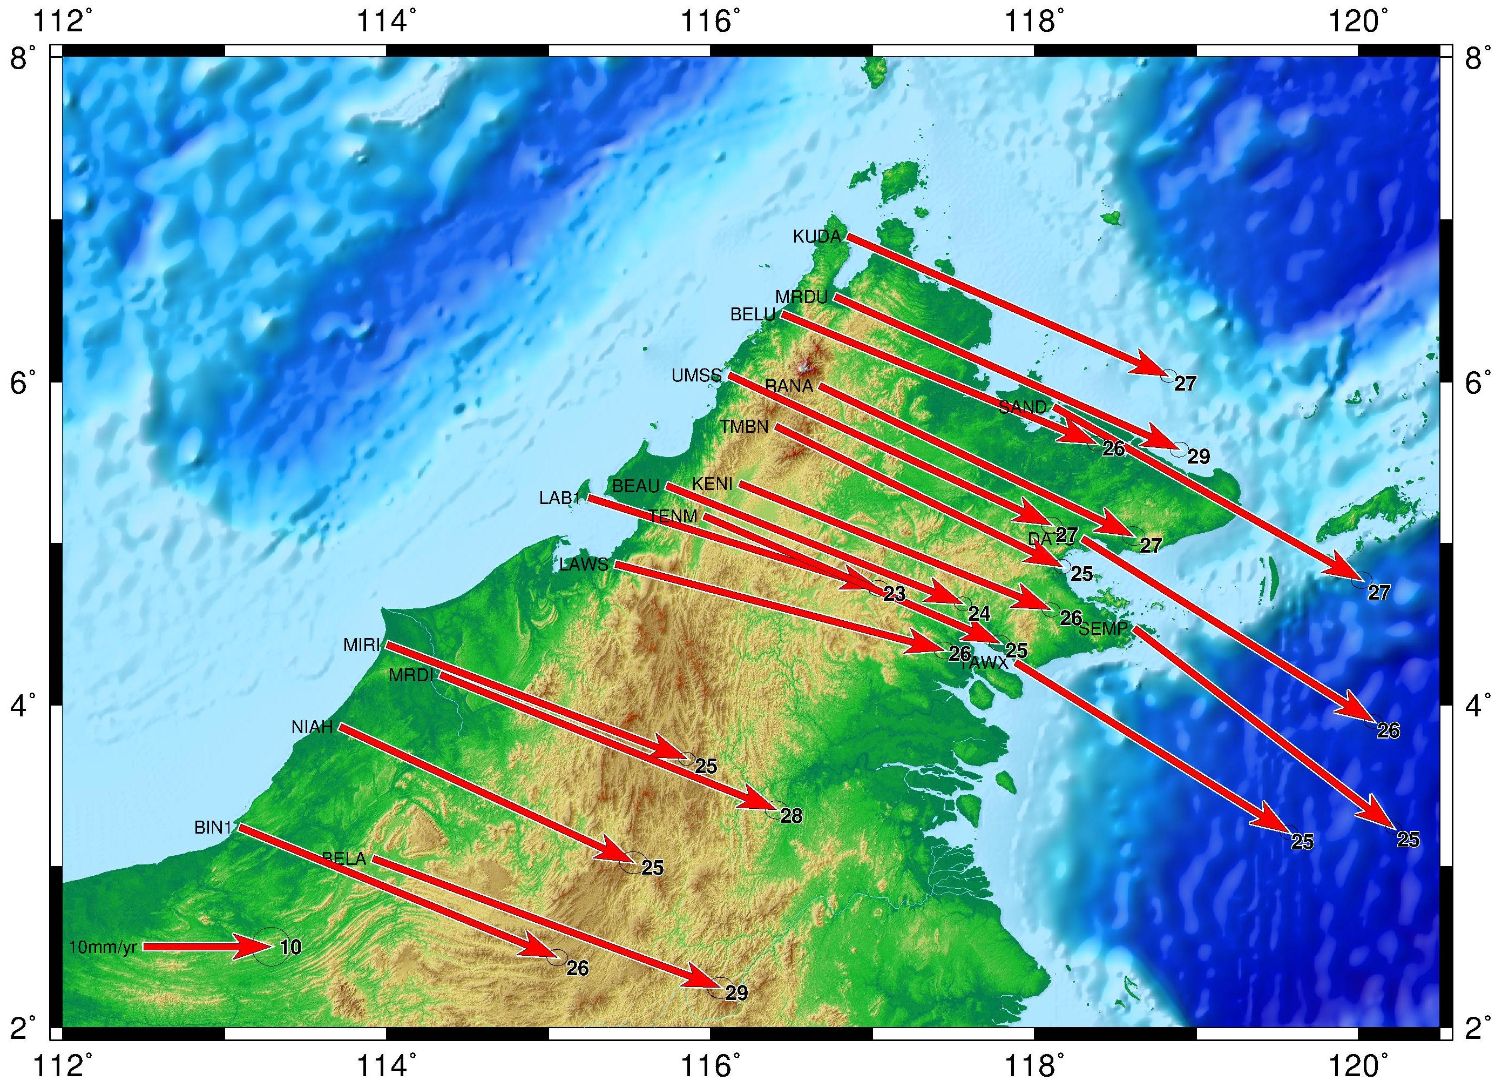
Fig. B: GPS velocities in North Borneo from the 2009-2011 solution. Velocity of each station shows the (absolute) motion in IGS08. Error ellipses represent 99% confidence limits.

Fig. B shows the direction and magnitude of the IGS08 (ITRF2008) velocities of all GPS stations in North Borneo. The range of the velocity magnitudes lies between 23 and 29 mm/yr. All stations on the western side are pointing ~113 degrees ESE except LAWS and LAB1. Station LAWS might be suffering from monument instability. The time series of LAWS (Fig. D) clearly shows that this station exhibits a vertical motion of -14mm/yr. In horizontal and vertical motions, LAB1 (Fig. C) does not show any obvious or dramatically motion change but the direction of the velocity magnitude is similar to the one of LAWS. Station MRDU also shows subsidence at a rate of almost 10 mm/yr (Fig. E) and a faster (regional) horizontal velocity of 29 mm/yr. Therefore, these three stations were excluded from regional analysis. Directions of four stations (TAWX, KUDA, SEMP and SAND) on the eastern side denote slightly bigger SE orientation compared to the stations at the western side. This refers to a different motional behavior between the east and west sides of North Borneo. The velocity magnitudes of BELA and MRDI clearly illustrate that these stations are spreading away from BIN1, NIAH and MIRI. A similar deformation pattern cannot be so clearly observed in the northern side of Borneo.

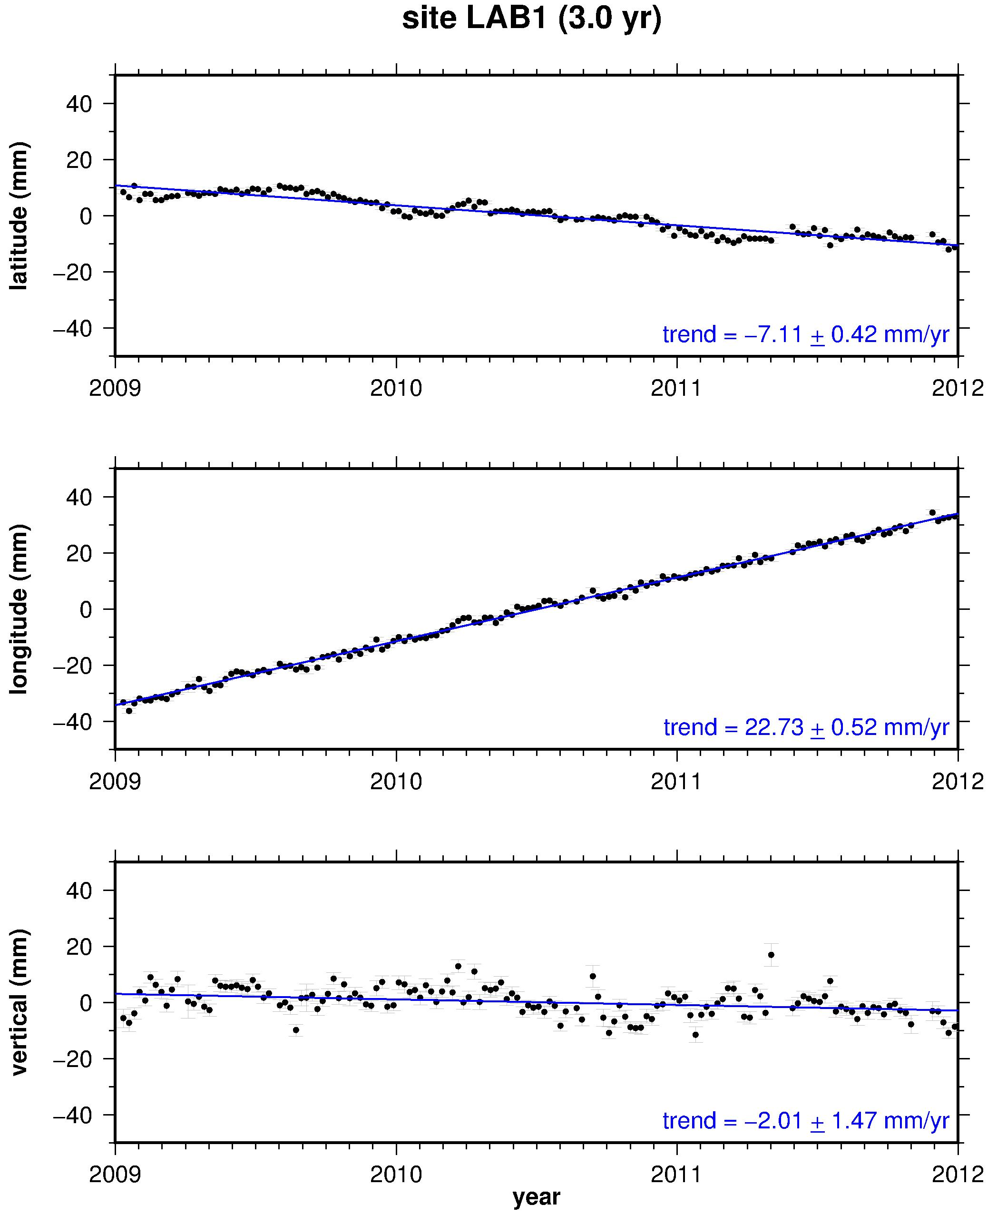
Fig C: Time series of LAB1 in IGS08 (ITRF2008). Errors of the velocity trend estimation are given at 99% confidence level.

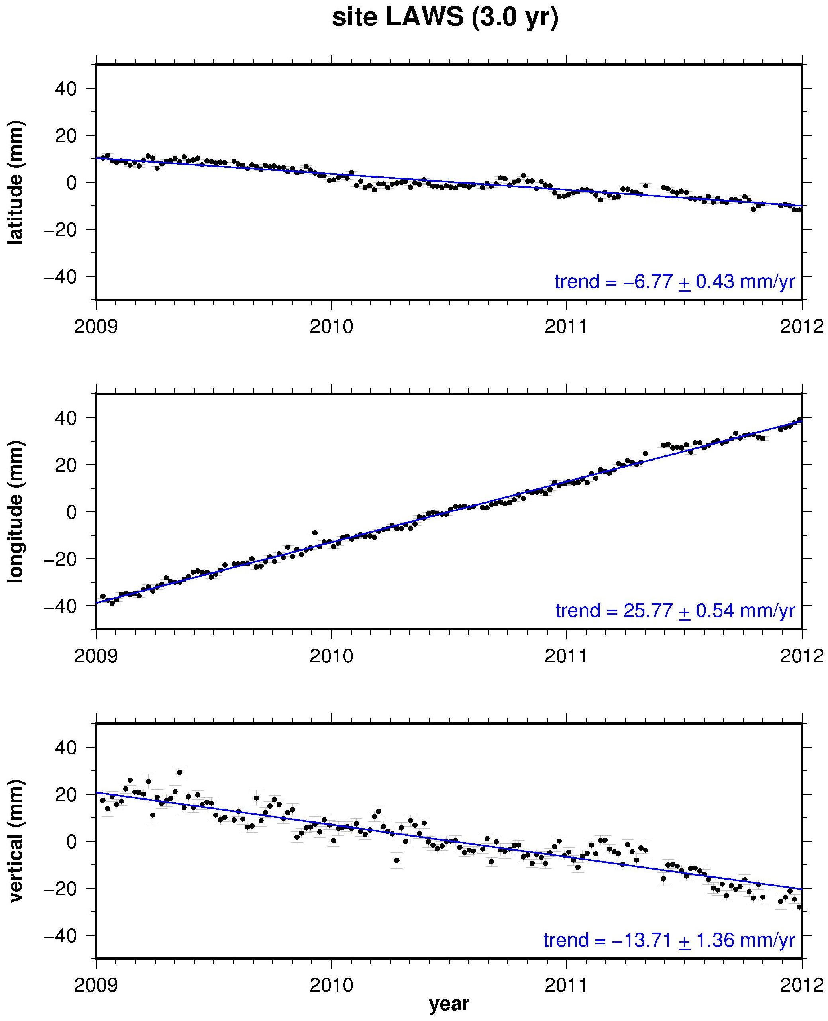
Fig. D : Time series of LAWS in IGS08 (ITRF2008). Errors of the velocity trend estimation are given at 99% confidence level

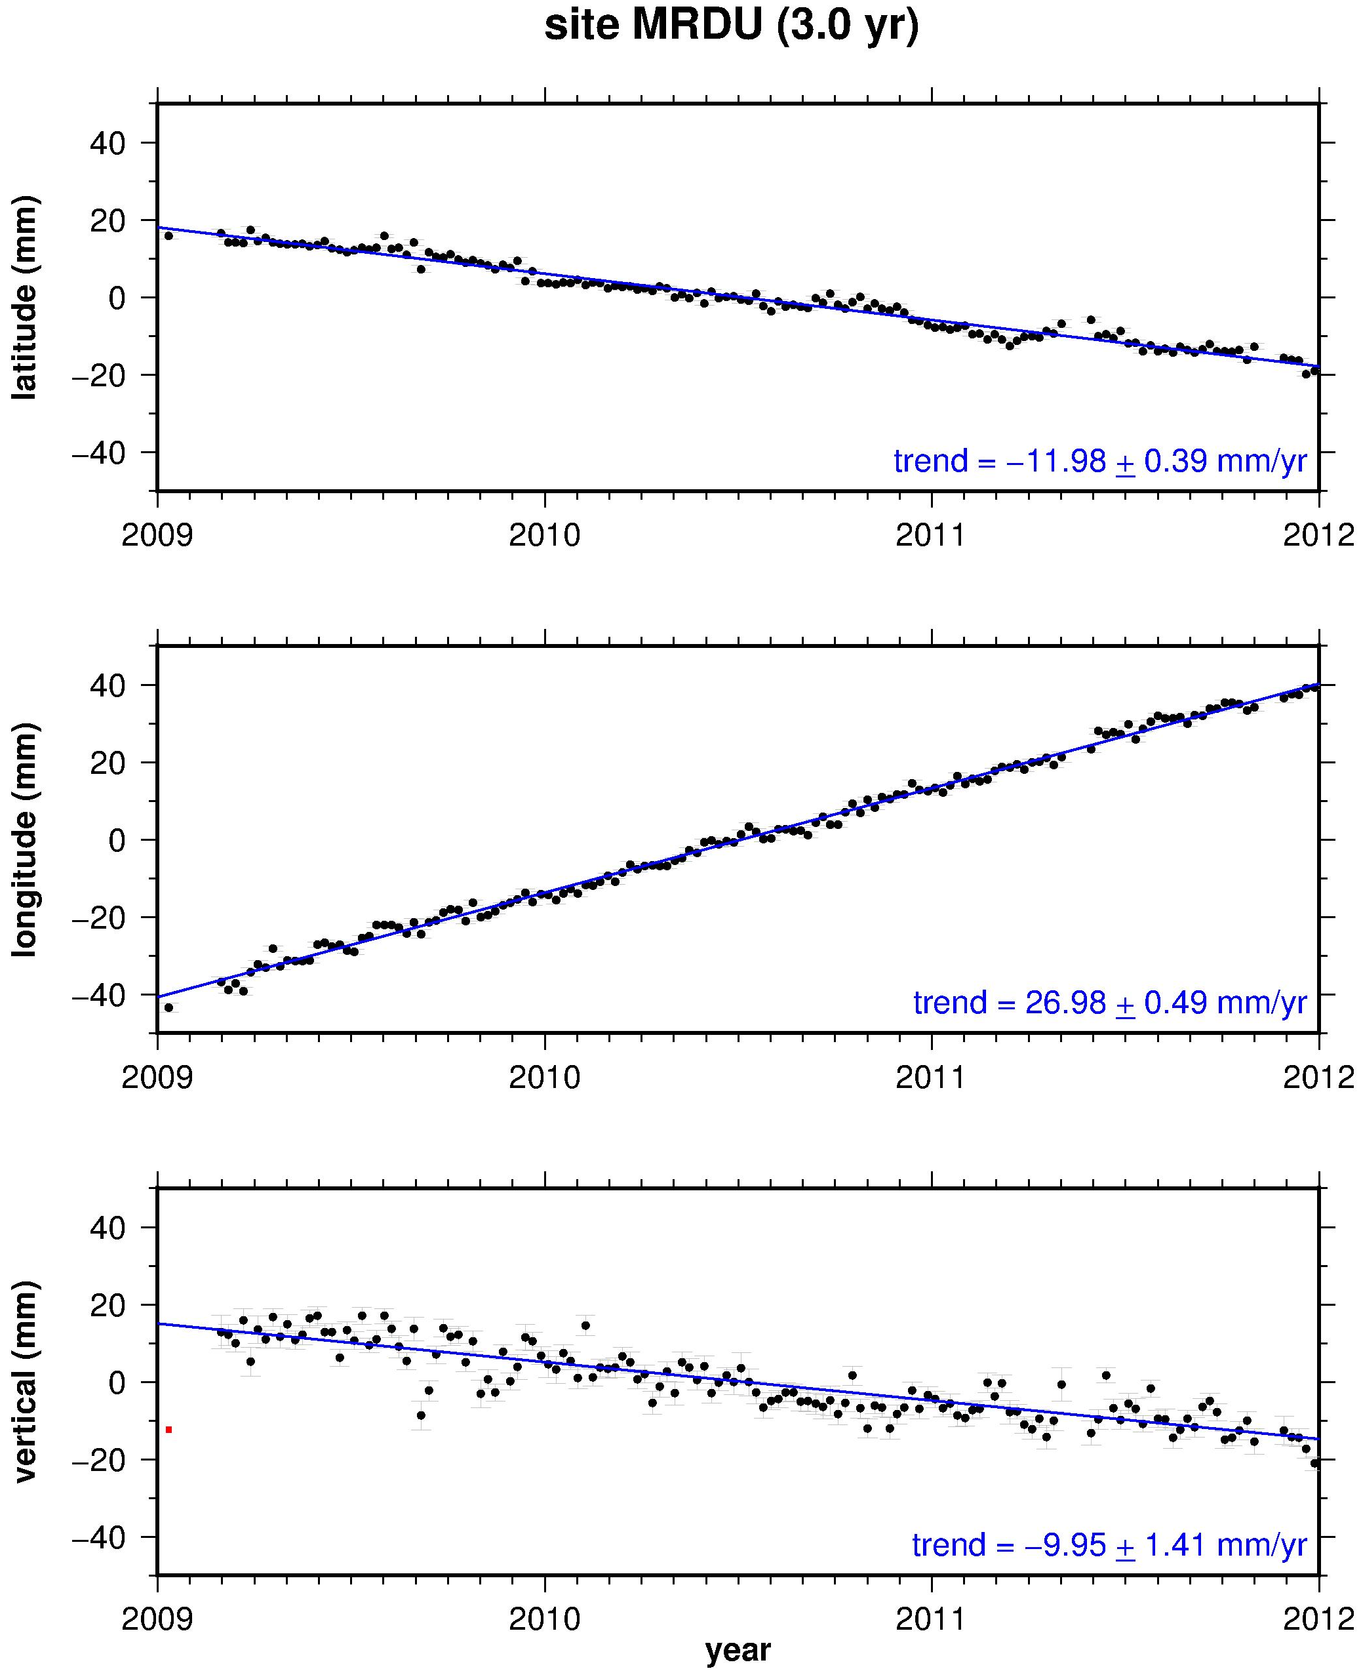
Fig. E : Time Series of MRDU in IGS08 (ITRF2008). Errors of the velocity trend estimation are given at 99% confidence level.

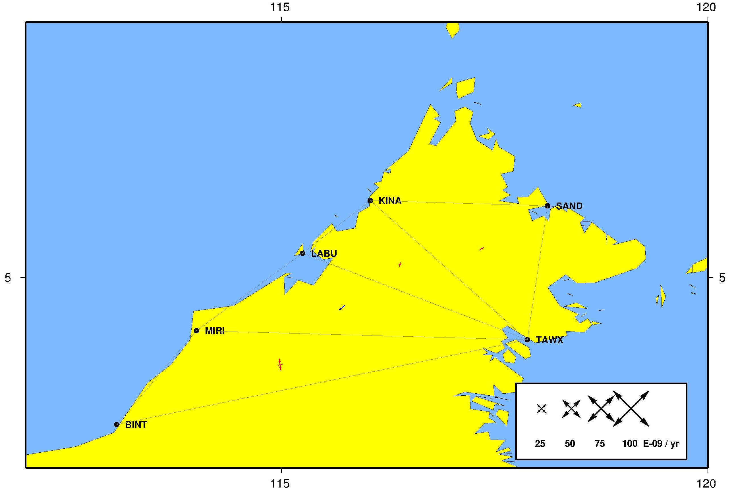
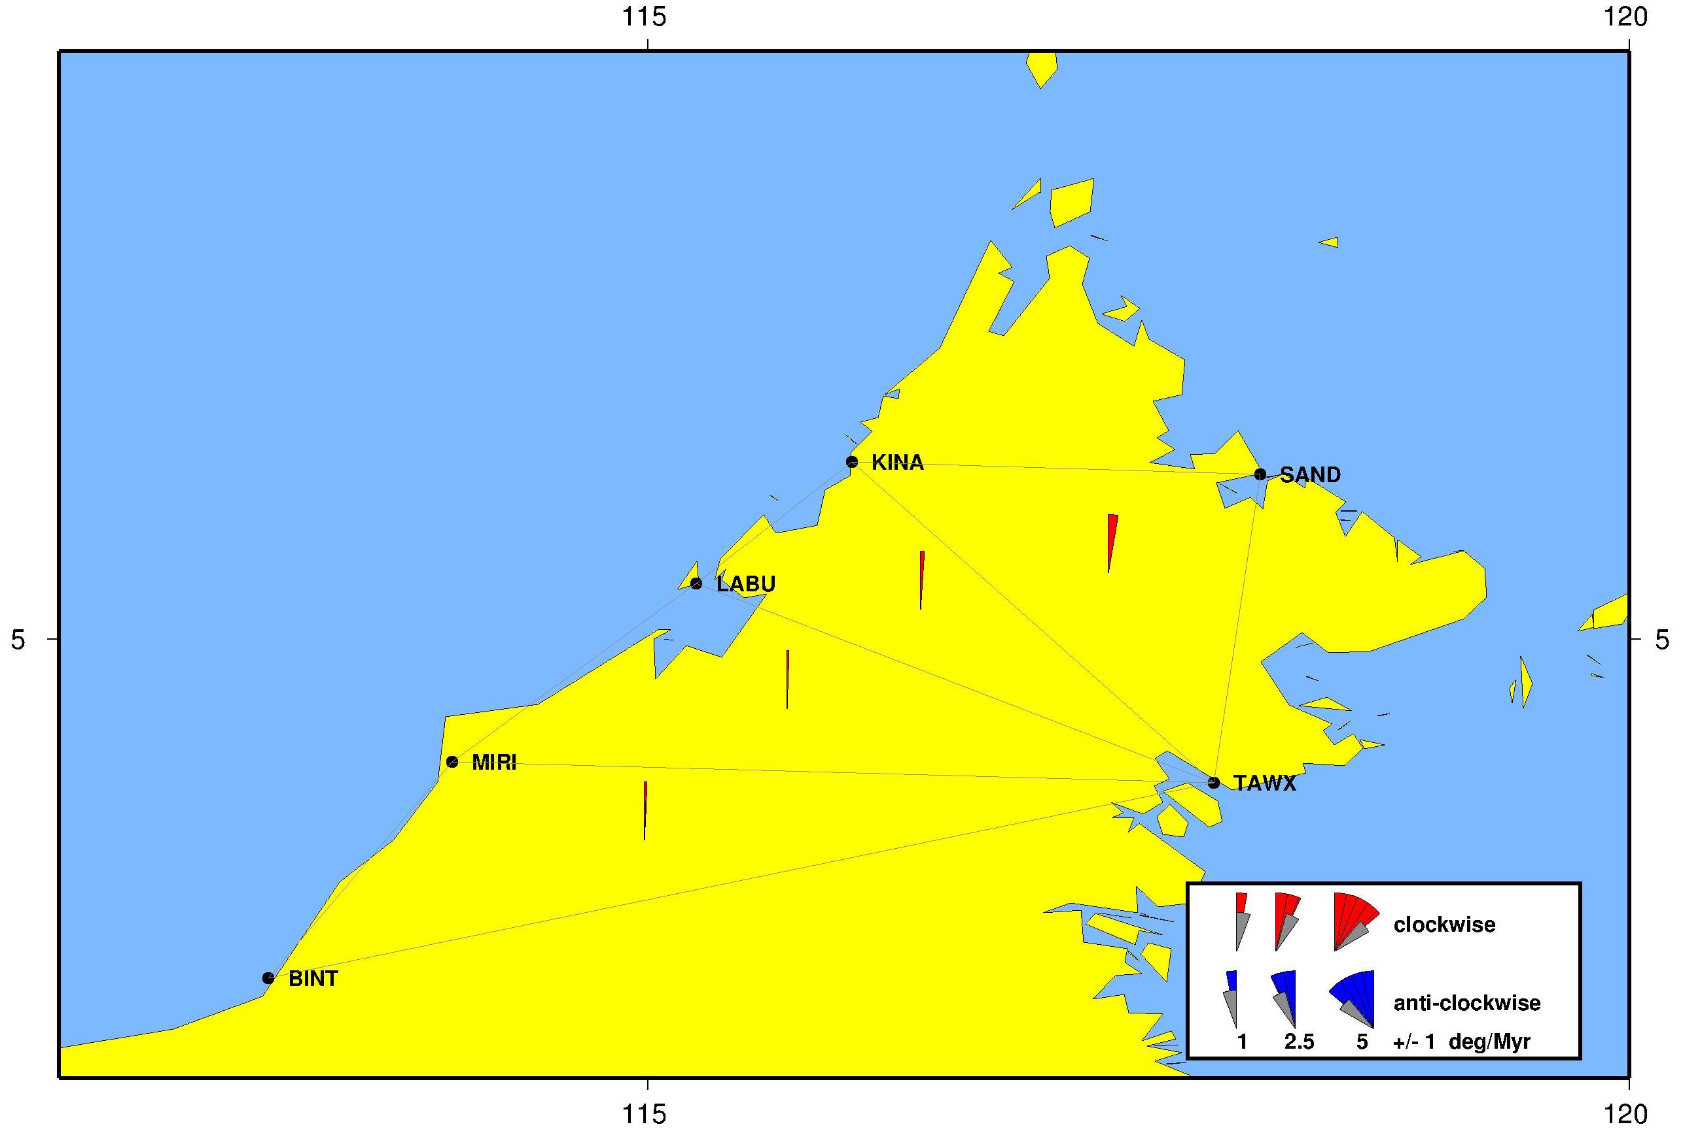
Fig F: Strain and rotation rate tensors from the 1999-2004 solution. Top panel, red arrows show extension deformation, blue arrows indicate shortening deformation and green arrows represent shear deformation. 1 nanostrain/yr represents 1 mm deformation over a 1000 km baseline per year. Bottom panel, red wedges represent clockwise rotation rates and blue wedges indicate anti-clockwise rotation rates.

Fig. F (top panel) shows very small extension rate in the middle of North Borneo and small compression rate in between northern and western Borneo. Meanwhile, bottom panel of Fig F, illustrates less than 1 degree of clockwise rotation rate of North Borneo. This rotation rates are strongly correlated to the TAWX velocity as all delauney triangles are connected to it.

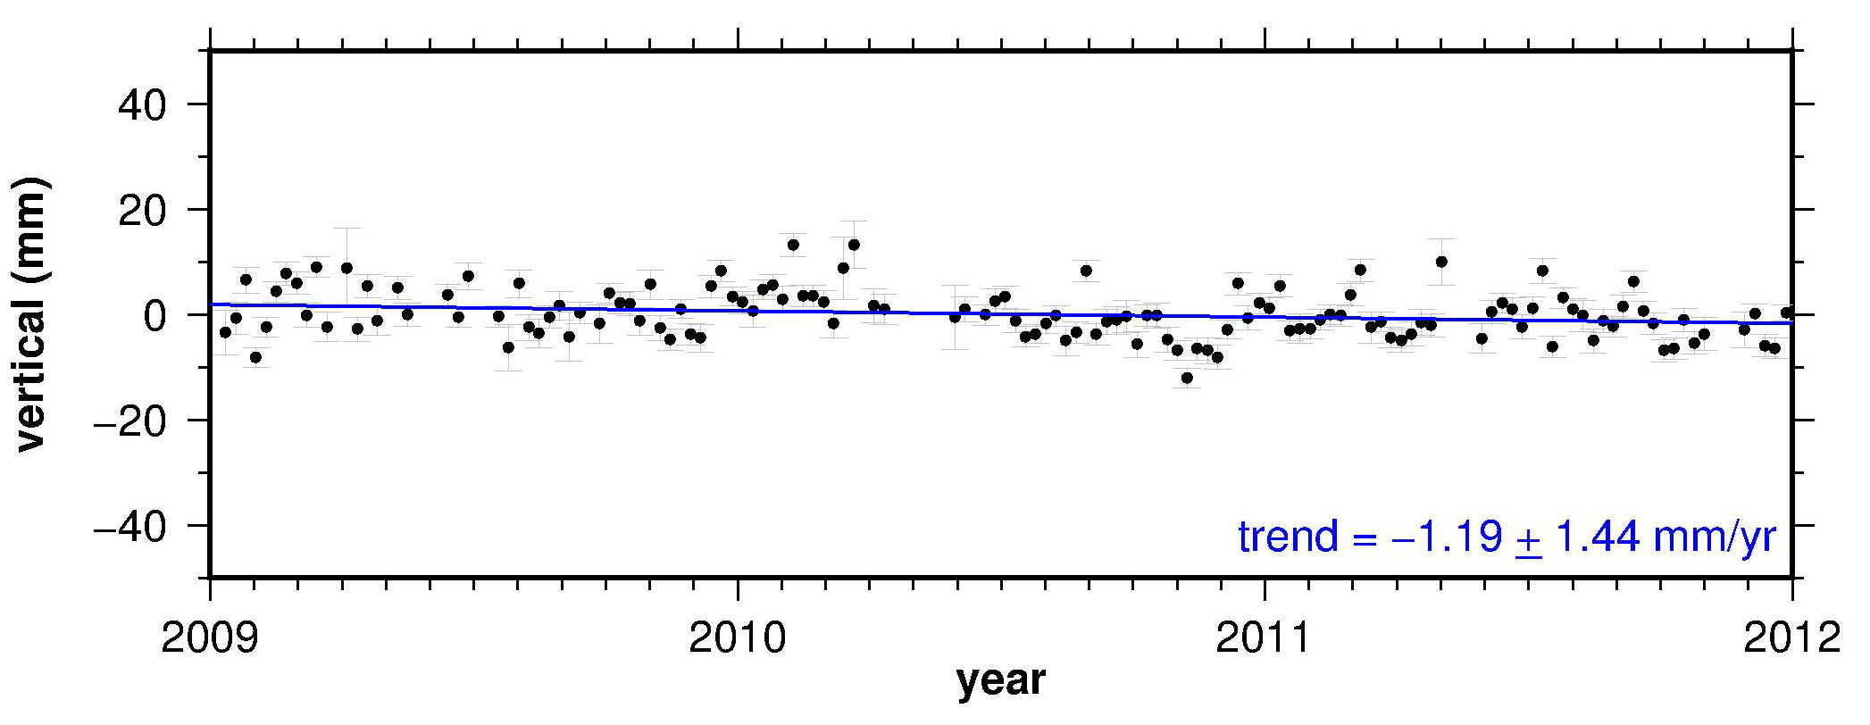
BELU
DATU
KUDA
KENI

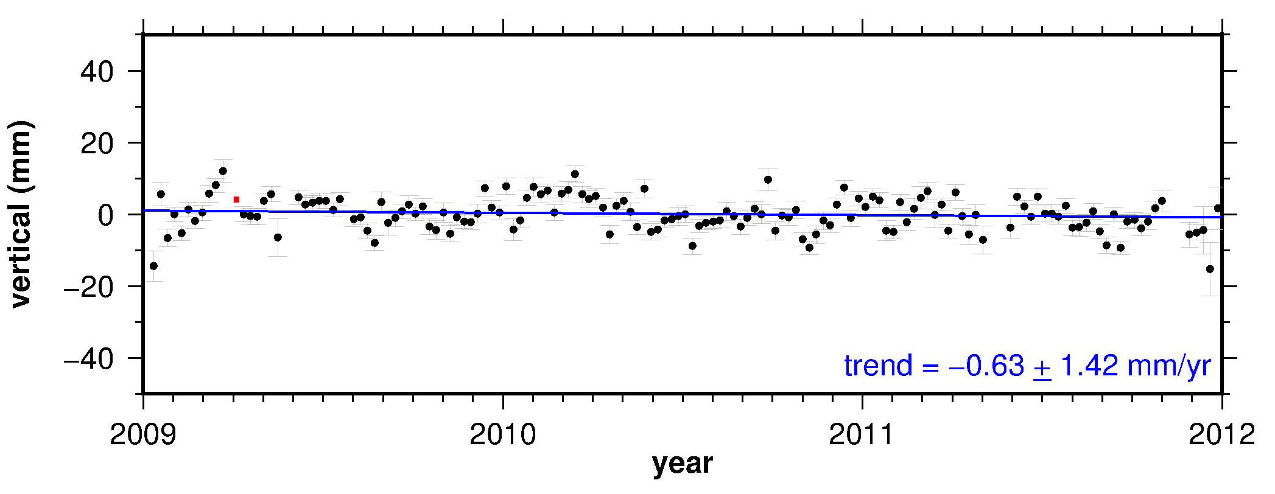

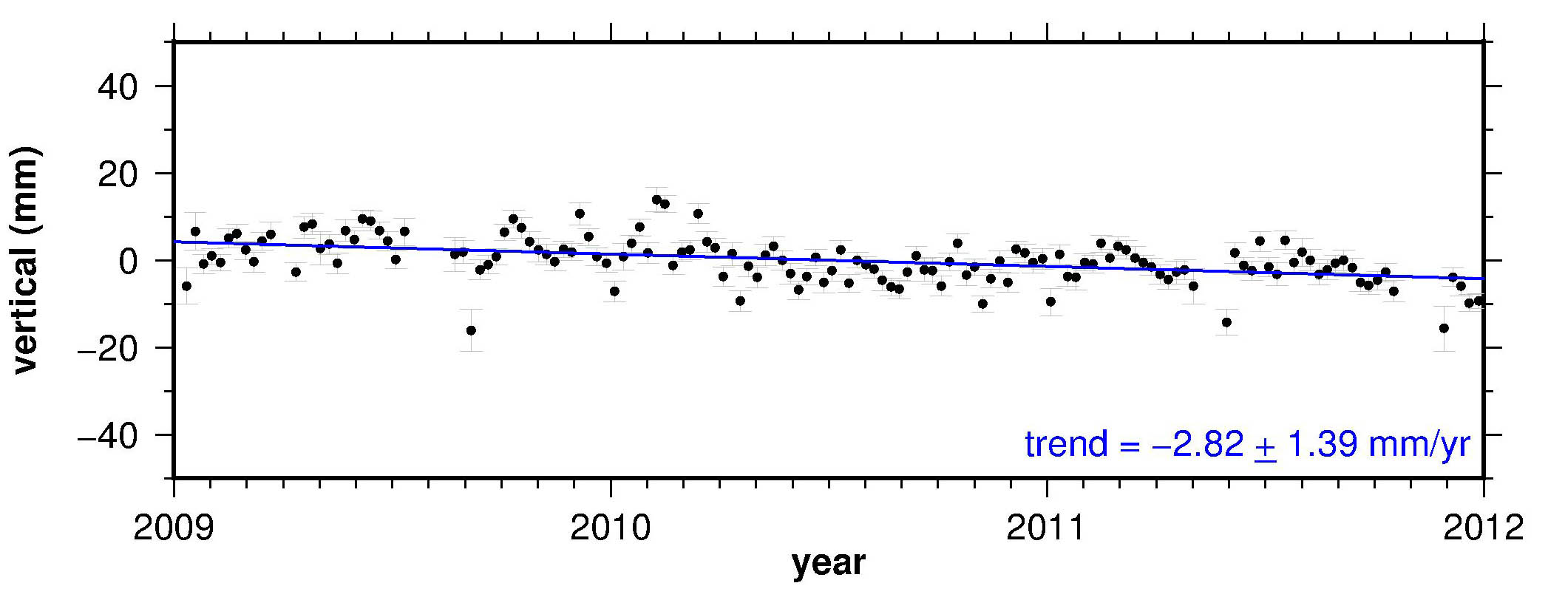

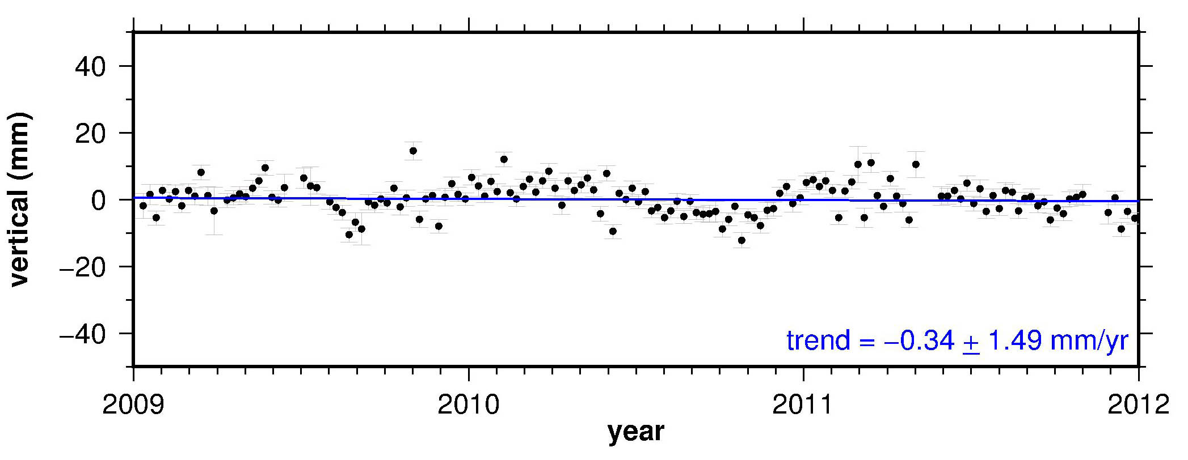

Fig G : Vertical motions of BELU, DATU, KENI and KUDA. Errors of the velocity trend estimation are given at 99% confidence level.

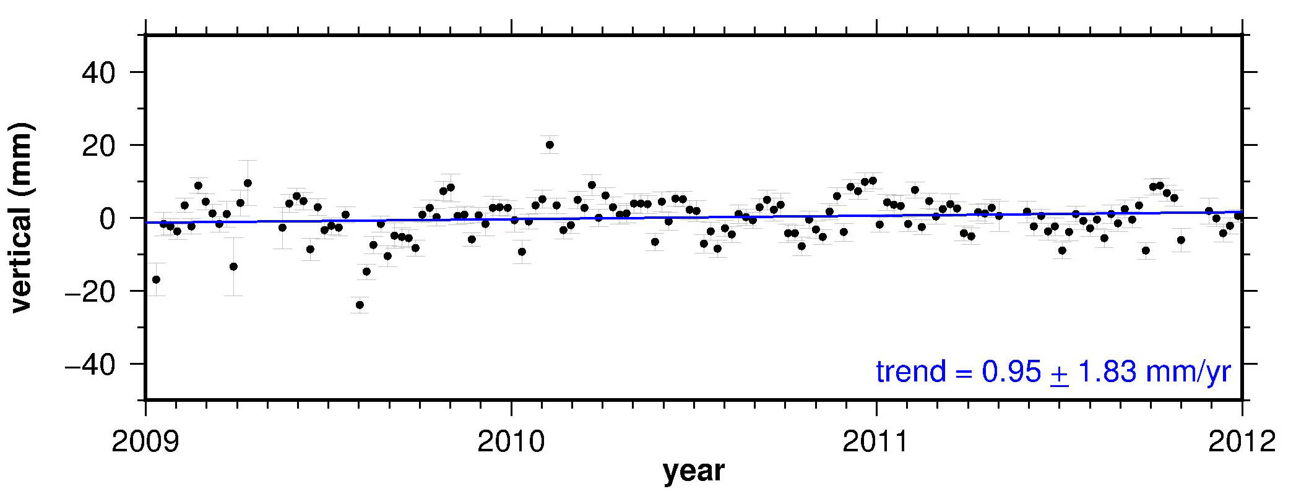
SEMP
RANA
SAND
TAWX

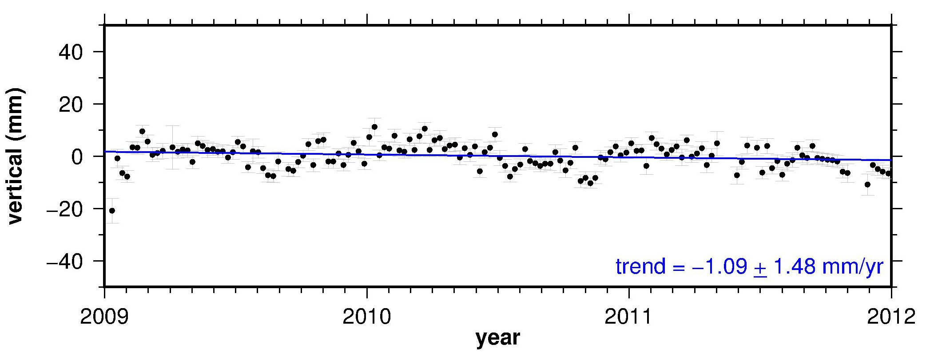
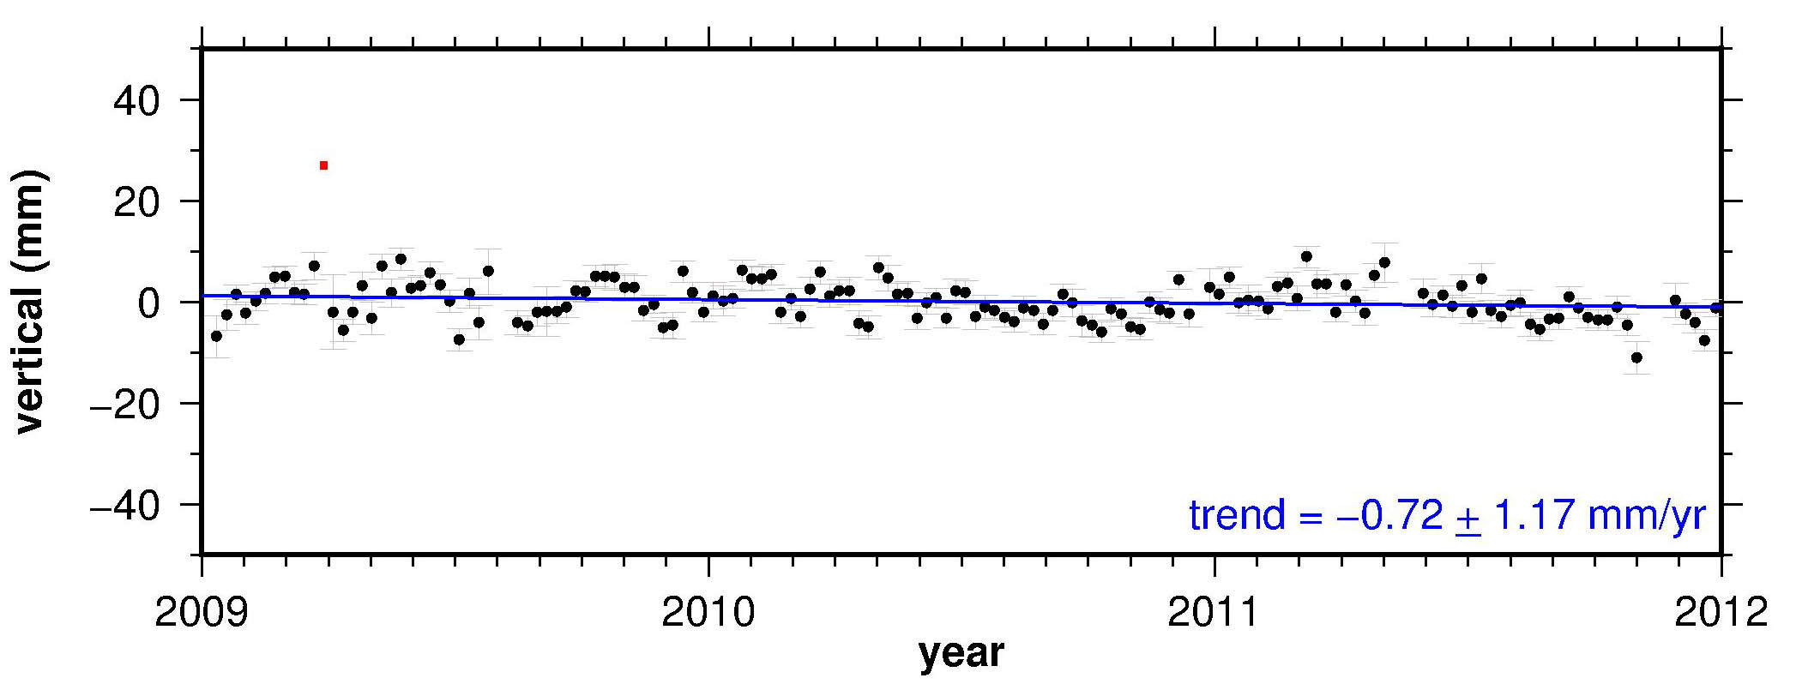

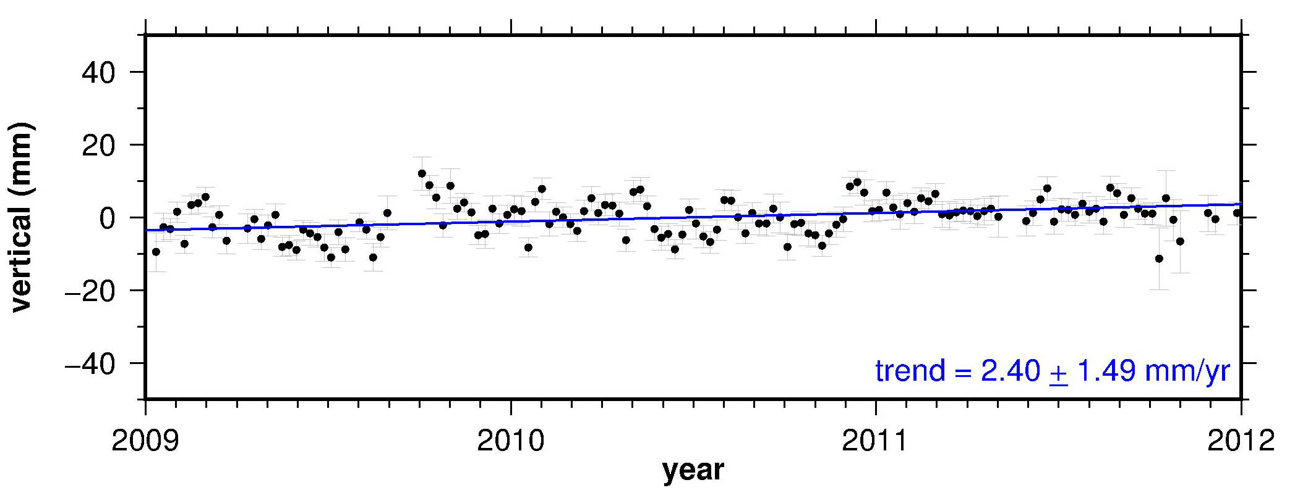

Fig H : Vertical motions of RANA, SEMP, SAND and TAWX. Errors of the velocity trend estimation are given at 99% confidence level.

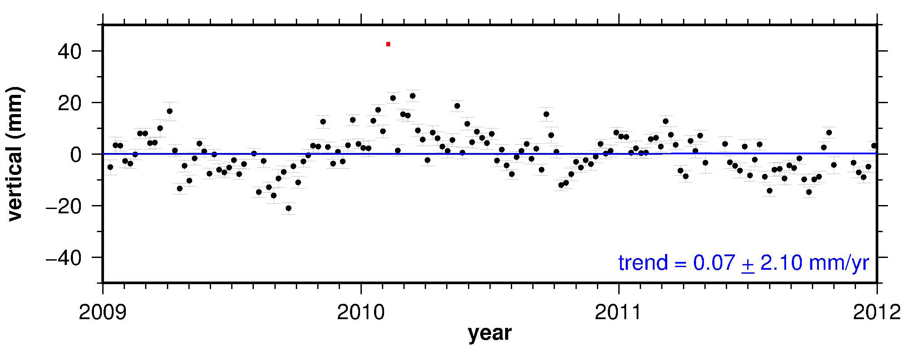
TENM
UMSS
TMBN

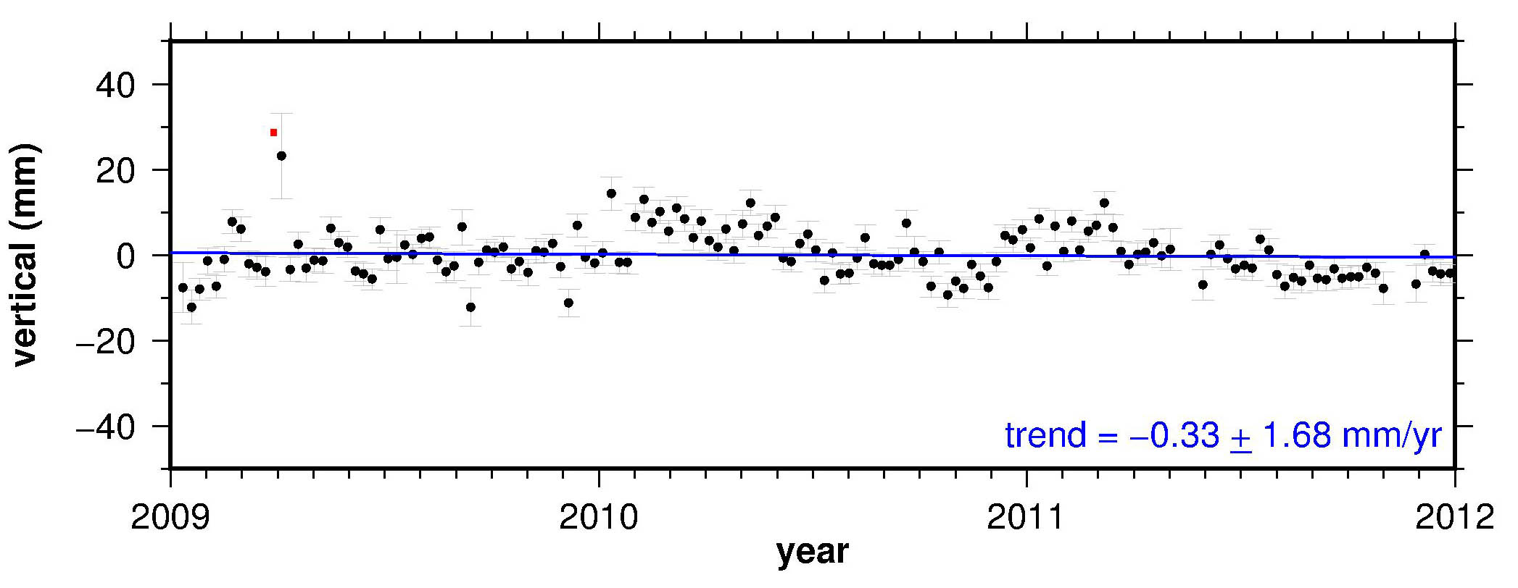

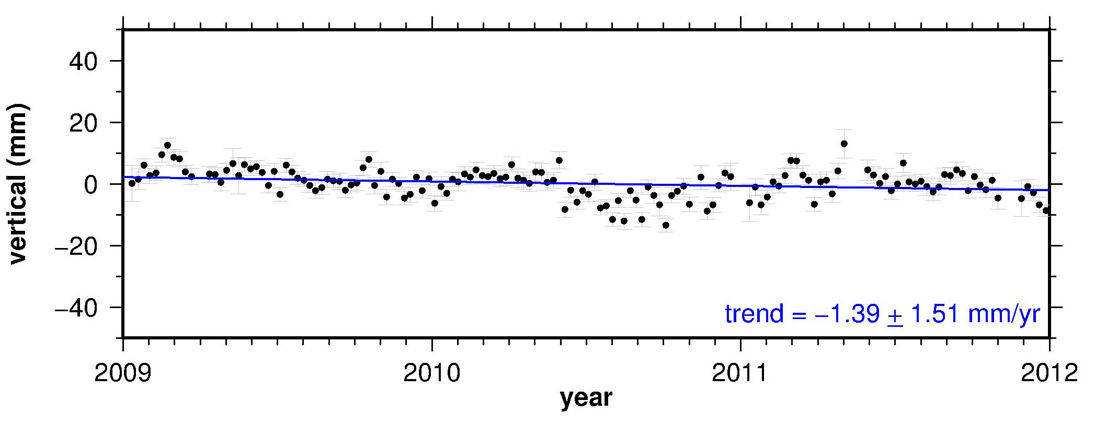

Fig I : Vertical motions of TENM, TMBN and UMSS. Errors of the velocity trend estimation are given at 99% confidence level.

Fig. G - I give the vertical position time series for all stations in North Borneo for the 2009-2011 solution. The vertical position time series for (excluded) stations LAB1, LAWS and MRDI can be observed in Figures C, D and E. The velocity trend estimations account for annual seasonal variations (Blewitt and Lavallée 2002) and are given along with their 99% confidence error limits.

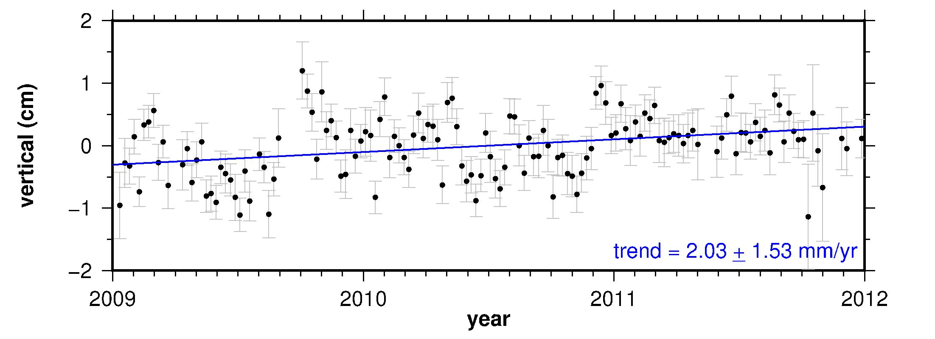

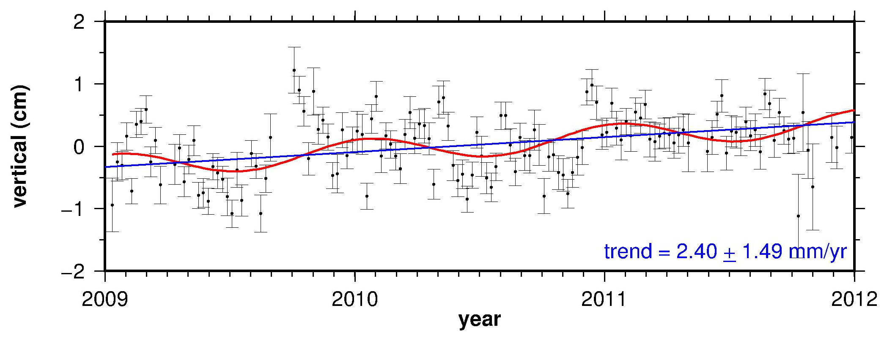

Fig. J : Vertical trend motion estimation for station TAWX. Top panel: Trend estimation without seasonal variations correction. Bottom panel: Trend estimation with seasonal variations correction. Red line is estimated seasonal variation.

By also estimating seasonal variations, the impact of any data gaps on the final vertical estimates will be minimal. This is illustrated above for station TAWX in Fig J. In the 2009 – 2011 data set, there is a data gap of about a month in August 2009. Fig. J shows small differences in the estimated trends before and after seasonal variations were considered. Therefore, this data gap did not affect the vertical trend estimations. Similar results were obtained for all the other vertical motion estimates in North Borneo (Fig. G to I).

(a) site TAWX (x-file)
(b) site TAWX (igs)
Fig K: Trend estimation residuals for station TAWX from 2009-2011 solution. Panel (a): X-file mapping solutions; Panel (b): IGS sub-network mapping solutions

Fig. L: Pillar for KUAL, PDIC, TOKA, UMAS, ARAU and JRNT stations. Most of MyRTKKnet stations have their own dedicated pillar.
ARAU
KUAL
UMAS
JRNT
TOKA
PDIC

