Table S 1. Series one thickness time-pressure data
Test Data of Viscoelastic Materials with Various Thicknesses
Material Characteristics |  |  | Waveform Data
Test No | Material Type | Thickness (mm) | Peak Pressure (kPa) | Duration (ms) | Rise Time (ms) | Decay Time (ms) | Impulse (kPa*ms)
1 | Polyurethane-based Material | 1 | 184.3 | 0.204 | 0.101 | 0.103 | 21.42
2 | Polyurethane-based Material | 1 | 190.9 | 0.199 | 0.109 | 0.090 | 20.99
3 | Polyurethane-based Material | 1 | 197.1 | 0.199 | 0.101 | 0.098 | 21.82
4 | Polyurethane-based Material | 3 | 218.2 | 0.256 | 0.147 | 0.109 | 25.08
5 | Polyurethane-based Material | 3 | 221.9 | 0.253 | 0.148 | 0.105 | 24.99
6 | Polyurethane-based Material | 3 | 214.1 | 0.255 | 0.149 | 0.106 | 24.68
7 | Polyurethane-based Material | 5 | 184.8 | 0.310 | 0.195 | 0.115 | 27.76
8 | Polyurethane-based Material | 5 | 169.8 | 0.310 | 0.185 | 0.125 | 26.53
9 | Polyurethane-based Material | 5 | 169.9 | 0.307 | 0.183 | 0.124 | 26.26
10 | Polyurethane-based Material | 7 | 191.0 | 0.339 | 0.213 | 0.126 | 28.35
11 | Polyurethane-based Material | 7 | 195.7 | 0.333 | 0.203 | 0.130 | 29.03
12 | Polyurethane-based Material | 7 | 202.9 | 0.330 | 0.200 | 0.130 | 29.03
13 | Polyurethane-based Material | 9 | 201.5 | 0.335 | 0.220 | 0.115 | 31.14
14 | Polyurethane-based Material | 9 | 192.5 | 0.358 | 0.218 | 0.140 | 30.61
15 | Polyurethane-based Material | 9 | 197.1 | 0.351 | 0.220 | 0.131 | 31.92
16 | Silicone Rubber-based Material | 1 | 298.2 | 0.358 | 0.078 | 0.279 | 23.28
17 | Silicone Rubber-based Material | 1 | 276.9 | 0.355 | 0.085 | 0.270 | 22.86
18 | Silicone Rubber-based Material | 1 | 279.5 | 0.350 | 0.084 | 0.266 | 22.26
19 | Silicone Rubber-based Material | 3 | 267.2 | 0.326 | 0.128 | 0.197 | 24.20
20 | Silicone Rubber-based Material | 3 | 276.6 | 0.322 | 0.128 | 0.193 | 24.28
21 | Silicone Rubber-based Material | 3 |  | 0.339 | 0.124 | 0.215 | 23.60
22 | Silicone Rubber-based Material | 5 | 226.9 | 0.343 | 0.162 | 0.181 | 27.72
23 | Silicone Rubber-based Material | 5 | 218.1 | 0.348 | 0.165 | 0.183 | 26.48
24 | Silicone Rubber-based Material | 5 | 213.0 | 0.348 | 0.163 | 0.185 | 26.21
25 | Silicone Rubber-based Material | 7 | 180.0 | 0.370 |  | 0.166 | 31.43
26 | Silicone Rubber-based Material | 7 | 187.3 | 0.365 | 0.193 | 0.172 | 29.03
27 | Silicone Rubber-based Material | 7 | 202.4 | 0.359 |  | 0.178 | 28.55
28 | Silicone Rubber-based Material | 9 | 196.2 | 0.380 | 0.207 | 0.173 | 29.40
29 | Silicone Rubber-based Material | 9 | 201.1 | 0.379 | 0.199 | 0.180 | 27.59
30 | Silicone Rubber-based Material | 9 | 204.3 |  | 0.193 |  | 26.95

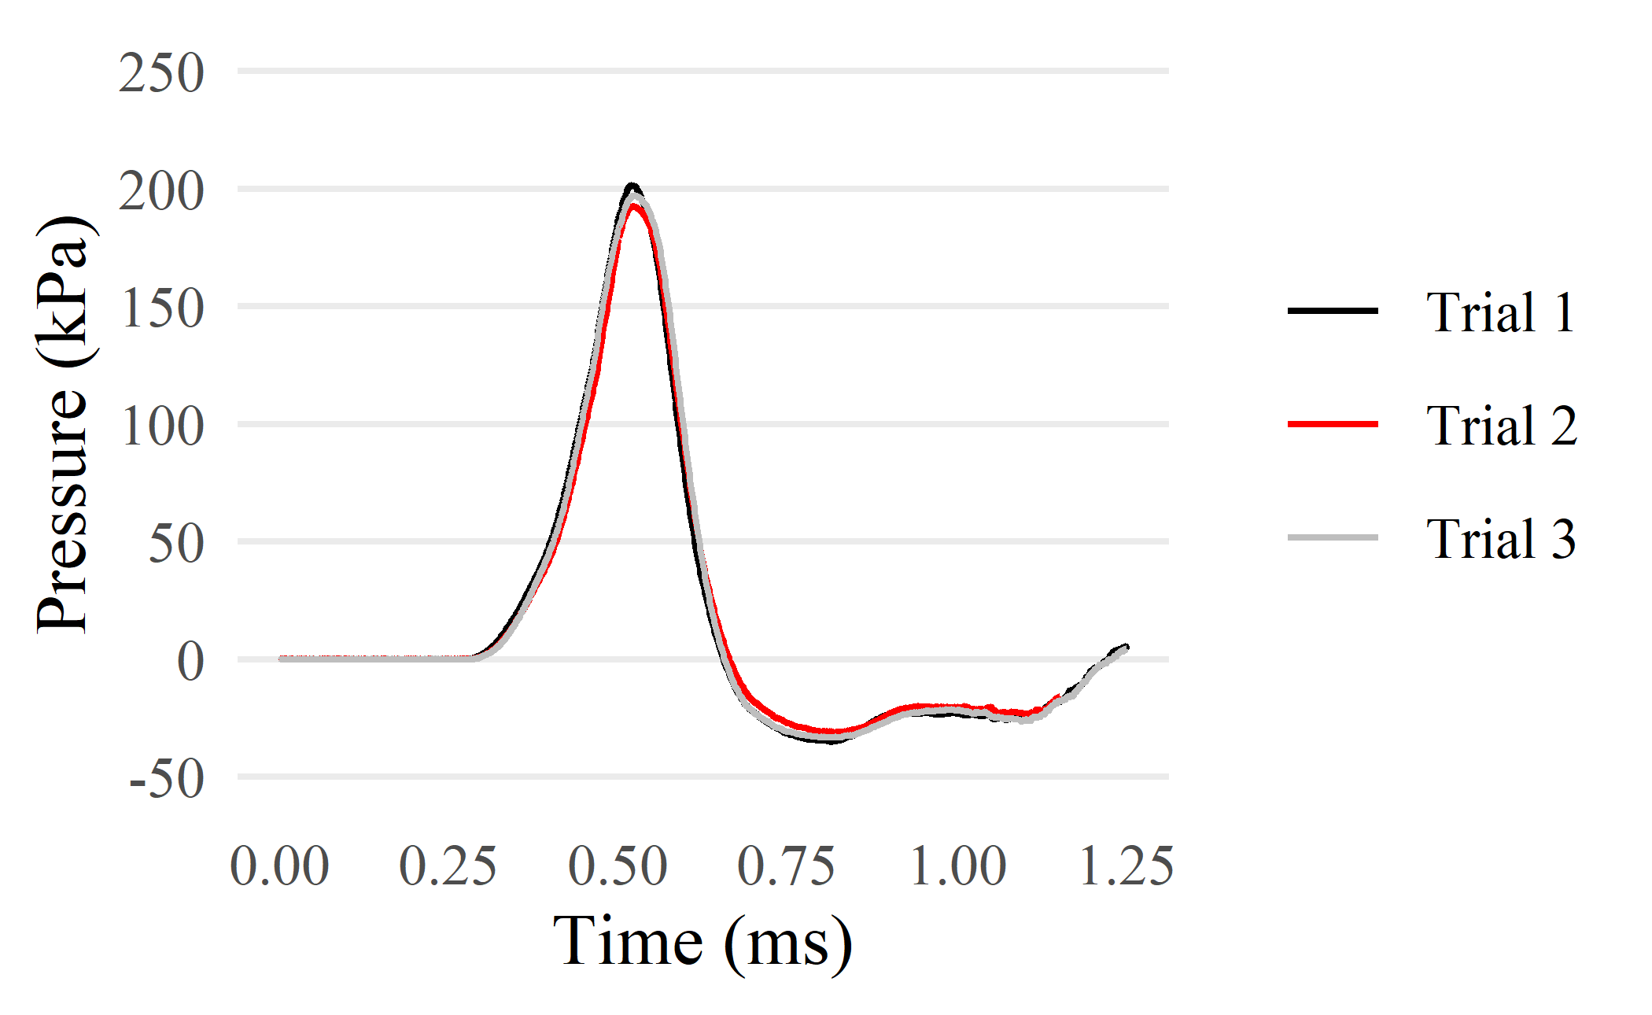
Figure S 1. Three trial comparison of 9 mm polyurethane-based material

Table S 2. Significance coefficients for thickness-based regression
Material | Test Variable | R² | ρ
Polyurethane | Peak Pressure (kPa) | 0.016 | 0.909
Polyurethane | Duration (ms) | 0.989 | < 0.001
Polyurethane | Rise Time (ms) | 0.990 | < 0.001
Polyurethane | Decay Time (ms) | 0.813 | < 0.001
Polyurethane | Impulse (kPa*ms) | 0.975 | < 0.001
Silicone Rubber | Peak Pressure (kPa) | 0.913 | < 0.001
Silicone Rubber | Duration (ms) | 0.720 | 0.001
Silicone Rubber | Rise Time (ms) | 0.983 | < 0.001
Silicone Rubber | Decay Time (ms) | 0.942 | < 0.001
Silicone Rubber | Impulse (kPa*ms) | 0.790 | < 0.001

Table S 3. Series two GNP time-pressure data
Test Data of Viscoelastic Materials Impregnated with GNPs by wt.%
Material Characteristics |  |  | Waveform Data
Test No | Material Type | GNP (wt.%) | Peak Pressure (kPa) | Duration (ms) | Rise Time (ms) | Decay Time (ms) | Impulse (kPa*ms)
1 | Polyurethane-based Material | 0.00% | 178.6 | 0.307 | 0.183 | 0.123 | 26.55
2 | Polyurethane-based Material | 0.00% | 175.7 | 0.304 |  |  | 25.85
3 | Polyurethane-based Material | 0.00% | 170.3 | 0.302 |  |  | 25.50
4 | Polyurethane-based Material | 0.50% | 196.8 | 0.304 | 0.193 | 0.111 | 28.36
5 | Polyurethane-based Material | 0.50% | 208.2 | 0.298 | 0.190 | 0.107 | 28.55
6 | Polyurethane-based Material | 0.50% | 204.7 | 0.299 | 0.189 | 0.110 | 28.55
7 | Polyurethane-based Material | 1.00% | 213.0 | 0.299 | 0.190 | 0.109 | 28.60
8 | Polyurethane-based Material | 1.00% | 217.0 | 0.296 | 0.191 | 0.105 | 29.39
9 | Polyurethane-based Material | 1.00% | 211.2 | 0.298 | 0.191 | 0.107 | 28.83
10 | Polyurethane-based Material | 1.50% | 228.2 | 0.304 | 0.192 | 0.112 | 29.81
11 | Polyurethane-based Material | 1.50% | 218.5 | 0.304 | 0.192 | 0.112 | 28.83
12 | Polyurethane-based Material | 1.50% | 226.3 | 0.300 | 0.189 | 0.111 | 29.90
13 | Polyurethane-based Material | 2.00% | 179.1 | 0.312 | 0.196 | 0.116 | 27.41
14 | Polyurethane-based Material | 2.00% | 174.6 | 0.310 | 0.197 | 0.113 | 26.88
15 | Polyurethane-based Material | 2.00% | 178.9 | 0.312 | 0.194 | 0.117 | 27.18
16 | Silicone Rubber-based Material | 0.00% | 218.7 | 0.331 | 0.165 | 0.166 | 25.84
17 | Silicone Rubber-based Material | 0.00% | 213.0 | 0.332 | 0.165 | 0.167 | 26.33
18 | Silicone Rubber-based Material | 0.00% | 215.3 | 0.330 | 0.164 | 0.166 | 24.61
19 | Silicone Rubber-based Material | 0.50% | 208.2 | 0.330 | 0.172 | 0.158 | 25.38
20 | Silicone Rubber-based Material | 0.50% | 204.2 | 0.327 | 0.174 | 0.152 | 26.92
21 | Silicone Rubber-based Material | 0.50% | 197.4 | 0.333 | 0.174 | 0.159 | 27.03
22 | Silicone Rubber-based Material | 1.00% | 193.9 | 0.312 | 0.168 | 0.144 | 28.19
23 | Silicone Rubber-based Material | 1.00% | 186.5 | 0.313 | 0.169 | 0.144 | 27.29
24 | Silicone Rubber-based Material | 1.00% | 187.0 | 0.311 | 0.166 | 0.144 | 27.09
25 | Silicone Rubber-based Material | 1.50% | 179.8 | 0.316 | 0.176 | 0.139 | 27.32
26 | Silicone Rubber-based Material | 1.50% | 186.5 | 0.316 | 0.172 | 0.144 | 27.93
27 | Silicone Rubber-based Material | 1.50% | 173.7 | 0.319 | 0.176 | 0.143 | 25.97
28 | Silicone Rubber-based Material | 2.00%
29 | Silicone Rubber-based Material | 2.00%
30 | Silicone Rubber-based Material | 2.00%

Table S 4. Significance coefficients for GNP-based regression
Material | Test Variable | R² | ρ
Polyurethane | Peak Pressure (kPa) | 0.849 | < 0.001
Polyurethane | Duration (ms) | 0.845 | < 0.001
Polyurethane | Rise Time (ms) | 0.623 | 0.008
Polyurethane | Decay Time (ms) | 0.763 | 0.001
Polyurethane | Impulse (kPa*ms) | 0.882 | < 0.001
Silicone Rubber | Peak Pressure (kPa) | 0.917 | < 0.001
Silicone Rubber | Duration (ms) | 0.679 | 0.006
Silicone Rubber | Rise Time (ms) | 0.415 | 0.089
Silicone Rubber | Decay Time (ms) | 0.944 | < 0.001
Silicone Rubber | Impulse (kPa*ms) | 0.476 | 0.055

Table S 5. Series three multilayered time-pressure data
Test Data of Multilayered Viscoelastic Materials
Material Characteristics |  | Waveform Data
Test No | Sample Layering | Peak Pressure (kPa) | Duration (ms) | Rise Time (ms) | Decay Time (ms) | Impulse (kPa*ms)
1 | 3 mm Poly | 163.1 | 0.281 | 0.143 | 0.138 | 22.68
2 | 3 mm Poly | 163.0 | 0.273 | 0.141 | 0.132 | 22.20
3 | 3 mm Poly |  | 0.286 | 0.143 | 0.143 | 22.55
4 | 3 mm Poly | 163.7 | 0.286 |  | 0.130 | 22.69
5 | 3 mm Silicone | 174.4 | 0.343 | 0.141 | 0.202 | 23.53
6 | 3 mm Silicone | 162.5 | 0.342 | 0.140 | 0.202 | 23.83
7 | 3 mm Silicone
8 | 3 mm Silicone | 174.2 | 0.339 | 0.140 | 0.199 | 23.77
9 | 5 mm Poly | 185.0 | 0.312 | 0.195 | 0.117 | 28.05
10 | 5 mm Poly | 197.9 | 0.304 | 0.186 | 0.118
11 | 5 mm Poly | 186.1 | 0.314 | 0.187 |  | 28.32
12 | 5 mm Poly | 191.2 | 0.306 | 0.193 | 0.113 | 28.28
13 | 5 mm Silicone | 194.0 | 0.349 | 0.165 | 0.184 | 26.23
14 | 5 mm Silicone | 187.2 | 0.344 | 0.168 | 0.176 | 25.66
15 | 5 mm Silicone | 194.8 | 0.346 | 0.156 | 0.190 | 26.58
16 | 5 mm Silicone |  | 0.337 | 0.156 | 0.181 | 25.73
17 | PSP |  | 0.293 | 0.152 | 0.141 | 24.59
18 | PSP | 157.7 | 0.299 | 0.151 | 0.148 | 24.10
19 | PSP | 154.5 | 0.297 | 0.151 | 0.146 | 22.37
20 | PSP | 158.8 | 0.299 | 0.155 | 0.144 | 23.28
21 | SPS | 158.0 | 0.354 | 0.155 | 0.199 | 24.80
22 | SPS | 165.3 | 0.330 | 0.143 | 0.187
23 | SPS | 172.9 | 0.307 | 0.145 | 0.162 | 24.67
24 | SPS | 157.0 | 0.366 | 0.151 | 0.215 | 24.71
25 | P3SP | 184.2 | 0.309 | 0.179 | 0.130 | 27.80
26 | P3SP | 172.4 | 0.315 | 0.182 | 0.133 | 26.52
27 | P3SP | 187.0 | 0.131 | 0.186 | 0.127 | 28.33
28 | P3SP | 182.0 | 0.315 | 0.194 | 0.121 | 27.52
29 | S3PS | 163.1 | 0.373 | 0.171 | 0.202 | 25.73
30 | S3PS | 159.8 | 0.351 | 0.164 | 0.187 | 26.35
31 | S3PS | 162.4 | 0.353 | 0.162 | 0.191 | 255.98
32 | S3PS | 153.4 | 0.367 | 0.157 | 0.210 | 26.06
33 | PSPSP | 153.4 | 0.329 | 0.179 | 0.150 | 25.98
34 | PSPSP | 168.3 | 0.321 | 0.180 | 0.141 | 27.32
35 | PSPSP | 166.5 | 0.319 |  | 0.142 | 26.09
36 | PSPSP | 157.0 | 0.328 | 0.179 | 0.149 | 26.51
37 | SPSPS | 168.1 | 0.373 | 0.165 | 0.208 | 25.61
38 | SPSPS | 172.8 | 0.373 | 0.163 | 0.210 | 25.58
39 | SPSPS | 174.3 | 0.376 | 0.167 | 0.209 | 26.33
40 | SPSPS |  | 0.379 | 0.157 |  | 25.96

Table S 6. Multilayered bartlett tests of variance results
Bartlett Tests Assessing Multilayered Viscoelastic Materials
Waveform Characteristic | Combined Samples | External Layer Grouping
Waveform Characteristic | Combined Samples | Polyurethane | Silicone Rubber
Peak Pressure (kPa) | 0.053 | 0.044 | 0.153
Duration (ms) | < 0.001 | 0.658 | 0.002
Rise Time (ms) | 0.027 | 0.023 | 0.174
Decay Time (ms) | < 0.001 | 0.743 | < 0.001
Impulse (kPa*ms) | 0.018 | 0.094 | 0.223

Table S 7. Generalized linear regression p-values for multilayered samples
Sample Thickness | Samples Characteristic | Waveform Characteristic
Sample Thickness | Samples Characteristic | Peak Pressure (kPa) | Duration (ms) | Rise Time (ms) | Decay Time (ms) | Impulse (kPa*ms)
3 mm | Number of Layers | 0.115 | 0.427 | 0.273 | 0.216 | 0.345
3 mm | Layering Pattern | 0.034 | < 0.001 | 0.492 | < 0.001 | 0.022
3 mm | Material Ratio | 0.414 | 0.258 | 0.628 | 0.186 | 0.946
3 mm | Number of Layers & Layering Pattern | NA | NA | NA | NA | NA
3 mm | Number of Layers & Material Ratio | NA | NA | NA | NA | NA
3 mm | Layering Pattern & Material Ratio | NA | NA | NA | NA | NA
5 mm | Number of Layers | < 0.001 | 0.002 | 0.048 | < 0.001 | < 0.001
5 mm | Layering Pattern | 0.0417 | < 0.001 | 0.002 | < 0.001 | 0.002
5 mm | Material Ratio | 0.112 | 0.324 | 0.890 | 0.444 | 0.529
5 mm | Number of Layers & Layering Pattern | < 0.001 | 0.171 | 0.122 | 0.368 | 0.018
5 mm | Number of Layers & Material Ratio | NA | NA | NA | NA | NA
5 mm | Layering Pattern & Material Ratio | 0.004 | 0.662 | 0.692 | 0.803 | 0.542

