APPENDIX
(Available as supplementary material online)

LIST OF TABLES AND FIGURES

TABLE S1. Characteristics of the databases participating in the study
TABLE S2. Diagnostic codes used to identify cases of cardiac valvulopathy from the databases
SUMMARY: Risk of valvulopathy among users of drugs for osteoporosis
TABLE S3. Risk of cardiac valvulopathy among users of anti-osteoporosis, results of pooled analyses (extended cohort)
Figure S1. Risk of cardiac valvulopathy overall among users of all anti-osteoporosis drugs, results of meta-analyses (all ORs are adjusted for relevant confounders)
Figure S2. Risk of cardiac valve regurgitation among users of all anti-osteoporosis drugs, results of meta-analyses (all ORs are adjusted for relevant confounders)
TABLE S4. Risk of cardiac valvulopathy, stratified by age and sex, results of pooled analyses
Figure S3. Risk of cardiac valvulopathy overall among users of all anti-osteoporosis drugs, results of meta-analyses (all ORs are adjusted for relevant confounders)
Figure S4. Risk of cardiac valve regurgitation among users of all anti-osteoporosis drugs, results of meta-analyses (all ORs are adjusted for relevant confounders)

Table S1. Characteristics of the databases participating in the study
CHARACTERISTICS | HSD (IT) | LOMBARDY (IT) | TUSCANY (IT) | IPCI (NL) | PHARMO (NL) | THIN (UK)
Current source population | 1,230,000 | 11,270,000 | 4,450,000 | 1,100,000 | 4,380,000 | 9,000,000
Type of database | Medical records | Administrative | Administrative | Medical records | Administrative claims and medical records | Medical records
Age range | From 16 onwards | All ages | All ages | All ages | All ages | All ages
% Males | 47.2 | 48.8 | 48.1 | 49.6 | 45.8 | 47.8
Years covered in this study | 2000-2012 | 2004-2011 | 2003-2012 | 1996-2012 | 1998-2010 | 1996-2012
DEMOGRAPHIC INFORMATION
Date of registration | Yes | Yes | Yes | Yes | Yes | Yes
Date of transferring out | Yes | Yes | Yes | Yes | Yes | Yes
Date of birth | MM-YY | DD-MM-YY | DD-MM-YY | MM-YY | DD-MM-YY | YYYY
Sex | Yes | Yes | Yes | Yes | Yes | Yes
DRUG EXPOSURE INFORMATION
Date of prescription/dispensing | Yes | Yes | Yes | Yes | Yes | Yes
Dosing regimen and quantity | Yes | No | No | Yes | Yes | Yes
Indication of use | Yes | No | No | Yes | No | Yes
OUTCOME INFORMATION
Outpatient primary care diagnoses | Yes, as free text/codes | No | No | Yes, as free text/codes | No | Yes
Outpatient specialist care diagnoses | Yes | No | No | Yes | No | Yes
Hospital discharge diagnoses | Yes, as free text/codes | Yes | Yes | Yes, as free text /codes | Yes | Yes
Diagnosis coding scheme | ICD-9CM | ICD-9CM | ICD-9CM | ICPC | ICD-9CM | Read
Diagnostic or laboratory procedures | Yes, some | Yes, some | Yes, some | Yes, some | Yes, some, mainly surgical and if occurring during hospital admission | Yes, some
Table S2. Diagnostic codes used to identify cases of cardiac valvulopathy from the databases
International Classification of Primary Care (ICPC) | International Classification of Diseases 9th version – Clinical Modification (ICD9-CM) | Read Coding System
K83.. Heart valve disease | 394.2 Mitral stenosis with insufficiency; Mitral stenosis with incompetence or regurgitation  (NOT “rheumatic*”) | G11..00 Mitral valve diseases (NOT “rheumatic*”)
 | 394.9 Other and unspecified mitral valve diseases  (NOT “rheumatic*”) | G110.00 Mitral stenosis (NOT “rheumatic*”)
 | 396.1Mitral valve stenosis and aortic valve insufficiency  (NOT “rheumatic*”) | G112.00 Mitral stenosis with insufficiency (NOT “rheumatic*”)
 | 396.2 Mitral valve insufficiency and aortic valve stenosis  (NOT “rheumatic*”) | G112.12 Mitral stenosis with incompetence (NOT “rheumatic*”)
 | 396.3 Mitral valve insufficiency and aortic valve insufficiency (NOT “rheumatic*”) | G112.13 Mitral stenosis with regurgitation (NOT “rheumatic*”)
 | 396.8 Multiple involvement of mitral and aortic valves; Stenosis and insufficiency of mitral or aortic valve with stenosis or insufficiency, or both, of the other valve  (NOT “rheumatic*”) | G113.00 Nonrheumatic mitral valve stenosis (NOT “rheumatic*”)
 | 396.9 Mitral and aortic valve diseases, unspecified  (NOT “rheumatic*”) | G13..00 Diseases of mitral and aortic valves (NOT “rheumatic*”)
 | 397.0 Diseases of tricuspid valve: insufficiency; obstruction; regurgitation; or stenosis  (NOT “rheumatic*”) | G130.00 Mitral and aortic stenosis (NOT “rheumatic*”)
 | 424.0 Mitral valve disorders: Mitral valve incompetence of specified cause, except rheumatic; insufficiency of specified cause, except rheumatic; regurgitation of specified cause, except rheumatic | G131.00 Mitral stenosis and aortic insufficiency (NOT “rheumatic*”)
 | 424.1 Aortic valve disorders: Aortic valve incompetence of specified cause, except rheumatic; insufficiency of specified cause, except rheumatic; regurgitation of specified cause, except rheumatic; stenosis of specified cause, except rheumatic | G131.13 Mitral stenosis and aortic incompetence (NOT “rheumatic*”)
 | 424.2 Tricuspid valve disorders, specified as nonrheumatic: incompetence; regurgitation; stenosis | G131.14 Mitral stenosis and aortic regurgitation (NOT “rheumatic*”)
 | 424.3 Pulmonary valve disorders: incompetence NOS; insufficiency NOS; regurgitation NOS; stenosis NOS  (NOT “rheumatic*”) | G132.00 Mitral insufficiency and aortic stenosis (NOT “rheumatic*”)
 | 429.81 Other disorders of papillary muscle | G132.12 Mitral incompetence and aortic stenosis (NOT “rheumatic*”)
 |  | G132.13 Mitral regurgitation and aortic stenosis (NOT “rheumatic*”)
 |  | G133.00 Mitral and aortic incompetence (NOT “rheumatic*”)
 |  | G133.11 Mitral and aortic insufficiency (NOT “rheumatic*”)
 |  | G133.12 Mitral and aortic regurgitation (NOT “rheumatic*”)
G13y.00 Multiple mitral and aortic valve involvement
(NOT “rheumatic*”)
 |  | G13z.00 Mitral and aortic valve disease NOS (NOT “rheumatic*”)
 |  | G140300 Tricuspid stenosis, cause unspecified (NOT “rheumatic*”)
 |  | G140500 Tricuspid stenosis and insufficiency, cause unspecified (NOT “rheumatic*”)
 |  | G140511 Tricuspid stenosis and incompetence, cause unspecified (NOT “rheumatic*”)
 |  | G140514 Tricuspid stenosis and regurgitation, cause unspecified (NOT “rheumatic*”)
 |  | G54..11 Heart valve disorders - non rheumatic
 |  | G540.00 Mitral valve incompetence (NOT “rheumatic*”)
 |  | G540.12 Mitral valve insufficiency (NOT “rheumatic*”)
 |  | G540.14 Mitral valve regurgitation (NOT “rheumatic*”)
 |  | G540.15 Mitral valve prolapse (NOT “rheumatic*”)
 |  | G540.16 Mitral regurgitation (NOT “rheumatic*”)
 |  | G540000 Mitral incompetence, non-rheumatic
 |  | G540100 Mitral incompetence, cause unspecified (NOT “rheumatic*”)
 |  | G540200 Mitral valve prolapse (NOT “rheumatic*”)
 |  | G540300 Mitral valve leaf prolapse (NOT “rheumatic*”)
 |  | G541000 Aortic incompetence, non-rheumatic
 |  | G541011 Aortic insufficiency, non-rheumatic
 |  | G541012 Aortic regurgitation, non-rheumatic
 |  | G541100 Aortic stenosis, non-rheumatic
G541200 Aortic incompetence alone, cause unspecified
(NOT “rheumatic*”)
G541211 Aortic insufficiency alone, cause unspecified
(NOT “rheumatic*”)
G541212 Aortic regurgitation alone, cause unspecified
(NOT “rheumatic*”)
G541300 Aortic stenosis alone, cause unspecified
(NOT “rheumatic*”)
G541400 Aortic valve stenosis with insufficiency
(NOT “rheumatic*”)
G541500 Aortic stenosis
(NOT “rheumatic*”)
 |  | G541700 Aortic valve calcification
G541z00 Aortic valve disorders NOS
(NOT “rheumatic*”)
 |  | G542.00 Tricuspid valve disorders, non-rheumatic
 |  | G542000 Tricuspid incompetence, non-rheumatic
 |  | G542011 Tricuspid insufficiency, non-rheumatic
 |  | G542012 Tricuspid regurgitation, non-rheumatic
 |  | G542100 Tricuspid stenosis, non-rheumatic
 |  | G542200 Nonrheumatic tricuspid valve stenosis with insufficiency
 |  | G543000 Pulmonary incompetence, non-rheumatic
 |  | G543011 Pulmonary insufficiency, non-rheumatic
 |  | G543012 Pulmonary regurgitation, non-rheumatic
 |  | G543100 Pulmonary stenosis, non-rheumatic
G543200 Pulmonary incompetence, cause unspecified
(NOT “rheumatic*”)
G543213 Pulmonary insufficiency, cause unspecified
(NOT “rheumatic*”)
G543215 Pulmonary regurgitation, cause unspecified
(NOT “rheumatic*”)
G543300 Pulmonary stenosis, cause unspecified
(NOT “rheumatic*”)
G543311 Pulmonary stenosis, cause unspecified
(NOT “rheumatic*”)
G543400 Pulmonary valve stenosis with insufficiency
(NOT “rheumatic*”)
 |  | G543z00 Pulmonary valve disorders NOS (NOT “rheumatic*”)
 |  | G544.00 Multiple valve diseases (NOT “rheumatic*”)
G544000 Disorders of both aortic and tricuspid valves
(NOT “rheumatic*”)
G544100 Disorders of both mitral and tricuspid valves
(NOT “rheumatic*”)
G544200 Combined disorders of mitral, aortic and tricuspid valves
(NOT “rheumatic*”)
G54z000 Incompetence of unspecified heart valve
(NOT “rheumatic*”)
G54z013 Regurgitation of unspecified heart valve
(NOT “rheumatic*”)
G54z014 Insufficiency of unspecified heart valve
(NOT “rheumatic*”)
 |  | G5yy.11 Papillary muscle disease
 |  | G5yy100 Papillary muscle degeneration
 |  | G5yy300 Papillary muscle scarring
 |  | G5yy400 Papillary muscle disorder NOS
 |  | Gyu1000 [X]Other mitral valve diseases
 |  | Gyu1200 [X]Other tricuspid valve diseases
 |  | Gyu1300 [X]Other multiple valve diseases
 |  | Gyu1500 [X]Multiple valve disease, unspecified
 |  | Gyu5500 [X]Other nonrheumatic mitral valve disorders
 |  | Gyu5600 [X]Other aortic valve disorders
 |  | Gyu5700 [X]Other nonrheumatic tricuspid valve disorders
 |  | Gyu5800 [X]Other pulmonary valve disorders
 |  | Gyu5A00 [X]Aortic valve disorders in diseases classified elsewhere
 |  | Gyu5D00 [X]Multiple valve disorders/diseases CE

SUMMARY: Risk of valvulopathy among users of drugs for osteoporosis
Pooled analyses (see Table S3 below) revealed increased valvulopathy risk with current use of any bisphosphonate and with past use of any anti-osteoporosis drug, when compared with distant past use (of any anti-osteoporosis drug). This increased risk was confirmed by results from meta-analyses (see Figure S1). Similar to findings in the primary cohort, meta-analyses showed increased valvulopathy risk with current use of alendronate, risedronate, and alendronate/colecalciferol (Figure S1). Among non-bisphosphonates, only strontium ranelate had an increased risk: OR 1.17 (95%CI 1.03-1.32), although the risk was not statistically significant in the individual databases.
For valve regurgitation (Table S3), pooled analyses demonstrated increased risk with current use of any bisphosphonate and past use of any drug for osteoporosis as well as with current use of alendronate, risedronate, alendronate/colecalciferol, and strontium ranelate. Meta-analyses (Figure S2) largely reflected the same increased risks.
Pooled analyses of the 144 cases of valve calcification showed current use of alendronate to be associated with increased risk vs. distant past use of any osteoporosis drug (Table S3); this risk persisted on meta-analyses.
Table S3. Risk of cardiac valvulopathy among users of anti-osteoporosis drugs, results from pooled analyses (extended cohort)
Exposure categories | ALL VALVULOPATHY |  |  |  | VALVE REGURGITATION |  |  |  | VALVE CALCIFICATION
 | Cases, n  (%) | Controls, n  (%) | Crude OR  (95% CI) | Adjusted OR  (95% CI) | Cases, n  (%) | Controls, n  (%) | Crude OR  (95% CI) | Adjusted OR  (95% CI) | Cases, n  (%) | Controls, n  (%) | Crude OR  (95% CI) | Adjusted OR  (95% CI)
Distant past use or never use | 9,815  (56.5) | 931,415  (59.0) | reference | reference | 5,279  (55.3) | 499,292  (57.6) | reference | reference | 74  (51.4) | 6,533  (57.4) | reference | reference
Past use of any bisphosphonate/other drug† | 885  (5.1) | 75,845  (4.8) | 1.16  (1.08-1.25) | 1.13  (1.05-1.21) | 533  (5.6) | 41,912  (4.8) | 1.26  (1.15-1.38) | 1.23  (1.12-1.35) | 7  (4.9) | 443  (3.9) | 1.29  (0.58-2.90) | 1.39  (0.62-3.11)
Current use of any bisphosphonate | 6,161  (35.5) | 524,845  (33.2) | 1.16  (1.12-1.20) | 1.18  (1.14-1.22) | 3,462  (36.3) | 299,507  (34.6) | 1.13  (1.07-1.18) | 1.15  (1.09-1.21) | 60  (41.7) | 4,117  (36.2) | 1.28  (0.89-1.84) | 1.41  (0.98-2.03)
Current use of any other osteoporosis drug† | 417  (2.4) | 40,691  (2.6) | 1.06  (0.96-1.18) | 1.10  (0.99-1.22) | 227  (2.4) | 21,751  (2.5) | 1.08  (0.94-1.23) | 1.12  (0.97-1.28) | 2  (1.4) | 246  (2.2) | 0.69  (0.16-2.93) | 0.80  (0.19-3.36)
Current use of both bisphosphonate and other† | 84  (0.50) | 6,977  (0.40) | 1.25  (1.00-1.55) | 1.22  (0.99-1.52) | 43  (0.50) | 3,796  (0.40) | 1.16  (0.86-1.57) | 1.13  (0.83-1.53) | 1  (0.70) | 34  (0.30) | 2.40  (0.31-18.25) | 2.74  (0.36-20.68)
Current use of specific drug:
etidronate | 24  (0.10) | 2,424  (0.20) | 0.78  (0.52-1.17) | 0.87  (0.58-1.31) | 12  (0.10) | 1,453  (0.20) | 0.64  (0.36-1.15) | 0.74  (0.42-1.32)
clodronate | 58  (0.30) | 4,609  (0.30) | 1.12  (0.86-1.45) | 1.16  (0.89-1.51) | 37  (0.40) | 2,733  (0.30) | 1.18  (0.85-1.64) | 1.24  (0.89-1.72)
alendronate | 3,720  (21.4) | 316,268  (20.0) | 1.16  (1.11-1.21) | 1.19  (1.14-1.24) | 2,090  (21.9) | 181,098  (20.9) | 1.13  (1.06-1.19) | 1.15  (1.08-1.22) | 39  (27.1) | 2,346  (20.6) | 1.53  (1.01-2.31) | 1.70  (1.12-2.56)
ibandronate | 178  (1.0) | 18,284  (1.20) | 1.02  (0.87-1.18) | 1.01  (0.87-1.18) | 88  (0.90) | 9,984  (1.2) | 0.92  (0.74-1.14) | 0.92  (0.75-1.15)
risedronate | 1,380  (7.9) | 115708  (7.30) | 1.18  (1.11-1.25) | 1.19  (1.12-1.26) | 778  (8.20) | 65,637  (7.6) | 1.16  (1.07-1.25) | 1.16  (1.07-1.26) | 12  (8.30) | 961  (8.40) | 1.02  (0.54-1.93) | 1.09  (0.57-2.08)
zoledronate | 5  (<0.01) | 471  (<0.01) | 0.92  (0.38-2.22) | 0.89  (0.36-2.17) | 3  (<0.01) | 292  (<0.01) | 0.90  (0.29-2.81) | 0.85  (0.27-2.70)
etidronate and calcium | 117  (0.70) | 9,545  (0.60) | 1.02  (0.84-1.24) | 1.10  (0.90-1.34) | 79  (0.80) | 5,879  (0.70) | 1.12  (0.88-1.42) | 1.22  (0.96-1.56)
risedronate and calcium | 21  (0.10) | 1,126  (0.10) | 1.57  (1.01-2.44) | 1.68  (1.08-2.62) | 13  (0.10) | 766  (0.10) | 1.44  (0.82-2.51) | 1.52  (0.87-2.66)
alendronate and colecalciferol | 485  (2.80) | 42,102  (2.70) | 1.18  (1.07-1.29) | 1.21  (1.10-1.33) | 273  (2.90) | 23,622  (2.7) | 1.18  (1.03-1.33) | 1.21  (1.07-1.37) | 4  (2.80) | 412  (3.60) | 0.81  (0.29-2.26) | 0.96  (0.35-2.68)
Current use of >1 bisphosphonate | 172  (1.0) | 14,197  (0.90) | 1.22  (1.05-1.42) | 1.21  (1.04-1.41) | 89  (0.90) | 7,977  (0.90) | 1.11  (0.90-1.37) | 1.09  (0.88-1.35)
raloxifene | 105  (0.60) | 11,689  (0.70) | 0.90  (0.74-1.09 | 0.96  (0.79-1.17) | 48  (0.50) | 6,113  (0.70) | 0.77  (0.57-1.02) | 0.82  (0.62-1.10)
teriparatide | 15  (0.10) | 1,640  (0.10) | 0.94  (0.57-1.57) | 0.92  (0.55-1.53) | 11  (0.10) | 898  (0.10) | 1.27  (0.70-2.31) | 1.17  (0.64-2.13)
strontium ranelate | 293  (1.7) | 27,090  (1.70) | 1.14  (1.01-1.29) | 1.17  (1.03-1.32) | 167  (1.7) | 14,577  (1.7) | 1.21  (1.03-1.42) | 1.24  (1.06-1.46)
Current use of >1 other osteoporosis drug | 4  (<0.01) | 235  (<0.01) | 1.78  (0.66-4.78) | 1.88  (0.70-5.06) | 1  (<0.01) | 127  (<0.01) | 0.82  (0.12-5.90) | 0.79  (0.11-5.71)
Current use of both bisphosphonate and other | 84  (0.50) | 6,977  (0.40) | 1.25  (1.00-1.55) | 1.23  (0.99-1.52) | 43  (0.50) | 3,796  (0.40) | 1.16  (0.86-1.57) | 1.13  (0.83-1.53) | 1  (0.70) | 34  (0.30) | 2.44  (0.32-18.56) | 2.76  (0.37-20.85)

* Current use: duration of prescription lasts up to index date (date of diagnosis) or ends ≤180 days before. Past use: duration of prescription ends between 181 and up to 365 days before index date. Distant past use: no exposure within 366 days before index date. ORs were adjusted for the following covariates: coronary heart disease, cerebrovascular disease; use of gastroprotective agents; heart failure; peripheral arterial disease.

Figure S1. Risk of cardiac valvulopathy overall among users of all anti-osteoporosis drugs, results of meta-analyses (all ORs are adjusted for relevant confounders).

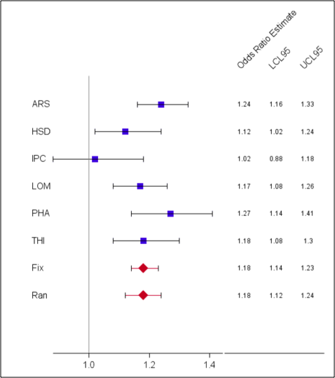
A. Current use of any bisphosphonate (test for heterogeneity: Q statistic=8.8481; p value=0.1153; I2=43.49)

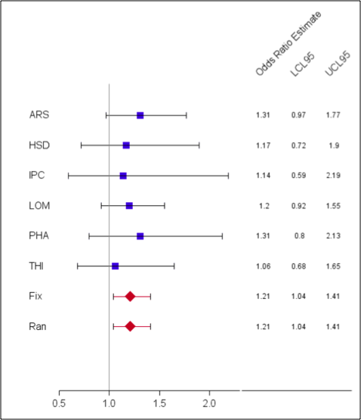
D. Current use of >1 bisphosphonate (test for heterogeneity: Q statistic=0.7576; p value=0.9797; I2=0)
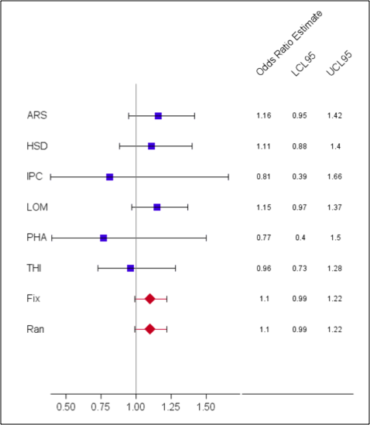
B. Current use of any non-bisphosphonate (test for heterogeneity: Q statistic=3.2273; p value=0.665; I2=0)
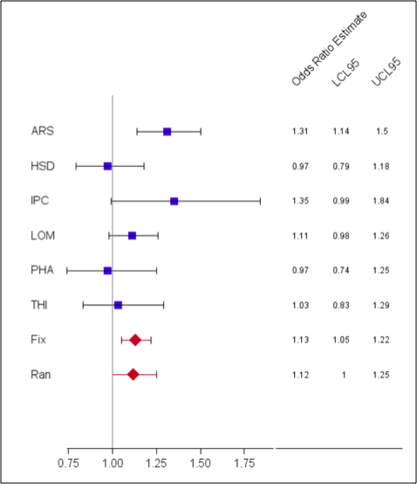
E. Past use of any bisphosphonate (test for heterogeneity: Q statistic=9.7719; p value=0.08196; I2=48.83)
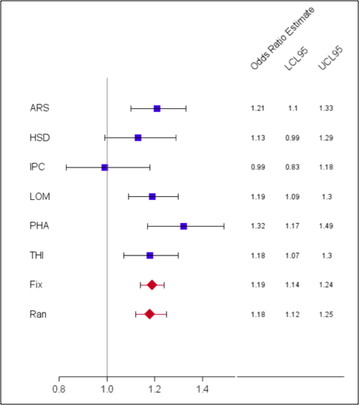
C. Current use of alendronate (test for heterogeneity: Q statistic=7.7727; p value=0.1692; I2=35.67)

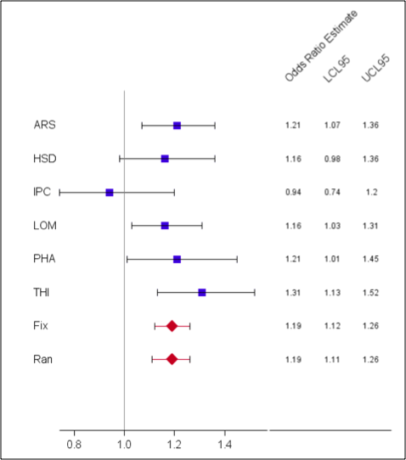
F. Current use of risedronate (test for heterogeneity: Q statistic=5.3782; p value=0.3715; I2=7.03)

Figure S2. Risk of cardiac valve regurgitation among users of all anti-osteoporosis drugs, results of meta-analyses (all ORs are adjusted for relevant confounders)

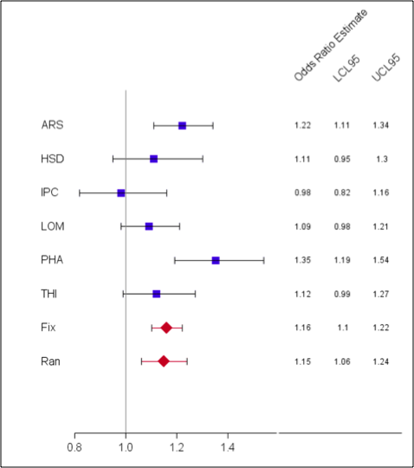
A. Current use of any bisphosphonate (test for heterogeneity: Q statistic= 12.076; p value=0.03376; I2=58.6)
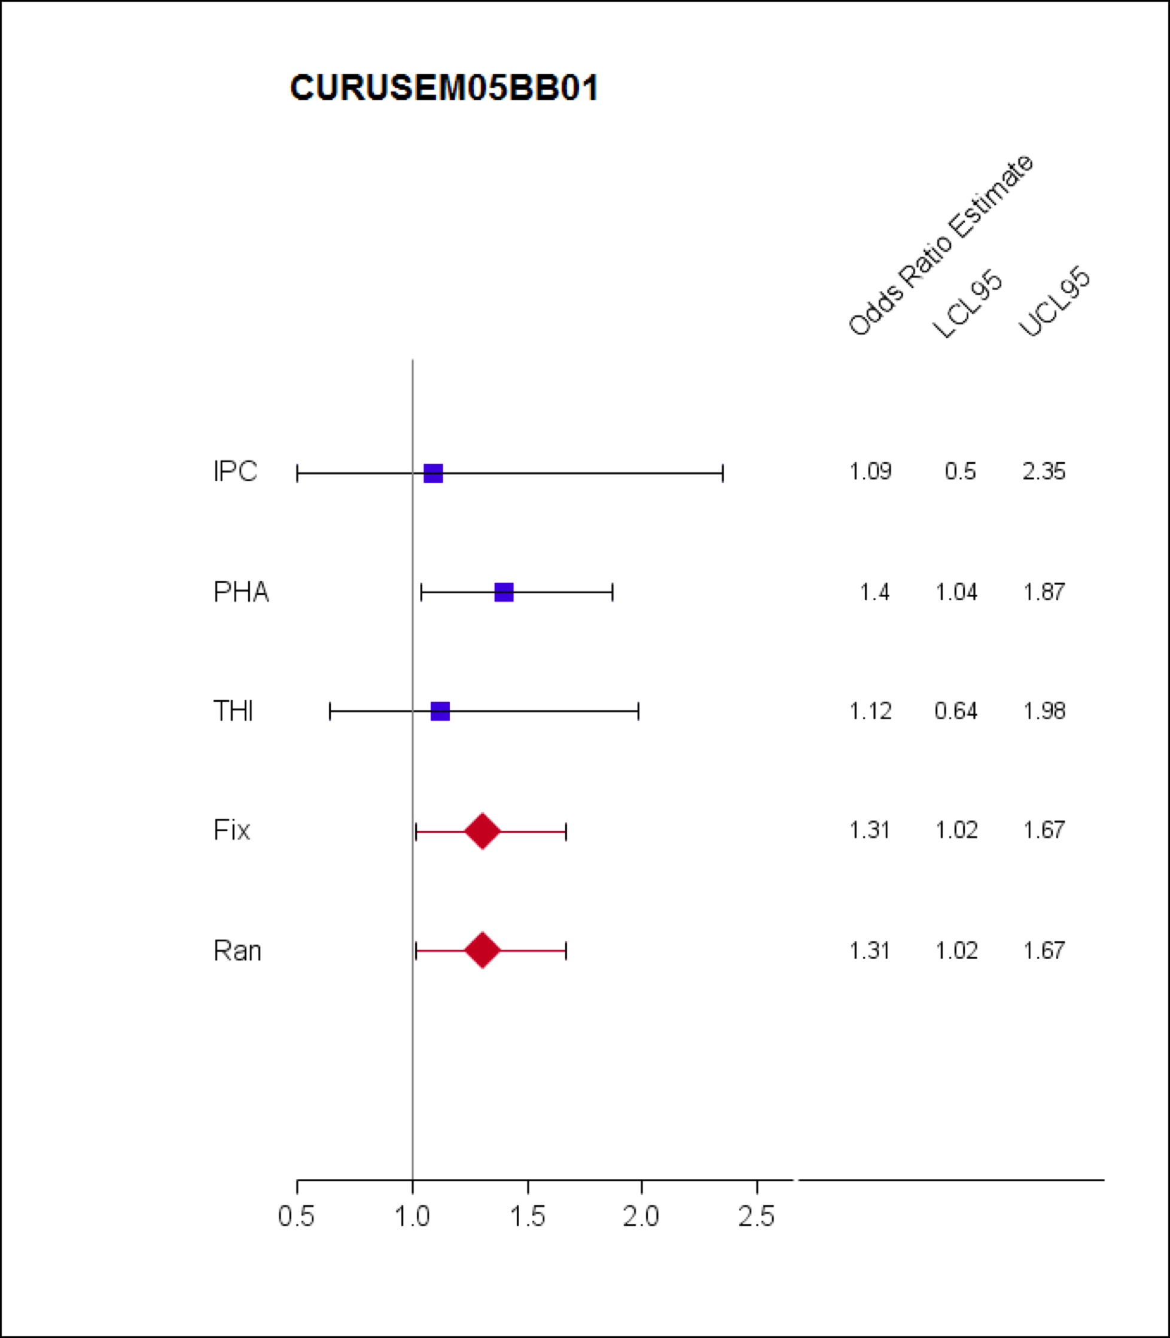
D. Current use of etidronate/calcium (test for heterogeneity: Q statistic= 0.6915; p value=0.7077; I2=0)

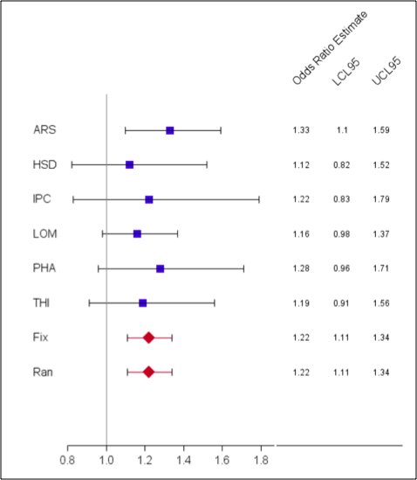
B. Past use of bisphosphonate/non-bisphosphonate (test for heterogeneity: Q statistic= 1.6261; p value=0.8981; I2=0)

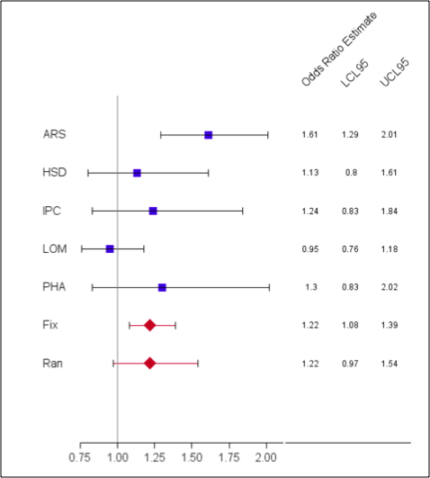
E. Current use of alendronate/colecalciferol (test for heterogeneity: Q statistic= 11.475; p value=0.02171; I2=65.14)

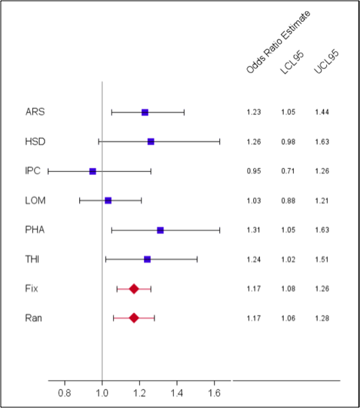
C. Current use of risedronate (test for heterogeneity: Q statistic= 6.4767; p value=0.2626;
I2=22.8)
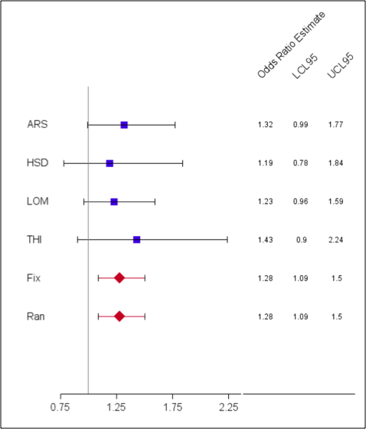
F. Current use of strontium ranelate (test for heterogeneity: Q statistic= 0.4438; p value=0.9311; I2=0)

Abbreviations: LCL95 – lower limit of 95% confidence interval
UCL95 – upper limit of 95% confidence interval
ARS – Tuscany regional database
HSD – HealthSearch database
IPC – IPCI database
LOM – Lombardy regional database
PHA – PHARMO database
THI – THIN database
Fix – Fixed effects meta-analysis
Ran – Random effects meta-analysis

Table S4. Modifying effects of age and sex on the risk of cardiac valvulopathy, results from pooled analyses
 | ALL VALVULOPATHY |  |  |  | VALVE REGURGITATION |  |  |  | VALVE CALCIFICATION
 | Male | Female | <65 years | ≥65 years | Male | Female | <65 years | ≥65 years | Male | Female | <65 years | ≥65 years
Exposure categories | OR  (95%CI) | OR  (95%CI) | OR  (95% CI) | OR  (95% CI) | OR  (95%CI) | OR  (95%CI) | OR  (95% CI) | OR  (95% CI) | OR  (95%CI) | OR  (95%CI) | OR  (95% CI) | OR  (95% CI)
Distant past use of any bisphosphonate | reference | reference | reference | reference | reference | reference | reference | reference | reference | reference | reference | reference
Past use of any bisphosphonate | 1.12  (0.91-1.37) | 1.11  (1.02-1.22) | 1.26  (0.99-1.61) | 1.09  (1.00-1.20) | 1.23  (0.96-1.59 | 1.21  (1.07-1.36) | 1.49  (1.06-2.10) | 1.19  (1.06-1.33) | 3.36  (0.29-38.42) | 0.68  (0.15-3.07) | 1.18 | 1.09  (0.34-3.41)
Current use of any bisphosphonate | 1.29  (1.14-1.46) | 1.16  (1.10-1.22) | 1.27  (1.09-1.49) | 1.16  (1.11-1.22) | 1.21  (1.04-1.42) | 1.14  (1.06-1.22) | 1.12  (0.89-1.40) | 1.15  (1.07-1.23) | 1.54  (0.19-12.85) | 1.20  (0.60-2.40) | - | 1.10  (0.56-2.14)
 | P interaction =0.11 |  | P interaction = 0.37 |  | P-interaction = 0.63 |  | P-interaction = 0.32 |  | P-interaction = 0.48 |  | Too few cases; very little variation in their exposure to test significance of interaction
Current use of:
etidronate | 1.00  (0.47-2.14) | 1.12  (0.67-1.86) | 0.62  (0.08-4.55) | 1.11  (0.72-1.71) | 0.68  (0.21-2.14) | 1.03  (0.52-2.02) | -- | 0.99  (0.55-1.78)
clodronate | 1.24  (0.78-1.96) | 0.95  (0.64-1.42) | 0.40  (0.10-1.62) | 1.14  (0.84-1.54) | 0.99  (0.52-1.88) | 1.04  (0.62-1.74) | 0.43  (0.06-3.12) | 1.07  (0.71-1.62)
alendronate | 1.33  (1.16-1.53) | 1.16  (1.09-1.23) | 1.37  (1.15-1.63) | 1.16  (1.10-1.23) | 1.25  (1.05-1.50) | 1.13  (1.05-1.23) | 1.20  (0.94-1.54) | 1.14  (1.06-1.23) | 0.82  (0.07-9.31) | 1.61  (0.78-3.31) | - | 1.22  (0.60-2.48)
ibandronate | 0.68  (0.35-1.33) | 0.96  (0.81-1.13) | 1.25  (0.83-1.87) | 0.89  (0.75-1.06) | 0.71  (0.32-1.61) | 0.90  (0.72-1.13) | 0.92  (0.44-1.91) | 0.88  (0.70-1.11)
risedronate | 1.32  (1.10-1.57) | 1.18  (1.09-1.27) | 1.17  (0.94-1.46) | 1.20  (1.11-1.29) | 1.25  (0.99-1.58) | 1.17  (1.06-1.29) | 1.10  (0.80-1.52) | 1.18  (1.08-1.30) | 4.33  (0.46-40.49) | 0.46  (0.13-1.66) | 1.02 | 0.96  (0.37-2.47)
zoledronate | 0.33  (0.05-2.38) | 1.65  (0.61-4.46) | -- | 1.02  (0.42-2.49) | 0.53  (0.07-3.82) | 1.39  (0.34-5.66) | -- | 1.04  (0.33-3.26)
etidronate and calcium | 1.09  (0.60-2.00) | 1.07  (0.78-1.46) | 1.14  (0.50-2.58) | 1.07  (0.79-1.43) | 1.39  (0.68-2.83) | 1.21  (0.84-1.76) | 1.07  (0.40-2.83) | 1.27  (0.90-1.80)
risedronate and calcium | 1.03  (0.25-4.25) | 1.90  (1.00-3.60) | 2.05  (0.48-8.67) | 1.60  (0. 85-3.03) | 0.76  (0.10-5.52) | 1.14  (0.42-3.08) | 3.72  (0.84-16.5) | 0.70  (0.22-2.21)
alendronate and colecalciferol | 1.31  (0.99-1.74) | 1.17  (1.04-1.30) | 1.07  (0.76-1.50) | 1.19  (1.07-1.33) | 1.20  (0.83-1.75) | 1.16  (1.00-1.34) | 0.75  (0.42-1.34) | 1.20  (1.04-1.38) | - | 1.18  (0.32-4.34 | 0.61 | 1.00  (0.28-3.65)
Current use of >1 bisphosphonate | 1.16  (0.71-1.90) | 1.31  (1.10-1.55) | 1.64  (1.03-2.61) | 1.25  (1.05-1.48) | 1.16  (0.62-2.21) | 1.23  90.98-1.56) | 1.33  (0.66-2.67) | 1.21  (0.96-1.52)
 | P-interaction = 0.51 |  | P interaction =0.46 |  | P-interaction = 0.99 |  | P-interaction = 0.54 |  | P-interaction = 0.17 |  | Too few cases; very little variation in their exposure to test significance of interaction

Current use: duration of prescription lasts up to index date (date of diagnosis) or ends ≤180 days before. Past use: duration of prescription ends between 181 and up to 365 days before index date. Distant past use: no exposure within 366 days before index date.

Figure S3. Sensitivity analysis for residual confounding due to severe of osteoporosis, array approach.

Legend: RR “True” or fully adjusted exposure relative risk
ARR Apparent (or observed) exposure relative risk
RR_{CD} Association between severe osteoporosis and cardiac valvulopathy
P_{C1} Prevalence of severe osteoporosis among current users of bisphosphonates
P_{C0} Prevalence of severe osteoporosis among distant past users of bisphosphonates
Note: A (fixed) 10% prevalence of severe osteoporosis among distant past users of any bisphosphonate is assumed and the prevalence of the confounder among exposed is varied between 0 to 50%.

Figure S4. Sensitivity analysis for residual confounding due to severe of osteoporosis, rule-out approach.

Legend: ARR Apparent (or observed) exposure relative risk
RR_{CD} Relative odds of cardiac valvulopathy
OR_{EC} Relative odds of cardiac valvulopathy
Note: Considering all possible unmeasured confounders (which may include smoking and over-the-counter use of calcium supplements) as a single factor and assuming prevalence of the confounder to be 20%. The curve denotes the various combinations of strength of association of the unmeasured confounder with valvulopathy and with bisphosphonate use that are required to bring down the observed OR of 1.18 to null.

