Supplementary Material

Haralick Features of the 3D Co-occurrence Matrix (HAR) extraction:
Haralick et al. [1] originally suggested 14 statistical measures to evaluate the properties of Cd,(w,$\hat{w}$)Due to redundancy, 13 of these measures have been used. These measures are derived from Cd(w,$\hat{w}$) as a scalar texture measure Hf (d) , where f = {1, 2, ..., 13}:
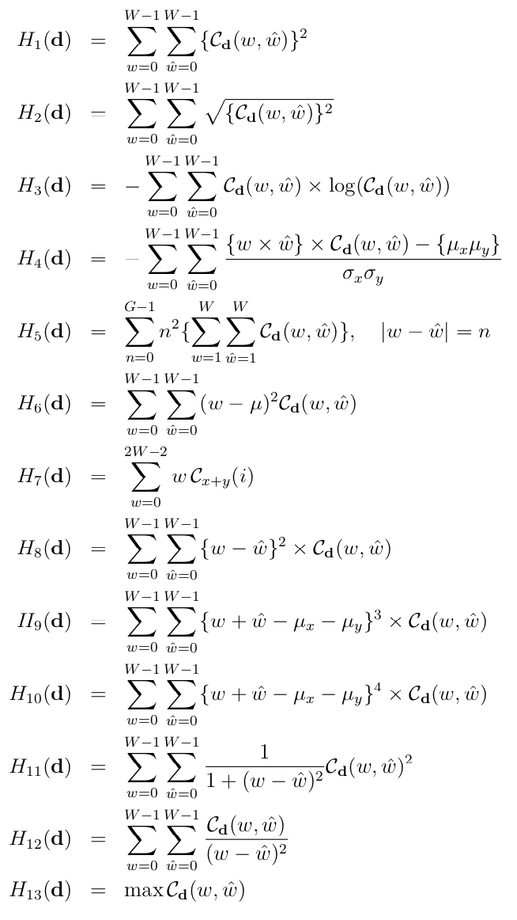
where μx, μy, σx and σy are the means and standard deviations of the probability density function Cd(w, $\hat{w}$) at different distances d. The feature names are presented in Table 1.
Table 1: Feature names proposed by Haralick et al. [1]
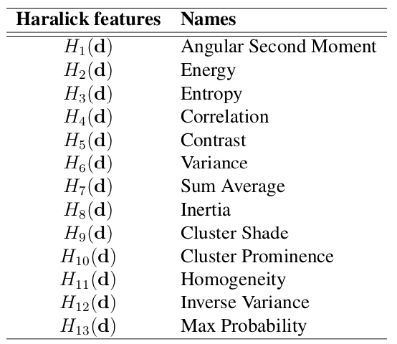

References

[1] Haralick RM, Shanmugam K, Dinstein I. Textural Features for Image Classification. IEEE Trans Syst, Man, Cybern, Syst 1973;3:610–621. doi:10.1109/TSMC.1973.4309314

Supplementary Table 1: Feature importance (Gini Importance) of vertebra vs. feature class. The row maximum is displayed in bold numbers.

 | Density Features |  | Texture Features
 | vBMD | BMDr | HAR | HOG | LBP | WL
T1 | 3.40E-05 | 1.85E-04 | 8.00E-05 | 2.67E-04 | 3.75E-04 | 1.10E-04
T2 | 3.10E-04 | 5.74E-04 | 1.70E-04 | 2.55E-04 | 5.94E-04 | 4.42E-04
T3 | 4.43E-04 | 5.46E-04 | 7.80E-05 | 1.63E-04 | 4.86E-04 | 3.21E-04
T4 | 1.79E-04 | 4.64E-04 | 1.55E-04 | 9.70E-05 | 2.38E-04 | 2.65E-04
T5 | 9.40E-05 | 1.42E-03 | 2.10E-04 | 1.20E-04 | 5.72E-04 | 8.08E-04
T6 | 2.30E-05 | 2.01E-04 | 8.80E-05 | 1.03E-04 | 1.83E-04 | 3.72E-04
T7 | 5.00E-05 | 1.22E-04 | 6.00E-05 | 1.21E-04 | 3.30E-04 | 1.80E-04
T8 | 1.98E-04 | 2.72E-04 | 1.47E-04 | 1.07E-04 | 2.90E-04 | 2.17E-04
T9 | 9.30E-05 | 3.91E-04 | 1.07E-04 | 1.36E-04 | 2.21E-04 | 4.21E-04
T10 | 5.60E-05 | 2.09E-04 | 1.80E-04 | 1.82E-04 | 2.30E-04 | 1.11E-04
T11 | 6.10E-05 | 3.18E-04 | 1.48E-04 | 8.00E-05 | 3.44E-04 | 2.81E-04
T12 | 4.70E-05 | 1.43E-04 | 4.28E-04 | 7.30E-05 | 2.58E-04 | 5.11E-04
L1 | 5.80E-05 | 2.80E-04 | 4.40E-04 | 1.08E-04 | 5.98E-04 | 2.40E-04
L2 | 6.20E-05 | 1.29E-04 | 6.70E-05 | 1.95E-04 | 8.39E-04 | 3.20E-04
L3 | 1.24E-04 | 2.36E-04 | 8.80E-05 | 1.13E-04 | 2.84E-04 | 2.38E-04
L4 | 1.09E-04 | 1.17E-03 | 6.90E-05 | 9.50E-05 | 3.09E-04 | 3.24E-04
L5 | 2.84E-04 | 4.03E-04 | 2.99E-04 | 1.56E-04 | 9.39E-04 | 3.71E-04

Supplementary Table 2: Mean and standard deviation (SD) of volumetric bone mineral density (vBMD) of each individual vertebra l of the complete thoracolumbar spine (T1-L5) on a global level for the fracture (FX) and non fracture cohort (noFX). The number of vertebrae included (n) in the FX and nonFX group is sorted by gender (M: male, F: female).

vBMD: | FX |  |  | FX (M) |  |  | FX (F) |  |  | noFX |  |  | noFX (M) |  |  | noFX (F) |  |  | All
 | mean | SD | n | mean | SD | n | mean | SD | n | mean | SD | n | mean | SD | n | mean | SD | n | mean | SD | n
T1 | 107.82 | 22.08 | 45 | 105.25 | 15.33 | 16 | 109.23 | 24.92 | 29 | 125.40 | 38.19 | 91 | 128.96 | 18.33 | 29 | 123.73 | 44.44 | 62 | 119.58 | 34.72 | 136
T2 | 97.97 | 23.68 | 50 | 95.32 | 17.69 | 16 | 99.21 | 25.94 | 34 | 115.69 | 41.66 | 98 | 122.74 | 20.13 | 31 | 112.43 | 48.14 | 67 | 109.70 | 37.54 | 148
T3 | 92.50 | 23.75 | 51 | 87.66 | 14.74 | 17 | 94.92 | 26.83 | 34 | 111.81 | 28.53 | 99 | 116.75 | 19.04 | 32 | 109.45 | 31.82 | 67 | 105.25 | 28.51 | 150
T4 | 91.28 | 24.08 | 50 | 85.95 | 13.58 | 16 | 93.79 | 27.32 | 34 | 109.88 | 27.54 | 98 | 112.18 | 17.92 | 31 | 108.81 | 30.94 | 67 | 103.60 | 27.85 | 148
T5 | 89.96 | 23.94 | 48 | 83.09 | 14.24 | 16 | 93.39 | 26.89 | 32 | 108.08 | 27.56 | 98 | 112.59 | 22.43 | 32 | 105.89 | 29.49 | 66 | 102.12 | 27.76 | 146
T6 | 90.64 | 22.28 | 44 | 82.05 | 12.53 | 15 | 95.09 | 24.78 | 29 | 106.36 | 25.76 | 97 | 109.81 | 22.28 | 32 | 104.67 | 27.16 | 65 | 101.46 | 25.78 | 141
T7 | 88.83 | 22.48 | 43 | 78.22 | 13.83 | 13 | 93.43 | 23.90 | 30 | 103.11 | 26.31 | 97 | 105.59 | 22.74 | 32 | 101.89 | 27.82 | 65 | 98.72 | 26.04 | 140
T8 | 85.11 | 23.34 | 46 | 78.90 | 17.05 | 13 | 87.55 | 24.98 | 33 | 101.30 | 26.36 | 96 | 104.36 | 21.67 | 31 | 99.84 | 28.20 | 65 | 96.05 | 26.52 | 142
T9 | 86.32 | 24.43 | 49 | 77.18 | 16.85 | 14 | 89.98 | 25.99 | 35 | 101.06 | 26.96 | 100 | 101.69 | 22.81 | 33 | 100.75 | 28.78 | 67 | 96.22 | 27.06 | 149
T10 | 85.41 | 23.82 | 49 | 76.62 | 20.22 | 15 | 89.28 | 24.26 | 34 | 102.90 | 30.78 | 101 | 105.95 | 30.74 | 33 | 101.42 | 30.69 | 68 | 97.18 | 29.84 | 150
T11 | 82.87 | 21.15 | 47 | 73.26 | 18.44 | 15 | 87.38 | 20.83 | 32 | 100.28 | 26.86 | 99 | 103.14 | 26.98 | 33 | 98.84 | 26.68 | 66 | 94.67 | 26.44 | 146
T12 | 75.38 | 19.77 | 44 | 64.42 | 16.79 | 17 | 82.28 | 18.34 | 27 | 89.76 | 22.81 | 100 | 89.75 | 20.73 | 33 | 89.77 | 23.77 | 67 | 85.37 | 22.91 | 144
L1 | 70.60 | 19.40 | 45 | 62.47 | 15.87 | 17 | 75.54 | 19.68 | 28 | 88.92 | 21.88 | 94 | 87.85 | 17.66 | 33 | 89.50 | 23.83 | 61 | 82.99 | 22.78 | 139
L2 | 76.47 | 22.10 | 52 | 72.68 | 23.94 | 18 | 78.48 | 20.79 | 34 | 94.75 | 23.52 | 99 | 96.77 | 23.04 | 33 | 93.74 | 23.69 | 66 | 88.46 | 24.62 | 151
L3 | 79.68 | 23.81 | 47 | 75.11 | 26.43 | 16 | 82.04 | 21.97 | 31 | 96.62 | 24.86 | 97 | 99.07 | 24.99 | 31 | 95.47 | 24.71 | 66 | 91.09 | 25.78 | 144
L4 | 85.88 | 22.65 | 50 | 83.08 | 23.86 | 17 | 87.32 | 21.86 | 33 | 101.30 | 26.81 | 93 | 103.04 | 24.20 | 31 | 100.43 | 27.98 | 62 | 95.91 | 26.48 | 143
L5 | 96.68 | 27.06 | 50 | 96.41 | 28.99 | 17 | 96.82 | 26.02 | 33 | 115.47 | 30.92 | 95 | 113.40 | 25.16 | 31 | 116.47 | 33.31 | 64 | 108.99 | 30.97 | 145
 |  |  | 810 |  |  | 268 |  |  | 542 |  |  | 1652 |  |  | 541 |  |  | 1111 |  |  | 2462

Supplementary Figure 1: Figure 1: A discrete 3D signal (i.e., the CT image) is decomposed into the weighted sum of a high frequency signal (H) and a lower one (L) in each direction. Three generated sub-bands volumes (i.e. LLL, HLL, LHL) are depicted of one-eighth the size of the original volume. High frequency coefficients capture high frequency signals such as edges and noise, whereas low frequency coefficients give a smoother representation of the signal. The combination of the high and low frequency highlights edges and ridges in specific directions as indicators of textures. LLL represents the approximated version of the original image patch (L1) at one-eighth the resolution.

