Burden of disease associated with X-linked hypophosphataemia in adults: a systematic literature review
Lothar Seefried¹ · Michael Smyth² · Richard Keen³ · Pol Harvengt⁴
¹Orthopedic Institute, König-Ludwig Haus, University of Würzburg, Würzburg, Germany
²Formerly of Kyowa Kirin International, Galashiels, UK
³Royal National Orthopaedic Hospital, Stanmore, UK
⁴RVRH-XLH, French association of patients with XLH (a member of the International XLH Alliance), Suresnes, France

Corresponding author: P. Harvengt
Email: pol.harvengt@gmail.com

Supplementary material
Table S1 Search terms used in the systematic review
Number | Searches
Embase, Ovid MEDLINE and the Cochrane Library
1 | X-linked hypophosphatemia/
2 | (X-linked hypophosphatemia or X-linked hypophosphataemia or XLH).mp.
3 | (X-linked dominant hypophosphatemic rickets or X-linked dominant hypophosphataemic rickets).mp.
4 | (X-linked hypophosphatemic rickets or X-linked hypophosphataemic rickets or XLHR).mp.
5 | (familial hypophosphatemia or familial hypophosphataemia).mp.
6 | (heritable hypophosphatemic rickets or heritable hypophosphataemic rickets).mp.
7 | X-linked vitamin D-resistant rickets.mp.
8 | vitamin D-resistant rickets.mp.
9 | phosphate diabetes.mp.
10 | or/1-9
11 | limit 10 to (english language and humans)
Northern Light Life Sciences Conference Abstracts database
1 | (X-linked hypophosphatemia or X-linked hypophosphataemia or XLH).mp.
2 | (X-linked dominant hypophosphatemic rickets or X-linked dominant hypophosphataemic rickets).mp.
3 | (X-linked hypophosphatemic rickets or X-linked hypophosphataemic rickets or XLHR).mp.
4 | (familial hypophosphatemia or familial hypophosphataemia).mp.
5 | (heritable hypophosphatemic rickets or heritable hypophosphataemic rickets).mp.
6 | X-linked vitamin D-resistant rickets.mp.
7 | vitamin D-resistant rickets.mp.
8 | phosphate diabetes.mp.
9 | or/1-8
10 | limit 9 to last 5 years
XLH, X-linked hypophosphataemia; XLHR, X-linked hypophosphataemic rickets
Table S2 Quality assessment of non-clinical trial research studies
Reference | Study design (sample size) | Quality of evidence
Cohort studies |  | Selection |  |  |  | Comparability | Outcome |  |  | Total score
 |  | Representativeness of the exposed cohort:  a) Truly* representative  b) Somewhat representative*  c) Selected group of patients  d) No description of the derivation of the cohort | Selection of the non-exposed cohort:  a) Drawn from same community as intervention cohort*  b) Drawn from a different source  c) No description of the derivation of the non-intervention cohort | Ascertainment of exposure:  a) Secure record*  b) Structured interview*  c) Written self-report  d) Other / no description | Demonstration that outcome of interest was not present at start of study:  a) Yes*  b) No | Comparability of cohorts on the basis of the design or analysis controlled for confounders:  a) Study controls for age and sex*  b) Study controls for any additional factors* | Assessment of outcome:  a) Independent blind assessment*  b) Record linkage*  c) Self-report  d) Other / no description | Was follow-up long enough for outcomes to occur:  a) Yes, if median duration of follow-up ≥ 6 month*  b) No, if median duration of follow-up < 6 months | Adequacy of follow-up of cohorts:  a) Complete follow up: all patients accounted for*  b) Patients lost to follow up unlikely to introduce bias: number lost ≤ 20%, or description of those lost suggesting no different from those followed*  c) Follow-up rate < 80% and no description of those lost  d) No statement or unclear
Bernt et al, 1996 [1] | Clinical examination, retrospective review, survey (23) | a (+1) | NA (0) | a (+1) | NA (0) | NA (0) | a and c (+1) | a (+1) | a (+1) | 5/9  Satisfactory
Biosse Duplan et al, 2017 [2] | Clinical examination (34) | b (+1) | NA (0) | a (+1) | NA (0) | NA (0) | a (+1) | a (+1) | a (+1) | 5/9  Satisfactory
Chaussain-Miller et al, 2003 [3] | Clinical examination (16ª) | a (+1) | a (+1) | a (+1) | NA (0) | NA (0) | a (+1) | a (+1) | a (+1) | 6/9  Good
Che et al, 2016 [4] | Paired- cohort study (52) | a (+1) | a (+1) | a (+1) | NA (0) | a (+1) | a and c (+1) | NA (0) | NA (0) | 5/9  Satisfactory
Chesher et al, 2018 [5] | Retrospective chart review (59^{b}) | a (+1) | NA (0) | a (+1) | NA (0) | NA (0) | a (+1) | a (+1) | a (+1) | 5/9  Satisfactory
Ehrich et al, 1996 [6] | Retrospective chart review (32ª) | b (+1) | NA (0) | a (+1) | NA (0) | NA (0) | a and c (+1) | a (+1) | a (+1) | 5/9  Satisfactory
Haffner et al, 1999 [7] | Retrospective chart review (26^{c,d}) | a (+1) | NA (0) | a (+1) | NA (0) | NA (0) | a (+1) | a (+1) | a (+1) | 5/9  Satisfactory
Lee et al, 2012 [8] | Clinical examination, retrospective study (44^{d}) | a (+1) | NA (0) | a (+1) | NA (0) | NA (0) | a (+1) | a (+1) | a (+1) | 5/9  Satisfactory
McNair and Stickler, 1969 [9] | Retrospective chart review (36^{d}) | a (+1) | NA (0) | a (+1) | NA (0) | NA (0) | a (+1) | b (0) | d (0) | 3/9  Poor
Nakamura et al, 2017 [10] | Retrospective chart review (22) | a (+1) | NA (0) | a (+1) | NA (0) | NA (0) | a (+1) | a (+1) | a (+1) | 5/9  Satisfactory
Nehgme et al, 1997 [11] | Prospective cohort study (2ª) | d (0) | a (+1) | a (+1) | NA (0) | a (+1) | a (+1) | NA (0) | a (+1) | 5/9  Satisfactory
Reid et al, 1989 [12] | Clinical examination and retrospective review (22) | c (0) | NA (0) | a (+1) | NA (0) | NA (0) | a and c (+1) | NA (0) | NA (0) | 2/9  Poor
Shanbhogue et al, 2018 [13] | Prospective cohort study (27) | a (+1) | a (+1) | a (+1) | NA (0) | a (+1) | a and c (+1) | a (+1) | a (+1) | 7/9  Good
Song et al, 2007 [14] | Retrospective chart review, genetic analysis (11ª) | d (0) | NA (0) | a (+1) | NA (0) | NA (0) | a (+1) | a (+1) | a (+1) | 4/9  Poor
Stickler and Morgenstern, 1989 [15] | Retrospective chart review (52) | a (+1) | NA (0) | a (+1) | NA (0) | NA (0) | b and c (+1) | a (+1) | b (+1) | 5/9  Satisfactory
Sullivan et al, 1992 [16] | Prospective cohort study (17ª) | d (0) | NA (0) | a (+1) | NA (0) | NA (0) | a and c (+1) | a (+1) | b (+1) | 4/9  Poor
Zhang et al, 2019 [17] | Retrospective chart review, genetic analysis (261^{d}) | a (+1) | NA (0) | a (+1) | NA (0) | NA (0) | a (+1) | a (+1) | b (+1) | 5/9  Satisfactory
Cross-sectional studies |  | Selection |  |  |  | Comparability | Outcome |  |  | Total score
 |  | Representativeness of the sample:  a) Truly representative of the average in the target population*  b) Somewhat representative of the average in the target population*  c) Selected group of users  d) No description of the sampling strategy | Sample size:  (> 50)  a) Justified and satisfactory*  b) Not justified | Non-respondents:  a) Comparability between respondents and non-respondents’ characteristics is established, and the response rate is satisfactory*  b) The response rate is unsatisfactory, or the comparability between respondents and non-respondents is unsatisfactory c) No description of the response rate or the characteristics of the responders and the non-responders | Ascertainment of the exposure (risk factor):  a) Validated measurement tool**  b) Non-validated measurement tool, but the tool is available or described*  c) No description of the measurement tool | The patients in different outcome groups are comparable, based on the study design or analysis. Confounding factors are controlled  a) The study controls for the most important factor (select one) *  b) The study controls for any additional factor* | Assessment of the outcome  a) Independent blind assessment **  b) Record linkage**  c) Self report*  d) No description | Statistical test:  a) The statistical test used to analyse the data is clearly described and appropriate, and the measurement of the association is presented, including confidence intervals and the probability level (p value)*  b) The statistical test is not appropriate, not described or incomplete | –
Anderson et al, 2012 [18] | Prospective cross-sectional study (36ª) | a (+1) | a (+1) | c (0) | a (+2) | NA (0) | a (+2) | a (+1) | – | 7/10  Good
Beck-Nielsen et al, 2010 [19] | Prospective cross-sectional study (38) | b (+1) | b (0) | c (0) | a (+2) | NA (0) | a (+2) | a (+1) | – | 6/10  Satisfactory
Connor et al, 2015 [20] | Retrospective cross-sectional study (52) | c (0) | a (+1) | c (0) | a (+2) | a and b (+2) | a (+2) | a (+1) | – | 8/10  Good
Davies et al, 1984 [21] | Prospective cross-sectional study (22ª) | d (0) | b (0) | NA (0) | c (0) | NA (0) | a (+2) | b (0) | – | 2/10  Poor
Econs et al, 1994 [22] | Survey (50^{a,c}) | b (+1) | a (+1) | c (0) | a (+2) | NA (0) | c (+1) | a (+1) | – | 6/10  Satisfactory
Endo et al, 2015 [23] | Survey (36^{c,d}) | a (+1) | a (+1) | b (0) | c (0) | NA (0) | a (+2) | b (0) | – | 4/10  Poor
Forestier-Zhang et al, 2016[24] | Survey (24^{c}) | b (+1) | b (0) | b (0) | a (+2) | NA (0) | c (+1) | a (+1) | – | 5/10  Satisfactory
Harrison et al, 1976 [25] | Prospective cross-sectional study (7^{b}) | d (0) | b (0) | NA (0) | a (+2) | NA (0) | a (+2) | b (0) | – | 4/10  Poor
Theodore-Oklota et al, 2018 [26] | Interview (18) | b (+1) | b (0) | c (0) | c (0) | NA (0) | c (+1) | b (0) | – | 2/10  Poor
Veilleux et al, 2012 [27] | Prospective cross-sectional study (34^{d}) | b (+1) | b (0) | c (0) | a (+2) | a (+1) | a (+2) | a (+1) | – | 7/10  Good
Veilleux et al, 2013 [28] | Prospective cross-sectional study (30^{d}) | b (+1) | b (0) | c (0) | a (+2) | a (+1) | a (+2) | a (+1) | – | 7/10  Good
Wiemann et al, 2018 [29] | Survey (13^{c,e}) | b (+1) | a (+1) | b (0) | c (0) | NA (0) | c (+1) | a (+1) | – | 4/10  Poor
Yuan et al, 2015 [30] | Genetic analysis (4^{c}) | c (0) | b (0) | NA (0) | a (+2) | NA (0) | a (+2) | NA (0) | – | 4/10  Poor
The Newcastle–Ottawa Scale for assessing the quality of cohort and cross-sectional studies was used in this evaluation [31]. Asterisks denote the allocation of stars in the evaluation. Quality of evidence from cohort studies was rated as poor, satisfactory and good for studies scoring ≤ 4, 5 and ≥ 6 out of 9 stars, respectively; quality of evidence from cross-sectional studies was rated as poor, satisfactory and good for studies scoring ≤ 4, 5 or 6 and ≥ 7 out of 10 stars, respectively
ªThese studies included children; sample sizes stated here include adult patients (aged ≥ 18 years) only. ^{b}These studies included patients aged 17 years. ^{c}These studies included individuals without XLH; sample sizes stated here include patients with XLH only. ^{d}The number of adults included in these studies was not reported. ^{e}This study may have included patients aged 16 or 17 years
NA, not applicable; XLH, X-linked hypophosphataemia
Table S3 Search terms used in the structured Internet search
Number | Searches
1 | X-linked hypophosphat(a)emia / XLH AND disease burden
2 | X-linked hypophosphat(a)emia / XLH AND quality of life
3 | X-linked hypophosphat(a)emia / XLH AND unmet needs
4 | X-linked hypophosphat(a)emia / XLH AND patient experience
5 | X-linked hypophosphat(a)emia / XLH AND insurance
6 | X-linked hypophosphat(a)emia / XLH AND mobility
7 | X-linked hypophosphat(a)emia / XLH AND diagnosis
XLH, X-linked hypophosphataemia

Table S4 Included websites identified in the structured Internet search
Title | Resource type | URL
Ultragenyx announces presentation of disease burden data in adult patients with X-linked hypophosphatemia | Press release | http://globenewswire.com/news-release/2015/03/09/713519/10123739/en/Ultragenyx-Announces-Presentation-of-Disease-Burden-Data-in-Adult-Patients-With-X-Linked-Hypophosphatemia.html
Kyowa Hakko Kirin announces positive interim data from pediatric and adult phase 2 studies of KRN23 in X-linked hypophosphatemia | Press release | http://kyowa-kirin.com/news_releases/2016/pdf/e20160920_02.pdf
Diagnosis and management of X-linked hypophosphatemia (XLH) | Slide presentation | http://syllabus.aace.com/2018/Chapters/Heartland/slides/Rush_Diagnosis%20and%20Management%20Xlinked_HRLD2018AM.pdf
X-linked hypophosphatemia in a South African population | MSc dissertation | http://wiredspace.wits.ac.za/bitstream/handle/10539/14070/Basu%20D%201999-001.pdf?sequence=1&isAllowed=y
Banjogrrldiaries (XLH and me) | Blog written by an adult with XLH | https://banjogrrldiaries.wordpress.com/tag/x-linked-hypophosphatemia/
X-linked hypophosphatemia (XLH) case study: a dynamic development model for rare disease | Slide presentation | https://everylifefoundation.org/wp-content/uploads/2018/09/Alison-Skrinrar-Ultragenyx.pdf
Hereditary X-linked hypophosphatemia and thoracic myelopathy | Journal article (case study) | https://journals.aace.com/doi/pdf/10.4158/EP15858.CR
Research offers new hope for XLH patients | Video containing interview with an adult with XLH | https://medicine.iu.edu/expertise/musculoskeletal-health/research/hypophosphatemic-rickets/
X-linked hypophosphatemia in adults: new biology, new therapies | Slide presentation | https://medicine.yale.edu/lab/insogna/ASBMR.KLI.2016.Sep14KIpm_275856_1095_5_v1.pdf
Humanistic and economic burden of X-linked hypophosphatemia (XLH): a systematic literature review | Congress poster | https://tools.ispor.org/research_pdfs/60/pdffiles/PMS116.pdf
David: living life to the fullest | Website article written by an adult with XLH | https://ultrarareadvocacy.com/patient-story/xlh/
Ultragenyx Pharmaceuticals announces presentation of disease burden data in adult patients with X-linked hypophosphatemia | Press release | https://www.biospace.com/article/releases/ultragenyx-pharmaceuticals-announces-presentation-of-disease-burden-data-in-adult-patients-with-x-linked-hypophosphatemia-/
Familial X-linked hypophosphatemic rickets of 3 generations: a clinicohistopathological study | Journal article (case study) | https://www.ecronicon.com/ecde/pdf/ECDE-18-00898.pdf
X-linked hypophosphatemia symptoms | Video containing interviews with adults with XLH | https://www.news-medical.net/health/X-Linked-Hypophosphatemia-Symptoms.aspx
Passing my disability on to my children | Newspaper article written by an adult with XLH | https://www.nytimes.com/2016/09/07/opinion/passing-my-disability-on-to-my-children.html
Dental management of patients with X-linked hypophosphatemia | Journal article (case study) | https://www.rde.ac/Synapse/Data/PDFData/2185RDE/rde-42-146.pdf
X-linked hypophosphatemia (XLH) impairs skeletal health outcomes and physical function in affected adults | Congress poster | https://www.ultragenyx.com/file.cfm/22/docs/KRN23%20-%20ENDO%20adult%20disease%20burden%20poster%20March%202015.pdf
X-linked hypophosphatemia: a new therapeutic approach | Online case study | https://www.upmcphysicianresources.com/news/032719-xlinked-hypophosphatemia-a-new-therapeutic-approach
Adults with XLH have an ongoing active disease due to unresolved symptoms that can result in disability | Online resource for patients and caregivers | https://www.xlhlink.com/hcp/burden-of-disease-adults/
URL, Uniform Resource Locator; XLH, X-linked hypophosphataemia

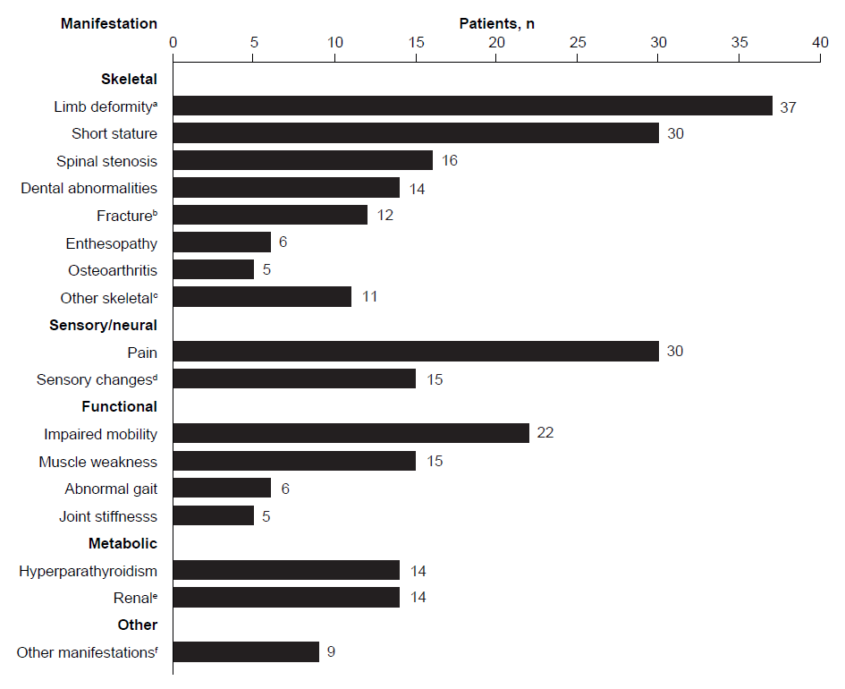
Fig. S1 Reported occurrence of XLH manifestations in case studies (n = 68)
Case studies in articles and conference abstracts were included; duplicates were removed prior to analysis. In total, 33 of the 68 patients (49%) were reported to have received conventional supplementation therapy for XLH
ªLimb deformity included bowing of the legs and genu varum. ^{b}Types of fracture reported included insufficiency fractures (n = 4) and pseudofractures (n = 4); four case studies did not specify the type of fractures experienced. ^{c}Other skeletal manifestations were those that were reported in ≤ 4 case studies and included osteomalacia (n = 3), Chiari malformation (n = 2), hip dysplasia (n = 2), syringomyelia (n = 2) and cranial abnormalities (n = 2). ^{d}Sensory changes included paraesthesia (n = 5), numbness (n = 5), hearing loss (n = 2) and tinnitus (n = 1); three case studies did not specify the type of sensory changes experienced. ^{e}Renal manifestations included nephrocalcinosis (n = 6), renal disease (n = 5), kidney stone (n = 2) and renal cancer (n = 1). ^{f}Other manifestations were those that were reported in ≤ 4 case studies and included hypertension (n = 3), fatigue (n = 3), obesity (n = 2) and cardiovascular disease (n = 1)
XLH, X-linked hypophosphataemia

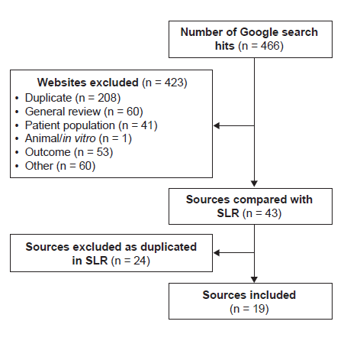
Fig. S2 PRISMA diagram showing the selection of web-based sources identified in the structured Internet search
PRISMA, Preferred Reporting Items for Systematic Reviews and Meta-Analyses; SLR, systematic literature review

References

1. Berndt M, Ehrich JHH, Lazovic D, Zimmermann J, Hillmann G, Kayser C, Prokop M, Schirg E, Siegert B, Wolff G, Brodehl J (1996) Clinical course of hypophosphatemic rickets in 23 adults. Clin Nephrol 45 (1):33–41
2. Biosse Duplan M, Coyac BR, Bardet C, Zadikian C, Rothenbuhler A, Kamenicky P, Briot K, Linglart A, Chaussain C (2017) Phosphate and vitamin D prevent periodontitis in X-linked hypophosphatemia. J Dent Res 96 (4):388–395
3. Chaussain-Miller C, Sinding C, Wolikow M, Lasfargues JJ, Godeau G, Garabedian M (2003) Dental abnormalities in patients with familial hypophosphatemic vitamin D-resistant rickets: prevention by early treatment with 1-hydroxyvitamin D. J Pediatr 142 (3):324–331
4. Che H, Roux C, Etcheto A, Rothenbuhler A, Kamenicky P, Linglart A, Briot K (2016) Impaired quality of life in adults with X-linked hypophosphatemia and skeletal symptoms. Eur J Endocrinol 174 (3):325–333
5. Chesher D, Oddy M, Darbar U, Sayal P, Casey A, Ryan A, Sechi A, Simister C, Waters A, Wedatilake Y, Lachmann RH, Murphy E (2018) Outcome of adult patients with X-linked hypophosphatemia caused by PHEX gene mutations. J Inherit Metab Dis 41 (5):865–876
6. Ehrich JHH, Filler G (1996) Hypophosphataemic rickets in children and adults. Nephrol Dial Transplant 11 (9):1918–1919
7. Haffner D, Weinfurth A, Manz F, Schmidt H, Bremer HJ, Mehls O, Scharer K (1999) Long-term outcome of paediatric patients with hereditary tubular disorders. Nephron 83 (3):250-260
8. Lee SH, Agashe MV, Suh SW, Yoon YC, Song SH, Yang JH, Lee H, Song HR (2012) Paravertebral ligament ossification in vitamin D-resistant rickets: incidence, clinical significance, and genetic evaluation. Spine 37 (13):E792-796
9. McNair SL, Stickler GB (1969) Growth in familial hypophosphatemic vitamin-D-resistant rickets. N Engl J Med 281 (10):512-516
10. Nakamura Y, Takagi M, Takeda R, Miyai K, Hasegawa Y (2017) Hypertension is a characteristic complication of X-linked hypophosphatemia. Endocr J 64 (3):283–289
11. Nehgme R, Fahey JT, Smith C, Carpenter TO (1997) Cardiovascular abnormalities in patients with X-linked hypophosphatemia. J Clin Endocrinol Metab 82 (8):2450-2454
12. Reid IR, Hardy DC, Murphy WA, Teitelbaum SL, Bergfeld MA, Whyte MP (1989) X-linked hypophosphatemia: a clinical, biochemical and histopathologic assessment of morbidity in adults. Medicine 68 (6):336–352
13. Shanbhogue VV, Hansen S, Jorgensen NR, Beck-Nielsen SS (2018) Impact of conventional medical therapy on bone mineral density and bone turnover in adult patients with X-linked hypophosphatemia: a 6-year prospective cohort study. Calcif Tissue Int 102 (3):321–328
14. Song HR, Park JW, Cho DY, Jae HY, Yoon HR, Jung SC (2007) PHEX gene mutations and genotype–phenotype analysis of Korean patients with hypophosphatemic rickets. J Korean Med Sci 22 (6):981–986
15. Stickler GB, Morgenstern BZ (1989) Hypophosphataemic rickets: final height and clinical symptoms in adults. Lancet 2 (8668):902–905
16. Sullivan W, Carpenter T, Glorieux F, Travers R, Insogna K (1992) A prospective trial of phosphate and 1,25-dihydroxyvitamin D3 therapy in symptomatic adults with X-linked hypophosphatemic rickets. J Clin Endocrinol Metab 75 (3):879–885
17. Zhang C, Zhao Z, Sun Y, Xu L, JiaJue R, Cui L, Pang Q, Jiang Y, Li M, Wang O, He X, He S, Nie M, Xing X, Meng X, Zhou X, Yan L, Kaplan JM, Insogna KL, Xia W (2019) Clinical and genetic analysis in a large Chinese cohort of patients with X-linked hypophosphatemia. Bone 121:212-220
18. Andersen MG, Beck-Nielsen SS, Haubek D, Hintze H, Gjorup H, Poulsen S (2012) Periapical and endodontic status of permanent teeth in patients with hypophosphatemic rickets. J Oral Rehabil 39 (2):144–150
19. Beck-Nielsen SS, Brusgaard K, Rasmussen LM, Brixen K, Brock-Jacobsen B, Poulsen MR, Vestergaard P, Ralston SH, Albagha OM, Poulsen S, Haubek D, Gjorup H, Hintze H, Andersen MG, Heickendorff L, Hjelmborg J, Gram J (2010) Phenotype presentation of hypophosphatemic rickets in adults. Calcif Tissue Int 87 (2):108-119
20. Connor J, Olear EA, Insogna KL, Katz L, Baker S, Kaur R, Simpson CA, Sterpka J, Dubrow R, Zhang JH, Carpenter TO (2015) Conventional therapy in adults with X-linked hypophosphatemia: effects on enthesopathy and dental disease. J Clin Endocrinol Metab 100 (10):3625–3632
21. Davies M, Kane R, Valentine J (1984) Impaired hearing in X-linked hypophosphataemic (vitamin-D-resistant) osteomalacia. Ann Intern Med 100 (2):230–232
22. Econs MJ, Samsa GP, Monger M, Drezner MK, Feussner JR (1994) X-linked hypophosphatemic rickets: a disease often unknown to affected patients. Bone Miner 24 (1):17–24
23. Endo I, Fukumoto S, Ozono K, Namba N, Inoue D, Okazaki R, Yamauchi M, Sugimoto T, Minagawa M, Michigami T, Nagai M, Matsumoto T (2015) Nationwide survey of fibroblast growth factor 23 (FGF23)-related hypophosphatemic diseases in Japan: prevalence, biochemical data and treatment. Endocr J 62 (9):811–816
24. Forestier-Zhang L, Watts L, Turner A, Teare H, Kaye J, Barrett J, Cooper C, Eastell R, Wordsworth P, Javaid MK, Pinedo-Villanueva R (2016) Health-related quality of life and a cost-utility simulation of adults in the UK with osteogenesis imperfecta, X-linked hypophosphatemia and fibrous dysplasia. Orphanet J Rare Dis 11 (1):1–9
25. Harrison JE, Cumming WA, Fornasier V, Fraser D, Kooh SW, McNeill KG (1976) Increased bone mineral content in young adults with familial hypophosphatemic vitamin D refractory rickets. Metabolism 25 (1):33–40
26. Theodore-Oklota C, Bonner N, Spencer H, Arbuckle R, Chen CY, Skrinar A (2018) Qualitative research to explore the patient experience of X-linked hypophosphatemia and evaluate the suitability of the BPI-SF and WOMAC as clinical trial end points. Value Health 21 (8):973–983
27. Veilleux LN, Cheung M, Ben Amor M, Rauch F (2012) Abnormalities in muscle density and muscle function in hypophosphatemic rickets. J Clin Endocrinol Metab 97 (8):E1492-1498
28. Veilleux LN, Cheung MS, Glorieux FH, Rauch F (2013) The muscle-bone relationship in X-linked hypophosphatemic rickets. J Clin Endocrinol Metab 98 (5):E990-995
29. Wiemann S, Frenzel Baudisch N, Jordan RA, Kleinheinz J, Hanisch M (2018) Oral Symptoms and Oral Health-Related Quality of Life in People with Rare Diseases in Germany: A Cross-Sectional Study. Int J Environ Res Public Health 15 (7):1493
30. Yuan L, Wu S, Xu H, Xiao J, Yang Z, Xia H, Liu A, Hu P, Lu A, Chen Y, Xu F, Deng H (2015) Identification of a novel PHEX mutation in a Chinese family with X-linked hypophosphatemic rickets using exome sequencing. Biol Chem 396 (1):27-33
31. Wells GA, Shea B, O'Connell D, Peterson J, Welch V, Losos M, Tugwell P (2019) The Newcastle-Ottawa Scale (NOS) for assessing the quality of nonrandomised studies in meta-analyses. http://www.ohri.ca/programs/clinical_epidemiology/oxford.asp. Accessed May 2020

