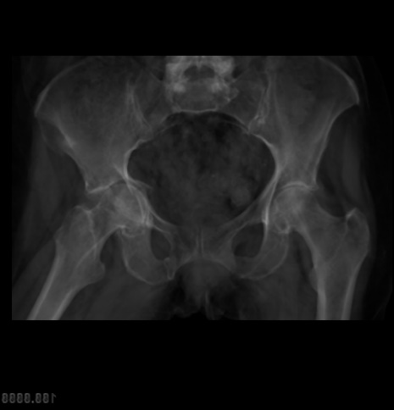
Supplementary Figure 1. The effect of pre-thresholding on the CT-AP images. (A) shows the summation image created from full HU and its histogram (0 - 255). (B) shows summation image created after thresholding at custom HU range and its histogram (0 - 255). The full range HU summation image has a single peak while a clear contrast of varying distribution of peaks and valleys can be seen in the histogram of the summation image created from slices thresholded at the custom HU range.
(A)
(B)

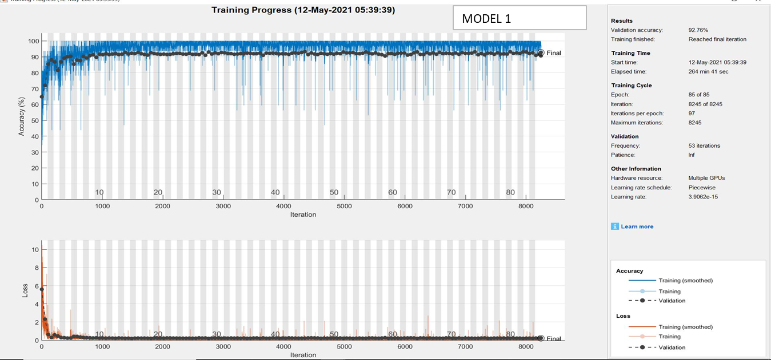
Supplementary Figure 2. The training progress of Model-1 that was trained using only unprocessed X-ray images.

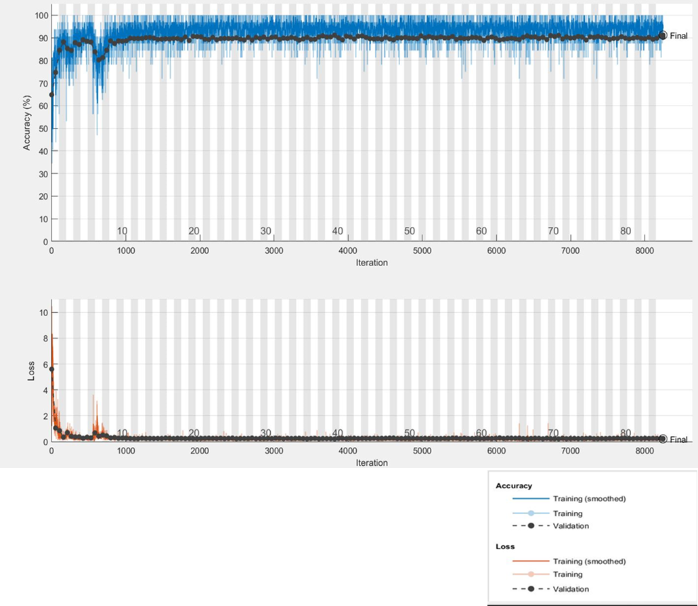
Supplementary Figure 3. The training progress of Model-2 that was trained using only under-sampled X-ray images.

Supplementary Figure 4. The training progress of Model-3 that was trained using a combination of the unprocessed X-ray images and the CT-AP images.
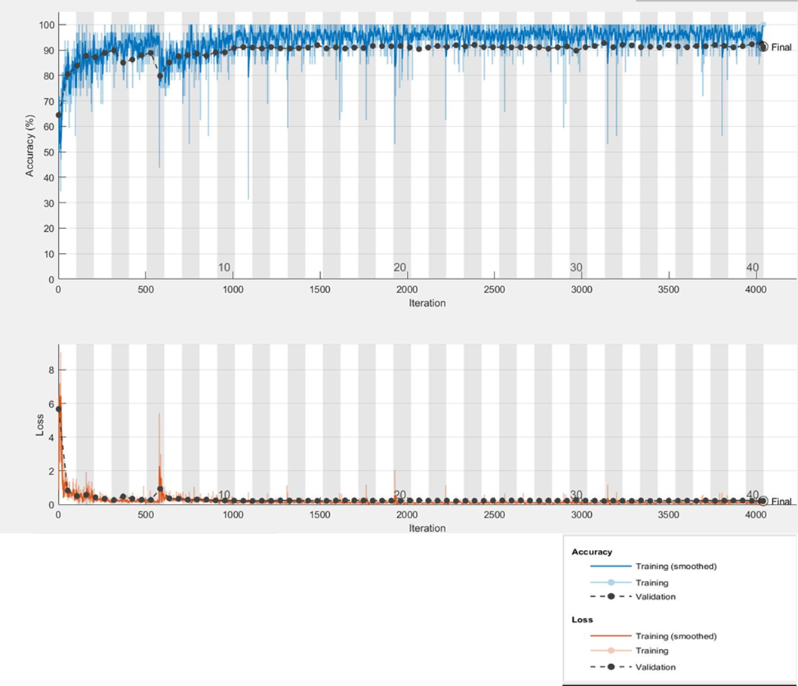
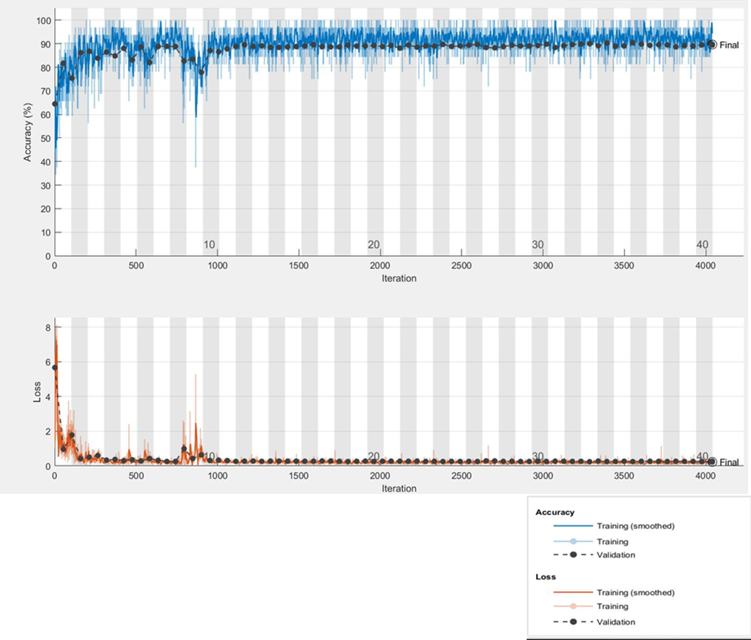
Supplementary Figure 5. The training progress of Model-4 that was trained using a combination of the under-sampled X-ray images and the CT-AP images.

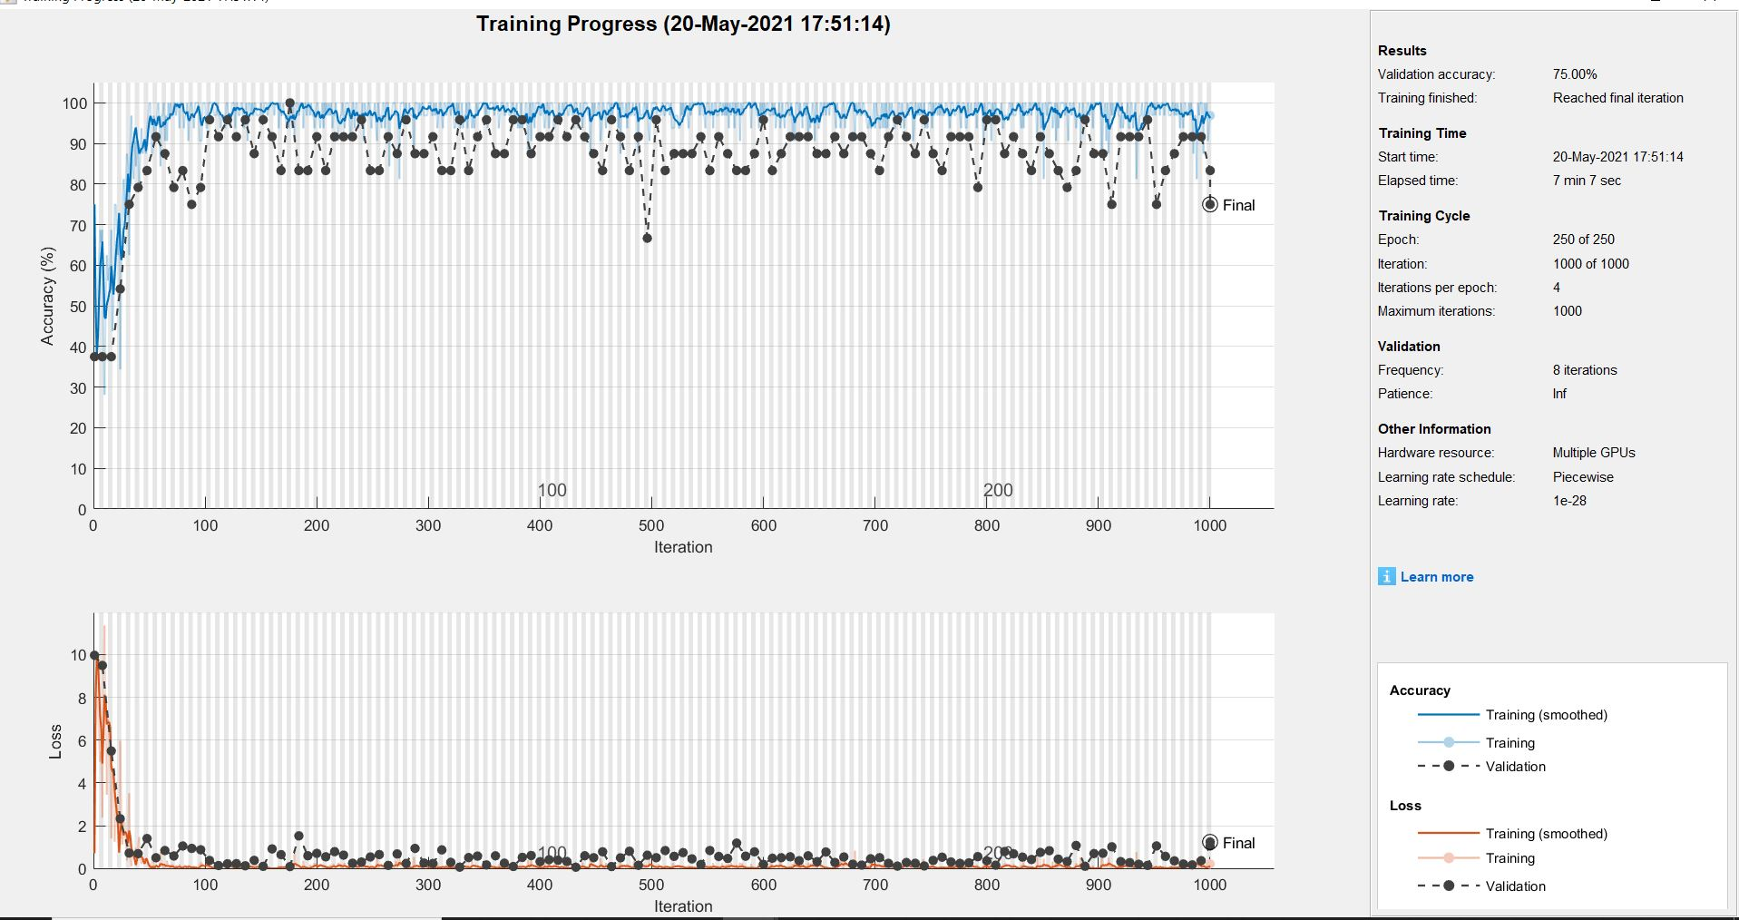
Supplementary Figure 6. The training progress of Model-5 that was trained using the CT-AP images.

