Supplemental Information:
Comparative Effectiveness and Cardiovascular Safety of Abaloparatide and Teriparatide in Postmenopausal Women New to Anabolic Therapy: A US Administrative Claims Database Study

Journal:
Osteoporosis International
Running Title:
Anabolic Effectiveness and CV Safety

Felicia Cosman¹, Cyrus Cooper², Yamei Wang³, Bruce Mitlak⁴, Sajan Varughese⁵, Setareh A. Williams⁶

¹Department of Medicine, Columbia University, New York, NY, USA
²MRC Lifecourse Epidemiology Centre, University of Southampton, Southampton, UK and NIHR Oxford Biomedical Research Centre, University of Oxford, Oxford, UK
³Biostatistics, Radius Health, Inc., Boston, MA, USA
⁴Clinical Development, Radius Health, Inc., Boston, MA, USA
⁵Pharmacovigilance, Radius Health, Inc., Boston, MA, USA
⁶Global Health Economics and Outcomes Research, Radius Health, Inc., Boston, MA, USA

Corresponding Author:
Bruce Mitlak
bmitlak@radiuspharm.com
Chief Medical Officer
22 Boston Wharf Road, 7th floor, Boston, MA 02210
ORCID: 0000-0001-7050-0703

Supplemental Figure 1. a) Forest Plot of Hazard Ratios of Nonvertebral Fractures for Abaloparatide vs Teriparatide. b) Forest Plot of Hazard Ratios of Hip Fracture for Abaloparatide vs Teriparatide

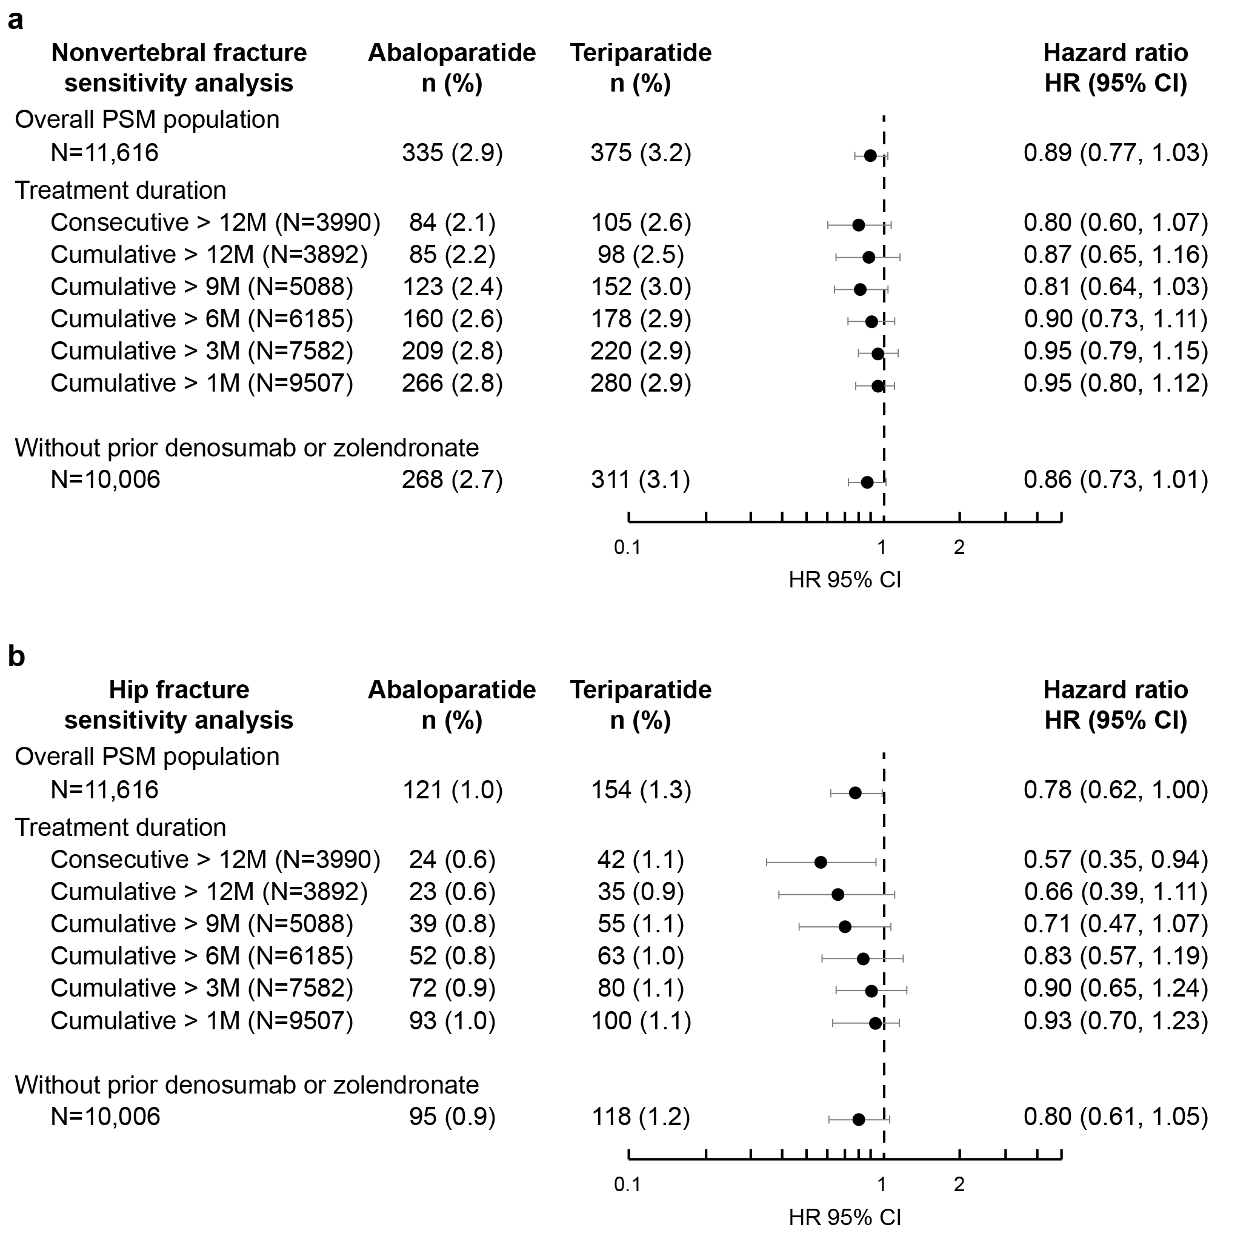

CI, confidence interval; N, number of matched pair in each subgroup; n (%), number of events and Kaplan-Meier estimate at the end of 19 months since index date; PSM, propensity score matching.
Patients were censored at 19 months after treatment initiation, or the date of death if no event happened before that.

Supplemental Figure 2. a) Forest Plot of Hazard Ratios of MI/Stroke/CV Death for Abaloparatide vs Teriparatide Sensitivity Analysis. b) Forest Plot of Hazard Ratios of MI/Stroke/HF/CV Death for Abaloparatide vs Teriparatide Sensitivity Analysis. c) Forest Plot of Hazard Ratios of Safety Endpoints for abaloparatide vs Teriparatide Sensitivity Analysis
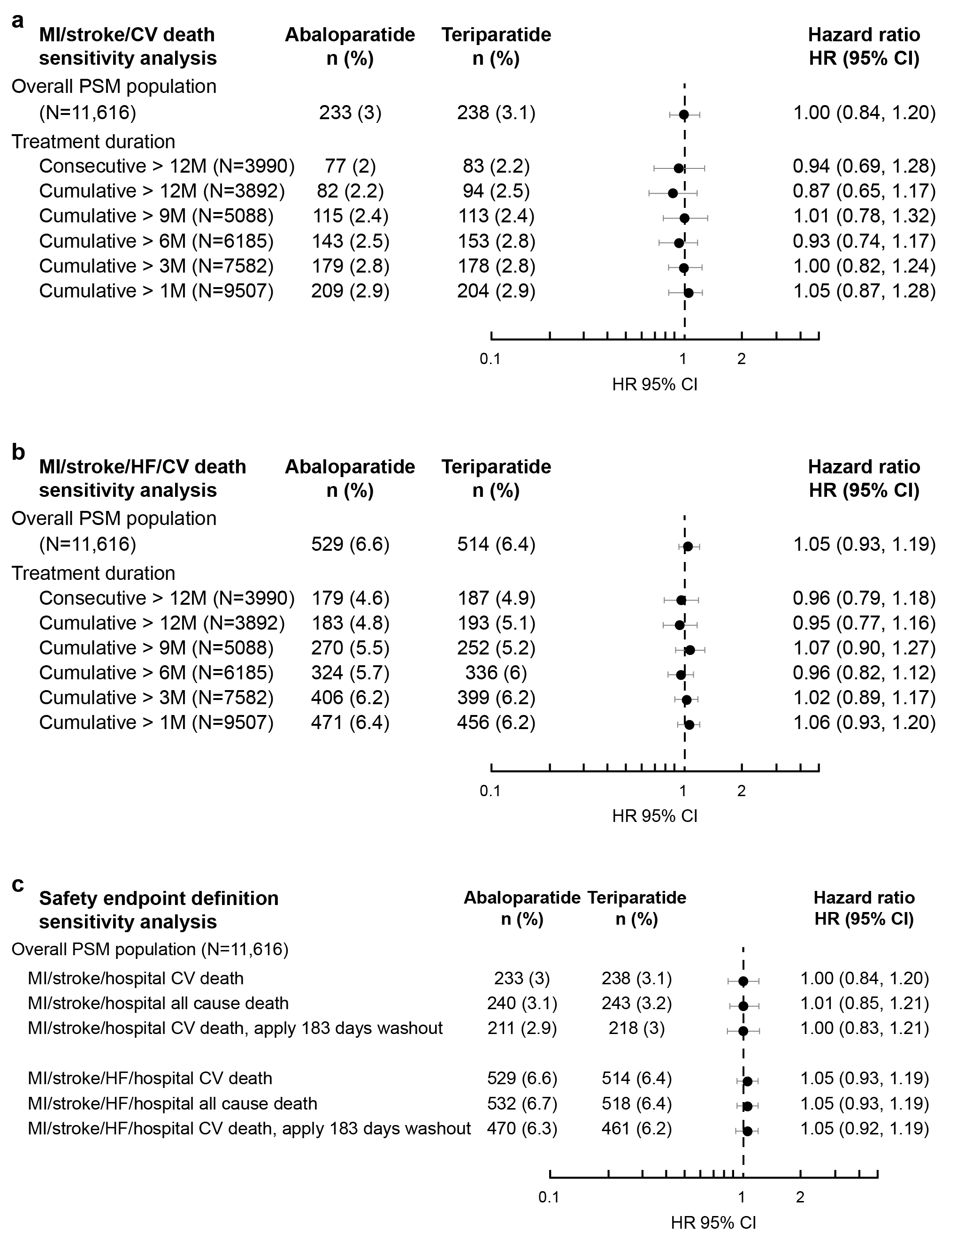

CI, confidence interval; CV, cardiovascular; HF, heart failure; HR, hazard ratio; MI, myocardial infarction; N, number of matched pair in each subgroup; n (%), number of event and Kaplan-Meier estimate at the end of 19 months since index date; PSM, propensity score matching.
Patients were censored at earliest of 30 days after treatment end, 30 days after 18 months of treatment, or the date of death if no event happened before that.

Appendix A. List of 73 matched variables
- Age group (50–64, 65–74, ≥75)
- Census Region US Census definition (Northeast, South, Midwest, West)
- Index date year quarter index date (2017 Q2, 2017 Q3, ... 2019 Q1, 2019 Q2)
- Insurance (Medicare, commercial, others)
- Prescribing physician specialty (endocrinology, rheumatology, family medicine, internal medicine, surgery, nursing related, obstetrics & gynecology, others)
- Osteoporosis disease history
  - Diagnosed osteoporosis prior to index date
  - Years since 1st diagnosis in 5 years pre-index date
- Fracture code at any time pre-index
  - Ankle
  - Hip
  - Other femur
  - Pelvis
  - Radius or ulna
  - Shoulder/spine
  - Tibia or fibula
  - Wrist
- Fracture in the year prior to index date
  - Ankle
  - Hip
  - Other femur
  - Pelvis
  - Radius or ulna
  - Shoulder/spine
  - Tibia or fibula
  - Wrist
- Osteoporosis treatment history
  - Alendronate
  - Ibandronate
  - Risedronate
  - Zoledronate
  - Denosumab
  - Hormone replacement therapy
- Oral glucocorticoids
  - Any prior or current exposure
  - Current use
- Comorbid conditions
  - Osteoarthritis
  - Rheumatoid arthritis
  - Arthritis
  - Chronic obstructive pulmonary disease (COPD)/asthma
  - Type II diabetes
  - Respiratory disease
  - Liver disease
  - Renal insufficiency
  - Hypothyroidism
  - Nephrolithiasis
  - Urolithiasis
  - Gastrointestinal disorders
    - Gastroesophageal reflux disease (GERD)
    - Nausea and/or vomiting
    - Gastritis
    - Dysphagia
    - Esophagitis
    - Gastric, duodenal, peptic, or esophageal ulcer
    - Esophageal ulcer
  - Fall risk conditions
    - Any stroke
    - Falls
    - Mobility issues
    - Visual impairment
    - Hearing impairment
    - Parkinson’s disease
    - Alzheimer’s disease
    - Muscle weakness, atrophy
    - Obesity
    - Rehabilitation
    - Dementia
    - Depression
    - Anxiety
    - Sleep disorders
  - Cardiovascular
    - Cardiovascular disease
    - Hypertension
    - Hyperlipidemia
    - Hypercholesterolemia
    - Hypertriglyceridemia
  - Cardiovascular event code prior to index date
    - Prior myocardial infarction
    - Prior stroke
    - Prior heart failure

