Supplement 7: Forest Plots with Risk of Bias Assessments

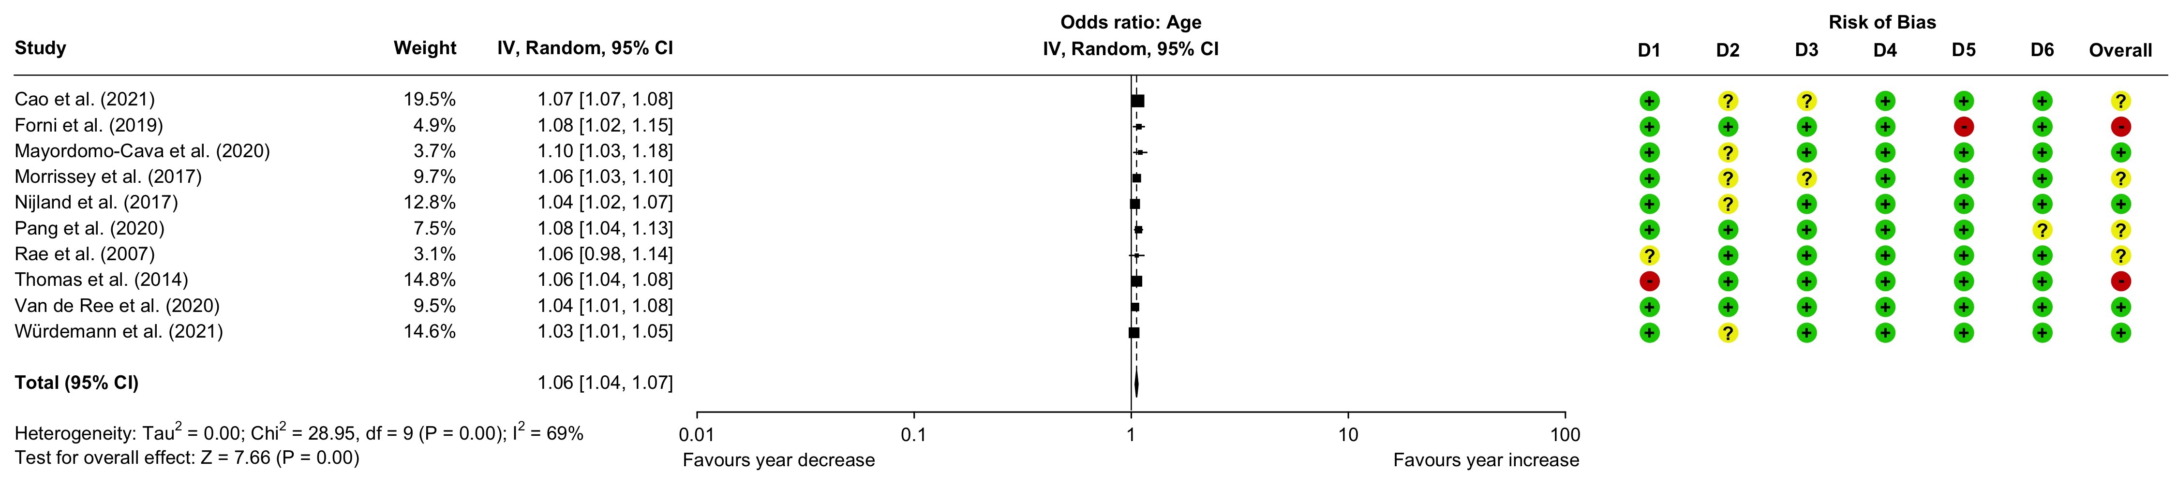
Figure 1. Forest plot illustrating the increased odds of 30-day mortality for advanced age (per year increase). High-quality evidence was found for age being a risk factor for 30-day mortality following hip fracture surgery.
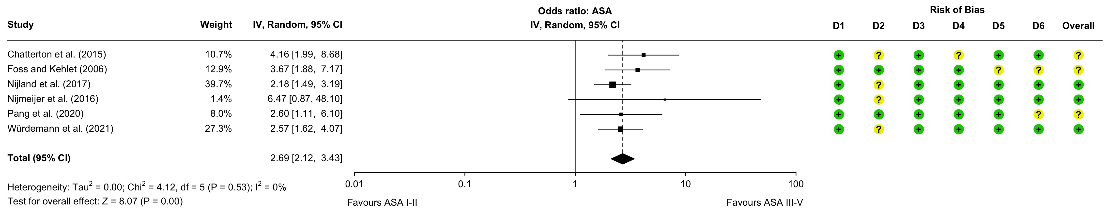
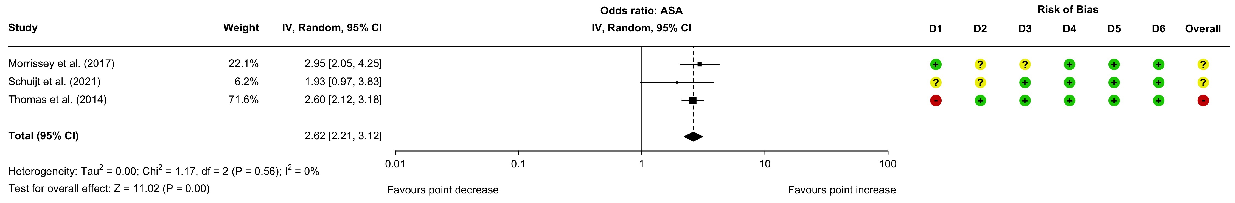
Figure 2. Forest plots illustrating the increased odds of 30-day mortality for increased ASA scores. The upper panel shows the influence of ASA III-V compared to ASA I-II. The lower panel shows the influence per point increase. Based on the analysis of the pooled estimate in the upper panel, which was based on more data, ASA scores were rated as a high-quality evidence predictor for 30-day mortality following hip fracture surgery.

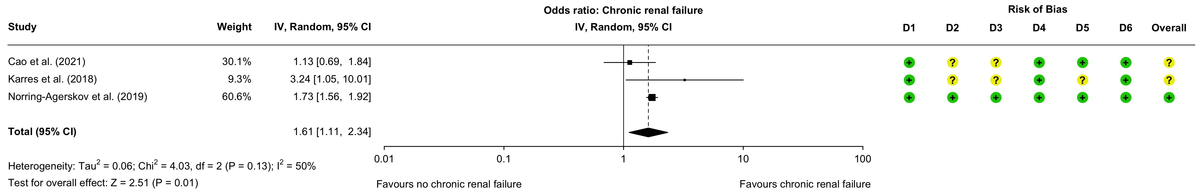
Figure 3. Forest plot illustrating the increased odds of 30-day mortality in presence of comorbid chronic renal failures. Moderate-quality evidence was found for chronic renal failure being a risk factor for 30-day mortality following hip fracture surgery.

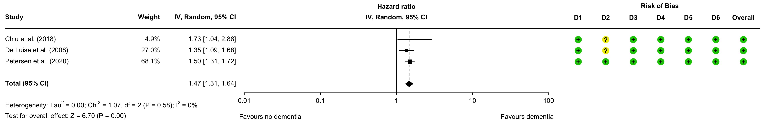
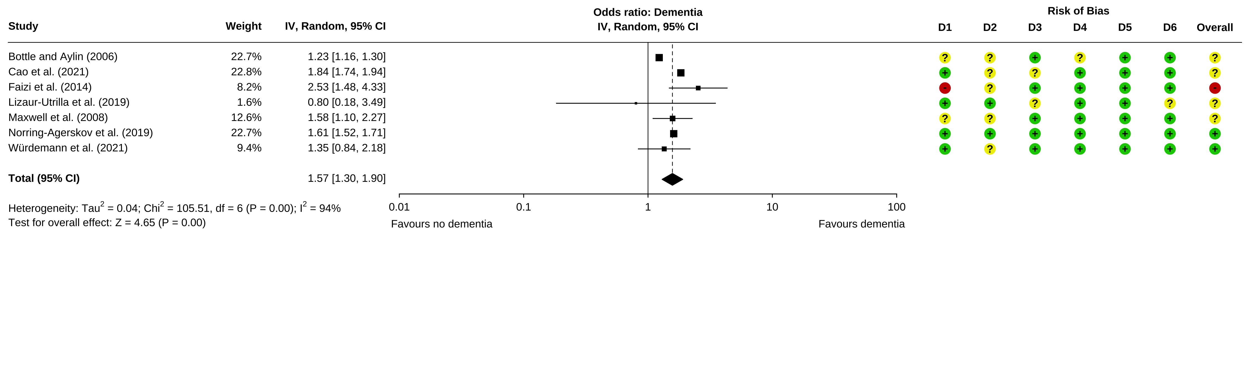
Figure 4. Forest plots illustrating the increased hazards and odds of 30-day mortality in presence of comorbid dementia. Based on the analysis of the pooled estimate in the lower panel, which was based on more data, dementia was rated as a moderate-quality evidence predictor for 30-day mortality following hip fracture surgery.
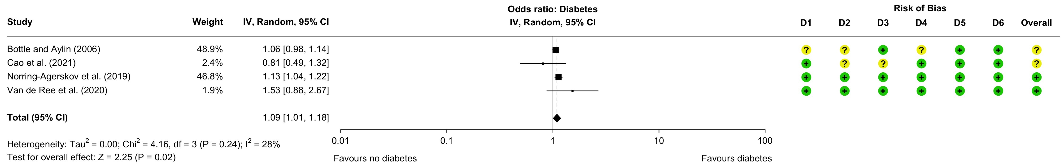
Figure 5. Forest plot illustrating the increased odds of 30-day mortality in presence of comorbid diabetes. Moderate-quality evidence was found for diabetes being a risk factor of 30-day mortality following hip fracture surgery.
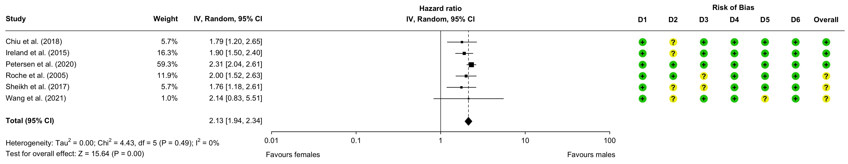
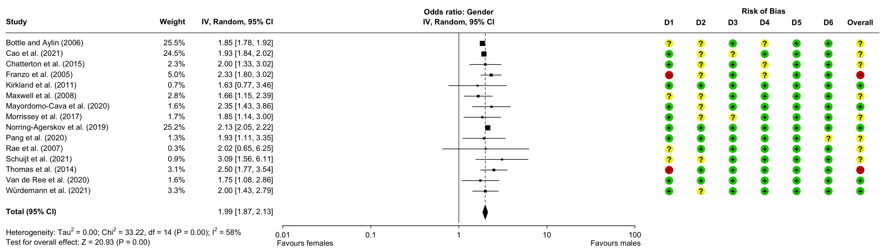
Figure 6. Forest plots illustrating the increased hazards and odds of 30-day mortality amongst males compared to females. Both pooled estimates were found to be of high-quality evidence, indicating that gender was a risk factor for 30-day mortality following hip fracture surgery.

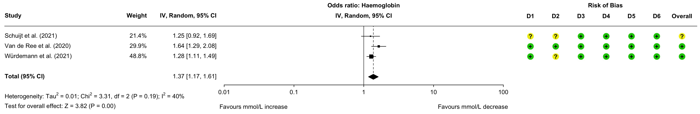
Figure 7. Forest plot illustrating the increased risk of 30-day mortality in case of lower haemoglobin levels at admission. Moderate-quality evidence was found for low haemoglobin being a risk factor of 30-day mortality following hip fracture surgery.
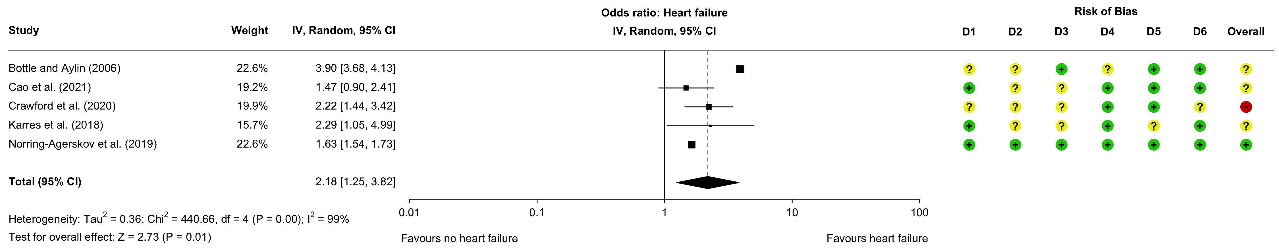
Figure 8. Forest plot illustrating the increased risk of 30-day mortality in presence of comorbid heart failures. Moderate-quality evidence was found for heart failure being a risk factor for 30-day mortality following hip fracture surgery.

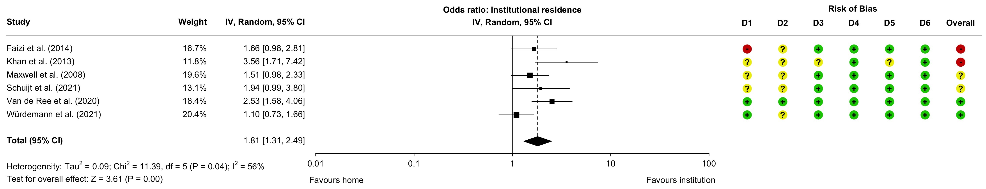
Figure 9. Forest plot illustrating the increased risk of 30-day mortality for patients living in an institution prior to admission. High-quality evidence was found for institutional residence being a risk factor for 30-day mortality following hip fracture surgery.
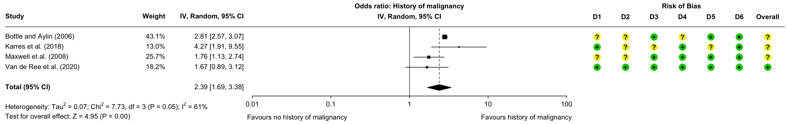
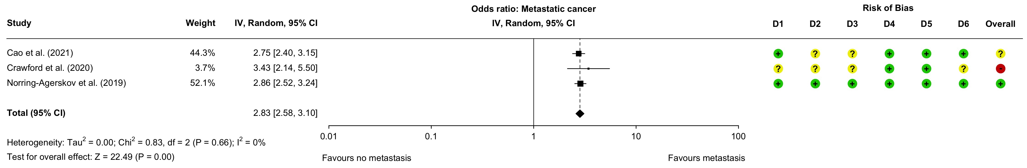
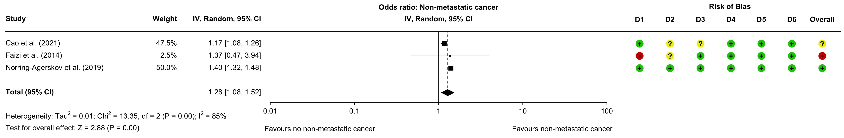
Figure 10. Forest plots illustrating the increased risk of 30-day mortality for patients with a history of (any) malignancy. From top to bottom, quality of evidence was rated as moderate, high, and low, respectively.

