Title: Improving Risk Communication in Osteoporosis : the RICO study
Appendices

Appendix 1. Results of the Phase I study
Table A1. Characteristics of the population
 | All (n=26) | Belgium (=5) | Japan (n=5) | USA (n=10) | The Netherlands (n=6)
Age | 70.5 ± 6.63 | 71.6 ± 3.05 | 69.2 ± 11.0 | 72.0 ± 5.39 | 68.3 ± 7.06
Level of education  Less than highschool  High school diploma  College (2-year)  College (4-year)  Graduate/professional  Trade school | 2 (7.7)  1 (3.8)  5 (19.2)  7 (26.9)  7 (26.9)  0 (0.00) | 0 (0.00)  0 (0.00)  1 (20.0)  3 (60.0)  1 (20.0)  0 (0.00) | 2 (40.0)  0 (0.00)  3 (60.0)  0 (0.00)  0 (0.00)  0 (0.00) | 0 (0.00)  1 (10.0)  1 (10.0)  3 (30.0)  5 (50.0)  0 (0.00) | 0 (0.00)  0 (0.00)  0 (0.00)  1 (16.7)  1 (16.7)  0 (0.00)
History of fracture | 13 (50.0) | 1 (20.0) | 1 (20.0) | 6 (60.0) | 5 (83.3)
Currently on OP treatment | 18 (69.2) | 1 (20.0) | 4 (80.0) | 8 (80.0) | 5 (83.3)
Good at calculating 15% (1-7) | 5 ± 1.77 | 4.2 ± 0.84 | 3.8 ± 2.2 | 6.2 ± 1.62 | 4.7 ± 1.21
Good for 25% reduction (1-7) | 5.7 ± 1.55 | 5.0 ± 1.41 | 4.2 ± 2.06 | 6.4 ± 0.97 | 6.0 ± 1.55
Preference of words (1) or number (7) | 4.88 ± 2.25 | 3.2 ± 3.03 | 4.4 ± 2.30 | 5.7 ± 2.06 | 5.33 ± 1.21
Forecast preference of words (0) or numbers (7) | 4.88 ± 2.37 | 3.2 ± 3.03 | 5.75 ± 1.5 | 6.1 ± 1.91 | 3.67 ± 1.86
Already had a DXA | 25 (96.2) | 5 (100.0) | 5 (100.0) | 10 (100.0) | 5 (83.3)
Results of bone density | 20 (76.9) | 3 (60.0) | 5 (100.0) | 9 (90.0) | 3 (50.0)
Results of FRAX | 2 (7.7) | 0 (0.00) | 0 (0.00) | 2 (20.0) | 0 (0.00)
Importance to know the risk of fracture (1-7) | 5.88 ± 1.42 | 7.0 ± 0.00 | 5.8 ± 1.3 | 6.1 ± 1.29 | 4.67 ± 1.63
% of risk to start a treatment  <20%  ≥20% | 21 (80.8)  5 (19.2) | 4 (80.0)  1 (20.0) | 4 (80.0)  1 (20.0) | 8 (80.0)  2 (20.0) | 5 (83.3)  1 (16.7)
Self-consideration of risk of fracture  Low  Medium  High  NR | 4 (15.4)  11 (42.3)  5 (19.2)  6 (23.1) | 1 (20.0)  2 (40.0)  1 (20.0)  1 (20.0) | 0 (0.00)  4 (80.0)  1 (20.0)  0 (0.00) | 3 (30.0)  4 (40.0)  1 (10.0)  2 (20.0) | 0 (0.00)  1 (16.7)  2 (33.3)  3 (50.0)

Table A2. Preference for fracture risk framing
 | All (n=26) | Belgium (=5) | Japan (n=5) | USA (n=10) | The Netherlands (n=6)
Presentation 1  Easy to understand (1-7)  Feel worried (1-7)  Motivation for treatment initiation (1-7) | 5.52 ± 1.44  4.88 ± 1.61  5.8 ± 1.32 | 5.4 ± 1.82  5.6 ± 0.89  6.2 ± 1.30 | 4.8 ± 1.30  4.0 ± 1.22  5.4 ± 1.14 | 5.95 ± 1.42  5.3 ± 1.70  5.89 ± 1.69 | 5.5 ± 1.38  4.33 ± 1.97  5.67 ± 1.03
Presentation 2  Easy to understand (1-7)  Feel worried (1-7)  Motivation for treatment initiation (1-7) | 6.12 ± 1.63  5.84 ± 1.07  6.04 ± 1.22 | 6.4 ± 1.34  5.6 ± 0.89  6.0 ± 1.0 | 5.4 ± 2.51  6.0 ± 0.82  5.2 ± 1.64 | 6.2 ± 1.62  6.2 ± 1.23  6.5 ± 0.97 | 6.33 ± 1.21  5.33 ± 1.03  6.0 ± 1.26
Usefulness of colours (1-7)  Being in the red section (1-7) | 6.58 ± 0.86  6.19 ± 0.94 | 7.0 ± 1.0  5.8 ± 1.09 | 6.4 ± 0.55  6.6 ± 0.55 | 6.7 ± 0.95  6.6 ± 0.7 | 6.17 ± 1.17  5.5 ± 1.05
Preference for three graphs  Horizontal with arrow  Horizontal scaled on 100 without arrow  Vertical | 6 (23.1)  11 (42.3)  9 (34.6) | 0 (0.0)  4 (80.0)  1 (20.0) | 3 (60.0)  1 (20.0)  1 (20.0) | 2 (20.0)  3 (30.0)  5 (50.0) | 1 (16.7)  3 (50.0)  2 (33.3)
Presentation 3  Easy to understand (1-7)  Feel worried (1-7)  Motivation for treatment initiation (1-7) | 4.46 ±1.98  4.42 ± 1.86  4.72 ± 1.79 | 3.8 ± 2.28  5.4 ± 1.67  5.2 ± 2.17 | 3.6 ± 1.14  4.6 ± 1.52  4.6 ± 1.52 | 4.9 ± 1.91  3.9 ± 2.02  4.44 ± 7.74 | 5.0 ± 2.45  4.33 ± 2.07  4.83 ± 2.14
Preference for arrays  Add a scale  Inverse the scale (sad face bottom)  Use a lower scale  Use colours  Use other icon arrays  Preference for faces  Preference for bones  Preference for persons | 14 (53.8)  6 (23.1)  13 (50.0)  6 (23.1)  11 (42.3)  8 (30.8)  4 (15.4) | 2 (40.0)  2 (40.0)  3 (60.0)  3 (60.0)  2 (40.0)  3 (60.0)  0 (0.00) | 4 (80.0)  2 (40.0)  4 (80.0)  1 (20.0)  1 (20.0)  2 (40.0)  2 (40.0) | 7 (70.0)  2 (20.0)  5 (50.0)  2 (20.0)  6 (60.0)  2 (20.0)  2 (20.0) | 1 (16.7)  0 (0.00)  1 (16.7)  0 (0.00)  2 (33.3)  1 (16.7)  0 (0.00)
Presentation 4  Easy to understand (1-7)  Feel worried (1-7)  Motivation for treatment initiation (1-7) | 5.69 ± 1.64  5.8 ± 1.19  6.04 ± 1.14 | 6.4 ± 1.34  6.2 ± 0.84  6.4 ± 0.89 | 3.6 ± 1.52  5.0 ± 0.82  5.25 ± 0.96 | 6.5 ± 1.08  6.4 ± 1.07  6.8 ± 0.42 | 5.5 ± 1.38  5.0 ± 1.26  5.0 ± 1.26
General preference (easier to understand)  - Simple oral/written presentation of %  - Coloured graphs  - Icon arrays  - Risk with/without treatment | 2 (7.7)  20 (76.9)  0 (0.0)  4 (15.4) | 0 (0.00)  4 (80.0)  0 (0.00)  2 (20.0) | 0 (0.00)  5 (100.0)  0 (0.00)  0 (0.00) | 1 (10.0)  7 (70.0)  0 (0.00)  2 (20.0) | 1 (16.7)  4 (66.7)  0 (0.00)  1 (16.7)
General preference (for treatment initiation)*  - Simple oral/written presentation of %  - Coloured graphs  - Icon arrays  - Risk with/without treatment | 2 (7.7)  16 (61.5)  0 (0.0)  10 (38.5) | 0 (0.00)  2 (40.0)  0 (0.00)  3 (60.0) | 0 (0.00)  5 (100.0)  0 (0.00)  0 (0.00) | 1 (10.0)  5 (50.0)  0 (0.00)  6 (60.0) | 1 (16.7)  4 (66.7)  0 (0.00)  1 (16.7)
*two participants with multiple choice, so the total is on 28

Analysis of preference
Most patients (76.9%) preferred coloured graphs over other types of presentations. They also provided some advice to improve coloured graphs presentation.
“Colours and graphics are more meaningful for everybody. A lot of women do not take care about osteoporosis and consider that this is a disease for older people and do not take treatment. So visual graphics are important”.
“I want to stay healthy and if there is medication for that then I want to take it. Seeing that I fall into the red area gives me more motivation to take medication”.
“I think it is a good presentation but what I do if I was trying to present this more clearly, I would emphasize the black arrow pointing down more. For example, circle it or highlight it to make sure the patient know that they are close to the high risk”.
Icon arrays of actual fracture risk were never selected as the preferred method of communication.
“Using smileys is something actual. But the graphics are more direct, visually punchier”.
“This is hard to understand. It hard to see the faces and it seems to minimize the risk since there are more faces that are smiling. It diminishes the risk in someone’s mind”.
Most patients also reported that presenting both the risk of fracture with and without treatment would be more convincing to initiate a treatment.
“It is a good example showing me how well the medication might work to reduce bone fracture, it is not a fix for everybody. It a good presentation is showing the difference”.
Participants underlined the importance of visual aids in support to oral communication between patients and healthcare professionals and also suggested that fracture risk framing should also be supported with additional data, such as the consequences of fractures.
“Knowing consequences is important because I think everyone values their independence and if someone is in that age range of 60s then seeing this information will make people think of reality. Their freedom is eliminated or minimized over a something like a hip fracture, a lot of people don’t think about that”.
“The website would not be relevant, because too many people may use it but still not understand the risk of fracture and it may push people away from getting medications. You still need the doctor to explain what the results mean one on one”.
Patients also discussed and shared feelings about fracture risk communication. In a general way, patients showed interest in improving the communication between doctors and patients.
“Communication between doctors and patients is something very important. Being able to ask questions, discuss about some points is important. I feels that because of the covid situation, this aspect is missing. But not solely because of covid, this is a general feeling. Before, everybody could call her medical doctor, at any time, for questions, emergency. And now, it is not possible anymore. Communication is bad between doctors and patients”.

Appendix 2. Survey
Improving Risk communication in Osteoporosis
Step 3: Survey Discussion Guide

Welcome to the presentation and introduction of the project
Thank you for agreeing to take part in this interview. My name is (XXX, MODERATOR) and I will be moderating this interview.

We are getting together to participate in a discussion which is part of a larger scientific project aiming to improve the communication of fracture risk.
Nowadays, there are no tools to estimate - and thus to communicate - your fracture risk in the next 10 years. It is however essential that clinicians adequately and clearly explain to people what their personal risk or chance of breaking a bone is. This help people make choices about initiating medicines.

With this interview, you will help us understand how you prefer to get information about your personal fracture risk. Throughout our entire discussion, we will use the terminology “fracture”. Please consider “fracture” as a synonym of “broken bone” or “bone break”.

As a reminder, this discussion is being recorded to capture your input. This input will remain confidential, and your name will never be mentioned in any communication of the data. Do you agree with this procedure?

Now I will share my screen to show you the organization of today’s interview. The interview is organized into two main parts: an introduction that includes some questions for us to better understand who you are and a second part divided into three smaller sections.

It is very important for you to know that there are no right or incorrect answers in this interview.

- Introduction
Before we get started, I suggest we do some brief introductions. I will ask you a few questions about yourself including some questions to know how comfortable you are with using numbers.
  - What is your gender?
☐ Male
☐ Female
☐ Other
☐ Do not want to answer

  - What is your age?

  - What is the highest level of education you have completed?
☐ Primary school
☐ Lower secondary education
☐ Upper secondary education
☐ Post-secondary education (non-University)
☐ Post-secondary education (University)
  - Since the age of 50, have you broken a bone?
☐Yes
☐ No
    - If yes, please indicate the site of fracture
Spine: yes – no
Hip: yes – no
Wrist: yes – no
Humerus: yes – no
Other (and describe): yes – no

  - Have you been diagnosed by a doctor as having osteoporosis?
☐Yes
☐ No

  - Are you currently taking any drugs prescribed by a doctor (other than calcium and vitamin D) to treat osteoporosis?
☐ Yes
☐ No

  - Now I will ask you 4 questions to estimate how comfortable you are with graphics. Do not worry if you cannot answer these questions, you can simply tell us that you are not comfortable with the questions and that you do not want to answer.

Question 1
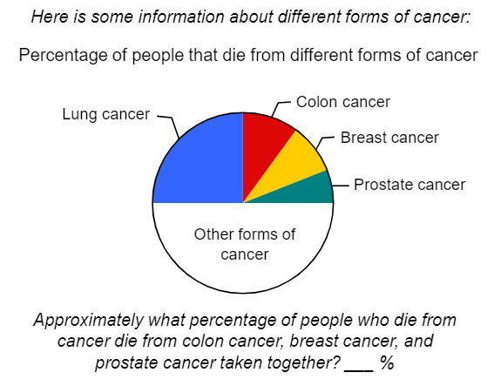
Response to question 1 (correct answer= 25% (24% and 26% accepted)
…………….. %

Scoring:
☐Correct (24%, 25%, 26%)
☐False (other responses, including can’t say)

Question 2
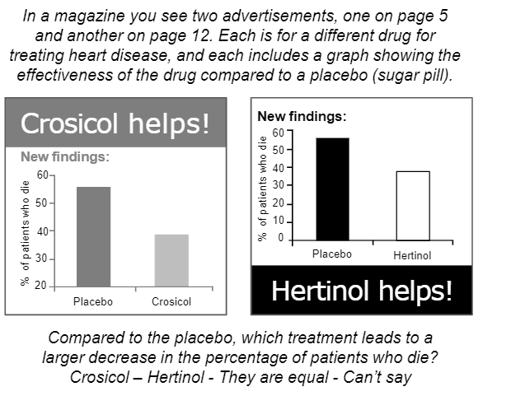
Response to question 2 (correct answer= they are equal):
☐ Crosicol
☐ Hertinol
☐ They are equal
☐ Can’t say

Scoring:
☐Correct (They are equal)
☐False (all other responses, including can’t say)

Question 3
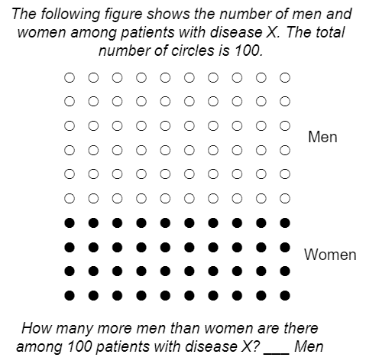
Response to question 3 (correct answer=20):
……………………
Scoring:
☐Correct (20)
☐False (all other responses)

  - I will now ask you 4 additional questions to estimate how comfortable you are with numbers and frequencies.
    - How good are you at calculating a 15% tip?
Not at all good |  |  | Neutral |  |  | Extremely good
☐ | ☐ | ☐ | ☐ | ☐ | ☐ | ☐
1 | 2 | 3 | 4 | 5 | 6 | 7
    - When people tell you the chance of something happening, do you prefer they use words (e.g., “it rarely happens”) or numbers (e.g., “there is 1% chance”)?
Always prefer words |  |  | Neutral |  |  | Always prefer numbers
☐ | ☐ | ☐ | ☐ | ☐ | ☐ | ☐
1 | 2 | 3 | 4 | 5 | 6 | 7

- Overview of the individual interview
I will now briefly explain what we will do during this discussion. Today’s discussion will last approximately 30 minutes. I will explain the objective of each step briefly as we go through. Please feel free to ask questions at any time.
The goal of today’s discussion is to assess your view on the communication of fracture risk. There are no right or wrong answers, since we are interested in your opinion, we would like to encourage to feel completely free to express your feelings.
We will discuss this in two ways. I will first ask you to share with us your initial knowledge and thoughts about your fracture risk. Second, I will present you a general fracture risk and different possibilities/options to communicate about this risk as well as several examples of how to communicate this risk. I will then ask you to indicate which examples you prefer.

Patient knowledge/consideration on fracture risk
In preparation for our discussion, we would like to first hear your initial thoughts on your own fracture risk. I will ask you some questions.

  - Have you already been told by a doctor (or another healthcare professional) about your future risk of fracture (e.g., your 10-year fracture risk)?
☐ Yes
☐ No (if no, go to question 2.2??)
☐ Unsure
    - If yes, can you tell me what you remember about your fracture risk?
☐ High
☐Average
☐Low
☐I do not remember
    - If yes, do you know/remember how the fracture risk was determined?
☐ The doctor used a fracture risk algorithm (such as FRAX)
☐ The doctor performed a DXA/bone density measurement
☐ Other, please describe: ………….
☐ I do not know/ do not remember
    - If yes, how did you receive the results of fracture risk?
☐Directly in doctor’s office
☐By phone
☐By mail
☐By postal letter
☐By online medical record
☐Other (please explain)
☐I do not remember
    - If yes, were you satisfied about the way you were told about your risk for future fracture?
☐ Yes
☐ Partially
☐ No
☐I do not remember
    - If yes, did the information provided make sense to you?
☐ Yes
☐ No
☐I do not remember

☐e) Was a bone density test (DXA) performed prior to communicating your risk of fracture to you?
☐ Yes
☐ No
☐I do not remember

  - How important is it for you to know your risk of having a fracture in the future?
Not important |  |  | Neutral |  |  | Very important
☐ | ☐ | ☐ | ☐ | ☐ | ☐ | ☐
1 | 2 | 3 | 4 | 5 | 6 | 7

  - Compared to someone of your age, do you consider yourself as having a low, moderate, high fracture risk?
☐ Low
☐ Moderate
☐ High
☐ I do not know

- Presentation of fracture risk
Now I will show you three different ways to communicate your 10-year fracture risk. Some tools have been developed to calculate risk of fracture (such as the FRAX®). Taking into account some potential risk factors (age, smoking, family history of osteoporosis, etc.) and your bone mineral density measured with DXA, these tools give an estimation of your risk of a major osteoporotic fracture including a clinical spine, forearm, or humerus fracture as well as risk of hip fracture.
I will start with a very simple explanation about your fracture risk. I will then show you some other ways to explain your fracture risk and I will ask your opinion about which way you find best.
The initial explanation is as follows:

PRESENTATION 1: verbal/written presentation
This first way to explain your fracture risk is verbal or in writing.

Your risk of osteoporosis-related fracture (e.g., spine, hip, forearm or shoulder fracture)
is 21% over 10 years

  - Do you consider this presentation of risk easy to understand?

Very difficult to understand |  |  | Neutral |  |  | Very easy to understand
☐ | ☐ | ☐ | ☐ | ☐ | ☐ | ☐
1 | 2 | 3 | 4 | 5 | 6 | 7

  - How would you feel if you were told you had this level of fracture risk?
Very worried about risk |  |  | Neutral |  |  | Not worried about risk
☐ | ☐ | ☐ | ☐ | ☐ | ☐ | ☐
1 | 2 | 3 | 4 | 5 | 6 | 7

The fracture risk “without medical treatment” can also be presented in comparison to the fracture risk “with medical treatment”, to highlight the benefits of treatment.
Example:
Your risk of fracture without medical treatment |  | Your risk of fracture with medical treatment
Without any osteoporosis medical treatment, your risk of osteoporosis-related fracture (e.g. spine, hip, forearm or shoulder) is 21% over 10 years |  | With osteoporosis medical treatment, your risk of osteoporosis-related fracture (e.g. spine, hip, forearm or shoulder) is 14% over 10 years.

  - Do you consider the adding of fracture risk with medical treatment useful?
Not useful at all |  |  | Neutral |  |  | Very useful
☐ | ☐ | ☐ | ☐ | ☐ | ☐ | ☐
1 | 2 | 3 | 4 | 5 | 6 | 7

  - Would you feel motivated to undertake lifestyle changes (e.g., doing more physical activity, ensure a diet rich in calcium, stop smoking, reduce alcohol consumption, follow a fall prevention programme) to lower your risk, if fracture risk is presented using the verbal/written presentation as presented above?
Not at all |  |  | Neutral |  |  | Yes very much
☐ | ☐ | ☐ | ☐ | ☐ | ☐ | ☐
1 | 2 | 3 | 4 | 5 | 6 | 7

  - Would you feel motivated to take a medical treatment (i.e. an osteoporotic drug) (associated with only minor transient side effects) to lower your risk, if fracture risk is presented using the verbal/written presentation as presented above?
Not at all |  |  | Neutral |  |  | Yes very much
☐ | ☐ | ☐ | ☐ | ☐ | ☐ | ☐
1 | 2 | 3 | 4 | 5 | 6 | 7

PRESENTATION 2: Visual presentation of the risk using a colored graph
Now let’s add a graph that uses a three part red, yellow and green colored stoplight/traffic light system to explain your fracture risk. Low risk is associated with green, moderate is associated with yellow and high risk is associated with red. All three parts of the arrow are of equal widths.
First example:
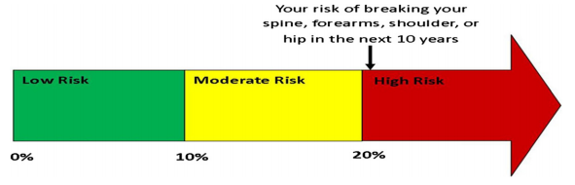

  - Do you consider this presentation of risk easy to understand?

Very difficult to understand |  |  | Neutral |  |  | Very easy to understand
☐ | ☐ | ☐ | ☐ | ☐ | ☐ | ☐
1 | 2 | 3 | 4 | 5 | 6 | 7

  - How would you feel if you were told you had this level of fracture risk?
Very worried about risk |  |  | Neutral |  |  | Not worried about risk
☐ | ☐ | ☐ | ☐ | ☐ | ☐ | ☐
1 | 2 | 3 | 4 | 5 | 6 | 7

  - As you might see on the graph, a classification of the risk level (low risk, moderate risk, high risk) is proposed. Do you consider this classification of low, moderate or high risk is important to help you decide if you will take a therapy?
Not useful at all |  |  | Neutral |  |  | Very useful
☐ | ☐ | ☐ | ☐ | ☐ | ☐ | ☐
1 | 2 | 3 | 4 | 5 | 6 | 7

  - What do you think about using colours for fracture risk communication to indicate low, moderate, high fracture risk?
Not useful at all |  |  | Neutral |  |  | Very useful
☐ | ☐ | ☐ | ☐ | ☐ | ☐ | ☐
1 | 2 | 3 | 4 | 5 | 6 | 7

  - How do you feel about being in the red section?
Not worried |  |  | Neutral |  |  | Very worried
☐ | ☐ | ☐ | ☐ | ☐ | ☐ | ☐
1 | 2 | 3 | 4 | 5 | 6 | 7

It is also possible to use stoplight/traffic light for risk in different ways.
A second example would be to present the risk scaled 0-100% horizontally.

Second example:
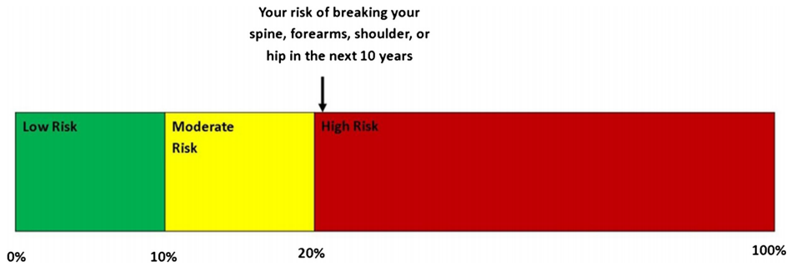
A third example would be to present the risk on the stoplight vertically.

Third example:

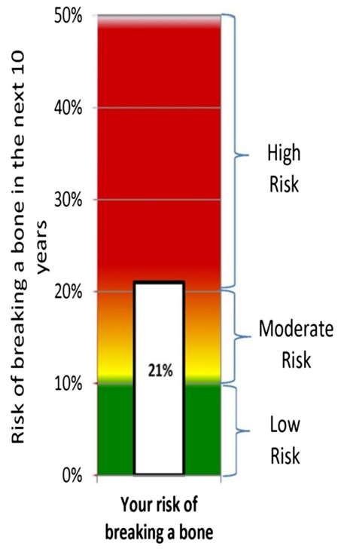

  - I will now question you about your preference for these different presentations. Which of these presentations do you prefer ? Please refer to the three examples below:

Proposals |  | Your preference
Proposal 1 |  | ☐
Proposal 2 |  | ☐
Proposal 3 |  | ☐

Again, doctors will likely communicate your risk of fracture with and without an OP treatment to highlight the potential benefits of an osteoporosis treatment on the fracture risk.
Example:

Your risk of fracture without medical treatment |  | Your risk of fracture with medical treatment
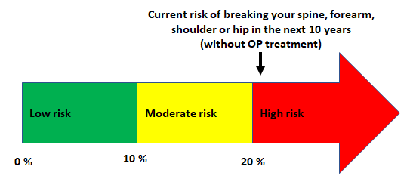 |  | 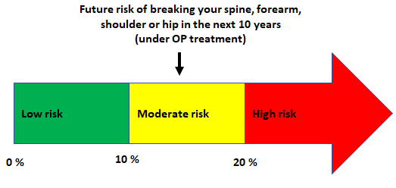

  - Do you consider this comparison of fracture risk with and without medical treatment to be useful?
Not useful |  |  | Neutral |  |  | Very useful
☐ | ☐ | ☐ | ☐ | ☐ | ☐ | ☐
1 | 2 | 3 | 4 | 5 | 6 | 7
  - Would you feel motivated to undertake lifestyle changes (e.g., doing more physical activity, ensure a diet rich in calcium, stop smoking, reduce alcohol consumption, follow a fall prevention programme) to lower your risk, if fracture risk is presented using coloured graphs?
Not at all |  |  | Neutral |  |  | Yes very much
☐ | ☐ | ☐ | ☐ | ☐ | ☐ | ☐
1 | 2 | 3 | 4 | 5 | 6 | 7

  - Would you feel motivated to take a medical treatment (i.e. an osteoporotic drug) (associated with only minor transient side effects) to lower your risk, if fracture risk is presented using coloured graphs as presented above?
Not at all |  |  | Neutral |  |  | Yes very much
☐ | ☐ | ☐ | ☐ | ☐ | ☐ | ☐
1 | 2 | 3 | 4 | 5 | 6 | 7

PRESENTATION 3: Visual presentation of the risk using icon array
Another way to communicate about 10-year fracture risk is using a visual presentation called “Icon array” which uses objects such as faces to communicate risk.
Example:
Your 10-year fracture risk is still 21%. Here we use an icon array using faces, a picture diagram with 100 faces. In our example, 79 faces were smiling indicating that 79 out of 100 persons will not break a bone in the next 10 years and 21 faces were colored red and frowning, indicating that 21 out of 100 will break a bone in the next 10 years. We do not know which one of these 100 faces will be you.

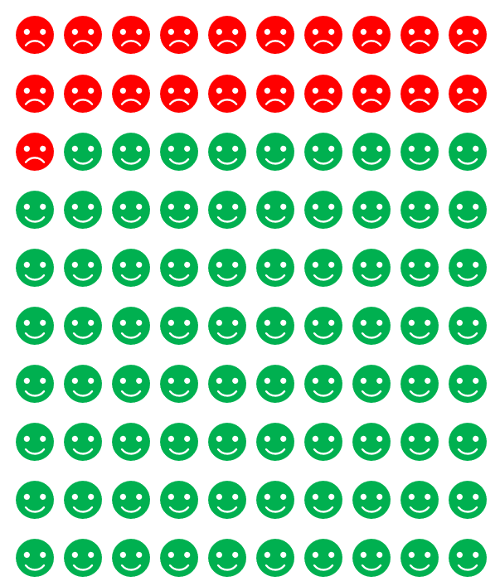

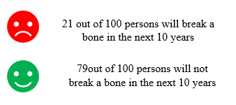

  - Do you consider this presentation of risk easy to understand?

Very difficult to understand |  |  | Neutral |  |  | Very easy to understand
☐ | ☐ | ☐ | ☐ | ☐ | ☐ | ☐
1 | 2 | 3 | 4 | 5 | 6 | 7

  - How would you feel if you were told you had this level of fracture risk? ?
Verry worried about risk |  |  | Neutral |  |  | Not worried about risk
☐ | ☐ | ☐ | ☐ | ☐ | ☐ | ☐
1 | 2 | 3 | 4 | 5 | 6 | 7

I will now show you some different examples of face arrays and ask your opinion on each:
Proposal 1. Add a scale.
The face arrays on the left shows 21 unhappy faces and the one on the right presents the same information with a reference scale. Which one is better?
- Your preference: |  | 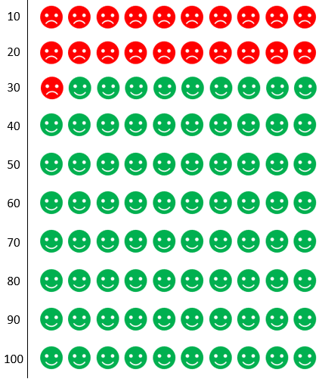
No preference  ☐ | ☐ | ☐
Proposal 2. Inverse the scale
Is it better to have the unhappy faces at the top or at the bottom?
- Your preference: |  | 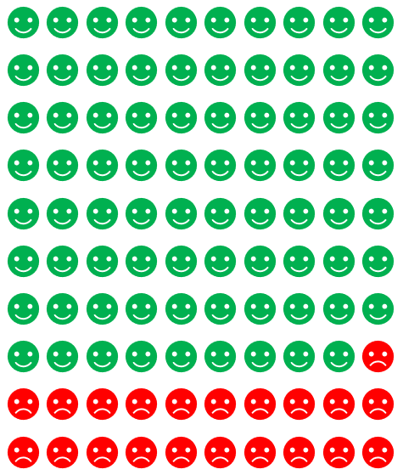
No preference  ☐ | ☐ | ☐
Proposal 3. Using less faces
Are many smiling faces confusing?
- Your preference: |  | 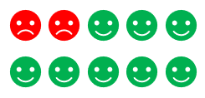
No preference  ☐ | ☐ | ☐
Proposal 4. Use colour
Does colour help you understand your risk compared to black and white?
- Your preference: |  | 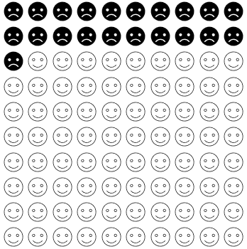
No preference  ☐ | ☐ | ☐

Proposal 5. Use icon arrays with different objects
Which one do you prefer? Unhappy faces, broken bones or persons?
- Your preference: |  | 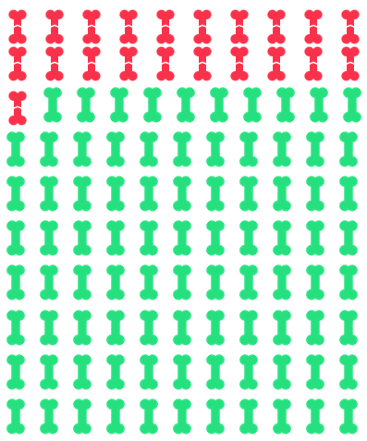 | 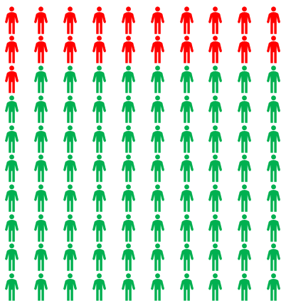
No preference  ☐ | ☐ | ☐ | ☐

Alternatively, doctors could also compare your risk of fracture without or with an osteoporosis treatment to highlight the potential benefits of an osteoporosis treatment on the fracture risk.
Example:
If we look at the picture of the left, each colored spot represents a person like you. Over the next 10 years, for 100 people like you, 79 (shown in green) of these 100 people will not break a bone and 21 (shown in red) will. Now if we take a look at the picture on the right, this is the difference that medicine could make. If these same 100 people were to take osteoporosis medication, 87 would not break a bone over the next 10 years (indicated by both the green and yellow icons). The 8 icons in yellow represent the people who have avoided breaking a bone by engaging in treatment. However, the remaining 13 (shown in red) of 100 people would still break a bone over the next 10 years. We do not know which one of these 100 colored spots will be you

Your risk of fracture without medical treatment |  | Your risk of fracture with medical treatment
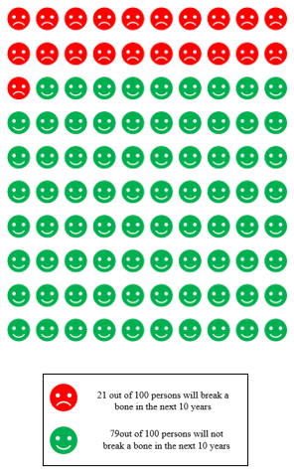 |  | 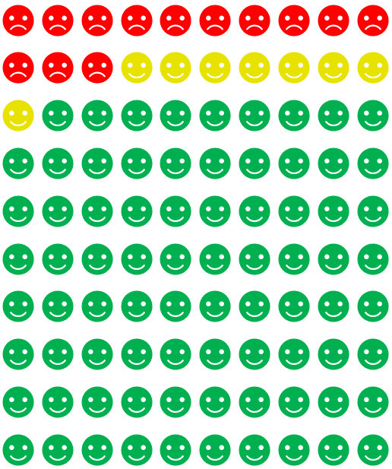  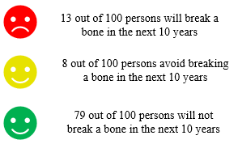

  - Do you consider the adding of effects of medical treatment on fracture risk useful?
Not useful at all |  |  | Neutral |  |  | Very useful
☐ | ☐ | ☐ | ☐ | ☐ | ☐ | ☐
1 | 2 | 3 | 4 | 5 | 6 | 7

  - Would you feel motivated to undertake lifestyle changes (e.g., doing more physical activity, ensure a diet rich in calcium, stop smoking, reduce alcohol consumption, follow a fall prevention programme) to lower your risk, if fracture risk is presented using icon arrays?
Not at all |  |  | Neutral |  |  | Yes very much
☐ | ☐ | ☐ | ☐ | ☐ | ☐ | ☐
1 | 2 | 3 | 4 | 5 | 6 | 7

  - Would you feel motivated to take a medical treatment (i.e. an osteoporotic drug) (associated with only minor transient side effects) to lower your risk, if fracture risk is presented using icon arrays as presented above?
Not at all |  |  | Neutral |  |  | Yes very much
☐ | ☐ | ☐ | ☐ | ☐ | ☐ | ☐
1 | 2 | 3 | 4 | 5 | 6 | 7

- Preferences between presentations
We would like to know your preference among the three different ways of communicating fracture risk.
  - Could you please rank the 3 presentations, from the easiest to understand (1) to the most difficult to understand (3):
 | Ranking  1= easiest to understand  3= most difficult to understand  Circle your choice | Ranking  1= most convincing to start an osteoporosis treatment  3= less convincing to start an osteoporosis treatment  Circle your choice
PRESENTATION 1: verbal/written presentation  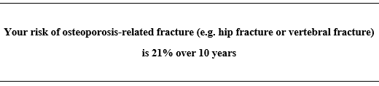 | 1 - 2 - 3 | 1 - 2 - 3
PRESENTATION 2: Visual presentation of the risk using a colored graph | 1 - 2 - 3 | 1 - 2 - 3
PRESENTATION 3: Visual presentation of the risk using icon arrays  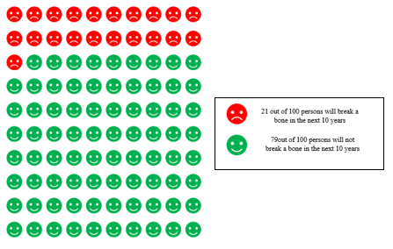 | 1 - 2 - 3 | 1 - 2 - 3

- Additional questions regarding the way to communicate fracture risk
I will now ask you about other factors that may influence your understanding of your fracture risk.
You probably know that osteoporotic fractures may have important consequences on your health. To effectively communicate one’s fracture risk, doctors may discuss the consequences of a fracture on your individual health.
    - In the following table, we will ask you to perform two different tasks. First, could you please indicate whether you would like to receive the information on the 5 following potential consequences of an osteoporotic fracture? Chose as many consequences as you want by ticking the corresponding case in first column. Then, could you please rate these five consequences from 1 (most important consequence to communicate to patients) to 5 (least important consequence to communicate to patients)?

 | Please tick the case if you would like to know each of the following risk for you | Please rank the consequences from the most important (1) to the least important (5) to you
Increased risk of dying

Increased risk of being unable to walk on your own
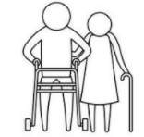
Increased risk of losing your independence (requiring the need of a caregiver or entering in nursing home)
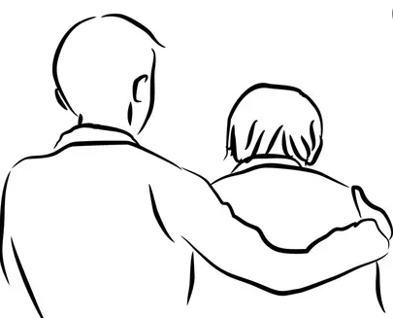
Increased risk of losing your quality of life
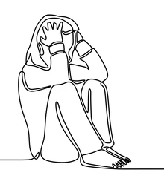
Increased your risk of being stooped over (being kyphotic, bent over looking at the ground)
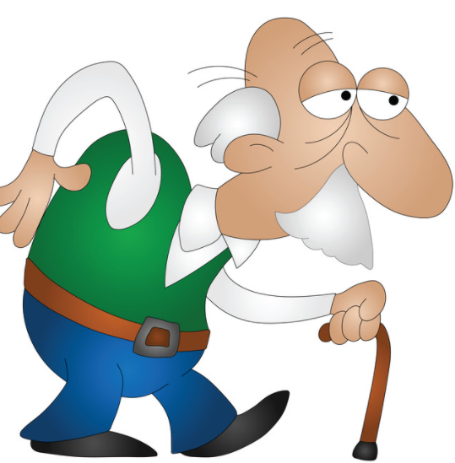

    - Do you consider the use of pictures helpful for this communication?
☐ Yes
☐ No
☐ I do not have a preference/opinion

  - In addition to a visual presentation of your fracture risk, how important do you consider further explanation provided by a health professional (such as a doctor or nurse)?
Not necessary at all |  |  | Neutral |  |  | Absolutely necessary
☐ | ☐ | ☐ | ☐ | ☐ | ☐ | ☐
1 | 2 | 3 | 4 | 5 | 6 | 7
…………………………………………………………………………………………………..
…………………………………………………………………………………………………..

  - To what extent do you consider it important for a patient to receive the information about their fracture risk in a printed form to take home?
Not necessary at all |  |  | Neutral |  |  | Absolutely necessary
☐ | ☐ | ☐ | ☐ | ☐ | ☐ | ☐
1 | 2 | 3 | 4 | 5 | 6 | 7
…………………………………………………………………………………………………..
………………………………………………………………………………………………….

  - What do you think about the development of an online tool that would allow you to access a visual representation of your fracture risk both at home and/or with your doctor?

Not relevant |  |  | Neutral |  |  | Very relevant
☐ | ☐ | ☐ | ☐ | ☐ | ☐ | ☐
1 | 2 | 3 | 4 | 5 | 6 | 7
…………………………………………………………………………………………………..
………………………………………………………………………………………………….

Appendix 3. Results of Phase II
Table A3. Preferences for fracture risk communication according to the presence of history of fractures
 | History of fracture (n=160) | No history of fracture (n=172) | p-value ª
Oral/written communication  Easy to understand (1-7)  Feel worried (1-7)  Add FR with treatment (1-7)  Lifestyle change (1-7)  Medical treatment (1-7) | 5.20±1.92  3.27±1.74  6.19±1.40  6.18±1.28  6.10±1.38 | 5.08±1.93  3.45±1.79  6.01±1.42  5.94±1.59  5.52±1.74 | 0.56  0.36  0.26  0.13  0.001
Coloured graph  Easy to understand (1-7)  Feel worried (1-7)  Add FR with treatment (1-7)  Lifestyle change (1-7)  Medical treatment (1-7) | 6.40±1.24  2.70±1.95  6.18±1.55  6.07±1.43  6.09±1.35 | 6.35±1.21  2.78±1.81  6.06±1.51  6.13±1.41  5.78±1.68 | 0.74  0.70  0.51  0.71  0.07
Preference for three graphs  Horizontal with arrow  Horizontal scaled on 100  Vertical | 64 (40.0)  52 (32.5)  44 (27.5) | 78 (45.3)  54 (31.4)  40 (23.3) | 0.55
Icon array  Easy to understand (1-7)  Feel worried (1-7)  Add FR with treatment (1-7)  Lifestyle change (1-7)  Medical treatment (1-7) | 5.44±2.03  3.80±1.96  5.63±1.88  5.71±1.67  5.57±1.80 | 4.96±2.13  3.63±1.86  5.63±1.80  5.49±1.80  5.23±1.87 | 0.04  0.41  0.99  0.27  0.09
General preference (easier to understand)  Simple oral/written presentation of %  Coloured graphs  Icon arrays | 25 (15.6)  103 (64.4)  34 (21.3) | 34 (19.8)  100 (58.1)  37 (21.5) | 0.39  0.26  1.00
General preference (for treatment initiation)  Simple oral/written presentation of %  Coloured graphs  Icon arrays | 27 (16.9)  100 (62.5)  35 (21.9) | 35 (20.3)  103 (59.9)  34 (19.8) | 0.48  0.65  0.69
Additional considerations
Oral explanation from caregivers (1-7) | 6.53±1.24 | 6.57±1.02 | 0.76
Information printed (1-7) | 6.27±1.44 | 6.26±1.39 | 0.96
Development of an online website (1-7) | 5.54±1.82 | 5.56±1.82 | 0.89
Nb. Quantitative variables are expressed in mean±SD; binary and categorial variables are expressed in absolute and relative frequencies , n(%).
ª p-value assessing statistical differences between groups were obtained using a Chi² test (or exact Fisher test) for categorial/binary variables and using a student T-test for quantitative variable

Table A4. Preferences for fracture risk communication according to educational level
 | With college degree (n=214) | Without college degree (n=118) | p-value ª
Oral/written communication  Easy to understand (1-7)  Feel worried (1-7)  Add FR with treatment (1-7)  Lifestyle change (1-7)  Medical treatment (1-7) | 5.16±1.90  3.40±1.68  6.06±1.42  6.20±1.39  5.81±1.58 | 5.09±1.96  3.29±1.91  6.17±1.39  5.78±1.51  5.78±1.65 | 0.77  0.57  0.48  0.01  0.88
Coloured graph  Easy to understand (1-7)  Feel worried (1-7)  Add FR with treatment (1-7)  Lifestyle change (1-7)  Medical treatment (1-7) | 6.48±1.06  2.66±1.84  6.15±1.56  6.21±1.38  6.00±1.52 | 6.19±1.47  2.88±1.94  6.05±1.47  5.92±1.47  5.81±1.56 | 0.04  0.31  0.55  0.07  0.28
Preference for three graphs  Horizontal with arrow  Horizontal scaled on 100  Vertical | 95 (44.4)  69 (32.2)  50 (23.4) | 47 (39.8)  37 (31.4)  34 (28.8) | 0.16
Icon array  Easy to understand (1-7)  Feel worried (1-7)  Add FR with treatment (1-7)  Lifestyle change (1-7)  Medical treatment (1-7) | 5.08±2.14  3.85±1.88  5.50±1.94  5.54±1.78  5.25±1.86 | 5.39±2.00  3.46±1.94  5.86±1.61  5.70±1.67  5.64±1.79 | 0.20  0.07  0.09  0.41  0.06
General preference (easier to understand)  Simple oral/written presentation of %  Coloured graphs  Icon arrays | 35 (16.4)  133 (62.1)  47 (22.0) | 24 (20.3)  70 (59.3)  24 (20.3) | 0.37  0.64  0.78
General preference (for treatment initiation)  Simple oral/written presentation of %  Coloured graphs  Icon arrays | 36 (16.8)  135 (63.1)  45 (21.0) | 26 (22.0)  68 (57.6)  24 (20.3) | 0.24  0.35  1.00
Additional considerations
Oral explanation from caregivers (1-7) | 6.61±1.01 | 6.44±1.32 | 0.19
Information printed (1-7) | 6.26±1.43 | 6.28±1.39 | 0.89
Development of an online website (1-7) | 5.78±1.75 | 5.14±1.87 | 0.002
Nb. Quantitative variables are expressed in mean±SD; binary and categorial variables are expressed in absolute and relative frequencies , n(%).
ª p-value assessing statistical differences between groups were obtained using a Chi² test (or exact Fisher test) for categorial/binary variables and using a student T-test for quantitative variable

Table A5. Preferences for fracture risk communication according to OP treatment
 | OP treatment (n=167) | Non OP treatment (n=165) | p-value ª
Oral/written communication  Easy to understand (1-7)  Feel worried (1-7)  Add FR with treatment (1-7)  Lifestyle change (1-7)  Medical treatment (1-7) | 5.26±1.92  3.32±1.72  6.23±1.39  6.08±1.37  6.32±1.22 | 5.01±1.92  3.41±1.81  5.96±1.43  6.02±1.53  5.27±1.76 | 0.24  0.65  0.09  0.74  <0.001
Coloured graph  Easy to understand (1-7)  Feel worried (1-7)  Add FR with treatment (1-7)  Lifestyle change (1-7)  Medical treatment (1-7) | 6.41±1.17  2.55±1.74  6.23±1.55  6.14±1.37  6.31±1.26 | 6.34±1.28  2.93±1.98  6.00±1.49  6.07±1.46  5.54±1.68 | 0.58  0.06  0.16  0.62  <0.001
Preference for three graphs  Horizontal with arrow  Horizontal scaled on 100  Vertical | 71 (42.5)  51 (30.5)  39 (23.6) | 71 (43.0)  55 (33.3)  39 (23.6) | 0.11
Icon array  Easy to understand (1-7)  Feel worried (1-7)  Add FR with treatment (1-7)  Lifestyle change (1-7)  Medical treatment (1-7) | 5.39±2.08  3.53±1.97  5.93±1.65  5.74±1.69  5.92±1.61 | 4.99±2.09  3.89±1.84  5.32±1.97  5.45±1.79  4.86±1.92 | 0.08  0.09  0.002  0.14  <0.001
General preference (easier to understand)  Simple oral/written presentation of %  Coloured graphs  Icon arrays | 27 (16.2)  101 (60.5)  39 (23.4) | 32 (19.4)  102 (61.8)  32 (19.4) | 0.47  0.82  0.42
General preference (for treatment initiation)  Simple oral/written presentation of %  Coloured graphs  Icon arrays | 27 (16.2)  102 (61.1)  38 (22.8) | 35 (21.2)  101 (61.2)  31 (18.8) | 0.26  1.00  0.42
Additional considerations
Oral explanation from caregivers (1-7) | 6.65±0.98 | 6.45±1.26 | 0.1
Information printed (1-7) | 6.30±1.31 | 6.23±1.52 | 0.66
Development of an online website (1-7) | 5.62±1.80 | 5.48±1.84 | 0.51
Nb. Quantitative variables are expressed in mean±SD; binary and categorial variables are expressed in absolute and relative frequencies , n(%).
ª p-value assessing statistical differences between groups were obtained using a Chi² test (or exact Fisher test) for categorial/binary variables and using a student T-test for quantitative variable

Table A6. Preferences for fracture risk communication according to osteoporosis status
 | Osteoporosis (n=284) | No osteoporosis (n=48) | p-value ª
Oral/written communication  Easy to understand (1-7)  Feel worried (1-7)  Add FR with treatment (1-7)  Lifestyle change (1-7)  Medical treatment (1-7) | 5.14±1.93  3.26±1.74  6.17±1.39  6.13±1.40  5.92±1.55 | 5.12±1.89  3.94±1.80  5.69±1.47  5.58±1.66  5.08±1.76 | 0.97  0.01  0.03  0.01  0.001
Coloured graph  Easy to understand (1-7)  Feel worried (1-7)  Add FR with treatment (1-7)  Lifestyle change (1-7)  Medical treatment (1-7) | 6.40±1.25  2.56±1.81  6.23±1.48  6.21±1.33  6.04±1.46 | 6.23±1.06  3.83±1.91  5.46±1.66  5.46±1.70  5.29±1.81 | 0.37  <0.001  0.001  0.001  0.002
Preference for three graphs  Horizontal with arrow  Horizontal scaled on 100  Vertical | 113 (39.8)  99 (34.9)  72 (25.4) | 29 (60.4)  7 (14.6)  12 (25.0) | 0.009
Icon array  Easy to understand (1-7)  Feel worried (1-7)  Add FR with treatment (1-7)  Lifestyle change (1-7)  Medical treatment (1-7) | 5.18±2.13  3.71±1.93  5.73±1.81  5.74±1.67  5.55±1.76 | 5.23±1.89  3.69±1.82  5.00±1.89  4.75±1.94  4.46±2.07 | 0.89  0.93  0.01  <0.001  <0.001
General preference (easier to understand)  Simple oral/written presentation of %  Coloured graphs  Icon arrays | 53 (18.7)  175 (61.6)  57 (20.1) | 6 (12.5)  25 (58.3)  14 (29.2) | 0.41  0.75  0.18
General preference (for treatment initiation)  Simple oral/written presentation of %  Coloured graphs  Icon arrays | 54 (19.0)  173 (60.9)  59 (20.8) | 8 (16.7)  30 (62.5)  10 (20.8) | 0.84  0.87  1.00
Additional considerations
Oral explanation from caregivers (1-7) | 6.58±1.10 | 5.40±1.28 | 0.30
Information printed (1-7) | 6.30±1.39 | 6.08±1.54 | 0.34
Development of an online website (1-7) | 5.64±1.79 | 5.02±1.91 | 0.03
Nb. Quantitative variables are expressed in mean±SD; binary and categorial variables are expressed in absolute and relative frequencies , n(%).
ª p-value assessing statistical differences between groups were obtained using a Chi² test (or exact Fisher test) for categorial/binary variables and using a student T-test for quantitative variable

Table A7. Preferences for fracture risk communication according to literacy level
 | Low numeric literacy (n=116) | Medium numeric literacy (n=132) | High numeric literacy (n=83) | p-value ª
Oral/written communication  Easy to understand (1-7)  Feel worried (1-7)  Add FR with treatment (1-7)  Lifestyle change (1-7)  Medical treatment (1-7) | 5.10±2.05  3.20±1.87  6.19±1.54  6.03±1.50  6.05±1.44 | 5.15±1.88  3.41±1.63  6.03±1.27  6.00±1.44  5.79±1.52 | 5.17±1.84  3.54±1.82  6.11±1.41  6.22±1.31  5.48±1.89 | 0.52  0.41  0.85  0.73  0.10
Coloured graph  Easy to understand (1-7)  Feel worried (1-7)  Add FR with treatment (1-7)  Lifestyle change (1-7)  Medical treatment (1-7) | 6.28±1.46  2.75±1.98  6.17±1.47  6.08±1.47  6.08±1.46 | 6.48±0.90  2.80±1.85  6.16±1.41  6.06±1.40  5.89±1.47 | 6.39±1.29  2.63±1.79  6.00±1.77  6.24±1.36  5.84±1.66 | 0.62  0.22  0.73  0.78  0.67
Preference for three graphs  Horizontal with arrow  Horizontal scaled on 100  Vertical | 54 (46.6)  31 (26.7)  31 (26.7) | 49 (37.1)  50 (37.9)  33 (25.0) | 38 (45.8)  25 (30.1)  20 (24.1) | 0.38
Icon array  Easy to understand (1-7)  Feel worried (1-7)  Add FR with treatment (1-7)  Lifestyle change (1-7)  Medical treatment (1-7) | 5.31±2.14  3.36±1.95  5.73±1.89  5.96±1.55  5.76±1.77 | 4.98±2.07  3.88±1.85  5.55±1.72  5.39±1.76  5.17±1.83 | 5.33±2.07  3.93±1.91  5.59±1.96  5.45±1.91  5.28±1.86 | 0.57  0.06  0.61  0.06  0.07
General preference (easier to understand)  Simple oral/written presentation of %  Coloured graphs  Icon arrays | 21 (18.1)  62 (53.4)  32 (27.6) | 25 (18.9)  84 (63.6)  23 (17.4) | 13 (15.7)  56 (67.5)  16 (19.3) | 0.83  0.09  0.13
General preference (for treatment initiation)  Simple oral/written presentation of %  Coloured graphs  Icon arrays | 22 (19.0)  63 (54.4)  31 (26.7) | 24 (18.2)  84 (63.6)  24 (18.2) | 16 (19.3)  55 (66.3)  14 (16.9) | 0.98  0.17  0.15
Additional considerations
Oral explanation from caregivers (1-7) | 6.46±1.27 | 6.60±1.02 | 6.64±1.07 | 0.25
Information printed (1-7) | 5.99±1.76 | 6.50±0.93 | 6.30±1.45 | 0.02
Development of an online website (1-7) | 5.27±1.96 | 5.61±1.73 | 5.90±1.63 | 0.05
Nb. Quantitative variables are expressed in mean±SD; binary and categorial variables are expressed in absolute and relative frequencies , n(%).
ª p-value assessing statistical differences between groups were obtained using a Chi² test (or exact Fisher test) for categorial/binary variables and using ANOVA test for quantitative variable

