Online Resource 2. Quality assessment and summary of study quality using a modified version of the QUADAS-2 tool.
Table SI1. Signaling questions in the original and modified QUADAS-2 tool.
Domain |  | Original QUADAS-2 tool | Modified QUADAS-2 tool
1. Patient Selection | Risk of bias | - Was a consecutive or random sample of patients enrolled?  - Was a case-control design avoided?  - Did the study avoid inappropriate exclusions?  - Could the selection of patients have introduced bias? | - Was a consecutive or random sample of patients enrolled?  - Was a case-control design avoided?  - Did the study avoid inappropriate exclusions?  - Could the selection of patients have introduced bias?
1. Patient Selection | Concerns regarding applicability | - Is there concern that the included patients do not match the review question? | - Were participants representative of individuals from the general population?
2. Index Test | Risk of bias | - Were the index test results interpreted without knowledge of the results of the reference standard?  - If a threshold was used, was it pre-specified?  - Could the conduct or interpretation of the index test have introduced bias? | - Were investigators working on the index tests blinded to fracture status?  - Were pre-specified diagnostic thresholds used to assess discriminative ability?  - Could the conduct or interpretation of the index test have introduced bias?
2. Index Test | Concerns regarding applicability | - Is there concern that the index test, its conduct, or interpretation differ from the review question? | - Is there concern that the index test, its conduct, or interpretation differ from the review question?
3. Reference Standard* | Risk of bias | - Is the reference standard likely to correctly classify the target condition?  - Could the reference standard, its conduct, or its interpretation have introduced bias? | - Were fractures verified or only self-reported?  - Is there concern that the target condition as defined by the reference standard does not match the review question?
3. Reference Standard* | Concerns regarding applicability | - Is there concern that the target condition as defined by the reference standard does not match the review question? | - Is there concern that the target condition as defined by the reference standard does not match the review question?
4. Flow and Timing | Risk of bias | - Did all patients receive a reference standard?  - Did patients receive the same reference standard?  - Were all patients included in the analysis?  - Could the patient flow have introduced bias? | - Were all fractures verified with the reference standard?  - Were all fractures verified with the same methodology?  - Were at least 90% of eligible participants included in the analysis?  - Could the patient flow have introduced bias?
*One question from Domain 3: Reference Standard (“Were the reference standard results interpreted without knowledge of the results of the index test?) was excluded from the Modified Quadas-2 tool due to irrelevance.
Table SI2. Domain-wise quality assessment for the 35 studies included in the meta-analysis.
 | Patient Selection |  | Index Test |  | Reference Standard |  | Flow and Timing
Author, Year | Risk of Bias | Applicability | Risk of Bias | Applicability | Risk of Bias | Applicability | Risk of Bias
Adams, 2018
Baum, 2011
Baum, 2012
Borggrefe, 2015
Burian, 2021
Christensen, 2020
Dagan, 2020
Dieckmeyer, 2021
Dieckmeyer, 2022
Fang, 2018
Graffy, 2017
Lee, 2017
Leonhardt, 2020
Loffler, 2019
Loffler, 2021
Michalski, 2021
Neuhaus, 2016
Perrier-Cornet, 2019
Pickhardt, 2020
Pickhardt, 2022
Roux, 2021
Schwaiger, 2014
Snyder, 2009
Sollmann, 2022
Therkildsen, 2020
Valentinitsch, 2019
Zou, 2020
Kim, 2017
Allaire, 2019
Bhattacharya, 2019
Enns-Bray, 2019
Fleps, 2022
Falcinelli, 2014
Qasim, 2016
Anitha, 2017
Baum, 2014
Bodden, 2021
Buckens, 2014
Gruber, 2013
Lee, 2018
Li, 2022
Liebl, 2015
Link, 2004
Mookiah, 2018
Park, 2020
Rayudu, 2020
Schreiber, 2015
Sollmann, 2020
Sollmann, 2021
Johannesdottir, 2021
Dworak, 2018
Kopperdahl, 2014
Keyak, 2013
Gruenewald, 2022
Wang, 2023
Yosibash, 2023
Biamonte, 2022
Bodden, 2023
Carnevale, 2022
Goller, 2023
Poullain, 2023
: high risk; : low risk; : unclear risk

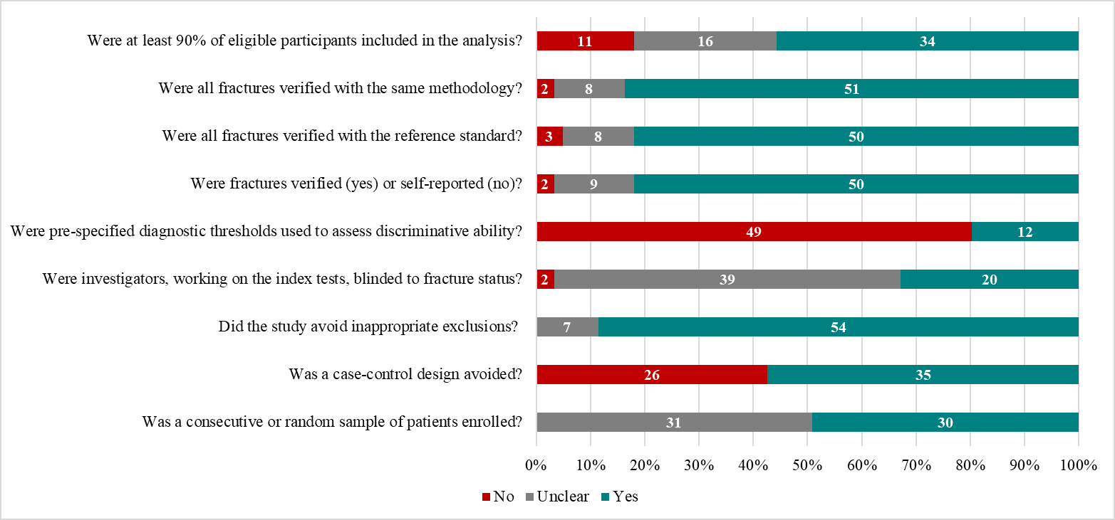
Figure SI1. Item-wise quality assessment for the 35 studies included in the meta-analysis.

