Supplementary Appendix

To

The Significance of Recent Fracture Location
For Imminent Risk of Hip and Vertebral Fractures
– a Nationwide Cohort Study on Older Adults in Sweden

By

Mattias Lorentzon, Henrik Litsne and Kristian F. Axelsson,

TABLE OF CONTENTS

Extended Methods 2
Additional Information on Registers used 2
Standardized Differences 2
Table S1: Categorization of Fracture Codes for the Hip Fracture Analysis Outcome 3
Table S1: Categorization of Fracture Codes for the Hip Fracture Analysis Outcome (continued) 4
Table S2: Categorization of Fracture Codes for the Vertebral Fracture Outcome Analysis 5
Table S2: Categorization of Fracture Codes for the Vertebral Fracture Outcome Analysis (continued) 6
Table S3: Detailed Definitions of Fractures 7
Table S4: Detailed Definitions of Covariates 8
Table S5a: Interaction p-values (group + age/sex) for Incident Hip Fracture Analysis 9
Table S5b: Interaction p-values (group + age/sex) for Incident Vertebral Fracture Analysis 10
Figure S1: Risk of Hip Fracture per Site of Recent Fracture – Subgroup Analyses 11
Figure S1a: Risk of Hip Fracture per Site of Recent Fracture – Men 12
Figure S1b: Risk of Hip Fracture per Site of Recent Fracture – Women 13
Figure S1c: Risk of Hip Fracture per Site of Recent Fracture – Age 50-64 14
Figure S1d: Risk of Hip Fracture per Site of Recent Fracture – Age 65-79 15
Figure S1e: Risk of Hip Fracture per Site of Recent Fracture – Age 80 years and older 16
Figure S1f: Risk of Hip Fracture per Site of Recent Fracture – Censored After Two Years of Follow-up 17
Figure S2: Risk of Vertebral Fracture per Site of Recent Fracture – Subgroup Analyses 18
Figure S2a: Risk of Vertebral Fracture per Site of Recent Fracture – Men 19
Figure S2b: Risk of Vertebral Fracture per Site of Recent Fracture – Women 19
Figure S2c: Risk of Vertebral Fracture per Site of Recent Fracture – Age 50-64 20
Figure S2d: Risk of Vertebral Fracture per Site of Recent Fracture – Age 65-79 20
Figure S2e: Risk of Vertebral Fracture per Site of Recent Fracture – Age 80 years and older 21
Figure S2f: Risk of Vertebral Fracture per Site of Recent Fracture – Censored After Two Years of Follow-up 21
Table S6: Adjusted Subhazard Ratios for Hip Fracture using Fine Gray Competing Risk of Death 22
Table S7: Adjusted Subhazard Ratios for Vertabral Fracture using Fine Gray Competing Risk of Death 23

Extended Methods

Additional Information on Registers used
National Patient Register started in 1964 with diagnoses from admitted patients which became compulsory nationally in 1987. Diagnoses from outpatient visits were added in 2001. Only diagnoses set by physicians are included. We only used ICD-10 codes, which has been registered since 1998.

Swedish Prescribed Drug Register: Started July 1st 2005 and includes ATC codes of prescribed and collected medications.

Standardized Differences
For categorical variables, standardized differences were calculated as follows:
https://support.sas.com/resources/papers/proceedings12/335-2012.pdf

Table S1: Categorization of Fracture Codes for the Hip Fracture Analysis Outcome
Site of recent fracture | ICD-10 code | At risk (n=)
Skull and facial bones |  | 5358
Skull and facial bones | S02 |  | 1
Vault of skull | S020 |  | 172
Base of skull | S021 |  | 485
Nasal bones | S022 |  | 1899
Orbital floor | S023 |  | 521
Malar and maxillary bones | S024 |  | 565
Tooth | S025 |  | 410
Mandible | S026 |  | 288
Multiple involving skull and facial bone | S027 |  | 278
Other skull and facial bones | S028 |  | 259
Skull and facial bones, unspecified | S029 |  | 480
Cervical vertebra |  | 1112
First cervical vertebra | S120 |  | 111
Second cervical vertebra | S121 |  | 481
Other specified cervical vertebra | S122 |  | 468
Multiple fractures of cervical spine | S127 |  | 52
Thoracic vertebra |  | 1693
Thoracic vertebra | S220 |  | 1644
Multiple fractures of thoracic spine | S221 |  | 49
Lumbar vertebra | S320 | 2663
Collapsed vertebra, unspecified | M485 | 6815
Rib |  | 8482
Single rib | S223 |  | 6727
Multiple ribs | S224 |  | 1755
Pelvis |  | 6184
Sacrum | S321 |  | 389
Coccyx | S322 |  | 141
Ilium | S323 |  | 233
Acetabulum | S324 |  | 694
Pubis | S325 |  | 3045
Other and unspecified parts of lumbar | S328 |  | 1682
Clavicle | S420 | 2914
Scapula | S421 | 946
Upper end of humerus | S422 | 11984
Shaft of humerus | S423 | 1227
Lower end of humerus | S424 | 1238
Upper end of ulna | S520 | 1638
Upper end of radius | S521 | 2204
Forearm shaft |  | 1146
Shaft of ulna | S522 |  | 403
Shaft of radius | S523 |  | 457
Shafts of both ulna and radius | S524 |  | 286
Lower end of radius | S525 | 22313
Lower end of ulna and radius | S526 | 2051
Carpus |  | 1957
Scaphoid bone of hand | S620 |  | 1204
Other carpal bones | S621 |  | 753
Metacarpus |  | 3590
First metacarpal bone | S622 |  | 522
Other metacarpal bone | S623 |  | 2993
Multiple fractures of metacarpal bones | S624 |  | 75
Finger |  | 6237
Thumb | S625 |  | 1232
Other finger | S626 |  | 4911
Multiple fingers | S627 |  | 94

Table S1: Categorization of Fracture Codes for the Hip Fracture Analysis Outcome (continued)

Site of recent fracture | ICD-10 code | At risk (n=)
Neck of femur | S720 | 12412
Pertrochanteric fracture | S721 | 8464
Subtrochanteric fracture | S722 | 1861
Shaft of femur | S723 | 1110
Lower end of femur | S724 | 1058
Patella | S820 | 1803
Upper end of tibia | S821 | 2730
Shaft of tibia | S822 | 1010
Lower end of tibia | S823 | 986
Fibula alone | S824 | 1274
Ankle |  | 7303
Lateral malleolus | S826 |  | 6535
Medial malleolus | S825 |  | 768
Other parts of lower leg | S828 | 4340
Tarsus |  | 1183
Calcaneus | S920 |  | 627
Talus | S921 |  | 184
Other tarsal bones | S922 |  | 372
Metatarsus | S923 | 3689
Toe |  | 2408
Great toe | S924 |  | 963
Other toe | S925 |  | 1445
Other recent fracture |  | 2397
Neck | S12 |  | 3
Other parts of neck | S128 |  | 23
Neck part, unspecified | S129 |  | 79
Sternum | S222 |  | 370
Flail chest | S225 |  | 13
Other parts of bony thorax | S228 |  | 21
Bony thorax part, unspecified | S229 |  | 134
Multiple fractures of lumbar spine and pelvis | S327 |  | 99
Multiple fractures of clavicle scapula and humerus | S427 |  | 14
Other parts of shoulder and upper arm | S428 |  | 80
Shoulder girdle part, unspecified | S429 |  | 47
Multiple fractures of forearm | S527 |  | 11
Other parts of forearm | S528 |  | 386
Forearm part, unspecified | S529 |  | 112
Other and unspecified parts of wrist or hand | S628 |  | 285
Multiple fractures of femur | S727 |  | 15
Other parts of femur | S728 |  | 124
Femur part, unspecified | S729 |  | 142
Multiple fractures of lower leg | S827 |  | 53
Lower leg part, unspecified | S829 |  | 71
Multiple fractures of foot | S927 |  | 23
Foot, unspecified | S929 |  | 129
Fractures involving multiple body regions | T02x |  | 92
Fracture involving spine, unspecified part | T089 |  | 27
Fracture involving upper limb, unspecified part | T109 |  | 17
Fracture involving lower limb, unspecified part | T129 |  | 17
Unspecified body region | T142 |  | 10

Table S2: Categorization of Fracture Codes for the Vertebral Fracture Outcome Analysis
Site of recent fracture | ICD-10 code | At risk (n=)
Skull and facial bones |  | 5,358
Skull and facial bones | S02 |  | 1
Vault of skull | S020 |  | 172
Base of skull | S021 |  | 485
Nasal bones | S022 |  | 1,899
Orbital floor | S023 |  | 521
Malar and maxillary bones | S024 |  | 565
Tooth | S025 |  | 410
Mandible | S026 |  | 288
Multiple involving skull and facial bone | S027 |  | 278
Other skull and facial bones | S028 |  | 259
Skull and facial bones, unspecified | S029 |  | 480
Rib |  | 8,482
Rib | S223 |  | 6,727
Multiple ribs | S224 |  | 1,755
Any vertebra |  | 5,468
First cervical vertebra | S120 |  | 111
Second cervical vertebra | S121 |  | 481
Other specified cervical vertebra | S122 |  | 468
Multiple fractures of cervical spine | S127 |  | 52
Thoracic vertebra | S220 |  | 1,644
Multiple fractures of thoracic spine | S221 |  | 49
Lumbar vertebra | S320 |  | 2,663
Collapsed vertebra, unspecified | M485 | 6,815
Pelvis |  | 6,184
Sacrum | S321 |  | 389
Coccyx | S322 |  | 141
Ilium | S323 |  | 233
Acetabulum | S324 |  | 694
Pubis | S325 |  | 3,045
Other and unspecified parts of lumbar | S328 |  | 1,682
Upper end of humerus | S422 | 11,984
Upper arm, other |  | 6,466
Clavicle | S420 |  | 2,914
Scapula | S421 |  | 946
Shaft of humerus | S423 |  | 1,227
Lower end of humerus | S424 |  | 1,238
Multiple fractures of clavicle scapula and humerus | S427 |  | 14
Other parts of shoulder and upper arm | S428 |  | 80
Shoulder girdle part, unspecified | S429 |  | 47
Lower end of radius | S525 | 22,313
Forearm, other |  | 7,548
Upper end of ulna | S520 |  | 1,638
Upper end of radius | S521 |  | 2,204
Shaft of ulna | S522 |  | 403
Shaft of radius | S523 |  | 457
Shafts of both ulna and radius | S524 |  | 286
Lower end of ulna and radius | S526 |  | 2,051
Multiple fractures of forearm | S527 |  | 11
Other parts of forearm | S528 |  | 386
Forearm part, unspecified | S529 |  | 112
Carpus/metacarpus |  | 5,547
Scaphoid bone of hand | S620 |  | 1,204
Other carpal bones | S621 |  | 753
First metacarpal bone | S622 |  | 522
Other metacarpal bone | S623 |  | 2,993
Multiple fractures of metacarpal bones | S624 |  | 75

Table S2: Categorization of Fracture Codes for the Vertebral Fracture Outcome Analysis (continued)
Site of recent fracture | ICD-10 code | At risk (n=)
Finger |  | 6,237
Thumb | S625 |  | 1,232
Other finger | S626 |  | 4,911
Multiple fingers | S627 |  | 94
Hip |  | 22,737
Neck of femur | S720 |  | 12,412
Pertrochanteric fracture | S721 |  | 8,464
Subtrochanteric fracture | S722 |  | 1,861
Knee |  | 5,591
Lower end of femur | S724 |  | 1,058
Patella | S820 |  | 1,803
Upper end of tibia | S821 |  | 2,730
Ankle |  | 7,303
Medial malleolus | S825 |  | 768
Lateral malleolus | S826 |  | 6,535
Lower leg, other |  | 7,734
Shaft of tibia | S822 |  | 1,010
Lower end of tibia | S823 |  | 986
Fibula alone | S824 |  | 1,274
Multiple fractures of lower leg | S827 |  | 53
Other parts of lower leg | S828 |  | 4,340
Lower leg part, unspecified | S829 |  | 71
Foot |  | 7,432
Calcaneus | S920 |  | 627
Talus | S921 |  | 184
Other tarsal bones | S922 |  | 372
Metatarsus | S923 |  | 3,689
Great toe | S924 |  | 963
Other toe | S925 |  | 1,445
Multiple fractures of foot | S927 |  | 23
Foot, unspecified | S929 |  | 129
Other recent fracture |  | 2,581
Neck | S12 |  | 3
Other parts of neck | S128 |  | 23
Neck part, unspecified | S129 |  | 79
Sternum | S222 |  | 370
Flail chest | S225 |  | 13
Other parts of bony thorax | S228 |  | 21
Bony thorax part, unspecified | S229 |  | 134
Multiple fractures of lumbar spine and pelvis | S327 |  | 99
Other and unspecified parts of wrist or hand | S628 |  | 285
Shaft of femur | S723 |  | 1,110
Multiple fractures of femur | S727 |  | 15
Other parts of femur | S728 |  | 124
Femur part, unspecified | S729 |  | 142
Fractures involving multiple body regions | T02x |  | 92
Fracture involving spine, unspecified part | T089 |  | 27
Fracture involving upper limb, unspecified part | T109 |  | 17
Fracture involving lower limb, unspecified part | T129 |  | 17
Unspecified body region | T142 |  | 10

Table S3: Detailed Definitions of Fractures

Variable | Definitions Using ICD-10 Codes
Any Fracture | S02, S12, S22, S32, S42, S52, S62, S72, S82, S92,  T02, T08, T10, T12, T142, M485
Hip Fracture | S720-S722 with a code for surgical procedure (NFB, NFC, NFJ)
Vertebral Fracture | Cervical (S120, S121, S122, S127), thoracic (S220, S221) and lumbar (S320)

Fracture data was refined in multiple steps. First, fracture diagnoses with a simultaneous code indicating a revisit (Z09, Z47, Z48) and hip fracture diagnoses without a simultaneous code for a surgical procedure were discarded. Second, a washout period of five months was used, so that if a fracture diagnosis referring to the same skeletal site was repeated within a period of five months, the latter diagnosis was discarded to avoid including codes from revisits. All characters for the above codes were available.

Table S4: Detailed Definitions of Covariates
Variable | Definitions Using ICD-10 Codes and/or ATC-Codes
Age | At baseline
Osteoporosis medication | Prescriptions*: Bisphosphonates (M05BA and M05BB), Denosumab (M05BX04), Teriparatide (H05AA02), Strontium Ranelate (M05BX03), Raloxifene (G03XC01), Testosterone (G03BA03), Systemic estrogens (G03CA), and Tibolone (G03CX01).
 | Non-prescribed parenteral treatment offered to patients at outpatient clinics or while admitted: The combination of an osteoporosis diagnosis (M80, M81 or M859) and a code for intravenous (DT016) or subcutaneous (DT021) administration was used.
Multiple recent fracture | Two or more during the 2 most recent years  Three or more during the 2 most recent years
Charlson comorbidity index (weight) | The weighted sum of the diseases below. Diagnoses from both outpatient visits and admissions used.
Dementia (1) | F00-F03
Ischemic heart disease (1) | I20-I25
Heart failure (1) | I50
Cerebrovascular disease (1) | I60-I69
Vascular diseases (1) | I70-I79
Chronic pulmonary diseases (1) | J43-J46
Chronic liver disease (1) | K70-K77
Tumor without metastasis (2) | C00-C76, C80, C97
Lymphoma or leukemia (2) | C81-C96
Diabetes (1) | E10-E14
with end organ damage (+1) | E102, E103, E104, E105, E107, E112, E113, E114, E115, E117, H360
Kidney disease (1) | N17-N19
moderate or severe (+1) | N18.2-N18.5
Hemiplegia (2) | G81
Peptic ulcer disease (2) | K25-K27
Metastatic solid tumor (6) | C77-C79

*Recent (last prescription less than 120 days before baseline) and repeated (two or more prescriptions last year)

Table S5a: Interaction p-values (group + age/sex) for Incident Hip Fracture Analysis

Site of recent fracture | At risk (N) | Incident hip | P-value for interaction with
Site of recent fracture | At risk (N) | fractures, n (%) | Age | Sex
Skull and facial bones | 5,358 | 358 (6.7%) | <0.001 | 0.17
Cervical vertebra | 1,112 | 79 (7.1%) | 0.02 | 0.30
Thoracic vertebra | 1,693 | 181 (11%) | <0.001 | 0.01
Lumbar vertebra | 2,663 | 285 (11%) | <0.001 | 0.004
Collapsed vertebra, unspec. | 6,815 | 977 (14%) | <0.001 | <0.001
Rib | 8,482 | 668 (7.9%) | <0.001 | <0.001
Pelvis | 6,184 | 908 (15%) | <0.001 | <0.001
Clavicle | 2,914 | 203 (7.0%) | <0.001 | 0.16
Scapula | 946 | 51 (5.4%) | 0.22 | 0.007
Upper end of humerus | 11,984 | 1,471 (12%) | <0.001 | <0.001
Shaft of humerus | 1,227 | 126 (10%) | <0.001 | <0.001
Lower end of humerus | 1,238 | 127 (10%) | <0.001 | 0.09
Upper end of ulna | 1,638 | 160 (9.8%) | <0.001 | 0.04
Upper end of radius | 2,204 | 80 (3.6%) | 0.75 | 0.48
Forearm shaft | 1,146 | 81 (7.1%) | 0.04 | 0.39
Lower end of radius | 22,313 | 1,811 (8.1%) | <0.001 | <0.001
Lower end of ulna and radius | 2,051 | 222 (11%) | <0.001 | 0.67
Carpus | 1,957 | 68 (3.5%) | 0.08 | 0.15
Metacarpus | 3,590 | 229 (6.4%) | 0.001 | 0.01
Finger | 6,237 | 304 (4.9%) | 0.02 | 0.57
Neck of femur | 12,412 | 1,406 (11%) | <0.001 | <0.001
Pertrochanteric fracture | 8,464 | 905 (11%) | <0.001 | <0.001
Subtrochanteric fracture | 1,861 | 178 (9.6%) | <0.001 | <0.001
Shaft of femur | 1,110 | 86 (7.7%) | <0.001 | 0.68
Lower end of femur | 1,058 | 76 (7.2%) | <0.001 | 0.45
Patella | 1,803 | 179 (9.9%) | <0.001 | 0.16
Upper end of tibia | 2,730 | 201 (7.4%) | <0.001 | 0.001
Shaft of tibia | 1,010 | 49 (4.9%) | <0.001 | 0.33
Lower end of tibia | 986 | 49 (5.0%) | <0.001 | 0.09
Fibula alone | 1,274 | 65 (5.1%) | 0.05 | 0.19
Ankle | 7,303 | 293 (4.0%) | 0.02 | <0.001
Other parts of lower leg | 4,340 | 249 (5.7%) | <0.001 | 0.26
Tarsus | 1,183 | 61 (5.2%) | 0.08 | 0.27
Metatarsus | 3,689 | 180 (4.9%) | <0.001 | 0.27
Toe | 2,408 | 79 (3.3%) | 0.32 | 0.06
Other recent fracture | 2,397 | 247 (10%) | <0.001 | <0.001
Fracture more 2y ago | 293,051 | 20,516 (7.0%) | <0.001 | <0.001

The interaction p-values derive from two different Cox models (group variable multiplied with age and sex respectively), both analyses adjusted for age, sex, inclusion year, osteoporosis medication, multiple recent fractures and Charlson comorbidity index (=model 2).

Table S5b: Interaction p-values (group + age/sex) for Incident Vertebral Fracture Analysis
Site of recent fracture | At risk (N) | Incident vertebral | P-value for interaction with
Site of recent fracture | At risk (N) | fractures, n (%) | Age | Sex
Skull and facial bones | 5,358 | 75 (1.4%) | 0.01 | 0.70
Rib | 8,482 | 178 (2.1%) | <0.001 | 0.51
Any vertebra | 5,468 | 315 (5.8%) | <0.001 | 0.07
Collapsed vertebra, unspec. | 6,815 | 259 (3.8%) | <0.001 | 0.06
Pelvis | 6,184 | 120 (1.9%) | <0.001 | 0.43
Upper end of humerus | 11,984 | 229 (1.9%) | <0.001 | 0.90
Upper arm, other | 6,466 | 114 (1.8%) | 0.07 | 0.85
Lower end of radius | 22,313 | 276 (1.2%) | 0.03 | 0.001
Forearm, other | 7,548 | 119 (1.6%) | 0.12 | 0.21
Carpus/metacarpus | 5,547 | 90 (1.6%) | 0.67 | 0.92
Finger | 6,237 | 75 (1.2%) | 0.001 | 0.77
Hip | 22,737 | 337 (1.5%) | <0.001 | <0.001
Knee | 5,591 | 84 (1.5%) | 0.04 | 0.91
Ankle | 7,303 | 83 (1.1%) | <0.001 | 0.03
Lower leg, other | 7,734 | 92 (1.2%) | 0.05 | 0.08
Foot | 7,432 | 105 (1.4%) | 0.23 | 0.18
Other recent fracture | 2,581 | 45 (1.7%) | <0.001 | 0.64
Fracture more 2y ago | 293,051 | 3,925 (1.3%) | <0.001 | <0.001

The interaction p-values derive from two different Cox models (group variable multiplied with age and sex respectively), both analyses adjusted for age, sex, inclusion year, osteoporosis medication, multiple recent fractures and Charlson comorbidity index (=model 2).

Figure S1: Risk of Hip Fracture per Site of Recent Fracture – Subgroup Analyses
- Men
- Women
- Age 50-64
- Age 65-79
- Age ≥80
- Censored after two years of follow-up

Adjusted hazard ratios and number of patients at risk per site of recent fracture (≤ 2 years) compared to patients with no previous fracture. The Cox model is adjusted for age, sex, inclusion year, osteoporosis medication, multiple recent fractures and Charlson comorbidity index (=model 2).

Figure S1a: Risk of Hip Fracture per Site of Recent Fracture – Men
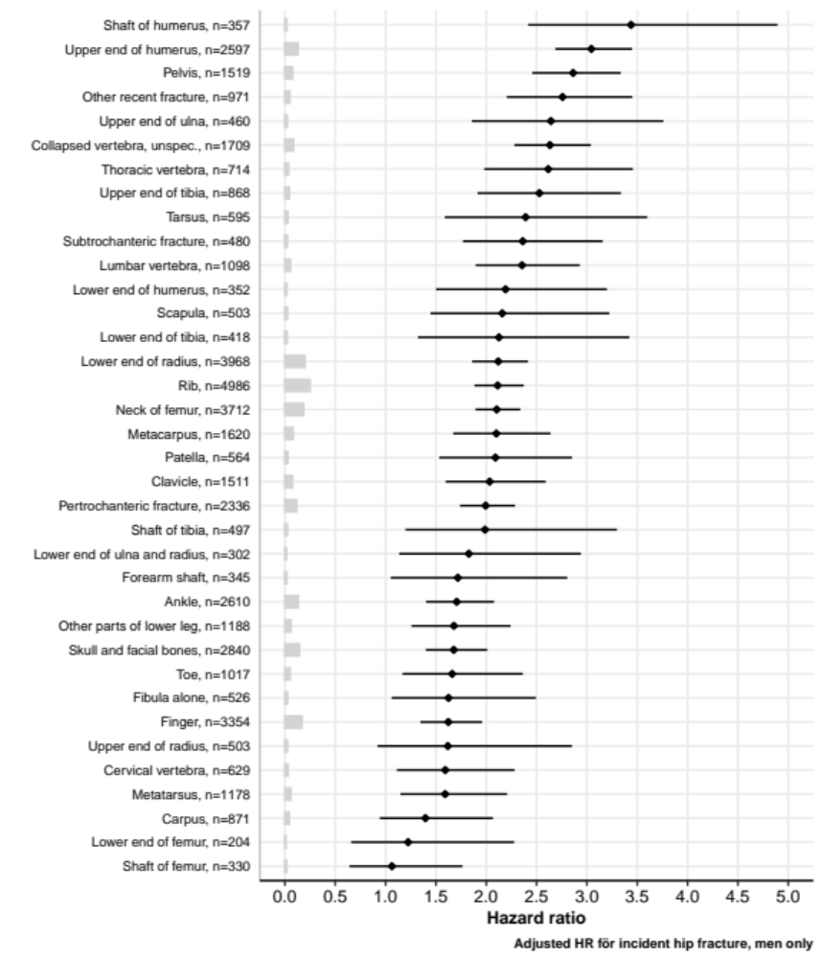

Figure S1b: Risk of Hip Fracture per Site of Recent Fracture – Women
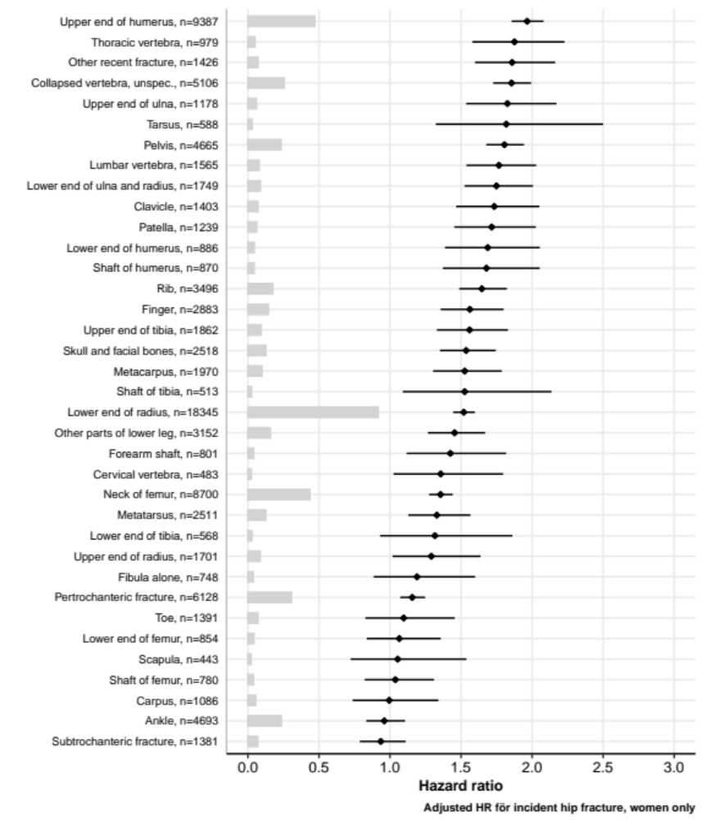

Figure S1c: Risk of Hip Fracture per Site of Recent Fracture – Age 50-64
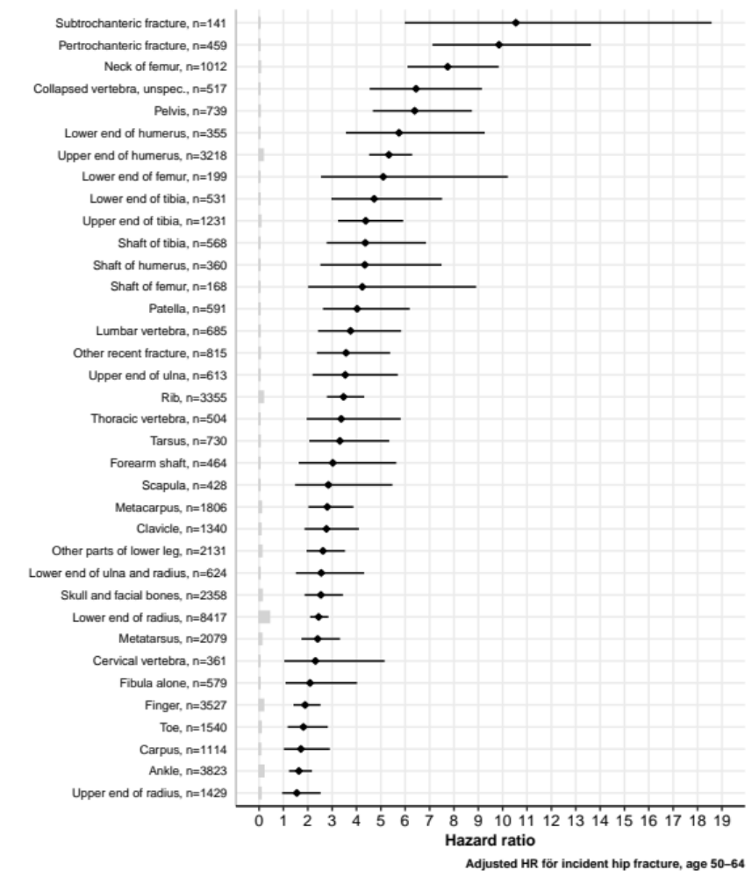

Figure S1d: Risk of Hip Fracture per Site of Recent Fracture – Age 65-79
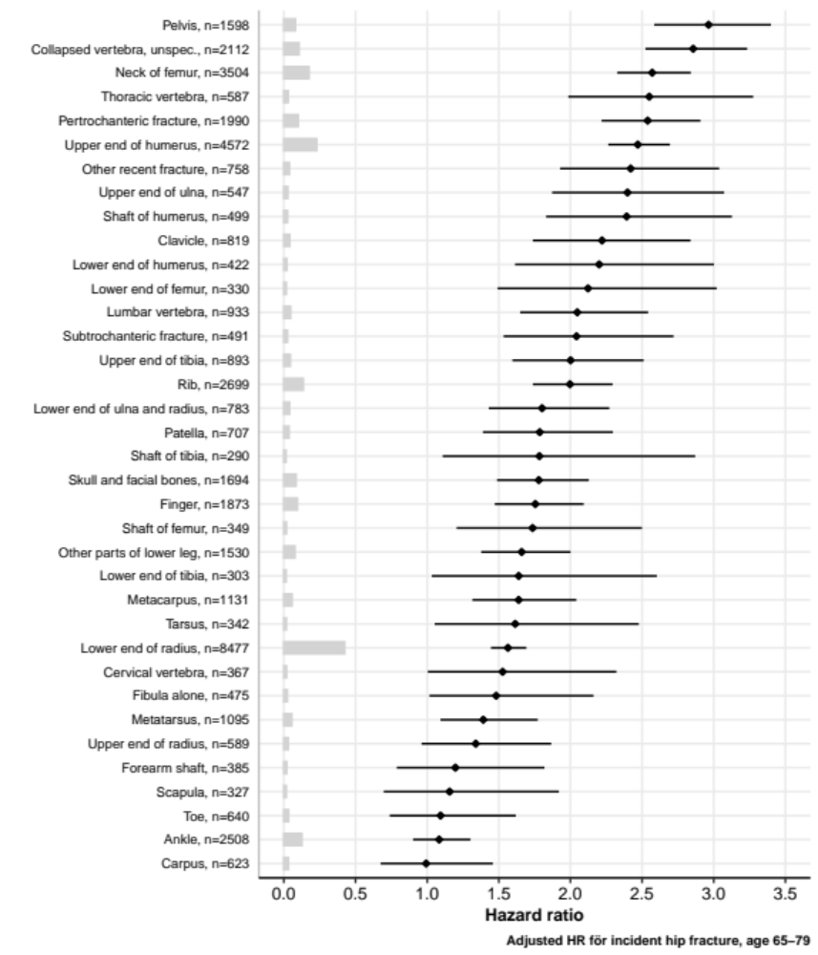

Figure S1e: Risk of Hip Fracture per Site of Recent Fracture – Age 80 years and older
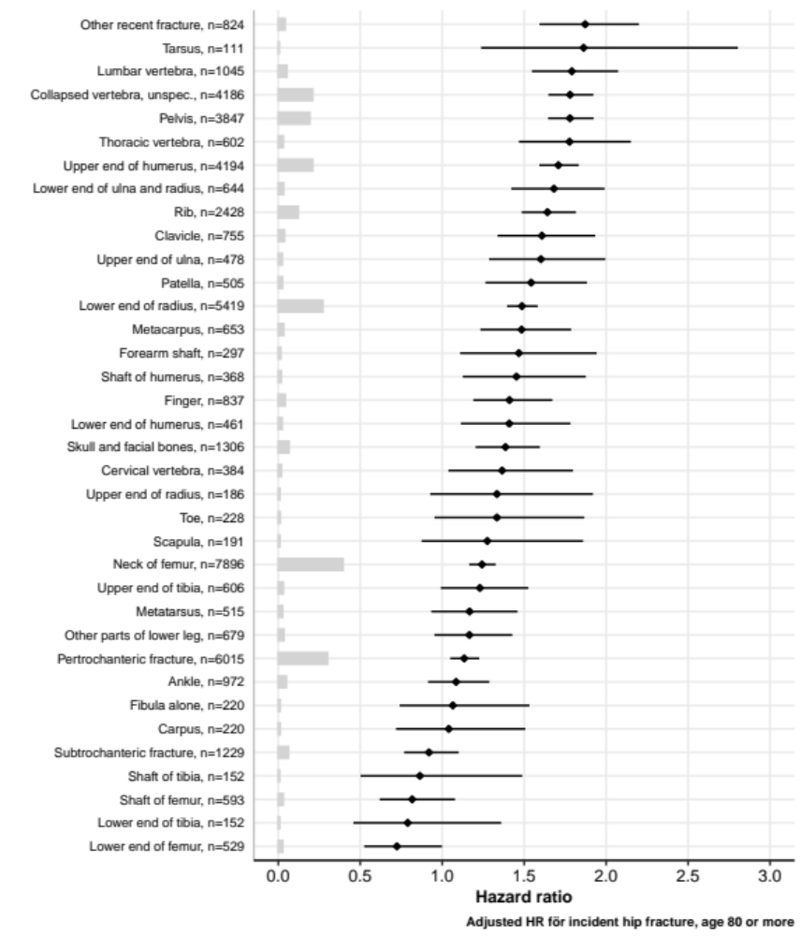

Figure S1f: Risk of Hip Fracture per Site of Recent Fracture – Censored After Two Years of Follow-up
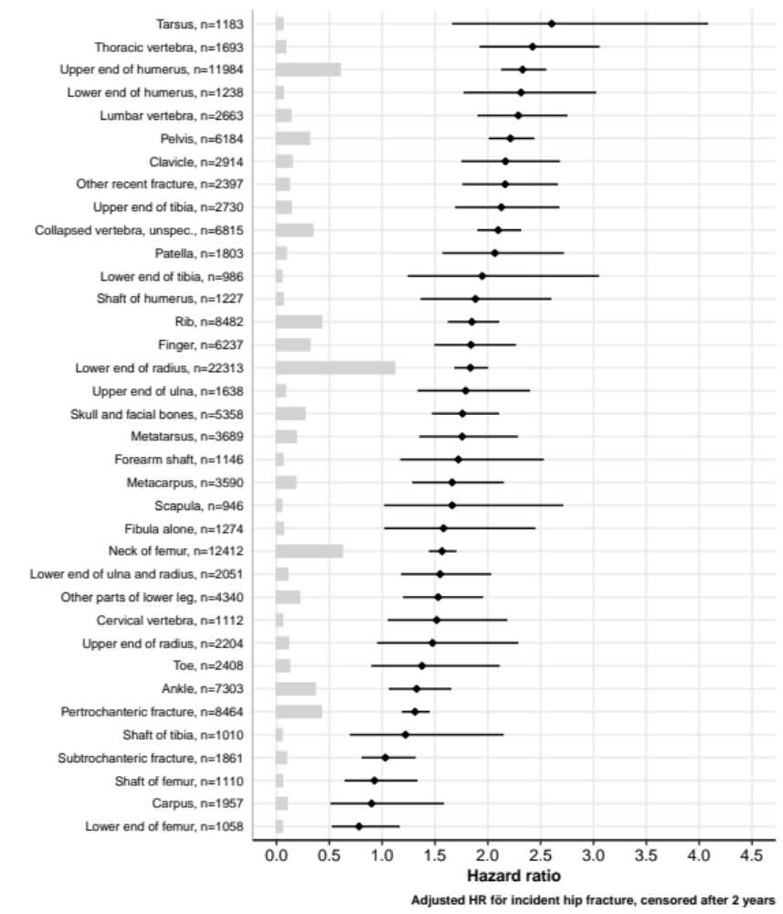

Figure S2: Risk of Vertebral Fracture per Site of Recent Fracture – Subgroup Analyses
- Men
- Women
- Age 50-64
- Age 65-79
- Age ≥80
- Censored after two years of follow-up

Adjusted hazard ratios and number of patients at risk per site of recent fracture (≤ 2 years) compared to patients with no previous fracture. The Cox model is adjusted for age, sex, inclusion year, osteoporosis medication, multiple recent fractures and Charlson comorbidity index (=model 2).

Figure S2a: Risk of Vertebral Fracture per Site of Recent Fracture – Men
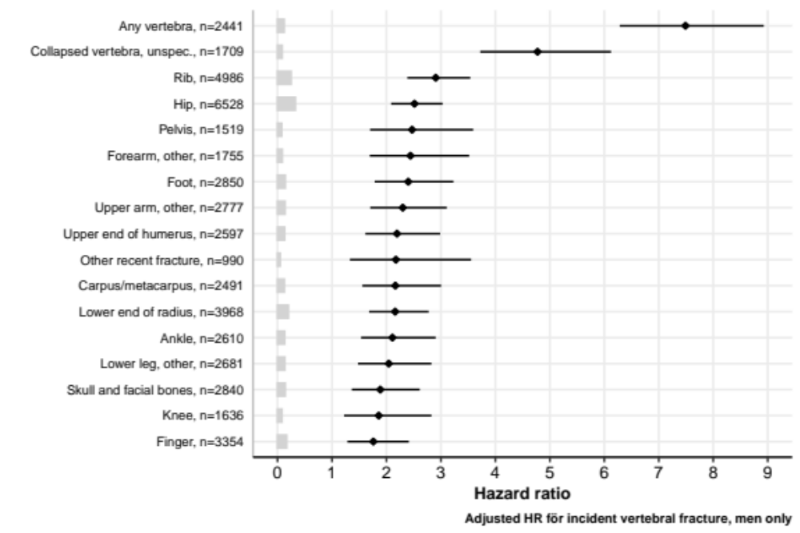

Figure S2b: Risk of Vertebral Fracture per Site of Recent Fracture – Women
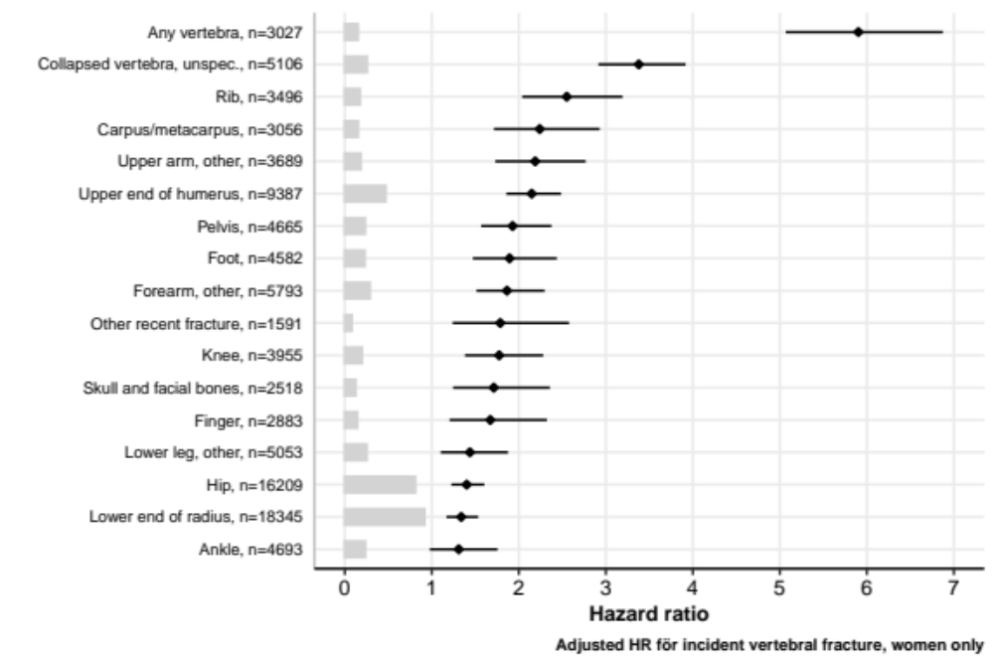

Figure S2c: Risk of Vertebral Fracture per Site of Recent Fracture – Age 50-64
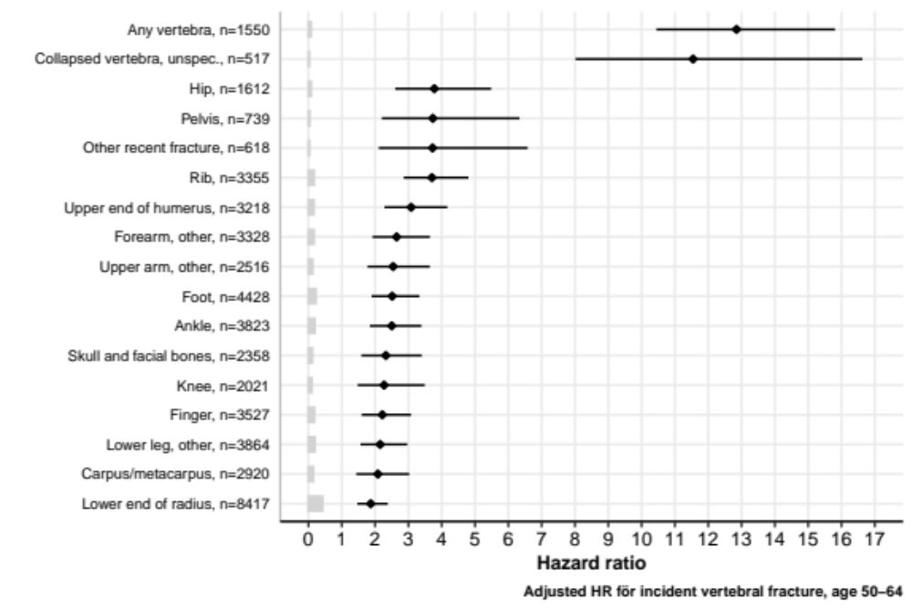

Figure S2d: Risk of Vertebral Fracture per Site of Recent Fracture – Age 65-79
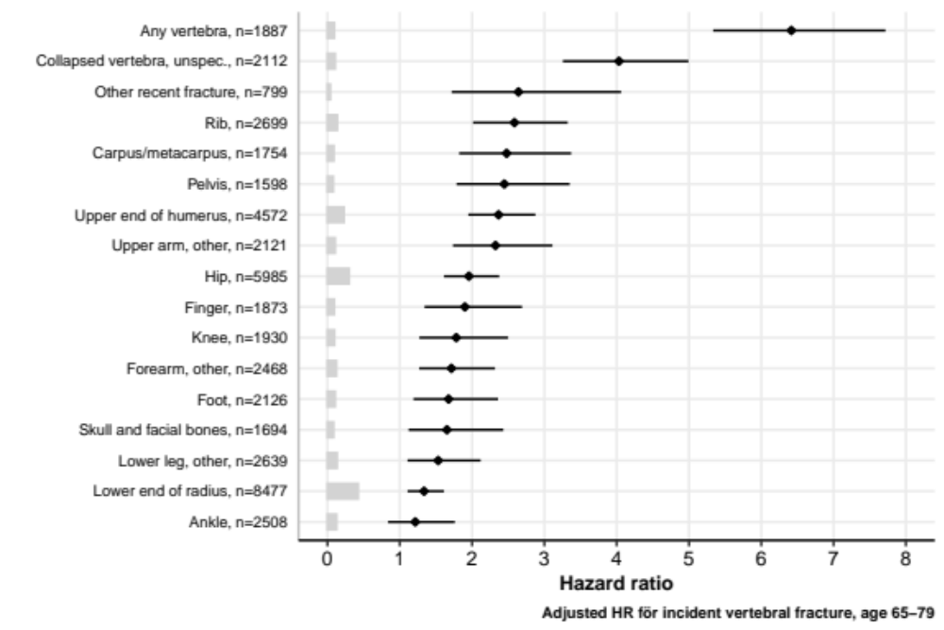

Figure S2e: Risk of Vertebral Fracture per Site of Recent Fracture – Age 80 years and older
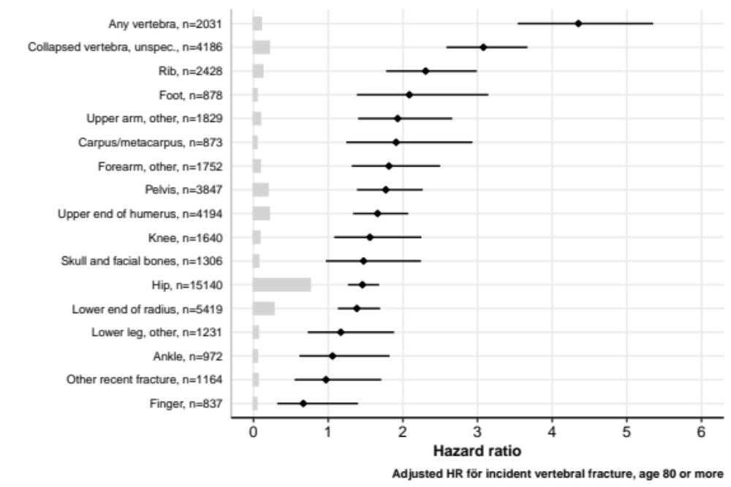

Figure S2f: Risk of Vertebral Fracture per Site of Recent Fracture – Censored After Two Years of Follow-up
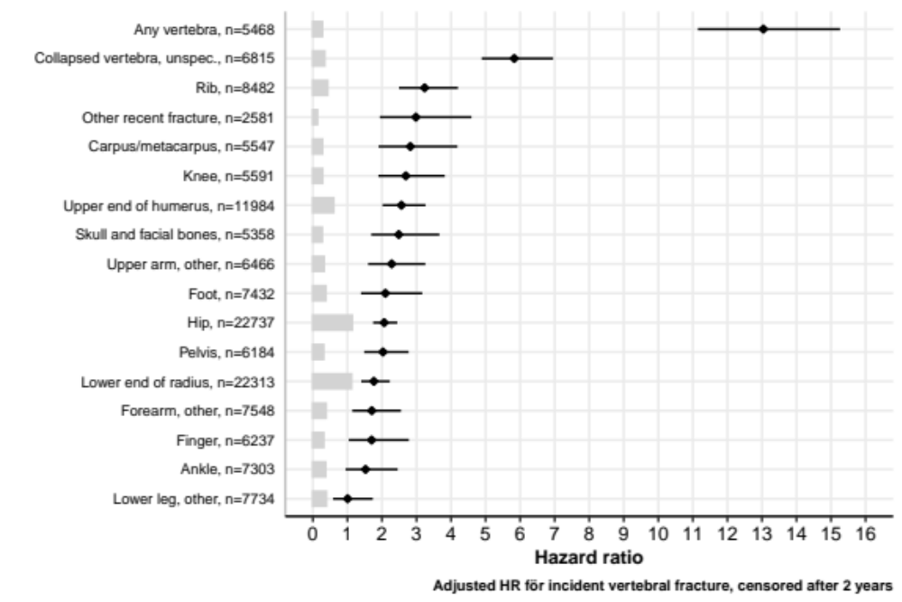

Table S6: Adjusted Subhazard Ratios for Hip Fracture using Fine Gray Competing Risk of Death
 |  | Deaths | Incident Hip Fractures |  | Cox Model 1 | Fine Gray Model 1* | Cox Model 2 | Fine Gray Model 2*
Recent fracture | N at risk | n (%) | n (%) | Event rate | HR (95%CI) | SHR (95%CI) | HR (95%CI) | SHR (95%CI)
Skull and facial bones | 5,358 | 2,024 (37.8%) | 358 (6.7%) | 9.78 (8.79-10.84) | 1.69 (1.52-1.88) | 1.40 (1.23-1.59) | 1.58 (1.43-1.76) | 1.34 (1.17-1.53)
Cervical vertebra | 1,112 | 548 (49.3%) | 79 (7.1%) | 11.55 (9.14-14.39) | 1.53 (1.22-1.90) | 1.17 (0.93-1.48) | 1.45 (1.16-1.80) | 1.12 (0.89-1.42)
Thoracic vertebra | 1,693 | 882 (52.1%) | 181 (10.7%) | 17.99 (15.46-20.81) | 2.18 (1.88-2.52) | 1.92 (1.63-2.26) | 2.05 (1.77-2.37) | 1.86 (1.57-2.19)
Lumbar vertebra | 2,663 | 1,388 (52.1%) | 285 (10.7%) | 17.92 (15.90-20.12) | 2.05 (1.82-2.30) | 1.92 (1.67-2.21) | 1.92 (1.71-2.15) | 1.92 (1.67-2.22)
Collapsed vertebra, unspec. | 6,815 | 5,212 (76.5%) | 977 (14.3%) | 33.81 (31.73-36.00) | 2.15 (2.02-2.29) | 1.92 (1.72-2.14) | 1.98 (1.86-2.11) | 1.95 (1.74-2.19)
Rib | 8,482 | 3,616 (42.6%) | 668 (7.9%) | 12.10 (11.20-13.05) | 1.95 (1.81-2.10) | 1.65 (1.48-1.84) | 1.82 (1.69-1.96) | 1.61 (1.44-1.80)
Pelvis | 6,184 | 4,403 (71.2%) | 908 (14.7%) | 32.43 (30.35-34.61) | 2.06 (1.93-2.20) | 1.76 (1.57-1.98) | 1.94 (1.82-2.08) | 1.71 (1.52-1.92)
Clavicle | 2,914 | 1,112 (38.2%) | 203 (7%) | 10.34 (8.97-11.87) | 1.91 (1.66-2.19) | 1.59 (1.36-1.86) | 1.83 (1.59-2.09) | 1.59 (1.36-1.86)
Scapula | 946 | 279 (29.5%) | 51 (5.4%) | 7.30 (5.44-9.60) | 1.44 (1.09-1.89) | 1.33 (1.01-1.76) | 1.40 (1.06-1.84) | 1.33 (1.01-1.75)
Upper end of humerus | 11,984 | 5,465 (45.6%) | 1,471 (12.3%) | 19.36 (18.38-20.37) | 2.19 (2.08-2.31) | 2.22 (2.02-2.45) | 2.11 (2.01-2.23) | 2.22 (2.01-2.45)
Shaft of humerus | 1,227 | 568 (46.3%) | 126 (10.3%) | 16.20 (13.50-19.29) | 2.07 (1.73-2.46) | 1.75 (1.45-2.12) | 1.93 (1.62-2.30) | 1.74 (1.44-2.10)
Lower end of humerus | 1,238 | 610 (49.3%) | 127 (10.3%) | 16.75 (13.97-19.93) | 1.91 (1.61-2.27) | 1.55 (1.28-1.88) | 1.80 (1.51-2.14) | 1.54 (1.27-1.86)
Upper end of ulna | 1,638 | 638 (38.9%) | 160 (9.8%) | 14.62 (12.45-17.07) | 2.04 (1.74-2.38) | 1.72 (1.45-2.05) | 1.96 (1.67-2.28) | 1.72 (1.44-2.04)
Upper end of radius | 2,204 | 323 (14.7%) | 80 (3.6%) | 4.46 (3.53-5.55) | 1.39 (1.11-1.73) | 1.20 (0.95-1.50) | 1.35 (1.09-1.69) | 1.19 (0.95-1.49)
Forearm shaft | 1,146 | 362 (31.6%) | 81 (7.1%) | 9.83 (7.80-12.21) | 1.54 (1.24-1.92) | 1.46 (1.17-1.83) | 1.49 (1.20-1.85) | 1.42 (1.13-1.79)
Lower end of radius | 22,313 | 6,601 (29.6%) | 1,811 (8.1%) | 11.06 (10.56-11.58) | 1.63 (1.56-1.71) | 1.57 (1.43-1.72) | 1.60 (1.53-1.68) | 1.57 (1.43-1.72)
Lower end of ulna and radius | 2,051 | 736 (35.9%) | 222 (10.8%) | 15.51 (13.54-17.69) | 1.82 (1.59-2.07) | 2.31 (1.98-2.69) | 1.78 (1.56-2.03) | 2.37 (2.03-2.77)
Carpus | 1,957 | 358 (18.3%) | 68 (3.5%) | 4.32 (3.36-5.48) | 1.15 (0.91-1.46) | 1.10 (0.86-1.40) | 1.12 (0.88-1.42) | 1.08 (0.84-1.38)
Metacarpus | 3,590 | 983 (27.4%) | 229 (6.4%) | 8.52 (7.45-9.70) | 1.76 (1.54-2.00) | 1.63 (1.41-1.88) | 1.69 (1.48-1.92) | 1.59 (1.38-1.85)
Finger | 6,237 | 1,328 (21.3%) | 304 (4.9%) | 6.24 (5.56-6.98) | 1.64 (1.47-1.84) | 1.43 (1.26-1.64) | 1.58 (1.41-1.77) | 1.41 (1.23-1.61)
Neck of femur | 12,412 | 9,296 (74.9%) | 1,406 (11.3%) | 25.54 (24.23-26.91) | 1.58 (1.50-1.67) | 1.91 (1.70-2.15) | 1.49 (1.42-1.58) | 2.03 (1.79-2.29)
Pertrochanteric fracture | 8,464 | 6,937 (82.0%) | 905 (10.7%) | 26.78 (25.07-28.59) | 1.36 (1.28-1.46) | 1.68 (1.47-1.91) | 1.28 (1.20-1.37) | 1.79 (1.56-2.04)
Subtrochanteric fracture | 1,861 | 1,398 (75.1%) | 178 (9.6%) | 21.07 (18.08-24.40) | 1.18 (1.02-1.36) | 1.53 (1.28-1.84) | 1.11 (0.96-1.28) | 1.63 (1.36-1.96)
Shaft of femur | 1,110 | 714 (64.3%) | 86 (7.7%) | 14.79 (11.83-18.27) | 1.10 (0.89-1.36) | 1.35 (1.07-1.71) | 1.05 (0.85-1.29) | 1.45 (1.15-1.83)
Lower end of femur | 1,058 | 683 (64.6%) | 76 (7.2%) | 14.26 (11.23-17.84) | 1.16 (0.93-1.45) | 0.82 (0.64-1.05) | 1.09 (0.87-1.37) | 0.80 (0.62-1.03)
Patella | 1,803 | 610 (33.8%) | 179 (9.9%) | 14.09 (12.10-16.31) | 1.87 (1.62-2.17) | 1.93 (1.64-2.28) | 1.80 (1.56-2.09) | 1.90 (1.61-2.25)
Upper end of tibia | 2,730 | 927 (34.0%) | 201 (7.4%) | 10.44 (9.05-11.99) | 1.80 (1.57-2.07) | 1.54 (1.31-1.82) | 1.74 (1.52-2.00) | 1.52 (1.29-1.79)
Shaft of tibia | 1,010 | 317 (31.4%) | 49 (4.9%) | 6.70 (4.96-8.86) | 1.75 (1.32-2.31) | 1.26 (0.95-1.68) | 1.64 (1.24-2.17) | 1.24 (0.93-1.65)
Lower end of tibia | 986 | 300 (30.4%) | 49 (5%) | 6.89 (5.09-9.10) | 1.58 (1.20-2.09) | 1.24 (0.93-1.65) | 1.52 (1.15-2.01) | 1.22 (0.92-1.63)
Fibula alone | 1,274 | 366 (28.7%) | 65 (5.1%) | 7.01 (5.41-8.94) | 1.36 (1.07-1.74) | 1.22 (0.95-1.57) | 1.31 (1.03-1.67) | 1.18 (0.92-1.52)
Ankle | 7,303 | 1,650 (22.6%) | 293 (4%) | 5.13 (4.56-5.75) | 1.17 (1.05-1.32) | 1.09 (0.95-1.24) | 1.14 (1.02-1.28) | 1.07 (0.94-1.23)
Other parts of lower leg | 4,340 | 1,154 (26.6%) | 249 (5.7%) | 7.58 (6.67-8.58) | 1.58 (1.40-1.79) | 1.35 (1.17-1.57) | 1.51 (1.33-1.71) | 1.31 (1.13-1.52)
Tarsus | 1,183 | 228 (19.3%) | 61 (5.2%) | 6.60 (5.05-8.48) | 2.10 (1.63-2.70) | 1.81 (1.40-2.34) | 2.00 (1.56-2.57) | 1.78 (1.38-2.30)
Metatarsus | 3,689 | 822 (22.3%) | 180 (4.9%) | 6.29 (5.40-7.28) | 1.44 (1.25-1.67) | 1.28 (1.09-1.51) | 1.38 (1.20-1.60) | 1.24 (1.06-1.47)
Toe | 2,408 | 430 (17.9%) | 79 (3.3%) | 4.09 (3.24-5.09) | 1.32 (1.06-1.64) | 1.13 (0.90-1.41) | 1.27 (1.02-1.59) | 1.11 (0.88-1.40)
Other recent fracture | 2,397 | 1,112 (46.4%) | 247 (10.3%) | 16.65 (14.64-18.87) | 2.23 (1.97-2.53) | 1.65 (1.43-1.92) | 2.08 (1.83-2.35) | 1.61 (1.38-1.88)
Fracture more 2y ago§ | 293,051 | 101,759 (34.7%) | 20,516 (7%) | 10.13 (9.99-10.27) | 1.51 (1.49-1.53) | 1.34 (1.17-1.53) | 1.50 (1.48-1.52) | 1.33 (1.16-1.52)
Non-significant hazard and subhazard ratios are marked in bold. When calculating the hazard ratios for the Cox models, all study patients were included.
*In the Fine Gray analyses, a random sample of 20,000 controls without previous fracture (instead of 2,984,489) was used to save processing power.
§In the Fine Gray analyses, a random sample of 5,000 patients with a previous fracture more than 2 years ago (instead of 293,051) was used to save processing power.

Table S7: Adjusted Subhazard Ratios for Vertabral Fracture using Fine Gray Competing Risk of Death
 |  | Death | Incident Vertebral Fractures |  | Cox Model 1 | Fine Gray Model 1* | Cox Model 2 | Fine Gray Model 2*
Recent fracture | N at risk | n (%) | n (%) | Event rate | HR (95%CI) | SHR (95%CI) | HR (95%CI) | SHR (95%CI)
Skull and facial bones | 5,358 | 2,024 (37.8%) | 75 (1.4%) | 2.01 (1.58-2.51) | 2.09 (1.66-2.62) | 1.96 (1.47-2.61) | 1.82 (1.45-2.29) | 1.85 (1.38-2.49)
Rib | 8,482 | 3,616 (42.6%) | 178 (2.1%) | 3.17 (2.72-3.67) | 3.13 (2.70-3.63) | 2.88 (2.28-3.64) | 2.76 (2.38-3.20) | 2.76 (2.18-3.50)
Any vertebra | 5,468 | 2,818 (51.5%) | 315 (5.8%) | 9.61 (8.58-10.73) | 8.33 (7.45-9.31) | 7.98 (6.44-9.91) | 6.65 (5.93-7.46) | 6.81 (5.44-8.51)
Collapsed vertebra, unspec. | 6,815 | 5,212 (76.5%) | 259 (3.8%) | 8.57 (7.55-9.67) | 5.38 (4.76-6.09) | 5.14 (3.96-6.66) | 3.80 (3.35-4.31) | 4.40 (3.34-5.81)
Pelvis | 6,184 | 4,403 (71.2%) | 120 (1.9%) | 4.01 (3.33-4.80) | 2.61 (2.18-3.12) | 2.38 (1.79-3.16) | 2.13 (1.77-2.55) | 2.19 (1.65-2.92)
Upper end of humerus | 11,984 | 5,465 (45.6%) | 229 (1.9%) | 2.89 (2.52-3.29) | 2.49 (2.19-2.84) | 2.65 (2.11-3.33) | 2.22 (1.95-2.53) | 2.54 (2.01-3.20)
Upper arm, other | 6,466 | 2,637 (40.8%) | 114 (1.8%) | 2.60 (2.14-3.12) | 2.60 (2.16-3.12) | 2.45 (1.91-3.15) | 2.28 (1.89-2.74) | 2.27 (1.76-2.93)
Lower end of radius | 22,313 | 6,601 (29.6%) | 276 (1.2%) | 1.64 (1.46-1.85) | 1.64 (1.46-1.85) | 1.75 (1.39-2.19) | 1.50 (1.33-1.69) | 1.59 (1.26-2.00)
Forearm, other | 7,548 | 2,263 (30.0%) | 119 (1.6%) | 2.12 (1.76-2.54) | 2.26 (1.89-2.71) | 2.25 (1.75-2.88) | 2.02 (1.69-2.42) | 2.10 (1.64-2.70)
Carpus/metacarpus | 5,547 | 1,341 (24.2%) | 90 (1.6%) | 2.09 (1.68-2.57) | 2.44 (1.99-3.01) | 2.33 (1.79-3.04) | 2.23 (1.82-2.75) | 2.10 (1.60-2.76)
Finger | 6,237 | 1,328 (21.3%) | 75 (1.2%) | 1.52 (1.20-1.91) | 1.87 (1.49-2.34) | 1.76 (1.33-2.33) | 1.73 (1.38-2.17) | 1.61 (1.21-2.14)
Hip | 22,737 | 17,631 (77.5%) | 337 (1.5%) | 3.27 (2.93-3.64) | 1.96 (1.76-2.18) | 2.06 (1.56-2.73) | 1.71 (1.54-1.91) | 1.98 (1.49-2.63)
Knee | 5,591 | 2,220 (39.7%) | 84 (1.5%) | 2.19 (1.74-2.71) | 2.10 (1.70-2.60) | 2.03 (1.53-2.69) | 1.84 (1.48-2.28) | 1.73 (1.30-2.31)
Ankle | 7,303 | 1,650 (22.6%) | 83 (1.1%) | 1.44 (1.15-1.78) | 1.71 (1.38-2.13) | 1.69 (1.28-2.22) | 1.60 (1.29-1.98) | 1.55 (1.17-2.05)
Lower leg, other | 7,734 | 2,187 (28.3%) | 92 (1.2%) | 1.58 (1.27-1.93) | 1.85 (1.51-2.27) | 1.74 (1.33-2.27) | 1.65 (1.35-2.03) | 1.49 (1.13-1.98)
Foot | 7,432 | 1,526 (20.5%) | 105 (1.4%) | 1.78 (1.46-2.16) | 2.30 (1.90-2.79) | 2.19 (1.70-2.82) | 2.10 (1.73-2.54) | 1.96 (1.51-2.55)
Other recent fracture | 2,581 | 1,458 (56.5%) | 45 (1.7%) | 2.99 (2.18-4.00) | 2.38 (1.78-3.19) | 2.11 (1.46-3.05) | 1.96 (1.46-2.63) | 1.69 (1.15-2.49)
Fracture more 2y ago§ | 293,051 | 101,759 (34.7%) | 3,925 (1.3%) | 1.90 (1.84-1.96) | 1.88 (1.81-1.94) | 1.58 (1.16-2.17) | 1.79 (1.73-1.86) | 1.55 (1.13-2.13)
P-value < 0.001 for all hazard ratios and at least <0.01 for all subhazard ratios.
When calculating the hazard ratios for the Cox models, all study patients were included.
*In the Fine Gray analyses, a random sample of 20,000 controls without previous fracture (instead of 2,984,489) was used to save processing power.
§In the Fine Gray analyses, a random sample of 5,000 patients with a previous fracture more than 2 years ago (instead of 293,051) was used to save processing power.

