A novel sequential treatment approach between denosumab and romosozumab in patients with severe osteoporosis
Osteoporosis International
Shejil KUMAR^{a, b, c}, Matti L GILD^{b, c}, Michelle M MCDONALD^{d, e,} Albert S KIM^{a, d, e}, Roderick J CLIFTON-BLIGH^{b, c} Christian M GIRGIS^{a, b}
- Department of Diabetes & Endocrinology, Westmead Hospital, Sydney, Australia
- Faculty of Medicine & Health, University of Sydney, Sydney, Australia
- Department of Diabetes & Endocrinology, Royal North Shore Hospital, Sydney, Australia
- Faculty of Medicine, University of New South Wales, Sydney, Australia
- Bone Biology Program, Garvan Institute of Medical Research, Sydney, Australia

Corresponding author:
Christian GIRGIS
Department of Diabetes and Endocrinology, Westmead Hospital, Cnr Hawkesbury Rd and Darcy Rd, NSW, Australia, 2145
Christian.girgis@sydney.edu.au

Supplementary Figure 1 – Thoracolumbar spinal imaging demonstrating acute vertebral fractures (case one)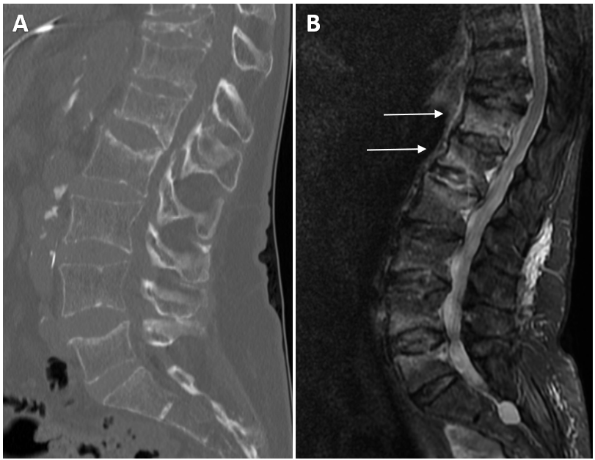Case one experienced acute compression fractures on a background of multilevel chronic vertebral compression fractures. Sagittal-view bone-window computed tomography (CT) images of the thoracolumbar spine demonstrate compression fractures in T11, T12, L1, L2, L3 and L5 (Fig 1A). Sagittal-view magnetic resonance imaging (MRI) short tau inversion recovery (STIR) images of the thoracolumbar spine reveal marrow oedema consistent with acute T12 and L1 fractures (Fig 1B). These scans were performed 4-months prior to the pre-romosozumab DXA scan (outside of the acute fracture phase). The acutely fractured L1 vertebra was excluded from BMD analyses.

Supplementary Table 1 – Characteristics and outcomes of studies assessing denosumab to romosozumab treatment sequence in patients with osteoporosis
Author/s | McClung et al. | Tominaga et al. |  | Ebina et al. | Hong et al.
Publication year | 2021 | 2022 |  | 2021 | 2023
Study design | Phase II randomised controlled trial | Retrospective study |  | Prospective observational study | Propensity score-matched cohort study
Patients pre-treated with denosumab (n) | n = 16 | <1-year (n = 24)  >1-year (n = 16) |  | n = 45 | n = 105
Inclusion criteria | Postmenopausal women  55-85 years old  T-score between  -2.0 and -3.5 SD | Multiple fragility fractures  OR  T-score <-2.5 SD |  | Postmenopausal women with osteoporosis | Postmenopausal women with osteoporosis
Duration of prior denosumab exposure | 12-months | <1-year  - mean 10-months  ≥1-year  - mean 33-months |  | Mean 24-months | Median 24-months
Timing of romosozumab commencement (after last denosumab dose) | 6-months | 6-months |  | 6-months | 6-months
Timing of denosumab recommencement (after commencing romosozumab) | NR | NR |  | 12-months | NR
Baseline BMD T-score SD  - Lumbar spine  - Total hip  - Femoral neck | -2.1  -1.3  -1.8 | <1-year  -2.7  -2.25  NR | ≥1-year  -2.48  -2.31  NR | -2.9  -2.7  -3.1 | NR  NR  NR
12-month change in BMD  - Lumbar spine  - Total hip  - Femoral neck | +5.3%  +0.9%  +1.0% | <1-year  +10.2%  +5.9%  NR | ≥1-year  +6.3%  -1.0%  NR | +6.6%  +0.6%  +0.7% | +7.0%  -0.9%  +1.3%
Vertebral fractures | Nil | Nil |  | n = 1 (multiple fractures) ª | Nil
BMD = bone mineral density; SD = standard deviation; NR = not reported.
a) The patient with new vertebral fractures in the study by Ebina et al. commenced romosozumab 9-months after the last denosumab dose.

Supplementary Figure 2 – 12-month changes in lumbar spine and left hip bone mineral density (BMD) with sequential overlapping romosozumab and denosumab treatment
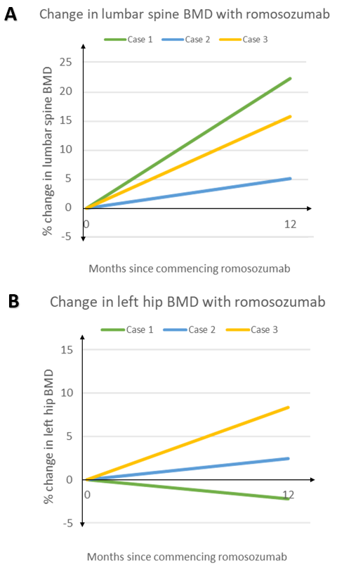
The percentage change in lumbar spine BMD (Fig. 3A) and left hip BMD (Fig. 3B) after 12-months of romosozumab treatment is represented for case 1 (green), case 2 (blue) and case 3 (yellow). Left hip BMD values refer to either left total hip (case 1, case 3) or left femoral neck (case 2).

