Title: PTH1 receptor agonists for fracture risk: a systematic review and network meta-analysis

APPENDICES
Appendix A – Search strategies used in different bibliographic databases

Embase – May 2024
Session Results
.......................................................
No. Query Results Results Date
#35. #28 NOT #34 4,269
#34. #29 OR #30 OR #31 OR #32 OR #33 7,625,719
#33. 'conference paper'/it OR 'editorial'/it OR 7,079,526
'letter'/it OR 'note'/it OR 'review'/it
#32. letter:ti 86,656
#31. comment:ti 63,686
#30. protocol:ti 101,181
#29. review:ti 874,514
#28. #15 AND #21 AND [humans]/lim AND [english]/lim 6,796
#27. #15 AND #21 8,345
#26. #15 AND #21 AND #24 AND [humans]/lim AND 4,735
[english]/lim
#25. #15 AND #21 AND #24 5,356 30 Apr 2024
#24. #22 OR #23 404,478 30 Apr 2024
#23. fracture*:ti,ab,kw 401,382 30 Apr 2024
#22. 'fragility fracture'/exp 24,833 30 Apr 2024
#21. #16 OR #17 OR #18 OR #19 OR #20 11,551 30 Apr 2024
#20. 'parathyroid receptor':ti,ab,kw 16 30 Apr 2024
#19. 'pth* receptor':ti,ab,kw 1,690 30 Apr 2024
#18. abaloparatide:ti,ab,kw 491 30 Apr 2024
#17. 'teriparatide':ti,ab,kw 4,641 30 Apr 2024
#16. 'parathyroid hormone[1-34]'/exp 9,612 30 Apr 2024
#15. #1 OR #2 OR #3 OR #4 OR #5 OR #6 OR #7 OR #8 OR 327,967 30 Apr 2024
#9 OR #10 OR #11 OR #12 OR #13 OR #14
#14. 'osteoporotic fracture*':ti,ab,kw 15,116 30 Apr 2024
#13. 'metabolic bone disease':ti,ab,kw 3,675 30 Apr 2024
#12. 'bone demineralization':ti,ab,kw 960 30 Apr 2024
#11. 'bone demineralisation':ti,ab,kw 109 30 Apr 2024
#10. 'bone deterioration':ti,ab,kw 399 30 Apr 2024
#9. 'bone loss*':ti,ab,kw 48,413 30 Apr 2024
#8. 'bone mineral content':ti,ab,kw 9,592 30 Apr 2024
#7. 'bone density':ti,ab,kw 28,725 30 Apr 2024
#6. 'bone mineral density':ti,ab,kw 73,175 30 Apr 2024
#5. 'metabolic bone disease'/exp 206,454 30 Apr 2024
#4. 'bone density'/exp 118,507 30 Apr 2024
#3. osteopeni*:ti,ab,kw 22,645 30 Apr 2024
#2. osteoporos*:ti,ab,kw 139,974 30 Apr 2024
#1. 'osteoporosis'/exp 161,206 30 Apr 2024

Database: Ovid MEDLINE(R) ALL – May 2024
Search Strategy:
1 Osteoporosis/ (52307)
2 Bone Diseases, Metabolic/ (9386)
3 Bone Density/ (62287)
4 Bone Demineralization, Pathologic/ (372)
5 Osteoporotic Fractures/ (8479)
6 osteoporo*.ti,ab,kf. (98234)
7 osteopeni*.ti,ab,kf. (13210)
8 (bone* adj1 (densit* or content)).ti,ab,kf. (23166)
9 (bone* adj1 (demineralization or demineralisation of loss* or decreas* ordeterioration*)).ti,ab,kf. (664)
10 metabolic bone disease*.ti,ab,kf. (3412)
11 (osteoporo* adj1 fracture*).ti,ab,kf. (9801)
12 or/1-11 (157439)
13 Teriparatide/ (2313)
14 teriparatide.ti,ab,kf. (2496)
15 abaloparatide.ti,ab,kf. (282)
16 Receptor, Parathyroid Hormone, Type 1/ (1041)
17 ((pth* or pth-related or parathyroid) adj2 receptor).ti,ab,kf. (2138)
18 "hPTH (1-34)".ti,ab,kf. (424)
19 BA058.ti,ab,kf. (4)
20 or/13-19 (5973)
21 12 and 20 (2790)
22 21 not (exp animals/ not humans.sh.) (2517)
23 limit 22 to english language (2309)
24 (protocol* or review* or comment*).ti. (982994)
25 23 not 24 (2124)
Database: EBM Reviews - Cochrane Central Register of Controlled Trials – May 2024
Search Strategy:
1 Osteoporosis/ (3197)
2 Bone Diseases, Metabolic/ (703)
3 Bone Density/ (5996)
4 Bone Demineralization, Pathologic/ (17)
5 Osteoporotic Fractures/ (611)
6 osteoporo*.ti,ab,kf. (10811)
7 osteopeni*.ti,ab,kf. (1552)
8 (bone* adj1 (densit* or content)).ti,ab,kf. (3668)
9 (bone* adj1 (demineralization or demineralisation of loss* or decreas* ordeterioration*)).ti,ab,kf. (40)
10 metabolic bone disease*.ti,ab,kf. (191)
11 (osteoporo* adj1 fracture*).ti,ab,kf. (1123)
12 or/1-11 (17144)
13 Teriparatide/ (444)
14 teriparatide.ti,ab,kf. (824)
15 abaloparatide.ti,ab,kf. (114)
16 ((pth* or pth-related or parathyroid) adj2 receptor).ti,ab,kf. (35)
17 "hPTH (1-34)".ti,ab,kf. (33)
18 BA058.ti,ab,kf. (15)
19 or/13-18 (955)
20 12 and 19 (790)
21 20 not (exp animals/ not humans.sh.) (790)
22 limit 21 to english language (782)
23 (protocol* or review* or comment*).ti. (46552)
24 22 not 23 (772)

Appendix B - Table of PT included in each safety analyses
Classification _SOC | Description
SOC or grouped categorization | Preferred terms (PTs) as classified by authors within manuscripts or according to PT of MedDRA
SOC Cardiac Disorders | Cardiac arrest  Heart rate and rhythm  Cardiovascular events  Palpitations  Myocardial Infarction  Cardiac disorders  Heart failure
SOC Gastrointestinal disorders | Dental caries  Nausea  Abdominal discomfort  Constipation  Vomiting  Diarrhea  Gastritis
SOC General disorders and administration site conditions | Pain  Injection site bruising  Contusion  Headache  Dizziness  Pain in extremities  Malaise
SOC Metabolism and nutrition disorders | Hypokalemia  Hypercalcemia  Blood uric acid increase  Blood calcium increase  Hyperuricemia
SOC Musculoskeletal and Connective Tissue Disorders | New or worsened back pain  Leg cramps  Muscle spasms  Muscle weaknesses  Back pain  Arthralgia  Pain in hands or feet  Osteoarthritis  Bone contusion  Leg cramps
SOC Neoplasms | Total neoplasms  Neoplasms benign, malignant and unspecified
Grouped PTs Cardiac Arrhythmias | Hart rate and rhythm  Palpitations
Grouped PTs_Coronary Heart Disease and Stroke | Cardiac arret  Cardiovascular events  Myocardial Infarction  Stroke
Grouped PTs_Heart Failure | Heart Failure
Grouped PTs Blood Pressure Disorders | Hypotension  Orthostatic hypotension
MACE 3 | Myocardial infarction  Cardiovascular death  Stroke
MACE 4 | Myocardial infarction  Cardiovascular death  Stroke  Heart failure
MACE 5 | Myocardial infarction  Cardiovascular death  Stroke  Heart failure  Heart rhythm problems (excl. palpitations)

Appendix C. Pairwise meta-analyses

Outcome : Vertebral fractures

- Pairwise MA – Teriparatide vs Placebo (k=4)

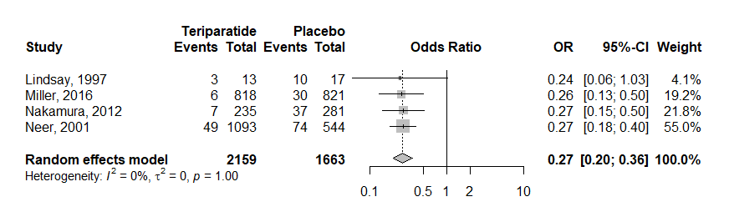

- Pairwise MA Abalopartide vs Placebo (k=2)

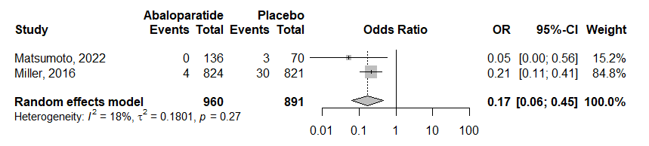

- Pairwise MA Abaloparatide vs Teriparatide (k=1)
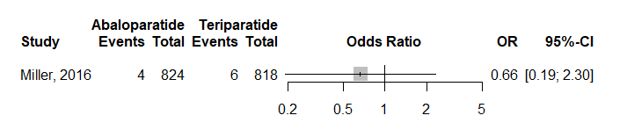

Outcome: Non-vertebral fractures
- Pairwise MA – Teriparatide vs Placebo (k=3)
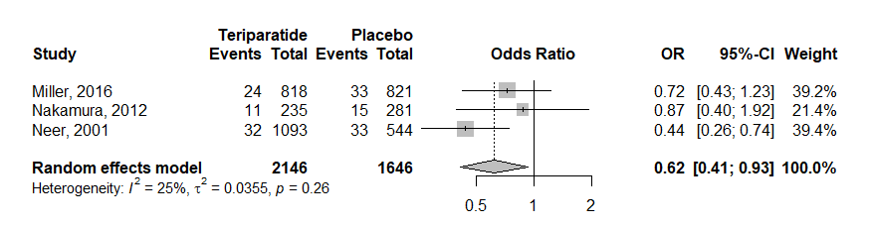
- Pairwise MA Abalopartide vs Placebo (k=2)
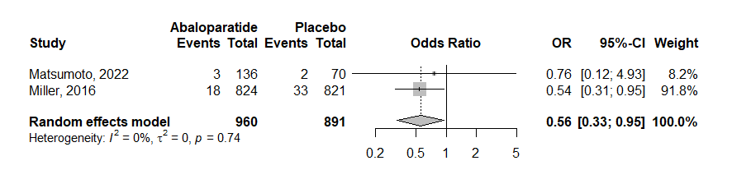
- Pairwise MA Abaloparatide vs Teriparatide (k=2)
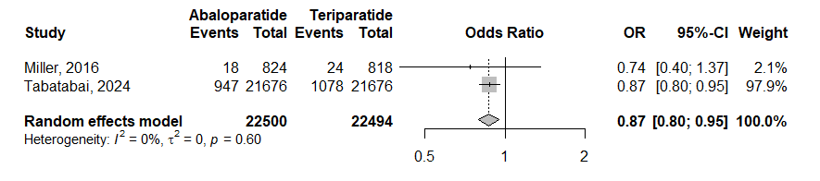

Outcome: Hip fractures
- Pairwise MA – Teriparatide vs Placebo (k=1)

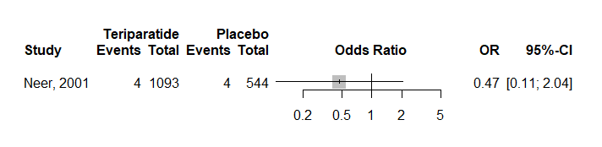

- Pairwise MA Abalopartide vs Placebo (k=0)
No study in the literature responding to our inclusion criteria provided hip fracture outcome for Abaloparatide vs Placebo

- Pairwise MA Abaloparatide vs Teriparatide (k=2)
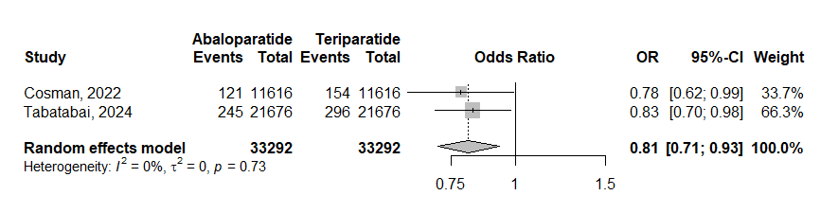

Outcome: Any fractures
- Pairwise MA – Teriparatide vs Placebo (k=3)

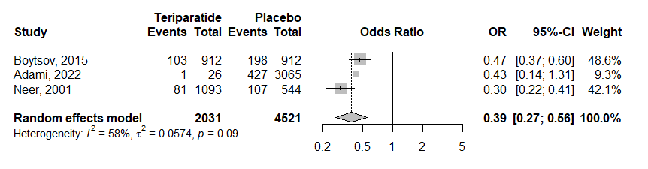

- Pairwise MA Abalopartide vs Placebo (k=2)

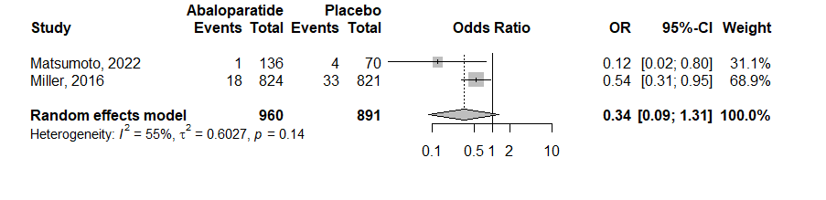

- Pairwise MA Abaloparatide vs Teriparatide (k=3)
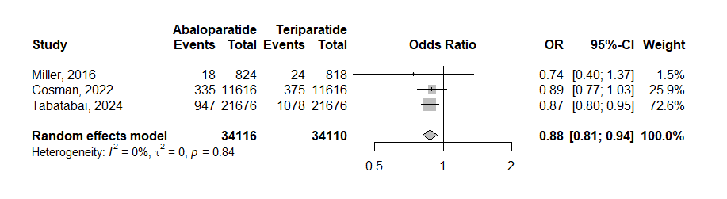

Appendix E: Safety analyses results

All Adverse Events
NMA design description
- Number of studies: k = 11
- Number of pairwise comparisons: m = 13
- Number of treatments: n = 6
- Number of designs: d = 7

Netgraph “All adverse events” safety model
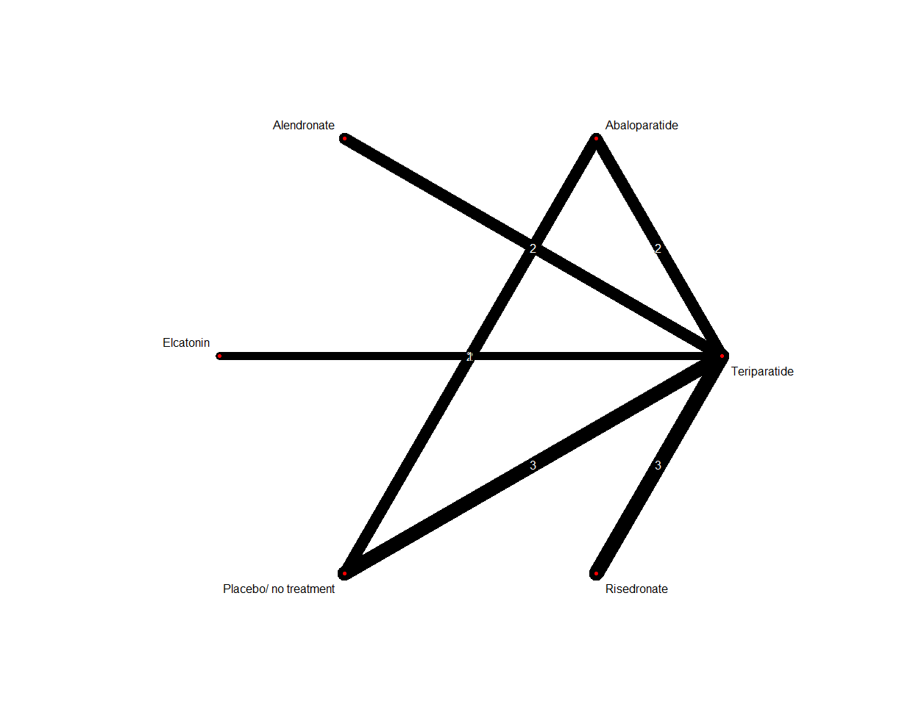
Teriparatide vs others
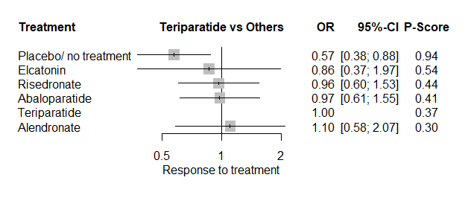
- When all AEs are combined together, placebo is demonstrated to be safer than teriparatide. No other significant difference was found between teriparatide and other treatments included in the model.
Abaloparatide vs others
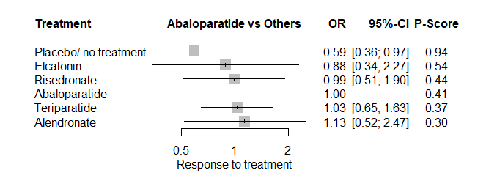
- When all AEs are combined together, placebo is demonstrated to be safer than abaloparatide. No other significant difference was found between abaloparatide and other treatments included in the model.

All Adverse Events without Hypercalcemia
NMA design description
- Number of studies: k = 11
- Number of pairwise comparisons: m = 13
- Number of treatments: n = 6
- Number of designs: d = 7
Netgraph “All adverse events” safety model

Teriparatide vs others
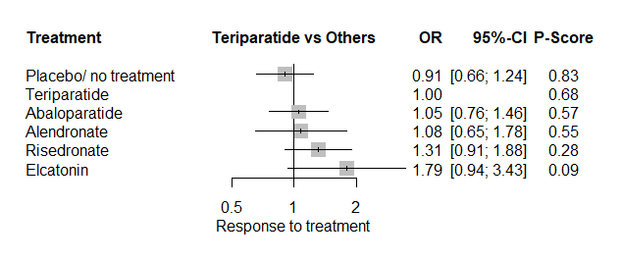
- When all AEs are combined together without hypercalcemia, teriparatide is demonstrated to be as safe as other treatments/placebo included in the model.

Abaloparatide vs others
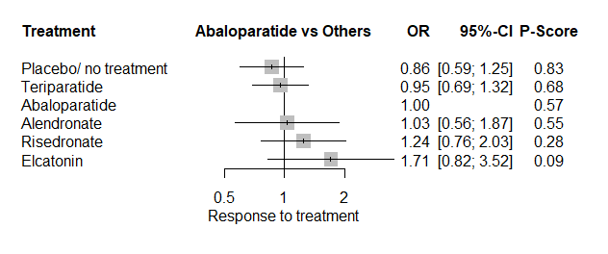
- When all AEs are combined together without hypercalcemia, abaloparatide is demonstrated to be as safe as other treatments/placebo included in the model.

Serious Adverse Events
NMA design description
- Number of studies: k = 5
- Number of pairwise comparisons: m = 7
- Number of treatments: n = 4
- Number of designs: d = 4

Netgraph “All adverse events” safety model
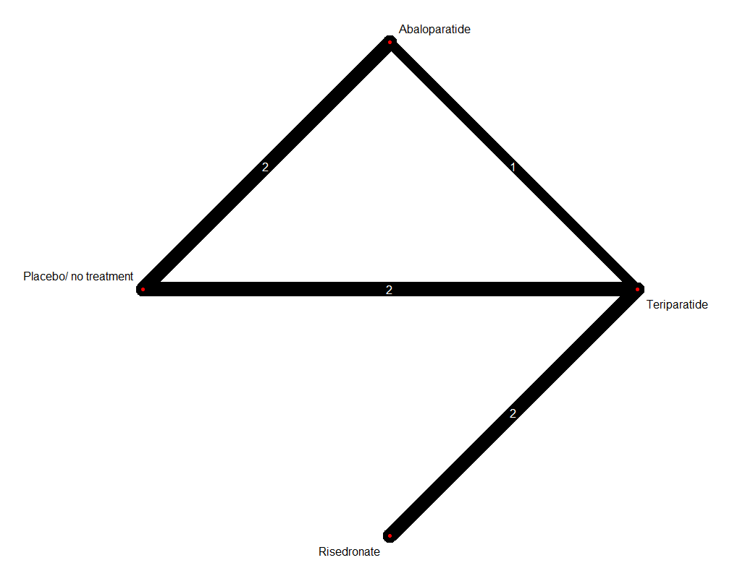
Teriparatide vs others
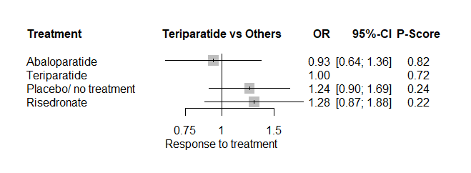
- In terms of serious AEs (categorized as “serious” by authors themselves in the different manuscripts), teriparatide is demonstrated to be as safe as other treatments/placebo included in the model.
Abaloparatide vs others
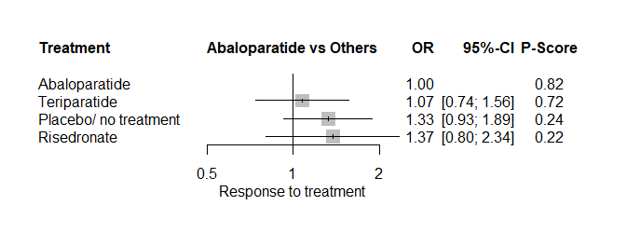
- In terms of serious AEs (categorized as “serious” by authors themselves in the different manuscripts), abaloparatide is demonstrated to be as safe as other treatments/placebo included in the model.

Deaths
NMA design description
- Number of studies: k = 7
- Number of pairwise comparisons: m = 9
- Number of treatments: n = 6
- Number of designs: d = 5
Netgraph “All adverse events” safety model
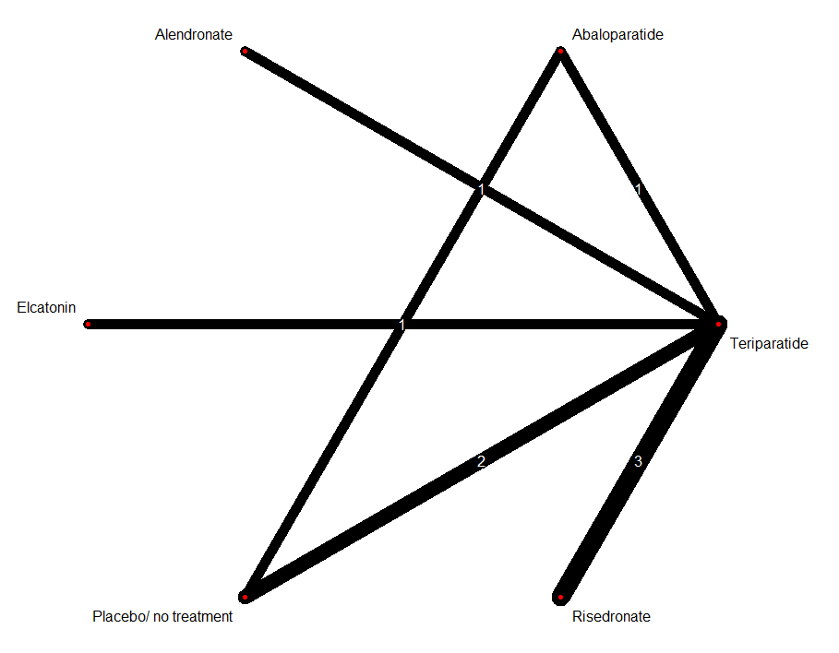

Teriparatide vs others
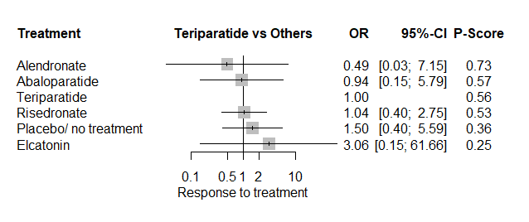
- In term of death outcome, teriparatide is demonstrated to be as safe as other treatments/placebo included in the model

Abaloparatide vs others
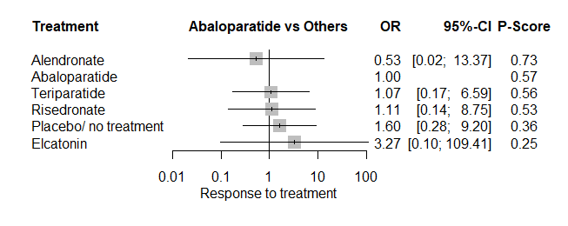
- In term of death outcome, abaloparatide is demonstrated to be as safe as other treatments/placebo included in the model

SOC_Cardiac Disorders
NMA design description
- Number of studies: k = 7
- Number of pairwise comparisons: m = 9
- Number of treatments: n = 5
- Number of designs: d = 6

Netgraph “All adverse events” safety model
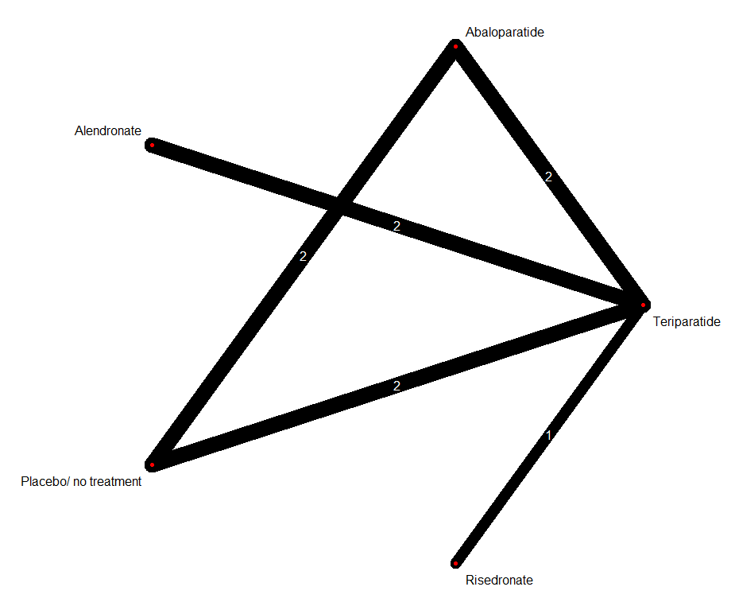
Teriparatide vs others
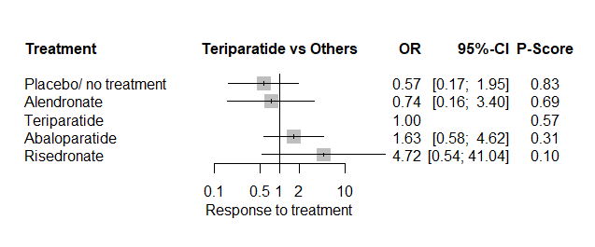
- In term of cardiac disorder SOC, teriparatide is demonstrated to be as safe as other treatments/placebo included in the model

Abaloparatide vs others
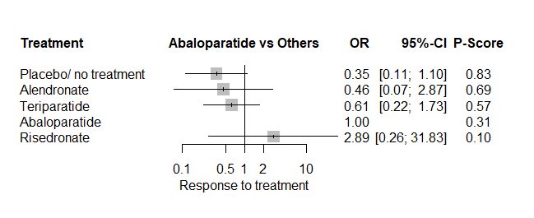
- In term of cardiac disorder SOC, abaloparatide is demonstrated to be as safe as other treatments/placebo included in the model

SOC_Gastrointestinal Disorders
NMA design description
- Number of studies: k = 7
- Number of pairwise comparisons: m = 9
- Number of treatments: n = 6
- Number of designs: d = 6
Netgraph “All adverse events” safety model
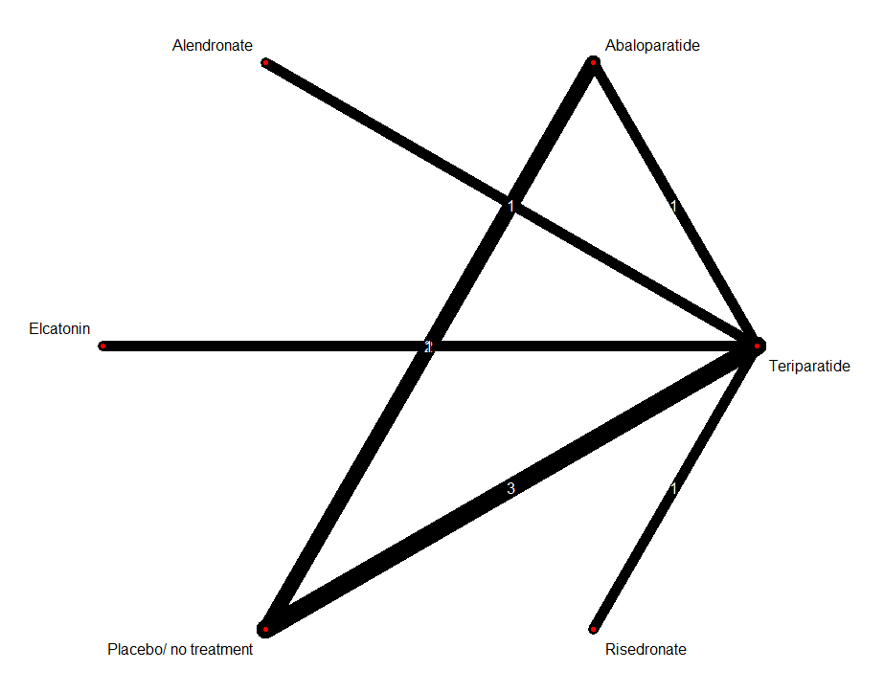

Teriparatide vs others
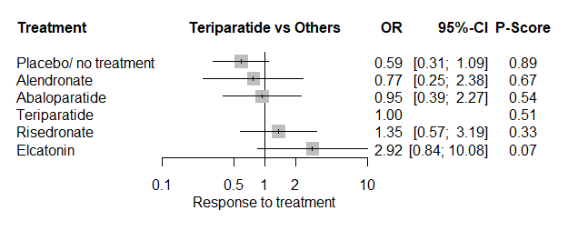
- In terms of gastrointestinal disorders SOC, teriparatide is demonstrated to be as safe as other treatments/placebo included in the model.

Abaloparatide vs others
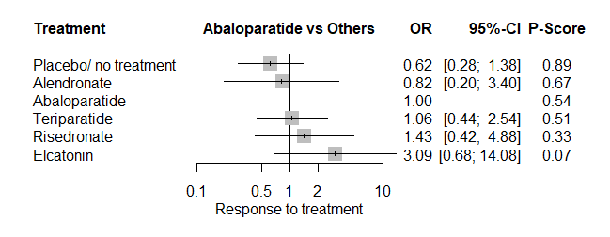
- In terms of gastrointestinal disorders SOC, abaloparatide is demonstrated to be as safe as other treatments/placebo included in the model.

SOC_General Disorders and Administration Site Conditions
NMA design description
- Number of studies: k = 6
- Number of pairwise comparisons: m = 8
- Number of treatments: n = 5
- Number of designs: d = 5

Netgraph “All adverse events” safety model
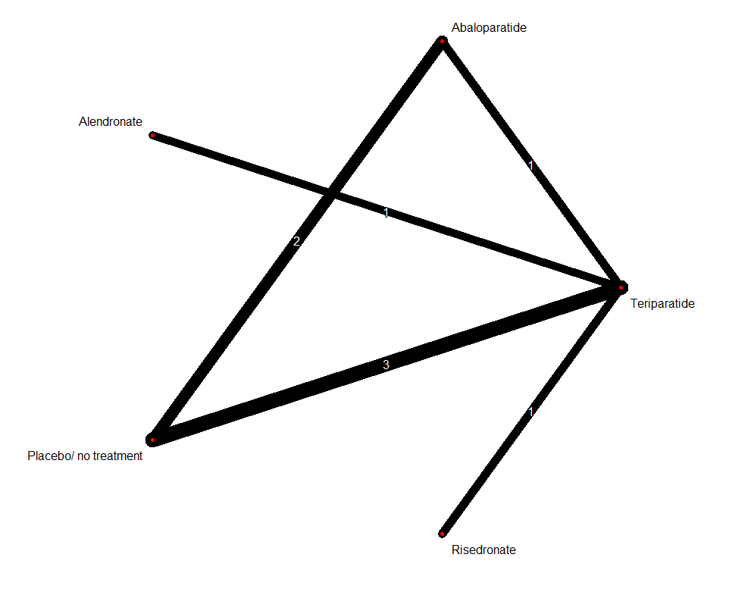
Teriparatide vs others
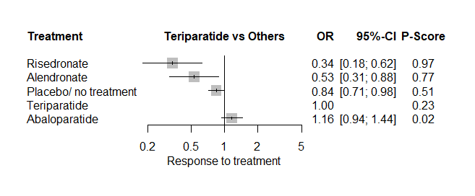
- In terms of general disorders and administrative site conditions SOC, risedronate, alendronate and placebo demonstrated to be safer than teriparatide.
Abaloparatide vs others
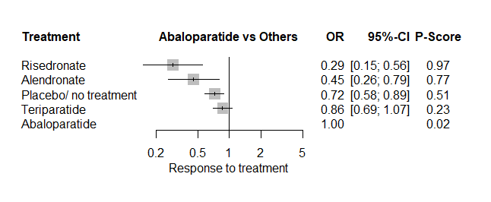
- In terms of general disorders and administrative site conditions SOC, risedronate, alendronate and placebo demonstrated to be safer than abaloparatide.

SOC_Metabolism and Nutrition Disorders
NMA design description
- Number of studies: k = 7
- Number of pairwise comparisons: m = 9
- Number of treatments: n = 5
- Number of designs: d = 5

Netgraph “All adverse events” safety model
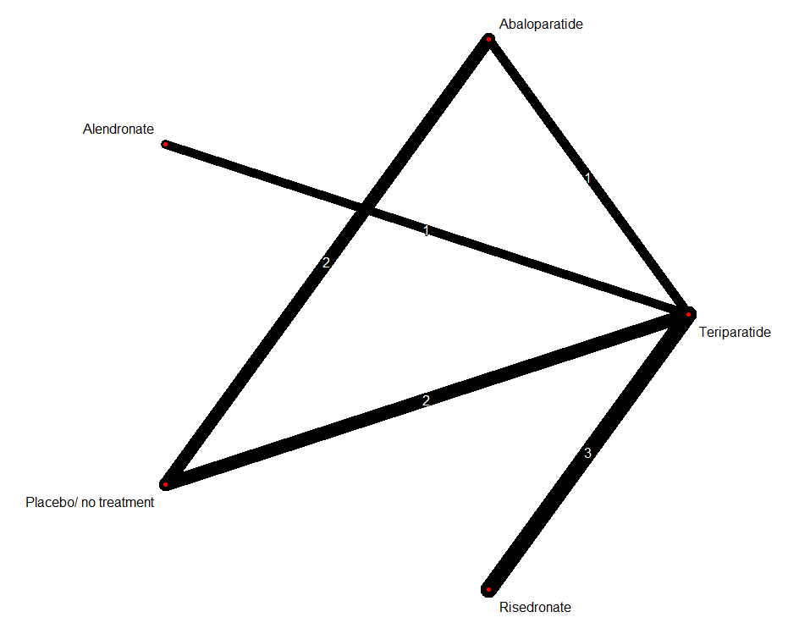
Teriparatide vs others
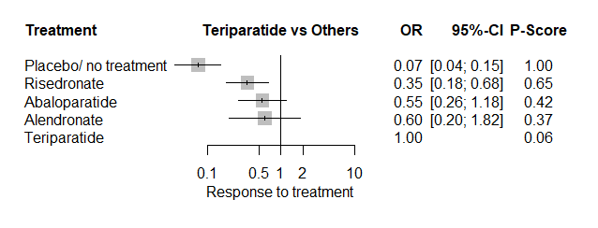
- In terms of metabolism and nutrition SOC, risedronate and placebo demonstrated to be safer than teriparatide.

Abaloparatide vs others
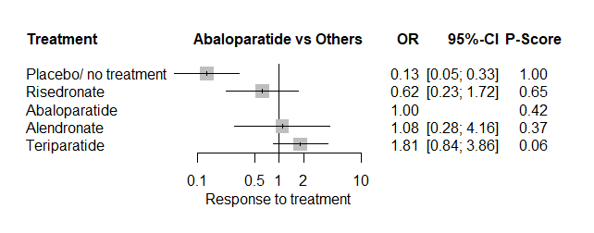
- In terms of metabolism and nutrition SOC placebo demonstrated to be safer than abaloparatide.

SOC_Musculoskeletal and Connective Tissue Disorders
NMA design description
- Number of studies: k = 8
- Number of pairwise comparisons: m = 10
- Number of treatments: n = 5
- Number of designs: d = 5

Netgraph “All adverse events” safety model
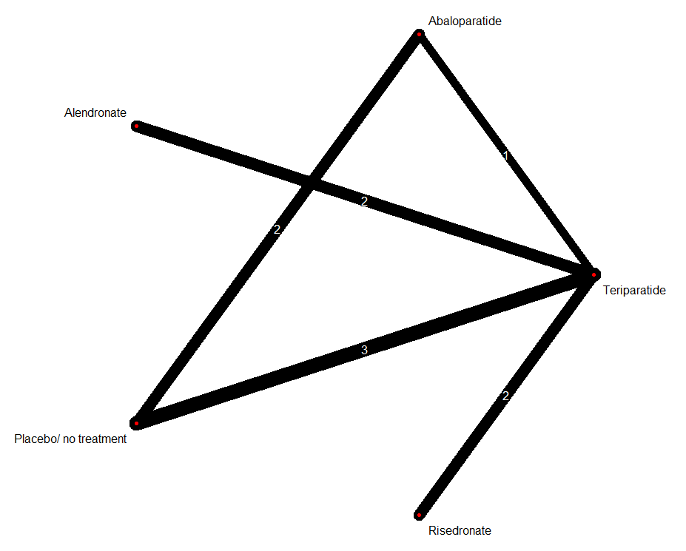

Teriparatide vs others
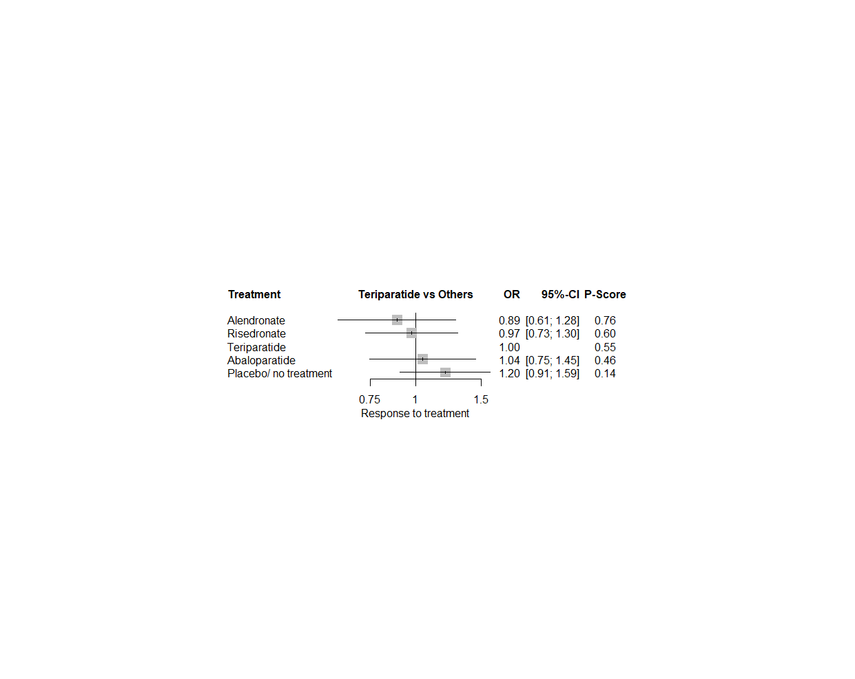
- In term of musculoskeletal and connective tissue disorders SOC, teriparatide is demonstrated to be as safe as other treatments/placebo included in the model.
Abaloparatide vs others
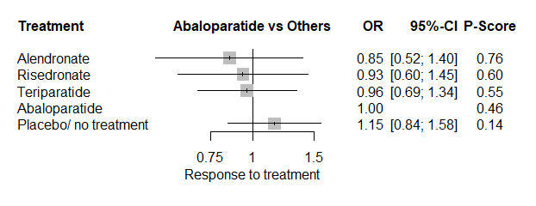
- In term of musculoskeletal and connective tissue disorders SOC, abaloparatide is demonstrated to be as safe as other treatments/placebo included in the model.

SOC_Neoplasms
NMA design description
- Number of studies: k = 4
- Number of pairwise comparisons: m = 6
- Number of treatments: n = 4
- Number of designs: d = 3

Netgraph “All adverse events” safety model
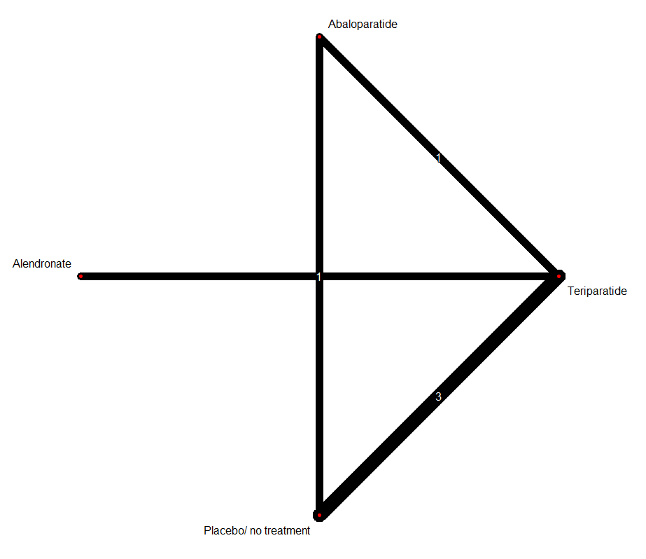

Teriparatide vs others
- In term of neoplasms SOC, teriparatide is demonstrated to be as safe as other treatments/placebo included in the model.

Abaloparatide vs others
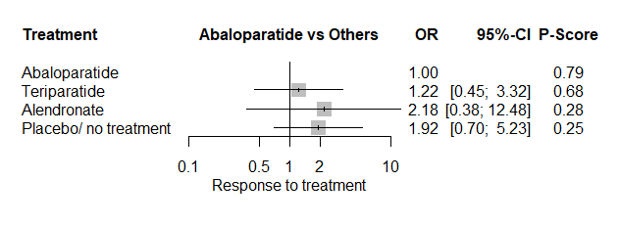
- In term of musculoskeletal and connective tissue disorders SOC, abaloparatide is demonstrated to be as safe as other treatments/placebo included in the model.

Grouped PTs_Cardiac Arrhythmias
NMA design description
- Number of studies: k = 3
- Number of pairwise comparisons: m = 5
- Number of treatments: n = 4
- Number of designs: d = 3

Netgraph “All adverse events” safety model
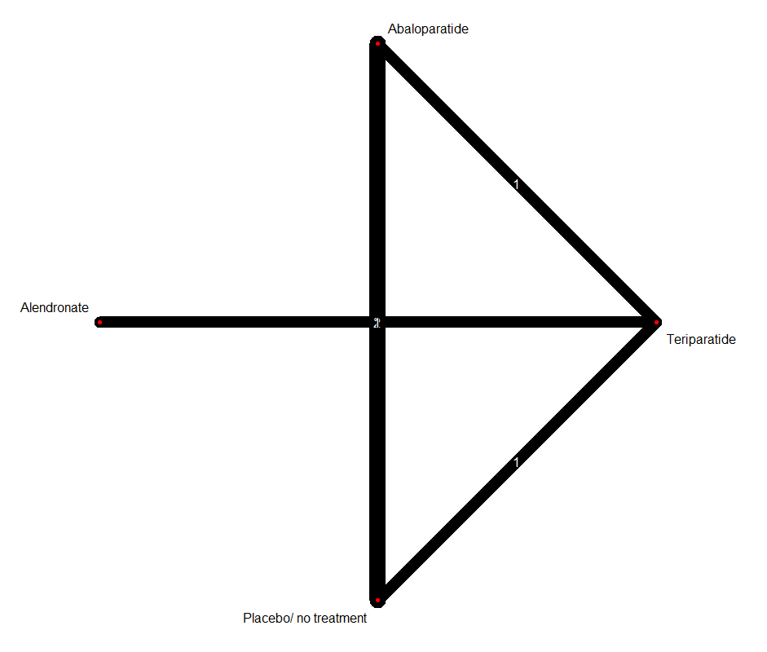

Teriparatide vs others
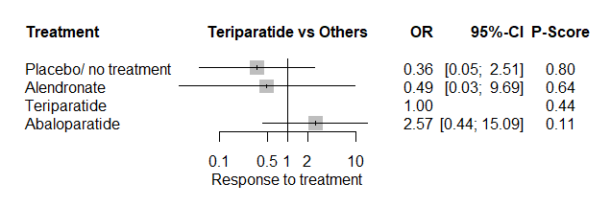
- In term of cardiac arythmias PT, teriparatide is demonstrated to be as safe as other treatments/placebo included in the model.

Abaloparatide vs others
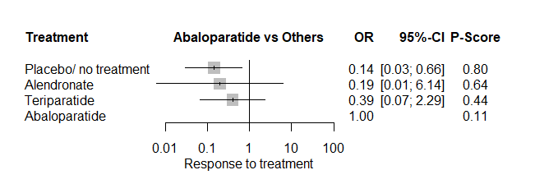
- In terms of cardiac arythmias PT, placebo demonstrated to be safer than abaloparatide.

Grouped PTs_Coronary Heart Disease and Stroke
NMA design description
- Number of studies: k = 3
- Number of pairwise comparisons: m = 5
- Number of treatments: n = 3
- Number of designs: d = 3

Netgraph “All adverse events” safety model
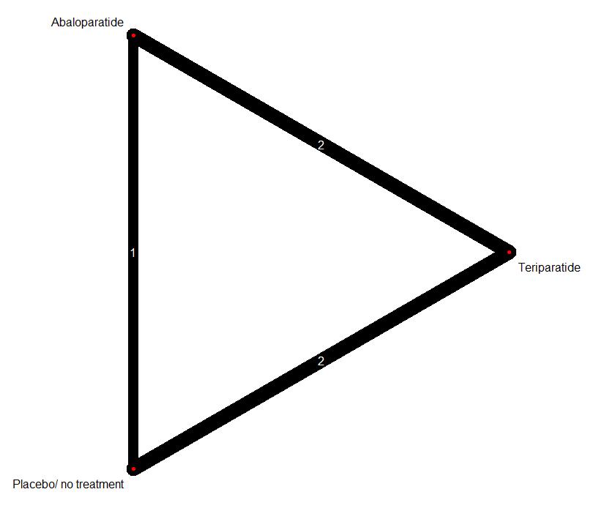

Teriparatide vs others
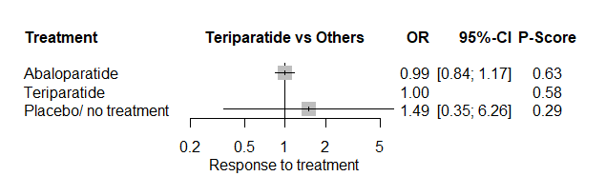
- In term of coronary heart diseases and stroke PT, teriparatide is demonstrated to be as safe as placebo and abaloparatide.

Abaloparatide vs others
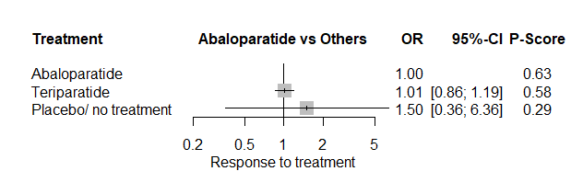
- In term of coronary heart diseases and stroke PT, abaloparatide is demonstrated to be as safe as placebo and teriparatide.

Grouped PTs_Heart Failure
NMA design description
- Number of studies: k = 3
- Number of pairwise comparisons: m = 3
- Number of treatments: n = 4
- Number of designs: d = 3

Netgraph “All adverse events” safety model
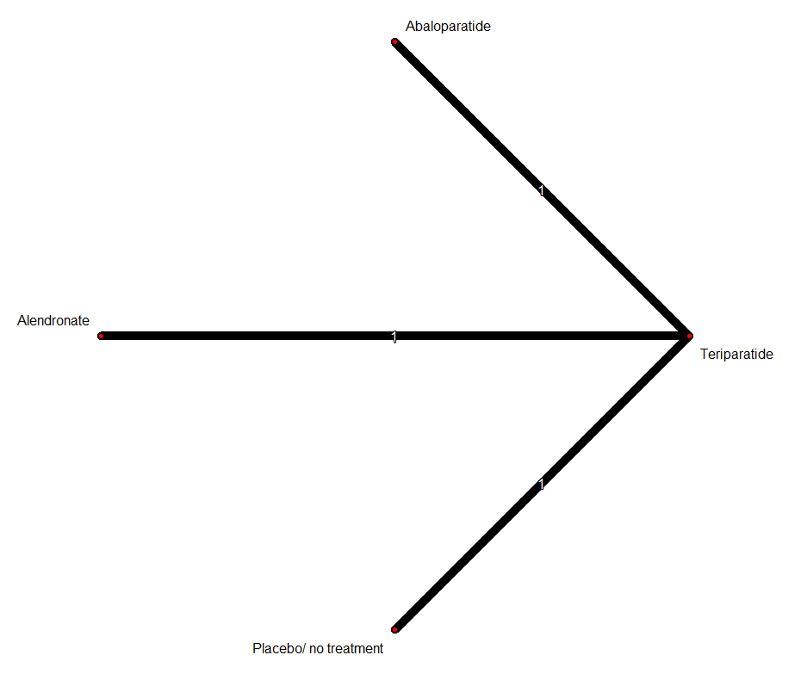

Teriparatide vs others
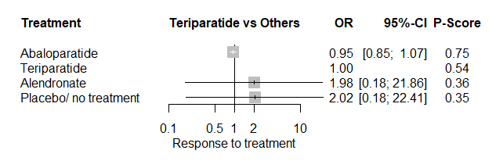
- In term of heart failure PT, teriparatide is demonstrated to be as safe as other treatments/placebo included in the model.

Abaloparatide vs others
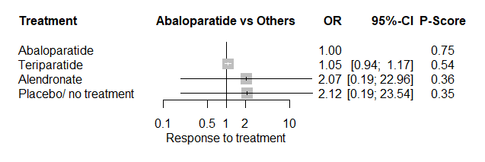
- In term of heart failure PT, abaloparatide is demonstrated to be as safe as other treatments/placebo included in the model.

Grouped PTs_Blood Pressure Disorders

NMA design description
- Number of studies: k = 3
- Number of pairwise comparisons: m = 5
- Number of treatments: n = 4
- Number of designs: d = 3

Netgraph “All adverse events” safety model
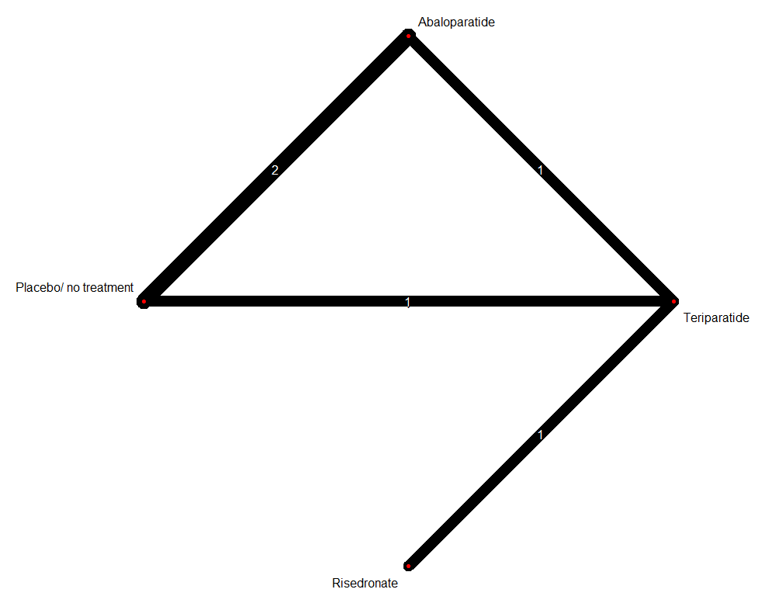
Teriparatide vs others
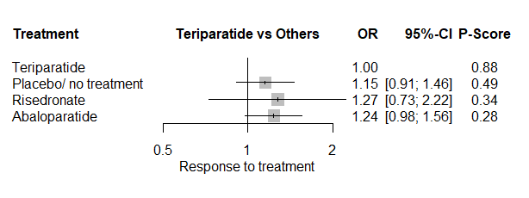
- In term of blood pressure disorder PT, teriparatide is demonstrated to be as safe as other treatments/placebo used in the model.

Abaloparatide vs others
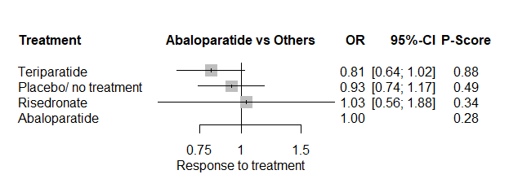
- In term of coronary heart diseases and stroke PT, abaloparatide is demonstrated to be as safe as other treatments/placebo used in the model.

Supplementary analyses_Cardiovascular deaths

NMA design description
- Number of studies: k = 3
- Number of pairwise comparisons: m = 5
- Number of treatments: n = 4
- Number of designs: d = 3

Netgraph “All adverse events” safety model
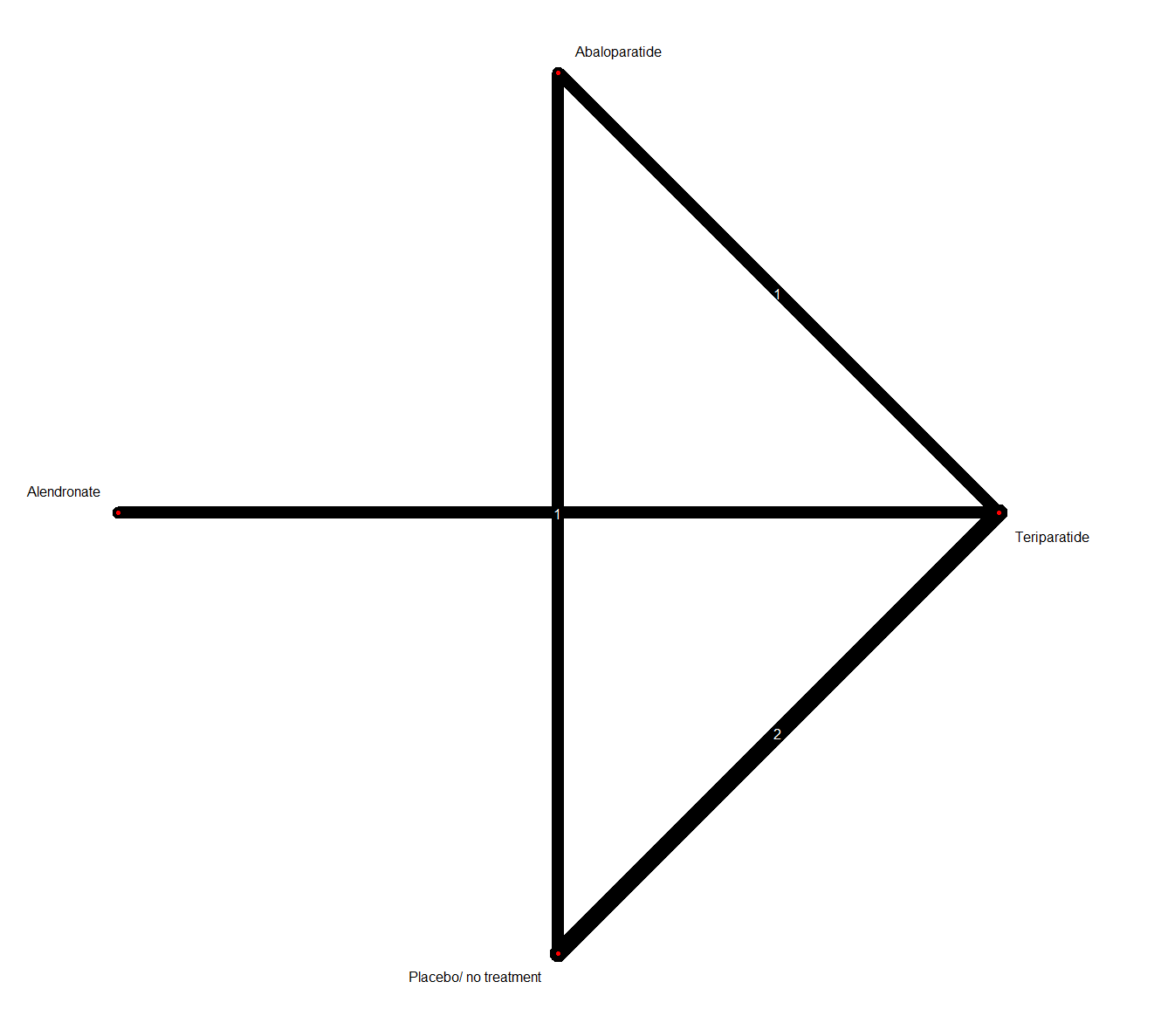

Teriparatide vs others
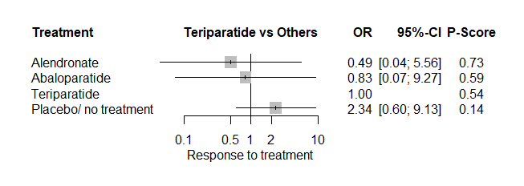
- In term of cardiovascular death, teriparatide is demonstrated to be as safe as other treatments/placebo included in the model.
Abaloparatide vs others
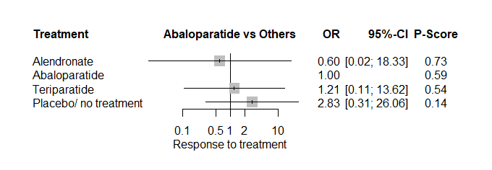
- In term of cardiovascular death, abaloparatide is demonstrated to be as safe as other treatments/placebo included in the model.

Supplementary analyses_MACE3

NMA design description
- Number of studies: k = 4
- Number of pairwise comparisons: m = 6
- Number of treatments: n = 4
- Number of designs: d = 4

Netgraph “All adverse events” safety model
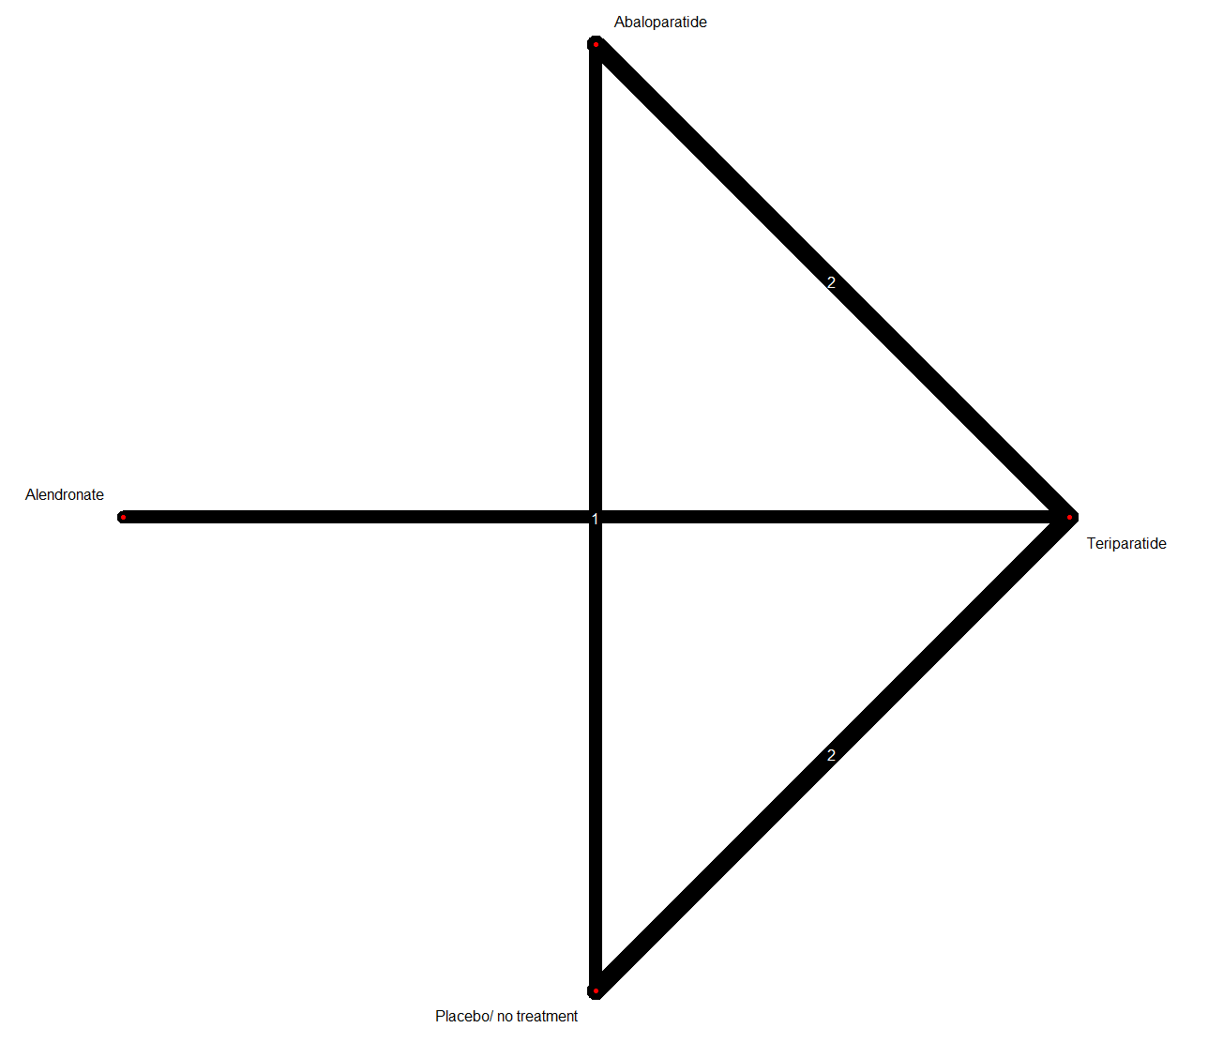

Teriparatide vs others
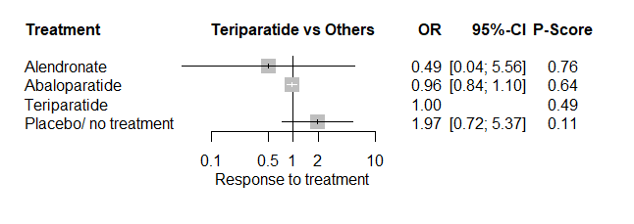
- In term of MACE3, teriparatide is demonstrated to be as safe as other treatments/placebo included in the model.

Abaloparatide vs others
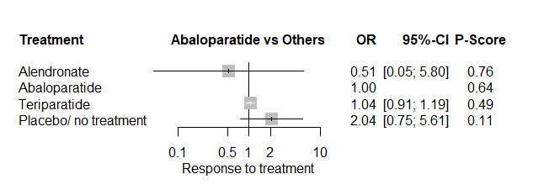
- In term of MACE3, abaloparatide is demonstrated to be as safe as other treatments/placebo included in the model.

Supplementary analyses_MACE4

NMA design description
- Number of studies: k = 4
- Number of pairwise comparisons: m = 6
- Number of treatments: n = 4
- Number of designs: d = 4

Netgraph “All adverse events” safety model

Teriparatide vs others
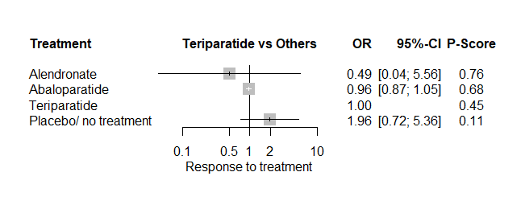
- In term of MACE4, teriparatide is demonstrated to be as safe as other treatments/placebo included in the model.

Abaloparatide vs others
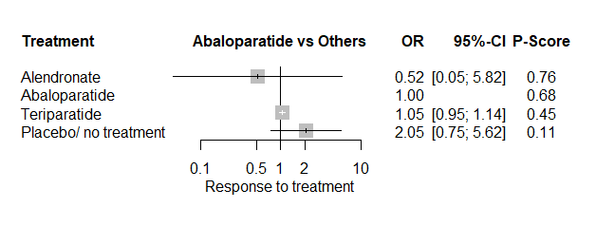
- In term of MACE3, abaloparatide is demonstrated to be as safe as other treatments/placebo included in the model.

Supplementary analyses_MACE5

NMA design description
- Number of studies: k = 5
- Number of pairwise comparisons: m = 7
- Number of treatments: n = 4
- Number of designs: d = 5

Netgraph “All adverse events” safety model
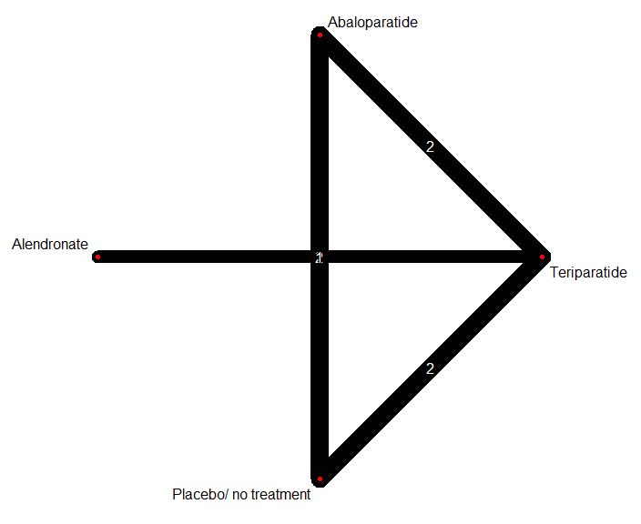

Teriparatide vs others
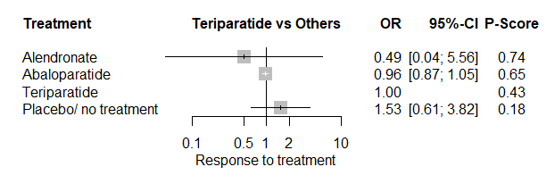
- In term of MACE5, teriparatide is demonstrated to be as safe as other treatments/placebo included in the model.

Abaloparatide vs others
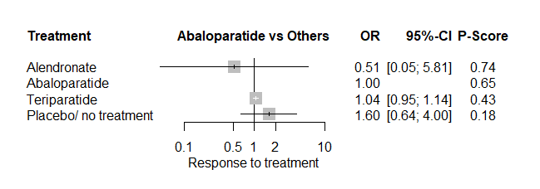
- In term of MACE5, abaloparatide is demonstrated to be as safe as other treatments/placebo included in the model.

For studies reporting adverse events according to MedDRA.

