Online Resource 1

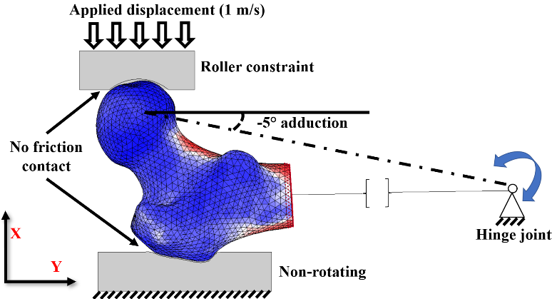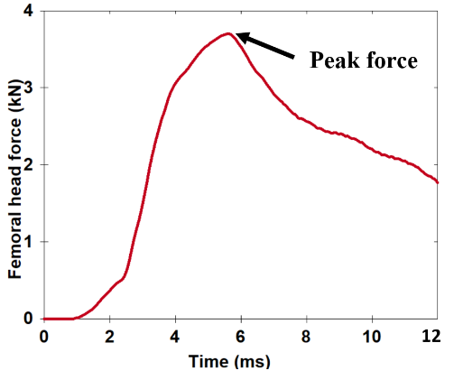
B
A
Figure A1. Finite element model boundary conditions for sideways fall configuration of -5° adduction and 0° internal rotation (A) and a sample force-time response recorded at the femoral head (B).

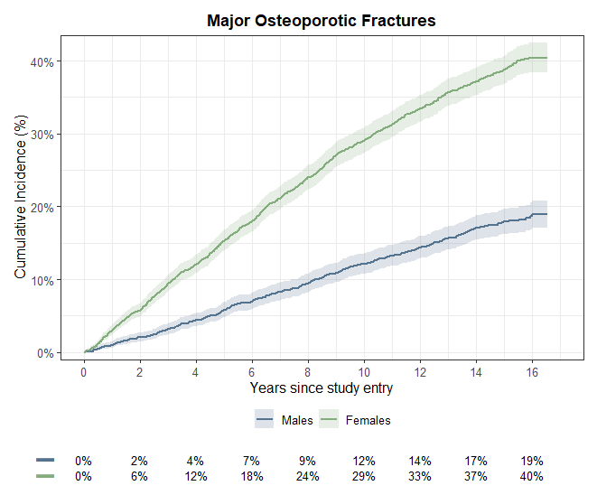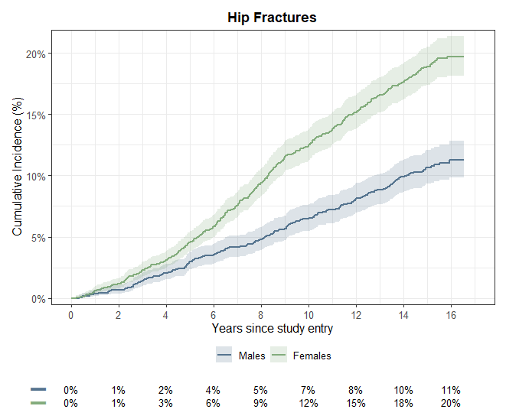
B
A
Figure A2. Cumulative incidence rates of male and female subjects sustaining HFs (A) and MOFs (B) from study entry to end of follow-up.

Table A1. Summary of main characteristics of CT studies that predicted hip (HF) or major osteoporotic fracture (MOF) using finite-element (FE) analysis (n = 8).
No. | Author, Year | Study Design | Image acquisition | Follow-up (years) | Sample size (women) | Mean Age (years) | Fracture type | Fracture cases (%) | Outcomes
1 | Adams et al., 2018 ⁽⁷⁾ | CC, R | At baseline, pre-fracture | 5 | 2783 (1922) | Fx / non-Fx  Women: 79.5 / 74  Men: 80.3 / 75.7 | HF | 1306 (47) | AUC of DXA_aBMD (Females/Males): 0.72 / 0.73  AUC of bone strength (Females/Males): 0.73 / 0.75  Sensitivity of DXA_aBMD (Females/Males): 0.52 / 0.43  Sensitivity of bone strength (Females/Males): 0.63 / 0.48  Specificity of DXA_aBMD (Females/Males): 0.77 / 0.83  Specificity of bone strength (Females/Males): 0.69 / 0.82
2 | Bhattacharya et al., 2019 ⁽⁸⁾ | CC | Post-fracture | 0 | 98 (98) | Fx / non-Fx  75 / 75 | HF | 49 (50) | AUC of ARF0: 0.852
3 | Falcinelli et al., 2014 ⁽⁹⁾ | CC | Post-fracture, contralateral side | 0 | 55 (55) | Fx / non-Fx  80 / 69 | HF | 22 (40) | AUC of aBMD: 0.77  AUC of bone strength: 0.79
4 | Fleps et al., 2022 ⁽¹⁰⁾ | CC | At baseline, pre-fracture | 5 | 601 (362) | Fx / non-Fx  79.5 / 76.4 | HF | 201 (33) | AUC of aBMD: 0.71  AUC of bone strength: 0.75
5 | Michalski et al., 2021 ⁽¹¹⁾ | R | At baseline, pre-fracture | 2 | 490 (187) | Fx / non-Fx  66.4 / 62.4 | HF | 123 (25) | AUC of aBMD (Females/Males): 0.65 / 0.64  AUC of bone strength (Females/Males): 0.67 / 0.63  Sensitivity of aBMD (Females/Males): 0.55 / 0.49  Sensitivity of bone strength (Females/Males): 0.74 / 0.47  Specificity of aBMD (Females/Males): 0.74 / 0.77  Specificity of bone strength (Females/Males): 0.58 / 0.81
6 | Qasim et al., 2016 ⁽¹²⁾ | CC | Post-fracture, contralateral side | 0 | 98 (98) | Fx / non-Fx  75 / 75 | HF | 49 (50) | AUC of aBMD: 0.75  AUC of bone strength: 0.79
7 | Kopperdahl et al., 2014 ⁽¹³⁾ | CC | At baseline, pre-fracture | 5 | 1048 (608) | Fx / non-Fx  Women: 79.4 / 74.7  Men: 80.2 / 75.2 | HF | 171 (16) | AUC of bone strength: Women: 0.78, Men:0.84  AUC of load-to-strength ratio: Women:0.8, Men:0.86
8 | Yosibash et al., 2023 ⁽¹⁴⁾ | CC, R | At baseline, pre-fracture | Case: 2  Control: 5 | 418 (280) | Fx / non-Fx  [T2DM: 75.8 / 77.5] [non-T2DM: 75.8 / 75.9] | HF | 239 (57) | AUC of bone strength + ML T2DM: 0.92  AUC of bone strength + ML non-T2DM: 0.84
Abbreviations: R: retrospective; P: prospective; CC: case-control; Fx: Fractures; BMD: bone mineral density; DXA: dual-energy X-ray absorptiometry; CT: Computed Tomography; ARF0: absolute risk of current fracture; ML: machine learning; T2DM: type 2 diabetic mellitus.

