Appendix A. Supplementary tables and figures
Table A.1. Baseline characteristic of the hip and spine dataset stratified by utility and genders
Parameter | Hip dataset (N = 3677) |  |  |  | Spine dataset (N =3383)
Parameter | Developing (N = 2743) |  | Testing (N = 934) |  | Developing (N = 2391) |  | Testing (N = 992)
Parameter | Women (N = 1802) | Men (N = 941) | Women (N = 617) | Men (N = 317) | Women (N = 1547) | Men (N = 844) | Women (N = 650) | Men (N = 342)
Age, yr | 48.2 $±$ 13.8 | 46.3 $±$ 14.8 | 47.9 $±$ 14.3 | 45.9 $±$ 15.2 | 47.7 $±$ 13.8 | 45.1 $±$ 15.0 | 47.7 $±$ 13.9 | 45.9 $±$ 15.2
Age group, yr:
18 – 49 | 909 (50.4%) | 524 (55.7%) | 300 (48.6%) | 163 (51.4%) | 784 (50.7%) | 486 (57.6%) | 335 (51.5%) | 189 (55.3%)
50 – 59 | 557 (30.9%) | 257 (27.3%) | 206 (33.4%) | 103 (32.5%) | 492 (31.8%) | 226 (26.8%) | 208 (32.0%) | 101 (29.5%)
60 – 69 | 250 (13.9%) | 119 (12.6%) | 85 (13.8%) | 35 (11.0%) | 210 (13.6%) | 99 (11.7%) | 78 (12.0%) | 37 (10.8%)
70+ | 86 (4.8%) | 41 (4.4%) | 26 (4.2%) | 16 (5.0%) | 61 (3.9%) | 33 (3.9%) | 29 (4.5%) | 15 (4.4%)
Weight, kg | 53.4 $±$ 8.0 | 62.7 $±$ 10.3 | 53.3 $±$ 8.3 | 62.4 $±$ 10.8 | 53.4 $±$ 8.0 | 62.8 $±$ 10.6 | 53.1 $±$ 8.0 | 62.1 $±$ 9.6
Height, cm | 153.1 $±$ 5.3 | 163.9 $±$ 5.9 | 153.1 $±$ 5.5 | 163.9 $±$ 8.1 | 153.1 $±$ 5.2 | 164.1 $±$ 6.8 | 153.2 $±$ 5.3 | 163.7 $±$ 5.9
BMI, kg/m² | 22.8 $±$ 3.3 | 23.3 $±$ 3.3 | 22.8 $±$ 3.4 | 24.0 $±$ 18.4 | 22.8 $±$ 3.3 | 23.6 $±$ 11.6 | 22.6 $±$ 3.3 | 23.2 $±$ 3.2
BMI category:
Underweight | 32 (1.8%) | 16 (1.7%) | 15 (2.4%) | 8 (2.5%) | 29 (1.9%) | 12 (1.4%) | 16 (2.5%) | 10 (2.9%)
Normal | 985 (54.7%) | 463 (49.2%) | 344 (55.8%) | 156 (49.2%) | 858 (55.5%) | 434 (51.4%) | 363 (55.8%) | 157 (45.9%)
Overweight | 640 (35.5%) | 353 (37.5%) | 206 (33.4%) | 127 (40.1%) | 535 (34.6%) | 305 (36.1%) | 225 (34.6%) | 146 (42.7%)
Obese | 145 (8.0%) | 109 (11.6%) | 52 (8.4%) | 26 (8.2%) | 125 (8.1%) | 93 (11.0%) | 46 (7.1%) | 29 (8.5%)
aBMD*, g/cm² | 0.69 $±$ 0.12 | 0.77 $±$ 0.12 | 0.69 $±$ 0.12 | 0.77 $±$ 0.12 | 0.88 $±$ 0.12 | 0.92 $±$ 0.10 | 0.89 $±$ 0.12 | 0.92 $±$0.11
T-score | -1.00 $±$1.05 | -0.65 $±$ 0.94 | -1.04 $±$ 1.08 | -0.61 $±$ 0.89 | -0.71 $±$ 1.05 | -1.08 $±$ 0.86 | -0.65 $±$ 1.10 | -1.08 $±$ 0.93
T-score category**:
Normal | 246 (27.5%) | 194 (46.5%) | 75 (23.7%) | 74 (48.1%) | 284 (37.2%) | 142 (39.7%) | 114 (36.2%) | 58 (37.9%)
Osteopenia | 514 (57.6%) | 210 (50.4%) | 192 (60.6%) | 76 (49.4%) | 417 (54.7%) | 182 (50.8%) | 171 (54.3%) | 78 (51.0%)
Osteoporosis | 133 (14.9%) | 13 (3.1%) | 50 (15.8%) | 4 (2.6%) | 62 (8.1%) | 34 (9.5%) | 30 (9.5%) | 17 (11.1%)
Values are presented as mean $±$ standard deviation or number (%). BMI: body mass index; aBMD: areal bone mineral density.
*Hip dataset used femoral neck aBMD; Spine dataset used lumbar spine aBMD.
**Classified among participant over 50 years old: Hip dataset used femoral neck T-score; Spine dataset used lumbar spine T-score.
Table A.2. Performance of VGG16, ResNet34, unadjusted and adjusted ensembles
Parameter | Femoral neck |  |  |  | Lumbar spine
Parameter | VGG16 | ResNet34 | Unadjusted | Adjusted | VGG16 | ResNet34 | Unadjusted | Adjusted
Overall
$r$ | 0.829 | 0.880 | 0.898 | 0.896 | 0.838 | 0.832 | 0.869 | 0.873
MAE (SD) | 0.056 (0.045) | 0.046 (0.038) | 0.042 (0.036) | 0.042 (0.036) | 0.050 (0.041) | 0.050 (0.042) | 0.046 (0.037) | 0.046 (0.037)
Bias (SD) | 0.007 (0.071) | -0.003 (0.060) | 0.003 (0.055) | 0.003 (0.055) | -0.002 (0.065) | 0.003 (0.066) | 0.003 (0.059) | 0.004 (0.059)
Women
$r$ | 0.841 | 0.886 | 0.902 | 0.900 | 0.846 | 0.837 | 0.872 | 0.874
MAE (SD) | 0.052 (0.040) | 0.043 (0.035) | 0.040 (0.032) | 0.041 (0.032) | 0.049 (0.042) | 0.050 (0.044) | 0.046 (0.039) | 0.045 (0.039)
Bias (SD) | 0.004 (0.065) | -0.005 (0.055) | 0.000 (0.051) | 0.000 (0.052) | 0.005 (0.064) | 0.008 (0.066) | 0.007 (0.060) | 0.004 (0.060)
Men
$r$ | 0.758 | 0.825 | 0.854 | 0.851 | 0.822 | 0.818 | 0.861 | 0.865
MAE (SD) | 0.064 (0.053) | 0.050 (0.044) | 0.045 (0.042) | 0.045 (0.042) | 0.052 (0.039) | 0.052 (0.038) | 0.047 (0.034) | 0.047 (0.033)
Bias (SD) | 0.012 (0.082) | 0.001 (0.067) | 0.009 (0.061) | 0.008 (0.061) | -0.014 (0.063) | -0.004 (0.064) | -0.004 (0.058) | 0.003 (0.057)
20-49 years
$r$ | 0.766 | 0.818 | 0.839 | 0.838 | 0.769 | 0.758 | 0.811 | 0.818
MAE (SD) | 0.058 (0.048) | 0.048 (0.043) | 0.044 (0.041) | 0.044 (0.041) | 0.051 (0.041) | 0.052 (0.042) | 0.048 (0.037) | 0.047 (0.037)
Bias (SD) | 0.016 (0.074) | -0.003 (0.064) | 0.004 (0.060) | 0.008 (0.060) | -0.006 (0.065) | 0.002 (0.067) | 0.002 (0.061) | 0.005 (0.060)
50-59 years
$r$ | 0.839 | 0.887 | 0.913 | 0.913 | 0.843 | 0.833 | 0.878 | 0.878
MAE (SD) | 0.052 (0.040) | 0.043 (0.032) | 0.038 (0.029) | 0.038 (0.029) | 0.047 (0.036) | 0.048 (0.039) | 0.043 (0.034) | 0.043 (0.034)
Bias (SD) | 0.003 (0.065) | -0.001 (0.054) | 0.005 (0.048) | 0.002 (0.048) | 0.002 (0.060) | 0.006 (0.062) | 0.004 (0.055) | 0.002 (0.055)
60-69 years
$r$ | 0.754 | 0.817 | 0.837 | 0.834 | 0.791 | 0.777 | 0.826 | 0.834
MAE (SD) | 0.054 (0.039) | 0.045 (0.032) | 0.042 (0.030) | 0.043 (0.031) | 0.051 (0.046) | 0.051 (0.048) | 0.046 (0.043) | 0.045 (0.043)
Bias (SD) | -0.012 (0.066) | -0.012 (0.055) | -0.006 (0.051) | -0.013 (0.051) | 0.004 (0.069) | 0.005 (0.070) | 0.005 (0.063) | 0.002 (0.062)
70+ years
$r$ | 0.635 | 0.773 | 0.800 | 0.798 | 0.742 | 0.801 | 0.841 | 0.841
MAE (SD) | 0.065 (0.053) | 0.049 (0.038) | 0.045 (0.038) | 0.047 (0.035) | 0.058 (0.051) | 0.048 (0.049) | 0.047 (0.041) | 0.047 (0.041)
Bias (SD) | -0.010 (0.084) | 0.006 (0.062) | 0.007 (0.059) | -0.005 (0.059) | 0.007 (0.077) | 0.005 (0.068) | 0.002 (0.062) | -0.002 (0.063)

Table A.3. Classification of normal, osteopenia and osteoporosis by aBMD compared to xBMD among those aged 50 years and older
Classification based on femoral neck xBMD | Classification based on femoral neck aBMD
Classification based on femoral neck xBMD | Normal | Osteopenia | Osteoporosis
Women
Normal | 72 | 27 | 0
Osteopenia | 3 | 107 | 3
Osteoporosis | 0 | 58 | 47
Men
Normal | 68 | 10 | 0
Osteopenia | 6 | 62 | 0
Osteoporosis | 0 | 4 | 4
The classification of osteoporosis and/or osteopenia was based on the following femoral neck BMD T-scores: -1.2, -2.0 for women and -1.2, -2.3 for men.
For osteoporosis classification: Women: sensitivity = 0.94 (0.83 to 0.99), specificity = 0.78 (0.73 to 0.83); Men: sensitivity = 1.00 (0.40 to 1.00), specificity = 0.97 (0.93 to 0.99).
For osteopenia classification: Women: sensitivity = 0.95 (0.90 to 0.98), specificity = 0.56 (0.48 to 0.63); Men: sensitivity = 0.92 (0.84 to 0.97), specificity = 0.82 (0.71 to 0.90).
Classification based on lumbar spine xBMD | Classification based on lumbar spine aBMD
Classification based on lumbar spine xBMD | Normal | Osteopenia | Osteoporosis
Women
Normal | 96 | 36 | 0
Osteopenia | 17 | 84 | 4
Osteoporosis | 1 | 51 | 26
Men
Normal | 49 | 15 | 0
Osteopenia | 9 | 53 | 1
Osteoporosis | 0 | 10 | 16
The classification of osteoporosis and/or osteopenia was based on the following femoral neck BMD T-scores: -1.2, -1.8 for women and -1.2, -2.0 for men.
For osteoporosis classification: Women: sensitivity = 0.87 (0.69 to 0.96), specificity = 0.82 (0.77 to 0.86); Men: sensitivity = 0.94 (0.71 to 1.00), specificity = 0.93 (0.87 to 0.96).
For osteopenia classification: Women: sensitivity = 0.85 (0.79 to 0.91), specificity = 0.49 (0.41 to 0.57); Men: sensitivity = 0.87 (0.77 to 0.93), specificity = 0.68 (0.56 to 0.78).

Table A.4. Classification of high fracture risk calculated by aBMD compared to xBMD among those aged 50 years and older
Hip fracture
Classification based on femoral neck xBMD | Classification based on femoral neck aBMD
Classification based on femoral neck xBMD | High-risk | Not high-risk
Women
High-risk | 77 | 39
Not high-risk | 9 | 192
Men
High-risk | 8 | 4
Not high-risk | 0 | 142
The classification of high risk was based on 10-year probability of hip fracture > 0.02 for women and 0.03 for men.
For women: sensitivity = 0.90 (0.81 to 0.95), specificity = 0.83 (0.78 to 0.88).
For men: sensitivity = 1.00 (0.63 to 1.00), specificity = 0.97 (0.93 to 0.99).
Classification based on lumbar spine xBMD | Classification based on lumbar spine aBMD
Classification based on lumbar spine xBMD | High-risk | Not high-risk
Women
High-risk | 37 | 36
Not high-risk | 2 | 240
Men
High-risk | 3 | 3
Not high-risk | 1 | 147
The classification of high risk was based on 10-year probability of hip fracture > 0.02 for both women and men.
For women: sensitivity = 0.95 (0.83 to 0.99), specificity = 0.87 (0.82 to 0.91).
For men: sensitivity = 0.75 (0.19 to 0.99), specificity = 0.98 (0.94 to 1.00).
Any fracture
Classification based on femoral neck xBMD | Classification based on femoral neck aBMD
Classification based on femoral neck xBMD | High-risk | Not high-risk
Women
High-risk | 27 | 14
Not high-risk | 2 | 274
Men
High-risk | 4 | 1
Not high-risk | 1 | 148
The classification of high risk was based on 10-year probability of any fracture > 0.17 for women and 0.18 for men.
For women: sensitivity = 0.93 (0.77 to 0.99), specificity = 0.95 (0.92 to 0.97).
For men: sensitivity = 0.80 (0.28 to 0.99), specificity = 0.99 (0.96 to 1.00).
Classification based on lumbar spine xBMD | Classification based on lumbar spine aBMD
Classification based on lumbar spine xBMD | High-risk | Not high-risk
Women
High-risk | 9 | 9
Not high-risk | 1 | 296
Men
High-risk | 1 | 0
Not high-risk | 1 | 152
The classification of high risk was based on 10-year probability of any fracture > 0.18 for women and 0.30 for men.
For women: sensitivity = 0.90 (0.55 to 1.00), specificity = 0.97 (0.94 to 0.99).
For men: sensitivity = 0.50 (0.01 to 0.99), specificity = 1.00 (0.98 to 1.00).

Table A.5. Classification of normal, osteopenia and osteoporosis by aBMD compared to xBMD among 1252 women and 584 men aged 50 years and older in the dataset
Classification based on xBMD* | Classification based on aBMD**
Classification based on xBMD* | Normal | Osteopenia | Osteoporosis
Women | 211 | 695 | 346
Normal (N = 236) | 179 | 53 | 4
Osteopenia (N = 788) | 32 | 611 | 145
Osteoporosis (N = 228) | 0 | 31 | 197
Men | 171 | 334 | 79
Normal (N = 187) | 156 | 31 | 0
Osteopenia (N = 340) | 15 | 294 | 31
Osteoporosis (N = 57) | 0 | 9 | 48
The classification of osteoporosis and/or osteopenia was based on World Health Organisation T-scores.
For osteoporosis classification: Women: sensitivity = 0.57 (0.52 to 0.62), specificity = 0.97 (0.95 to 0.98), PPV = 0.86 (0.81 to 0.90), NPV = 0.85 (0.83 to 0.88); Men: sensitivity = 0.61 (0.49 to 0.72), specificity = 0.98 (0.97 to 0.99); PPV = 0.88 (0.84 to 0.92), NPV = 0.82 (0.76 to 0.87)
For osteopenia classification: Women: sensitivity = 0.88 (0.85 to 0.90), specificity = 0.68 (0.64 to 0.72), PPV = 0.78 (0.75 to 0.80), NPV = 0.82 (0.78 to 0.85); Men: sensitivity = 0.88 (0.84 to 0.91), specificity = 0.82 (0.76 to 0.86), PPV = 0.61 (0.50 to 0.72), NPV = 0.98 (0.97 to 0.99).
*Based on lowest femoral neck and lumbar spine xBMD.
**Based on lowest femoral neck, total hip and lumbar spine aBMD.

Fig. A.1. Bland-Altman plot compared AI-predicted to DXA-measured bone mineral density at the femoral neck (left) and lumbar spine (right).

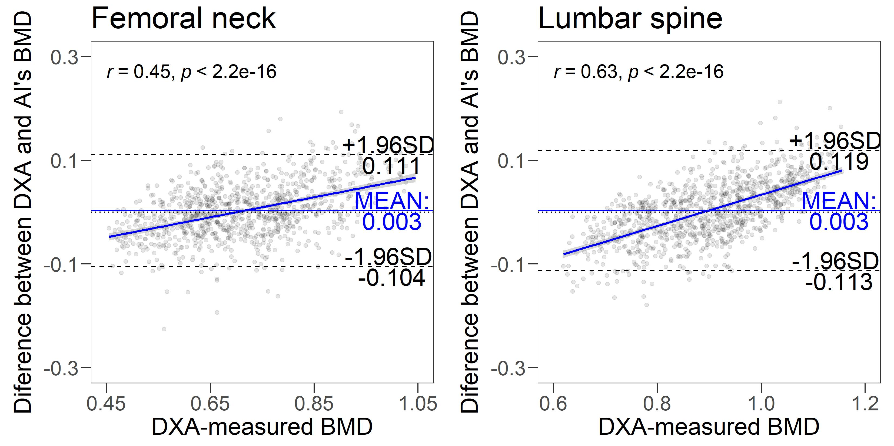

Fig. A.2. Evaluation between AI-predicted and DXA-measured bone mineral density at the femoral neck and lumbar spine for GARVAN (left) and FRAX (right): The first and second rows display the correlation between fracture risks, with red indicating hip fracture risk and blue indicating any fracture risk; The third row highlights performance in discriminating individuals over 50 years old at high fracture risk, red denoted hip fracture risk ≥ 3% and blue denoted any fracture risk ≥ 20%.
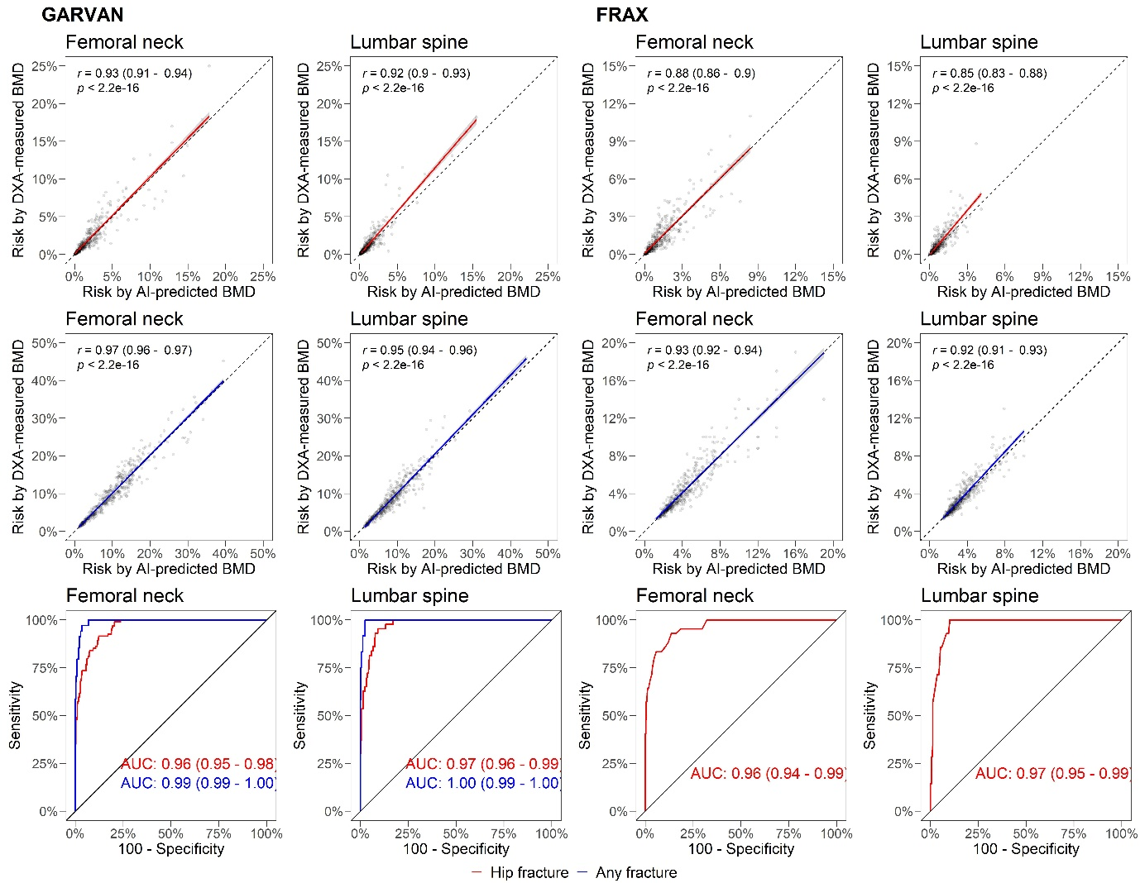

Appendix B. Artificial intelligence system development

B.1. Data collection
For the segmentation and labeling of the development set, three rheumatologists were involved. For spine X-rays, we drew bounding boxes around vertebral bodies with 20% padding for positioning variability. Active learning was used, starting with 700 X-rays to train the initial detection module. Rheumatologists reviewed and corrected detections, followed by iterative retraining until all development X-rays were processed.
For segmentation, we created masks from 146 spine X-ray to highlight vertebral bodies and remove the background using GIMP2. Black represented the background, and colors indicated target areas. We produced 146 pairs of masks for superior and inferior projections to address overlapping vertebrae. Bounding boxes were preferred over segmented masks for vertebrae localization due to their narrow spacing.
For pelvis X-rays, we created a mask that partitioned the image to highlight the right hip and femoral neck. Active learning was used to train the segmentation model with 200 X-rays, continuing until all development X-rays were processed. Cropped images of the right hip or femoral neck were extracted from the masks with 20% padding. We also experimented with background removal to assess its impact on prediction accuracy.

B.2. Artificial intelligence
B.2.1. Specification
The system comprises two components, a detection module ($D$) and a BMD prediction model ($P$), tailored for both the spine and hip workflows:
- For the spine workflow, the detection module uses a two-step process to identify vertebrae from L4 to L1 in a lateral lumbar spine image ($L$), first detecting all vertebrae and then eliminating those that do not match using centroid location. The system retains the second to fifth vertebrae from the bottom to the top of the image, L4 to L1, as the first vertebral image is L5. This is expressed mathematically as $D(L) = v_{2→5}$. Next, each of the four retained vertebrae images is passed through $P$ separately to obtain L4BMD to L1BMD, which are then averaged to obtain the lumbar spine BMD (${BMD}_{spine}$): $P(v_{2→5}) = {BMD}_{spine}$.
- Similarly, for the hip workflow, the detection module differentiates and obtains the right hip's image, which corresponds to the left hip of the patient, from the frontal hip image ($H$) based on their centroids, where the right hip is the second image from the left border: $D(H) = h_{right}$. The right hip image is directly passed through $P$ to obtain the femoral neck BMD (${BMD}_{neck}$): $P(h_{right}) ={BMD}_{neck}$.
To potentially enhance the prediction accuracy, the system employed a segmentation scheme on the input for both the spine and hip workflows. This was done to experiment with the denoising of $v_{2→5}$ and $h_{right}$ before passing them through $P$. To further improve, three ensemble models were created, combining all trained models of either $BMD_{spine}$, or ${BMD}_{neck}$. This approach leverages the strengths of each model to obtain a more robust and accurate prediction of bone mineral density.
B2.2. Development
In this study, we developed an AI system and its components using the PyTorch framework. For detection of vertebra, we trained a YOLOv8x, the latest and most advanced model in the YOLO family, with the default settings for 100 epochs. In addition, we developed a Unet for denoising the vertebral image on a subset of unused spine radiographs. For the detection of hip’s region, we trained a Unet to segment the right hip and its femoral neck which the bounding box was computed based on the segmentation mask to fully enclosed the right hip.
All Unets were trained with similar recipe. Synchronous augmentation on both input and mask was applied using augmentation pipeline AugMix. The input was processed with contrast-limited histogram equalizer, while the output underwent a morphological closing operation. We optimized the Unet using Adam and binary cross-entropy logit loss, setting the learning rate from 1$×$10⁻³ to 1$×$10⁻⁸ and reduce on plateau, and set the batch size to 32. However, background removal hindrance learning therefore was not used in the final system.
The $P$ consisted of a backbone and two fully connected layers with linear activation functions. To accelerate the training process of the prediction module, we used pre-trained backbone. To minimize the mean squared error, the models were optimized through stochastic gradient descent, with the learning rate set to decrease on a plateau. For each region, we fit two “Gradient Boosting with Component-wise Linear Models” ensembles. The first model integrates the features from the seven backbones and adding gender, age, weight, and height in the second for potential improvement. The two ensembles were trained with the validation set and test on the test set.
B.2.3. Additional results
B.2.3.1. Detection module
For the vertebrae detection module on the validation set, the results are as follows: precision of 0.99, recall of 1.00, and a mean average precision of 1.00 with an intersection over union threshold of 0.5. For hip detection, the model obtained precision and recall of 1.00. Manual assessment by a rheumatologist confirmed perfect performance for both vertebrae and hip detection on the test set.
B.2.3.2. Denoise module
The denoise module was tested with the hypothesis that focusing on the bone regions would improve the prediction model's performance. Three U-Nets were trained to differentiate between bone and non-bone regions (background). The module demonstrated high segmentation accuracy, achieving Dice scores of 0.94 for the vertebrae, 0.96 for the hip, and 0.92 for the femoral neck. The denoise model was introduced between the detection and prediction modules, where the region of interest, after detection, was processed to remove background before passing through the prediction model. However, this approach significantly reduced the performance. Preliminary experiments of a single model, showed that the correlation on the spine set dropped from 0.86 to 0.70, and on the hip set, from 0.87 to 0.67. Therefore, the denoise module was not included in the final system development and testing. These results suggest that the deep learning model predicts BMD based on the differences between the non-bone and the bone regions.
B.2.3.3. Performance with clinical predictors
Adding age, sex, weight, and height had a minimal impact on BMD prediction, as detailed in Supplementary Table A.2. The difference between ensemble models was negligible. For osteoporosis discrimination at the spine, the area under the curve (AUC) was 0.93 (95% CI, 0.89 to 0.96) unadjusted and 0.93 (95% CI, 0.89 to 0.96) adjusted (p = 0.791). For the hip, the AUC was 0.94 (95% CI, 0.92 to 0.97) unadjusted and 0.94 (95% CI, 0.92 to 0.96) adjusted (p = 0.442).

