Exercise improves quality of life, mental health and pain in people living with osteoporosis: A systematic review and meta-analysis.
Caroline Fitzgerald^{1,3}, Dr Claire Burley (ORCiD 0000-0002-7632-5632)^{1,2,3}, A/Prof Kemi Wright (ORCiD 0000-0002-7146-0835)³, Dr Kelly McLeod (ORCiD 0000-0001-8453-3039)³, Sara Asadi (ORCiD 0000-0002-0887-244X)¹, Prof Belinda Parmenter (ORCiD 0000-0001-8013-5658)^{1,3,4}
¹ UNSW Medicine & Health Lifestyle Clinic, School of Health Sciences, Faculty of Medicine & Health, UNSW Sydney, Sydney, Australia
² Centre for Healthy Brain Ageing, School of Clinical Medicine, Faculty of Medicine & Health, UNSW Sydney, Sydney, Australia
³ School of Health Sciences, Faculty of Medicine & Health, UNSW Sydney, Sydney, Australia
⁴ Discipline Sport and Exercise Science, School of Health, University of the Sunshine Coast, Sippy Downs, QLD, Australia
Osteoporosis International

Caroline Fitzgerald (ORCiD 0009-0008-7340-9911)
caroline.fitzgerald@unsw.edu.au
Online Resource 2: Funnel plots for primary outcomes
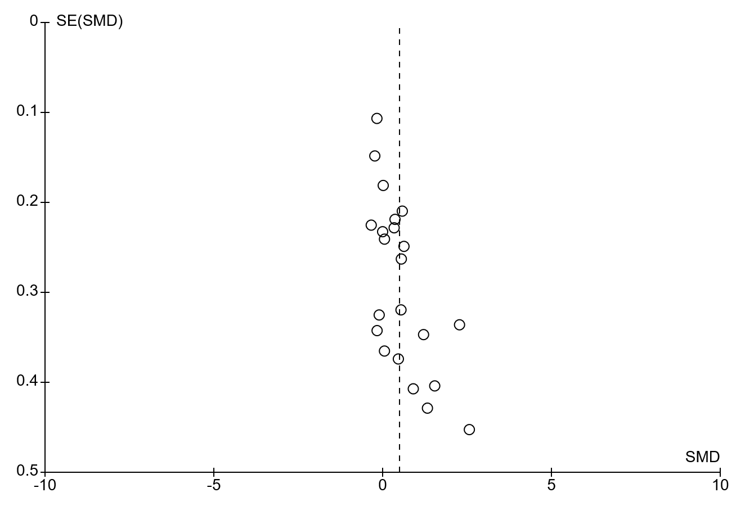
Figure 7 Funnel plot showing exercise v control for mental health
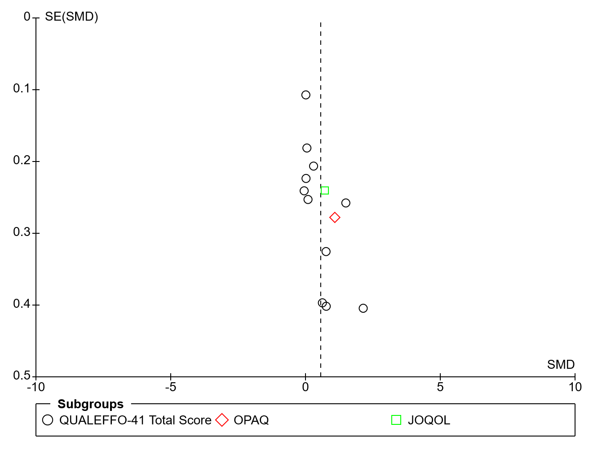Figure 8 Funnel plot showing exercise v control for quality of life
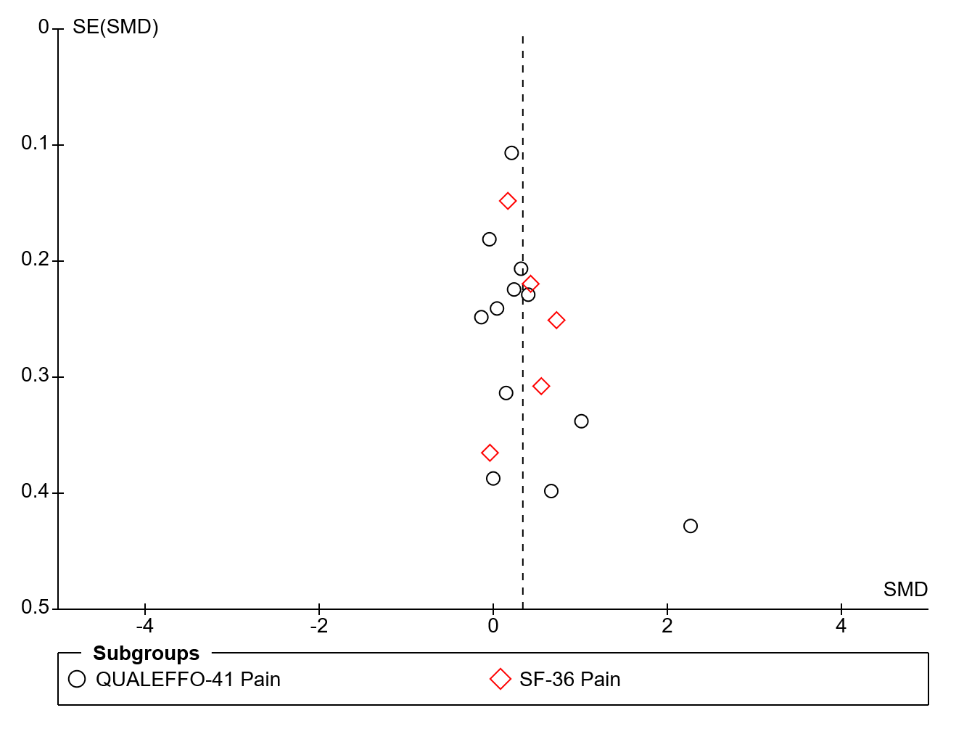Figure 9 Funnel plot showing exercise v control for pain
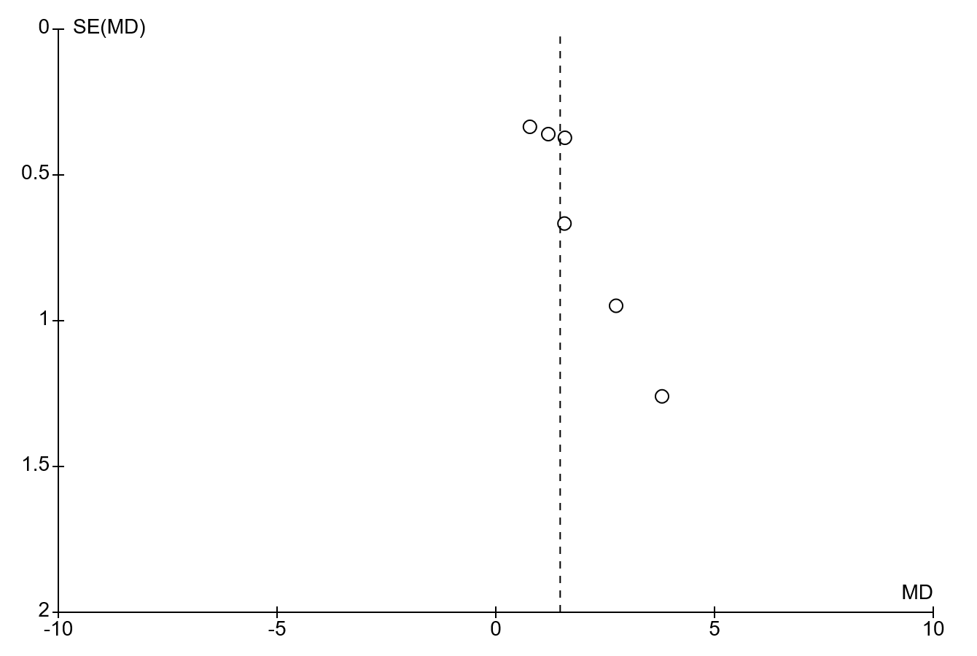
Figure 10 Funnel plot showing exercise v control for pain at rest (VAS)

