Exercise improves quality of life, mental health and pain in people living with osteoporosis: A systematic review and meta-analysis.
Caroline Fitzgerald^{1,3}, Dr Claire Burley (ORCiD 0000-0002-7632-5632)^{1,2,3}, A/Prof Kemi Wright (ORCiD 0000-0002-7146-0835)³, Dr Kelly McLeod (ORCiD 0000-0001-8453-3039)³, Sara Asadi (ORCiD 0000-0002-0887-244X)¹, Prof Belinda Parmenter (ORCiD 0000-0001-8013-5658)^{1,3,4}
¹ UNSW Medicine & Health Lifestyle Clinic, School of Health Sciences, Faculty of Medicine & Health, UNSW Sydney, Sydney, Australia
² Centre for Healthy Brain Ageing, School of Clinical Medicine, Faculty of Medicine & Health, UNSW Sydney, Sydney, Australia
³ School of Health Sciences, Faculty of Medicine & Health, UNSW Sydney, Sydney, Australia
⁴ Discipline Sport and Exercise Science, School of Health, University of the Sunshine Coast, Sippy Downs, QLD, Australia
Osteoporosis International

Caroline Fitzgerald (ORCiD 0009-0008-7340-9911)
caroline.fitzgerald@unsw.edu.au
Online Resource 4: Sub-group analyses for primary outcomes

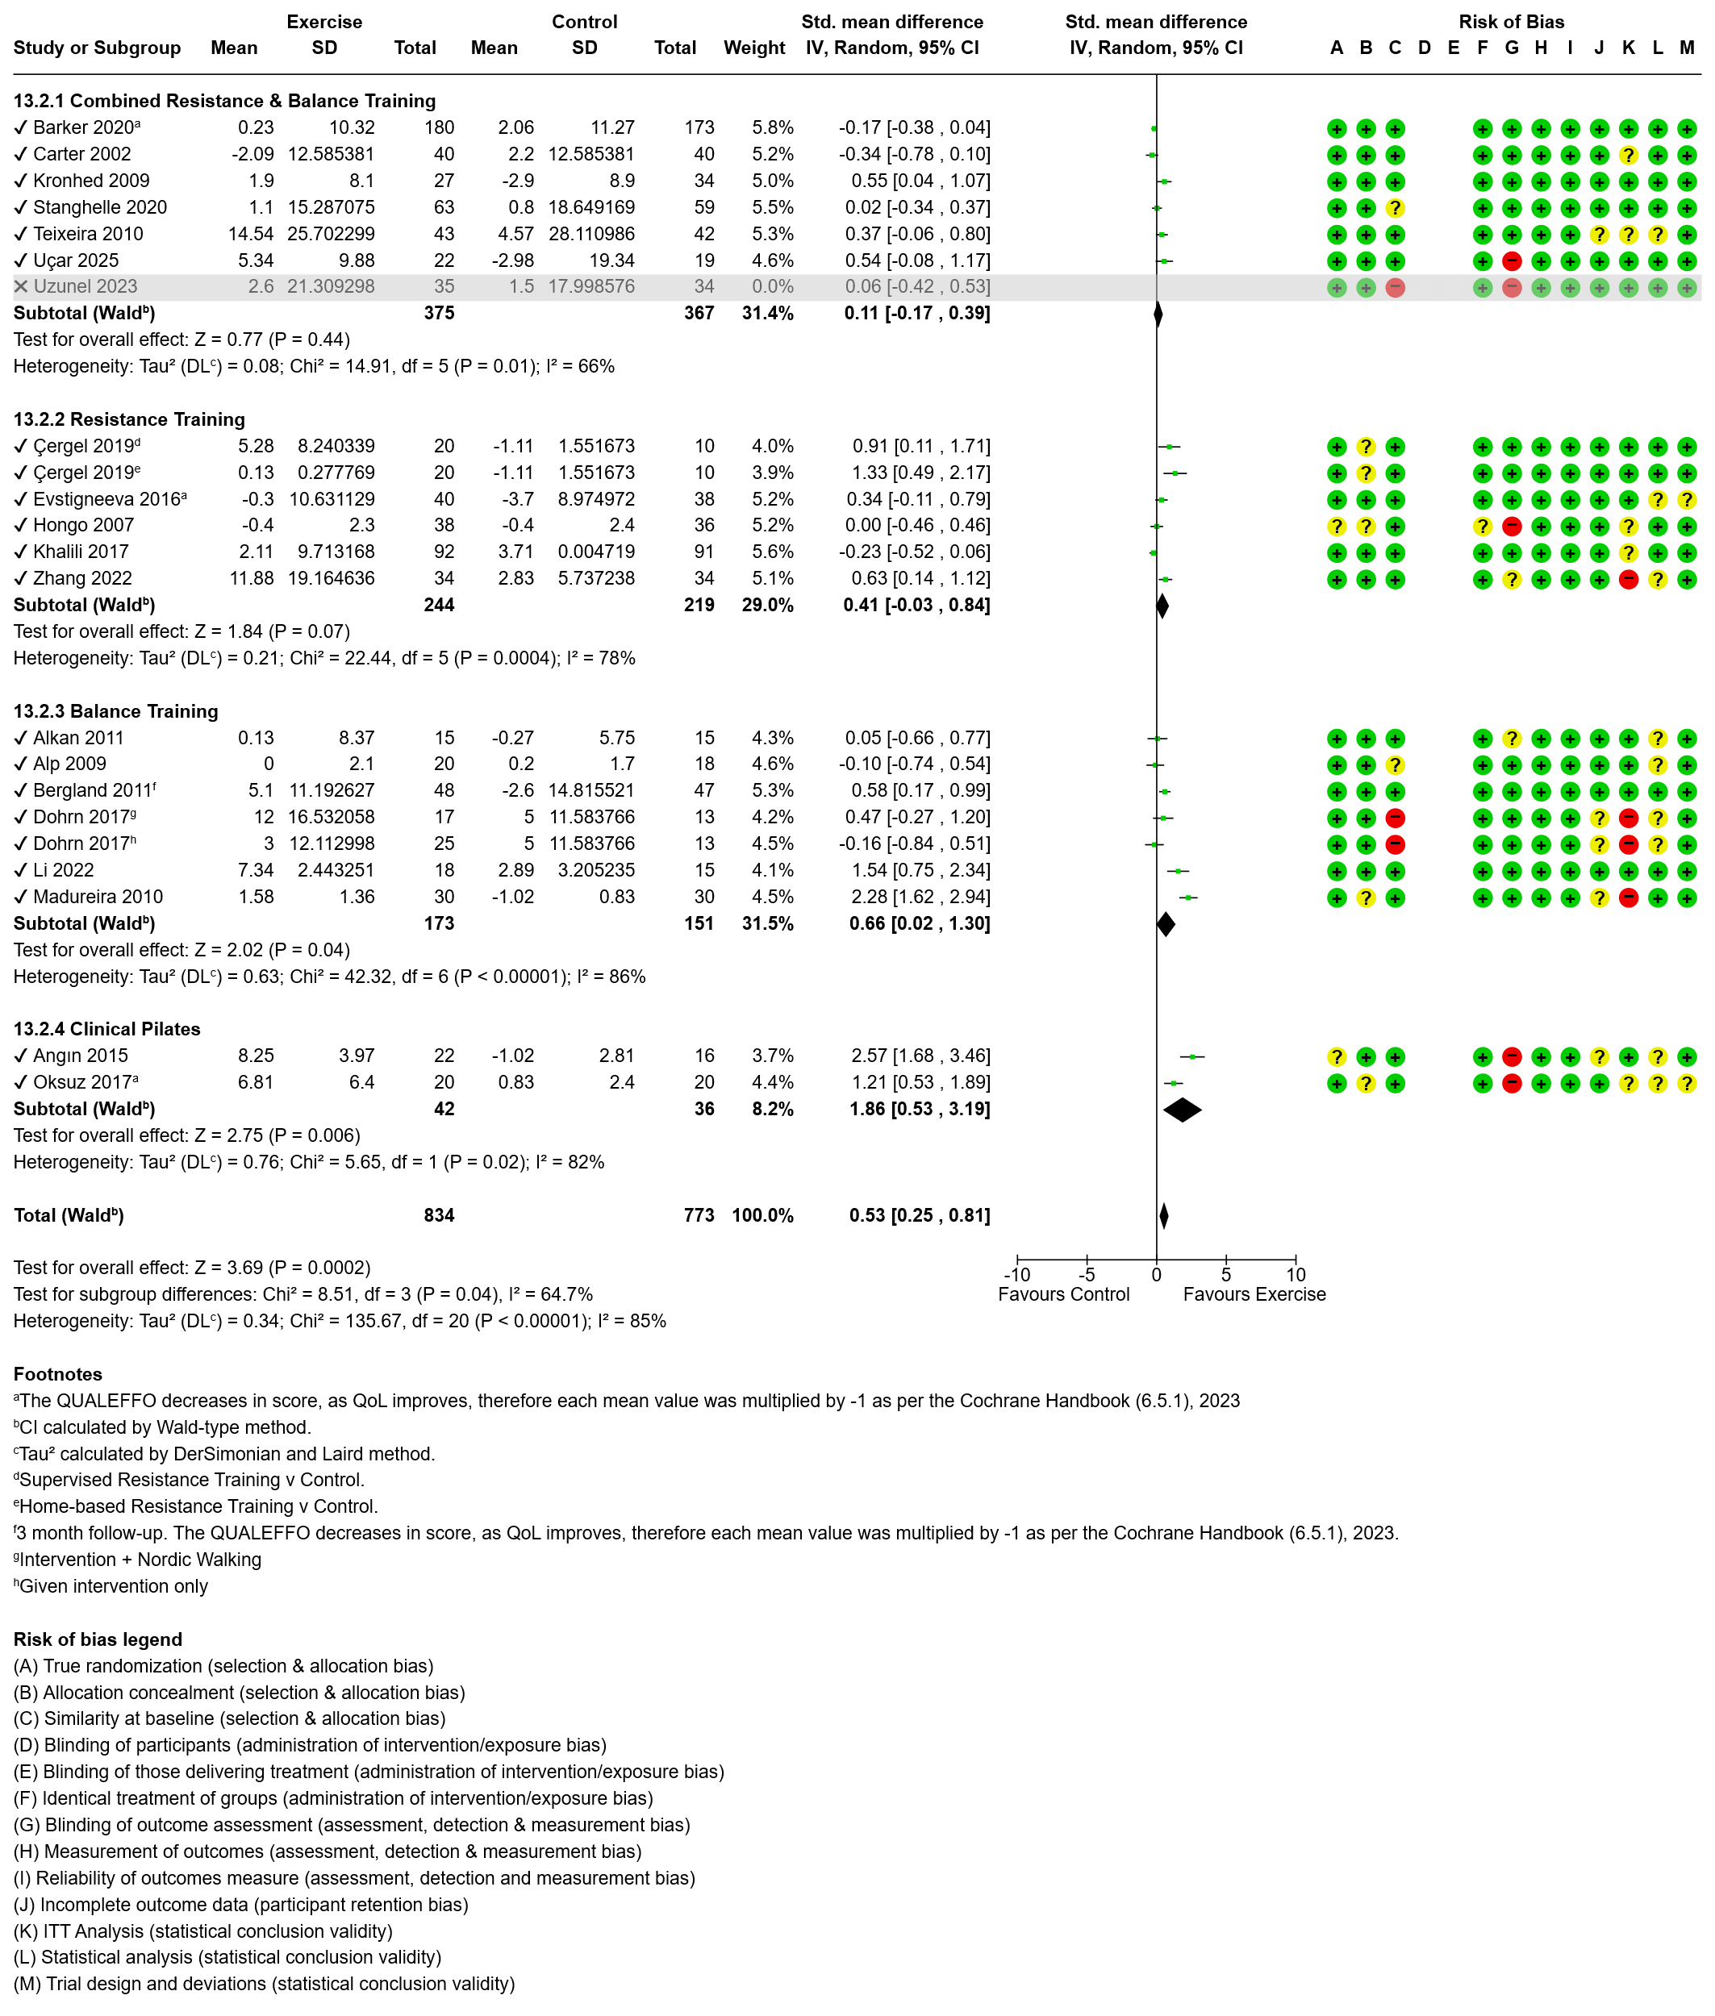
Figure 11 Effect of exercise on mental health with subgroup analysis by exercise modality.

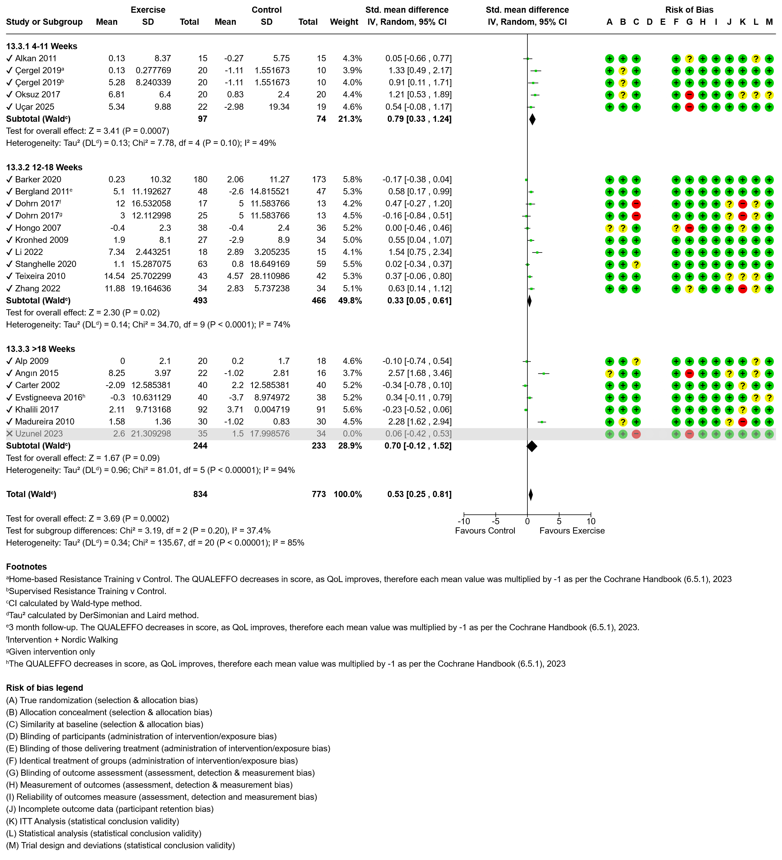
Figure 12 Effect of exercise on mental health with subgroup analysis by intervention duration.

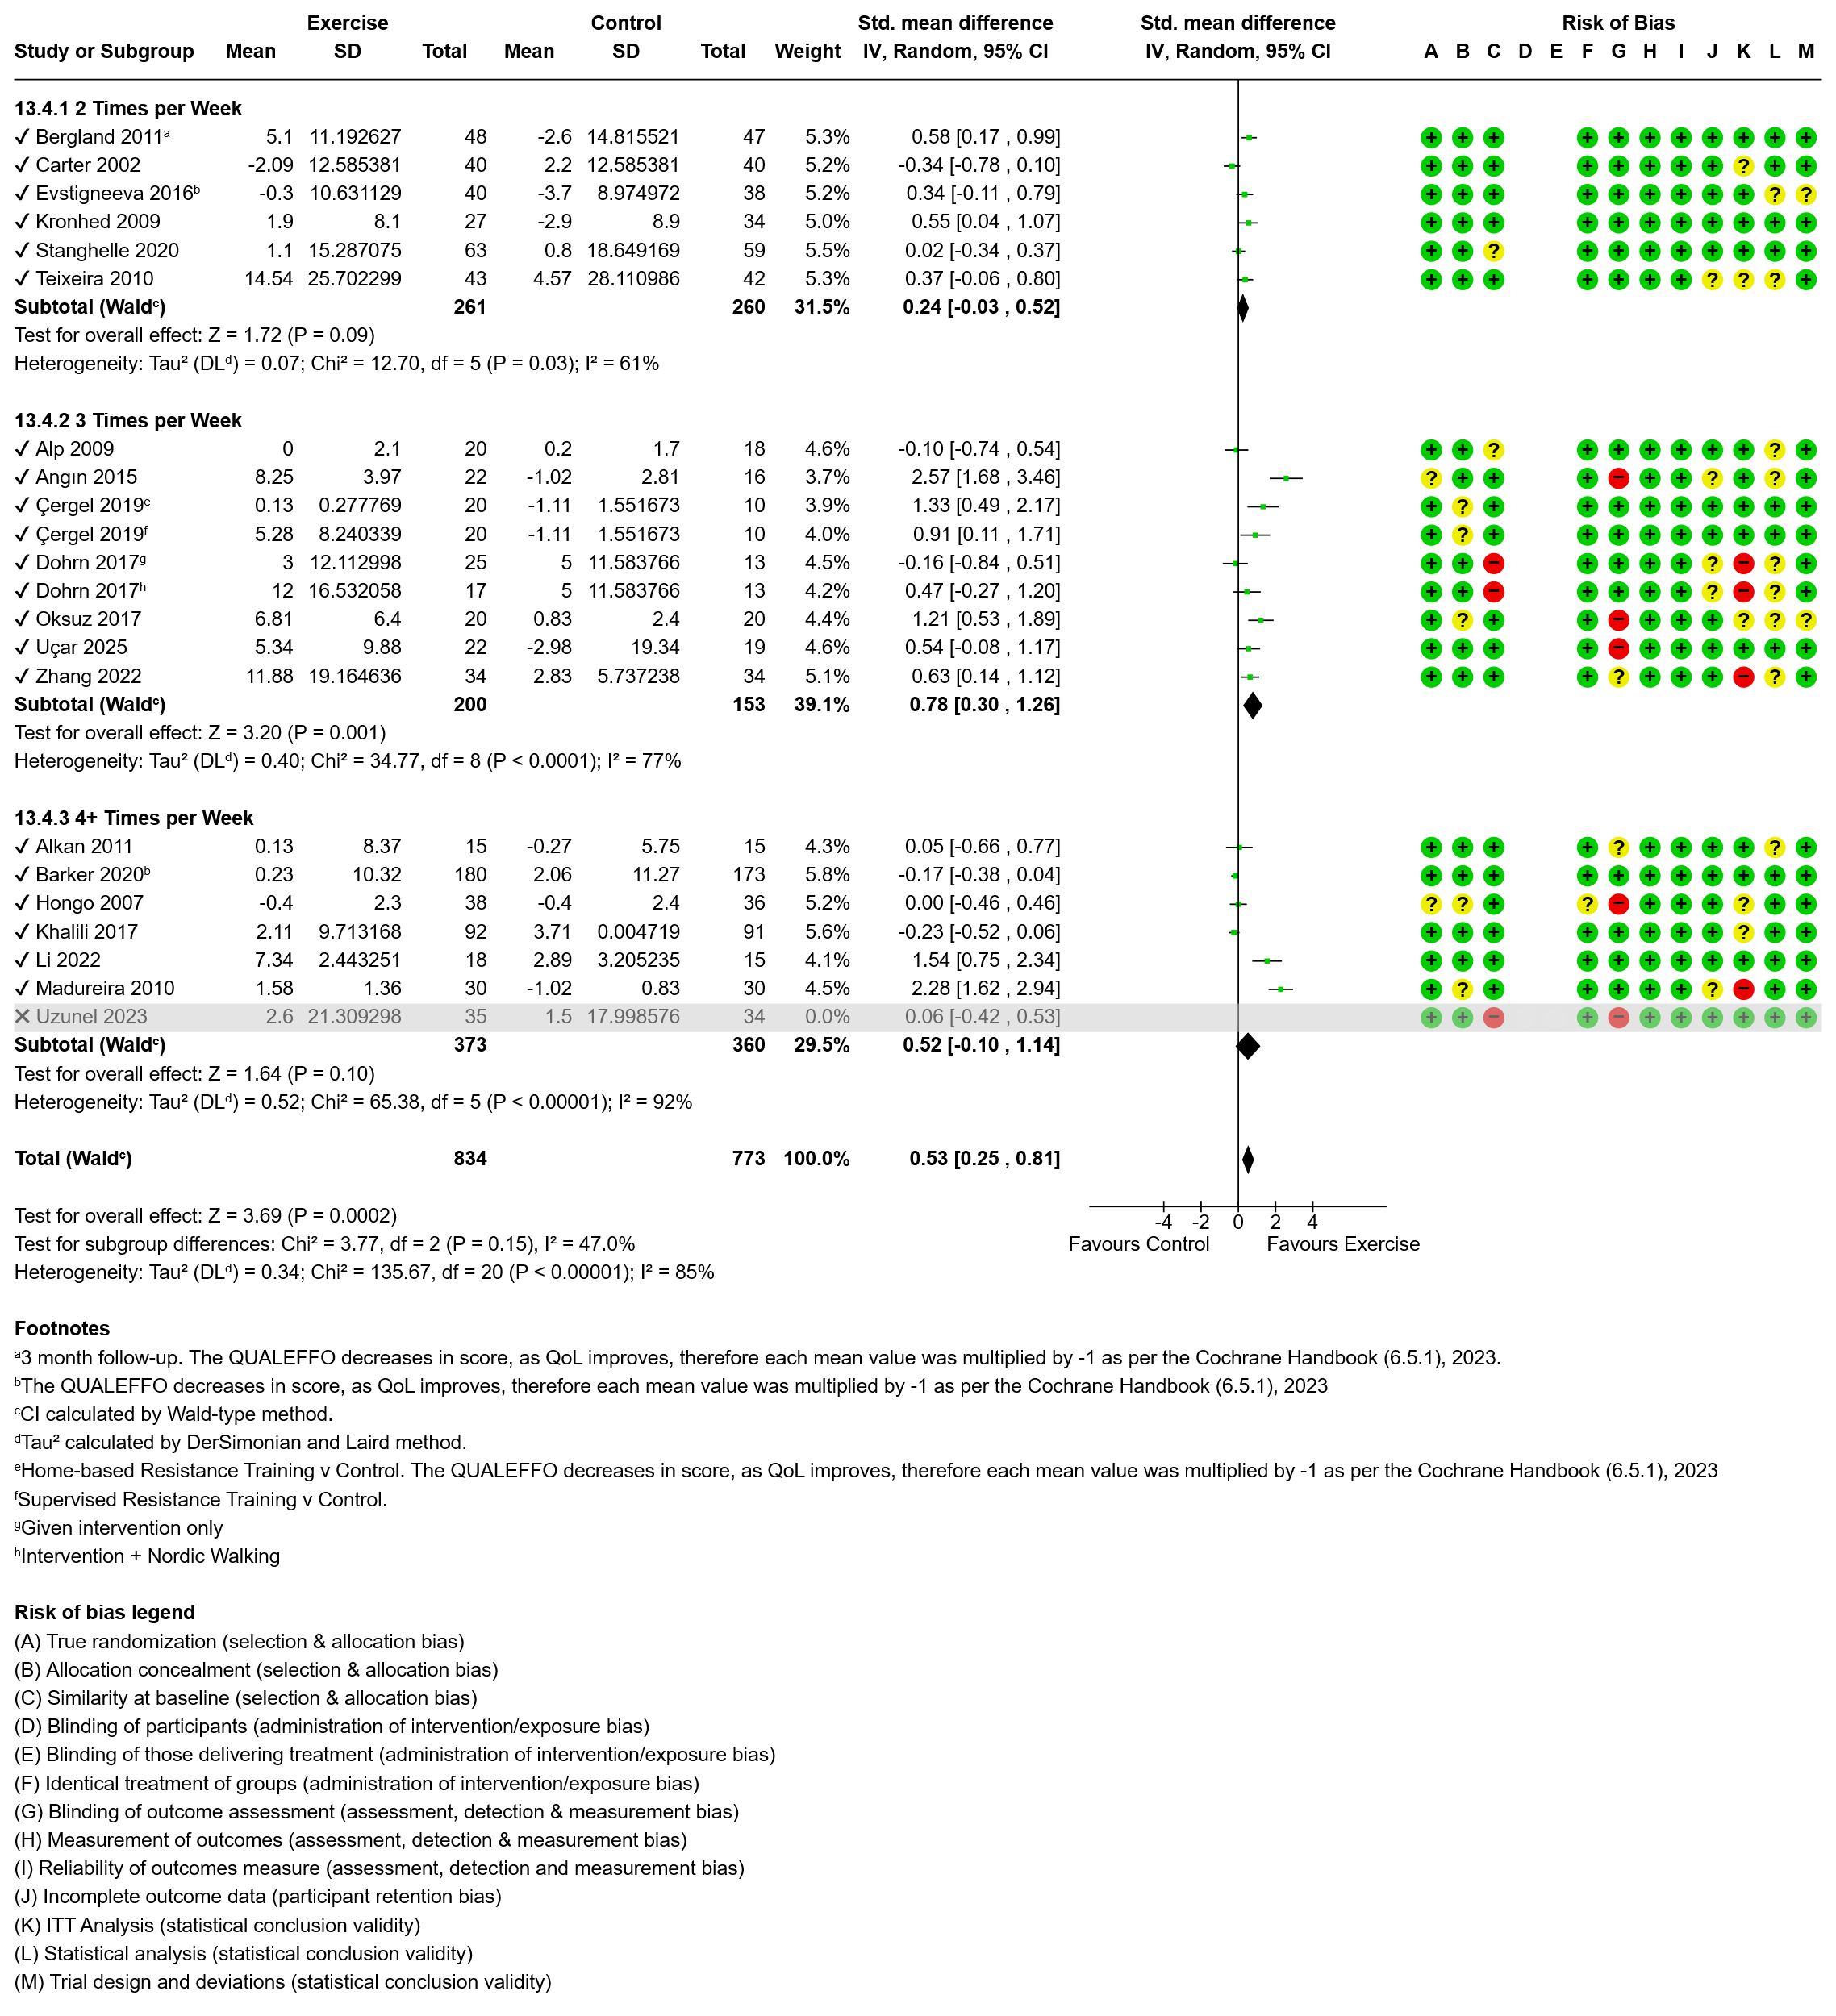
Figure 13 Effect of exercise on mental health with subgroup analysis by intervention frequency.

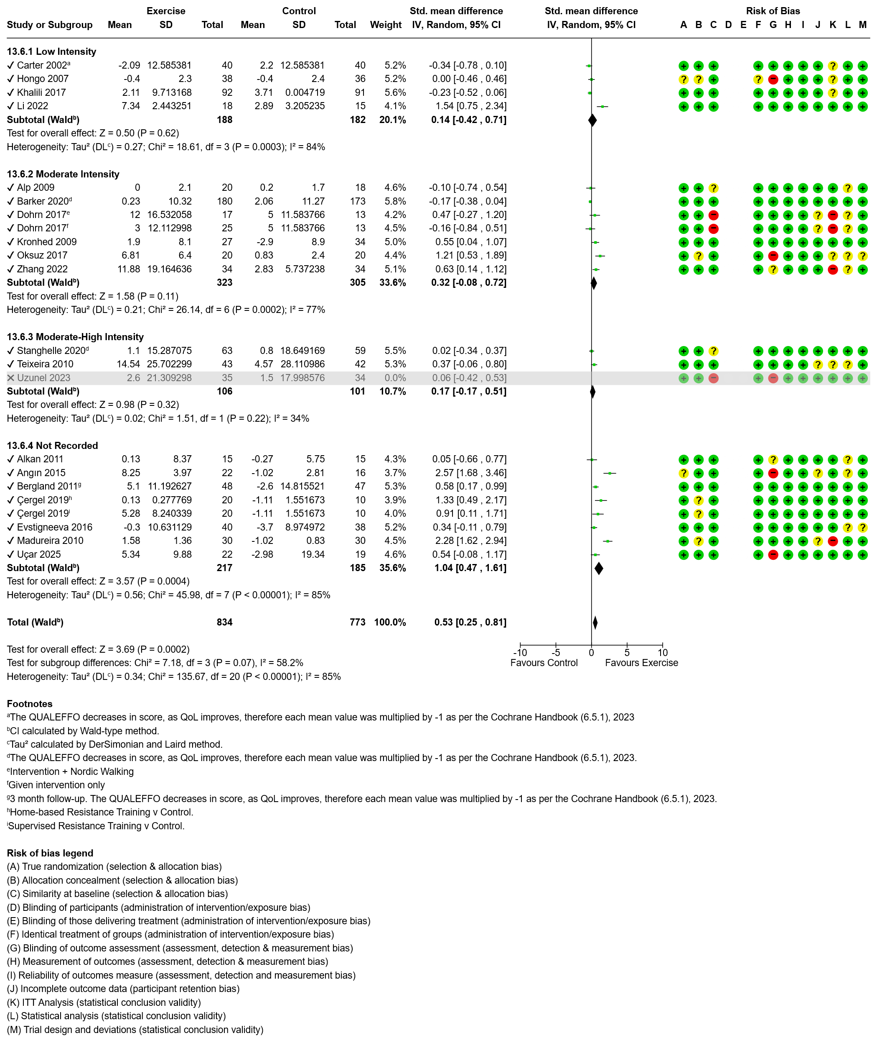Figure 14 Effect of exercise on mental health with subgroup analysis by intervention intensity.

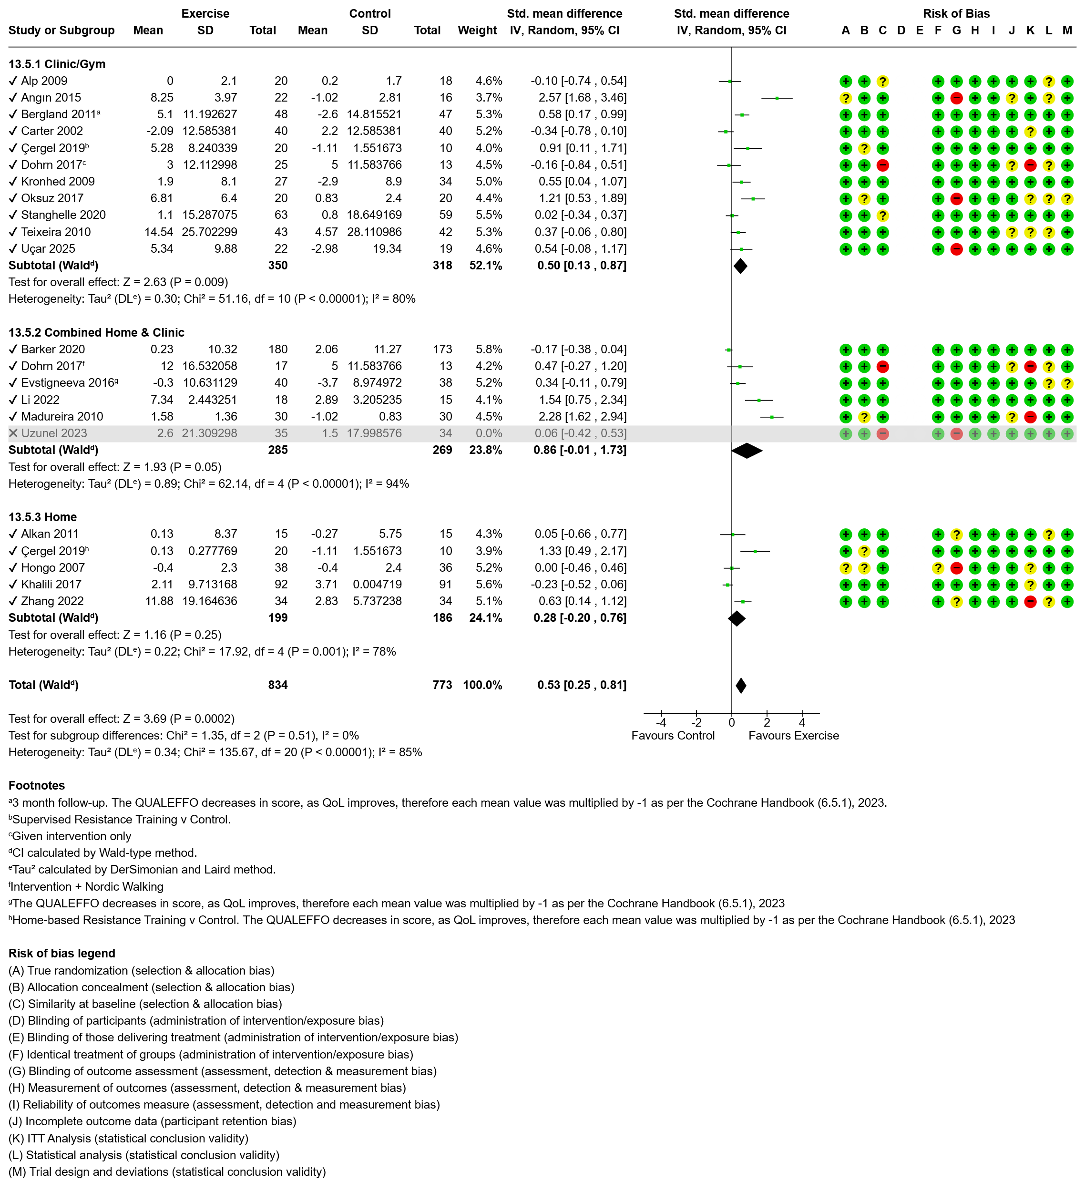Figure 15 Effect of exercise on mental health with subgroup analysis by intervention setting.

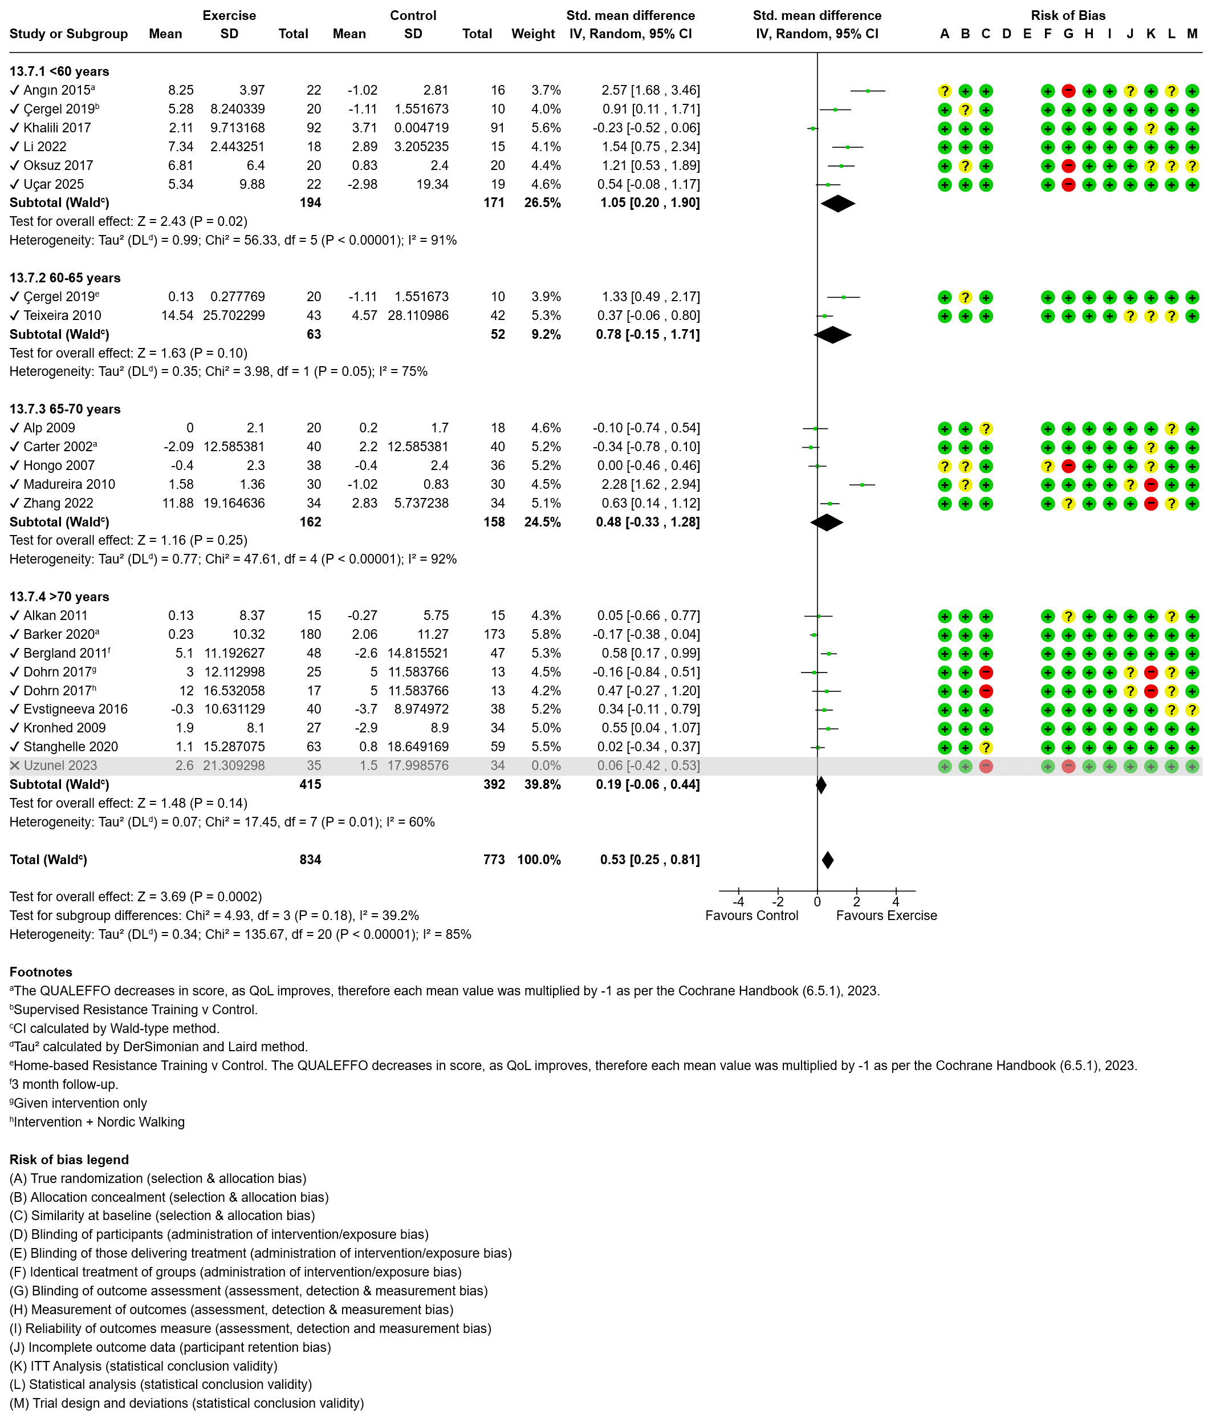
Figure 16 Effect of exercise on mental health with subgroup analysis by participant age.

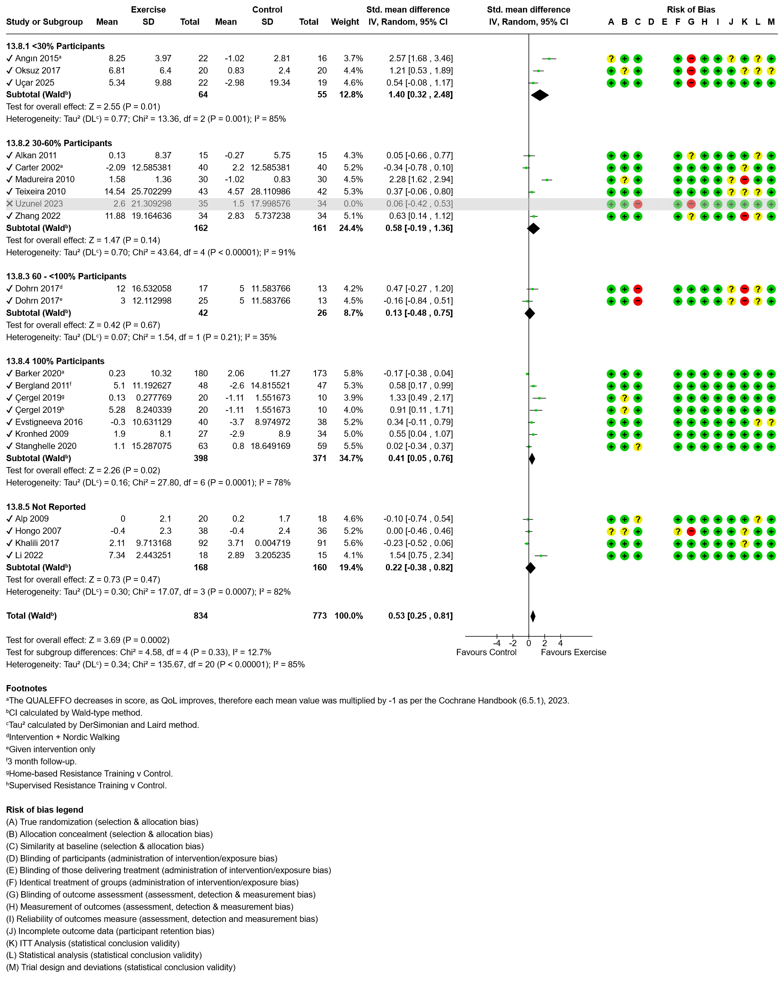Figure 17 Effect of exercise on mental health with subgroup analysis by presence of fracture.
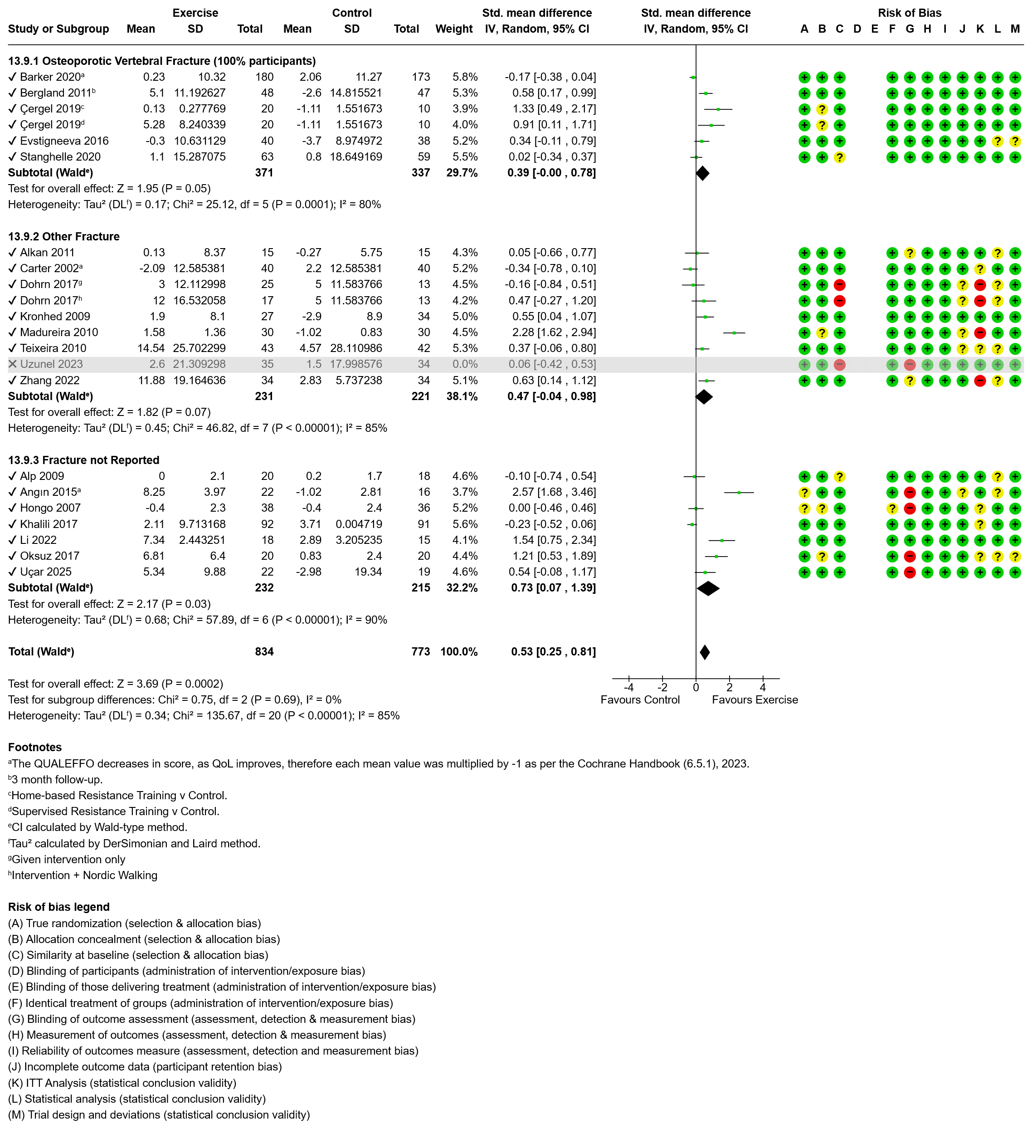Figure 18 Effect of exercise on mental health with subgroup analysis by nature of fracture.
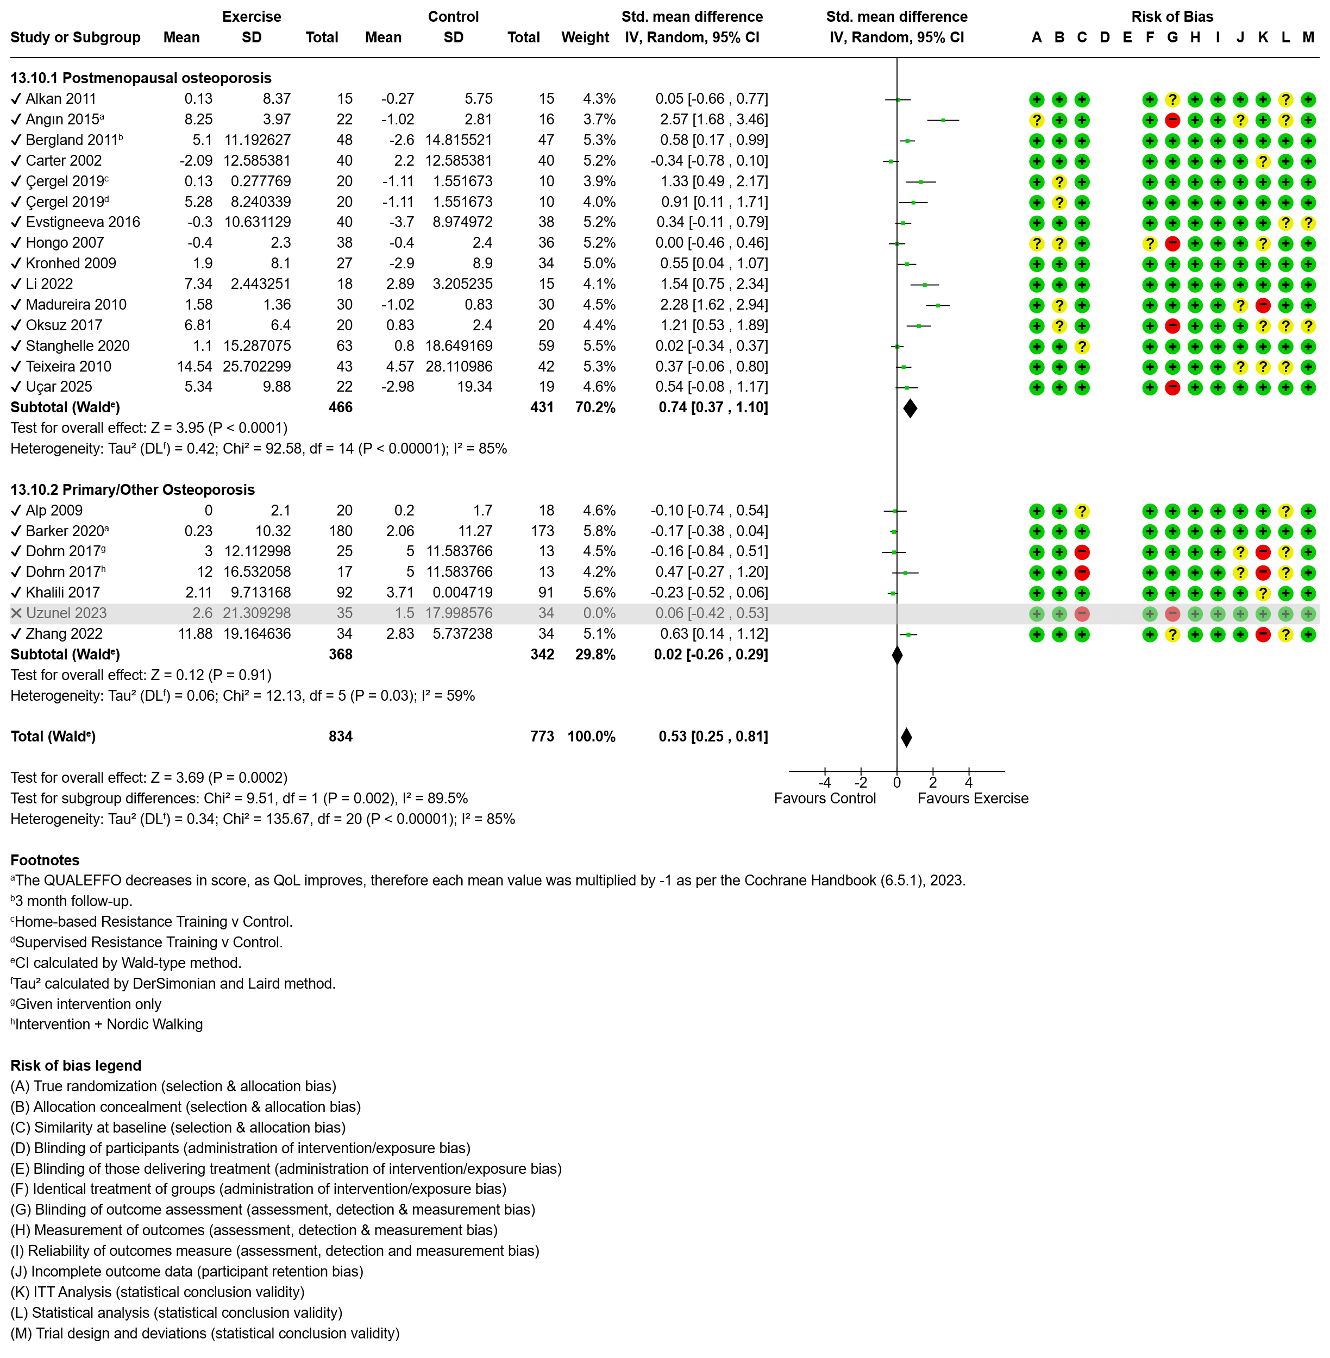Figure 19 Effect of exercise on mental health with subgroup analysis by osteoporosis diagnosis.

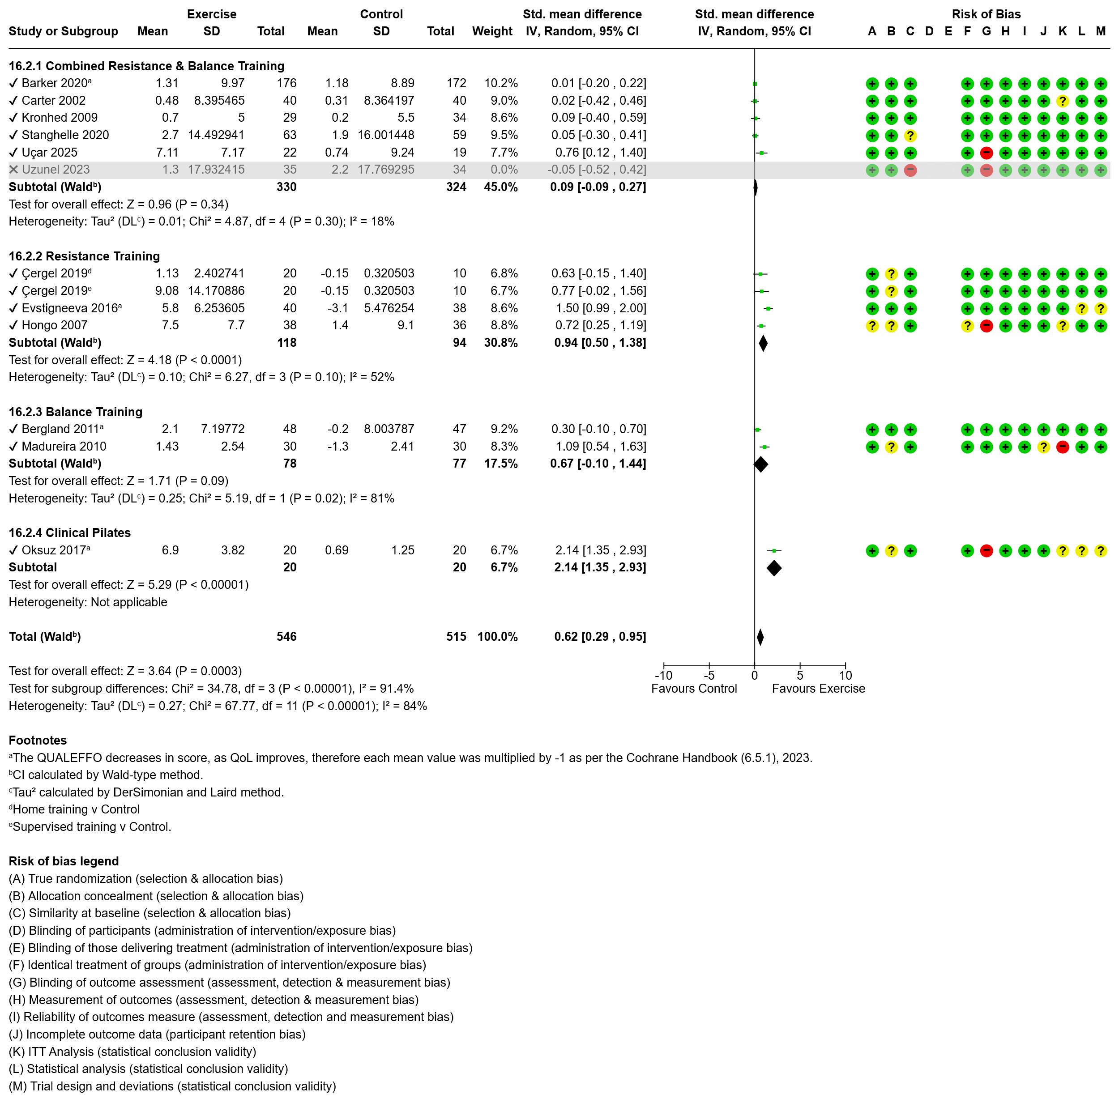Figure 20 Effect of exercise on quality of life with subgroup analysis by exercise modality.

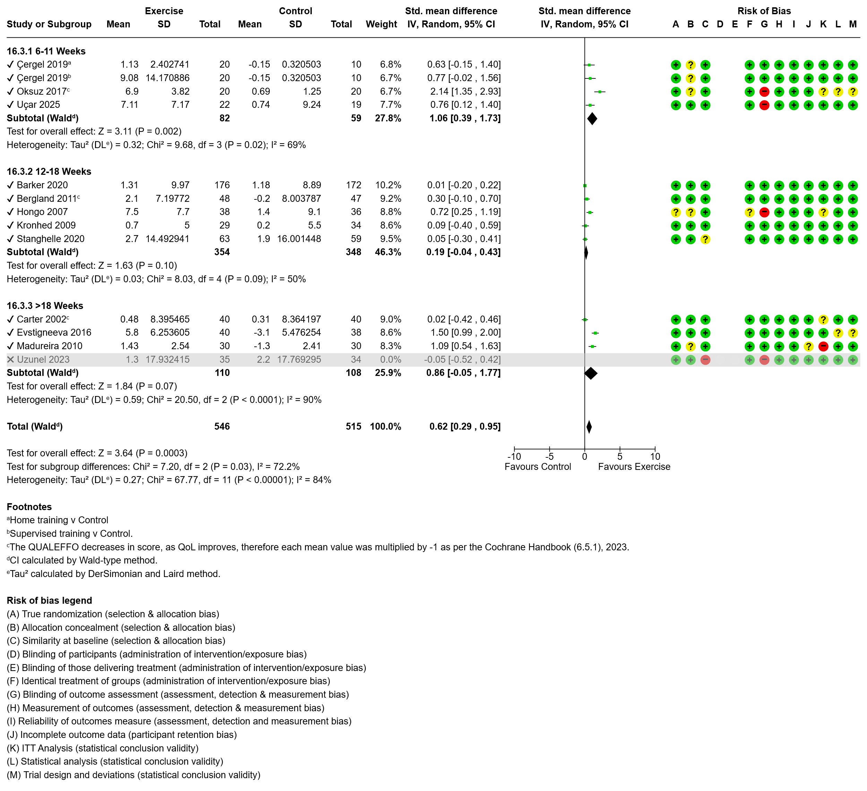Figure 21 Effect of exercise on quality of life with subgroup analysis by intervention duration.
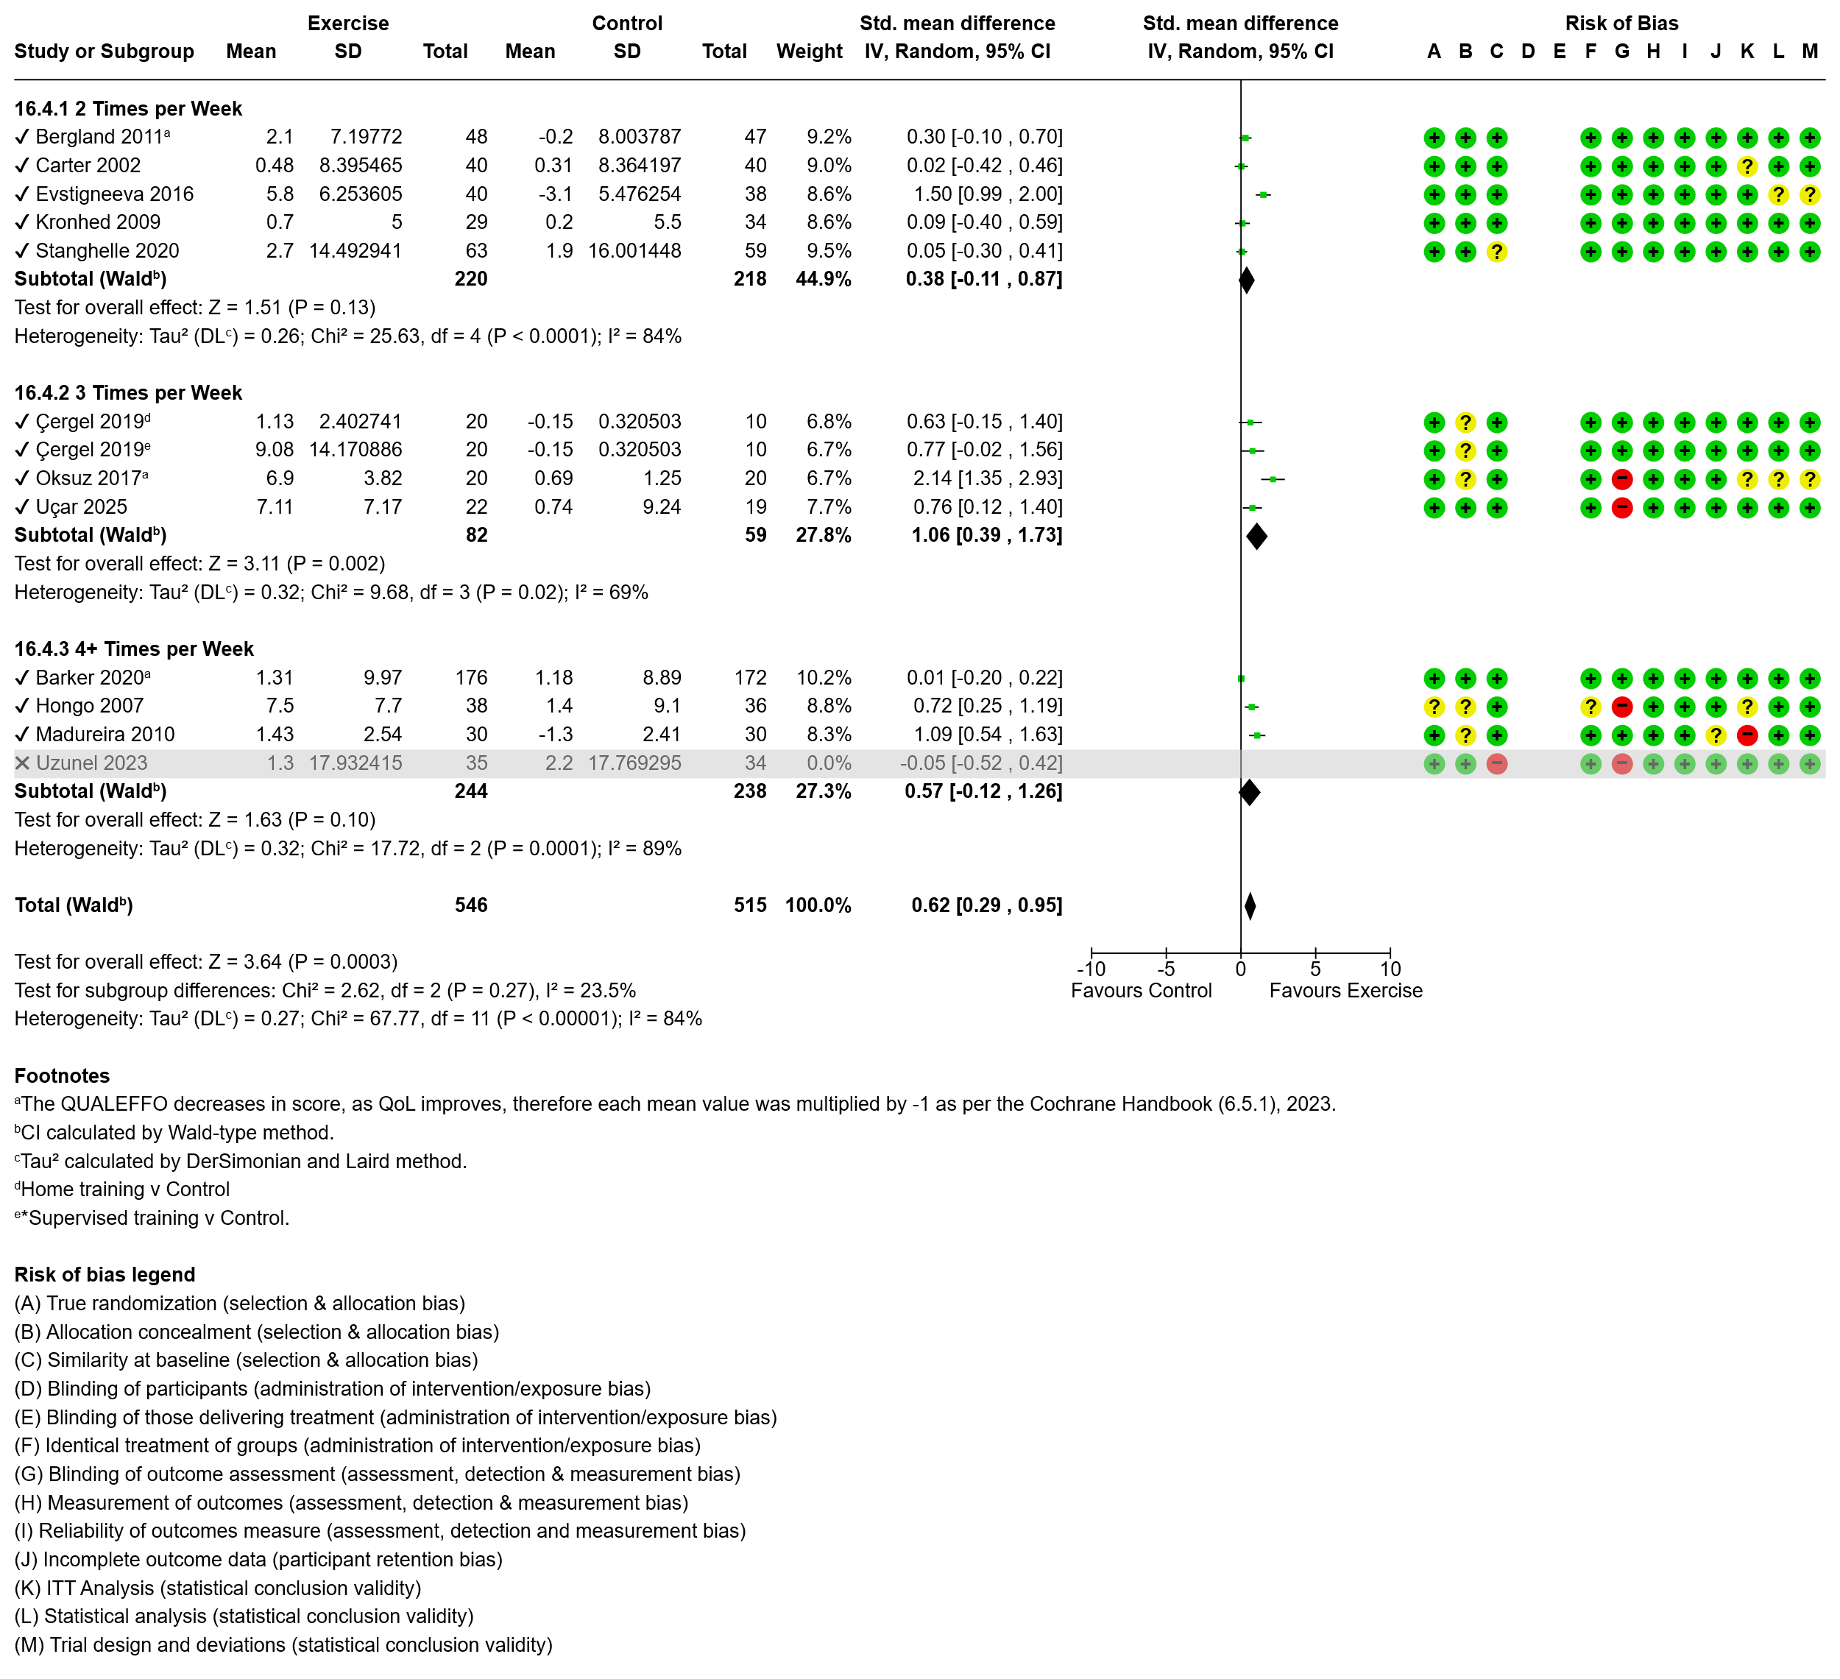Figure 22 Effect of exercise on quality of life with subgroup analysis by intervention frequency.
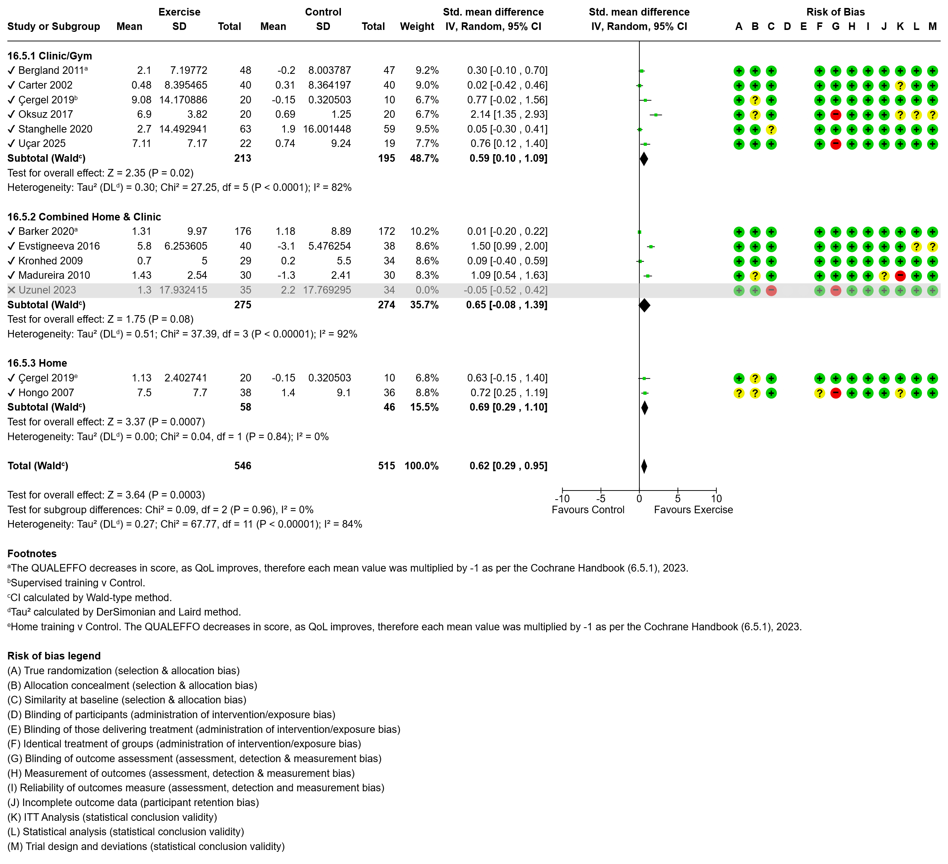Figure 23 Effect of exercise on quality of life with subgroup analysis by intervention setting.
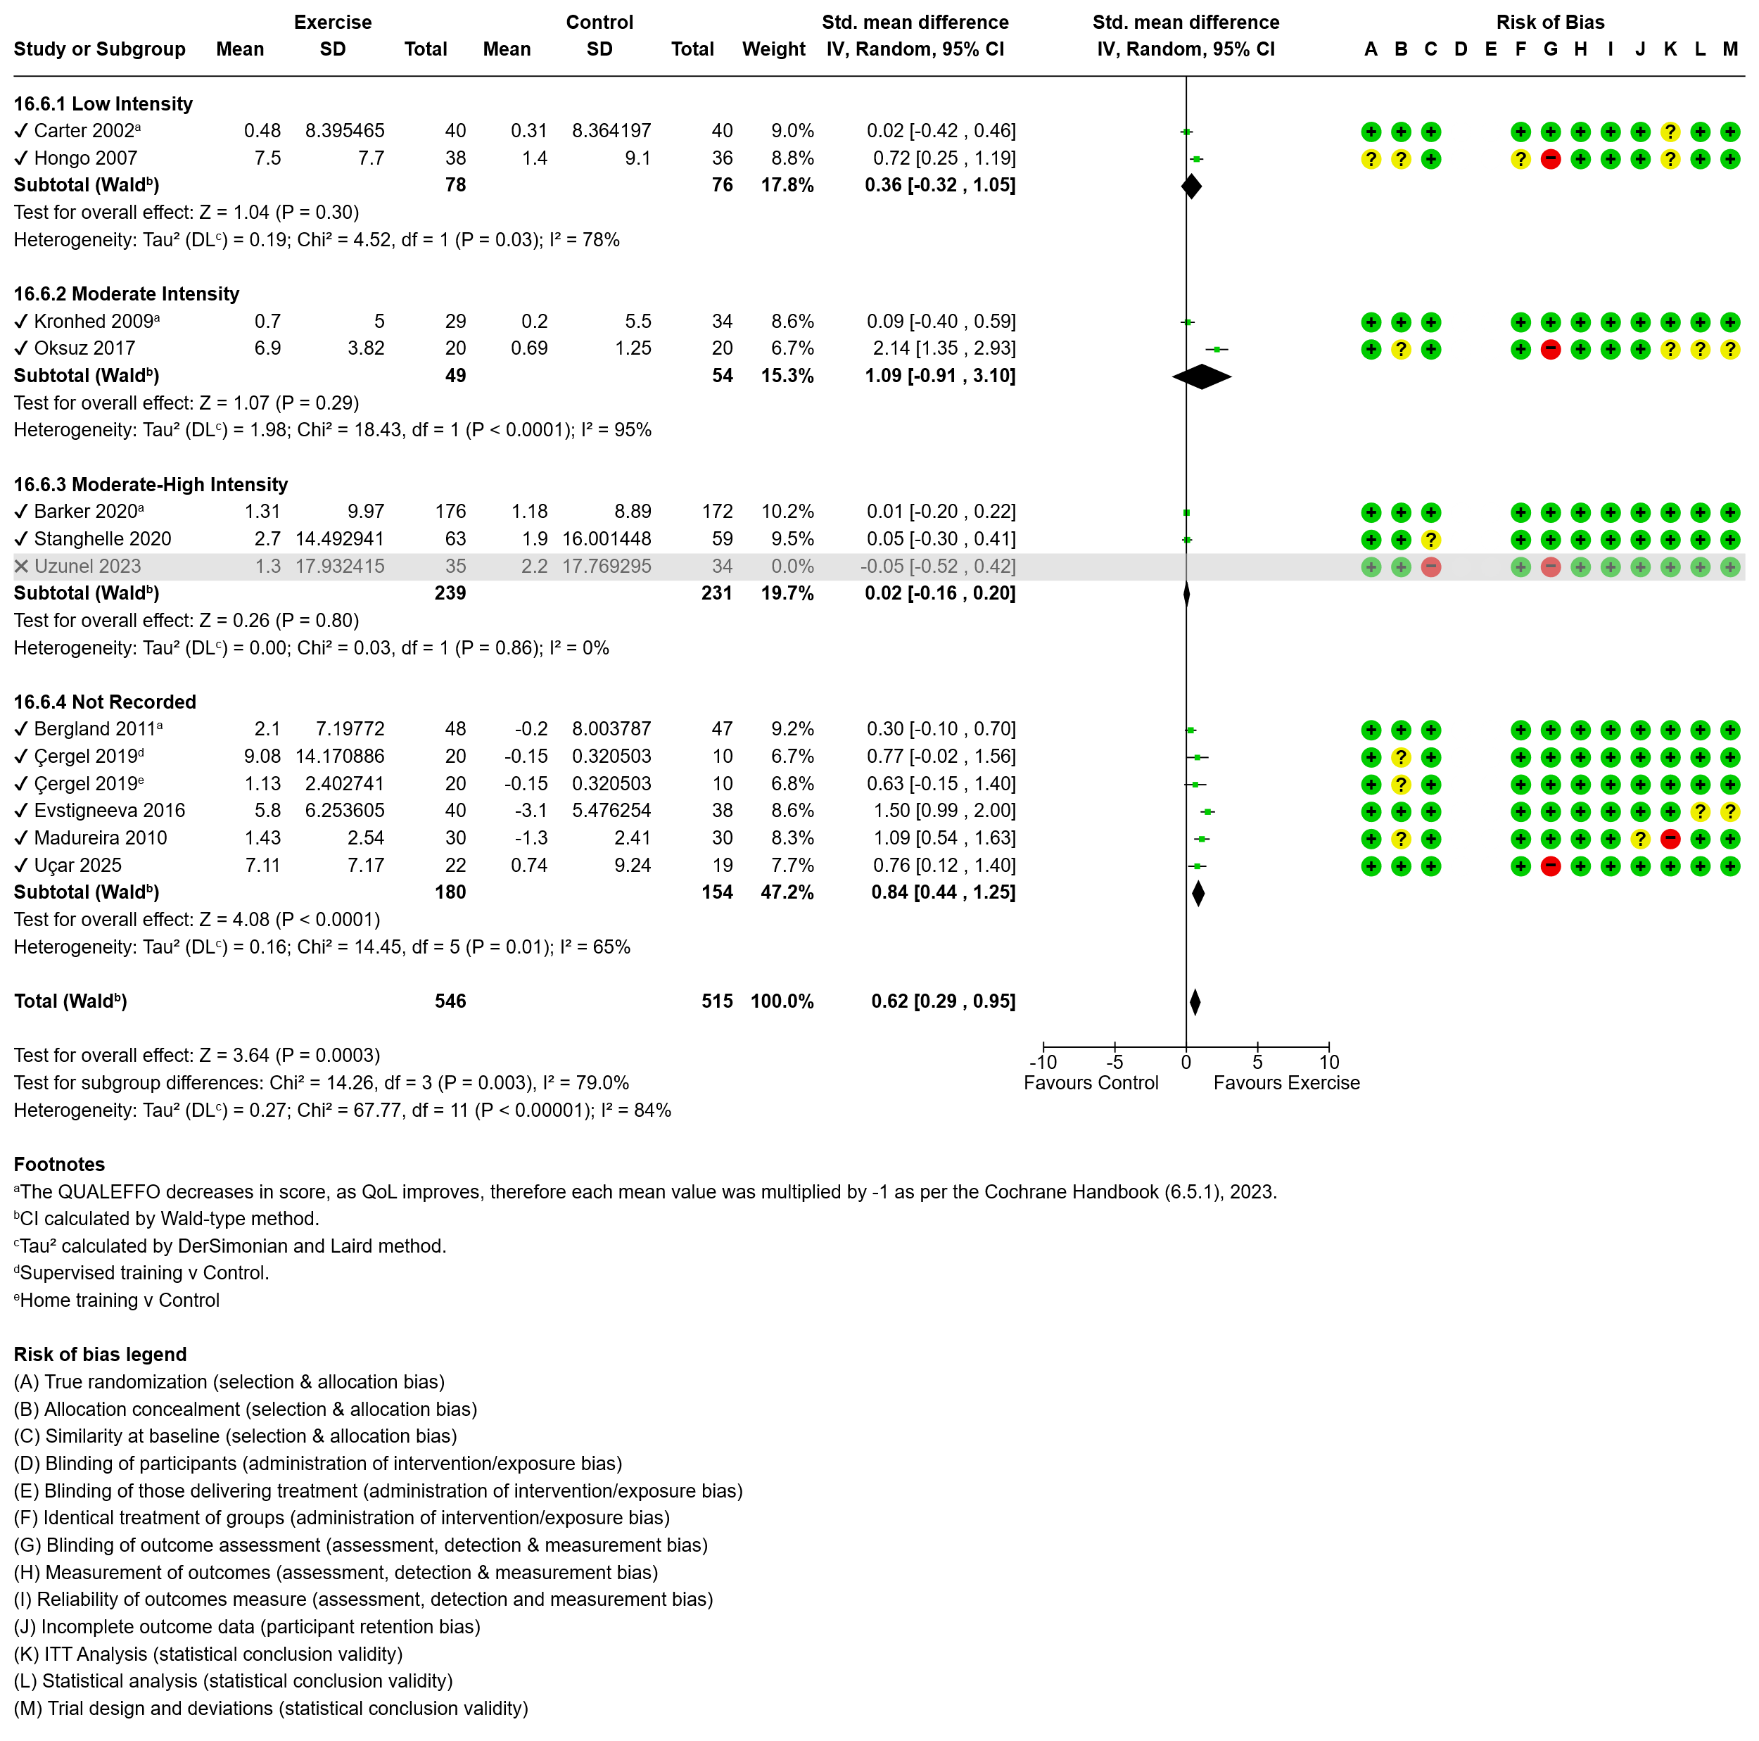Figure 24 Effect of exercise on quality of life with subgroup analysis by intervention intensity.
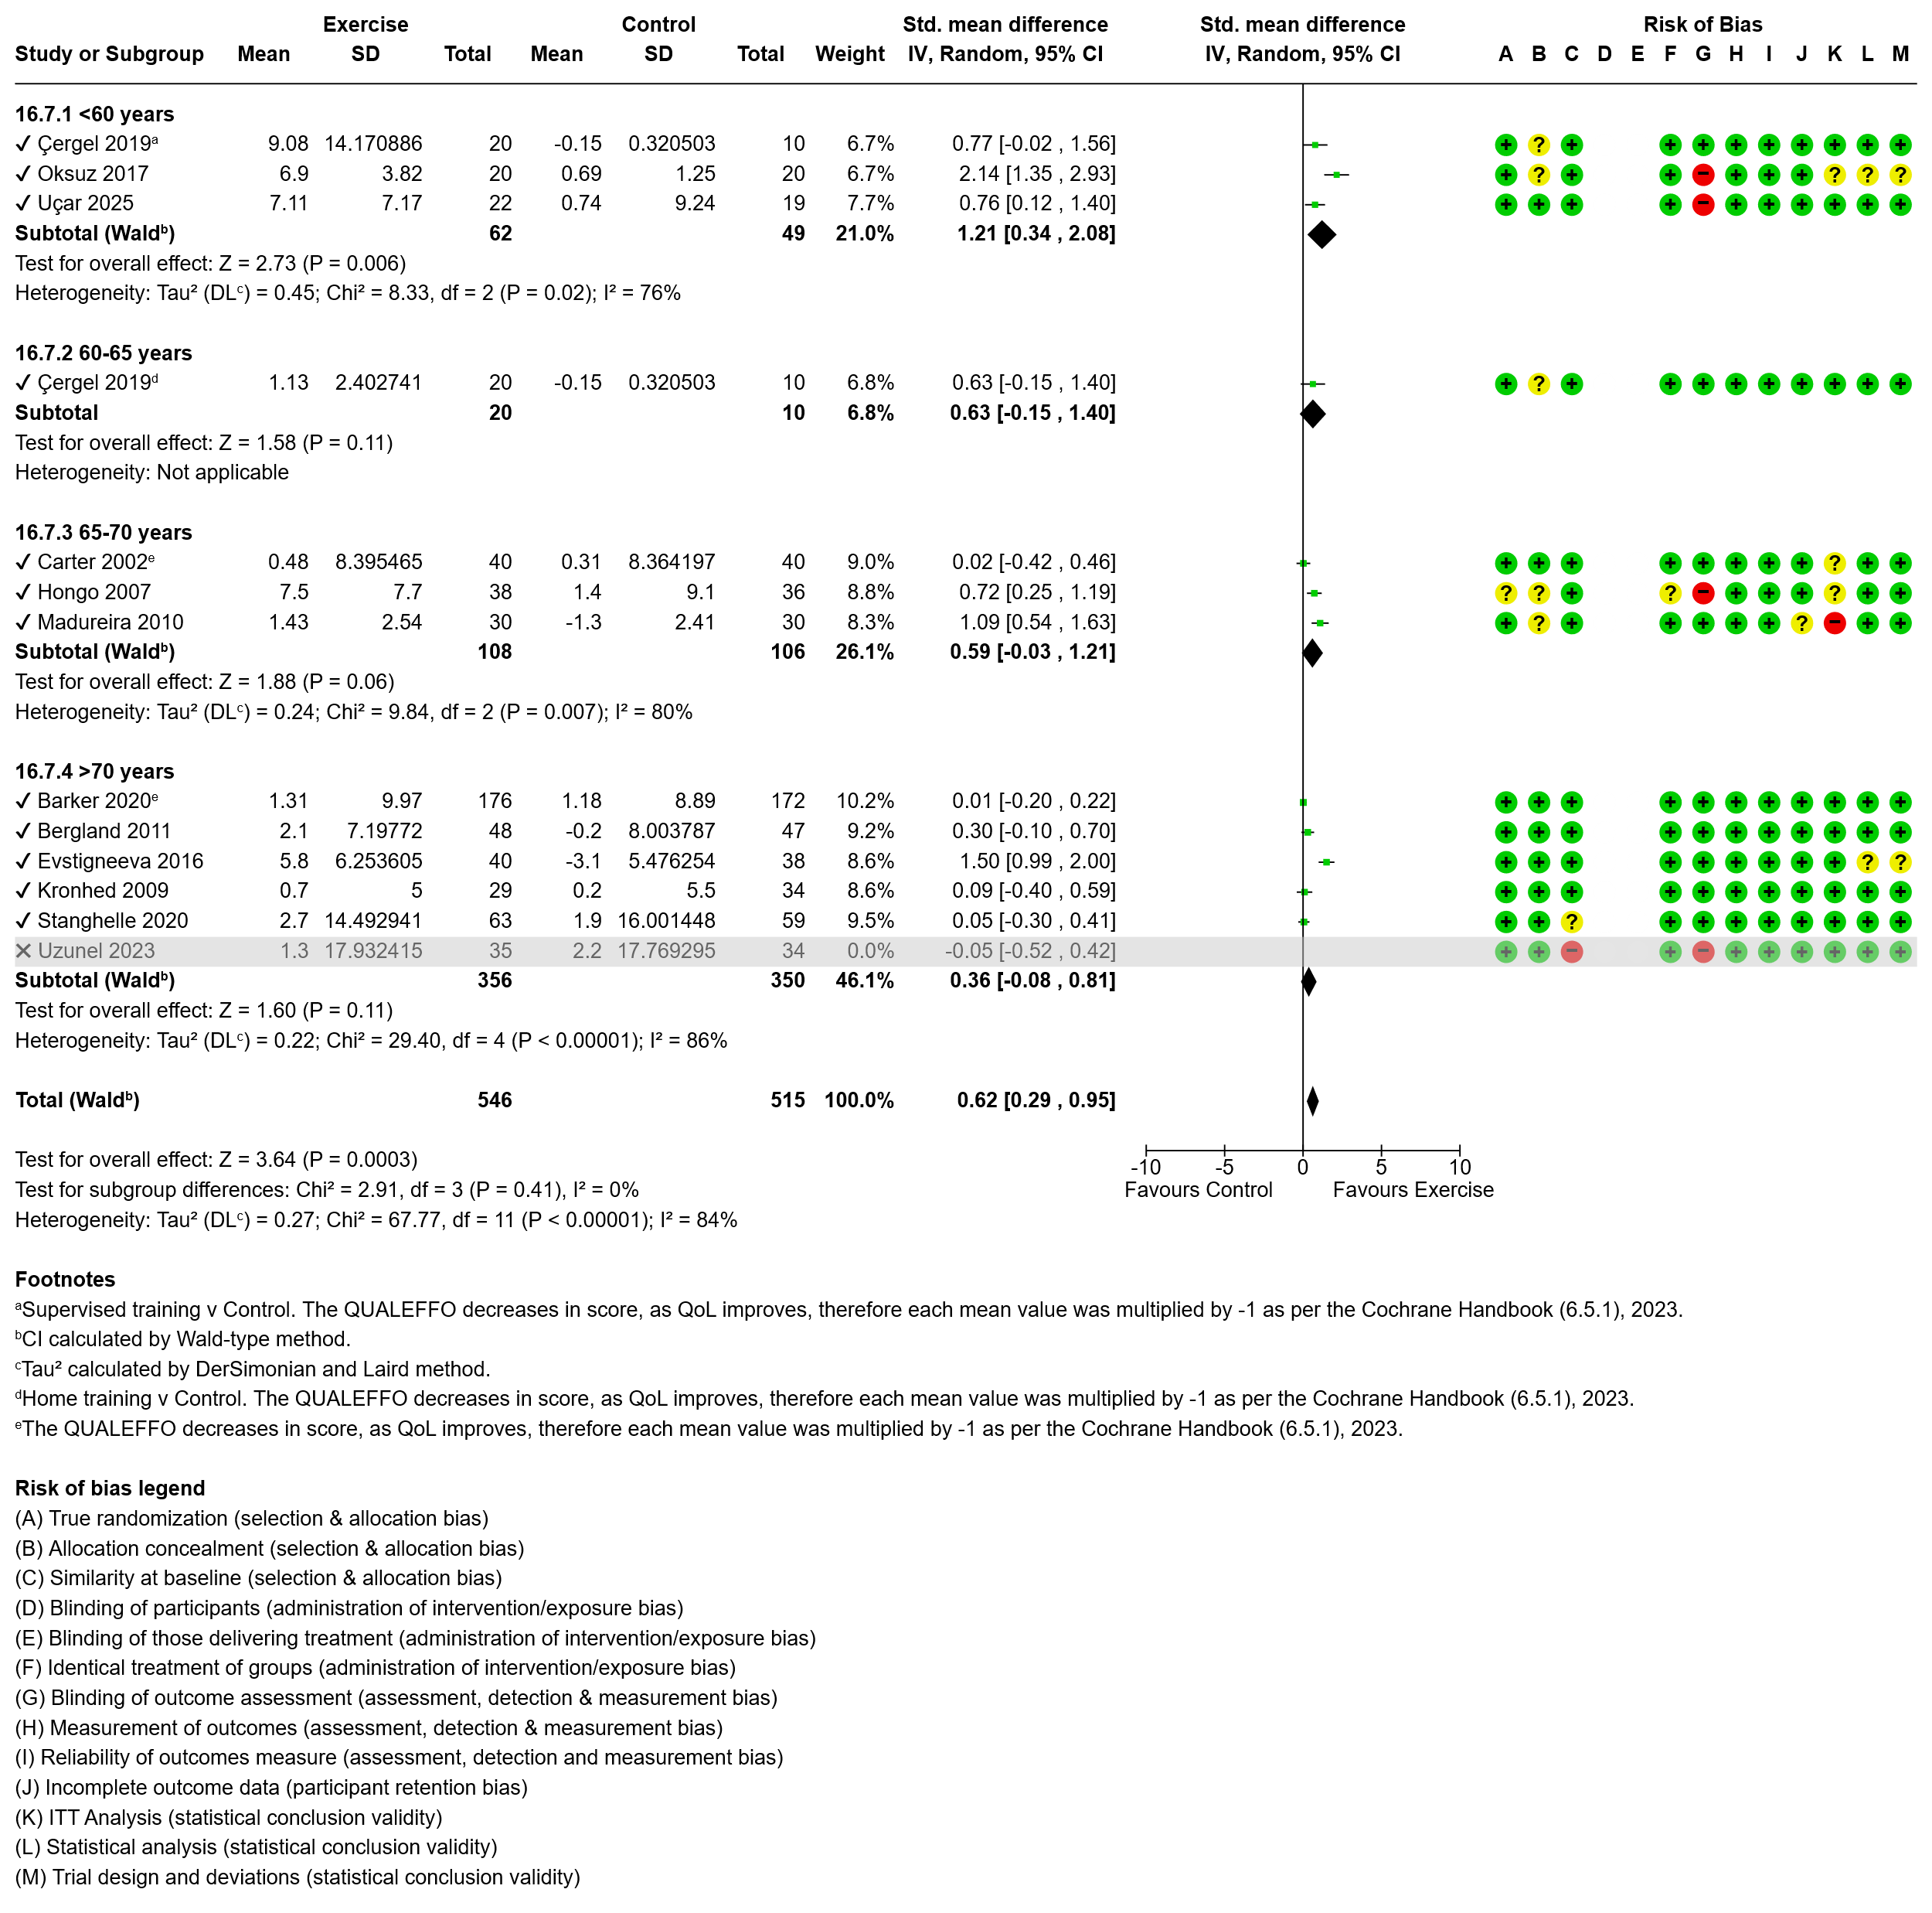Figure 25 Effect of exercise on quality of life with subgroup analysis by participant age.
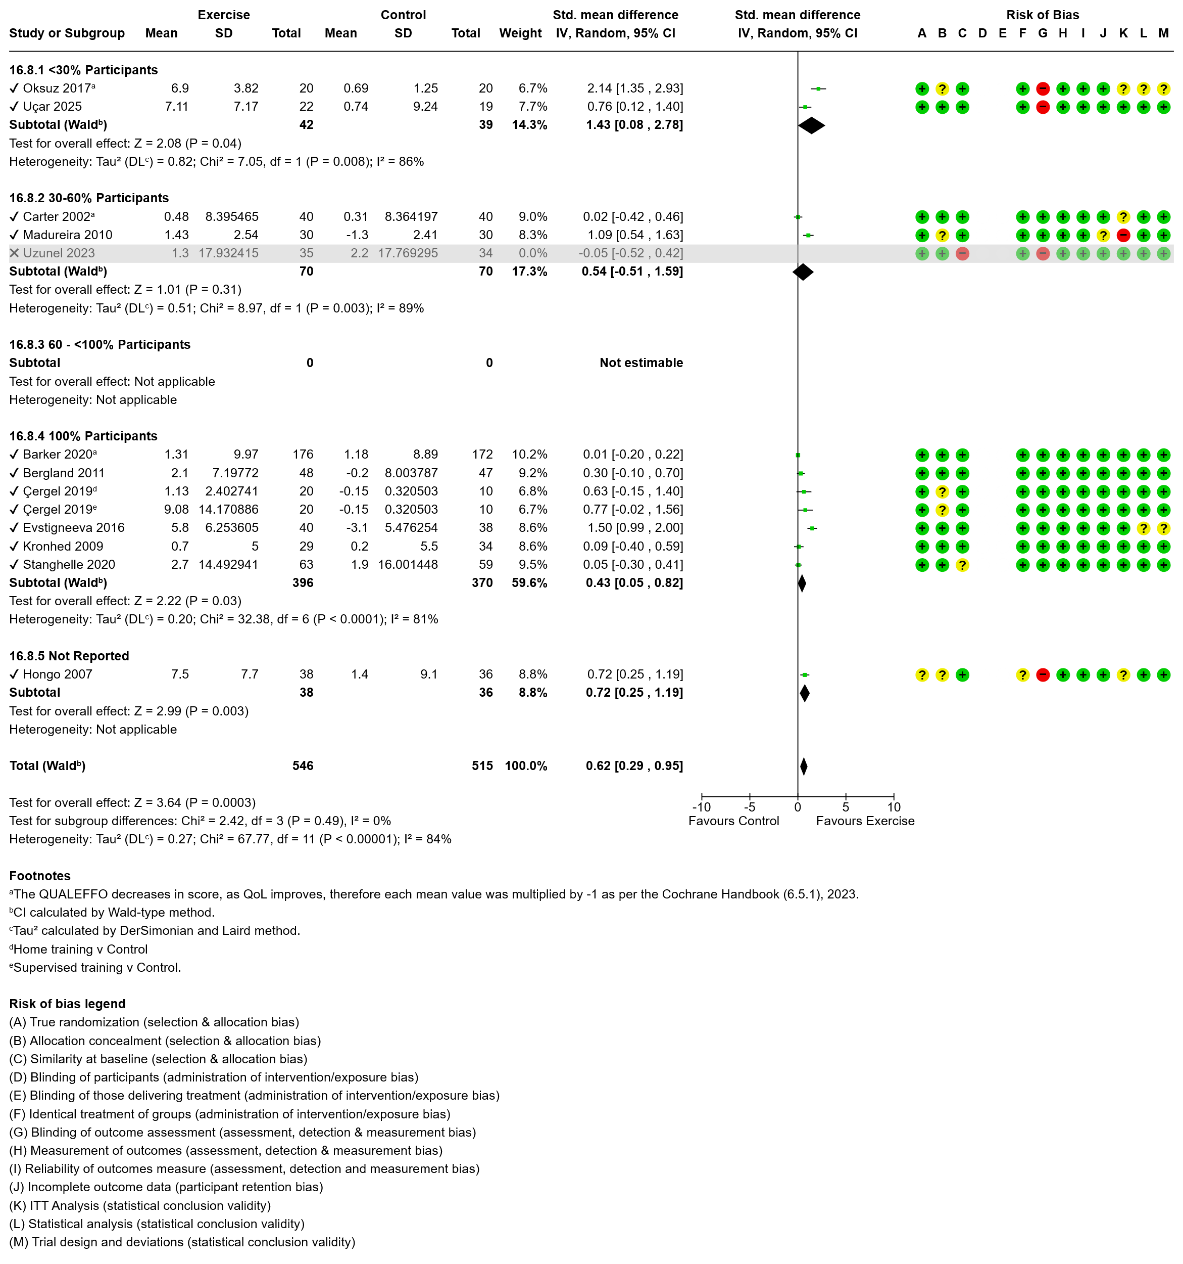Figure 26 Effect of exercise on quality of life with subgroup analysis by presence of fracture.
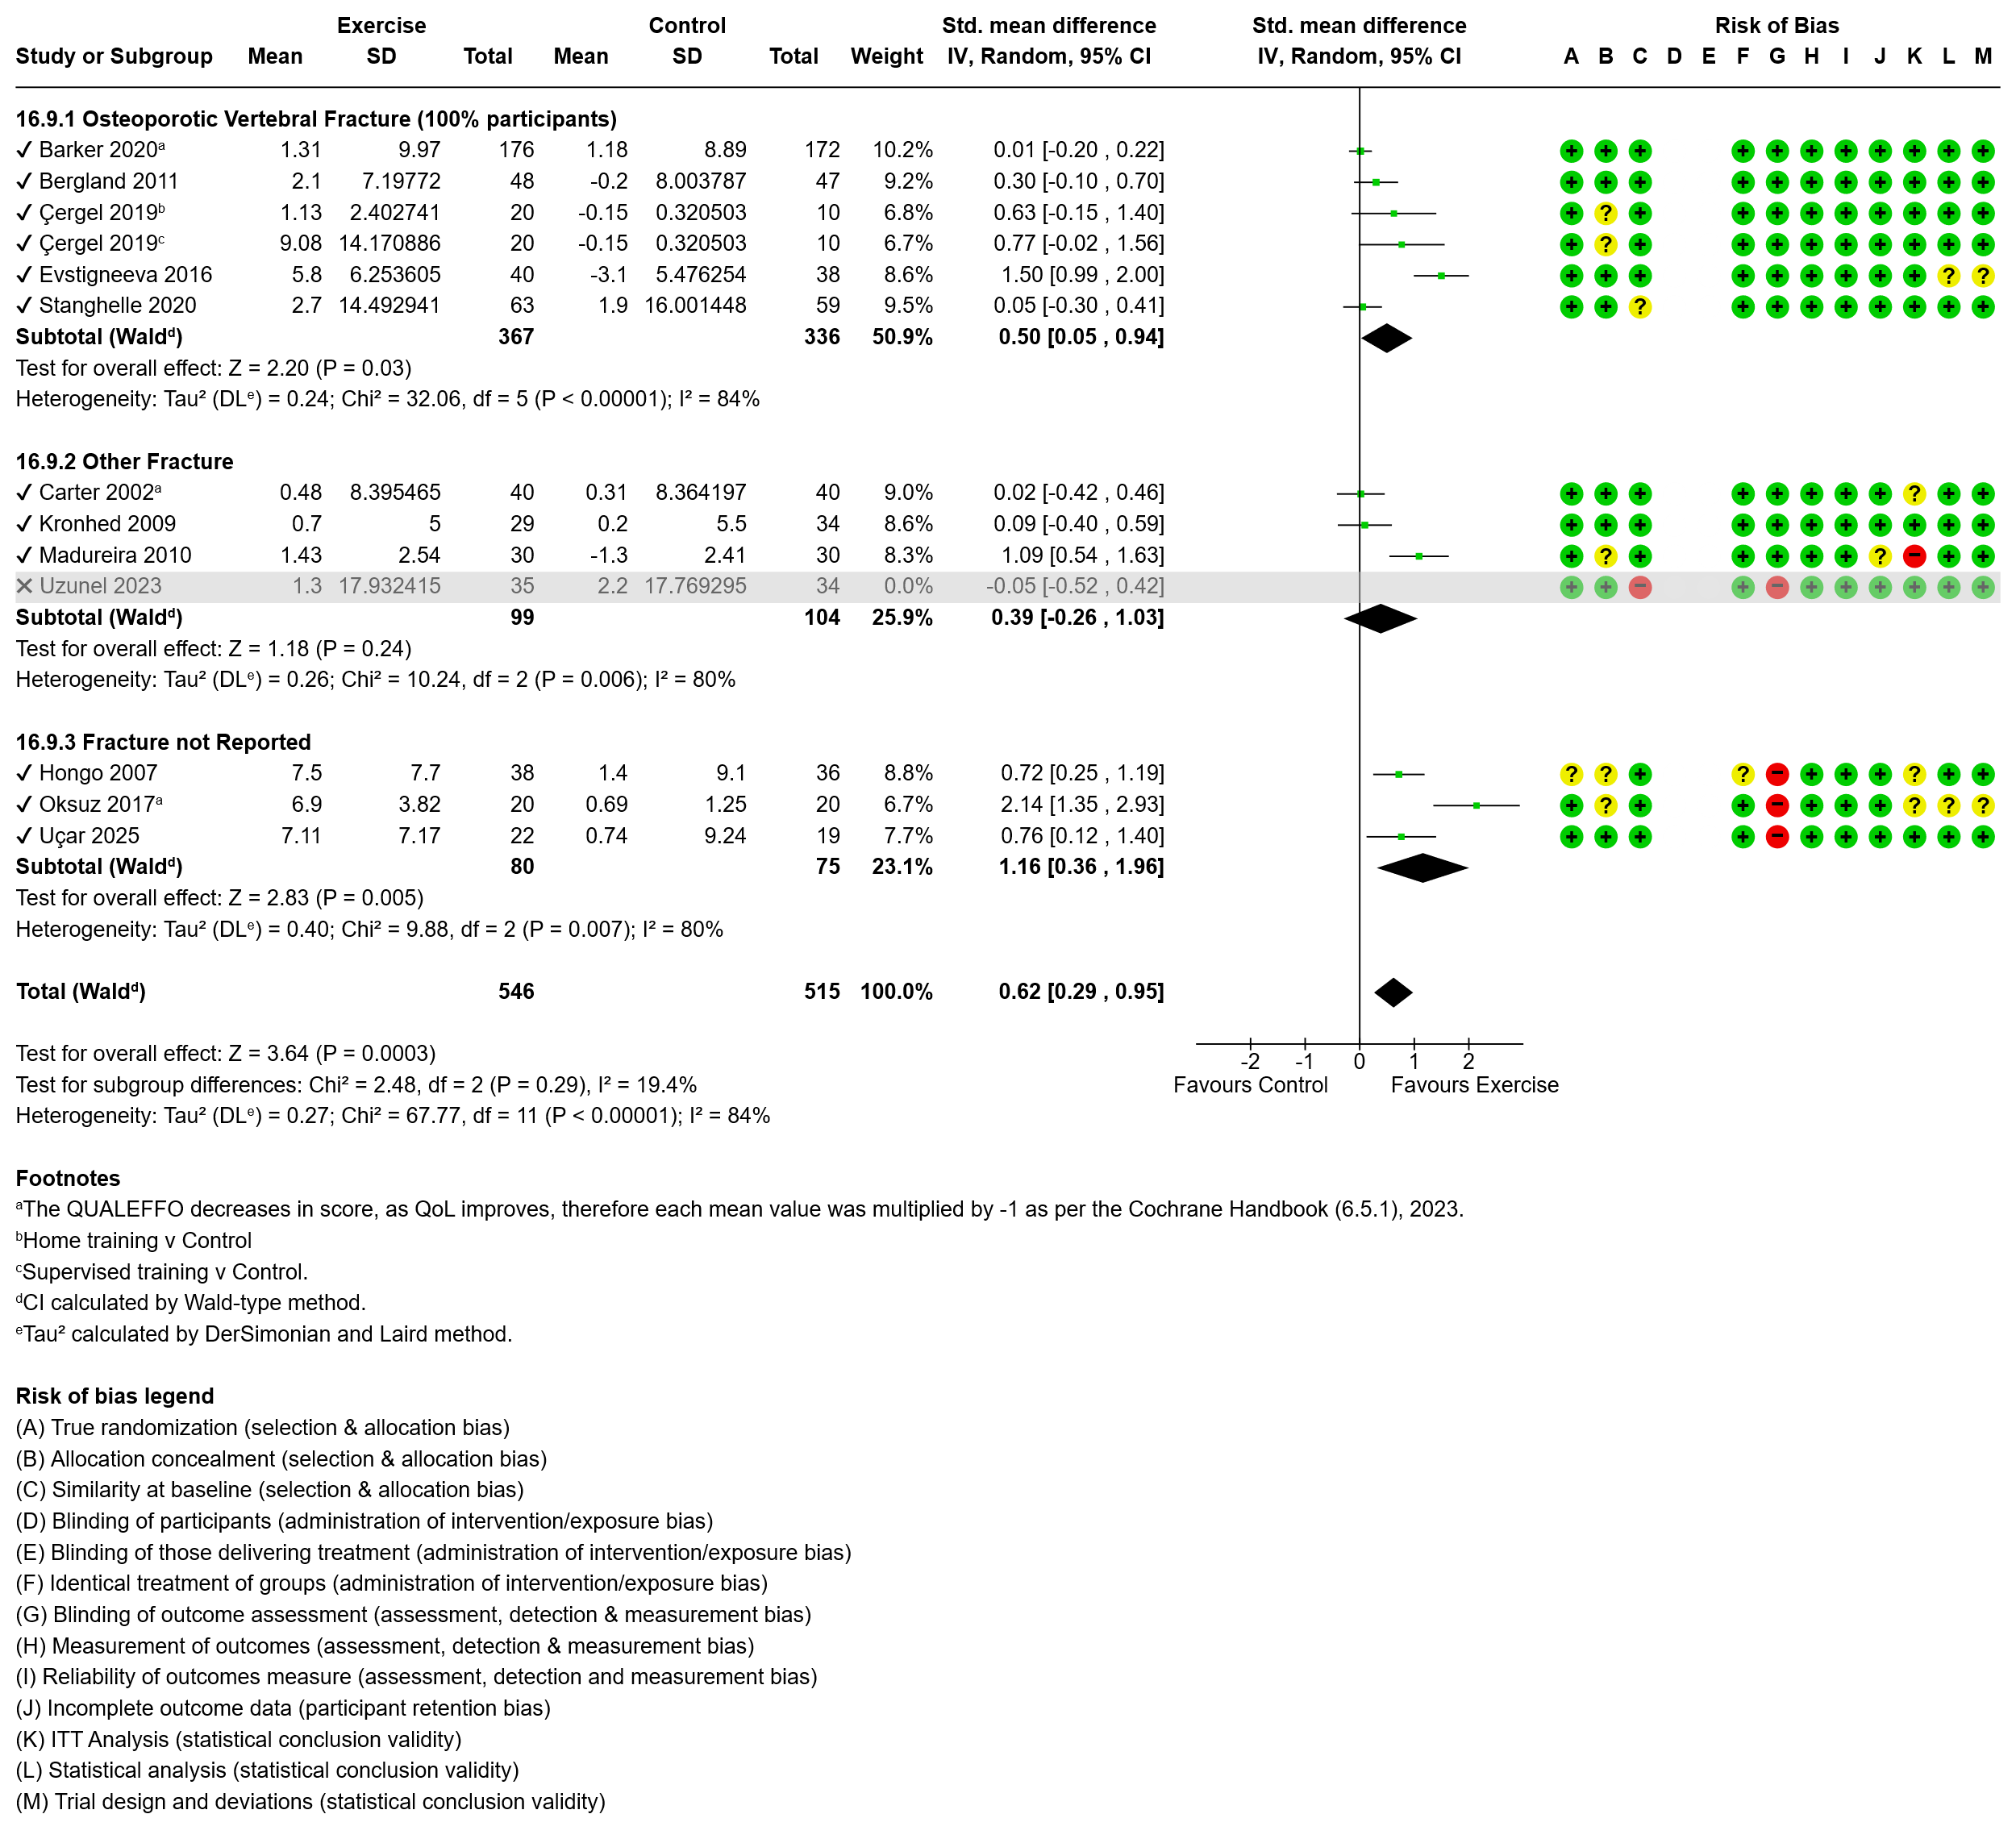Figure 27 Effect of exercise on quality of life with subgroup analysis by nature of fracture.
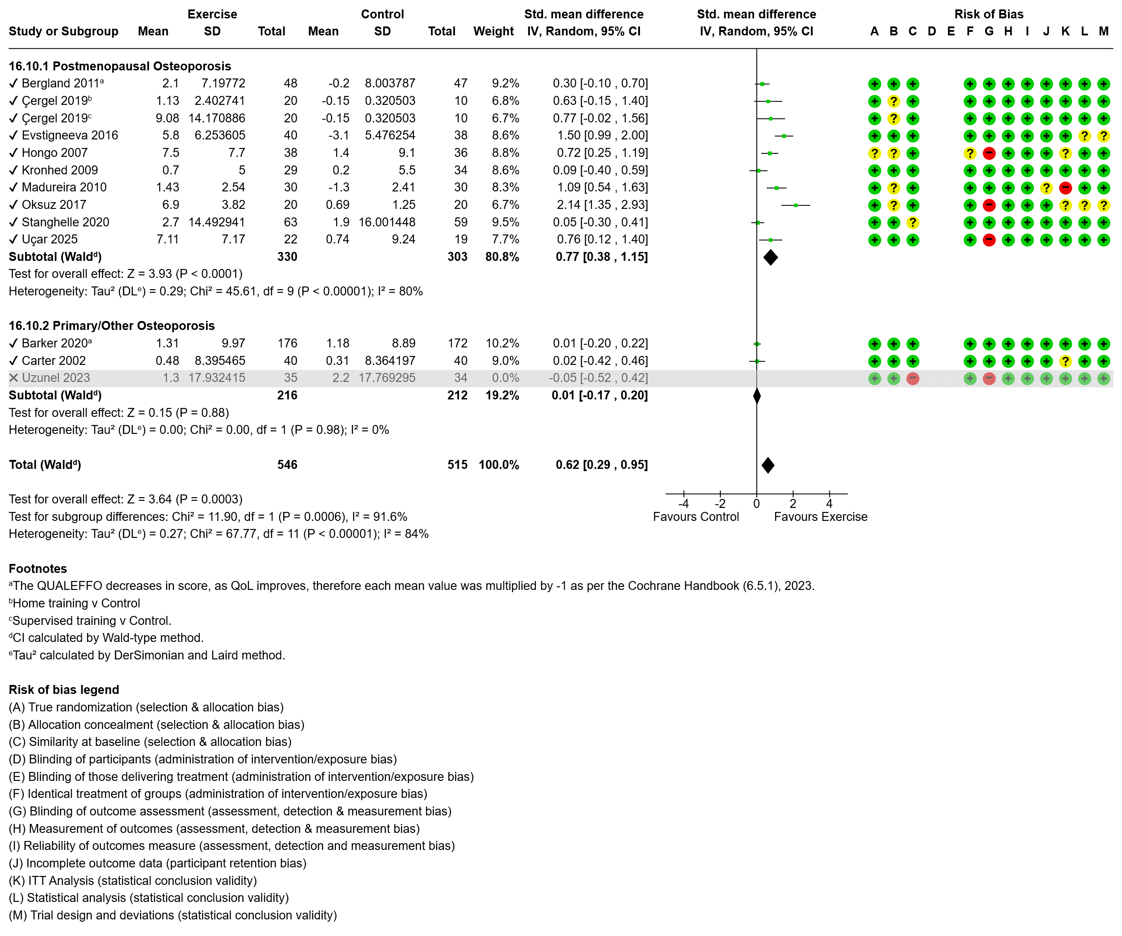
Figure 28 Effect of exercise on quality of life with subgroup analysis by osteoporosis diagnosis.
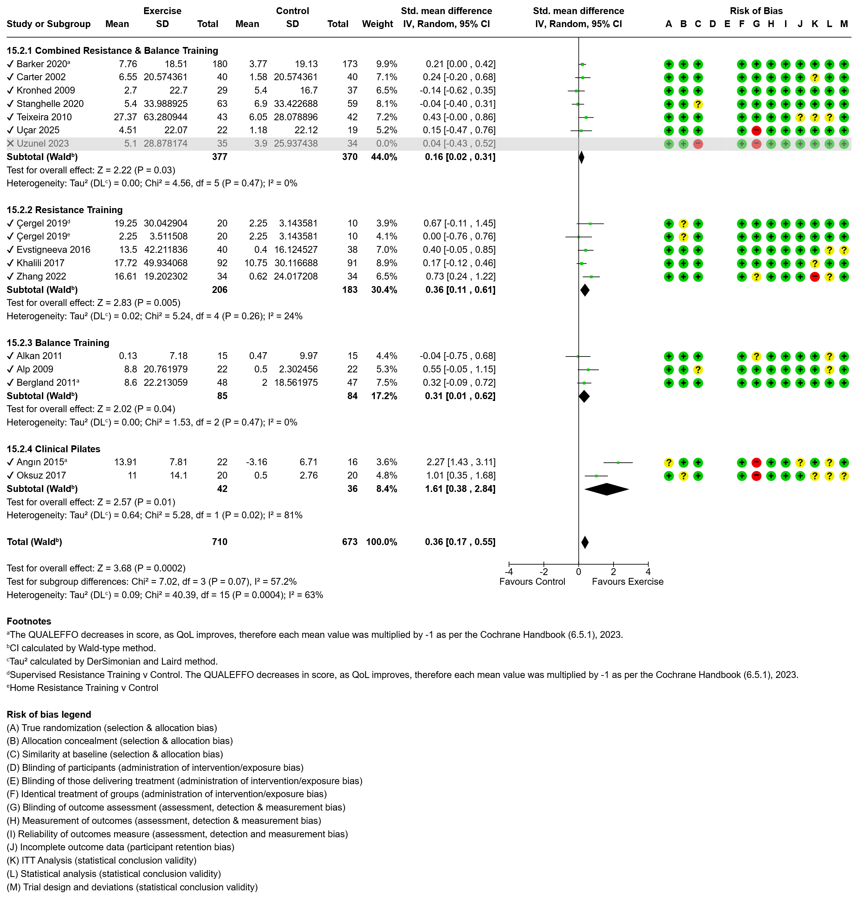Figure 29 Effect of exercise on pain with subgroup analysis by exercise modality.
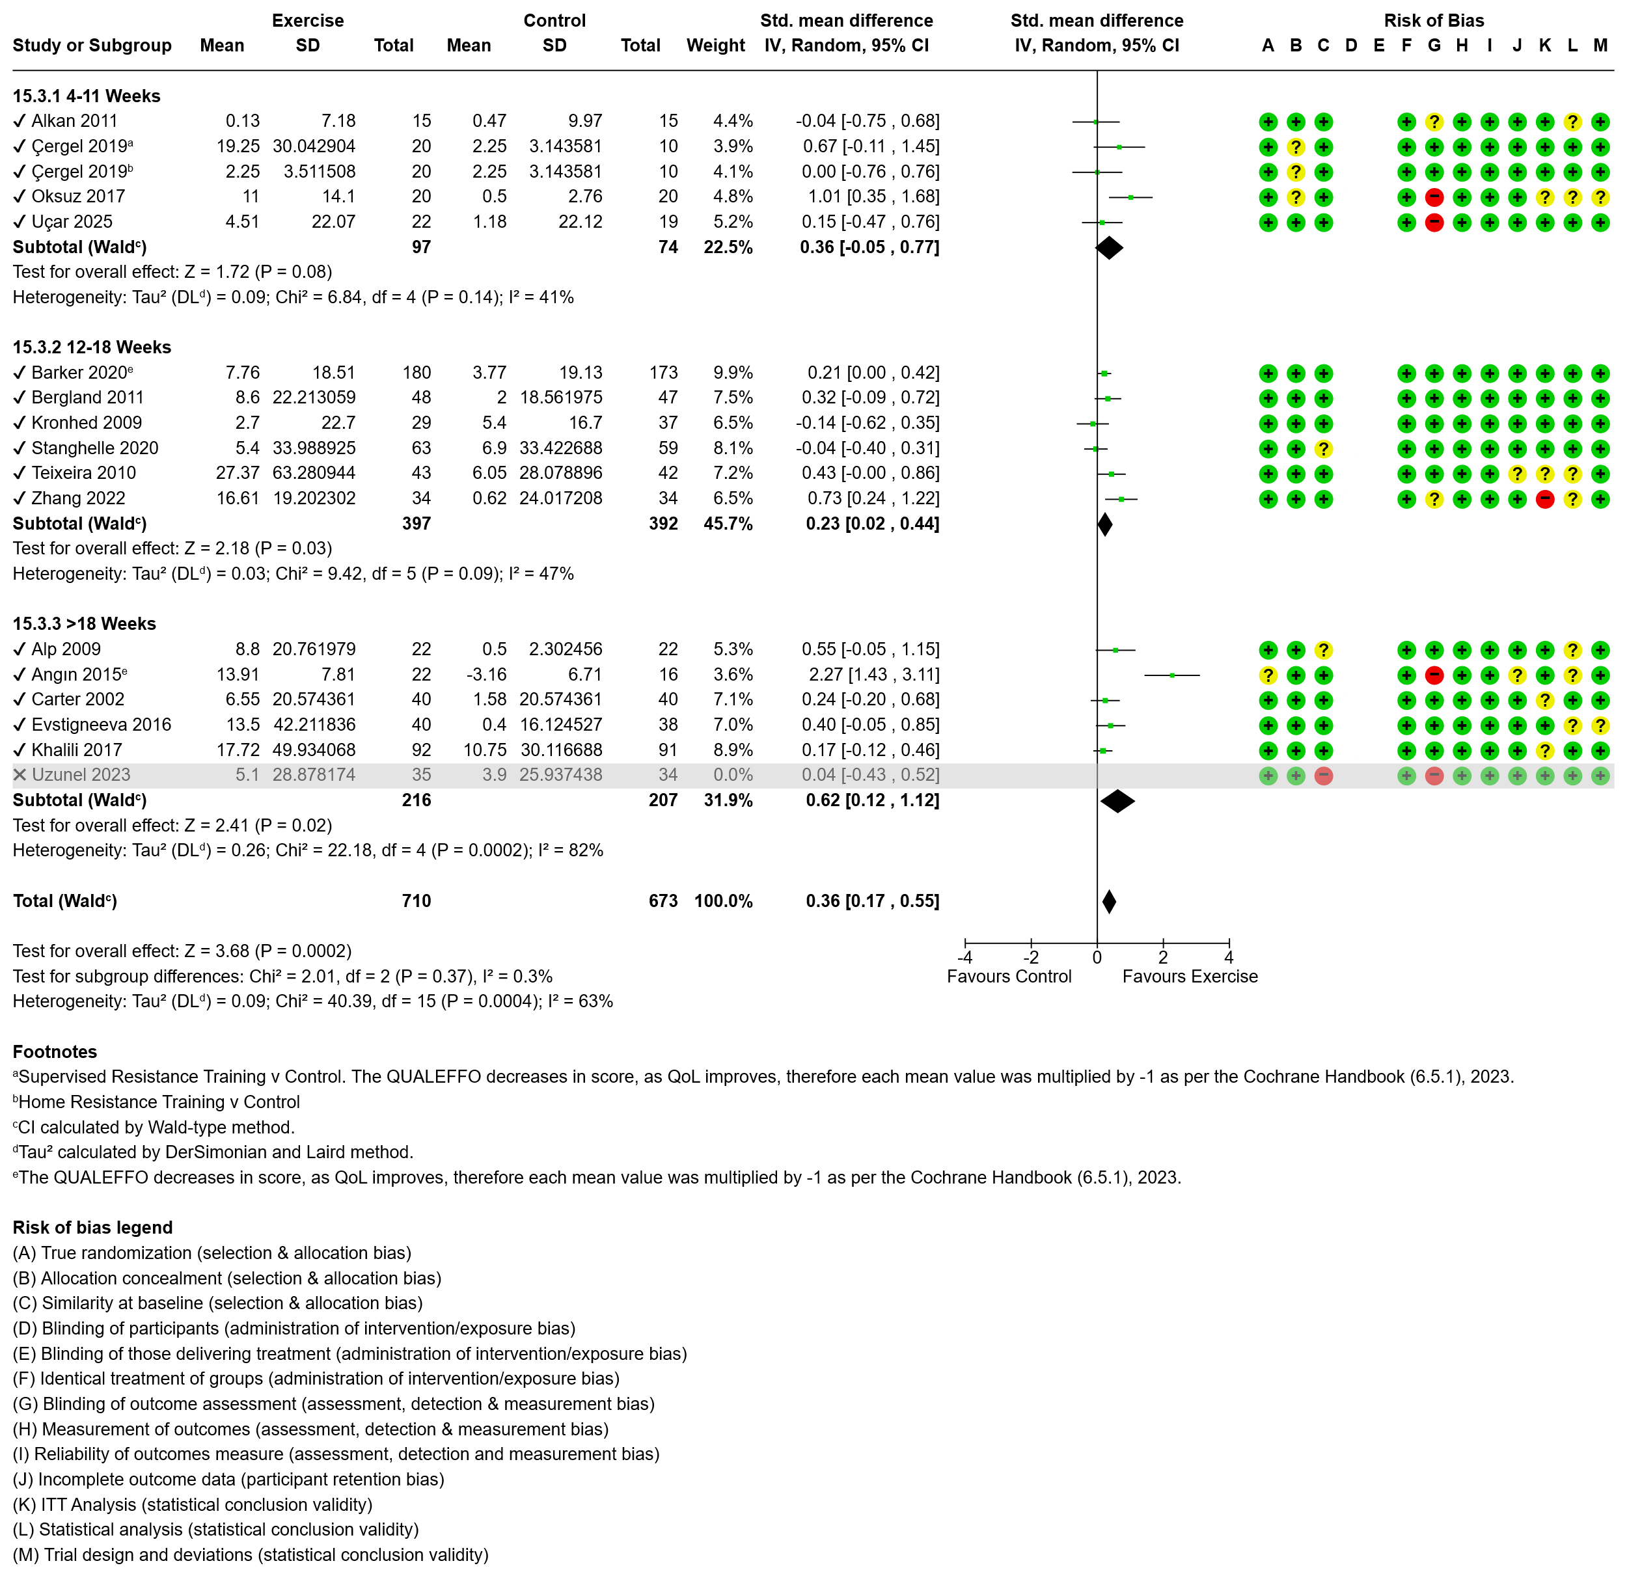Figure 30 Effect of exercise on pain with subgroup analysis by intervention duration.
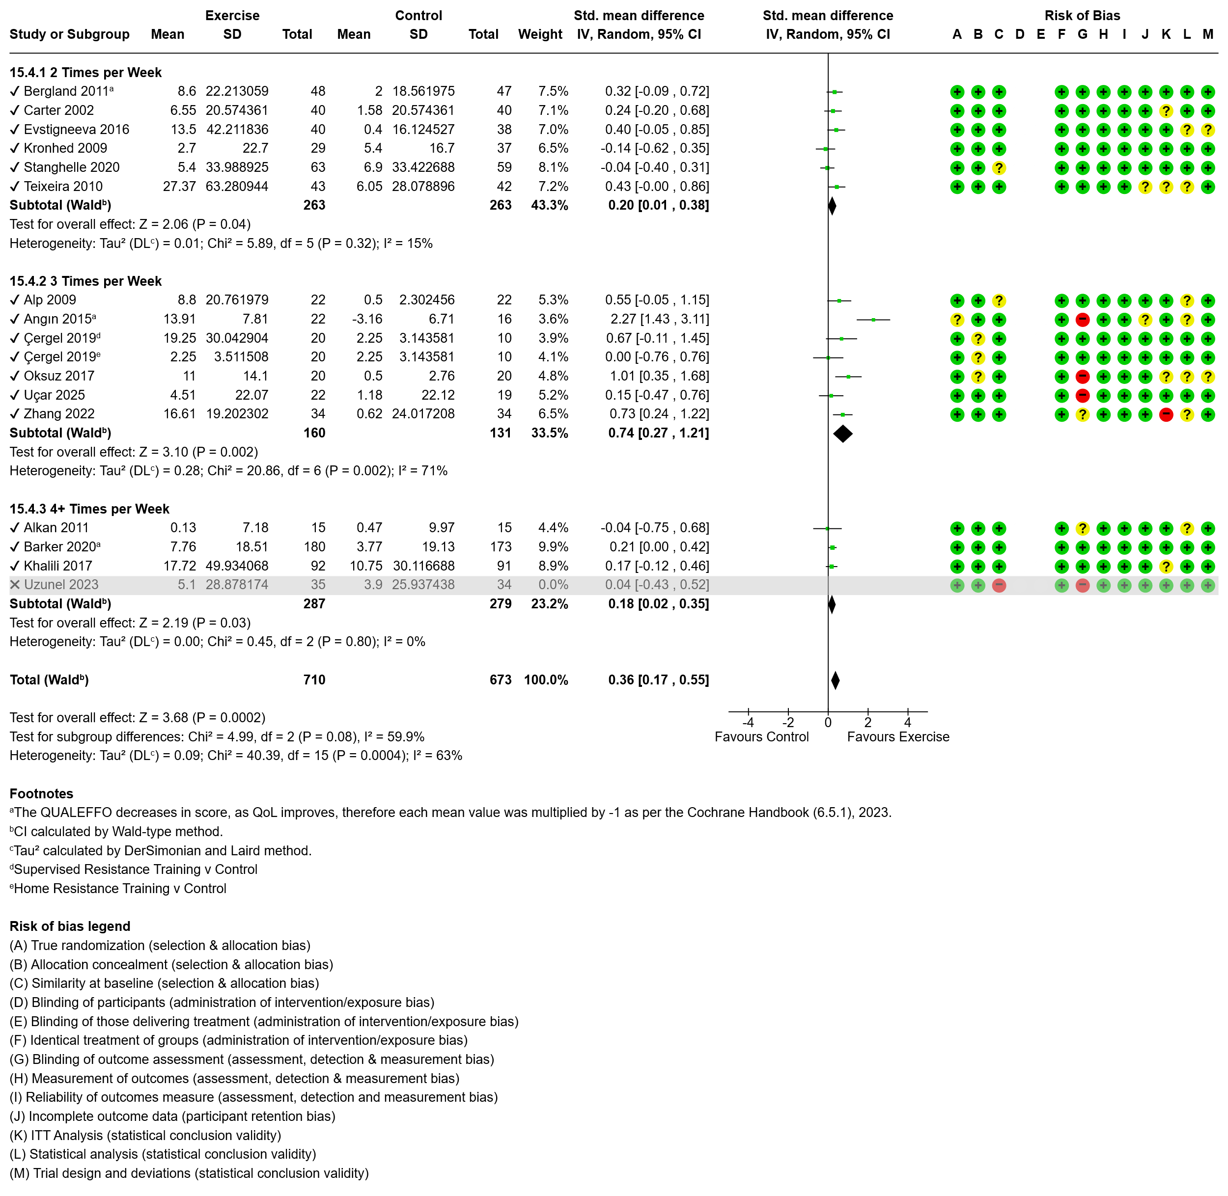Figure 31 Effect of exercise on pain with subgroup analysis by intervention frequency.
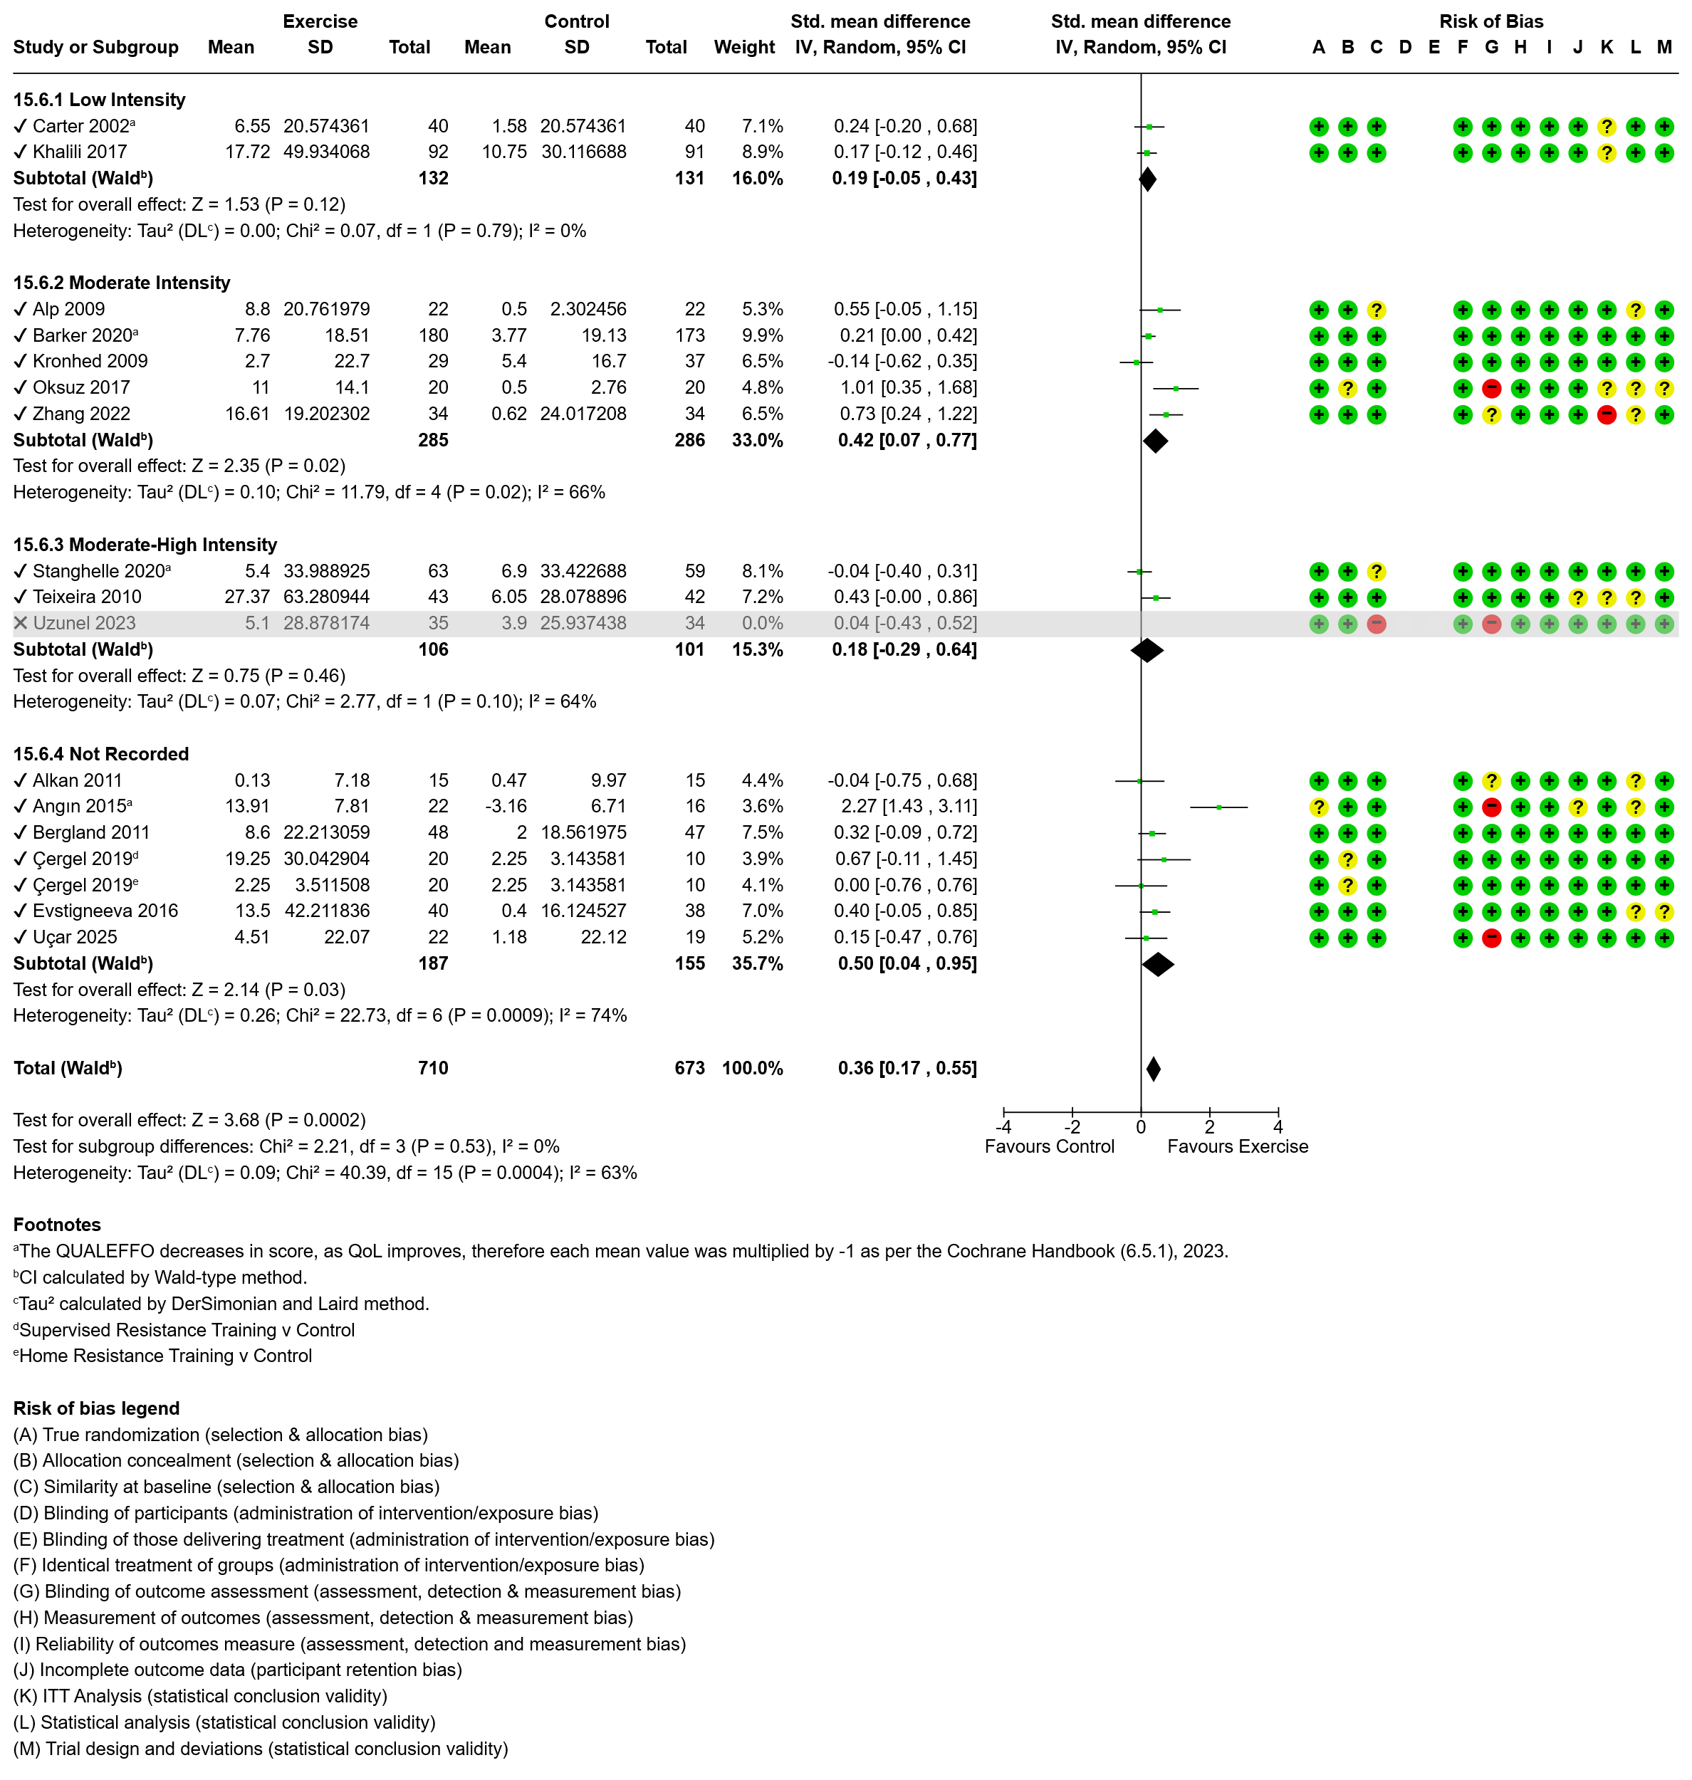Figure 32 Effect of exercise on pain with subgroup analysis by intervention intensity.
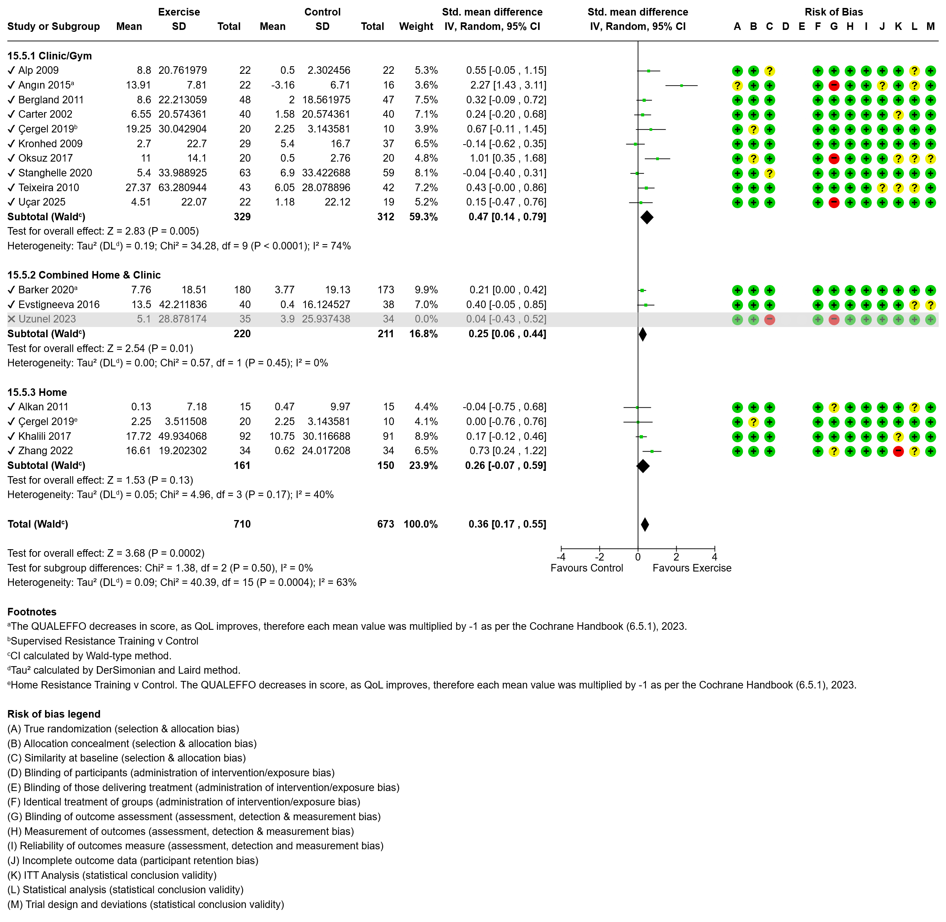Figure 33 Effect of exercise on pain with subgroup analysis by intervention setting.
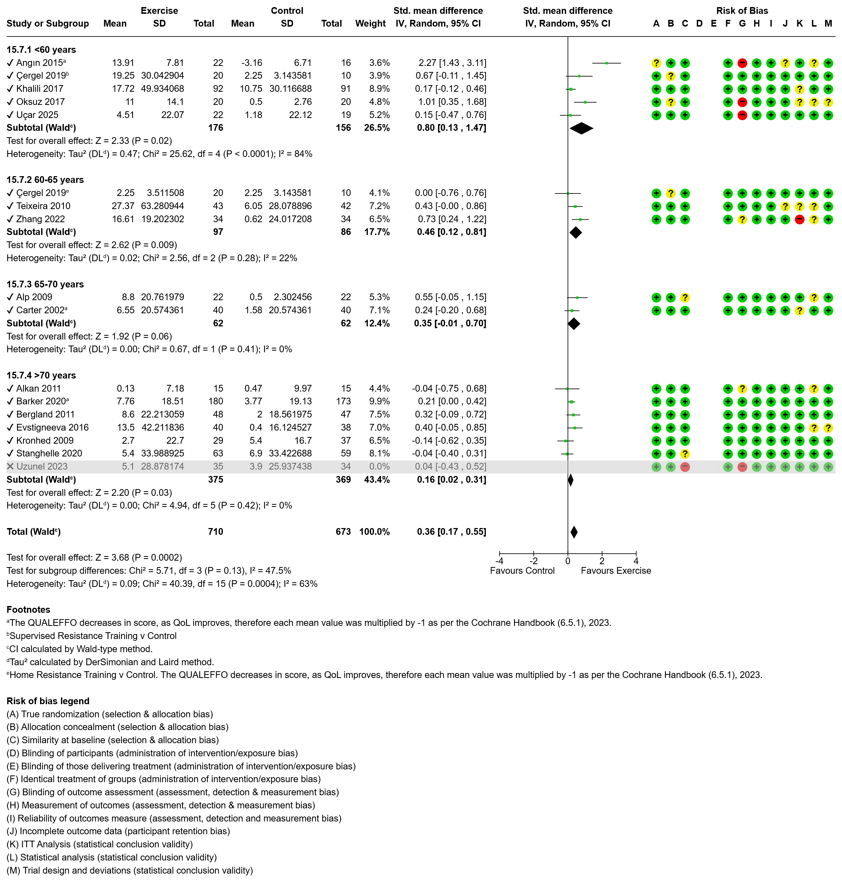Figure 34 Effect of exercise on pain with subgroup analysis by participant age.
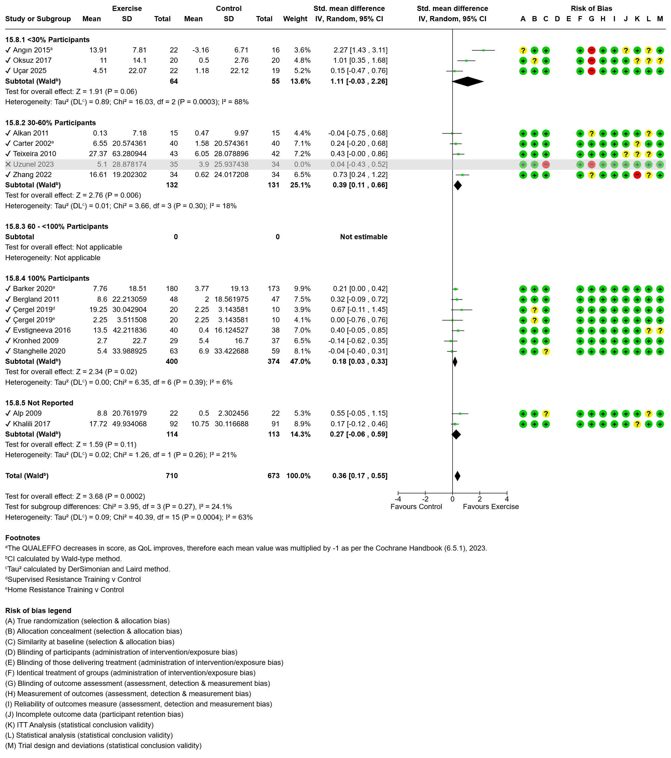Figure 35 Effect of exercise on pain with subgroup analysis by presence of fracture.
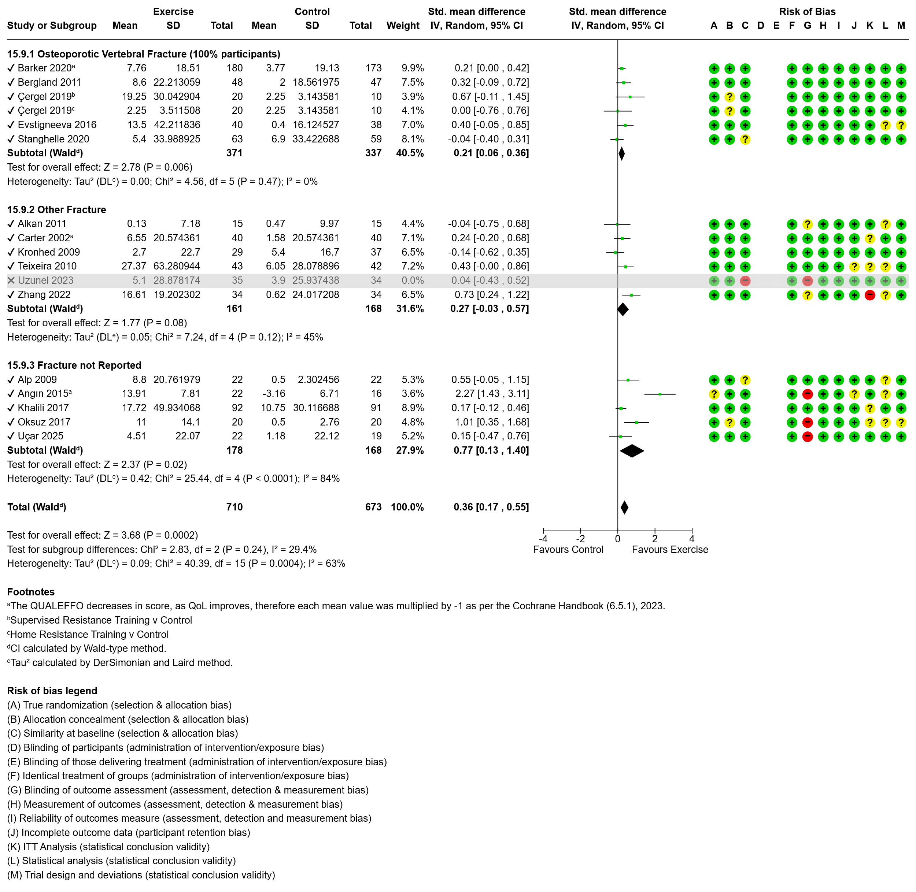Figure 36 Effect of exercise on pain with subgroup analysis by nature of fracture.
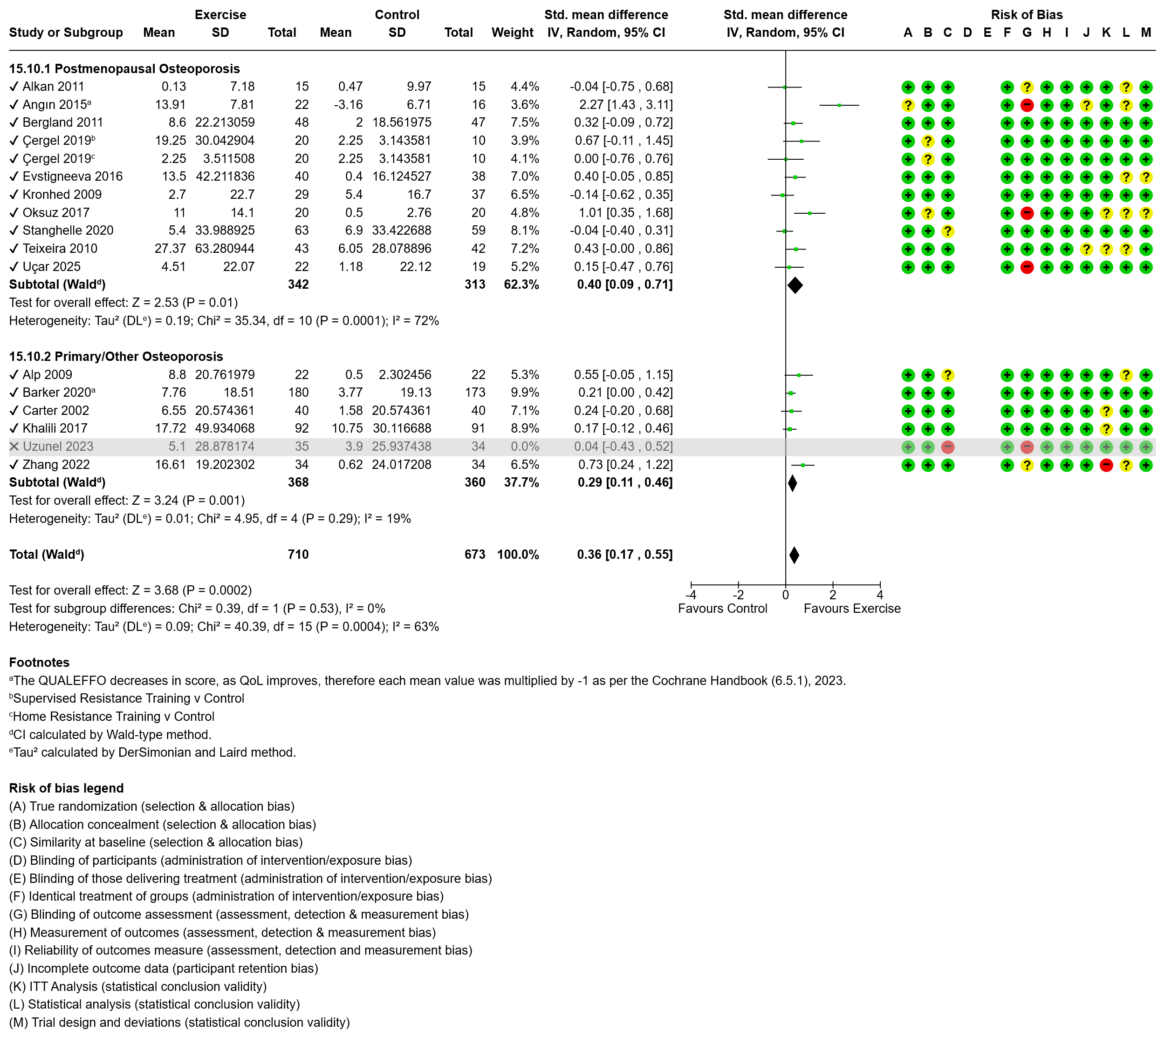Figure 37 Effect of exercise on pain with subgroup analysis by osteoporosis diagnosis.

