Supporting Information

Biodegradation of Polystyrene Nanoplastics by Achromobacter xylosoxidans M9 offers a Mealworm Gut-Derived Solution for Plastic Pollution

Najat El-Kurdi^{a,b *}, Mohamed Ghazy^{a,c}, , Sherif Hammad^{d}, Khaled ElBaghdady^{e} , Sahar El-Shatoury^{f*}
ª Biotechnology Program, Basic and Applied Science Institute, Egypt-Japan University of Science and Technology, New Burj Al-Arab, Alexandria, Egypt.
^{b} Aquaculture Biotechnology Department, Fish Farming and Technology Institute, Suez Canal University, Ismailia, Egypt.
^{c} Biochemistry Department, Faculty of Science, Ain Shams University, Cairo, Egypt.
^{d} PharmD program, Basic and Applied Science Institute, Egypt-Japan University of Science and Technology, New Burj Al-Arab, Alexandria, Egypt.
^{e} Botany and Microbiology Department, Faculty of Science, Ain Shams University, Cairo, Egypt.
^{f} Microbiology Department, Faculty of Science, Suez Canal University, Ismailia, Egypt.

Authors for correspondence:
sahar_hassan@science.suez.edu.eg (Prof. Sahar A. El-Shatoury).
nagat.elkurdi.fish@suez.edu.eg (Najat El-Kurdi).

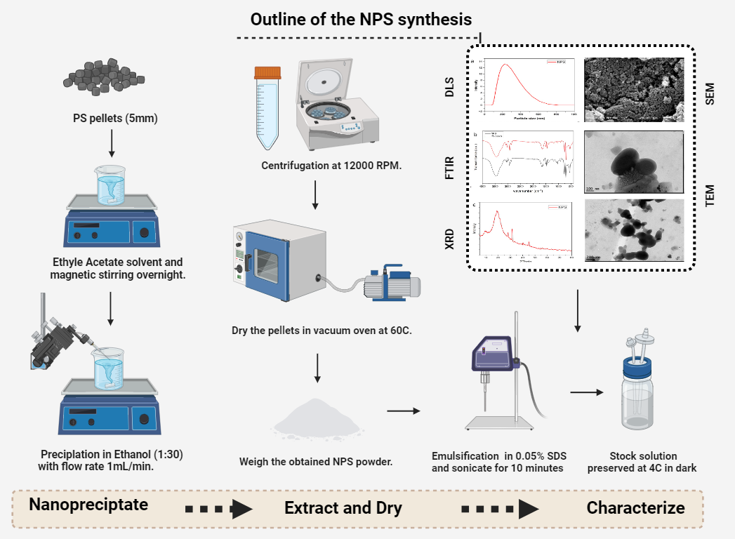
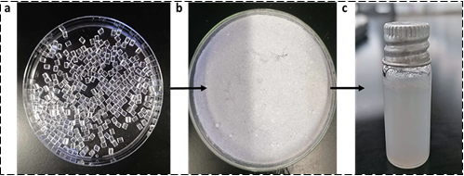

Fig S1. Overview of the environmental nanoplastics (NPS) preparation process, illustrating the transition from (a) polystyrene pellets (b) NPS powder, and (c) NPS emulsion (generated by Biorender.com)
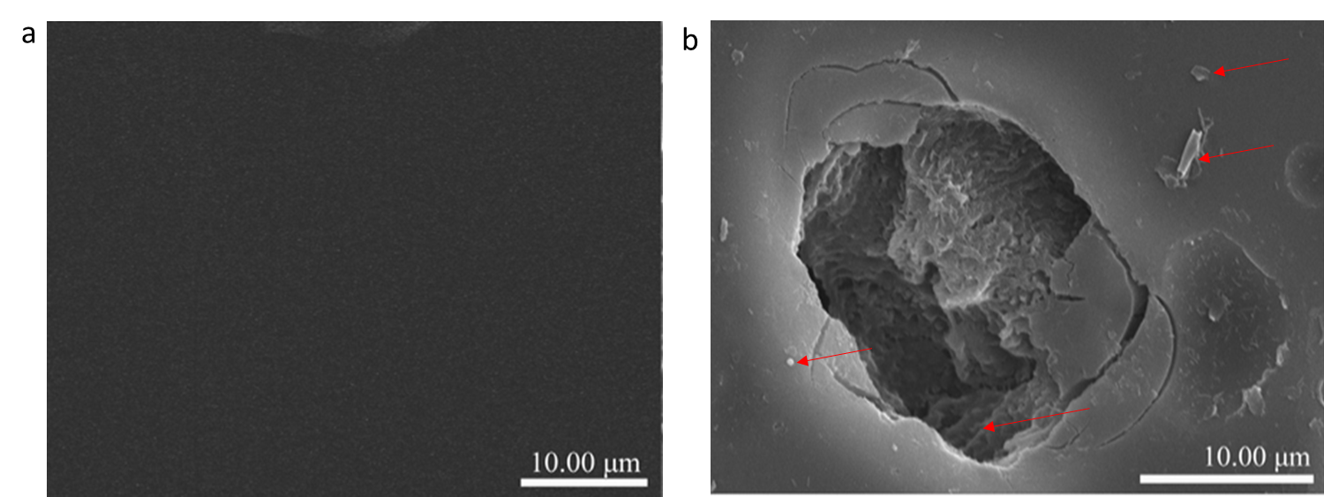
Fig S2. Release of the nano and micro-scale plastics from the PS film surface (Z. Wang et al., 2020)
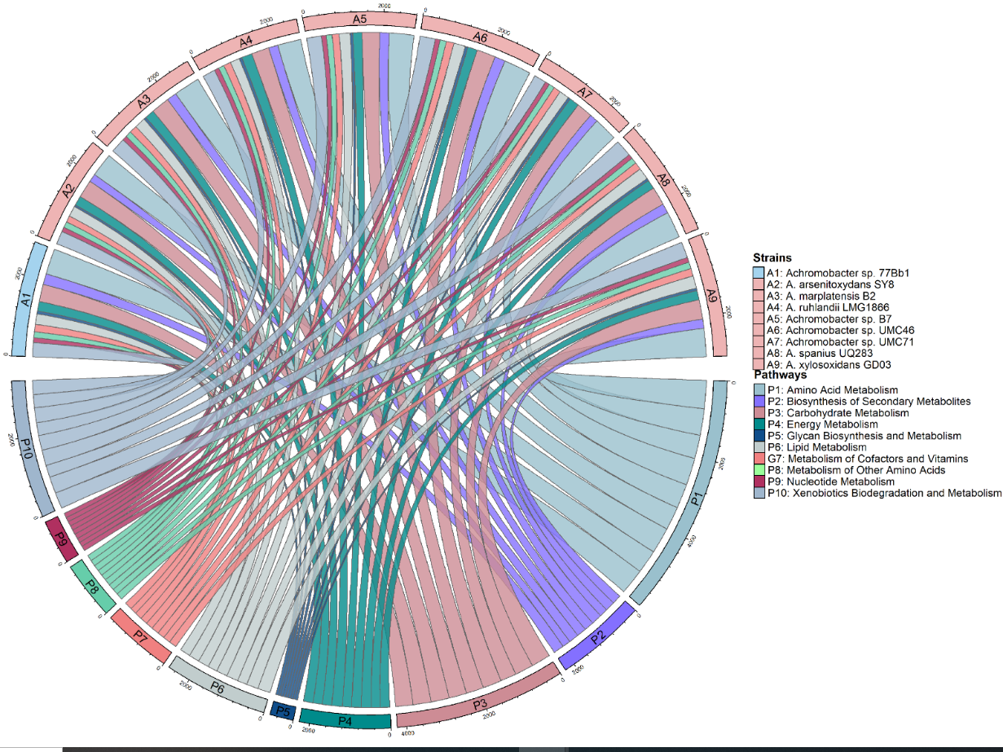

Fig. S3 Xenobiotic biodegradation pathway among the genome of A. xylosoxidans (Marzec-Grządziel & Gałązka, 2023)
Table S1 Pollutants degraded by genus Achromobacter sp.
Pollutant | Species | Origin | Reference
Neonicotinoids | Achromobacter sp. | Soil | (Gao et al., 2021)
Dibutyl phthalate | Achromobacter pulmonis sp. | Plastic contaminated water | (Qu et al., 2024)
Oxytetracycline | Achromobacter sp. ONK | Activated sludge | (Nguyen et al., 2023)
Quinoline | Achromobacter sp. strain JWJ-09 | Coking wastewater | (Deng et al., 2023)
Polyaromatic hydrocarbons (PAHs) | Achromobacter xylosoxidans BP1 | Contaminated soil | (Zhang et al., 2023)
Terpene | Achromobacter sp. UMC46 | Soil | (Marzec-Grządziel & Gałązka, 2023)
Arsenite | Achromobacter arsenitoxydans SY8. | Polychlorinated Biphenyl-contaminated soil | (X. Li et al., 2012)
Phenanthrene | Achromobacter sp. LH-1 | Soil | (Zang et al., 2020)
Anthracene | Achromobacter xylosoxidans strain BUK_BTEG6 | Petrochemical contaminated Soil | (Usman et al., 2023)
High-density polyethylene | Achromobacter xylosoxidans | Soil | (Kowalczyk et al., 2016)
Di-(2-ethylhexyl) phthalate | Achromobacter sp. RX | Activated sludge | (Wang et al., 2021)
Low-density polyethylene (LDPE) and polyvinyl chloride (PVC) microplastics | Achromobacter denitrificans Ebl13 | PVC and LDPE enriched compost sample | (Maleki Rad et al., 2022)
Pyrene | Achromobacter sp AC15 | Mangrove soil | (Li et al., 2020)
Phenanthrene | Achromobacter sp. PHED2 | Sludge | (Li et al., 2021)
Sulfamethoxazole (SMX) | Achromobacter JL9 | Sediments of a pharmaceutical wastewater treatment plant. | (Liang et al., 2021)

Table S2. Main reasons for choosing Tenebrio molitor in this study.
Application | Comments | Reference
Aquaculture Feed | a high-quality natural protein source, potentially replacing fishmeal in aquaculture diets. | (Hong et al., 2020)
Waste Management | Tenebrio molitor larvae can biodegrade polyether polyurethan, polystyrene, polyethylene, and polyvinyl chloride suggesting their potential in waste management. | (Brandon et al., 2018; Liu et al., 2022; B. Peng et al., 2023; B.-Y. Peng et al., 2020; Tsochatzis et al., 2021)
Organic Waste Recycling | T. molitor larvae can be used as a protein source for broiler chickens, recycling organic wastes and showing no significant differences in feed intake, weight gain, or feed efficiency after 15 days. | (Ramos-Elorduy et al., 2002)
Nutritional Value for Aquaculture | High content of proteins, fats, and essential amino acids, making T. molitor a suitable feed ingredient for fish and other aquaculture species. | (Hua, 2021)

Table S3 Results of the analysis
Keywords | Web of science | PubMed | Google Scholar | Scopus
Biodegradation of Polystyrene | 769 | 9,465 | 122,000 | 1,021
Mealworms Plastic Degradation | 57 | 79 | 5,270 | 51
Tenebrio molitor Polystyrene | 103 | 64 | 1,800 | 93
Mealworm Gut Microbiota and Polystyrene | 19 | 30 | 1,620 | 16
Achromobacter and polystyrene | 1 | 1 | 1 | 0
Achromobacter and polystyrene and mealworm | 0 | 0 | 0 | 0

References

Brandon, A., Gao, S., Tian, R., Ning, D., Yang, S., Zhou, J., Wu, W., & Criddle, C. (2018). Biodegradation of Polyethylene and Plastic Mixtures in Mealworms (Larvae of Tenebrio molitor) and Effects on the Gut Microbiome. Environ sci tech, 52(11), 6526–6533. https://doi.org/10.1021/acs.est.8b02301

Deng, M., Yu, F., Wang, J., Yu, J., & Jin, W. (2023). Bio-augmentation effect of Achromobacter sp. Strain JWJ-09 on quinoline and real coking wastewater under methanol co-metabolism. J. Water Pro Eng 53, 103611. https://doi.org/10.1016/j.jwpe.2023.103611
Gao, Y., Liu, M., Zhao, X., Zhang, X., & Zhou, F. (2021). Paracoccus and Achromobacter bacteria contribute to rapid biodegradation of imidacloprid in soils. Ecotoxicol. Environ. Saf. 225,112785. https://doi.org/10.1016/j.ecoenv.2021.112785
Hong, J., Han, T., & Kim, Y. Y. (2020). Mealworm (Tenebrio molitor Larvae) as an Alternative Protein Source for Monogastric Animal: A Review. Animals, 10(11), Article 11. https://doi.org/10.3390/ani10112068
Hua, K. (2021). A meta-analysis of the effects of replacing fish meals with insect meals on growth performance of fish. Aquaculture, 530, 735732. https://doi.org/10.1016/j.aquaculture.2020.735732
Kowalczyk, A., Chyc, M., Ryszka, P., & Latowski, D. (2016). Achromobacter xylosoxidans as a new microorganism strain colonizing high-density polyethylene as a key step to its biodegradation. Environ Sci Poll. Res, 23(11), 11349–11356. https://doi.org/10.1007/s11356-016-6563-y
Li, J., Wang, Y., Zhou, W., Chen, W., Deng, M., & Zhou, S. (2020). Characterization of a new biosurfactant produced by an effective pyrene-degrading Achromobacter species strain AC15. Int. Biodeterior. Biodegrad., 152, 104959. https://doi.org/10.1016/j.ibiod.2020.104959
Li, X., Hu, Y., Gong, J., Lin, Y., Johnstone, L., Rensing, C., & Wang, G. (2012). Genome Sequence of the Highly Efficient Arsenite-Oxidizing Bacterium Achromobacter arsenitoxydans SY8. J. Bact, 194(5), 1243–1244. https://doi.org/10.1128/jb.06667-11
Li, X., Peng, D., Zhang, Y., Ju, D., & Guan, C. (2021). Achromobacter sp. PHED2 enhances the phenanthrene degradation and stress tolerance in maize involving the participation of salicylic acid. Environ. Technol. Innov, 21, 101365. https://doi.org/10.1016/j.eti.2021.101365
Liang, D. hui, Hu, Y., Liang, D., Chenga, J., & Chena, Y. (2021). Bioaugmentation of Moving Bed Biofilm Reactor (MBBR) with Achromobacter JL9 for enhanced sulfamethoxazole (SMX) degradation in aquaculture wastewater. Ecotoxicol Environ. Saf., 207, 111258. https://doi.org/10.1016/j.ecoenv.2020.111258
Liu, J., Liu, J., Xu, B., Xu, A., Cao, S., Wei, R., Zhou, J., Jiang, M., & Dong, W. (2022). Biodegradation of polyether-polyurethane foam in yellow mealworms (Tenebrio molitor) and effects on the gut microbiome. Chemosphere, 304. https://doi.org/10.1016/j.chemosphere.2022.135263
Maleki Rad, M., Moghimi, H., & Azin, E. (2022). Biodegradation of thermo-oxidative pretreated low-density polyethylene (LDPE) and polyvinyl chloride (PVC) microplastics by Achromobacter denitrificans Ebl13. Mar. Poll. Bull., 181, 113830. https://doi.org/10.1016/j.marpolbul.2022.113830
Marzec-Grządziel, A., & Gałązka, A. (2023). Sequencing of the Whole Genome of a Bacterium of the Genus Achromobacter Reveals Its Potential for Xenobiotics Biodegradation. Agriculture, 13(8), Article 8. https://doi.org/10.3390/agriculture13081519
Nguyen, H. T., Siddiqui, S. I., Maeng, S. K., & Oh, S. (2023). Biological detoxification of oxytetracycline using Achromobacter-immobilized bioremediation system. J. Water Pro. Eng., 52, 103491. https://doi.org/10.1016/j.jwpe.2023.103491
Peng, B., Xu, Y., Sun, Y., Xiao, S., Sun, J., Shen, Z., Chen, J., Zhou, X., & Zhang, Y. (2023). Biodegradation of polyethylene (PE) microplastics by mealworm larvae: Physiological responses, oxidative stress, and residual plastic particles. J. Cle. Pro., 402. https://doi.org/10.1016/j.jclepro.2023.136831.
Peng, B.-Y., Chen, Z., Chen, J., Yu, H., Zhou, X., Criddle, C. S., Wu, W.-M., & Zhang, Y. (2020). Biodegradation of Polyvinyl Chloride (PVC) in Tenebrio molitor (Coleoptera: Tenebrionidae) larvae. Environ. Int., 145, 106106. https://doi.org/10.1016/j.envint.2020.106106
Qu, Y., Chen, J., Russel, M., Huang, W., Bingke, Y., lei, W., Zhang, D., & Blaszczak-Boxe, C. (2024). Optimizing concentration and interaction mechanism of Demodesmus sp. And Achromobacter pulmonis sp. Consortium to evaluate their potential for dibutyl phthalate removal from synthetic wastewater. Bio. Technol., 395, 130372. https://doi.org/10.1016/j.biortech.2024.130372
Ramos-Elorduy, J., González, E. A., Hernández, A. R., & Pino, J. M. (2002). Use of Tenebrio molitor (Coleoptera: Tenebrionidae) to Recycle Organic Wastes and as Feed for Broiler Chickens. J. Eco. Ent., 95(1), 214–220. https://doi.org/10.1603/0022-0493-95.1.214
Tsochatzis, E. D., Berggreen, I. E., Nørgaard, J. V., Theodoridis, G., & Dalsgaard, T. K. (2021). Biodegradation of expanded polystyrene by mealworm larvae under different feeding strategies evaluated by metabolic profiling using GC-TOF-MS. Chemosphere, 281, 130840. https://doi.org/10.1016/j.chemosphere.2021.130840
Usman, S., Yakasai, H. M., Gimba, M. Y., Shehu, D., & Jagaba, A. H. (2023). Anthracene degradation by Achromobacter xylosoxidans strain BUK_BTEG6 isolated from petrochemical contaminated soil. Case Stu. Chem. Environ. Eng., 8, 100418. https://doi.org/10.1016/j.cscee.2023.100418
Wang, P., Gao, J., Zhao, Y., Zhang, M., & Zhou, S. (2021). Biodegradability of di-(2-ethylhexyl) phthalate by a newly isolated bacterium Achromobacter sp. RX. Sci. Tot. Environ., 755, 142476. https://doi.org/10.1016/j.scitotenv.2020.142476
Wang, Z., Xin, X., Shi, X., & Zhang, Y. (2020). A polystyrene-degrading Acinetobacter bacterium isolated from the larvae of Tribolium castaneum. Sci. Tot. Environ., 726, 138564. https://doi.org/10.1016/j.scitotenv.2020.138564
Zang, H., Dai, Y., Sun, Y., Jia, T., Song, Q., Li, X., Jiang, X., Sui, D., Han, Z., Li, D., & Hou, N. (2020). Mechanism of the biodemulsifier-enhanced biodegradation of phenanthrene by Achromobacter sp. LH-1. Colloids and Surfaces. B, Biointerfaces, 195, 111253. https://doi.org/10.1016/j.colsurfb.2020.111253
Zhang, B., Xu, W., Ma, Y., Gao, X., Ming, H., & Jia, J. (2023). Effects of bioaugmentation by isolated Achromobacter xylosoxidans BP1 on PAHs degradation and microbial community in contaminated soil. J.Environ. Manag., 334, 117491. https://doi.org/10.1016/j.jenvman.2023.117491

