Targeting of Leishmania Proteins by β-Lapachone Derivatives Reveals a Promising Multitarget Candidate

Archives of Microbiology

Laércio Mariano-Fernandesª, Jacilene Silva^{b}, Matheus Nunes da Rocha^{c}, Márcia Machado Marinho^{c}, Emmanuel Silva Marinho^{a,c,*}

ª Postgraduate Program in Veterinary Sciences, State University of Ceará, Fortaleza, Ceará, Brazil
^{b} Department of Biological Chemistry, Regional University of Cariri, Crato, Ceará, Brazil
^{c} Postgraduate Program in Natural Sciences – PPGCN, State University of Ceará, Fortaleza, Brazil

* Corresponding author at: Bioprospecting and Natural Resource Monitoring Laboratory, State University of Ceará, Av. Dr. Silas Munguba, 1700 - Itaperi Campus, Fortaleza, CE, CEP: 60.714.903, Brazil
E-mail address: emmanuel.marinho@uece.br (E.S. Marinho).

ORCID of the authors
L. Mariano-Fernandes: 0000-0003-2130-804X
J. Silva: 0000-0001-5008-858X
M.N. da Rocha: 0000-0002-0929-4565
M.M. Marinho: 0000-0002-7640-2220
E.S. Marinho: 0000-0002-4774-8775

- Molecular Docking Simulations for β-Lapachone-derived Compounds
Table S1. RMSD of Protein-Ligand Complexes
Ligand | DHODH (3MHU)  RMSD (Å) | NMT (2WUU)  RMSD (Å) | CatB (3HHI)  RMSD (Å)
LPI1 | 1.413 | 1.324 | 1.603
LPI2 | 1.070 | 0.888 | 1.226
LPI3 | 0.868 | 0.786 | 0.909
LPI4 | 0.779 | 0.873 | 0.798
LPI5 | 1.077 | 0.804 | 1.598
LPI6 | 1.215 | 0.786 | 0.753
LPI7 | 1.630 | 1.529 | 1.653
MTF* | 1.219 | 1.378 | 1.433
AmphoB* | 1.997 | 1.441 | 1.401
Inhibitor** | 1.913 | 1.483 | 1.865
*Control ** EJZ (DHODH), NHW (NMT) and CA074 (CatB)
Table S2. Affinity Energy of Protein-Ligand Complexes
Ligand | DHODH (3MHU)  E_{A} (kcal/mol) | NMT (2WUU)  E_{A} (kcal/mol) | CatB (3HHI)  E_{A} (kcal/mol)
LPI1 | -8.4 | -9.8 | -8.0
LPI2 | -9.2 | -10.7 | -7.9
LPI3 | -9.4 | -12.2 | -8.9
LPI4 | -8.7 | -10.5 | -8.3
LPI5 | -9.3 | -10.9 | -7.5
LPI6 | -8.6 | -10.8 | -7.9
LPI7 | -9.1 | -11.4 | -8.5
MTF* | -5.7 | -7.2 | -4.4
AmphoB* | -7.7 | -8.2 | -7.3
Inhibitor** | -7.4 | -8.9 | -5.7
*Control ** EJZ (DHODH), NHW (NMT) and CA074 (CatB)

- Interaction Analysis Between β-lapachone-derived compounds and Protein Structure
Table S3. Interaction types between ligands and Dihydroorotate dehydrogenase
Ligand | Interaction Type | Residue (Distance in Å)
LPI1 | Hydrophobic | Met70A (3.74), Lys215A (3.62)
 | H-Bond | Ser196A (2.90), Asn199A (3.18)
LPI2 | Hydrophobic | Ser69A (3.83), Gln139A (3.53), Asp171B (3.59), Phe172B (3.50), Ala173B (3.77)
 | H-Bond | Asn199A (2.8)
LPI4 | Hydrophobic | Gln139A (3.59), Asp171B (3.88), Phe172B (3.42), Ala173B (3.74)
 | H-Bond | Asn199A (2.88)
LPI5 | Hydrophobic | Gln139A (3.62), Tyr142A (3.55), Pro167A (3.76), Asp171B (3.80), Phe172B (3.71), Ala173B (3.78)
 | H-Bond | Asn199A (2.96)
LPI6 | Hydrophobic | Ser69A (3.62), Asp171B (3.59)
 | H-Bond | Asn199A (2.76)
LPI7 | Hydrophobic | Met70A (3.66), Gln139A (3.75), Tyr142A (3.78), Asp171B (3.67)
 | H-Bond | Asn199A (2.84), Lys215A (3.49)

Table S4. Interaction types between ligands and N-myristoyltransferase
Ligand | Interaction Type | Residue (Distance in Å)
LPI1 | Hydrophobic | Tyr217A (3.51), Tyr217A (3.76)
 | H-Bond | Tyr345A (1.98)
 | π-Stacking | Tyr217A (3.85), Tyr217A (4.75)
LPI2 | Hydrophobic | Val81A (3.40), Phe90A (3.96), Tyr217A (3.35), Tyr217A (3.67), Tyr217A (3.84)
 | π-Stacking | Tyr217A (3.97)
LPI4 | Hydrophobic | Tyr80A (4.00), Val81A (3.54)
 | H-Bond | Asn167A (2.42)
 | π-Stacking | Tyr217A (4.19)
LPI5 | Hydrophobic | Val81A (3.72), Val206A (3.37), Tyr217A (3.99)
 | H-Bond | Gly205A (2.55)
 | π-Stacking | Tyr217A (3.88)
LPI6 | Hydrophobic | Val81A (3.49), Val206A (3.39)
 | H-bond | Gly205A (2.69)
 | π-Stacking | Tyr217A (3.85)
LPI7 | Hydrophobic | Val81A (3.76), Tyr217A (3.53), His219A (3.79), Phe232A (3.89), Ile328A (3.89), Tyr345A (3.51)
 | H-Bond | Tyr345A (2.20)
 | π-Stacking | Tyr217A (4.02)

Table S5. Interaction types between ligands and Cathepsin B
Ligand | Interaction Type | Residue (Distance in Å)
LPI1 | Hydrophobic | Gln112A (3.4), Ala114A (3.52), Val125A (3.53), Ala148A (3.24), Tyr187A (3.72), Tyr187A (3.4)
 | H-Bond | Asp115A (2.33), Ser129A (2.3)
LPI2 | Hydrophobic | Val125A (3.49), Ala128A (3.5), Ala148A (3.67)
 | H-Bond | Asp182A (2.15)
LPI4 | Hydrophobic | Val125A (3.41), Ala148A (3.53), Pro186A (3.66), Tyr187A (3.77)
 | H-Bond | Val125A (2.2), Ser129A (2.81), Asp182A (2.24)
LPI5 | Hydrophobic | Gln112A (3.79), Val125A (3.69)
 | π-Stacking | His191A (5.07)
LPI6 | Hydrophobic | Pro186A (3.48), Tyr187A (3.57)
 | H-Bond | Asp182A (2.6), Tyr187A (2.95)
LPI7 | Hydrophobic | Asp115A (3.7), Ala128A (3.75), Ala148A (3.56), Pro186A (3.26)
 | H-Bond | Asp182A (2.08)

- NMA-based Molecular Dynamics
Table S6. Active Site Residues of DHODH Characterized by Molecular Dynamics Simulation
Residue Index | Atom | Amino Acid
47 | Cα | Lys44A
71 | Cα | Asn68A
73 | Cα | Met70A
74 | Cα | Gly71A
75 | Cα | Leu72A
103 | Cα | Ser100A
104 | Cα | Gly101A
105 | Cα | Leu102A
110 | Cα | Asn107A
131 | Cα | Asn128A
132 | Cα | Leu129A
133 | Cα | Ser130A
134 | Cα | Cys131A
135 | C | Cys131A
136 | N | Gln139A
137 | Cα | Gln139A
138 | Cα | Val140A
148 | Cα | Cys150A
193 | Cα | Asn195A
194 | Cα | Ser196A

Table S7. Active Site Residues of NMT Characterized by Molecular Dynamics Simulation
Residue Index | Atom | Amino Acid
71 | Cα | Tyr80A
72 | Cα | Val81A
73 | Cα | Glu82A
74 | C | Glu82A
78 | Cα | Phe88A
80 | Cα | Phe90A
82 | Cα | Tyr92A
157 | Cα | Asn167A
193 | Cα | Thr203A
207 | Cα | Tyr217A
209 | Cα | Tyr219A
222 | Cα | Phe232A
316 | Cα | Tyr326A
318 | Cα | Ile328A
320 | Cα | Ser330A
327 | Cα | Leu341A
329 | Cα | Ala343A
331 | Cα | Tyr345A
360 | Cα | Val374A
382 | Cα | Asp396A
385 | Cα | Leu399A
406 | Cα | Met420A
407 | Cα | Leu421A
408 | C | Leu421A

Table S8. Active Site Residues of CatB Characterized by Molecular Dynamics Simulation
Residue Index | Atom | Amino Acid
46 | Cα | Cys122A
206 | Cα | His282A
226 | Cα | Asn302

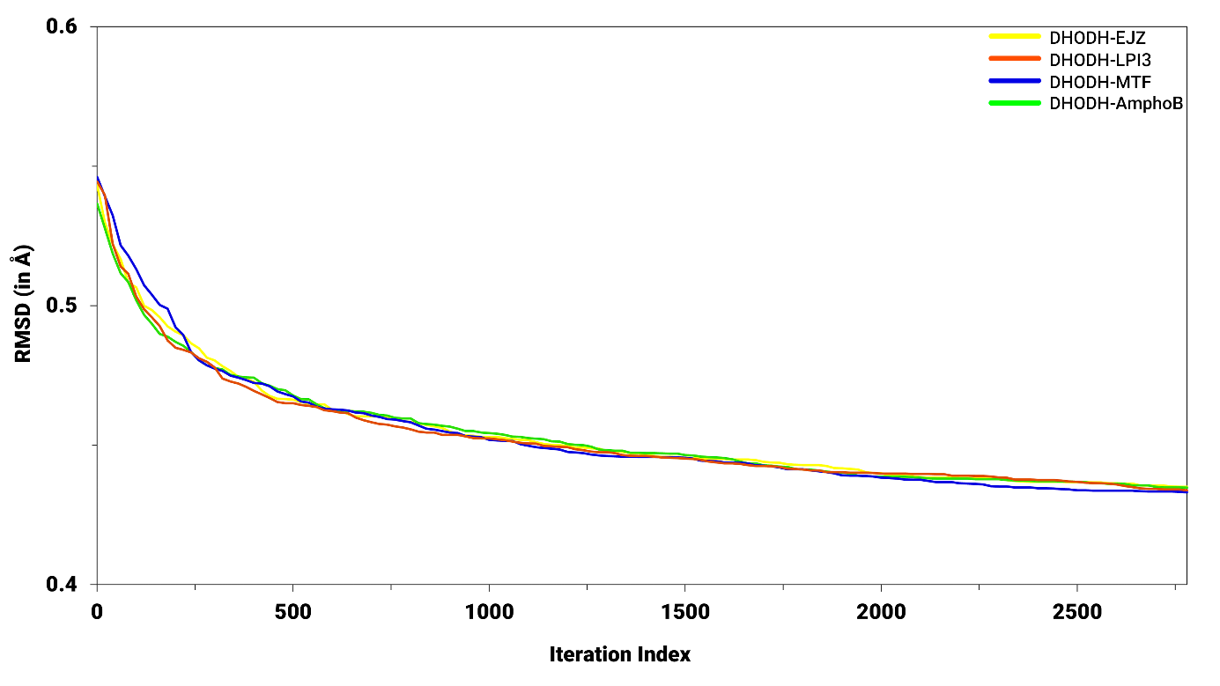
Fig. S1 Convergence of the morphing trajectory for the complexes DHODH-EJZ (yellow line), DHODH-LPI3 (red line), DHODH-MTF (blue line) and DHODH-AmphoB (green line), indicating the RMSD variation of Ca (in Å) in relation to the iteration index.

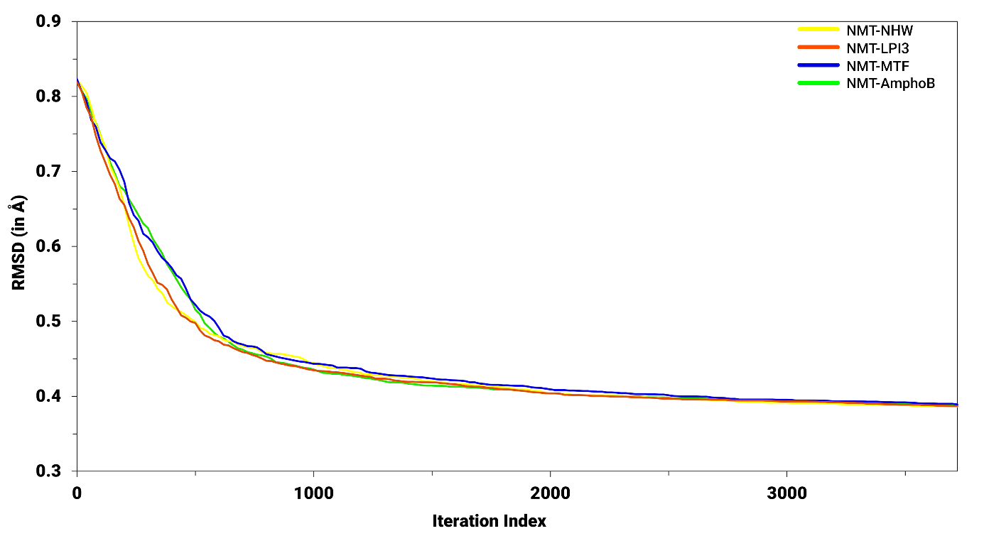
Fig. S2 Convergence of the morphing trajectory for the complexes NMT-NHW (yellow line), NMT-LPI3 (red line), NMT-MTF (blue line) and NMT-AmphoB (green line), indicating the RMSD variation of Ca (in Å) in relation to the iteration index.

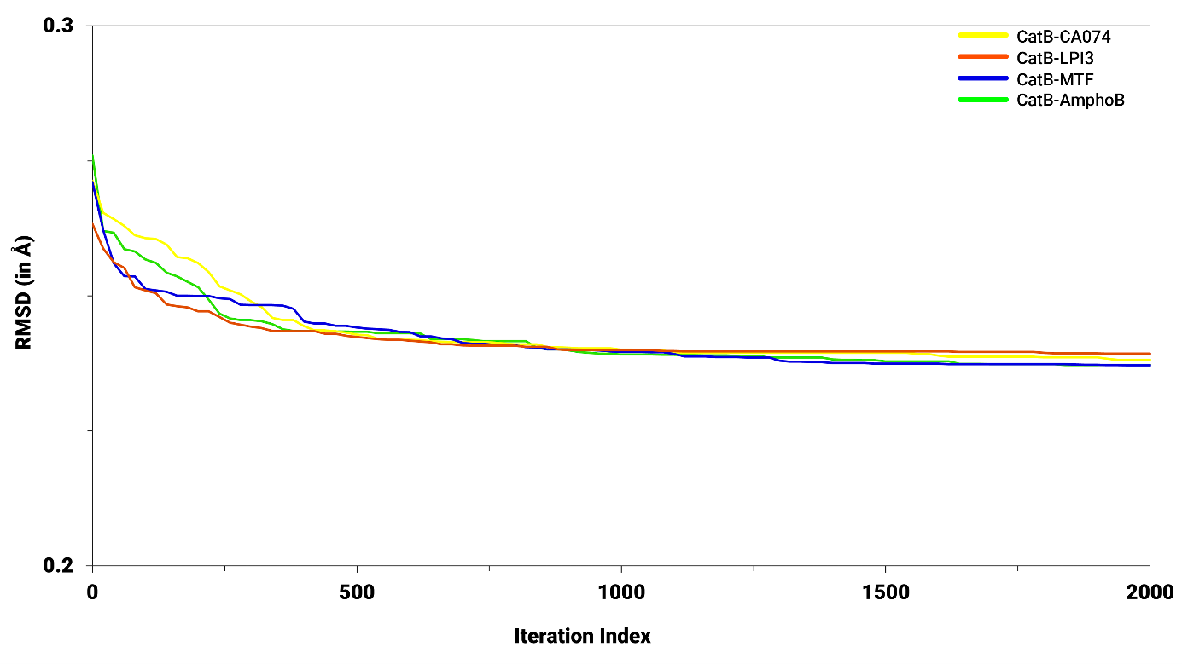
Fig. S3 Convergence of the morphing trajectory for the complexes CatB-CA074 (yellow line), CatB-LPI3 (red line), CatB-MTF (blue line) and CatB-AmphoB (green line), indicating the RMSD variation of Ca (in Å) in relation to the iteration index.

