Supplementary Materials
Comparative genomics of hypervirulent Klebsiella pneumoniae isolates from Brazil

Felipe G. Sacodaª, João V. O. Cruzª, Itana A. Santosª, Adriano S. S. Monteiro^{b,c}, Amanda O. S. Melo^{c}, Danilo J. P. G. Rocha^{d}, Emilia M. M. A. Belitardo^{d}, Flavia F. Aburjaile^{e}, Siomar C. Soares^{f}, Mateus M. Costa^{g}, Aristóteles Góes-Neto^{h}, Rommel T. J. Ramos^{i}, Bertram Brenig^{j}, Vasco Azevedo^{h}, Joice N. Reis^{b,c}, and Luis G. C. Pacheco^{a,b,d} *

ª Post-Graduate Program in Biotechnology, Federal University of Bahia, Salvador-BA, Brazil.

^{b} Gonçalo Moniz Institute, Oswaldo Cruz Foundation (FIOCRUZ), Salvador-BA, Brazil.

^{c} Faculty of Pharmacy, Federal University of Bahia, Salvador-BA, Brazil.

^{d} Institute of Health Sciences, Federal University of Bahia, Salvador-BA, Brazil.

^{e} Department of Preventive Veterinary Medicine, Federal University of Minas Gerais, Belo Horizonte-MG, Brazil.

^{f} Institute of Biological and Natural Sciences, Federal University of Triângulo Mineiro, Uberaba-MG, Brazil.

^{g} Federal University of the São Francisco Valley, Petrolina-PE, Brazil.

^{h} Institute of Biological Sciences, Federal University of Minas Gerais, Belo Horizonte-MG, Brazil.

^{i} Federal University of Pará, Belém-PA, Brazil.

^{j} Institute of Veterinary Medicine, University of Göttingen, 37073 Göttingen, Germany.

Correspondence: L. Pacheco. Gonçalo Moniz Institute, Oswaldo Cruz Foundation (IGM-Fiocruz), Salvador-BA, Brazil. E-mail: luis.pacheco@fiocruz.br

Supplementary table 1 - Assembly and annotation statistics for 25 sequenced Klebsiella pneumoniae isolates from Salvador, Bahia, Brazil
Samples Name | Number of contigs | G+C% Content | L50 | Genome size | N50 | Sequencing coverage | Completeness | tRNA | Number of coding sequences
OBAC799 | 38 | 57.23 | 4 | 5,511,551 | 440,925 | 168,961 | 100 | 75 | 5,389
OBAC840 | 46 | 57.25 | 5 | 5,531,322 | 365,715 | 188,137 | 100 | 77 | 5,436
OBAC898 | 33 | 57.24 | 3 | 5,388,700 | 499,608 | 162,555 | 100 | 77 | 5,265
OBAC908 | 48 | 57.07 | 7 | 5,420,545 | 303,481 | 190,182 | 100 | 76 | 5,329
OBAC950 | 45 | 57.29 | 6 | 5,374,056 | 335,825 | 182,077 | 100 | 76 | 5,321
HB103 | 45 | 57.29 | 6 | 5,374,056 | 335,825 | 154,227 | 100 | 72 | 5,321
ITUAC436 | 45 | 57.29 | 6 | 5,374,056 | 335,825 | 101,203 | 100 | 75 | 5,321
ITUAC449 | 70 | 57.26 | 12 | 5,304,412 | 168,872 | 167,272 | 100 | 75 | 5,209
HB083 | 92 | 57.05 | 8 | 5,838,199 | 239,778 | 166,102 | 100 | 79 | 5,841
HSR187 | 149 | 57.28 | 9 | 5,476,554 | 209,249 | 150,713 | 100 | 76 | 5,487
HSR496 | 62 | 57.40 | 5 | 5,364,213 | 427,2 | 161,647 | 100 | 72 | 5,259
HSR510 | 151 | 56.67 | 11 | 5,755,622 | 173,338 | 96,9 | 100 | 77 | 5,797
HSR544 | 140 | 57.34 | 8 | 5,756,333 | 279,949 | 155,884 | 100 | 81 | 5,821
HB044 | 77 | 57.18 | 6 | 5,562,200 | 328,771 | 151,743 | 100 | 78 | 5,539
HB068 | 77 | 57.18 | 6 | 5,562,181 | 328,771 | 175,828 | 100 | 78 | 5,541
HB070 | 92 | 57.09 | 6 | 5,658,344 | 328,771 | 194,402 | 100 | 78 | 5,672
HSR410 | 94 | 57.18 | 6 | 5,564,550 | 328,771 | 157,864 | 100 | 78 | 5,542
ICOM45 | 92 | 57.05 | 8 | 5,840,148 | 239,832 | 174,475 | 100 | 77 | 5,843
ICOM68 | 113 | 56.77 | 7 | 5,835,214 | 252,903 | 135,26 | 100 | 74 | 5,863
ICOM128 | 94 | 57.04 | 6 | 5,700,628 | 349,173 | 153,764 | 100 | 78 | 5,726
ICOM203 | 80 | 57.17 | 6 | 5,561,909 | 328,771 | 147,354 | 100 | 78 | 5,537
ICOM329 | 123 | 56.56 | 9 | 5,950,831 | 229,274 | 153,566 | 100 | 78 | 6,045
ICOM343 | 103 | 57.00 | 9 | 5,898,443 | 212,807 | 171,909 | 100 | 79 | 5,914
ICOM692 | 115 | 56.90 | 10 | 5,772,897 | 182,265 | 146,341 | 99.9 | 77 | 5,824
ICOM779 | 124 | 57.06 | 9 | 5,778,071 | 219,954 | 183,904 | 100 | 77 | 5,823

Supplementary table 2 - Annotation and GenBank ID of proteins present in clusters of hypervirulent K. pneumoniae isolates.
 | Protein_ID | Annotation | Location
1 | WLX18656.1 | small membrane protein | Chromosome
2 | WLX18679.1 | KPN_01571 family protein | Chromosome
3 | WLX18680.1 | carboxypeptidase M32 | Chromosome
4 | WLX18682.1 | serine protease | Chromosome
5 | WLX18683.1 | ArsR family transcriptional regulator | Chromosome
6 | WLX18684.1 | multidrug efflux SMR transporter subunit KpnF | Chromosome
7 | WLX18685.1 | multidrug efflux SMR transporter subunit KpnE | Chromosome
8 | WLX18686.1 | AI-2E family transporter | Chromosome
9 | WLX20320.1 | polysaccharide pyruvyl transferase family | Chromosome
10 | WLX20321.1 | glycosyltransferase | Chromosome
11 | WLX20322.1 | PAAR domain-containing protein | Chromosome
12 | WLX20323.1 | hypothetical protein | Chromosome
13 | WLX22602.1 | glycosyltransferase | Chromosome
14 | WLX22603.1 | alpha/beta hydrolase-fold protein | Chromosome
15 | WLX22898.1 | histone-like nucleoid-structuring protein H-NS | Chromosome
16 | WLX22941.1 | hypothetical protein | Chromosome
17 | WLX23215.1 | CcdB family protein | Chromosome
18 | WLX23576.1 | hypothetical protein | Plasmid
19 | WLX23577.1 | DMT family inner membrane transporter PEG344 | Plasmid
20 | WLX23578.1 | mucoid phenotype regulator RmpA | Plasmid
21 | WLX23579.1 | class I SAM-dependent methyltransferase | Plasmid
22 | WLX23587.1 | GTP-binding protein | Plasmid
23 | WLX23588.1 | transcriptional repressor | Plasmid
24 | WLX23589.1 | c-type lysozyme inhibitor | Plasmid
25 | WLX23593.1 | NIS family aerobactin synthetase IucA | Plasmid
26 | WLX23594.1 | N(6)-hydroxylysine O-acetyltransferase IucB | Plasmid
27 | WLX23595.1 | NIS family aerobactin synthetase IucC | Plasmid
28 | WLX23597.1 | DUF1471 domain-containing protein | Plasmid
29 | WLX23598.1 | TetR/AcrR family transcriptional regulator | Plasmid
30 | WLX23599.1 | DUF417 family protein | Plasmid
31 | WLX23600.1 | carboxymuconolactone decarboxylase family protein | Plasmid
32 | WLX23601.1 | DM13 domain-containing protein | Plasmid
33 | WLX23602.1 | DUF1471 domain-containing protein | Plasmid
34 | WLX23616.1 | Tn3 family transposase | Plasmid
35 | WLX23617.1 | alpha/beta hydrolase | Plasmid
36 | WLX23640.1 | DUF2251 domain-containing protein | Plasmid
37 | WLX23641.1 | DUF1778 domain-containing protein | Plasmid
38 | WLX23667.1 | ParB/RepB/Spo0J family plasmid partition protein | Plasmid
39 | WLX23668.1 | plasmid-partitioning protein SopA | Plasmid
40 | WLX23669.1 | RepB family plasmid replication initiator protein | Plasmid
41 | WLX23670.1 | plasmid transfer protein | Plasmid
42 | WLX23717.1 | DUF1173 family protein | Plasmid
43 | WLX23733.1 | zinc metallochaperone GTPase ZigA | Plasmid
44 | WLX23739.1 | RNA polymerase-binding protein DksA | Plasmid
45 | WLX23760.1 | DUF2384 domain-containing protein | Plasmid
46 | WLX23762.1 | TonB-dependent Fe(3+) dicitrate receptor FecA | Plasmid
47 | WLX23763.1 | ferric citrate uptake sigma factor FecI | Plasmid
48 | WLX23767.1 | salmochelin/enterobactin export ABC transporter IroC | Plasmid
49 | WLX23768.1 | IS3 family transposase | Plasmid
50 | WLX23772.1 | recombinase family protein | Plasmid
51 | WLX23774.1 | mucoid phenotype regulator RmpC | Plasmid
52 | WLX23775.1 | mucoid phenotype synthesis protein RmpD | Plasmid
53 | WLX23777.1 | MFS transporter | Plasmid

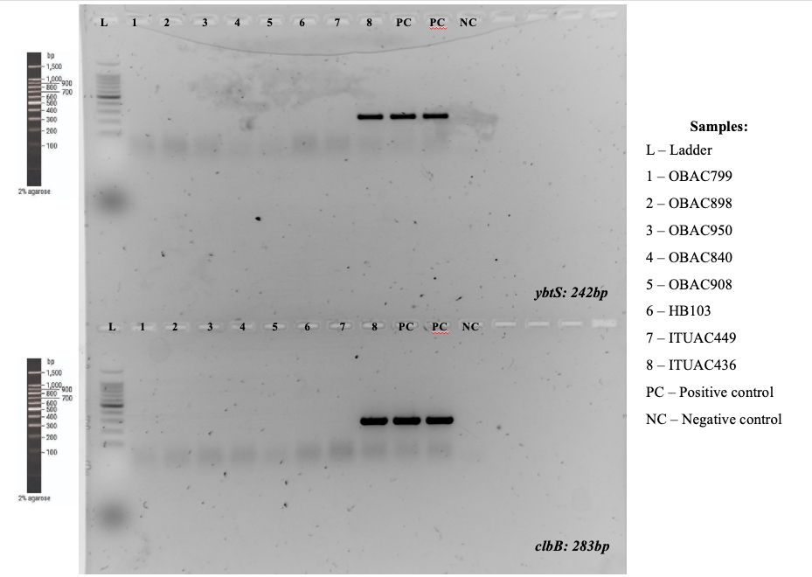
Supplementary Figure 1 - Agarose gel electrophoresis of the PCR products obtained for the ybt (yersiniabactin locus) and clb (colibactin locus) targets in the eight hvKp isolates from Salvador, Brazil. Reactions were performed with the GoTaq® G2 Hot Start Polymerase kit.
Supplementary File 2- Excel file
ESM1. Mobile genetic element-associated proteins identified in the eight hypervirulent Klebsiella pneumoniae isolates by mobileOG-db. Each worksheet corresponds to one isolate and lists all retained hits with their mobileOG-db identifiers. Functional categories follow the mobileOG-db classification scheme: integration/excision, replication/recombination/repair, stability/transfer/defense, transfer and phage.

