ESM-Fig. 1: Meteorological data in 2012, compared to the mean data 1984-2012

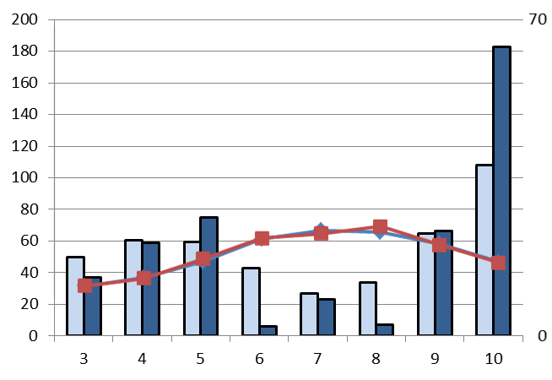
Rainfall (mm)
Temperature (ºC)
Rainfall (mean 1984-2012)
Rainfall (2012)
Temperature (mean 1984-2012)
Temperature (2012)
months

