Supplementary Material

Article title: Prenatal exposure to bisphenol A impacts neuronal morphology in the hippocampal CA1 region in developing and aged mice

Journal name: Archives of Toxicology

Authors names: Eiki Kimura¹, Chieri Matsuyoshi¹, Wataru Miyazaki¹, Seico Benner¹, Mayuko Hosokawa², Kazuhito Yokoyama², Masaki Kakeyama^{1, 3}, and Chiharu Tohyama¹

Affiliation: ¹Laboratory of Environmental Health Sciences, Center for Disease Biology and Integrative Medicine, Graduate School of Medicine, The University of Tokyo, Tokyo, Japan; ²Department of Epidemiology and Environmental Health, Juntendo University Faculty of Medicine; ³Graduate School of Biomedical Science, Nagasaki University, Nagasaki, Japan

E-mail address of the corresponding author: Chiharu Tohyama, mtohyama@mail.ecc.u-tokyo.ac.jp; Masaki Kakeyama, kakeyama@nagasaki-u.ac.jp

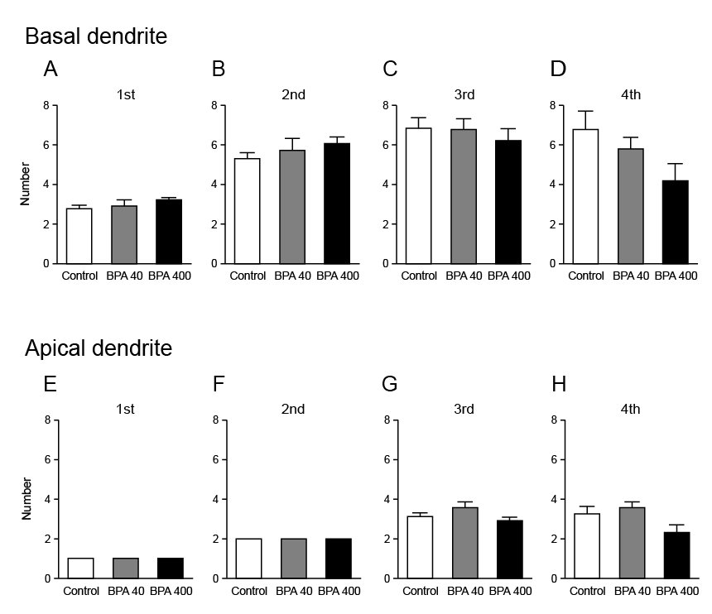

Fig. S1 Branching numbers of basal and apical dendrites of hippocampal CA1 pyramidal neurons of 21-day-old GFP-Thy1-M mice prenatally exposed to BPA. First- to fourth-order branching of basal (A–D) and apical dendrites (E–H) on CA1 pyramidal neurons. Values are shown as means ± S.E.M for five mice per group.

